HandOut.7: Delving Deep into Hbase

THIS LAB HAS BEEN WORKED ON BY BOTH MAHNOOR ADEEL AND ZUHA AQIB. BOTH OF US HAVE USED ZUHA’S VM FOR THIS LAB.

Installation
Access your docker working directory
Execute: git clone https://github.com/big-data-europe/docker-hbase.git
Execute (Hbase in standalone mode): docker-compose -f docker-compose-standalone.yml up -d
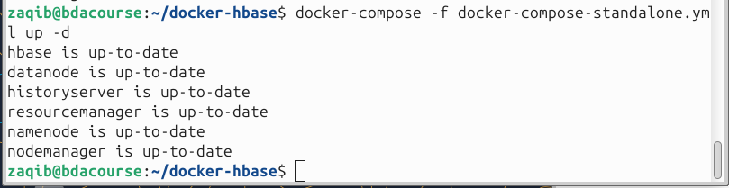
Check all containers: docker ps
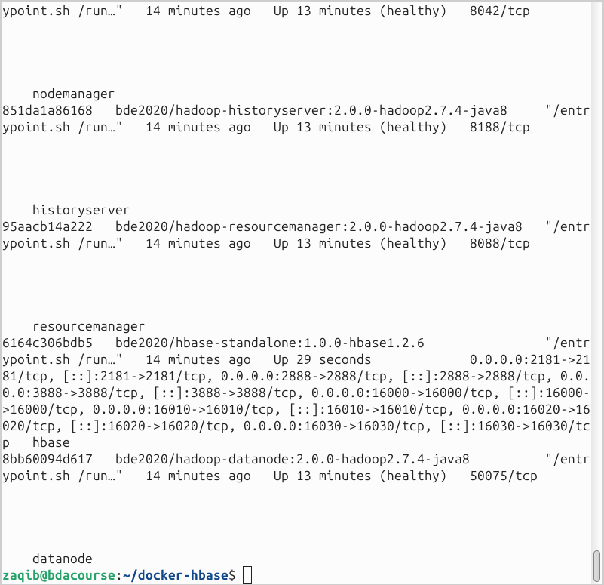
Check your IP: ipconfig /all
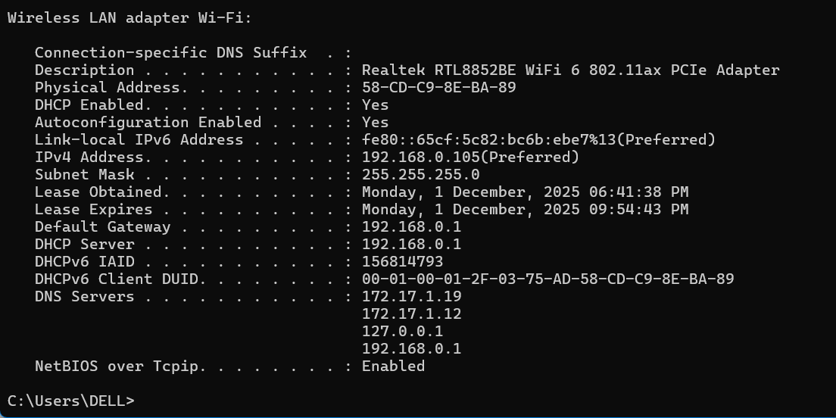
[ToDo: Paste relevant snapshot at port 16010]
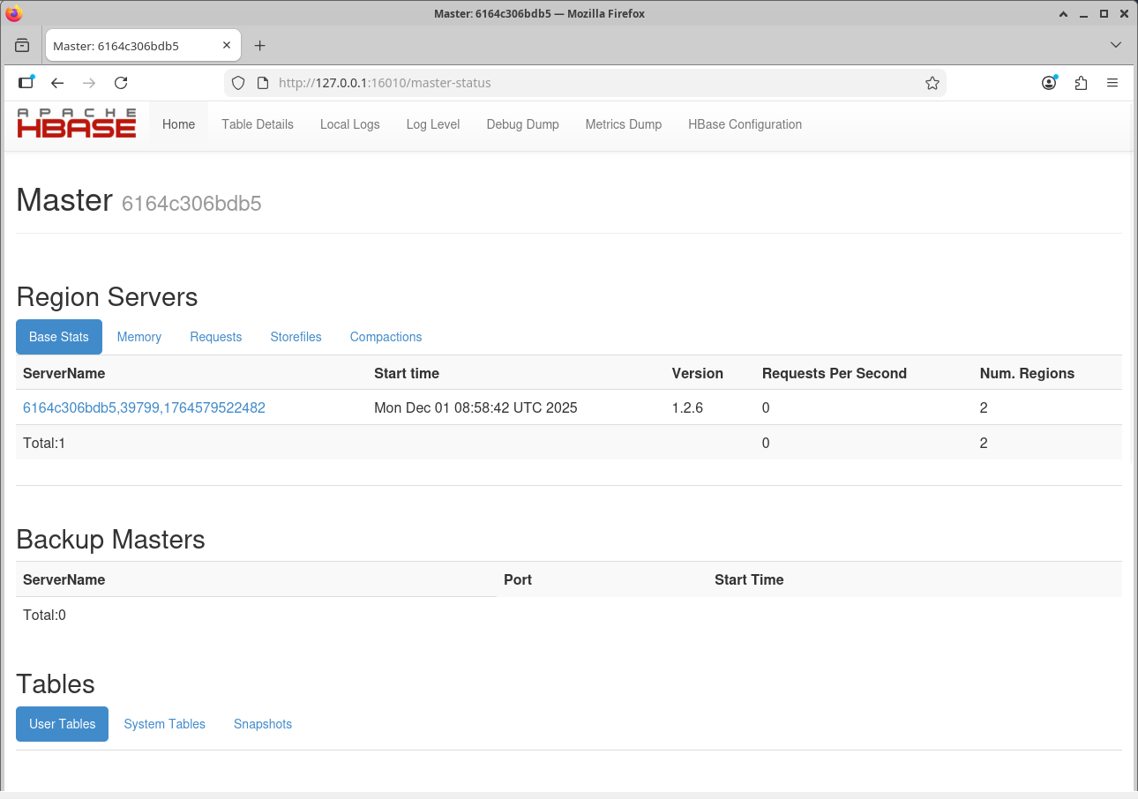
Execute: docker exec -it hbase /bin/bash
Execute: hbase shell
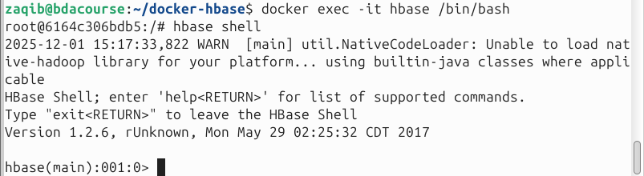
General Shell Commands
Starting HBase Shell: hbase shell
Exiting HBase Shell: exit
View existing tables in HBase: list
View existing servers in HBase: status
View version of HBase in use: version
To open guide for tables in HBase: table_help
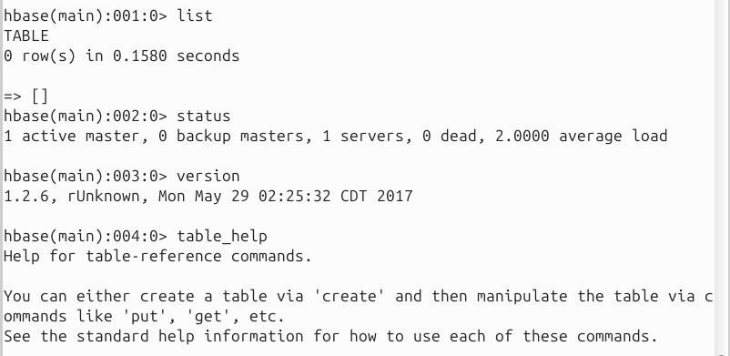
Create table in HBase:
create'ecommerce_transactions,'amount','card_type', 'websitename', 'countryname', 'datetime', 'transactionID', 'cityname', 'productname'
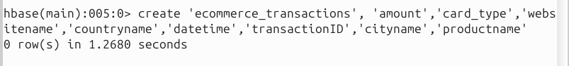
Insert some rows for tables in HBase:
put 'ecommerce_transactions', '2', 'card_type', 'MasterCard'
put 'ecommerce_transactions', '3', 'card_type', 'Visa'
put 'ecommerce_transactions', '4', 'card_type', 'MasterCard' put 'ecommerce_transactions', '5', 'card_type', 'Maestro'
put 'ecommerce_transactions', '1', 'amount', '50.87'
put 'ecommerce_transactions', '2', 'amount', '1023.2'
put 'ecommerce_transactions', '3', 'amount', '3321.1'
put 'ecommerce_transactions', '4', 'amount', '234.11'
put 'ecommerce_transactions', '5', 'amount', '321.11'
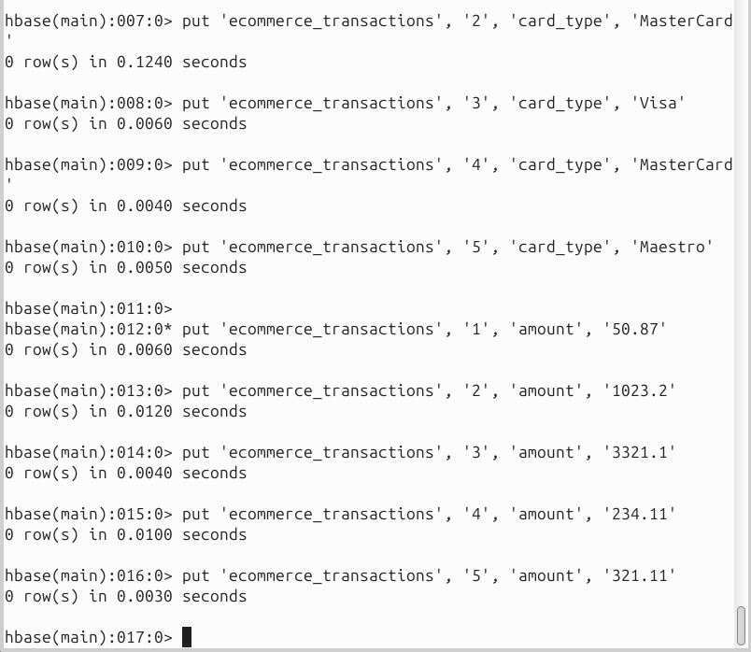

Get transactions for only row value 2 and 3 in HBase:
get 'ecommerce_transactions', '2' get 'ecommerce_transactions', '5' 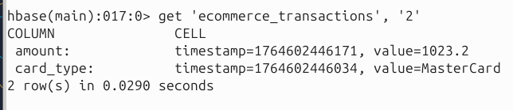
Get description of the table in HBase: describe 'ecommerce_transactions'
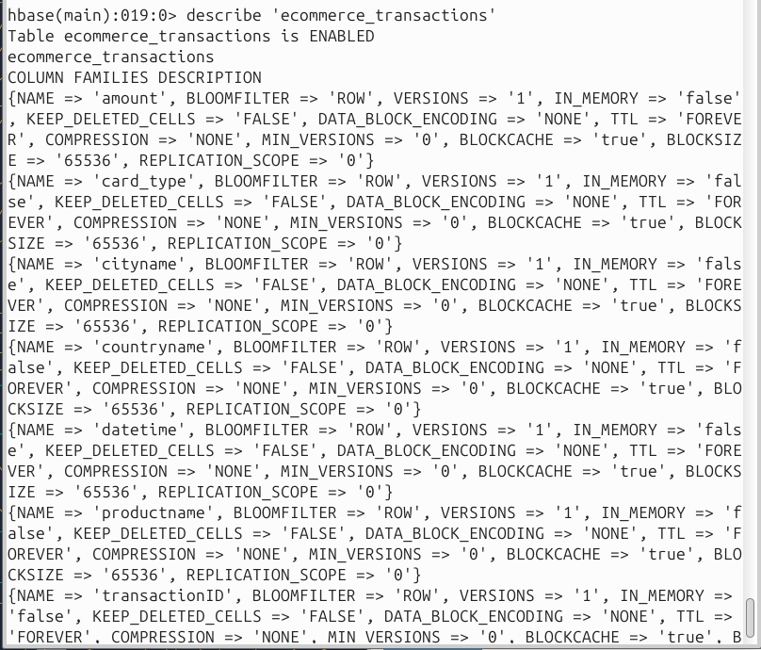

Alter is the command used to make changes to an existing table. This command can help change the maximum number of cells of a column family, set and delete table scope operators, and delete a column family from a table:
alter 'ecommerce_transactions', NAME => ‘card_type’, VERSIONS =>5
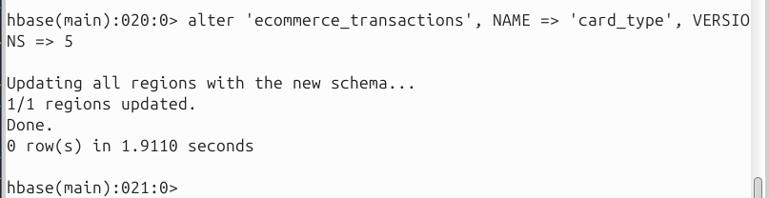
Deleting a cell in a table in HBase: delete 'ecommerce_transactions', ‘4’, ‘card_type’
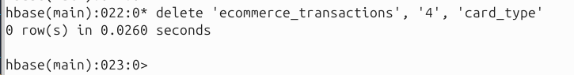
Deleting a row in a table in HBase: deleteall 'ecommerce_transactions', ‘4’
Count number of rows in a table in HBase: count 'ecommerce_transactions'
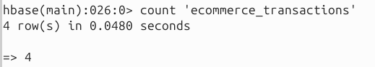
Disable, drop and recreate a table in HBase: truncate 'ecommerce_transactions'
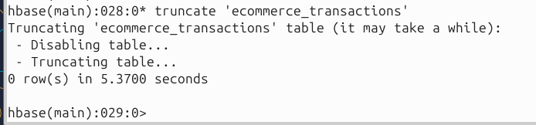
Check if a table is present in HBase: exists 'ecommerce_transactions'
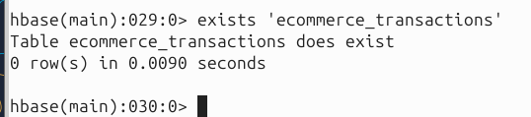
View all rows in a table of HBase: scan ‘ecommerce_transactions’
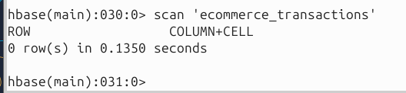
Disable a table of HBase: disable ‘ecommerce_transactions’
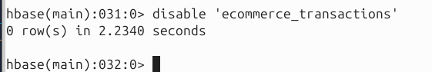
Drop a table of HBase: drop ‘ecommerce_transactions’
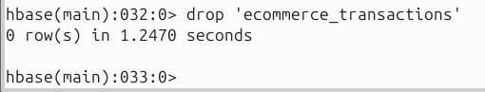
Note: drop won’t work till table has been disabled

Scan Filter Exercises
[ToDo: Paste snapshot of 2 filter outputs]
Using the data inserted in 'ecommerce_transactions' table, enhancing reads of data present in HBase using the scan filtering techniques. There are 6 most commonly used filters, but these can also be combined together for more specific searches.
Check for available filters in HBase to read data more specifically: show_filters (enter in HBase shell)
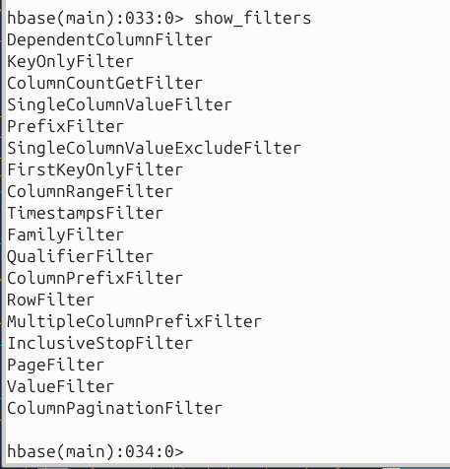
Using the data set we put earlier perform the following hands-on exercise:
RECREATED TABLE AND REINSERTED THE DATA AS IT WAS TRUNCATED/DROPPED BEFORE
Using KeyOnlyFilter get the names of columns and column family qualifiers without seeing their values (typically used for a dataset with very large values and we just want to see the attributes):
scan 'ecommerce_transactions', {FILTER => "KeyOnlyFilter()"}
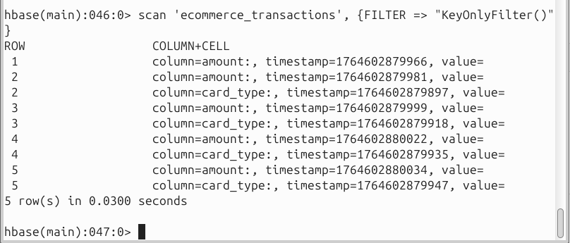
Using the PrefixFilter to find any pattern associated with our row keys: Check which row key represents which website for transactions?
scan 'ecommerce_transactions', {FILTER => "PrefixFilter('1')"}
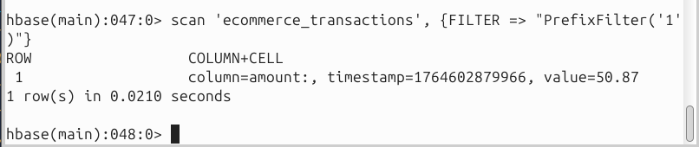
Combining filters: Suppose now we want to see which column families are on row key 2? Then we combine the two filters such that:
scan 'ecommerce_transactions',{FILTER => "PrefixFilter('2') AND KeyOnlyFilter()"}
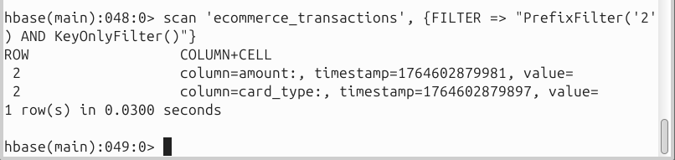
Using the ColumnPrefixFilter, find the column families which start with 'c'
scan 'ecommerce_transactions', {FILTER => "ColumnPrefixFilter('c')"}
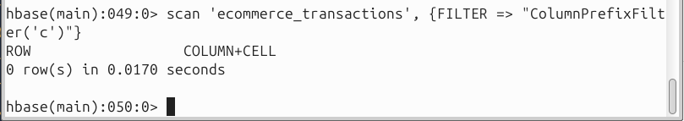
Similarly, specify two arguments in this filter and find all column families which start with 'c' or 'p'
scan 'ecommerce_transactions', {FILTER => "MultipleColumnPrefixFilter('c','p')"}
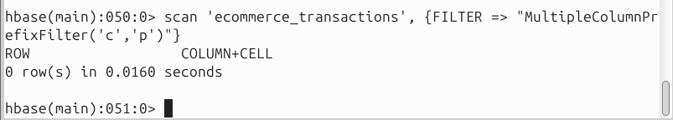
Using the PageFilter, read first two rows of the HBase table 'ecommerce_transactions':
scan 'ecommerce_transactions', {FILTER => "PageFilter(2)"}
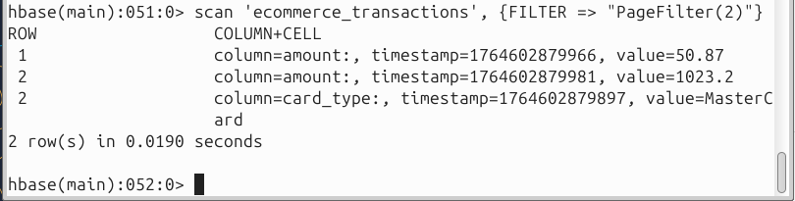
Combining this with another filter, get 3 rows with the column family starting with the letter
'c'
scan 'ecommerce_transactions', {FILTER => "PageFilter(3) AND ColumnPrefixFilter('c')"}
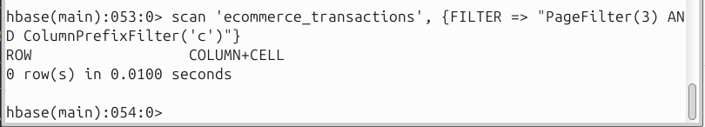
Using the InclusiveStopFilter, scan from start till the specified row 4 (including 4 in it)
scan 'ecommerce_transactions', {FILTER => "InclusiveStopFilter('4')"}
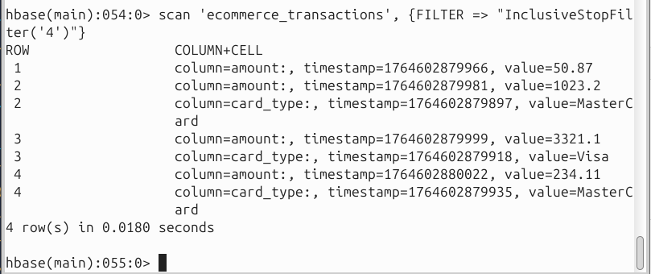
Now use the ValueFilter to do some basic search on values of the data. This works similar to the 'like' command of SQL. Find the card type starting with 'M'
scan 'ecommerce_transactions', {COLUMNS => 'card_type', FILTER => "ValueFilter(=,'binary prefix:M')"}
scan 'ecommerce_transactions',
{ COLUMNS => 'card_type',
FILTER => "ValueFilter(=, 'binaryprefix:M')" } # // CHANGED
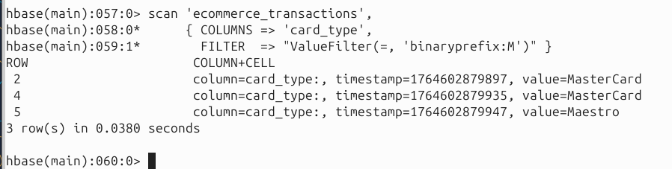
Return all countries starting with letters > 'I':
scan 'ecommerce_transactions', {COLUMNS => 'countryname', FILTER =>
"ValueFilter(>,'binary prefix:I')"}
scan 'ecommerce_transactions',
{ COLUMNS => 'countryname',
FILTER => "ValueFilter(>, 'binaryprefix:I')" } # // CHANGED
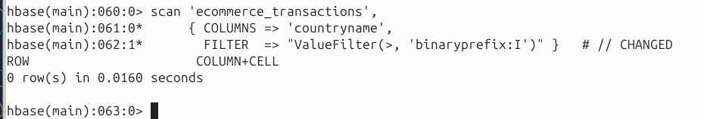
Using the STARTROW, scan only rows from row key 3 onwards:
scan 'ecommerce_transactions', {STARTROW => '3'}
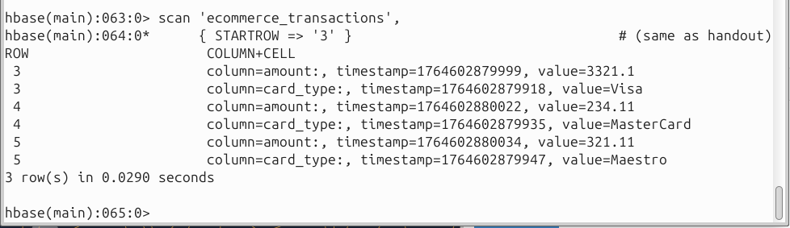

A Use Case Combining Hive and HBase
Definition of use case: To implement HBase for big data storage in NoSQL form and run that with integration to Hive HQL language in order to reuse the existing SQL queries Starting HBase shell: hbase shell
Creating table in HBase for e-commerce transactions data: create 'transaction_detail_HBase_tbl','transaction_data','customer_data'
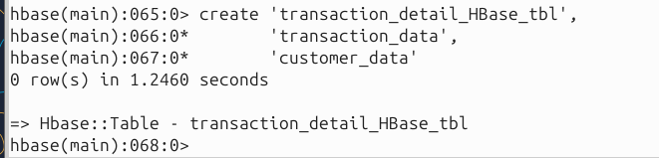
Note: the column families are declared in the create table command in order to create it successfully in HBase shell.
Entering some initial values to populate table:
[ToDo: Paste snapshot of below] put 'transaction_detail_HBase_tbl','1','transaction_data:transaction_amount','50.85' put
'transaction_detail_HBase_tbl','1','transaction_data:transaction_card_type','MasterCard' put
'transaction_detail_HBase_tbl','1','transaction_data:transaction_ecommerce_website_na me','www.ebay.com' put 'transaction_detail_HBase_tbl','1','transaction_data:transaction_datetime','2019-05-
14 15:24:12' put
'transaction_detail_HBase_tbl','1','transaction_data:transaction_product_name','Laptop' put 'transaction_detail_HBase_tbl','1','customer_data:transaction_ci ty_name','Mumbai' put 'transaction_detail_HBase_tbl','1','customer_data:transaction_co untry_name','India' put 'transaction_detail_HBase_tbl','2','transaction_data:transaction_amount','259.12' put
'transaction_detail_HBase_tbl','2','transaction_data:transaction_card_type','MasterCard' put
'transaction_detail_HBase_tbl','2','transaction_data:transaction_ecommerce_website_na me','www.amazon.com' put 'transaction_detail_HBase_tbl','2','transaction_data:transaction_datetime','2019-05-
14 15:24:13'
put 'transaction_detail_HBase_tbl','2','transaction_data:transaction_product_name','Wrist Band' put 'transaction_detail_HBase_tbl','2','customer_data:transaction_ci ty_name','Pune' put 'transaction_detail_HBase_tbl','2','customer_data:transaction_co untry_name','India' put 'transaction_detail_HBase_tbl','3','transaction_data:transaction_amount','328.16' put 'transaction_detail_HBase_tbl','3','transaction_data:transaction
_card_type','MasterCard' put
'transaction_detail_HBase_tbl','3','transaction_data:transaction_ecommerce_website_na me','www.flipkart.com' put 'transaction_detail_HBase_tbl','3','transaction_data:transaction_datetime','2019-05-
14 15:24:14'
put 'transaction_detail_HBase_tbl','3','transaction_data:transaction_product_name','TV Stand'
put 'transaction_detail_HBase_tbl','3','customer_data:transaction_ci ty_name','New York City'
put 'transaction_detail_HBase_tbl','3','customer_data:transaction_co untry_name','United States' put 'transaction_detail_HBase_tbl','4','transaction_data:transaction_amount','399.06' put 'transaction_detail_HBase_tbl','4','transaction_data:transaction_card_type','Visa' put
'transaction_detail_HBase_tbl','4','transaction_data:transaction_ecommerce_website_na me','www.snapdeal.com' put 'transaction_detail_HBase_tbl','4','transaction_data:transaction_datetime','2019-0514 15:24:15'
put 'transaction_detail_HBase_tbl','4','transaction_data:transaction_product_name','TV Stand' put 'transaction_detail_HBase_tbl','4','customer_data:transaction_ci ty_name','New Delhi' put 'transaction_detail_HBase_tbl','4','customer_data:transaction_co untry_name','India' put 'transaction_detail_HBase_tbl','5','transaction_data:transaction_amount','194.52' put 'transaction_detail_HBase_tbl','5','transaction_data:transaction_card_type','Visa' put
'transaction_detail_HBase_tbl','5','transaction_data:transaction_ecommerce_website_na me','www.ebay.com' put 'transaction_detail_HBase_tbl','5','transaction_data:transaction_datetime','2019-05-
14 15:24:16' put
'transaction_detail_HBase_tbl','5','transaction_data:transaction_product_name','External
Hard Drive' put 'transaction_detail_HBase_tbl','5','customer_data:transaction_city_name','Rome' put 'transaction_detail_HBase_tbl','5','customer_data:transaction_country_name','Italy'
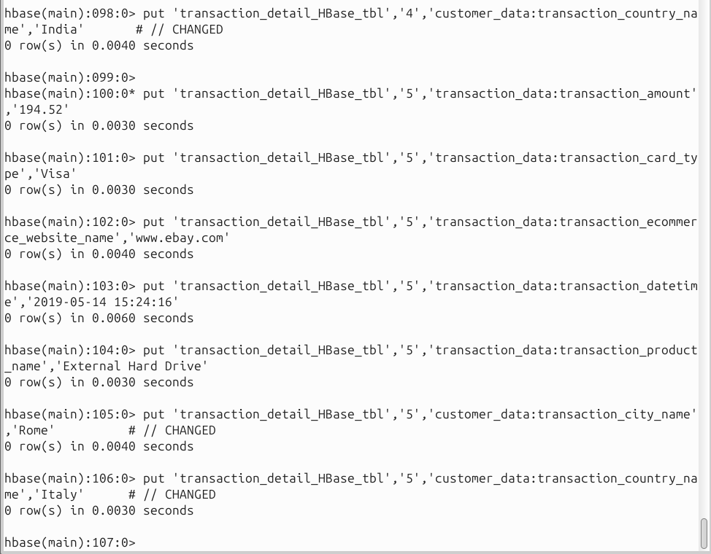
View the populated table to see the rows entered in the previous step:
[ToDo: Paste snapshot of below]
scan 'transaction_detail_HBase_tbl'
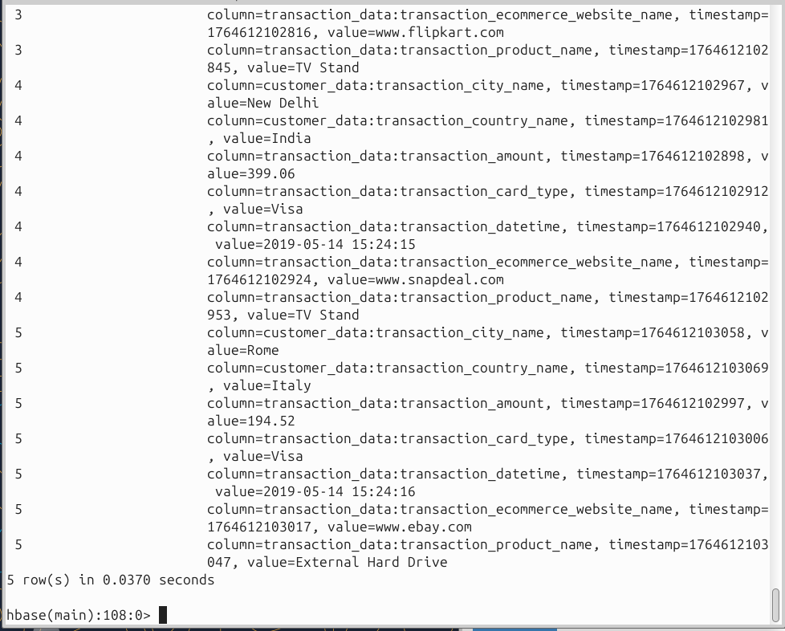
Once table has been populated, we exit the HBase shell and enter the Hive shell for integration purposes:
Exiting HBase Shell: exit
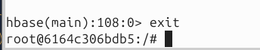
Next we enter Hive shell to make a connecting table to our HBase table (Hive docker should also be running)
Enter Hive shell (execute the beeline command)
beeline -u jdbc:hive2://hive-server:10000
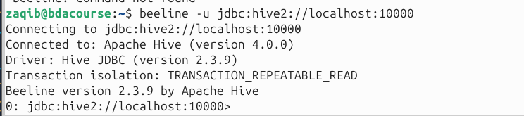
show databases; create database mydb300; use mydb300;
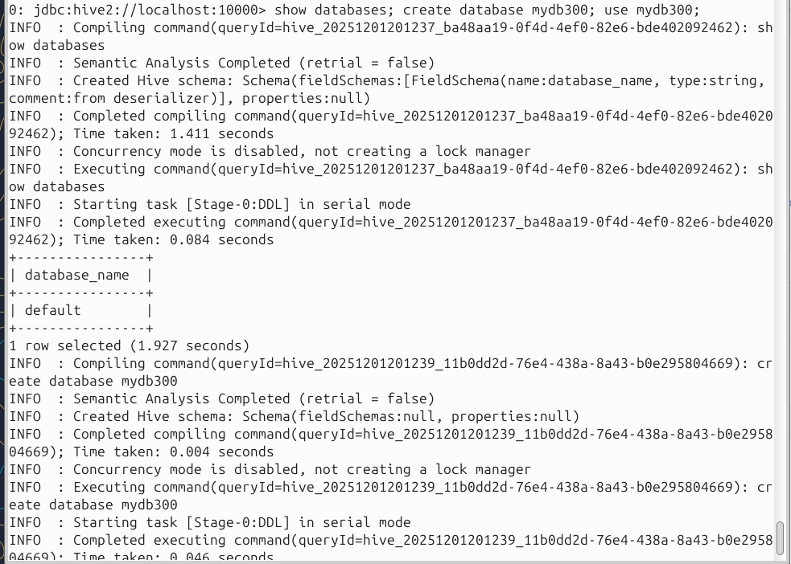
Now create an external table in hive which points to the table with data kept in HBase following an architecture such that:
[ToDo: Paste snapshot of below]
CREATE EXTERNAL TABLE transaction_detail_hive_tbl(transaction_id int, transaction_card_type string, transaction_ecommerce_website_name string, transaction_product_name string, transaction_datetime string, transaction_amount double, transaction_city_name string, transaction_country_name string) STORED BY 'org.apache.hadoop.hive.HBase.HBaseStorageHandler'
WITH SERDEPROPERTIES
("HBase.columns.mapping"=":key,transaction_data:transaction_card_type,transaction_d ata:transaction_ecommerce_website_name,transaction_data:transaction_product_name ,transaction_data:transaction_datetime,transaction_data:transaction_amount,customer_ data:tran saction_city_name,customer_data:transaction_country_name")
TBLPROPERTIES
("HBase.table.name"="transaction_detail_HBase_tbl");
For this command, we were initially getting errors that said HBaseStorageHandler class not found, this meant that the Hive server was not able to establish a connection with the Hbase.
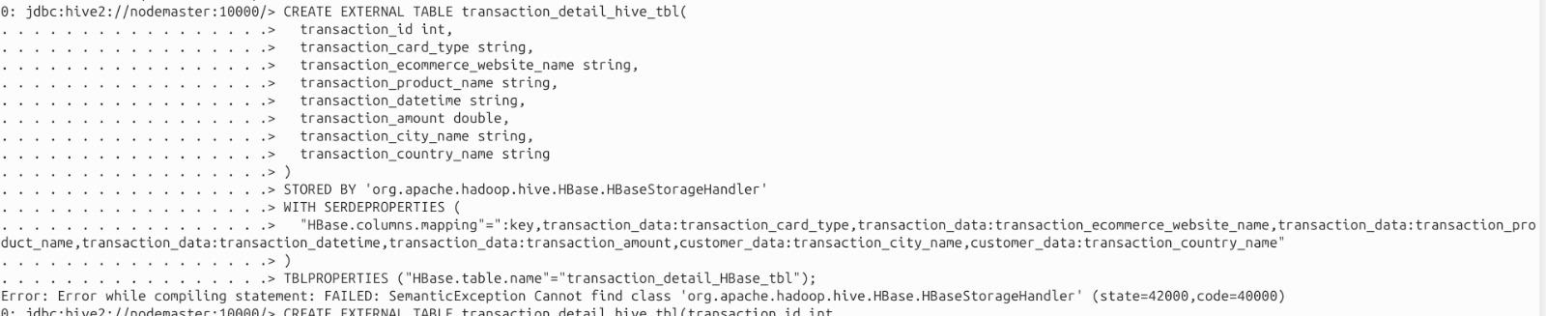Few possible reasons for this were that Hive and Hbase containers were on different networks initially and Hive didn’t have the HBase client jars and configuration available. We tried manually copying jars from the Hbbase container to the Hive container, fixed configurations by setting hbase-site.xml in Hive’s class path and ensured Hive had correct zookeeper quorum, and made both containers available on the same network. However, Hive was still not able to connect to Hbase and this query kept failing. We were looking for some documentation for Hbase and Hive integration. We found a repository that had scripts for running containers for both.
Repository Link: https://github.com/kennonsr/hadoop_hbase_hive_spark_docker
We started all the containers and checked if everything was working fine. We recreated the table transaction_detail_HBase_tbl in Hbase and populated it with the data given above.
Initially, we tried running the external table query, but it gave the same result. We then tried the same, copied Hbase client jar and config files from Hbase to Hive, ran a script for that.
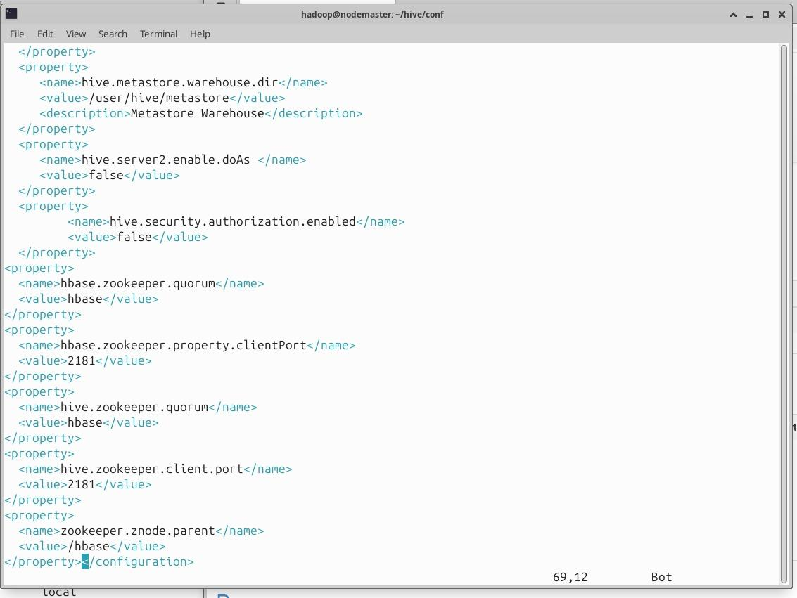Next we added ZooKeeper configurations in hive-site.xml to connect Hive with HBase via ZooKeeper.
Additions to hive-site.xml:
<property>
<name>hbase.zookeeper.quorum</name>
<value>hbase</value>
</property>
<property>
<name>hbase.zookeeper.property.clientPort</name>
<value>2181</value>
</property>
<property>
<name>hive.zookeeper.quorum</name>
<value>hbase</value>
</property>
<property>
<name>hive.zookeeper.client.port</name>
<value>2181</value>
</property>
<property>
<name>zookeeper.znode.parent</name>
<value>/hbase</value>
</property>

Then we restarted all the containers to apply the changes.
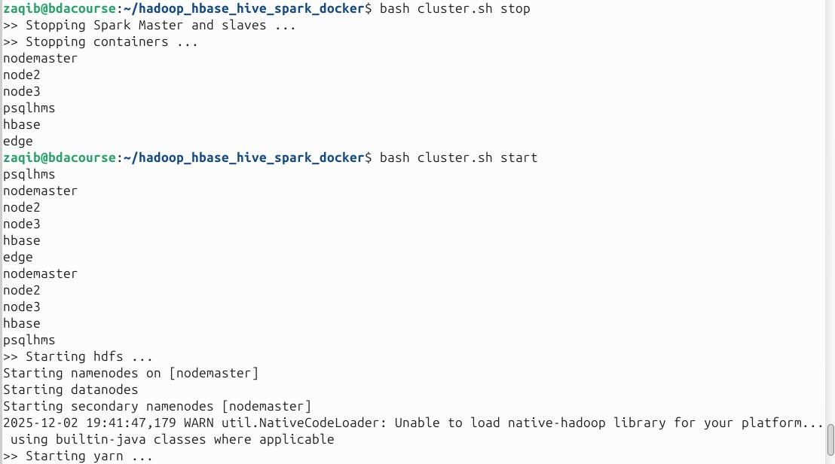
Finally we were able to run the command successfully and create an external table in Hive that mapped to the transaction_detail_HBase_tbl in Hbase using Hbase Storage Handler.
CREATE EXTERNAL TABLE transaction_detail_hive_tbl (
transaction_id INT,
transaction_card_type STRING,
transaction_ecommerce_website_name STRING,
transaction_product_name STRING,
transaction_datetime STRING,
transaction_amount DOUBLE,
transaction_city_name STRING,
transaction_country_name STRING
)
STORED BY 'org.apache.hadoop.hive.hbase.HBaseStorageHandler'
WITH SERDEPROPERTIES (
"hbase.columns.mapping" = ":key,
transaction_data:transaction_card_type,
transaction_data:transaction_ecommerce_website_name,
transaction_data:transaction_product_name,
transaction_data:transaction_datetime,
transaction_data:transaction_amount,
customer_data:transaction_city_name,
customer_data:transaction_country_name"
)
TBLPROPERTIES (
"hbase.table.name" = "transaction_detail_HBase_tbl"
);

(org.apache.hadoop.hive.HBase.HBaseStorageHandler changed to org.apache.hadoop.hive.hbase.HBaseStorageHandler)
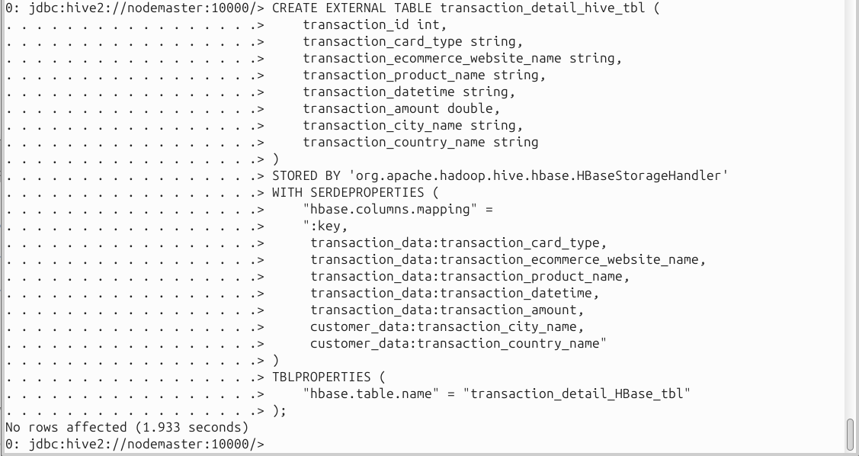
How this integration works:
A new table is created in Hive database using the create external table command which has all attributes and datatypes declared in Hive in a similar way as SQL tables.
This table is linked with HBase using a stored by operation using the storage handler for HBase as depicted in the architecture diagram above.
Furthermore, this command also adds serdeproperties where we specify all the column families and column family qualifiers that have to be connected to in HBase listing them in the same sequence as listed in the attributes declared after the create external table command.
Lastly this command creates a link to the HBase table using tblproperties.
Note: HBase table may have many columns however, in Hive we do not have to fetch all columns, but just the columns we need for analysis.
Once this is executed, the data can be fetched in Hive using similar queries to SQL.

View the HBase connected table in Hive:
[ToDo: Paste snapshot of below] select * from transaction_detail_hive_tbl;
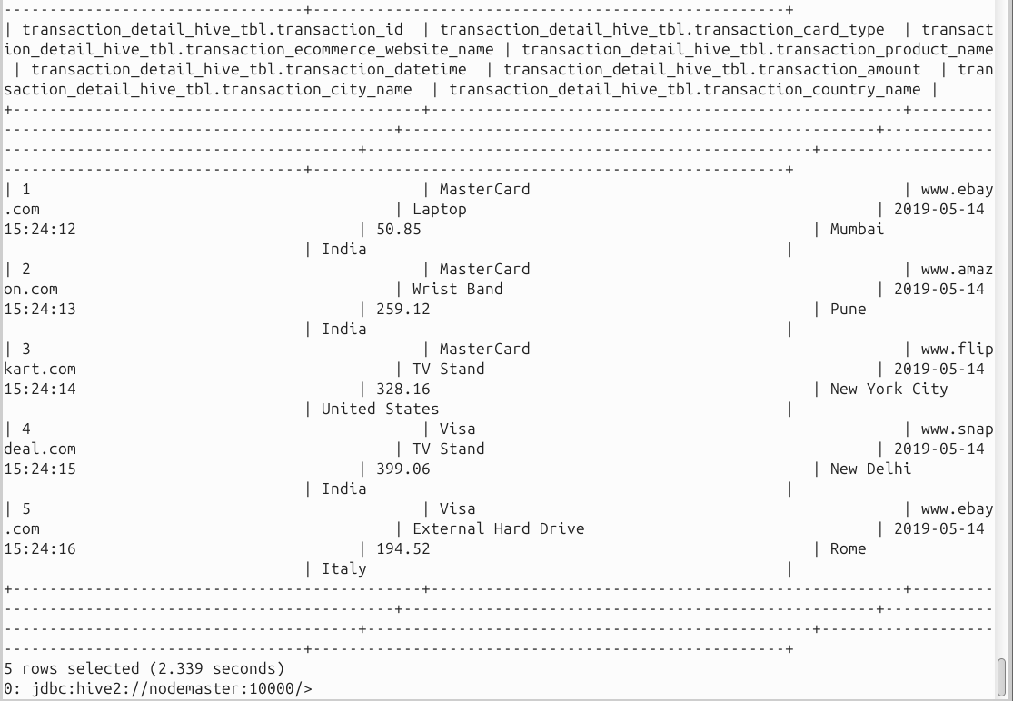
Note: all this data is stored in HBase and is directly coming from it. Nothing is ever stored in Hive. Hive is only being used as an interface to query the data for simplification purposes.

Inserting Big Data in HBase programmatically:
[ToDo: Do all below with Java/Python]
As seen above, sample data was inserted using the ‘put’ command in the HBase table to demo the integration with Hive.
However, for big data, multiple put commands will make the data insertion process inefficient. A better approach would be to write a program for data insertion.
Example program code for inserting large data set in HBase (this code is in jRuby, but can be written in java or python as well)
Create a JRuby file named multi.rb through which we will insert multiple rows in an HBase table:

Comment: Setting up packages and function to initiate HBase insertion program import ‘org.apache.hadoop.HBase.client.HTable’ import ‘org.apache.hadoop.HBase.client.Put’
def jbytes(*args) args.map {|arg| arg.to_s.to_java_bytes}
end

Comment: Creating HTable as an object called tables pointing to the transaction_detail_HBase_tbl
Comment: Creating an object called “row” with a row key specified table = HTable.new(@HBase.configuration, “transaction_detail_HBase_tbl”) row = Put.new(*jbytes(“200”))

Comment: Using the add method to put data into the “row” object row.add
(*jbytes(“customer_data”, “card_type”, “master card”))
(*jbytes(“customer_data”, “card_type”, “visa card”)) (*jbytes(“customer_data”, “card_type”, “multi card”)) table.put(row)

Executing from linux command prompt:
hbase shell multi.rb
We created a java script SingleInsertTest.java that connects to HBase and inserts one single transaction record into the HBase table, transaction_detail_HBase_tbl .
It firstly creates configuration and connects to Hbase:
config = HBaseConfiguration.create();
connection = ConnectionFactory.createConnection(config);
Next, it gets access to the table:
table = connection.getTable(TableName.valueOf("transaction_detail_HBase_tbl"));
Next, it creates a new row (row key = 100) in the HBase table and inserts transaction and customer data into it.
Put put = new Put(Bytes.toBytes("100"));

// transaction_data column family
put.addColumn(
Bytes.toBytes("transaction_data"),
Bytes.toBytes("transaction_amount"),
Bytes.toBytes("499.99") );
put.addColumn(
Bytes.toBytes("transaction_data"),
Bytes.toBytes("transaction_card_type"),
Bytes.toBytes("Visa") );
put.addColumn(
Bytes.toBytes("transaction_data"),
Bytes.toBytes("transaction_ecommerce_website_name"),
Bytes.toBytes("www.amazon.com") );
put.addColumn(
Bytes.toBytes("transaction_data"),
Bytes.toBytes("transaction_datetime"),
Bytes.toBytes("2019-05-25 14:30:00") );
put.addColumn(
Bytes.toBytes("transaction_data"),
Bytes.toBytes("transaction_product_name"),
Bytes.toBytes("Gaming Laptop") );

// customer_data column family
put.addColumn(
Bytes.toBytes("customer_data"),
Bytes.toBytes("transaction_city_name"),
Bytes.toBytes("Karachi") );
put.addColumn(
Bytes.toBytes("customer_data"),
Bytes.toBytes("transaction_country_name"),
Bytes.toBytes("Pakistan") );

// Insert data
table.put(put);

We copied this script into hbase container.
Compiled it: javac -cp "$(hbase classpath)" SingleInsertTest.java
Ran it: java -cp ".:$(hbase classpath)" SingleInsertTest

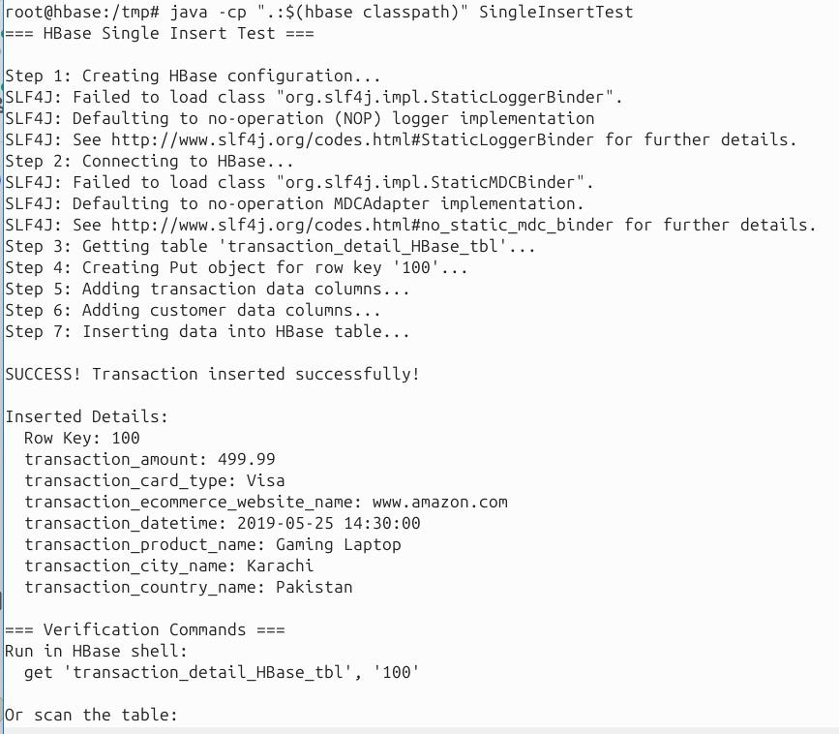
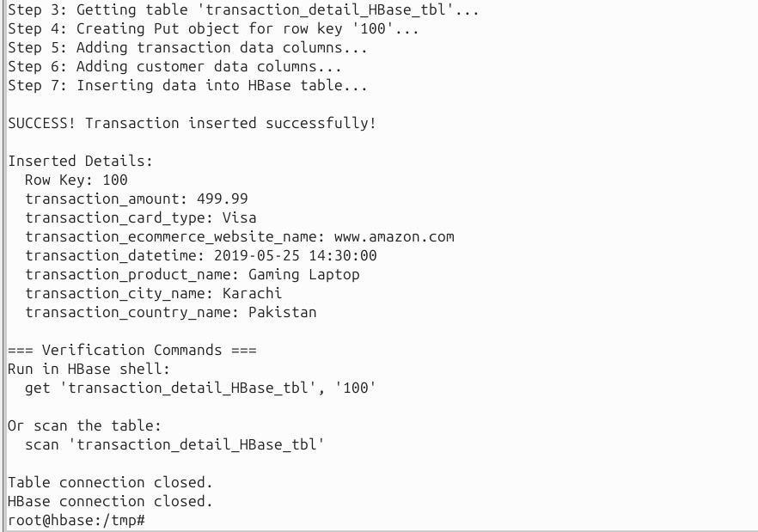

Next, we tested if the rows has been added correctly by running the query:
get 'transaction_detail_HBase_tbl', '100'
from the Hbase shell.
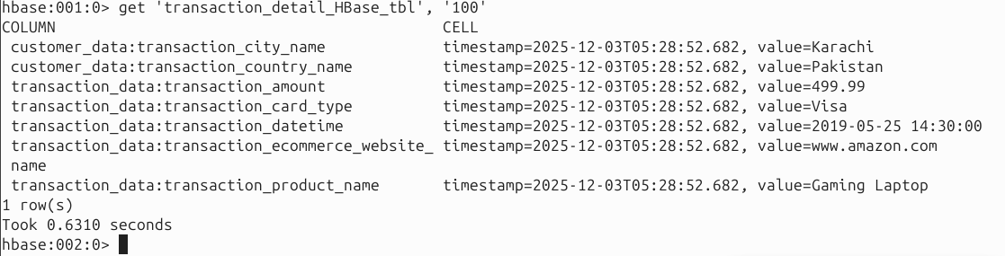

Big data import in HBase - Importing data from a CSV file + Assignment: 2.2% of your grade
[Import your big data into Hbase and query that first through Hbase and then through Hive] [Show all commands along with important snapshots]
Once the table has been created in HBase, then locate the CSV file on your computer. (transaction_detail.csv)
Make sure to remove the header row as attributes are declared in HBase.
[ToDo: Load the CSV file into the Hbase table and paste snapshot]
hbase org.apache.hadoop.hbase.mapreduce.ImportTsv - Dimporttsv.separator=',' - Dimporttsv.columns=HBASE_ROW_KEY,transaction_data:transaction_ca rd_type,transaction_data:transaction_ecommerce_website_name,tran saction_data:transaction_product_name,transaction_data:transacti on_datetime,transaction_data:transaction_amount,customer_data:tr ansaction_city_name,customer_data:transaction_country_name transaction_detail_HBase_tbl /user/hdfs/transaction_detail.csv
Firstly created a csv file with 100 rows, in the host machine with random data for the transaction_detail_HBase_tbl table. The rows in the csv had row-keys from 200-299. We also ensured the table did not have headers. The data was generated through an LLM.
Copied the csv file into the Hbase container and then copied it to HDFS:
docker cp transaction_detail.csv hbase:/tmp/
hdfs dfs -mkdir -p /user/hdfs
hdfs dfs -put -f /tmp/transaction_detail.csv /user/hdfs/transaction_detail.csv
Next we ran the ImportTsv command to load csv data into the table.
hbase org.apache.hadoop.hbase.mapreduce.ImportTsv \
-Dimporttsv.separator=',' \
-Dimporttsv.columns=HBASE_ROW_KEY,transaction_data:transaction_card_type,transaction_data:transaction_ecommerce_website_name,transaction_data:transaction_product_name,transaction_data:transaction_datetime,transaction_data:transaction_amount,customer_data:transaction_city_name,customer_data:transaction_country_name \
transaction_detail_HBase_tbl \
hdfs://nodemaster:9000/user/hdfs/transaction_detail.csv
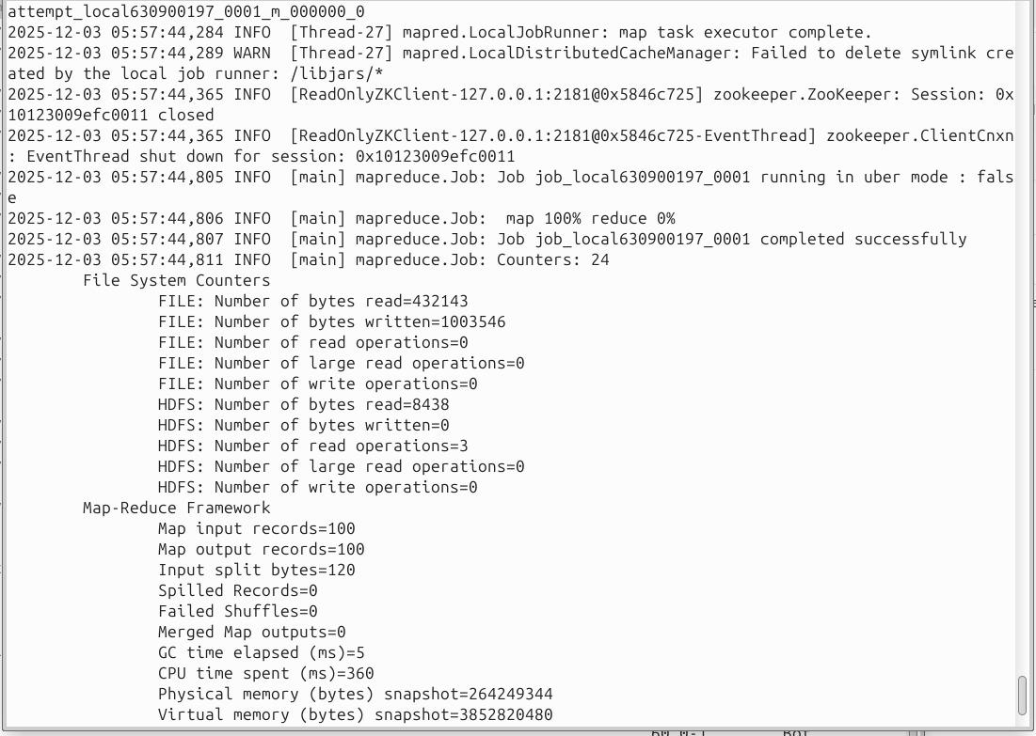

Next, we ran some queries from the Hbase shell to check if data has been loaded into the table.

HBase Queries
1. scan 'transaction_detail_HBase_tbl'
Displays all rows from the HBase table transaction_detail_HBase_tbl.
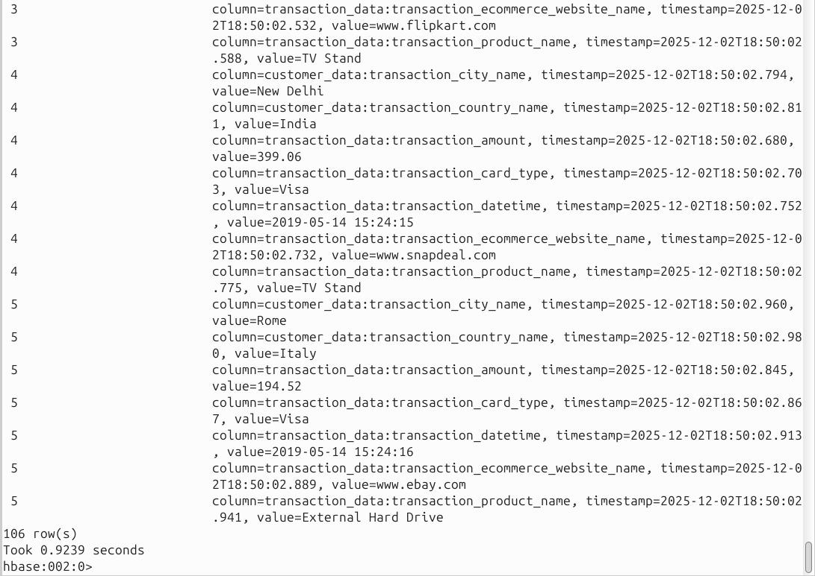
2. count 'transaction_detail_HBase_tbl'
Counts and returns the total number of rows in the table.
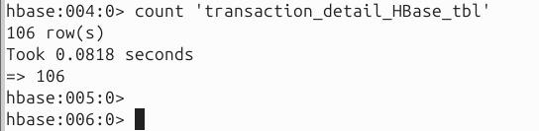
3. get 'transaction_detail_HBase_tbl', '250'
Retrieves all column values for the row with row key '250'.
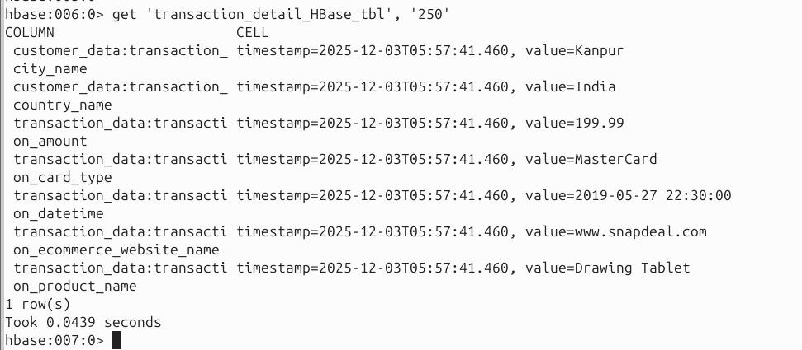
4. scan 'transaction_detail_HBase_tbl', {STARTROW => '200', STOPROW => '205'}
Retrieves all rows with row keys from '200' up to (but not including) '205'.
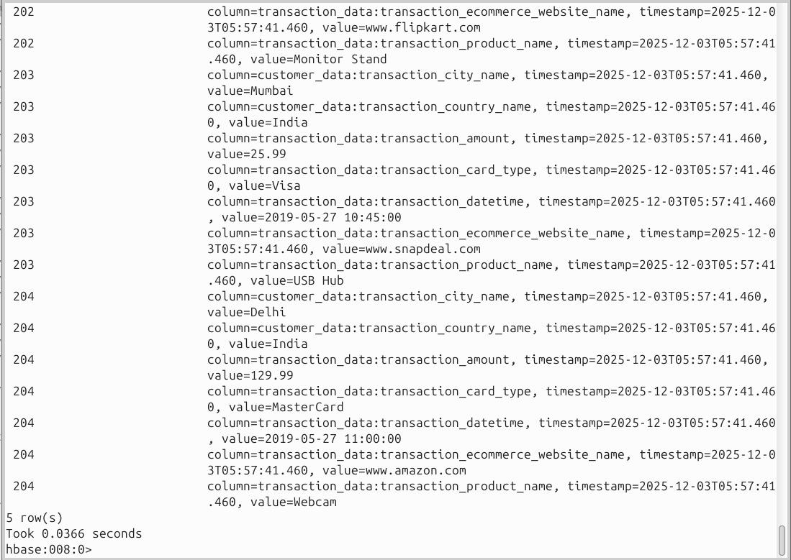
5. get 'transaction_detail_HBase_tbl', '250', {COLUMN => ['transaction_data:transaction_amount', 'transaction_data:transaction_card_type']}
Retrieves only the transaction_amount and transaction_card_type columns from the transaction_data column family for the row with key '300'
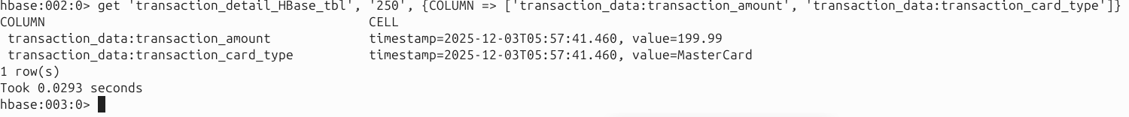
6. scan 'transaction_detail_HBase_tbl', {
FILTER => "SingleColumnValueFilter('transaction_data', 'transaction_amount', >, 'binary:300')"
}
Scans the table transaction_detail_HBase_tbl and returns only the rows where the transaction_amount in the transaction_data column family is greater than 300.
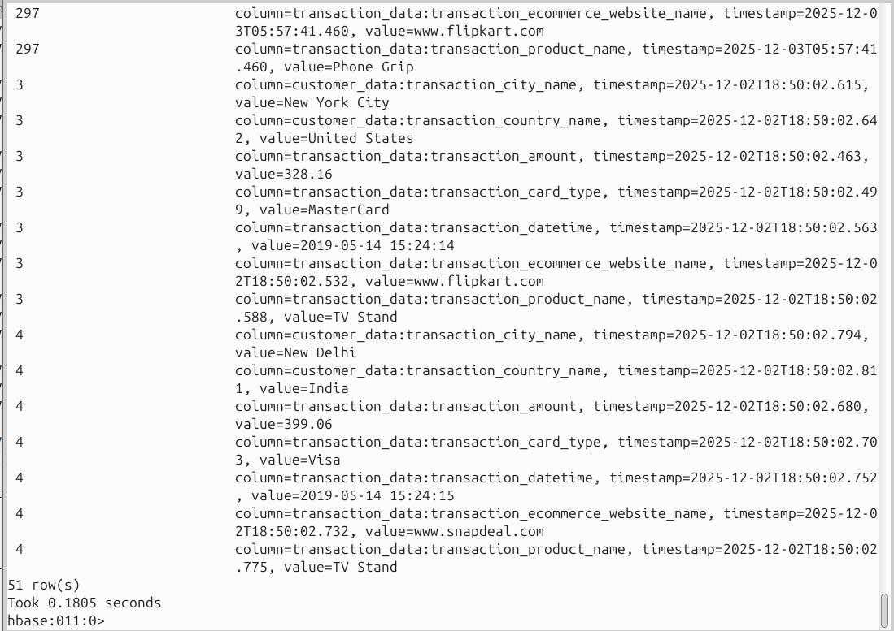

[Run SQL queries on the data using Hive and show snapshot]

Hive Queries
1. SELECT COUNT(transaction_id)
FROM transaction_detail_hive_tbl;
Counts the total number of transaction_id entries in the table.
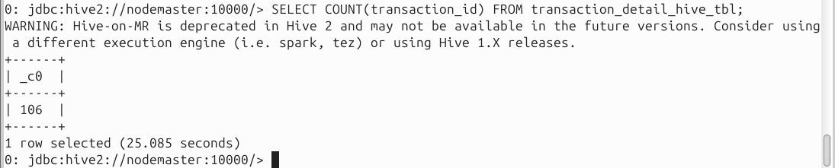
2. SELECT SUM(transaction_amount)
FROM transaction_detail_hive_tbl;
Calculates the total sum of the transaction_amount column across all rows in the table.
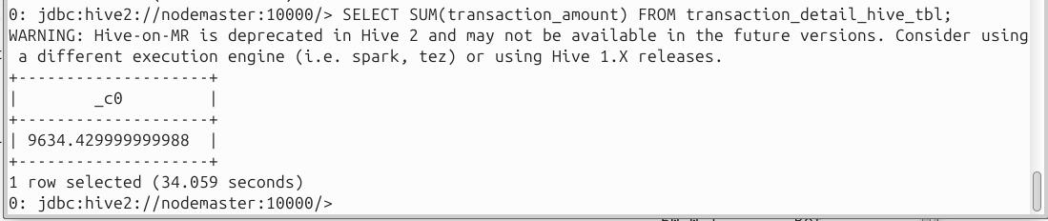
3. SELECT transaction_id, transaction_card_type, transaction_amount
FROM transaction_detail_hive_tbl
LIMIT 10;
Retrieves the first 10 rows of transaction_id, transaction_card_type, and transaction_amount.
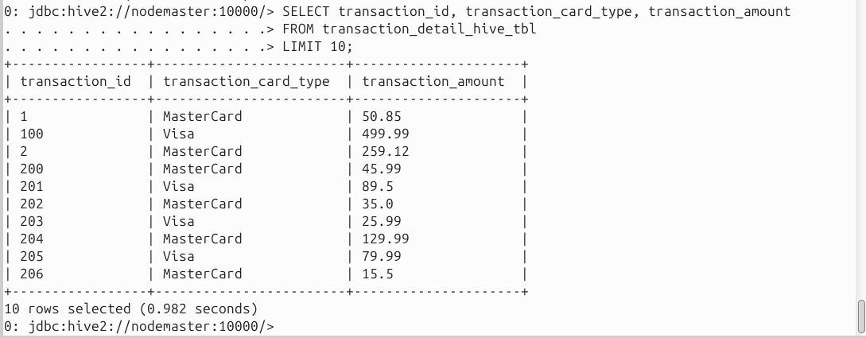

4. SELECT *
FROM transaction_detail_hive_tbl
WHERE transaction_id = 250;
Retrieves all columns for the row where transaction_id is 250.
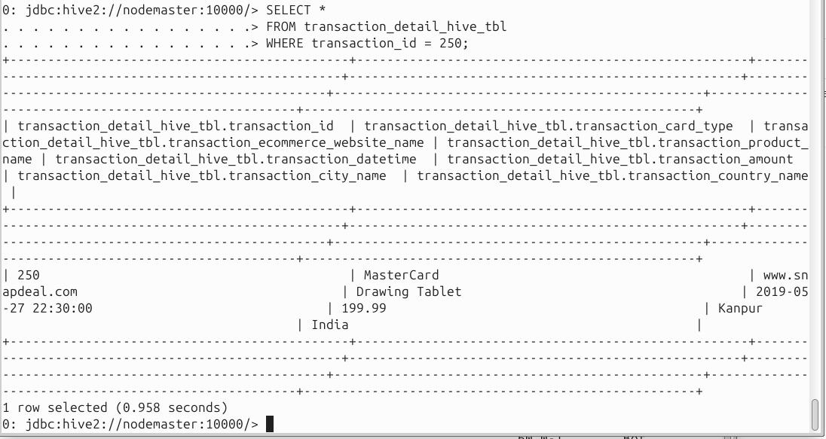
5. SELECT *
FROM transaction_detail_hive_tbl
WHERE transaction_amount > 300;
Retrieves all rows where the transaction_amount is greater than 300.
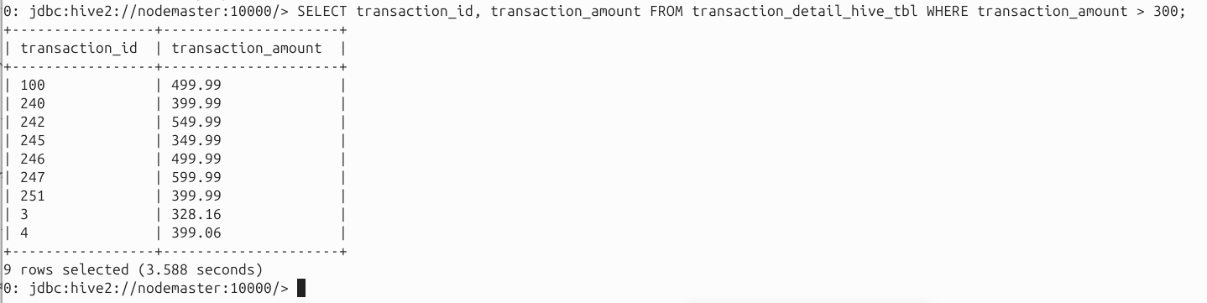
6. SELECT
transaction_ecommerce_website_name,
SUM(transaction_amount) AS total_amount,
COUNT(*) AS total_transactions
FROM transaction_detail_hive_tbl
GROUP BY transaction_ecommerce_website_name
ORDER BY total_amount DESC;
Groups transactions by e-commerce website, calculates the total transaction amount and count per website, and orders the results by total amount in descending order.
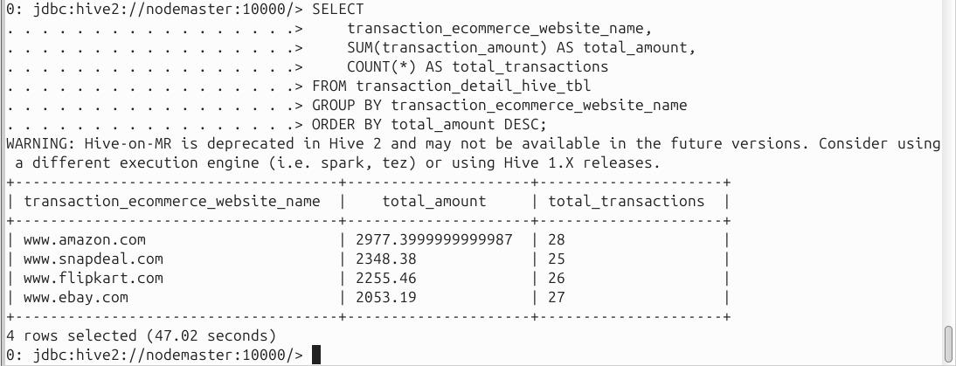

Client API: The Basics
Topic: Basics of client API, CRUD operations, KeyValue Class, application for inserting data into database, application for retrieving data from database, and row locks.
To perform CRUD operations which stands for create, read, update, and delete, on HBase table we use Java client API for HBase. Since HBase has a Java Native API and it is written in Java thus it offers programmatic access to DML (Data Manipulation Language).
Class HBase Configuration: This class adds HBase configuration files to a Configuration. It belongs to the org.apache.hadoop.hbase package.
Method: To create a Configuration with HBase resources, we use the following method:

static org.apache.hadoop.conf.Configuration create()

Class HTable in HBase Client API:
An HBase internal class which represents an HBase table is HTable. Basically, to communicate with a single HBase table, we use this implementation of a table. It belongs to the org.apache.hadoop.hbase.client class.
Constructors: We can create an object to access an HBase table by using the following constructors:
HTable()
HTable(TableName tableName, ClusterConnection connection, ExecutorService pool) Methods:
void close() : To release all the resources of the HTable, we use this method.
void delete(Delete delete) : The method “void delete(Delete delete)” helps to delete the specified cells/row.
Result get(Get get) : This method retrieves certain cells from a given row.
org.apache.hadoop.conf.Conf iguration getConfiguration() : It returns the Configuration object used by this instance.
TableName getName() : This method returns the table name instance of the table. HTableDescriptor getTableDescriptor() : It returns the table descriptor for the table. byte[] getTableName() : This method returns the name of the table. void put(Put put): We can insert data into the table, by using this method.

Class Put in HBase Client API:
To perform put operations for a single row, we use the class that belongs to the org.apache.hadoop.hbase.client package.
Constructors:
put(byte[] row): We can create a Put operation for the specified row, by using this constructor.
put(byte[] rowArray, int rowOffset, int rowLength): To make a copy of the passed-in row key to keep local, we use it.
put(byte[] rowArray, int rowOffset, int rowLength, long ts): We can make a copy of the passed-in row key to keep local, by using this constructor.
put(byte[] row, long ts): To create a Put operation for the specified row, using a given timestamp, we use it.

Methods
put add(byte[] family, byte[] qualifier, byte[] value): The method “Put add(byte[] family, byte[] qualifier, byte[] value)” adds the specified column and value to this Put operation.
put add(byte[] family, byte[] qualifier, long ts, byte[] value): With the specified timestamp, it adds the specified column and value, as its version to this Put operation.
put add(byte[] family, ByteBuffer qualifier, long ts, ByteBuffer value): This method adds the specified column and value, with the specified timestamp as its version to this Put operation.
put add(byte[] family, ByteBuffer qualifier, long ts, ByteBuffer value): With the specified timestamp, it adds the specified column and value, as its version to this Put operation.

The KeyValue class:
In our code we may have to deal with KeyValue instances directly. These instances contain the data as well as the coordinates of one specific cell. The coordinates are the row key, name of the column family, column qualifier, and timestamp.
The class provides a plethora of constructors that allow you to combine all of these in many variations. The fully specified constructor looks like this: KeyValue(byte[] row, int roffset, int rlength, byte[] family, int foffset, int flength, byte[] qualifier, int qoffset, int qlength, long timestamp, Type type, byte[] value, int voffset, int vlength)

Class Get in HBase Client API:
To perform Get operations on a single row, we use the class that belongs to the org.apache.hadoop.hbase.client package.
Constructor:
get(byte[] row): It is possible to create a Get operation for the specified row, by using this constructor.

Methods:
get addColumn(byte[] family, byte[] qualifier): To retrieve the column from the specific family with the specified qualifier, this method helps.
get addFamily(byte[] family): This one helps to retrieve all columns from the specified family.

Class Delete in HBase Client API Constructors delete(byte[] row): To create a delete operation for the specified row, we use it.
delete(byte[] rowArray, int rowOffset, int rowLength): This constructor creates a Delete operation for the specified row and timestamp.
delete(byte[] rowArray, int rowOffset, int rowLength, long ts): This constructor performs Delete operation.
delete(byte[] row, long timestamp): Again this constructor performs Delete operation.

Methods delete addColumn(byte[] family, byte[] qualifier): This method helps to delete the latest version of the specified column.
delete addColumns(byte[] family, byte[] qualifier, long timestamp): To delete all versions of the specified column we use this method, especially, with a timestamp less than or equal to the specified timestamp.
delete addFamily(byte[] family): This method deletes all versions of all columns of the specified family.
delete addFamily(byte[] family, long timestamp): Again, with a timestamp less than or equal to the specified timestamp, this method also deletes all columns of the specified family.

Class Result in HBase Client API Constructor result(): With no KeyValue payload, it is possible to create an empty Result; returns null if you call raw Cells(), by using this constructor. Methods
byte[] getValue(byte[] family, byte[] qualifier): In order to get the latest version of the specified column, we use this method.
byte[] getRow(): Moreover, to retrieve the row key which corresponds to the row from which this Result was created, we use this method.

Row Locks
The region servers provide a row lock feature ensuring that only a client holding the matching lock can modify a row. In practice, though, most client applications do not provide an explicit lock, but rather rely on the mechanism in place that guards each operation separately.
When you send, for example, a put() call to the server with an instance of Put, created with the following constructor: Put(byte[] row) , Which is not providing a RowLock instance parameter, the servers will create a lock on our behalf, just for the duration of the call.

Example Application:

1. Inserting data into HBase Table Using Java API
import org.apache.hadoop.conf.Configuration; import org.apache.hadoop.hbase.HBaseConfiguration; import
org.apache.hadoop.hbase.client.HTable; import org.apache.hadoop.hbase.client.Put; import org.apache.hadoop.hbase.util.Bytes; import java.io.IOException; public class PutExample { public static void main(String[] args) throws IOException {

Create the required configuration.
Configuration conf = HBaseConfiguration.create(); Instantiate a new client.
HTable table = new HTable(conf, "testtable"); Create Put with specific row.
Put put = new Put(Bytes.toBytes("row1"));
Add a column, whose name is “colfam1:qual1”, to the Put. put.add(Bytes.toBytes("colfam1"), Bytes.toBytes("qual1"), Bytes.toBytes("val1"));
Add another column, whose name is “colfam1:qual2”, to the Put. put.add(Bytes.toBytes("colfam1"), Bytes.toBytes("qual2"), Bytes.toBytes("val2")); Store the row with the column into the HBase table. table.put(put);
}
}
}
insertdata.java:
import org.apache.hadoop.conf.Configuration;
import org.apache.hadoop.hbase.HBaseConfiguration;
import org.apache.hadoop.hbase.TableName;
import org.apache.hadoop.hbase.client.*;
import org.apache.hadoop.hbase.util.Bytes;
import java.io.IOException;

public class insertdata {
public static void main(String[] args) {
Configuration config = null;
Connection connection = null;
Table table = null;

try {
// Step 1: Create configuration
config = HBaseConfiguration.create();

// Step 2: Establish connection
connection = ConnectionFactory.createConnection(config);

// Step 3: Get table reference
table = connection.getTable(TableName.valueOf("transaction_detail_HBase_tbl"));

// Step 4: Create Put object with row key '10'
Put put = new Put(Bytes.toBytes("10"));

// transaction_data column family
put.addColumn(
Bytes.toBytes("transaction_data"),
Bytes.toBytes("transaction_amount"),
Bytes.toBytes("499.99")
);

put.addColumn(
Bytes.toBytes("transaction_data"),
Bytes.toBytes("transaction_card_type"),
Bytes.toBytes("Visa")
);

put.addColumn(
Bytes.toBytes("transaction_data"),
Bytes.toBytes("transaction_ecommerce_website_name"),
Bytes.toBytes("www.amazon.com")
);

put.addColumn(
Bytes.toBytes("transaction_data"),
Bytes.toBytes("transaction_datetime"),
Bytes.toBytes("2019-05-25 14:30:00")
);

put.addColumn(
Bytes.toBytes("transaction_data"),
Bytes.toBytes("transaction_product_name"),
Bytes.toBytes("Gaming Laptop")
);

// customer_data column family
put.addColumn(
Bytes.toBytes("customer_data"),
Bytes.toBytes("transaction_city_name"),
Bytes.toBytes("Karachi")
);

put.addColumn(
Bytes.toBytes("customer_data"),
Bytes.toBytes("transaction_country_name"),
Bytes.toBytes("Pakistan")
);

// Step 7: Insert data
table.put(put);

} catch (IOException e) {
e.printStackTrace();
} finally {
// Step 8: Close resources
try {
if (table != null) {
table.close();
}
if (connection != null) {
connection.close();
}
} catch (IOException e) {
e.printStackTrace();
}
}
}
}

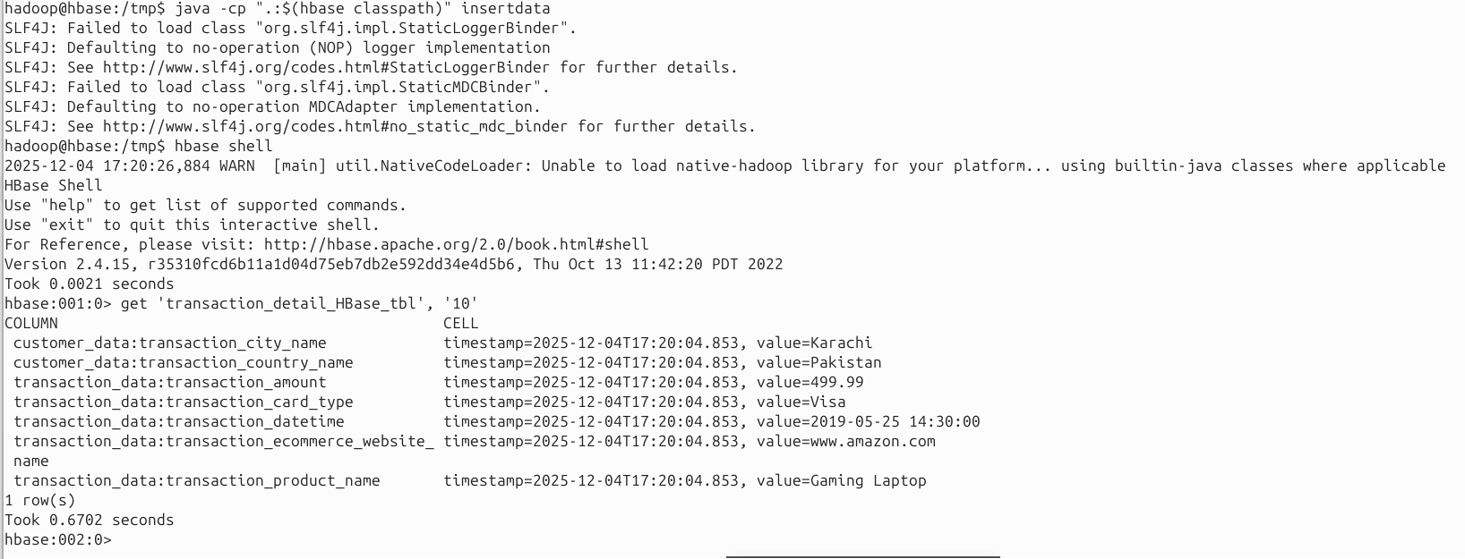

2.Retrieving data from HBase Table Using Java API Create the configuration:
Configuration conf = HBaseConfiguration.create(); Instantiate a new table reference:
HTable table = new HTable(conf, "testtable"); Create a Get with a specific row: Get get = new Get(Bytes.toBytes("row1")); Add a column to the Get: get.addColumn(Bytes.toBytes("colfam1"), Bytes.toBytes("qual1")); Retrieve a row with selected columns from HBase:
Result result = table.get(get);
Get a specific value for the given column:
byte[] val = result.getValue(Bytes.toBytes("colfam1"), Bytes.toBytes("qual1")); Print out the value while converting it back:
System.out.println("Value: " + Bytes.toString(val));
retrievedata.java:
import org.apache.hadoop.conf.Configuration;
import org.apache.hadoop.hbase.HBaseConfiguration;
import org.apache.hadoop.hbase.TableName;
import org.apache.hadoop.hbase.client.*;
import org.apache.hadoop.hbase.util.Bytes;
import java.io.IOException;

public class retrievedata {
public static void main(String[] args) {
Configuration config = null;
Connection connection = null;
Table table = null;

try {
// Create HBase configuration
config = HBaseConfiguration.create();

// Establish connection
connection = ConnectionFactory.createConnection(config);

// Get table reference
table = connection.getTable(TableName.valueOf("transaction_detail_HBase_tbl"));

// Create Get object for row key '10'
Get get = new Get(Bytes.toBytes("10"));

// Retrieve the result
Result result = table.get(get);

// Print each column value
byte[] transactionAmount = result.getValue(Bytes.toBytes("transaction_data"), Bytes.toBytes("transaction_amount"));
byte[] cardType = result.getValue(Bytes.toBytes("transaction_data"), Bytes.toBytes("transaction_card_type"));
byte[] website = result.getValue(Bytes.toBytes("transaction_data"), Bytes.toBytes("transaction_ecommerce_website_name"));
byte[] datetime = result.getValue(Bytes.toBytes("transaction_data"), Bytes.toBytes("transaction_datetime"));
byte[] productName = result.getValue(Bytes.toBytes("transaction_data"), Bytes.toBytes("transaction_product_name"));

byte[] city = result.getValue(Bytes.toBytes("customer_data"), Bytes.toBytes("transaction_city_name"));
byte[] country = result.getValue(Bytes.toBytes("customer_data"), Bytes.toBytes("transaction_country_name"));

System.out.println("Row key: 10");
System.out.println("transaction_amount: " + Bytes.toString(transactionAmount));
System.out.println("transaction_card_type: " + Bytes.toString(cardType));
System.out.println("transaction_ecommerce_website_name: " + Bytes.toString(website));
System.out.println("transaction_datetime: " + Bytes.toString(datetime));
System.out.println("transaction_product_name: " + Bytes.toString(productName));
System.out.println("transaction_city_name: " + Bytes.toString(city));
System.out.println("transaction_country_name: " + Bytes.toString(country));

} catch (IOException e) {
e.printStackTrace();
} finally {
// Close resources
try {
if (table != null) table.close();
if (connection != null) connection.close();
} catch (IOException e) {
e.printStackTrace();
}
}
}
}

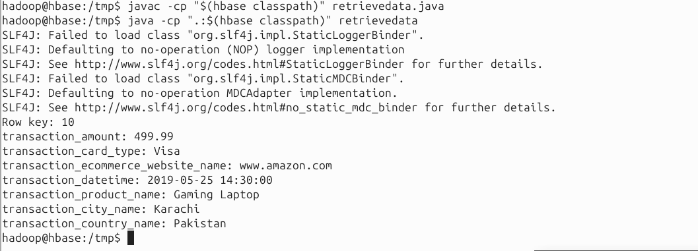

3. Deleting data from HBase Table Using Java API
Create a Delete with a specific row: Delete delete = new Delete(Bytes.toBytes("row1"));
Set a timestamp for row deletes: delete.setTimestamp(1); Delete a specific version in one column: delete.deleteColumn(Bytes.toBytes("colfam1"), Bytes.toBytes("qual1"), 1); Delete all versions in one column: delete.deleteColumns(Bytes.toBytes("colfam2"), Bytes.toBytes("qual1")); Delete the given and all older versions in one column:
delete.deleteColumns(Bytes.toBytes("colfam2"), Bytes.toBytes("qual3"), 15);
Delete the entire family, all columns and versions: delete.deleteFamily(Bytes.toBytes("colfam3"));
Delete the given and all older versions in the entire column family, that is, from all columns therein:
delete.deleteFamily(Bytes.toBytes("colfam3"), 3); Delete the data from the HBase table: table.delete(delete); table.close();

Deleterow.java:
import org.apache.hadoop.conf.Configuration;
import org.apache.hadoop.hbase.HBaseConfiguration;
import org.apache.hadoop.hbase.TableName;
import org.apache.hadoop.hbase.client.*;
import org.apache.hadoop.hbase.util.Bytes;
import java.io.IOException;

public class deleterow {
public static void main(String[] args) {
Configuration config = HBaseConfiguration.create();
Connection connection = null;
Table table = null;

try {
// Connect to HBase
connection = ConnectionFactory.createConnection(config);
table = connection.getTable(TableName.valueOf("transaction_detail_HBase_tbl"));

// Delete the entire row with key "10"
Delete deleteRow = new Delete(Bytes.toBytes("10"));
table.delete(deleteRow);

System.out.println("Row with key '10' deleted successfully.");

} catch (IOException e) {
e.printStackTrace();
} finally {
try {
if (table != null) table.close();
if (connection != null) connection.close();
} catch (IOException e) {
e.printStackTrace();
}
}
}
}

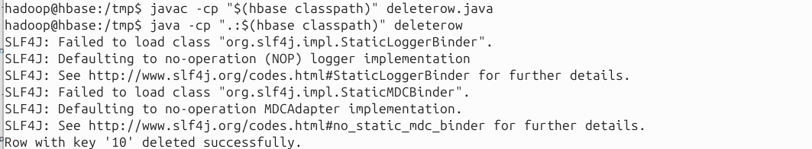
Checking if row has been deleted from Hbase shell:
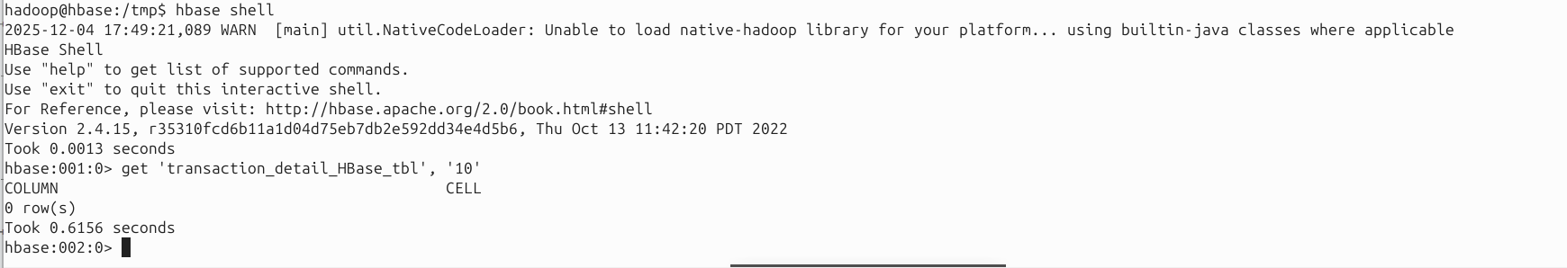

4. Scan The HBase Table Using Java API
The getScanner() method of the HTable class can be used to scan the entire data of Hbase table. The getScanner() method expects an instance of the Scan class. To summarize, steps to scan the entire data of HBase table are:
Instantiate the Configuration Class:
Configuration conf = HBaseConfiguration.create(); Instantiate the HTable Class:
HTable table = new HTable(conf, "testtable");
Instantiate the Scan Class: Scan scan = new Scan();
// scan the columns scan.addColumn(Bytes.toBytes("colfam1"), Bytes.toBytes("qual1")); scan.addColumn(Bytes.toBytes("colfam1"), Bytes.toBytes("val1"));
Get the ResultScanner instances by calling HTable's getScanner() method:
ResultScanner scanner = table.getScanner(scan); for (Result result = scanner.next(); result != null; result=scanner.next())
System.out.println("Found row : " + result);
Read values from ResultScanner and close it: scanner.close();
scandata.java:
import org.apache.hadoop.conf.Configuration;
import org.apache.hadoop.hbase.HBaseConfiguration;
import org.apache.hadoop.hbase.TableName;
import org.apache.hadoop.hbase.client.*;
import org.apache.hadoop.hbase.util.Bytes;
import java.io.IOException;

public class scandata {
public static void main(String[] args) {
Configuration conf = HBaseConfiguration.create();
Connection connection = null;
Table table = null;
ResultScanner scanner = null;

int limit = 5; // Limit the number of rows
int count = 0;

try {
connection = ConnectionFactory.createConnection(conf);
table = connection.getTable(TableName.valueOf("transaction_detail_HBase_tbl"));

Scan scan = new Scan();
// Optional: scan specific columns
// scan.addColumn(Bytes.toBytes("transaction_data"), Bytes.toBytes("transaction_amount"));
// scan.addColumn(Bytes.toBytes("customer_data"), Bytes.toBytes("transaction_city_name"));

scanner = table.getScanner(scan);

for (Result result = scanner.next(); result != null; result = scanner.next()) {
if (count >= limit) break; // Stop after reaching the limit
count++;

String rowKey = Bytes.toString(result.getRow());
System.out.println("Found row: " + rowKey);

result.listCells().forEach(cell -> {
String family = Bytes.toString(cell.getFamilyArray(), cell.getFamilyOffset(), cell.getFamilyLength());
String qualifier = Bytes.toString(cell.getQualifierArray(), cell.getQualifierOffset(), cell.getQualifierLength());
String value = Bytes.toString(cell.getValueArray(), cell.getValueOffset(), cell.getValueLength());
System.out.println(" " + family + ":" + qualifier + " = " + value);
});
System.out.println();
}

} catch (IOException e) {
e.printStackTrace();
} finally {
try {
if (scanner != null) scanner.close();
if (table != null) table.close();
if (connection != null) connection.close();
} catch (IOException e) {
e.printStackTrace();
}
}
}
}

