BIG DATA ANALYTICS

LECTURE 1

1. Introduction to Big Data Analytics
Big Data Analytics (BDA) refers to the process of extracting meaningful insights from massive and complex data sets that traditional tools cannot handle. These datasets exceed the capabilities of conventional IT systems in terms of storage, processing, and analysis.
The main challenges include data acquisition, storage, searching, sharing, analytics, and visualization.
The term “Big Data” was popularized by John R. Mashey. According to Gartner, Big Data refers to “high-volume, high-velocity, and high-variety information assets that demand cost-effective, innovative forms of processing for enhanced insight and decision-making.”

2. Global Applications of Big Data
Big Data has become essential across various industries:
- Energy: Smart grid analytics, consumption optimization
- Retail: Personalized marketing, demand forecasting
- Finance and Insurance: Fraud detection, risk modeling
- Healthcare: Predictive diagnostics, patient data management
- Telecommunications: Network optimization, churn prediction
- Governance and Crime Prevention: Policy optimization, surveillance analytics
- Agriculture: Yield prediction, precision farming
- Media and Advertising: Sentiment analysis, audience targeting

3. Big Data and Cloud Solution Companies
Key players in Big Data infrastructure and cloud computing include:
- Cloud Providers: AWS, Microsoft Azure, Google Cloud, Oracle, IBM
- Data Platforms and Tools: Apache, Cloudera, Databricks, Snowflake, Informatica
- Hardware and AI Accelerators: Dell, Intel, Nvidia, Cisco
- Databases: MongoDB, Redis, Neo4J
Cloud computing now serves as the backbone of scalable data processing and storage solutions.

4. Reasons for Big Data Project Failures
Many Big Data initiatives fail due to:
- Asking the wrong questions and solving irrelevant problems
- Poor data quality or unavailability
- Lack of skilled personnel and proper training
- Neglecting deployment (DevOps)
- Poor business involvement or misalignment
- Wrong technology stack or inefficient resource usage
- Ignoring technical requirements and optimization needs

5. Disruption and the Modern BDA Process
The cloud has removed traditional hardware and software barriers.
A typical Big Data project process includes:
- Understanding business operations and goals
- Defining the problem and performing benefit analysis
- Assessing risk and expected ROI
- Reviewing similar successful use cases
- Selecting appropriate cloud-based technologies
- Implementation and evaluation
Organizations must act quickly because Big Data tools and methodologies evolve rapidly.

6. Hadoop Ecosystem
Hadoop is an open-source distributed computing framework designed to store and process massive datasets (terabytes to petabytes) efficiently across clusters of commodity hardware.
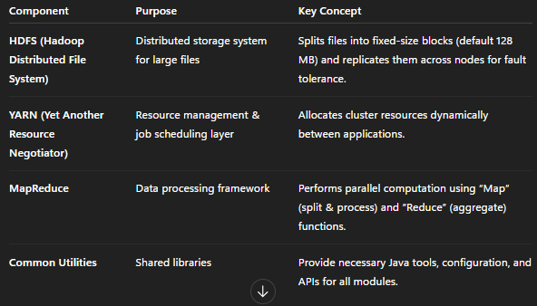
Key features:
- Fault tolerance
- Scalability
- Processes data where it resides to reduce network overhead
Core components:
- HDFS / HBase for storage
- MapReduce / Spark / Oozie for processing
- Hive for querying and development.
- Tableau, Power BI, SiSense for visualization

7. Required Skillset for Big Data Professionals
Key skills required:
- Data Science: interpreting and communicating data insights
- Machine Learning and Statistics: understanding algorithmic foundations
- Data Cleaning: preprocessing, wrangling, and dredging
- Data Analysis: SQL, data warehouse, and BI experience
- Data Visualization: BI tools and Python dashboards
- Linux OS proficiency
- Python programming using open-source technologies

8. Big Data Techniques and Architectures
Important technical concepts include:
- Parallel and distributed computing
- In-memory and columnar processing
- NoSQL databases for unstructured data
- Containerization using Docker
- Cloud architectures such as Lambda, Kappa, and HTAP
- High-speed networking
- AI and Data Science integration

9. Evolution of Big Data Analytics (2010–2025)
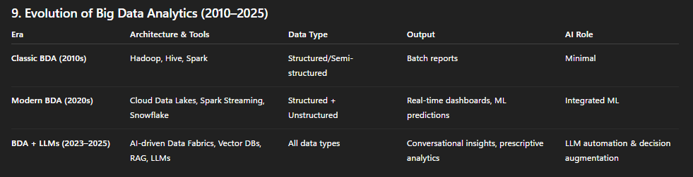

10. Scalability and In-Memory Computing
Scale-Up (Vertical Scaling): Increasing the capacity of a single machine (CPU, RAM).
Scale-Out (Horizontal Scaling): Adding more distributed nodes to a cluster.
In-Memory Spark: Performs computation in RAM instead of disk, reducing latency and improving performance.
Scale-out is superior to scale-up in Big Data Analytics because it offers:
- Linear scalability: Performance increases proportionally by adding inexpensive nodes, not expensive hardware.
- Fault tolerance: Failure of one node doesn’t halt processing — data is replicated across the cluster.
- Cost efficiency: Commodity machines replace costly high-end servers.
- Parallelism: Tasks execute concurrently on multiple nodes, reducing overall processing time.
- Elasticity: Resources can be dynamically added or removed based on workload.

11. GPUs vs CPUs
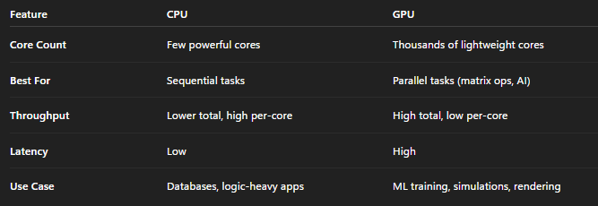

12. NoSQL Databases
Definition: “Not Only SQL” – flexible, non-relational data stores. Characteristics:
- No fixed schema or joins
- Scales horizontally
- Relaxes ACID (Atomicity, Consistency, Isolation, Durability) properties, adheres to CAP theorem (Consistency, Availability, Partition tolerance)
Types:
- Document-based (MongoDB)
- Key-Value (Redis)
- Columnar (Cassandra)
- Graph (Neo4J)
NewSQL: Combines NoSQL scalability with ACID compliance.

13. Big Data Problems
Main challenges in Big Data management:
- Where, when, and how to store and process data
- Data organization and metadata management
- Secure access and sharing
- Efficient data backup, movement, and replication
- Provenance: tracking data origin, ownership, and transformation history

14. Big Data Use Cases
Telecom: Customer churn prediction, network optimization
Retail: Recommendation systems, purchase behavior analysis
Location Tracking: Mobility pattern analysis, geo-fencing, targeted marketing

Sample Questions and Answers
Q1. What are the three Vs of Big Data?
A: Volume, Velocity, and Variety – representing the size, speed, and diversity of data.
Q2. Why do most Big Data projects fail?
A: Because of unclear objectives, poor data quality, lack of skilled staff, or wrong technology choices.
Q3. Differentiate between Scale-Up and Scale-Out.
A: Scale-Up increases the capacity of one system, while Scale-Out adds multiple systems for distributed workload.
Q4. What makes Hadoop fault-tolerant?
A: Data replication across nodes ensures reliability even if a node fails.
Q5. Explain the CAP theorem in NoSQL.
A: It states that a distributed database can guarantee only two of the three: Consistency, Availability, and Partition Tolerance.
Q6. How has Big Data Analytics evolved over time?
A: From batch-oriented Hadoop systems (2010s) to real-time cloud systems (2020s) and now to AI-driven intelligent data fabrics with LLMs (2023–2025).
Q7. What are common Big Data use cases in Retail and Telecom?
A: Retail uses Big Data for recommendations and forecasting, while Telecom uses it for churn prediction and network efficiency.

LECTURE 1.5

1. Introduction to Distributed Computing
Distributed computing refers to a system design where multiple independent computers (nodes) work together over a network to accomplish a shared goal.
Each node operates concurrently, and collectively they behave as one cohesive system from the user’s perspective.
- Multiple Nodes: Several computers connected via a network.
- Concurrency: All nodes operate and process tasks simultaneously.
- No Shared Clock: Each node maintains its own clock; there’s no global time reference.
- Independent Failures: Nodes may fail independently without collapsing the entire system.
- Transparency: To the end user, it appears as a single unified system, not a collection of distributed machines.

2. Core Features of Distributed Systems
Distributed systems are designed to achieve scalability, reliability, and performance.
Main Features:
- Scalability: Nodes can be added or removed dynamically without shutting down the system.
- Fault Tolerance: The system continues functioning even if some nodes fail.
- Resource Sharing: Hardware (CPU, memory, storage) and software resources are shared among nodes.
- Performance: Large queries or computations are divided across nodes to achieve faster results. Optimized queries should return results within seconds, not minutes.

3. Consensus in Distributed Systems
Consensus algorithms ensure that multiple nodes agree on a single, consistent value or decision even in the presence of failures or network delays.
They form the foundation of reliable distributed databases, coordination services, and fault-tolerant systems.
Common Use Cases
- Leader election
- Replicated state machines
- Log replication
Two main consensus algorithms are:
- Paxos
- Raft

4. Paxos Algorithm
Paxos, developed by Leslie Lamport (1998), is a foundational consensus algorithm. It allows nodes in a distributed system to agree on a single value despite failures or message delays.
Purpose
Used in systems like Google Chubby, Zookeeper, Cassandra, and etcd for coordination and consistency.
Core Principles
- Safety: Only one value can ever be chosen.
- Liveness: If most nodes are functioning and communicating, progress continues.
Roles in Paxos
- Proposer: Suggests a value to be agreed upon.
- Acceptor: Votes on proposals; a majority must agree for a value to be chosen.
- Learner: Learn the final agreed value after consensus is reached.
Phases of the Algorithm
Phase 1 – Prepare/Promise:
- A proposer selects a proposal number n and sends a Prepare(n) request to a majority of acceptors.
- Acceptors respond with a Promise not to accept proposals with smaller numbers.
- If an acceptor has already accepted a proposal, it includes the highest-numbered one in the reply.
Phase 2 – Accept/Accepted:
- After receiving promises from a majority, the proposer sends Accept(n, value) to acceptors.
- Acceptors accept the proposal unless they’ve already promised to a higher proposal.
- Once a majority accepts, the value is chosen and communicated to learners.
Example
- Proposer P1 sends Prepare(5) to acceptors A, B, C.
- They reply with promises.
- P1 sends Accept(5, X).
- A and B accept (majority), so X becomes the chosen value.
Advantages and Drawbacks
Advantages:
- Ensures correctness and fault tolerance.
- Drawbacks: Algorithm complexity and multiple message rounds make it slower in practice.

5. Raft Algorithm -
Understanding Raft
Raft, developed by Diego Ongaro and John Ousterhout (2014), simplifies the consensus process while maintaining the same guarantees as Paxos.
Purpose
Raft achieves distributed agreement on a single log of operations and is widely used in systems such as etcd, Consul, Kubernetes, RethinkDB, and CockroachDB.
Core Idea
Raft uses a leader-based approach for clarity and simplicity.
- One server acts as the Leader.
- Others are Followers.
- If the leader fails, Followers can become Candidates and run for election.
Roles
- Leader: Handles all client interactions and replicates logs to followers.
- Follower: Responds to leader or candidate requests passively.
- Candidate: Initiates elections when no leader is detected.
Leader Election
- Initially, all servers are followers.
- If a follower doesn’t hear from a leader, it becomes a candidate.
- The candidate requests votes via RequestVote RPC.
- If it gains a majority, it becomes the new leader.
- If votes split, the election restarts with a higher term number.
Log Replication
- The leader receives client commands and appends them to its log.
- It sends AppendEntries RPC to followers.
- When a majority acknowledges, the leader marks entries as committed and informs followers.
Safety and Log Consistency
- Only one leader per term.
- Followers vote only for candidates with complete logs.
- Committed entries persist across future leaders.
Log Compaction (Snapshots)
As logs grow, older entries are compacted into snapshots to save storage and improve performance.
Example
Leader L1 receives a request set x=5.
It appends [x=5] to its log and replicates to F1 and F2.
When a majority acknowledges, the entry is committed.
All nodes update their state to x=5.
Properties
- Understandability: Easier to learn than Paxos.
- Safety: No committed data is lost.
- Liveness: System continues if a majority of nodes are available.
- Performance: Generally faster and simpler than Paxos.
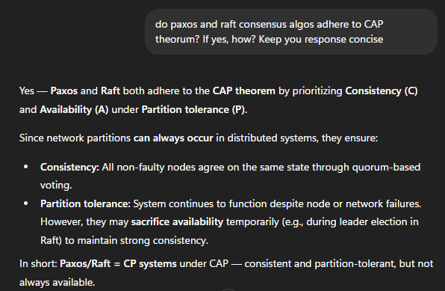

6. Synchronization and Logical Clocks
In distributed systems, there is no global clock. Events occur on different machines, and we need mechanisms to determine the order of events.
Lamport Timestamps (1978)
Introduced by Leslie Lamport to assign logical timestamps to events for partial ordering.
Key Idea
If event A happens before event B, then timestamp(A) < timestamp(B).
However, timestamp order does not guarantee causality if events are independent.
Rules
- Each process Pi maintains a logical counter Li.
- Increment Rule: Before any event, Li = Li + 1.
- Message Sending Rule: When Pi sends message m, timestamp(m) = Li.
- Message Rcving Rule: When Pj receives m with timestamp Tm, Lj = max(Lj, Tm) + 1.
Example
- P1 (L1=0) performs an event → L1=1.
- P1 sends a message with timestamp 1.
- P2 (L2=0) receives it → L2 = max(0,1)+1 = 2.
Hence, send event = 1, receive event = 2, maintaining order.
Properties
- Provides partial ordering.
- If A → B, then timestamp(A) < timestamp(B).
- But the reverse is not always true (not an iff case).

7. Vector Clocks
Vector clocks extend Lamport clocks to capture causal relationships and detect concurrent events more accurately.
Core Idea - Each process maintains a vector of integers representing its view of time across all processes. If there are N processes, process Pi keeps vector Vi of length N.
Vi[j] = Pi’s knowledge of Pj’s clock.
Rules
- Initialization: All entries start at 0.
- Local Event: Increment Vi[i].
- Message Send: Increment Vi[i] before sending message.
- Message Receive: On receiving vector Vm, set
Vj[k] = max(Vj[k], Vm[k]) for all k, then increment Vj[j].
Comparing Timestamps
For events a and b with vectors Va and Vb:
- a → b if Va[i] ≤ Vb[i] for all i, and Va[j] < Vb[j] for at least one j.
- If neither Va ≤ Vb nor Vb ≤ Va, the events are concurrent.
Example
- V1=[0,0,0], V2=[0,0,0].
- P1 performs an event → [1,0,0].
- P1 sends a message with [2,0,0].
- P2 receives → max([0,0,0],[2,0,0]) = [2,0,0]; then increments → [2,1,0].
Properties
- Causal Ordering: Precisely identifies cause-effect relationships.
- Concurrency Detection: Detects independent concurrent events.
- Overhead: Requires N integers per process (scales linearly).
- Comparison:
  - Lamport: partial ordering only
  - Vector: full causal ordering
Applications
Used in distributed debugging, version control systems, and distributed databases like Cassandra and DynamoDB.

Sample Questions and Answers
Q1. What are the main challenges of distributed computing?
A: Lack of a global clock, independent node failures, maintaining consistency, and achieving transparency across multiple nodes.
Q2. What is the difference between Paxos and Raft?
A: Paxos is mathematically complex and harder to implement, while Raft uses a leader-based model that is simpler and easier to understand with similar guarantees.
Q3. What are the roles in Paxos?
A: Proposer (suggests values), Acceptor (votes), and Learner (observes chosen value).
Q4. What ensures safety in Paxos and Raft?
A: Both guarantee that only one value is chosen and committed data is never lost, even if failures occur.
Q5. Why are logical clocks needed?
A: Because there is no universal time in distributed systems; logical clocks help determine the sequence of events.
Q6. What is the main difference between Lamport and Vector clocks?
A: Lamport clocks provide partial ordering, while vector clocks provide full causal ordering and detect concurrency.
Q7. What is the purpose of log compaction in Raft?
A: To reduce storage by saving system state in snapshots and discarding old log entries.
Q8. What does “consensus” mean in distributed systems?
A: Agreement among multiple nodes on a single consistent value, despite failures or network delays.

LECTURE 1.6

1. Communication Methods in Distributed Systems
Communication between nodes determines how information is shared, replicated, or coordinated. Different communication patterns are used depending on the system’s needs.

2. Broadcast
Definition: One-to-all communication where a single node sends a message to all other nodes.
Variants:
- Flooding: Each node forwards the message to all neighbors except the sender (can cause redundancy).
- Tree-Based Broadcast: Builds a spanning tree to distribute messages efficiently.
Uses: System updates, replicated data dissemination, and failure detection.

3. Multicast
Definition: One-to-many communication, where a message is sent to a specific subset of nodes.
Types:
- Reliable Multicast: Guarantees message delivery to all intended nodes.
- Atomic Multicast: Ensures all-or-nothing delivery for consistency.
Applications: Group communication, consensus algorithms, and collaborative distributed applications.

4. Gossip or Epidemic Communication
Concept: Each node randomly shares information with a few peers, allowing information to spread gradually through the network.
Analogy: Works like an epidemic where data “infects” other nodes over time.
Used in: Large-scale databases, blockchain networks, cluster state synchronization, and systems like Cassandra and DynamoDB.

5. Unicast
Definition: One-to-one communication between two nodes.
Forms the foundation for higher-level communication methods.
Purpose: Ensures reliable message delivery even in unreliable networks.
Examples: Client-to-server messaging in Hadoop HDFS or Kafka producers to brokers.

6. Anycast
Definition: A message is sent to any one node from a group of potential receivers.
Use Case: Load balancing and nearest server selection.
Example: Selecting the nearest Kafka broker or container service instance in Kubernetes.

7. Reduce / Convergecast
Definition: Many-to-one communication where multiple nodes send messages toward a single root node.
Applications:
- Aggregation operations (e.g., summation, averages).
- Used in: MapReduce framework, sensor networks, leader election, and result collection.

8. All-to-All Communication
Definition: Every node sends data to every other node.
Significance: Used in parallel computing tasks such as matrix multiplication or data shuffling.
Drawback: High communication cost, but vital in large-scale analytics.

9. Message Ordering in Distributed Systems
Since messages can arrive out of order due to network delays, proper ordering mechanisms are essential for maintaining consistency.
Challenges:
- Asynchronous message delivery.
- Delays or reordering in network communication.
- Different nodes may perceive event sequences differently.
Purpose: Message ordering ensures all nodes agree on the order of message delivery.

10. Types of Message Ordering
FIFO (First In, First Out):
- Messages from the same sender are received in the order sent.
- No guarantee across multiple senders.
- Example: Kafka partitions and TCP sockets.
Causal Ordering:
- Preserves cause-and-effect relationships using Lamport timestamps or vector clocks.
- Example: Collaborative document editing or distributed stream processing (Flink).
Total Ordering:
- All nodes deliver messages in the same global order, regardless of senders.
- Ensures strict synchronization.
- Example: ZooKeeper log replication and Kafka’s sequential message guarantees.

11. Synchronization in Distributed Systems
Synchronization is required because distributed nodes lack a shared memory or global clock. It ensures coordinated execution and consistent system behavior.
Purpose:
Aligns events and actions across nodes for accuracy and consistency.

12. Clock Synchronization Methods
Cristian’s Algorithm:
- A client requests time from a time server.
- The client sets its clock to T + (RTT / 2) where RTT is the round-trip delay.
- Used in early NTP implementations.
Berkeley’s Algorithm:
- No perfect time source.
- A coordinator polls all nodes, averages the times, and sends adjustments to each node.
- Used in cluster synchronization.
Network Time Protocol (NTP):
- Industry standard for synchronizing system clocks.
- Based on hierarchical strata:
  - Stratum 0: Atomic clocks, GPS.
  - Stratum 1: Servers connected to Stratum 0.
  - Stratum 2: Servers synced to Stratum 1, and so on.
- Uses four timestamps (T1–T4) to calculate round-trip delay and clock offset.
- Accuracy within milliseconds; used in Hadoop and Spark clusters.

13. Logical Clocks
When physical time synchronization is not possible or reliable, logical clocks are used.
Lamport Timestamps:
- Assigns logical counters to events.
- If A → B (A happens before B), then L(A) < L(B).
- Provides partial ordering but cannot detect concurrency.
Vector Clocks:
- Each node maintains a vector of counters (one per process).
- Enables detection of concurrent events and precise causal relationships.
- Used in: DynamoDB, Cassandra, and distributed conflict resolution.

14. Barrier Synchronization
A barrier ensures that all processes reach a common checkpoint before any proceed further.
Example:
In Hadoop or Spark, all mappers must finish before reducers begin.
Purpose:
Maintains synchronization during multi-stage distributed computations.

15. Mutual Exclusion
Ensures that only one process at a time accesses a shared resource or critical section.
Algorithms:
- Centralized: A coordinator grants locks.
- Distributed (Ricart–Agrawala): Each node requests permission from all others.
- Token-Based (Suzuki–Kasami): A circulating token grants access to the process holding it.
Applications:
- ZooKeeper for distributed locks and leader election.
- HBase master management.

16. Election Algorithms
Used to select a single leader node that coordinates operations across the system.
Types:
- Bully Algorithm: The node with the highest ID becomes the leader.
- Ring Algorithm: Nodes form a ring and pass messages until a leader is elected.
Examples:
- ZooKeeper leader election.
- Kafka controller election for partition coordination.

17. Big Data Tools and Frameworks Integration
Different communication and synchronization techniques are used in Big Data systems:
Communication Type | Example Tools | Usage
Unicast | Hadoop HDFS, Kafka, Spark | Data transfer between nodes or services.
Broadcast | Spark, MapReduce | Share variables or configurations with all nodes.
Multicast | Flink, Kafka | Stream data to multiple consumers or operators.
Gossip | Cassandra, DynamoDB | Cluster membership and failure detection.
Anycast | Kubernetes, Kafka | Load balancing requests.
Reduce / Convergecast | Spark, MapReduce | Aggregate intermediate results.
All-to-All (Shuffle) | Spark, Flink, Hive | Data redistribution among nodes.
Message Ordering | Kafka, ZooKeeper | Ensures consistent delivery order.
Barrier Synchronization | Spark | Synchronizes parallel processing stages.
Mutual Exclusion | ZooKeeper, HBase | Distributed locking and coordination.

Sample Questions and Answers
Q1. What is the primary challenge in distributed computing?
A: Lack of a shared global clock and the need to coordinate independent nodes for consistent results.
Q2. Differentiate between Broadcast and Multicast communication.
A: Broadcast sends messages to all nodes, while Multicast sends them to a selected subset.
Q3. What are the three types of message ordering?
A: FIFO, Causal, and Total ordering.
Q4. Describe how Cristian’s algorithm synchronizes clocks.
A: It estimates network delay using round-trip time and sets the client’s clock to the server time plus half the delay.
Q5. Why is NTP widely used in distributed systems?
A: It offers hierarchical time synchronization across the internet with millisecond accuracy.
Q6. How do Lamport and Vector clocks differ?
A: Lamport clocks provide partial ordering, while vector clocks detect both causality and concurrency.
Q7. What is the role of mutual exclusion?
A: To ensure only one process accesses a shared resource at a time, preventing conflicts.
Q8. Explain the purpose of the Bully algorithm.
A: It selects the node with the highest ID as the leader in a distributed system.
Q9. Give one example of barrier synchronization in Big Data tools.
A: In Spark, all tasks in a stage must be completed before the next stage begins.
Q10. Which communication pattern does MapReduce use for data aggregation?
A: Reduce or Convergecast pattern (many-to-one communication).

LECTURE 2

1. Linux History

The Unix Roots (1969–1980s)
- 1969: Unix was developed at AT&T Bell Labs by Ken Thompson and Dennis Ritchie.
- Initially written in assembly, later rewritten in C, which made it portable.
- Adopted widely by universities and research labs.
- Licensing restrictions by AT&T prevented Unix from being fully free.

The GNU Project (1983)
- Initiated by Richard Stallman to build a free and open-source Unix-like OS.
- The GNU Project developed critical tools:
  - GNU Compiler Collection (GCC)
  - GNU Shell (bash)
  - Core utilities (ls, cp, grep, etc.)
- The missing component was the kernel, as GNU Hurd was delayed.

Birth of the Linux Kernel (1991)
- Linus Torvalds, a Finnish student, began developing a free kernel inspired by Minix (Andrew S. Tanenbaum’s teaching OS).
- August 25, 1991: Linus announced Linux as a hobby project.
- September 1991: Released Linux 0.01.

Linux + GNU = A Complete OS (1992–1994)
- Combining GNU tools with the Linux kernel produced a complete free operating system.
- Linux adopted the GNU GPL license in 1992, ensuring openness.
- 1994: Linux 1.0 (first stable release) launched.

Rise of Distributions (Mid-1990s)
- Developers started packaging Linux with software, creating distributions (distros).
- Early examples: Debian (1993), Red Hat (1994).
- Distros simplified installation and usability.

Linux in Enterprises & Servers (Late 1990s–2000s)
- Adopted by IBM, HP, Dell for servers and enterprise systems.
- Popular for web hosting, data centers, and supercomputers.
- Formed the LAMP stack (Linux, Apache, MySQL, PHP/Perl/Python).

Linux Everywhere (2000s–Present)
- Supercomputers: Nearly all top supercomputers run Linux.
- Mobile: Android (2008) built on the Linux kernel.
- Cloud & Containers: Foundation for cloud, Docker, and Kubernetes.
- IoT & Embedded: Runs on routers, smart TVs, cars, and drones.

Modern Linux
- Managed by Linus Torvalds and thousands of global developers.
- Coordinated by the Linux Foundation (since 2000).
- Popular distros: Ubuntu, Fedora, Debian, Red Hat, SUSE, Arch, Alpine.
- Philosophy: Open-source, modular, and community-driven innovation.

2. Linux Architecture
Linux consists of multiple layers that interact to provide system functionality.

Hardware Layer
- The physical layer includes CPU, RAM, Storage, Network Cards, and I/O Devices.

Kernel Layer
- The core of Linux, operating in privileged mode.
- Controls hardware via device drivers and abstracts resources for applications.

System Call Interface (SCI)
- Bridge between user space and kernel space.
- Provides system calls like open(), read(), write(), fork(), etc.
- Implemented using GNU C Library (glibc).

User Space
- Includes user interfaces and utilities:
  - Shells: Command-line (bash, zsh) or GUI.
  - Utilities: ls, cp, cat, grep.
  - Applications: Browsers, compilers, editors.

3. Kernel Subsystems
The Linux kernel comprises five main components:

a) Process Management
- Handles creation, scheduling, and termination of processes.
- Manages process states and multitasking.
- Tools: ps, top, kill.

b) Memory Management
- Allocates and deallocates system memory.
- Implements virtual memory, paging, and swapping.
- Maintains caches and buffers for performance.

c) File System Management
- Organizes files in a hierarchical structure.
- Supports multiple file systems (ext4, XFS, Btrfs, FAT, NTFS).
- Uses inodes for metadata.
- Treats everything (files, sockets, devices) as a file.

d) Device Management
- Uses device drivers to control hardware.
- Devices represented as files in /dev (e.g., /dev/tty).

e) Networking
- Implements TCP/IP stack.
- Enables communication between systems.
- Supports firewall mechanisms (iptables, nftables).

4. User Space Components

a) Shell
- Interface between user and kernel.
- Translates commands into system calls.
- Examples: bash, sh, ksh, zsh.

b) System Utilities
- Core tools for file, user, and process management.
- Examples: cp, mv, chmod, grep.

c) Application Programs
- User-level software like LibreOffice, Firefox, Python.

5. Modes of Operation
- User Mode: Limited access; used for applications.
- Kernel Mode (Supervisor mode): Full access; used by kernel operations.
- System calls switch execution from user mode → kernel mode → back to user mode

6. Linux Philosophy
- Everything is a file (including devices and processes).
- Do one thing and do it well (small, efficient utilities).
- Open-source development (community-driven collaboration).

7. Virtual File System (VFS)
- Provides a common API for all file systems.
- Abstract functions like open(), close(), read(), write().
- File system-specific modules implement these at a lower level.
- Over 50 supported file systems (found under ./linux/fs).

8. Linux Directory Structure
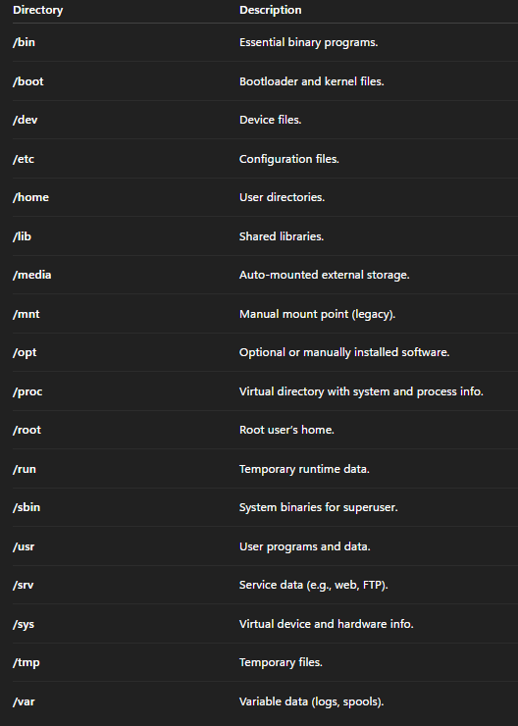

9. User Groups and Permissions

Users
- Root User: Superuser with full privileges.
- Normal Users: Limited access, own directories under /home.
- System Users: Service accounts like www-data, daemon.
Each user has:
- Username, UID, GID, and home directory.
- User data stored in /etc/passwd.

Groups
- Collection of users for permission management.
- Primary Group: Assigned at user creation.
- Secondary Groups: Additional memberships.
- Group data stored in /etc/group.

10. File Ownership and Permissions
Each file has:
- Owner (User) – creator.
- Group – associated group.

Permission Types
- Read (r) – view content.
- Write (w) – modify or delete.
- Execute (x) – run or enter (for directories).

Permission Categories
- Owner, Group, Others.
Example: -rwxr-xr--
- Owner: rwx
- Group: r-x
- Others: r--

Numeric Representation
- r=4, w=2, x=1.
- Example: rwxr-xr–x = 755. ~ Owner ke paas permissions, group ke paas permission, others ke paas permission.
- Common:
  - 777 → full access.
  - 755 → owner full, others read+execute.
  - 644 → owner read+write, others read.

Special Permissions
- SUID: Run as file owner (e.g., /usr/bin/passwd).
- SGID: Run as a group or inherit group in directories.
- Sticky Bit: In shared directories, users delete only their files (e.g., /tmp).

11. Linux Shells

Definition
A shell is an interface that takes user commands, translates them into system calls, and executes via the kernel.

Types of Shells
- sh (Bourne Shell): Original Unix shell.
- bash (Bourne Again Shell): Most common Linux shell.
- csh (C Shell): C-like syntax.
- ksh (Korn Shell): Combines sh and csh features.
- zsh (Z Shell): Highly customizable, modern shell.

Shell Responsibilities
- Command execution
- Input/output redirection (>, <, >>)
- Piping (|)
- Variable management (PATH, HOME)
- Scripting and automation

12. Linux File Systems

Major File Systems
- ext2: Early FS, no journaling.
- ext3: Added journaling.
- ext4: Default; supports large files, backward compatible.
- XFS: High-performance, scalable.
- Btrfs: Modern FS with snapshots and RAID support.
- Others: FAT32, NTFS, ISO9660.

Key Concepts
- Inodes: Store metadata (permissions, owner, timestamps).
- Mounting: Attaching a file system to a directory (e.g., /media/usb).

Sample Questions and Answers
Q1. Who created the Unix operating system and when?
A: Ken Thompson and Dennis Ritchie at AT&T Bell Labs in 1969.
Q2. What was missing in the GNU project that led to the birth of Linux?
A: The GNU project lacked a kernel; Linux filled that gap.
Q3. What is the purpose of the Linux kernel?
A: It controls hardware, manages memory, processes, and provides an interface for applications.
Q4. Define VFS (Virtual File System).
A: It provides a uniform API for interacting with multiple file system types.
Q5. What are the three permission categories in Linux?
A: Owner, Group, and Others.
Q6. Explain the function of the SUID permission.
A: Allows a program to run with the file owner’s privileges.
Q7. What is the difference between user mode and kernel mode?
A: User mode restricts hardware access; kernel mode allows full control.
Q8. What is the philosophy of Linux?
A: Everything is a file, tools should do one job well, and open-source collaboration.
Q9. List any three modern Linux distributions.
A: Ubuntu, Fedora, and Arch Linux.
Q10. How does Linux treat devices?
A: As files, located under /dev.

LECTURE 2.1

1. Introduction to Shell Scripting
Shell scripting originated in the early 1970s alongside the development of Unix. It enables automation of tasks through sequences of shell commands written in script files.
The Bourne Shell (sh) by Stephen Bourne was one of the earliest and most influential, forming the foundation for future shells.
Subsequent shells improved functionality:
- C Shell (csh) – introduced a C-like syntax for interactive use.
- Korn Shell (ksh) – added advanced programming features for enterprise Unix systems.
- Bourne Again Shell (bash) – developed under GNU in 1989, became the default Linux shell.
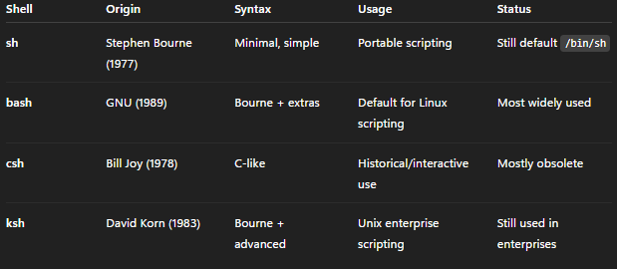
Shell scripting automates repetitive tasks, manages systems, and coordinates software operations.

2. Applications of Shell Scripting
Shell scripts are used across multiple domains to improve efficiency and consistency.
Area | Example Use Cases
System Automation | Backups, cleanup, cron jobs
Monitoring | CPU, disk usage, service health
File/Text Handling | Bulk renaming, parsing logs
Development | Build/test automation (CI/CD)
Deployment | Environment setup, software installs
Networking | Downloading, transfers, uptime checks
Data/ETL | Log cleaning, CSV merging, Hadoop prep
Security | Auditing permissions, login monitoring
Education | Learning OS and scripting fundamentals
Glue Work | Integrating multiple tools or tasks

3. Real-World Usage Examples in Linux-Based Environments

Setup Automation
Scripts can simplify Docker-based environments:
#!/bin/bash
docker network create hadoop-net
docker run -d --name namenode --net hadoop-net -p 9870:9870 hadoop-namenode
docker run -d --name datanode1 --net hadoop-net hadoop-datanode
docker run -d --name datanode2 --net hadoop-net hadoop-datanode

Data Ingestion
Automating data upload into Hadoop or Spark containers:
#!/bin/bash
docker cp dataset.csv namenode:/tmp/
docker exec namenode hdfs dfs -put /tmp/dataset.csv /input/

Job Submission
Running MapReduce or Spark jobs automatically:
#!/bin/bash
docker exec namenode hadoop jar /opt/hadoop/share/hadoop/mapreduce/hadoop-mapreduce-examples-*.jar wordcount /input /output

Monitoring and Logging
Monitor container logs and cluster health:
#!/bin/bash
for c in namenode datanode1 datanode2; do
echo "---- Logs for $c ----"
docker logs --tail 5 $c
done

Experiment Automation
Automate testing with varying parameters:
#!/bin/bash
for size in 1GB 2GB 5GB; do
echo "Running for dataset $size"
docker exec namenode hdfs dfs -put /datasets/$size.txt /input/
docker exec namenode hadoop jar ... wordcount /input /output_$size
done

Cluster Management
Start/stop all containers with one command:
#!/bin/bash
docker stop $(docker ps -q)
docker rm $(docker ps -aq)
docker network rm hadoop-net

Scheduling
Automate recurring jobs with cron, e.g., run a Hive query nightly.

4. Alpine Linux and Shell Scripting
Alpine Linux is a minimal, security-focused Linux distribution released in 2005.
- Uses musl libc and busybox for efficiency.
- Default shell: Almquist Shell (ash), a POSIX-compliant lightweight shell.
- POSIX (Portable Operating System Interface) ensures compatibility across systems. POSIX is a family of standards specified by the IEEE Computer Society for maintaining compatibility between operating systems.
- Package management via apk (Alpine Package Keeper).
Common scripting tasks in Alpine:
- Docker container management
- System and service monitoring
- DevOps deployment scripts
- Configuration automation

5. Understanding Bash (Bourne Again Shell)
A shell language is a programming language used as a command-line interface (CLI) for interacting with the OS. It provides a way for users to execute commands, run programs, and manage files and directories. It is an interpreter between the user and OS, allowing them to communicate and perform tasks. It is basically used to write scripts.
Key Features:
- Based on Bourne shell syntax.
- Variables declared as variable=value, accessed as $variable.
- Environment variables managed using export.
- Supports command-line editing, completion, and command history.
- Provides arrays, functions, and arithmetic operations.
- Enables advanced automation and administration workflows.
Community Support:
Bash has an extensive user community, documentation, and online resources, making it ideal for scripting and DevOps automation.

6. Shebang (#!)
The shebang indicates which interpreter executes the script. It appears on the first line.
Example:
#!/bin/bash
echo "Hello World"
When executed, the OS uses /bin/bash to interpret commands.

Common Shebangs:
- #!/bin/bash → Bash shell
- #!/bin/sh → Bourne shell
- #!/usr/bin/env python3 → Python 3 interpreter
- #!/usr/bin/perl → Perl interpreter
Important Notes:
- If omitted, the default /bin/sh is used.
- Only affects execution when running directly (e.g., ./script.sh).

7. chmod and Executable Scripts
Scripts must have execute permissions to run directly.
Example:
chmod +x myscript.sh
Process:
- Create script → echo -e '#!/bin/bash\necho "Hello World"' > myscript.sh
- Check permissions → ls -l myscript.sh (shows -rw-r--r--)
- Make executable → chmod +x myscript.sh → (-rwxr-xr-x)
- Execute → ./myscript.sh

8. Writing and Running Bash Scripts in Alpine
Steps:
Go into alpine:
docker run -it alpine
Install bash as follows:
• Update: apk update
• Add bash: apk add bash
• Check version: bash --version
Install nano (editor): apk add nano
Go to /home and: mkdir scripts and cd scripts
Create your first script: touch first.sh
Nano: nano first.sh
Add the Shebang and Content: #!/bin/bash echo "Hello, World!"
Ctrl+s and Ctrl+x
Make executable: chmod +x first.sh , Run: ./first.sh
9. Bash Operators and Parameters
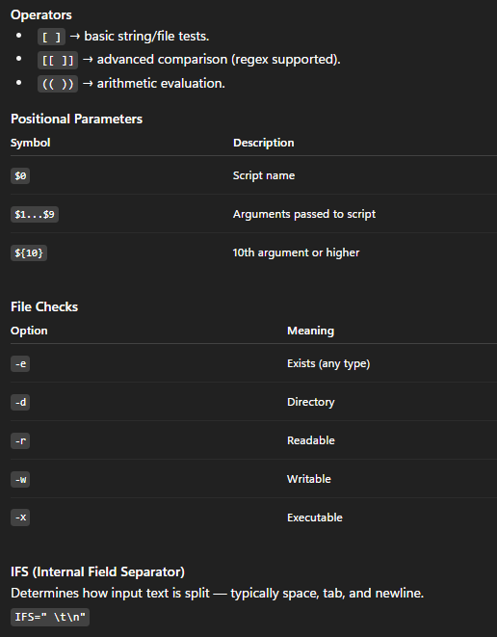

10. Common Bash Script Examples

Variables
name="Alpine"
echo "Welcome to $name Docker!"

Arithmetic
a=5; b=10
sum=$((a + b))
echo "Sum: $sum"

Conditional (if-else)
num=10
if [ "$num" -gt 5 ]; then
echo "$num is greater than 5"
else
echo "$num is less or equal"
fi

Loops
for i in {1..5}; do echo "Iteration $i"; done

count=1
while [ $count -le 5 ]; do
echo "Count: $count"
count=$((count+1))
done

Functions
greet() { echo "Hello, $1!"; }
greet "User"

Reading Input
read -p "Enter your name: " name
echo "Hello, $name!"

File and Directory Operations
mkdir -p /tmp/mydir
echo "Created directory."

cp file.txt /tmp/
rm -f file.txt

Output Redirection
echo "Log Entry" > log.txt
echo "Another line" >> log.txt
> : Overwrite the content if the file exists. Else make the file and then likhdo jo bhi is se pehle line hai.
>> : Append the line to the file
< : Bring from the file

Menu Script
while true; do
echo "1. List files"
echo "2. Create directory"
echo "3. Exit"
read choice
case $choice in
1) ls ;;
2) read dirname; mkdir -p "$dirname" ;;
3) exit ;;
*) echo "Invalid option" ;;
esac
done

11. Advanced Bash Scripting Examples
- String Manipulation
str="Hello"
echo ${str^^} # Uppercase
echo ${str,,} # Lowercase
- Arrays
fruits=("apple" "banana" "cherry")
echo ${fruits[@]}
- Error Handling
set -e
cp source.txt dest.txt || { echo "Copy failed"; exit 1; }
- Backup
backup_dir="backup_$(date +%Y%m%d)"
mkdir -p "$backup_dir"
cp *.txt "$backup_dir"
- Network Scripts
curl -O http://example.com/file.txt
response=$(curl -s -o /dev/null -w "%{http_code}" http://example.com)
[ "$response" -eq 200 ] && echo "Site is up"

12. Practical Projects and Exercises
- Calculator Script: Perform arithmetic using user input.
- Keyword Counter: Use grep to count words in text files.
- System Info Script: Output system stats using uname, uptime, df.
- Fibonacci Generator: Print sequence up to a given number.
- Web Scraper: Combine curl, grep, sed, or awk to extract webpage data.
- CSV to JSON Converter: Process CSV input into structured JSON output.

Ubuntu-Focused Exercises
- Log Analyzer: Extract services causing most errors from /var/log/syslog.
- Backup System: Compress a directory while skipping large files.
- User Manager: Create users and disable temporary accounts.
- Process Monitor: Log high-usage processes and terminate if persistent.
- Parallel Downloader: Download multiple URLs simultaneously (max 3).
- Custom ls Command: Display file name, size, owner, and last modified time sorted by size.

Sample Questions and Answers
Q1. Who developed the Bourne Shell and in which year?
A: Stephen Bourne in 1977.
Q2. What does a shebang (#!) do in a script?
A: It specifies the interpreter used to run the script.
Q3. What is POSIX compliance?
A: A standard ensuring compatibility between Unix-like operating systems.
Q4. What command makes a script executable?
A: chmod +x scriptname.sh
Q5. Explain the difference between sh and bash.
A: bash extends sh with features like command history, completion, and scripting enhancements.
Q6. What does IFS stand for and what does it do?
A: Internal Field Separator – defines how text is split into tokens.
Q7. Describe the function of the set -e command.
A: It stops the script execution if any command fails.
Q8. How can you check if a file is readable in Bash?
A: Use [ -r filename ] in a conditional statement.
Q9. What is the purpose of the Alpine Linux apk command?
A: It manages package installation and updates.
Q10. What is the benefit of using scripting in Docker-based Hadoop setups?
A: It automates setup, data transfer, monitoring, and cleanup, improving efficiency.

LECTURE 3

1. Introduction to Virtualization
Virtualization originated in the 1960s, when mainframe systems were first partitioned to allow multiple applications to run simultaneously. Over time, its definition evolved beyond mainframes into modern computing.
Today, virtualization refers to the creation of virtual (rather than physical) versions of computing resources, such as operating systems, servers, storage, and networks. It allows multiple virtual machines (VMs) to share the same physical hardware while maintaining isolation and flexibility.

2. Hardware Virtualization
Hardware virtualization creates virtual machines (VMs) that emulate physical computers. Each VM runs its own operating system (guest OS), independent of the host OS.
Key components:
- Host machine: The physical hardware where the virtualization software runs.
- Guest machine: The virtual machine that behaves like a separate computer.
- Hypervisor (Virtual Machine Monitor): Software or firmware that manages and monitors virtual machines.
Example:
A Windows host running a VM with Ubuntu installed — Ubuntu applications run on the VM, not the host.
Advantages:
- Multiple OS environments on one machine.
- Reduced hardware requirements.
- Easier testing, development, and deployment.

3. Types of Virtualization
Virtualization can occur at multiple layers of IT infrastructure. The major types include:
- Application Virtualization
- Server Virtualization
- Desktop Virtualization
- Storage Virtualization
- Network Virtualization
- Data Virtualization

4. Application Virtualization
Application virtualization runs applications in isolated containers rather than installing them directly on the host operating system.
How it works:
- Isolation Layer:
  - A virtualization layer intercepts system calls from the application.
  - Redirects file and registry operations to a virtual container.
- No Full Installation:
  - The app’s binaries, libraries, and configurations exist inside a package.
- Controlled Integration:
  - The app interacts with the OS (e.g., network or display) but does not modify system files.
Benefits:
- No software conflicts (e.g., DLL conflicts).
- Easy deployment via app streaming or portable packages.
- Security: App changes do not affect the host.
- Portability: Legacy apps can run on modern systems.
Example: Running multiple versions of the same app (e.g., MS Word 2010 and 2021) on one system without conflict.

5. Server Virtualization
Server virtualization divides a single physical server into multiple virtual servers using a hypervisor.
Each VM acts as an independent system with its own OS, CPU (vCPU), RAM, disk, and network interfaces. So instead of dedicating one physical server per workload, you run many workloads on one physical server.
Key Concepts:
- Hypervisor Layer: Manages CPU, memory, I/O, and device virtualization.
- VM Creation: Multiple VMs with different OS (e.g., Linux and Windows) share the same hardware.
- Resource Management: Hypervisors can dynamically allocate or overcommit resources.
Benefits:
- Better hardware utilization (multiple workloads per server).
- Fault isolation (one VM crash doesn’t affect others).
- Easier backups and snapshots.
- Scalability and flexibility (quickly deploy new VMs).
Example Setup:
A 32-core, 128 GB RAM server can host:
- 10 web servers (4 cores, 12 GB RAM each)
- 5 databases (2 cores, 4 GB RAM each)
- 2 analytics servers (8 cores, 32 GB RAM each)

6. Desktop Virtualization
Desktop virtualization separates the desktop environment (OS, apps, settings) from the physical machine. The desktop runs in a data center or cloud VM, and users connect remotely.
Key Features:
- The user accesses the desktop via a thin client, laptop, or browser.
- Computation and storage happen remotely.
- The user sees a familiar desktop interface.
Benefits:
- Access from anywhere and any device.
- Improved security — data stays on the server.
- Centralized IT management.
- Cost savings using thin clients.
- Easy disaster recovery.
Example:
Universities provide students with remote desktops hosting applications like MATLAB or Office from central servers.

7. Storage Virtualization
Storage virtualization combines multiple physical storage devices (HDDs, SSDs, SAN/NAS) into a unified logical storage pool.
Working:
- A virtualization layer maps logical storage to physical devices.
- Applications access storage as a single logical unit.
- Data can be distributed and mirrored across devices.

Benefits:
- Simplified centralized management.
- Scalability (add new disks easily).
- High availability and redundancy.
- Better resource utilization.
Example:
Combining 50 disks across 10 servers into a single logical storage pool accessible by multiple applications.

8. Network Virtualization
Network virtualization merges physical and software network resources to form a software-defined network (SDN). It makes the network behave like software, independent of the physical cabling and devices.
Core Components:
- Abstraction Layer: Virtual networks (vLANs, VXLANs, tunnels) run over physical hardware.
- Virtual Network Functions (VNFs): Traditional hardware devices (routers, firewalls) run as virtual software appliances.
- Software-Defined Networking (SDN): Centralized controllers dynamically manage network traffic. The physical network just provides connectivity; the logic lives in software.
Benefits:
- Simplified network management.
- Fast, programmable deployment of network services.
- Hardware independence.

9. Data Virtualization
Data virtualization is a technology that lets you access and use data from multiple different sources as if it were a single database, without physically moving or copying the data.
How it works:
- Connectors link to sources (databases, APIs, data lakes).
- A virtual layer maps sources into one logical schema.
- Queries are executed in real time, fetching and merging data dynamically.

Benefits:
- Unified access to heterogeneous data.
- Real-time analytics without ETL.
- Reduces duplication and storage costs.
Example:
A bank uses data virtualization to combine customer transactions (Oracle DB), support tickets (Salesforce), and credit reports (API) into one customer view.

10. Snapshot, Migration, and Failure Recovery
Snapshot:
A snapshot captures the state of a VM at a specific point in time. It enables rollback and recovery after risky operations or system failures.
Migration:
VMs can be moved between hosts (with their own hypervisors) while paused or live, maintaining uptime.
Failure Recovery (Failover):
If a host fails, VMs can automatically resume on another host using stored snapshots.

11. Advantages of Virtualization
- Multiple OS on one physical machine.
- Lower hardware and maintenance costs.
- Easy recovery from failures.
- Simplified management and faster provisioning.
- Improved scalability and IT productivity.

12. Virtualization Hosts and Hypervisors
- Hypervisor: Software that creates and manages VMs.
- Type 1 (Bare-metal): Runs directly on hardware (e.g., Hyper-V, AWS Xen).
- Type 2 (Hosted): Runs on top of an OS (e.g., VMware Workstation, VirtualBox).
Limitations:
- Each VM requires its own kernel, consuming more RAM and storage.
- Boot time is long.
- Running many VMs may degrade performance.
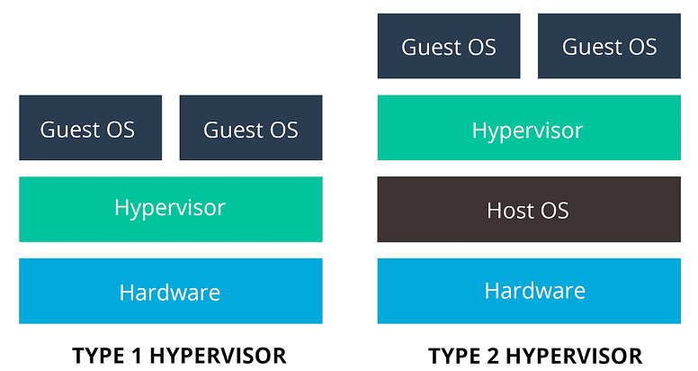

13. Disadvantages of Virtualization
- Performance degradation when multiple VMs run concurrently.
- Hypervisors are less efficient than bare-metal OS.
- Longer boot times.
- High resource consumption per VM.

14. The Need for Virtualization
- Resource Utilization:
  - Traditional systems underutilized hardware (10–15% usage).
  - Virtualization increases utilization by running multiple VMs per server.
- Cost Efficiency:
  - Reduces need for multiple physical servers.
  - Saves on power, hardware, and maintenance costs.
- Scalability and Flexibility:
  - Quickly create, modify, or migrate VMs to meet workload changes.
- Isolation and Security:
  - Application isolation prevents interference between workloads.
  - Each VM operates in a secure sandbox.

15. Containerization
Containerization virtualizes at the operating system level instead of the hardware level.
Concept:
- Containers share the host OS kernel and only include necessary binaries, libraries, and dependencies.
- They run isolated processes with minimal resource overhead.
- Faster boot times (seconds) and higher performance compared to VMs.
Advantages:
- Lightweight and fast.
- Efficient resource usage.
- Platform independence — “Build once, run anywhere.”
- Perfect for microservices and cloud-native applications.

16. Comparison: Application Virtualization vs Containerization
Feature | Application Virtualization | Containerization (Docker)
Virtualized Layer | Application layer only | Complete runtime (app + libs + OS user-space)
Dependency | Tied to host APIs | Shares host kernel
Isolation | Limited | Stronger process-level isolation
Deployment | Used for enterprise Windows apps | Used for microservices and DevOps
Performance | Near-native speed | Near-native with minimal overhead
Use Case | Run legacy/conflicting apps | Portable app deployment
Example | Run Word 2010 and 2021 on one PC | Package Python + Flask app in a container

17. Docker
Docker is the most popular containerization platform. It packages an application and all its dependencies into a single container, ensuring consistent operation across environments.
Core Features:
- Each container runs in isolation with its own dependencies.
- Developers can ship pre-configured environments to testers or production.
- QA teams can replicate environments without installing dependencies manually.
- Containers start in seconds and scale easily.
Benefits:
- Environment consistency across development, testing, and production.
- Simplified scaling and deployment.
- Efficient resource utilization.
- Time savings in testing and delivery pipelines.

Sample Questions and Answers
Q1. What is virtualization?
A: Virtualization is the process of creating virtual versions of hardware or software resources, allowing multiple operating systems or applications to run independently on the same physical hardware.
Q2. What is the difference between a host and a guest machine?
A: The host machine is the physical computer running the hypervisor, while the guest machine is the virtual instance created on the host.
Q3. Name three types of virtualization.
A: Application, Server, and Network virtualization.
Q4. What is the main function of a hypervisor?
A: A hypervisor creates, runs, and manages virtual machines by allocating physical resources like CPU, memory, and storage.
Q5. How does storage virtualization improve efficiency?
A: It pools multiple physical storage devices into a single logical resource, improving scalability, performance, and management.
Q6. What is a snapshot in virtualization?
A: A snapshot captures the state of a VM at a specific point in time for backup or rollback purposes.
Q7. List two advantages and disadvantages of virtualization.
A: Advantages: Lower cost, flexibility. Disadvantages: High resource usage, slower boot times.
Q8. How does containerization differ from virtualization?
A: Virtualization emulates hardware and requires a guest OS, while containerization shares the host OS kernel for lightweight and faster performance.
Q9. What are Type 1 and Type 2 hypervisors?
A: Type 1 runs directly on hardware (bare-metal), while Type 2 runs on an existing OS.
Q10. Why is Docker important for developers?
A: It ensures consistent development environments, easy deployment, and efficient scaling using container technology.

LECTURE 4

1. Introduction to Linux Containers
Linux containers are a lightweight virtualization technology that isolate applications and their dependencies from the host system while sharing the same operating system kernel (Same containerization wala concept in the last lecture)
They emerged as an evolution of earlier isolation mechanisms like chroot and FreeBSD Jails, eventually leading to the development of Docker and Kubernetes for modern cloud environments.

2. Early Developments: Chroot (1979)
Chroot (Change Root):
- Introduced in 1979 in Unix.
- Changes the root directory (/) for the current process.
- The process believed that /mnt/test was its own root directory.
- Provided filesystem isolation, but lacked true process and security isolation.
Limitation:
Chroot only isolated filesystems, not process IDs, users, or network resources, making it an early but incomplete form of virtualization.

3. FreeBSD Jails (2000)
Concept:
- Introduced in FreeBSD (2000) as an enhancement of chroot.
- Added stronger isolation:
  - Process, user, file, and network isolation.
- Each “jail” acted as a restricted environment for applications.
Key Features:
- Restricted what processes could access outside their jail.
- More secure and sandboxed than chroot.
- Foundation for future container architectures.

4. Solaris Containers (2004)
Overview:
- Introduced by Sun Microsystems for the Solaris OS.
- Enabled multiple isolated OS environments (zones) on a single host OS instance.
Features:
- Abstract layer separating applications from hardware details.
- Allowed resource allocation per zone.
- Supported scalability and performance isolation.
Impact:
Solaris Zones were among the first true container-like systems enabling multiple secure environments under one OS instance.

5. Linux Namespaces (2002)
Purpose:
Namespaces isolate what a process can “see.”
They partition OS resources so each process group has its own isolated view.
Types of Namespaces:
- PID: Isolates process IDs.
- NET: Isolates network interfaces, IPs, and routing.
- MNT: Isolates filesystem mount points.
- UTS: Isolates hostnames and domain names.
- IPC: Isolates inter-process communication.
- USER: Isolates user and group IDs.
- CGROUP: Isolates control group hierarchy.
Analogy:
Each namespace is a “box” of global resources—processes in one box can’t affect others.

6. Control Groups (Cgroups) (2007)
Developed by Google, cgroups manage what resources processes can use.
Capabilities:
- Allocate CPU, memory, I/O, and bandwidth per process group.
- Control (freeze, restart) processes easily.
- Enable fine-grained resource accounting and prioritization.
Significance:
Cgroups form one of the core building blocks of modern container systems like Docker, Kubernetes, and LXC.

7. Linux Containers (LXC) (2008)
LXC (Linux Containers):
- The first complete container implementation for Linux.
- Combined namespaces and cgroups to provide lightweight virtualization.
- Allowed multiple isolated environments on a single host.
- Included tools, libraries, templates, and runtime utilities.
Outcome:
LXC demonstrated that virtual machines could be replaced with faster, lightweight alternatives—containers.

8. Docker (2013)
Revolutionary Step:
Docker built upon LXC and made containers portable, developer-friendly, and highly scalable.
Key Innovations:
- libcontainer: Docker’s internal library replacing dependency on LXC.
- Container Images: Portable, versioned packages containing apps and dependencies.
- Ecosystem: Tools for container build, ship, and run workflows.
Impact:
Docker transformed container technology into a practical, standard tool for software development, testing, and deployment.

9. Orchestration
Definition:
Orchestration automates the deployment, coordination, and management of containers across distributed systems.
Core Functions:
- Provisioning and deployment of containers.
- Scheduling containers on optimal hosts.
- Managing resources, scaling, and networking.
- Rolling updates and secret management.
- Load balancing and fault recovery.
Popular Tools:
- Docker Swarm
- Kubernetes (K8s)
- Apache Mesos
- HashiCorp Nomad

10. Kubernetes Example
Kubernetes manages containerized applications with high availability.
Example configuration to run a web application with 3 replicas:
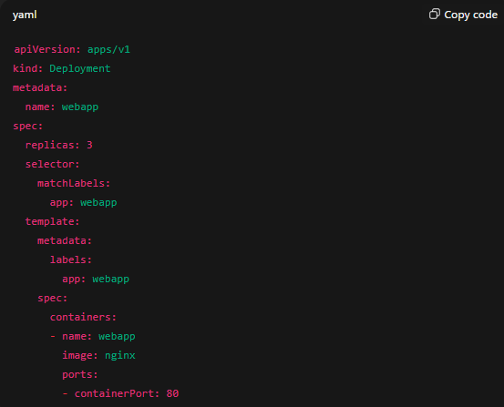
Features of Kubernetes:
- Automated scaling and failover.
- Self-healing and load balancing.
- Service discovery and rolling updates.

11. Containers in the Cloud
rkt (2014):
- Alternative to Docker, emphasizing security and standards compliance.
- Based on the App Container (appc) specification.
- Supported both appc and Docker images.
- Introduced pods — a group of applications sharing a context (inspired Kubernetes).
- No central daemon; provided a modular and pluggable architecture.
containerd:
- Originally a Docker subcomponent, later became a standalone runtime.
- Manages container lifecycle: image transfer, storage, execution, and networking.
- Uses gRPC API for client interaction.
- Implements OCI (Open Container Initiative) standards.
Kubernetes:
- Open-source orchestration platform developed by Google.
- Automates deployment, scaling, and management of containerized apps.
- Groups containers into logical units called pods.
- Provides fault tolerance and scalability for distributed systems.

12. Docker Overview
Definition:
Docker is an open-source container platform that packages applications and their dependencies into standardized units.
Each app runs in its own isolated container, sharing the host OS kernel.
Advantages:
- Lightweight and portable.
- Fast startup times.
- Cross-platform compatibility.
- Simplified CI/CD workflows.
Workflow:
Build → Ship → Run

13. Docker Architecture
Client–Server Model:
- Docker CLI: User interface for commands (e.g., docker run, docker build).
- Docker Daemon (dockerd): Core process managing containers, images, and networks.
- containerd: Handles low-level container management tasks.
- runc: Responsible for setting up namespaces and cgroups.
- Linux Kernel: Provides isolation mechanisms.

14. Docker Image and Dockerfile
Docker Image:
- A layered template used to create containers.
- Each layer contains binaries, libraries, and configurations.
- Layers are cached and reused for efficiency.
- Enables versioning, reusability, and compact storage.
A Docker image is a read-only blueprint that contains everything needed to run an application, its code, dependencies, libraries, and configuration. When you run it, it becomes a container, an isolated, running instance of that image.
Dockerfile:
A text file defining steps to build an image.
Commands include:
- FROM: Base image.
- RUN: Execute commands during build.
- COPY / ADD: Copy files into the image.
- WORKDIR: Set working directory.
- CMD / ENTRYPOINT: Define startup commands.
- EXPOSE: Document listening ports.
- VOLUME: Create persistent storage.
Example:
FROM python:3.11-slim
- Specifies the base image — here, a lightweight version of Python 3.11.
- This layer provides the runtime environment and core libraries.
- The slim tag ensures minimal image size, reducing build time and resource use.

WORKDIR /app
- Sets the working directory inside the container to /app.
- All subsequent commands (COPY, CMD, etc.) will execute from here.
- If /app doesn’t exist, Docker automatically creates it.

COPY app.py .
- Copies the local file app.py from your host machine into the container’s current working directory (/app).
- This bundles your application code inside the image.

CMD ["python", "app.py"]
- Defines the default command to run when the container starts.
- Here, it executes python app.py.
- Uses exec form (JSON array) to avoid invoking a shell, ensuring proper signal handling and efficient process management.

15. Docker Storage
Docker provides mechanisms to persist data beyond container lifecycles.
Types of Storage:
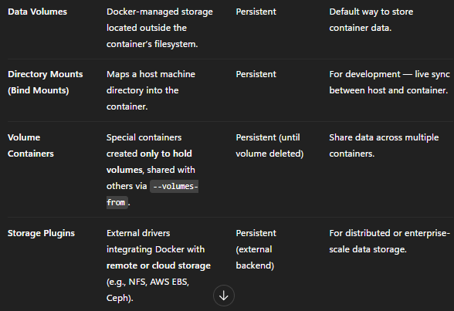
Benefits:
- Persistent and shareable data.
- Simplified backup and recovery.
- Supports distributed environments.
A Docker volume is a persistent storage mechanism used to save data outside a container’s writable layer, so that data isn’t lost when the container stops, restarts, or is rebuilt.
Key Points
- Persistence: Data in a volume survives container deletion.
- Isolation: Volumes are managed by Docker, separate from the container’s filesystem.
- Sharing: Multiple containers can access the same volume (for shared datasets or logs).
- Performance: Volumes are faster and more reliable than bind mounts for heavy I/O operations.

16. Summary of Containerization Evolution
Technology | Year | Key Feature
Chroot | 1979 | Filesystem isolation
FreeBSD Jails | 2000 | User and network isolation
Solaris Zones | 2004 | Virtualized OS environments
Namespaces | 2002 | Resource isolation
Cgroups | 2007 | Resource allocation control
LXC | 2008 | Complete Linux containers
Docker | 2013 | Developer-friendly containers
Kubernetes | 2015 | Container orchestration

Sample Questions and Answers
Q1. What is the purpose of Linux namespaces?
A: Namespaces isolate system resources such as processes, networks, filesystems, and users, ensuring one process cannot interfere with another.
Q2. What are cgroups, and why are they important?
A: Control Groups (cgroups) limit and monitor resource usage (CPU, RAM, I/O) for processes. They are foundational for container resource management.
Q3. Explain the role of the Docker Daemon.
A: The daemon manages images, containers, networks, and storage, communicating with clients through REST APIs.
Q4. What is the difference between a container and a virtual machine?
A: Containers share the host OS kernel, making them lightweight, whereas VMs include full OS instances, making them heavier.
Q5. What is orchestration, and why is it needed?
A: Orchestration automates deployment, scaling, and operation of containers, essential for managing large-scale distributed applications.
Q6. Define a Docker image and Dockerfile.
A: A Docker image is a layered template for containers; a Dockerfile is a script containing build instructions for that image.
Q7. List three benefits of container storage volumes.
A: Data persistence, easy backup/restore, and data sharing across containers.
Q8. What is Kubernetes used for?
A: It automates deployment, scaling, and management of containerized applications across multiple hosts.
Q9. What does containerd do in Docker architecture?
A: Manages container lifecycle, image storage, networking, and low-level runtime operations.
Q10. Why is Docker preferred for application deployment?
A: It ensures consistency, portability, and fast deployment across multiple environments.

LECTURE 5

1. Hard Disk Drives (HDD)
Definition and Structure:
- HDDs consist of a series of platters coated with a ferromagnetic layer.
- Data bits are represented by the direction of magnetization.
- The read/write head moves rapidly while disks spin at speeds like 7200 RPM, allowing quick data access.
Characteristics:
- Cost-effective for long-term, large-scale storage.
- Suitable for offline archival and data lakes.
- Slower than SSDs because of mechanical movement (seek and rotation delays).
Relevance in Big Data:
- Commonly used in Hadoop Distributed File System (HDFS) for batch analytics, cold storage, and archival layers.

2. Solid State Drives (SSD)
Definition:
- SSDs use NAND flash memory instead of spinning platters.
- No moving parts → faster, durable, and energy-efficient.
- Non-volatile, retaining data even without power.
Advantages over HDD:
- High speed (booting OS, program start-up, video rendering).
- Faster in ETL, real-time analytics, and machine learning pipelines.
- Durable and resistant to mechanical failure.
Use Cases in Big Data:
- Active data processing.
- Query acceleration in Presto, Hive LLAP, Spark, etc.

3. SATA vs NVMe Interfaces
SATA (Serial Advanced Technology Attachment):
- Common interface for connecting HDDs/SSDs to motherboards.
- SATA III supports 6 Gbps (600 MB/s).
- Uses 7-pin (data) + 15-pin (power) connectors.
NVMe (Non-Volatile Memory Express):
- Interface built for SSDs using the PCIe bus.
- Delivers speeds up to 7000 MB/s (via M.2 or U.2 slots).
- Much faster data transfers, ideal for high-performance analytics workloads.
Impact in Big Data:
- NVMe SSDs accelerate data ingestion, real-time processing, and low-latency queries compared to SATA and HDD.

4. Intel Optane and Persistent Memory in Analytics
Intel Optane (NVRAM):
- A form of persistent memory bridging DRAM and SSD speed.
- Supports hybrid storage tiers for in-memory analytics and checkpointing.
Key Use Cases:
- In-memory analytics: Expands memory capacity for Spark, Flink, Presto.
- Caching: Reduces latency in Hive LLAP and Druid.
- Hybrid tiers: Faster middle layer between DRAM and SSDs.
- Write-heavy workloads: Ideal for logs, ML checkpoints.
- Checkpointing/Recovery: Enables quick state recovery in Hadoop YARN and Kafka.

5. Comparison: HDD vs SSD in Big Data
Aspect | HDD | SSD | Impact on BDA
Technology | Magnetic spinning disk | NAND flash (no moving parts) | SSD eliminates mechanical delays → faster I/O
Speed | 80–160 MB/s | 500 MB/s (SATA) – 7 GB/s (NVMe) | SSD accelerates ingestion & queries
Latency | 5–10 ms | <0.1 ms | Crucial for real-time analytics
IOPS | 100–200 | 50,000–1,000,000+ | Supports massive parallel reads/writes
Durability | Sensitive to shock | High shock resistance | SSDs reliable in distributed nodes
Cost | $0.02–0.03/GB | $0.08–0.12/GB | HDD cheaper for cold data
Capacity | Up to 20 TB | 1–8 TB typical | HDD for raw lake storage
Power | 6–10 W | 2–5 W | SSDs reduce data center energy costs
Hybrid Use:
- HDDs for cold data lakes.
- SSDs for hot analytics and ML pipelines.

6. Performance Hierarchy: Storage to Memory
Parameter | HDD | SSD (SATA) | SSD (NVMe) | DRAM | Persistent Memory (Optane)
Transfer Speed | 80–160 MB/s | 500 MB/s | 3–7 GB/s | 10–25 GB/s | 1–3 GB/s
IOPS | ~200 | 100K | 1M | Millions | 800K
Latency | 5–10 ms | 0.1 ms | 10–50 µs | <100 ns | 300 ns
Best Use Case | Archival storage | Hot cache | Real-time workloads | In-memory computing | Hybrid layer
Impact:
Higher up the hierarchy → faster processing and lower latency, essential for real-time dashboards and streaming analytics.

7. Storage Blues – The Latency Challenge
Observation:
- Storage capacity of drives has increased rapidly, but read/write speed growth has lagged behind.
Example:
- 1990 HDD: 1.3 GB, 4.4 MB/s (5 minutes to read all data).
- 2020 HDD: 1 TB, 100 MB/s (2.5 hours to read all data).
- SSD: 500 MB/s (33 minutes for 1 TB).
Big Data Impact:
- Reading massive datasets from one disk is slow.
- Parallelism using multiple disks reduces time significantly (Hadoop concept).

8. Parallelism and Hardware Failure in Distributed Systems
Parallel Storage Concept:
- Instead of one large drive, distribute data across 100 drives.
- Each holds 1/100th of data → read complete dataset in ~2 minutes.
- Enables shared access to multiple users without interference.
Hardware Failure Problem:
- The more hardware you use, the higher the risk of failure.
Solution:
- Replication.
Aspect | RAID | HDFS Replication
Scope | Single server | Cluster-wide
Replication Unit | Disk-level | Block-level (128 MB default)
Replication Factor | Fixed (e.g., 2 in RAID1) | Configurable (default 3)
Data Location | Same machine | Distributed across nodes
Performance | Local redundancy | Network replication & parallel reads
Use Case | Metadata (NameNode) | Core data durability

9. Combining Distributed Data: MapReduce
Problem:
- Distributed datasets require combining and analysis across many nodes.
Solution – MapReduce Model:
- Abstracts disk I/O into a computation of key-value pairs.
- Two core functions:
  - Map: Processes and organizes data into key-value pairs.
  - Reduce: Aggregates and summarizes by key.
Benefits:
- Automatic fault tolerance using HDFS.
- Parallel data processing across nodes.
- Suitable for batch analytics.

10. Hadoop’s Power
Core Strengths:
- Scalable: Runs on commodity hardware.
- Reliable: Replication-based fault tolerance.
- Cost-effective: Open-source and distributed.
Example Use Case:
- Rackspace Mailtrust used Hadoop to analyze geographic user distributions.
- Insights influenced data center placement.
Limitation:
- Batch-oriented: Not suitable for interactive or low-latency queries (results take minutes).

11. Hadoop Ecosystem Evolution
Beyond HDFS and MapReduce:
- The ecosystem expanded into specialized components:
Component | Function
HBase | Key-value store for online reads/writes
YARN | Cluster resource manager for multi-framework execution
Hive/Impala/Trino | Interactive SQL engines for big data
Spark | In-memory processing for iterative analytics
Solr | Search engine for document indexing on HDFS
Impact:
Hadoop became a flexible ecosystem, not just a single framework.

12. Why Not Traditional Databases?
Reason:
- Seek time improvements are slower than transfer rate improvements.
- Relational databases (RDBMS) rely on B-trees, optimized for small updates.
- Hadoop uses Sort/Merge, better for rebuilding large datasets.
Conclusion:
MapReduce outperforms RDBMS for bulk data transformations, not small transactions.

13. Criticism and Evolution
DeWitt and Stonebraker (2007):
- Published “MapReduce: A Major Step Backwards.”
- Criticized MapReduce for lacking indexing, schema enforcement, and optimization.
Response:
- Community noted that MapReduce ≠ Database — each serves different goals.
- Modern tools (Hive, Spark SQL) bridge the gap between SQL databases and Hadoop frameworks.

14. High-Performance Computing (HPC) vs Hadoop
HPC Characteristics:
- Uses Message Passing Interface (MPI) for communication.
- Shared filesystem via Storage Area Network (SAN).
- Designed for compute-intensive workloads.
Limitations:
- Performance bottleneck due to network bandwidth when handling large data volumes.
Hadoop Approach:
- Moves computation to data (data locality) instead of moving data across network.
- Optimized for data-intensive workloads.
- Ensures scalability and efficient use of network topology.

15. MPI vs Hadoop
Aspect | MPI (HPC) | Hadoop
Programming Model | Explicit message passing (low-level C) | High-level data abstraction (key-value)
Data Handling | Shared via SAN | Distributed via HDFS
Failure Tolerance | Manual handling | Automatic recovery
Ease of Use | Complex | Simplified (automated I/O and fault handling)
Use Case | Scientific computation | Big Data analytics

16. History of Hadoop
Origins:
- Developed by Doug Cutting and Mike Cafarella as part of the Nutch project (2002).
- Inspired by Google’s GFS (2003) and MapReduce (2004) papers.
Timeline:
- 2004: Nutch develops open-source GFS-like NDFS.
- 2005: MapReduce implemented in Nutch.
- 2006: Hadoop becomes a Lucene subproject.
- 2008: Yahoo! uses Hadoop on a 10,000-core cluster for web indexing.
- 2008: Hadoop becomes a top-level Apache project.

17. Hadoop in Industry and Trends
Adoption:
- Used by Yahoo!, Facebook, Last.fm, and The New York Times (for large-scale PDF conversion).
Achievements:
- 2008: Broke world record by sorting 1 TB in 209 seconds (on 910 nodes).
- 2014: Databricks Spark cluster sorted 100 TB in 1406 seconds.
Current Landscape:
Tool | Strength | Weakness | Market Trend
Hadoop | Batch ETL, data lakes, HDFS | High latency | Used in enterprises (legacy)
Spark | In-memory, faster | Memory cost | Widely adopted
Flink | Real-time streaming | Smaller ecosystem | Growing
Cloud (BigQuery, Snowflake) | Fully managed, fast | Vendor lock-in | Preferred for analytics

Sample Questions and Answers
Q1. What is the main difference between HDD and SSD?
A: HDD uses magnetic platters with mechanical parts, while SSD uses NAND flash memory, making it faster, more durable, and energy-efficient.
Q2. Why is NVMe faster than SATA?
A: NVMe connects directly to the CPU via PCIe lanes, bypassing legacy controller bottlenecks in SATA.
Q3. What problem does Hadoop’s replication solve?
A: It ensures data durability and fault tolerance across distributed nodes.
Q4. Explain the significance of MapReduce.
A: It abstracts disk I/O and enables parallel data processing using map and reduce phases.
Q5. Why can’t traditional databases replace Hadoop?
A: Databases optimize for small transactions, whereas Hadoop efficiently processes massive datasets in parallel.
Q6. What is the role of YARN in the Hadoop ecosystem?
A: It manages cluster resources and allows multiple distributed applications to run simultaneously.
Q7. Define data locality in Hadoop.
A: The concept of moving computation closer to where data resides to reduce network transfer overhead.
Q8. How does Hadoop differ from HPC?
A: Hadoop emphasizes data locality and fault tolerance, while HPC focuses on compute-heavy operations using MPI.
Q9. Who created Hadoop and why?
A: Doug Cutting and Mike Cafarella, to build an open-source web-scale search system inspired by Google’s GFS and MapReduce papers.
Q10. What is the key limitation of Hadoop MapReduce?
A: High latency and unsuitability for interactive or real-time analysis.

LECTURE 6

1. Hadoop to the Rescue: Handling Unstructured Data
Types of Data:
- Semi-Structured Data: Has a loose structure or optional schema that may be ignored. Examples include spreadsheets, JSON files, and web logs.
- Unstructured Data: Lacks a defined internal structure, such as text documents, videos, and social media posts.
Hadoop’s Role:
- Hadoop is designed to process semi-structured and unstructured data efficiently.
- It follows the schema-on-read principle:
  - The schema is applied when data is processed, not when it’s stored.
  - This approach provides flexibility and avoids the rigid data loading process of relational databases (RDBMS).
- Data in Hadoop is simply stored as files, not preloaded into a database, enabling quick ingestion.
Advantage:
Flexible handling of raw data without predefined structures makes Hadoop well-suited for varied data sources such as logs, social media data, and IoT sensor streams.

2. Storage Blues: Normalization and Log Data
Normalization in Databases:
- Traditional databases normalize data to avoid redundancy and ensure data consistency.
- However, normalization creates multiple linked tables, which leads to non-local read operations.
Problem in Hadoop:
- Normalized data is inefficient for Hadoop’s streaming read/write model, as distributed file systems prefer sequential I/O.
Example:
- A web server log is not normalized; it stores repetitive information (like client hostnames) multiple times.
- This redundancy makes logs ideal for Hadoop, since Hadoop can efficiently stream through large repetitive datasets.
Key Takeaway:
Logfiles, sensor data, and other flat data structures are perfect candidates for Hadoop analytics.

3. MapReduce Power: Linear Scalability
Core Idea:
- MapReduce scales linearly with data size.
How It Works:
- Data is divided into partitions.
- Functional operations like map() and reduce() execute in parallel on different partitions.
Performance Characteristics:
- If input data doubles, runtime also doubles.
- However, doubling cluster size (nodes) keeps runtime constant.
Comparison with SQL:
- SQL queries typically do not scale linearly; performance can degrade with increasing data due to centralized execution.
Conclusion:
MapReduce’s distributed and parallel nature ensures predictable scalability — crucial for large datasets in big data processing.

4. Power of MapReduce: Fault Tolerance and Shared-Nothing Architecture
Challenge in Distributed Computing:
- Partial failures in distributed systems make coordination complex.
MapReduce Advantage:
- Automatically detects failed tasks and reassigns them to healthy nodes.
- Achieves fault tolerance via task rescheduling and data replication.
Architecture:
- Shared-nothing architecture: Each task operates independently without sharing memory or storage.
- This independence simplifies fault handling and ensures that one node’s failure does not affect others.
Programmer’s Perspective:
- Developers need not manage failure recovery or data distribution.
- Task order and node dependencies are abstracted away.
Key Point:
MapReduce’s reliability comes from stateless task design and robust fault recovery mechanisms.

5. Introduction to MapReduce Programming Model
Definition:
- MapReduce is a programming model for distributed data processing.
Languages Supported:
- Hadoop MapReduce programs can be written in Java, Python, or other languages compatible with Hadoop streaming.
Example Scenario:
- Processing global weather data collected hourly by sensors worldwide (semi-structured logs).
- Objective: Find the highest recorded temperature per year.
Data Source:
- National Climatic Data Center (NCDC) dataset – structured by date and weather station.
Why MapReduce:
- Large, line-oriented log data (text files) are efficiently processed using the map and reduce paradigm.

6. Need for MapReduce: Overcoming Sequential Processing Limits
Problem:
- Sequential programs cannot scale as data grows.
Parallelization Attempt:
- Data can be divided by year or record, and separate processes can handle partitions.
- However, dividing data evenly and combining results manually is complex.
Challenge:
- Even with parallel processing, a single machine’s capacity limits performance.
- Scaling beyond one system becomes impractical.
Solution:
- MapReduce divides processing across many nodes automatically.
- Combines partial results (reduces) efficiently and transparently.
Key Insight:
MapReduce overcomes the limits of single-machine parallelism by distributing both computation and data.

7. MapReduce: Core Working Principle
Processing Phases:
- Map Phase:
  - Input: Raw data (e.g., NCDC weather logs).
  - Extracts necessary fields (e.g., year and temperature).
  - Prepares data as key-value pairs (e.g., <year, temperature>).
  - Cleans data by filtering out invalid or missing records.
- Reduce Phase:
  - Groups intermediate key-value pairs by key (e.g., all temperatures for the same year).
  - Performs aggregation or computation (e.g., finding max temperature per year).
Key Features:
- Both map and reduce phases use key-value pairs.
- Each stage’s input and output data types are programmable.
Example:
- Map output: <1950, 35> <1950, 37> <1951, 36>
- Reduce output: <1950, 37> <1951, 36>
Benefit:
Automatic grouping and sorting simplify large-scale aggregation tasks.

8. MapReduce Data Type and Workflow
Data Types:
- Input and output for both Map and Reduce use key-value pairs.
- Must have compatible data types:
  - Example: Text and IntWritable in Hadoop.
Workflow:
- Input data split into chunks.
- Mappers process each chunk independently.
- Intermediate data sorted and grouped by key.
- Reducers aggregate grouped data.
- Final output written to distributed storage.
Fault Tolerance:
- Failed map or reduce tasks are re-executed automatically.
- Input splits and intermediate outputs are persisted until successful completion.

9. Configuring and Running a MapReduce Job
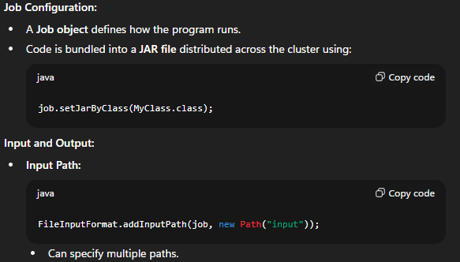
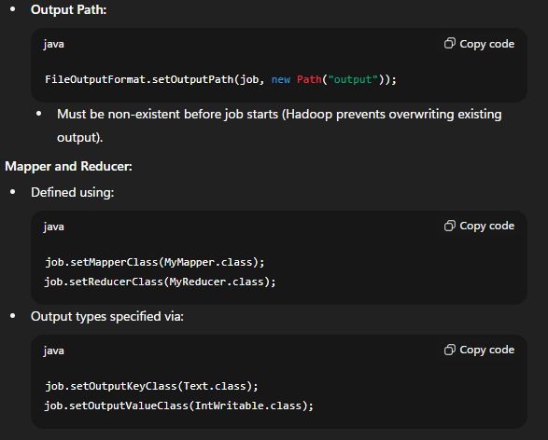

10. MapReduce Execution and Monitoring
Input Format:
- Default input format is TextInputFormat (reads line-by-line).
- Custom formats can handle structured data (e.g., SequenceFileInputFormat).
Job Submission:
Executed using:
job.waitForCompletion(true);
- Parameter true enables verbose logging (shows progress and status).
Exit Codes:
- Returns true for success and false for failure.
- Typical convention:
  - Success → Exit code 0
  - Failure → Exit code 1
Execution Flow:
- Job submitted to YARN (ResourceManager).
- Mappers and reducers execute in containers.
- Results stored in HDFS output directory.

11. Summary of MapReduce Workflow

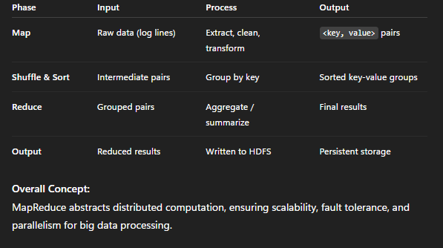

Sample Questions and Answers
Q1. What types of data does Hadoop handle best?
A: Hadoop efficiently handles semi-structured (e.g., logs, JSON) and unstructured (e.g., text, video) data using schema-on-read flexibility.
Q2. What is schema-on-read in Hadoop?
A: It means the schema is applied when data is processed, not when stored—allowing flexibility for diverse and evolving data types.
Q3. Why are log files suitable for Hadoop?
A: Logs are unnormalized and sequentially stored, ideal for Hadoop’s streaming read model.
Q4. Explain MapReduce scalability.
A: MapReduce scales linearly; doubling both data and cluster size maintains similar runtime.
Q5. What makes MapReduce fault-tolerant?
A: Tasks are stateless and re-executed upon failure; data replication ensures no data loss.
Q6. Describe the purpose of the map and reduce functions.
A: Map transforms input data into key-value pairs, while Reduce aggregates values by key to produce summarized output.
Q7. Why must the reduce function input types match the mapper output types?
A: Because the reducer consumes the mapper’s output; mismatched types cause runtime errors.
Q8. What is the role of setOutputPath() in a MapReduce job?
A: Defines the directory where final output is written; it must not pre-exist to prevent accidental overwriting.
Q9. How does Hadoop handle failed tasks?
A: Failed tasks are automatically detected, terminated, and re-run on healthy nodes.
Q10. What are the main limitations of single-machine parallelism addressed by MapReduce?
A: Limited compute capacity and lack of scalability; MapReduce distributes computation and data across multiple nodes.

LECTURE 7

1. MapReduce Overview
Definition and Function:
- A MapReduce (MR) job consists of input data, the MapReduce program, and configuration details.
- Hadoop executes the job by dividing it into smaller tasks, of two types:
  - Map tasks
  - Reduce tasks
Execution:
- Tasks are managed and scheduled through YARN (Yet Another Resource Negotiator).
- YARN runs these tasks on cluster nodes.
- In case of task failure, Hadoop automatically reschedules it on another node.
Input Splitting:
- The input data for a MapReduce job is divided into input splits (logical divisions of data).
- Hadoop creates one map task per input split.
- Each map task processes one record at a time from its assigned split.

2. HDFS Blocks and Splits
HDFS Data Storage:
- Files in HDFS are split into blocks (default size 128 MB or 256 MB).
- Each block is replicated across multiple DataNodes (default replication factor = 3).
Example:
file.txt → block0, block1, block2
block0 → node1, node2, node3
block1 → node2, node3, node4
block2 → node3, node4, node5
Relation between Splits and Blocks:
- The InputFormat (e.g., TextInputFormat) determines how input files are divided into splits.
- Normally, one split corresponds to one HDFS block.
- However, smaller blocks can be combined using CombineFileInputFormat.
Job Initialization:
- The ApplicationMaster (formerly JobTracker) creates one Map Task per input split.
- Example: 20 splits → 20 map tasks.

3. Scheduling and Data Locality
Task Scheduling Process:
- The ApplicationMaster requests containers from YARN’s ResourceManager.
- Each container runs a map task.
- The scheduler prioritizes running map tasks where the data block physically exists.
Levels of Locality:
- Node-local: Task runs on the same node as its data.
- Rack-local: Task runs on a different node in the same rack.
- Off-rack: Task runs on a node outside the rack (network transfer required).
Load Distribution:
- Data locality is prioritized over perfect workload balance.
- Nodes with more data may get more map tasks initially.
- As tasks finish, Hadoop dynamically redistributes pending work to idle nodes to maintain balance.

4. The Reality of Data Movement
- Hadoop minimizes data movement since transferring data across the network is costly.
- Data blocks remain stationary on their DataNodes, but data is read remotely when necessary.
- If a node is busy or lacks available slots:
  - The scheduler assigns the task to another node (rack-local or off-rack).
  - The block data is then streamed over the network to the node running the map task.
- Although Hadoop tries to avoid this, it cannot be completely prevented in large, busy clusters.

5. Concept of MapReduce Splits and Stragglers
Parallel Processing:
- MapReduce divides input into many splits to be processed in parallel.
- The job completes when the slowest task (straggler) finishes.
Effect of Uneven Workload:
- If workload distribution is uneven:
  - A few heavy tasks delay the entire job.
  - Parallelism benefits are reduced.
Optimization Goal:
- Split data evenly across tasks to ensure uniform workload distribution.
- Small splits improve load balance but introduce additional overhead.

6. Load Balancing and Parallelism
Parallelism Benefits:
- Multiple map tasks read and process different HDFS blocks simultaneously.
- Increases overall disk throughput and CPU utilization.
- On a single node, multiple map tasks can execute concurrently.
I/O Parallelization:
- While one task waits for I/O operations, another continues computation.
- Reduces idle time and improves resource usage.
Subdividing Workload:
- Smaller splits reduce the time each node spends processing.
- Shorter tasks mean quicker recovery on task failure.
- Scheduler can reassign tasks dynamically to achieve load balance.

7. Load Balancing in Hadoop
Definition:
- Load balancing ensures even distribution of work across nodes during both map and reduce phases.
- Prevents nodes from remaining idle while others are overloaded.
Why It’s Important:
- Heterogeneous clusters (with different node speeds) require adaptive scheduling.
- Failures or concurrent jobs make reallocation necessary.

8. Load Balancing during the Map Phase
Process:
- ApplicationMaster queries the NameNode for data block locations.
- Map tasks are assigned to nodes containing the data (data-local scheduling).
- No data movement occurs when scheduling is node-local.
Dynamic Adjustment:
- If nodes complete their tasks early:
  - Scheduler assigns new tasks from unfinished splits.
- For slow nodes:
  - Hadoop launches speculative execution—duplicate copies of slow tasks on faster nodes.
Goal:
- Keep all nodes fully utilized.
- Prevent delays caused by stragglers or slow machines.

9. Load Balancing during the Reduce Phase
Characteristics of Reduce Tasks:
- Reduce tasks have no data locality since they must aggregate output from all map tasks.
- Reducers fetch intermediate (map) data over the network.
Scheduling and Recovery:
- YARN places reducers on available nodes.
- If a node becomes slow or fails:
  - Reducers can be restarted on other nodes.
- When reducers start too early, they can still pull data incrementally from completed mappers.
Network Optimization:
- Intermediate data transfer (shuffle phase) is carefully optimized to prevent bandwidth overload.

10. Summary of Load Balancing Scenarios
Scenario | Action | Purpose
Node finishes early | Assign new map/reduce task | Keep node busy
Node is slow or fails | Rerun task elsewhere | Maintain progress
Data not available locally | Schedule remotely (rack/off-rack) | Ensure job completion

11. Optimal Split Size and Map Task Behavior
Split Size:
- Small splits improve load balance but increase overhead.
- Very small splits make scheduling and coordination expensive.
- Optimal split size = HDFS block size (usually 128 MB).
Locality in Execution:
- Ideally, map tasks execute on nodes storing the data block.
- If all replicas of a block are busy, Hadoop chooses a rack-local node.
- Occasionally, off-rack execution occurs due to cluster constraints.

12. Intermediate Map Output and Storage
Map Output Characteristics:
- Map output is intermediate data—consumed by reducers but not stored permanently.
- Written to local disk, not HDFS:
  - Avoids unnecessary replication overhead.
  - Faster local access.
- If a node fails before reducers consume the map output:
  - Hadoop automatically re-runs the map task to regenerate data.
Reasoning:
- Map outputs are temporary; they are discarded once the job completes.

13. Reduce Tasks and Data Flow
Reduce Input:
- Each reducer receives sorted map outputs from all mappers.
- Data must be transferred across the network to the reducer’s node.
Reduce Output:
- Reducer merges and processes intermediate data, producing the final output.
- Reduce results are stored in HDFS for reliability:
  - First replica on the local node.
  - Additional replicas on off-rack nodes.
Bandwidth Consideration:
- Writing to HDFS consumes normal network bandwidth, similar to standard HDFS operations.

14. Number of Reducers and Partitioning
Reducer Configuration:
- Number of reducers is not determined by input size; it’s set manually or programmatically.
Partitioning:
- Each mapper partitions its output into subsets—one per reducer.
- All records with the same key go to the same partition (and hence the same reducer).
Default Behavior:
- Hadoop uses a hash partitioner by default.
- Developers can implement custom partitioners to control data distribution.
Shuffle Phase:
- The process of transferring intermediate data from mappers to reducers.
- Efficiency of the shuffle has a major impact on job performance.

15. Combiner Functions (Mini-Reducers)
Purpose:
- Reduces the amount of data transferred between mappers and reducers.
- Acts as an optional optimization step between map and reduce phases.
Execution:
- Combiner runs on the mapper’s output before data is sent to reducers.
- Its output serves as input to the reduce function.
Guarantee:
- Hadoop does not guarantee how many times a combiner will execute per record.
- It can run zero, one, or multiple times depending on optimization decisions.
Requirement:
- Combiners must be idempotent (multiple executions produce consistent results).
- Example: Summation or counting functions are suitable combiners.
Benefits:
- Reduces network congestion by minimizing intermediate data volume.

Sample Questions and Answers
Q1. What is an input split in MapReduce?
A: An input split is a logical division of input data processed by one map task. It is typically aligned with HDFS block boundaries.
Q2. Explain data locality in Hadoop.
A: Data locality ensures tasks are executed on or near the node where the input data resides, minimizing network data transfer.
Q3. What causes data movement in Hadoop?
A: Data moves when a task cannot be scheduled on the node holding its data block, forcing remote data reads.
Q4. Define load balancing in Hadoop.
A: Load balancing distributes tasks evenly across nodes, dynamically shifting work to ensure all nodes are equally utilized.
Q5. Why are smaller splits advantageous?
A: Smaller splits improve parallelism and load balancing but increase overhead, so an optimal split equals the HDFS block size.
Q6. Why is map output stored locally instead of HDFS?
A: It is temporary data. Storing locally avoids replication overhead and speeds up reduce operations.
Q7. What is the shuffle phase in MapReduce?
A: The shuffle phase transfers intermediate data from mappers to reducers, grouping records by key for aggregation.
Q8. What is the purpose of a combiner function?
A: It minimizes data transfer by performing local aggregation before data reaches reducers.
Q9. How does speculative execution improve performance?
A: It runs duplicate copies of slow tasks on other nodes to prevent stragglers from delaying the job.
Q10. What is the role of partitioning in MapReduce?
A: Partitioning determines which reducer receives which key-value pairs, ensuring all data for a key is processed together.

LECTURE …

