Hadoop Word Count Lab

Note: The commands are all in red. The tasks required are highlighted in yellow. You should also explain the snapshots required.

Prerequisites Check
# Check Docker is installed and running
docker --version
docker compose version

# Check if you have docker compose (v2) or docker-compose (v1)
# Use 'docker compose' for v2 or 'docker-compose' for v1
docker compose version

STEP 1: Complete Cleanup (Run this first!)
What this does: Stops all Hadoop containers, removes old data directories, and cleans up previous lab attempts to ensure a fresh start.

# Navigate to your working directory (adjust path as needed)
cd ~
mkdir -p hadoop-lab
cd hadoop-lab

# Stop and remove any running Hadoop containers
docker compose down 2>/dev/null || docker-compose down 2>/dev/null || true

# Remove all Hadoop-related containers forcefully
docker rm -f namenode datanode1 datanode2 datanode3 resourcemanager nodemanager1 nodemanager2 nodemanager3 historyserver 2>/dev/null || true

# Remove old data directories
sudo rm -rf ./data

# Remove old compose file
rm -f docker-compose.yml docker-compose.phase2.yml

# Remove old result files
rm -f part-r-00000_*

echo "Cleanup complete!"

STEP 2: Create Docker Compose File (if indentation issues occur, seek help from gpt)
What this does: Creates a small Hadoop cluster (HDFS + YARN + MapReduce history server) using the bde2020 Docker images
- NameNode (master for HDFS metadata + web UI)
- 3 DataNodes (store HDFS blocks)
- ResourceManager (YARN central scheduler + web UI)
- 3 NodeManagers (YARN workers, run containers; provide shuffle service)
- HistoryServer (MapReduce job history UI)
- All containers are attached to a single Docker bridge network hadoop-net

version: "3.8"
services:
namenode:
image: bde2020/hadoop-namenode:2.0.0-hadoop3.2.1-java8
container_name: namenode
hostname: namenode
ports:
- "9870:9870"
- "9000:9000"
- "8020:8020"
volumes:
- ./data/namenode:/hadoop/dfs/name
environment:
- CLUSTER_NAME=hadoop-cluster
- CORE_CONF_fs_defaultFS=hdfs://namenode:8020
- CORE_CONF_hadoop_http_staticuser_user=root
- HDFS_CONF_dfs_namenode_rpc_bind_host=0.0.0.0
- HDFS_CONF_dfs_namenode_servicerpc_bind_host=0.0.0.0
- HDFS_CONF_dfs_namenode_http_bind_host=0.0.0.0
- HDFS_CONF_dfs_namenode_https_bind_host=0.0.0.0
- HDFS_CONF_dfs_replication=3
- HDFS_CONF_dfs_namenode_datanode_registration_ip___hostname___check=false
- YARN_CONF_yarn_resourcemanager_address=resourcemanager:8035
- YARN_CONF_yarn_resourcemanager_hostname=resourcemanager
networks:
- hadoop-net
healthcheck:
test: ["CMD", "curl", "-f", "http://localhost:9870"]
interval: 30s
timeout: 10s
retries: 5

datanode1:
image: bde2020/hadoop-datanode:2.0.0-hadoop3.2.1-java8
container_name: datanode1
hostname: datanode1
depends_on:
- namenode
ports:
- "9864:9864"
volumes:
- ./data/datanode1:/hadoop/dfs/data
environment:
- CLUSTER_NAME=hadoop-cluster
- CORE_CONF_fs_defaultFS=hdfs://namenode:8020
- HDFS_CONF_dfs_datanode_address=0.0.0.0:9866
- HDFS_CONF_dfs_datanode_http_address=0.0.0.0:9864
- HDFS_CONF_dfs_datanode_ipc_address=0.0.0.0:9867
networks:
- hadoop-net
restart: unless-stopped

datanode2:
image: bde2020/hadoop-datanode:2.0.0-hadoop3.2.1-java8
container_name: datanode2
hostname: datanode2
depends_on:
- namenode
ports:
- "9865:9864"
volumes:
- ./data/datanode2:/hadoop/dfs/data
environment:
- CLUSTER_NAME=hadoop-cluster
- CORE_CONF_fs_defaultFS=hdfs://namenode:8020
- HDFS_CONF_dfs_datanode_address=0.0.0.0:9866
- HDFS_CONF_dfs_datanode_http_address=0.0.0.0:9864
- HDFS_CONF_dfs_datanode_ipc_address=0.0.0.0:9867
networks:
- hadoop-net
restart: unless-stopped

datanode3:
image: bde2020/hadoop-datanode:2.0.0-hadoop3.2.1-java8
container_name: datanode3
hostname: datanode3
depends_on:
- namenode
ports:
- "9866:9864"
volumes:
- ./data/datanode3:/hadoop/dfs/data
environment:
- CLUSTER_NAME=hadoop-cluster
- CORE_CONF_fs_defaultFS=hdfs://namenode:8020
- HDFS_CONF_dfs_datanode_address=0.0.0.0:9866
- HDFS_CONF_dfs_datanode_http_address=0.0.0.0:9864
- HDFS_CONF_dfs_datanode_ipc_address=0.0.0.0:9867
networks:
- hadoop-net
restart: unless-stopped

resourcemanager:
image: bde2020/hadoop-resourcemanager:2.0.0-hadoop3.2.1-java8
container_name: resourcemanager
hostname: resourcemanager
ports:
- "8088:8088"
- "8035:8035" # <-- expose new RM RPC port on host
depends_on:
- namenode
environment:
- CLUSTER_NAME=hadoop-cluster
- CORE_CONF_fs_defaultFS=hdfs://namenode:8020
- YARN_CONF_yarn_resourcemanager_hostname=resourcemanager
- YARN_CONF_yarn_resourcemanager_address=resourcemanager:8035 # <-- new address
networks:
- hadoop-net
restart: unless-stopped

nodemanager1:
image: bde2020/hadoop-nodemanager:2.0.0-hadoop3.2.1-java8
container_name: nodemanager1
hostname: nodemanager1
depends_on:
- resourcemanager
ports:
- "8042:8042"
environment:
- CLUSTER_NAME=hadoop-cluster
- CORE_CONF_fs_defaultFS=hdfs://namenode:8020
- YARN_CONF_yarn_resourcemanager_hostname=resourcemanager
- YARN_CONF_yarn_resourcemanager_address=resourcemanager:8035
- YARN_CONF_yarn_nodemanager_aux___services=mapreduce_shuffle
- YARN_CONF_yarn_nodemanager_resource_memory___mb=4096
- YARN_CONF_yarn_nodemanager_resource_cpu___vcores=2
networks:
- hadoop-net
restart: unless-stopped

nodemanager2:
image: bde2020/hadoop-nodemanager:2.0.0-hadoop3.2.1-java8
container_name: nodemanager2
hostname: nodemanager2
depends_on:
- resourcemanager
ports:
- "8043:8042"
environment:
- CLUSTER_NAME=hadoop-cluster
- CORE_CONF_fs_defaultFS=hdfs://namenode:8020
- YARN_CONF_yarn_resourcemanager_hostname=resourcemanager
- YARN_CONF_yarn_resourcemanager_address=resourcemanager:8035
- YARN_CONF_yarn_nodemanager_aux___services=mapreduce_shuffle
- YARN_CONF_yarn_nodemanager_resource_memory___mb=4096
- YARN_CONF_yarn_nodemanager_resource_cpu___vcores=2

networks:
- hadoop-net
restart: unless-stopped

nodemanager3:
image: bde2020/hadoop-nodemanager:2.0.0-hadoop3.2.1-java8
container_name: nodemanager3
hostname: nodemanager3
depends_on:
- resourcemanager
ports:
- "8044:8042"
environment:
- CLUSTER_NAME=hadoop-cluster
- CORE_CONF_fs_defaultFS=hdfs://namenode:8020
- YARN_CONF_yarn_resourcemanager_hostname=resourcemanager
- YARN_CONF_yarn_resourcemanager_address=resourcemanager:8035
- YARN_CONF_yarn_nodemanager_aux___services=mapreduce_shuffle
- YARN_CONF_yarn_nodemanager_resource_memory___mb=4096
- YARN_CONF_yarn_nodemanager_resource_cpu___vcores=2
networks:
- hadoop-net
restart: unless-stopped

historyserver:
image: bde2020/hadoop-historyserver:2.0.0-hadoop3.2.1-java8
container_name: historyserver
hostname: historyserver
ports:
- "8188:8188"
depends_on:
- namenode
- resourcemanager
environment:
- CLUSTER_NAME=hadoop-cluster
- CORE_CONF_fs_defaultFS=hdfs://namenode:8020
- YARN_CONF_yarn_resourcemanager_address=resourcemanager:8035
- YARN_CONF_yarn_resourcemanager_hostname=resourcemanager
networks:
- hadoop-net
restart: unless-stopped

networks:
hadoop-net:
driver: bridge

To make sure the application log appears and it doesnt run locally, but runs on yarn:
- MAPRED_CONF_mapreduce_framework_name=yarn
- MAPRED_CONF_mapreduce_jobhistory_address=historyserver:10020
- MAPRED_CONF_yarn_app_mapreduce_am_env=HADOOP_MAPRED_HOME=/opt/hadoop-3.2.1

STEP 3: Create Base Words File
What this does: Creates a base text file with technical words that will be used as input for WordCount. You can replace this with your own words.txt if needed.

# Create a sample words.txt file with diverse content
cat > words.txt << 'EOF'
hadoop mapreduce distributed computing framework apache big data processing cluster parallel execution hdfs namenode datanode replication block storage yarn resourcemanager nodemanager container scheduling java programming language platform development linux ubuntu terminal command shell script docker container virtualization orchestration compose
network communication protocol tcp ip address database sql nosql query transaction acid
cloud computing infrastructure service platform machine learning algorithm model training prediction artificial intelligence neural network deep learning software engineering design pattern architecture web application frontend backend api rest security encryption authentication authorization performance optimization scalability throughput latency
EOF

echo "Base words.txt created with $(wc -l < words.txt) lines"

STEP 4: Start Hadoop Cluster
What this does: Creates necessary directories, starts all Hadoop services in detached mode, waits for initialization, and verifies all containers are running.

# Create data directories
mkdir -p data/namenode data/datanode1 data/datanode2 data/datanode3

# Start all containers
docker compose up -d

# Wait for services to initialize (30 seconds)
echo "Waiting for Hadoop services to start..."
sleep 30

# Check all containers are running
docker ps --format "table {{.Names}}\t{{.Status}}\t{{.Ports}}"
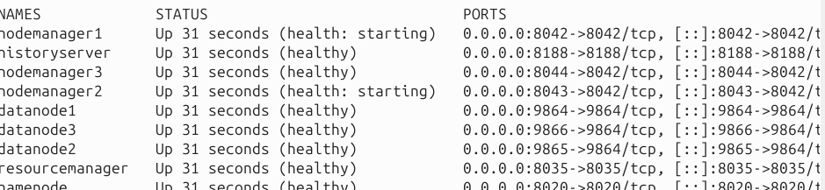

STEP 5: Copy Words File to NameNode
What this does: Copies your base words.txt file from the Ubuntu host into the namenode container's /tmp directory.

# Copy words.txt into the namenode container
docker cp words.txt namenode:/tmp/words.txt

# Verify the file was copied
docker exec namenode ls -lh /tmp/words.txt

echo "words.txt copied to namenode container"

STEP 6: Generate Large Dataset Files Inside NameNode
What this does: Creates four datasets inside the namenode container:
- set0: Original small file
- set1: 1 GB file (by repeatedly appending base file)
- set2: 1.5 GB file
- set3: 2 GB file
Note: This may take 5-15 minutes depending on your system. The script repeatedly concatenates the base file until reaching target sizes. You can ask gpt for a faster method.

# Execute all commands inside the namenode container
docker exec namenode bash -c '
# Create bigdata directory
mkdir -p /tmp/bigdata

# Copy base file
cp /tmp/words.txt /tmp/bigdata/words_base.txt
cd /tmp/bigdata

# Create set0 (original small file)
cp words_base.txt words_set0.txt

# Create set1 (1 GB)
echo "Creating 1 GB file (set1)..."
rm -f words_set1.txt
cp words_base.txt words_set1.txt
target1=$((1024*1024*1024))
while [ $(stat -c%s words_set1.txt) -lt $target1 ]; do
cat words_base.txt >> words_set1.txt
done

# Create set2 (1.5 GB)
echo "Creating 1.5 GB file (set2)..."
rm -f words_set2.txt
cp words_base.txt words_set2.txt
target2=$((1536*1024*1024))
while [ $(stat -c%s words_set2.txt) -lt $target2 ]; do
cat words_base.txt >> words_set2.txt
done

# Create set3 (2 GB)
echo "Creating 2 GB file (set3)..."
rm -f words_set3.txt
cp words_base.txt words_set3.txt
target3=$((2048*1024*1024))
while [ $(stat -c%s words_set3.txt) -lt $target3 ]; do
cat words_base.txt >> words_set3.txt
done

# Display file sizes
echo ""
echo "Generated files:"
ls -lh words_set*.txt
'

STEP 7: Upload Files to HDFS
What this does:
- Cleans up any old HDFS directories from previous lab runs
- Creates separate HDFS directories for each dataset
- Uploads all four dataset files to HDFS
- Displays the final HDFS directory structure

docker exec namenode bash -c '
# Remove any existing HDFS directories from previous runs
hdfs dfs -rm -r -f /user/inputdata 2>/dev/null || true
hdfs dfs -rm -r -f /user/output_wc_set0 2>/dev/null || true
hdfs dfs -rm -r -f /user/output_wc_set1 2>/dev/null || true
hdfs dfs -rm -r -f /user/output_wc_set2 2>/dev/null || true
hdfs dfs -rm -r -f /user/output_wc_set3 2>/dev/null || true

# Create HDFS directories for each dataset
hdfs dfs -mkdir -p /user/inputdata/set0
hdfs dfs -mkdir -p /user/inputdata/set1
hdfs dfs -mkdir -p /user/inputdata/set2
hdfs dfs -mkdir -p /user/inputdata/set3

echo "Uploading files to HDFS..."

# Upload files to HDFS (this may take time for large files)
hdfs dfs -put /tmp/bigdata/words_set0.txt /user/inputdata/set0/
echo "set0 uploaded"

hdfs dfs -put /tmp/bigdata/words_set1.txt /user/inputdata/set1/
echo "set1 uploaded"

hdfs dfs -put /tmp/bigdata/words_set2.txt /user/inputdata/set2/
echo "set2 uploaded"

hdfs dfs -put /tmp/bigdata/words_set3.txt /user/inputdata/set3/
echo "set3 uploaded"

echo ""
echo "HDFS directory structure:"
hdfs dfs -ls -R /user/inputdata
'
SCREENSHOT 1: Capture the output showing the HDFS directory listing with all uploaded files.

STEP 8: Locate Hadoop Examples JAR
What this does: Searches for the Hadoop MapReduce examples JAR file (which contains the WordCount program) and copies it to /tmp for easier access.

docker exec namenode bash -c '
echo "Searching for Hadoop MapReduce examples JAR..."
find /opt/hadoop* /usr/local/hadoop* -name "*examples*.jar" 2>/dev/null | head -5

# Copy the examples jar to /tmp for easy access
JAR_PATH=$(find /opt/hadoop* /usr/local/hadoop* -name "*examples*.jar" 2>/dev/null | grep -v sources | head -1)
if [ -n "$JAR_PATH" ]; then
cp "$JAR_PATH" /tmp/hadoop-examples.jar
echo ""
echo "Examples JAR copied to /tmp/hadoop-examples.jar"
ls -lh /tmp/hadoop-examples.jar
else
echo "Examples JAR not found. You may need to download it separately."
fi
'

STEP 9: Run WordCount on All Datasets
What this does:
- Runs the WordCount MapReduce job on all four datasets sequentially
- Measures and displays execution time for each job
- Removes previous output directories before each run
- Copies the final word count results to /tmp inside the container

docker exec namenode bash -c '
JAR=/tmp/hadoop-examples.jar
OUTPUT_BASE=/user/output_wc

# Function to run WordCount and measure time
run_wordcount() {
dataset=$1
echo "━━━━━━━━━━━━━━━━━━━━━━━━━━━━━━━━━━━━━━━━"
echo "Running WordCount on $dataset"
echo "━━━━━━━━━━━━━━━━━━━━━━━━━━━━━━━━━━━━━━━━"

# Remove old output
hdfs dfs -rm -r -f ${OUTPUT_BASE}_${dataset} 2>/dev/null || true

# Record start time
START=$(date +%s)

# Run WordCount
hadoop jar $JAR wordcount /user/inputdata/${dataset} ${OUTPUT_BASE}_${dataset}

# Record end time
END=$(date +%s)
DURATION=$((END - START))

echo ""
echo "$dataset completed in $DURATION seconds"
echo ""

# Copy output to local tmp
hdfs dfs -get ${OUTPUT_BASE}_${dataset}/part-r-00000 /tmp/part-r-00000_${dataset} 2>/dev/null || true
}

# Run WordCount on all datasets
run_wordcount "set0"
run_wordcount "set1"
run_wordcount "set2"
run_wordcount "set3"

echo "━━━━━━━━━━━━━━━━━━━━━━━━━━━━━━━━━━━━━━━━"
echo "All WordCount jobs completed!"
echo "━━━━━━━━━━━━━━━━━━━━━━━━━━━━━━━━━━━━━━━━"

# Show output files
ls -lh /tmp/part-r-00000_*
'

SCREENSHOT 2-5: Capture the completion message and execution time for each dataset (set0, set1, set2, set3).
- Expected times: set0 (~30 sec), set1 (~5-10 min), set2 (~10-15 min), set3 (~15-20 min) depending on your system.

STEP 10: Copy Results to Your Ubuntu Host
What this does: Copies all WordCount result files from the namenode container to your Ubuntu host machine, then displays a preview of the results.

# Copy all result files from namenode to current directory
docker cp namenode:/tmp/part-r-00000_set0 ./part-r-00000_set0
docker cp namenode:/tmp/part-r-00000_set1 ./part-r-00000_set1
docker cp namenode:/tmp/part-r-00000_set2 ./part-r-00000_set2
docker cp namenode:/tmp/part-r-00000_set3 ./part-r-00000_set3

# Display the results
echo "Result files copied to current directory:"
ls -lh part-r-00000_*

# Preview the word counts from largest dataset
echo ""
echo "Sample output from set3 (first 20 lines):"
head -20 part-r-00000_set3

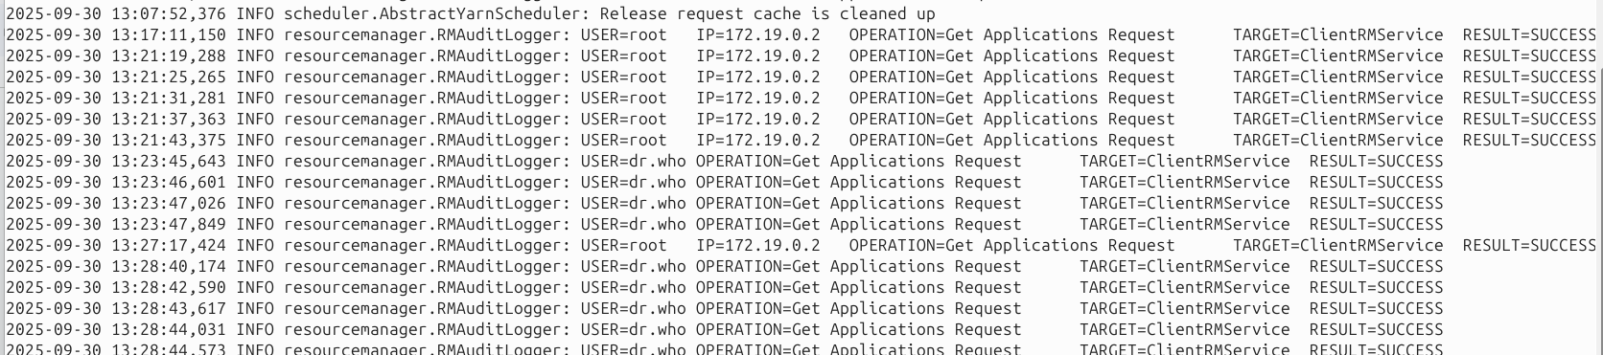
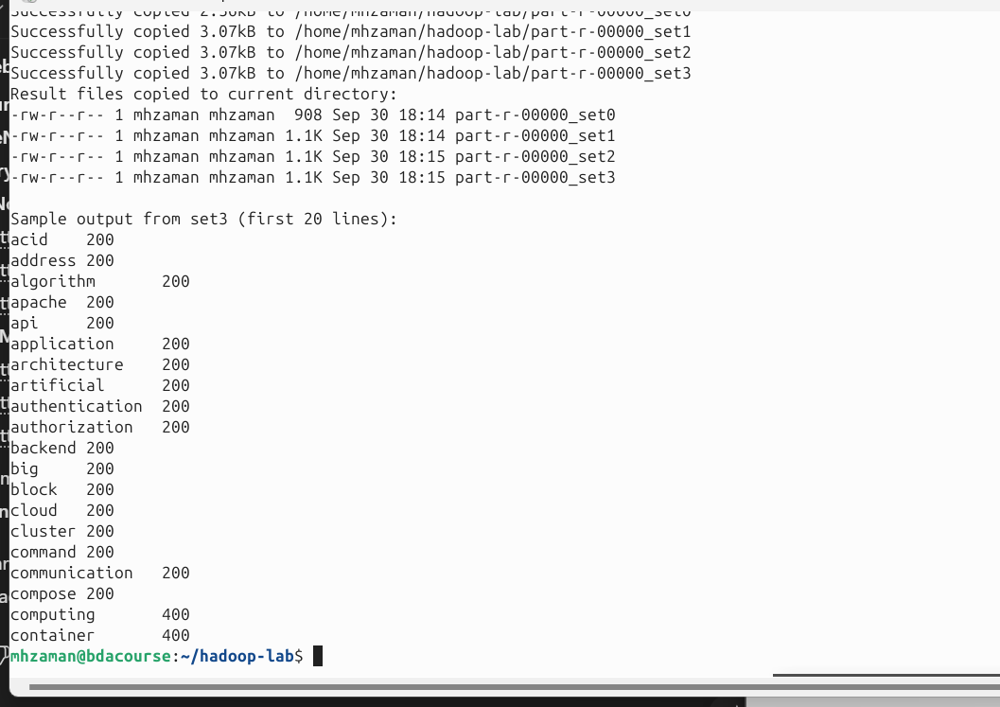
SCREENSHOT 6: Capture the sample output showing word counts.

STEP 11: Check HDFS Health and Metrics
What this does:
- hdfs dfs -du: Shows disk usage per directory in HDFS
- hdfs dfs -count: Displays file count, directory count, and total size
- hdfs dfsadmin -report: Shows DataNode status, capacity, and usage
- hdfs fsck: Performs filesystem check showing blocks and their locations

docker exec namenode bash -c '
echo "═══════════════════════════════════════════"
echo "HDFS DISK USAGE"
echo "═══════════════════════════════════════════"
hdfs dfs -du -h /user/inputdata

echo ""
echo "═══════════════════════════════════════════"
echo "HDFS FILE COUNT AND SIZE"
echo "═══════════════════════════════════════════"
hdfs dfs -count -h /user/inputdata

echo ""
echo "═══════════════════════════════════════════"
echo "HDFS CLUSTER REPORT"
echo "═══════════════════════════════════════════"
hdfs dfsadmin -report

echo ""
echo "═══════════════════════════════════════════"
echo "HDFS FILESYSTEM CHECK"
echo "═══════════════════════════════════════════"
hdfs fsck / -files -blocks -locations | head -50
'
SCREENSHOT 7: Capture the HDFS cluster report showing configured capacity and DFS usage.

STEP 12: Check YARN Applications
What this does: Lists all YARN applications (your WordCount jobs) with their IDs, states, and resource usage.

docker exec namenode bash -c '
echo "═══════════════════════════════════════════"
echo "YARN APPLICATIONS LIST"
echo "═══════════════════════════════════════════"
yarn application -list -appStates ALL

echo ""
echo "Tip: Copy an application_id from above and run:"
echo "docker exec namenode yarn application -status <application_id>"
'
SCREENSHOT 8: Paste it

STEP 13: Access Hadoop Web UI
Open these URLs in your browser (use localhost since you're on Ubuntu):
NameNode UI: http://localhost:9870
DataNode UI: http://localhost:9864
ResourceManager UI: http://localhost:8088
NodeManager UI: http://localhost:8042
History Server UI: http://localhost:8188

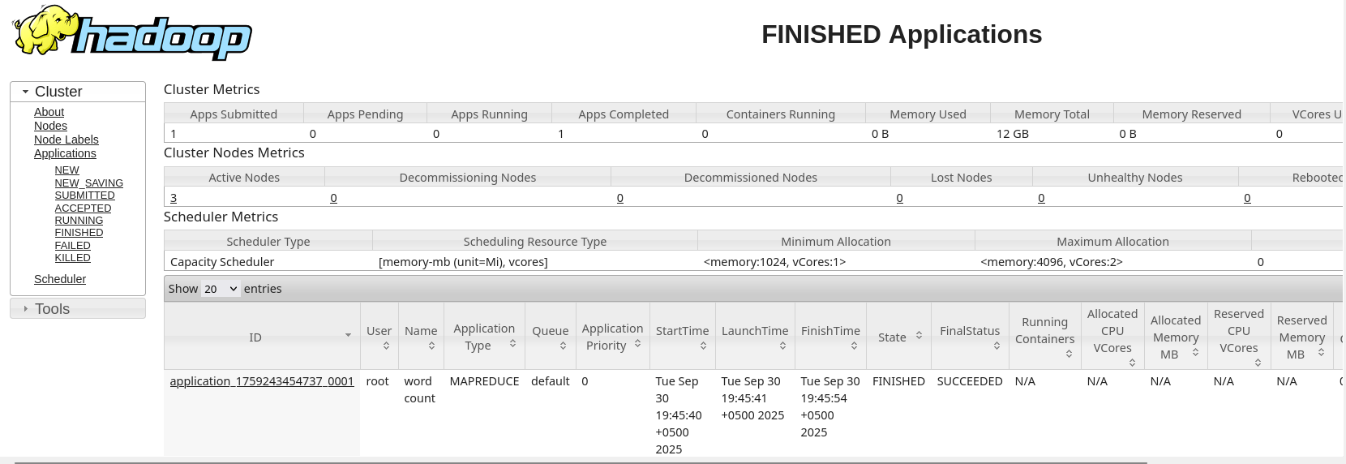

What to capture in each UI:
- NameNode UI (localhost:9870)
  - Overview page showing Configured Capacity, DFS Usage, Live DataNodes
  - Navigate to Datanodes tab to see all 3 datanodes
- ResourceManager UI (localhost:8088)
  - Click on "Applications" to see your 4 WordCount jobs
  - Click on any job to see detailed metrics
- History Server UI (localhost:8188)
  - Shows completed job history with detailed counters and timing
SCREENSHOT 9-13: Capture each of the 5 web UIs showing relevant metrics. Explain a bit.

STEP 14: Clean HDFS Snapshots and Advanced Commands
What this does:
- createSnapshot: Creates a point-in-time snapshot of the directory (for backup/recovery)
- setrep: Sets the replication factor (number of copies) for a file
- fsck: Checks filesystem health and block replication
- deleteSnapshot: Removes the snapshot

docker exec namenode bash -c '
echo "Creating HDFS snapshot..."
hdfs dfs -createSnapshot /user/inputdata snap_lab

echo "Listing snapshots:"
hdfs dfs -ls /user/inputdata/.snapshot

echo ""
echo "Setting replication factor for set3:"
hdfs dfs -setrep -w 3 /user/inputdata/set3/words_set3.txt

echo ""
echo "Checking block replication:"
hdfs fsck /user/inputdata/set3/words_set3.txt -files -blocks

echo ""
echo "Deleting snapshot:"
hdfs dfs -deleteSnapshot /user/inputdata snap_lab

echo "Advanced HDFS operations completed"
'
SCREENSHOT 14: Capture the snapshot operations and try to explain a bit

STEP 16: Stop and Cleanup (After completing the lab)
What this does: Gracefully stops all Hadoop services. Data is preserved unless you uncomment the rm command.

# Stop all containers
docker compose down

# Optional: Remove all data (if you want to completely reset)
# sudo rm -rf ./data

echo "Hadoop cluster stopped"
echo "Data directories preserved in ./data for restart"

Quick Reference Commands
# Restart the cluster
docker compose up -d

# Check container status
docker ps

# View container logs
docker logs namenode
docker logs resourcemanager

# Execute commands inside namenode
docker exec -it namenode bash

# Inside namenode, useful HDFS commands:
hdfs dfs -ls /
hdfs dfs -du -h /user
hdfs dfsadmin -report
yarn application -list

# Exit namenode shell
exit

Lab Report Checklist
Screenshots of:
- HDFS directory listing with uploaded files
- WordCount job completion for set0
- WordCount job completion for set1
- WordCount job completion for set2
- WordCount job completion for set3
- Sample word count output
- HDFS cluster report
- YARN applications list
- NameNode Web UI
- ResourceManager Web UI
- History Server Web UI
- DataNode metrics
- NodeManager metrics
- HDFS snapshot operation
To access the UI:
- for s in "NameNode:9870" "ResourceManager:8088" "HistoryServer:8188" "DataNode1:9864" "DataNode2:9865" "DataNode3:9866" "NodeManager1:8042" "NodeManager2:8043" "NodeManager3:8044"; do svc=${s%%:*}; port=${s##*:}; url="http://localhost:$port"; status=$(curl -s -o /dev/null -w "%{http_code}" $url); if [ "$status" = "200" ] || [ "$status" = "302" ]; then echo "$svc → $url → UP ($status)"; else echo "$svc → $url → DOWN ($status)"; fi; done

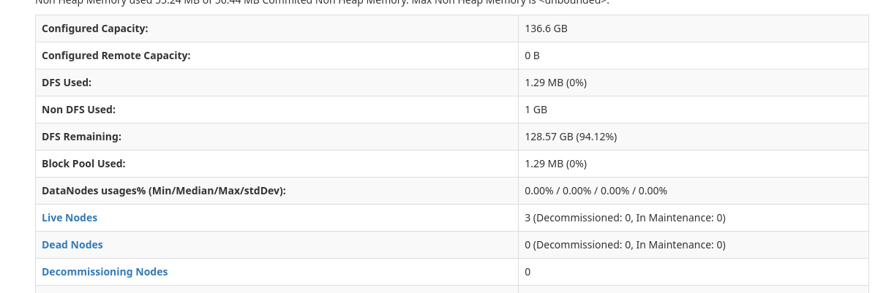

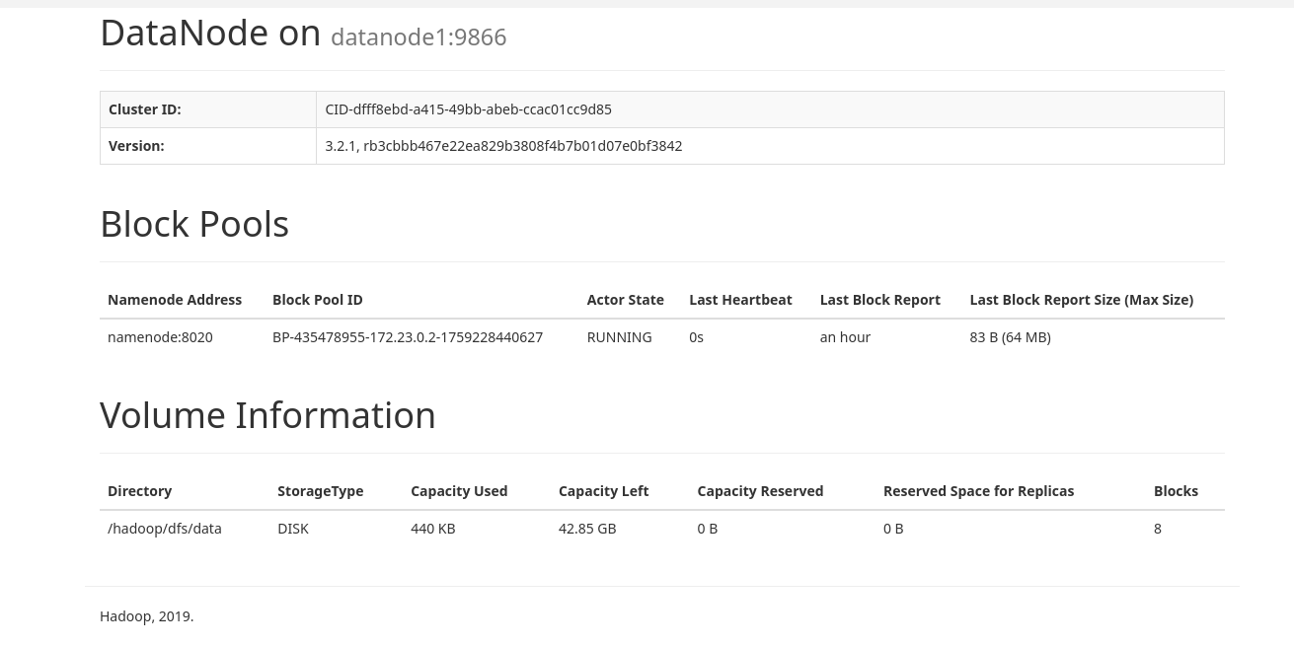
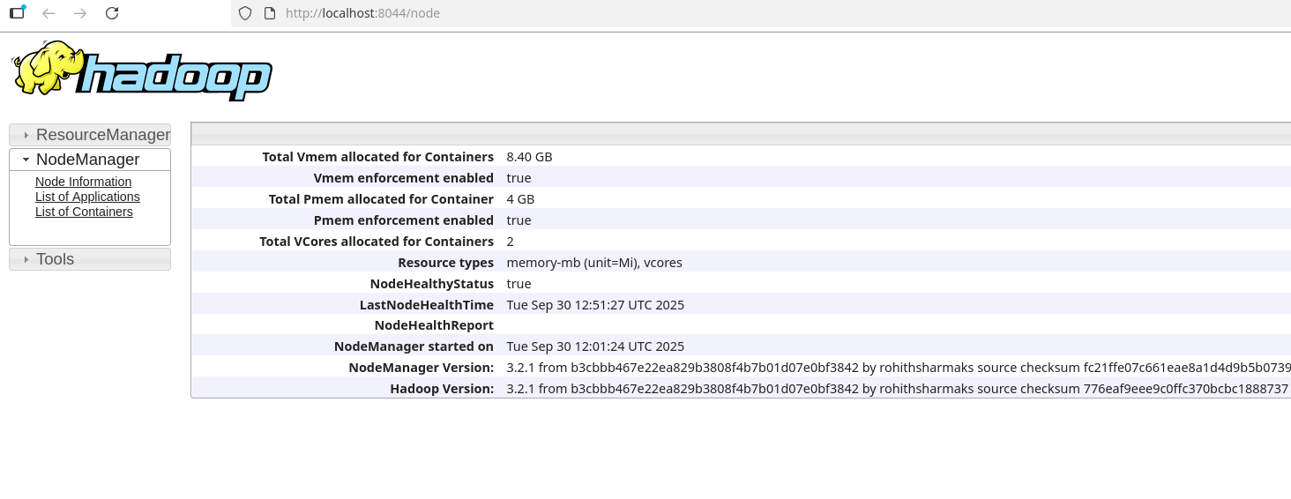

Final Checkpoint:

