Name: zuha aqib

Erp: 26106

Task: databases lab 7

Documentation:

So to display all the employees in frontend, we have this in employeesRoutes.js,

This means that we call the getAllEmployees function in employeeController. If we navigate to that, we have this:

Which gets all the employees. This also uses a function of listAllEmployees() which is in employeeModel.js,

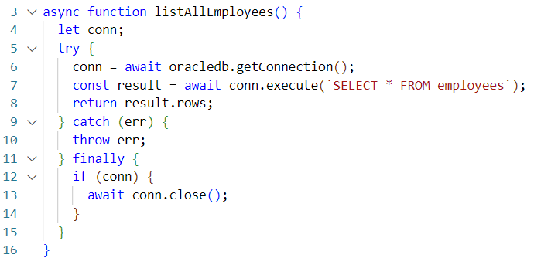

My first task is to add a similar function of getAllEmployees() in employeesController.js in backend to getAllDepartments() in departmentsController.js in backend.

Now my second task is to call this function in departmentRoutes.js,

Line 7 was added

Now my third task is to edit and add a function of listAllDepartments() in departmentModel.js,

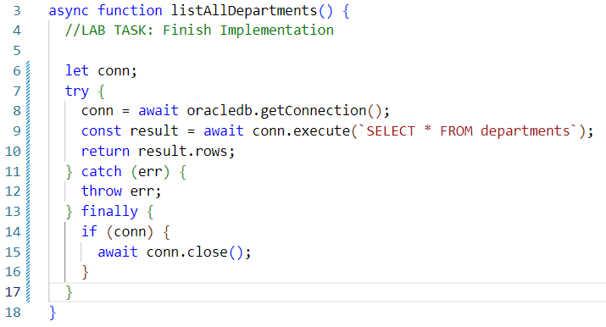

Done.

Now that backend is done, lets move to frontend. In frontend/src/components/Dashboard/employees.js, we had this code,

we added this code to call the API to get and display the employees,

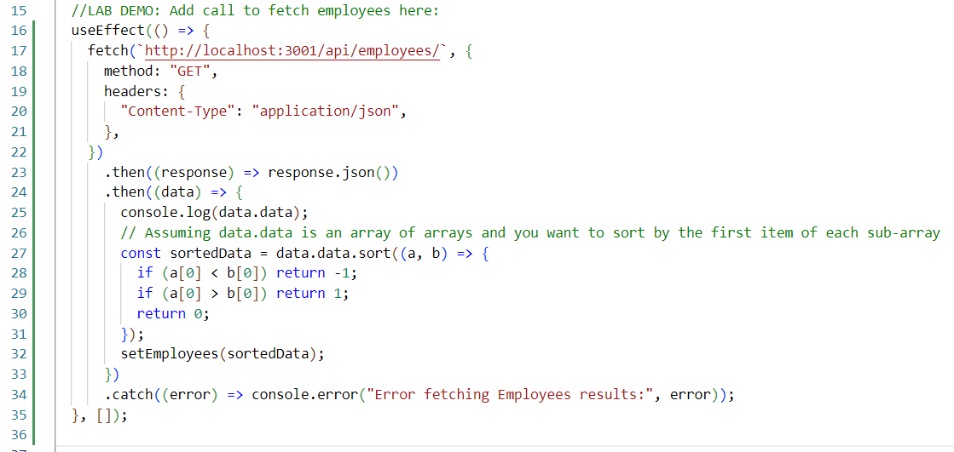

So we will do the same in departments.js, we have this existing code,

And we have to add the useEffect() function,

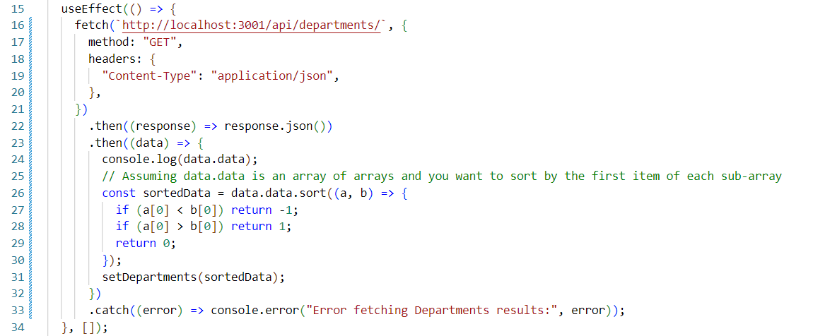

But it is not displaying on the screen,

So we will open PostMan app and see if listAllDepartments() works there,

And we found this error, that,

And ours is,



So we have to remove the ‘s’ from departments,



But still it did not work.

So now we will try and run postman,

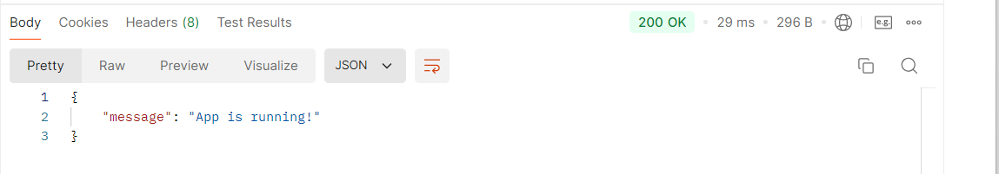

So I think we should save all these files and then run. So lets press Ctrl+C, stop running backend and frontend,

And then re-run by doing “npm run start” in backend folder and “npm start” in frontend folder and reload it,

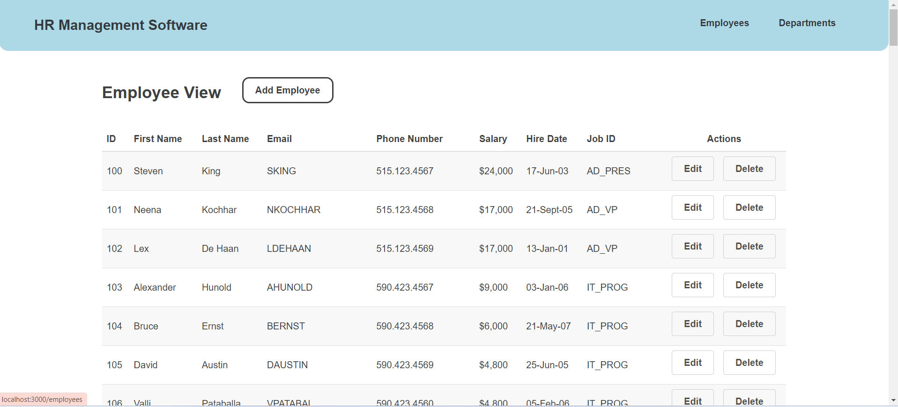

And then we click departments,

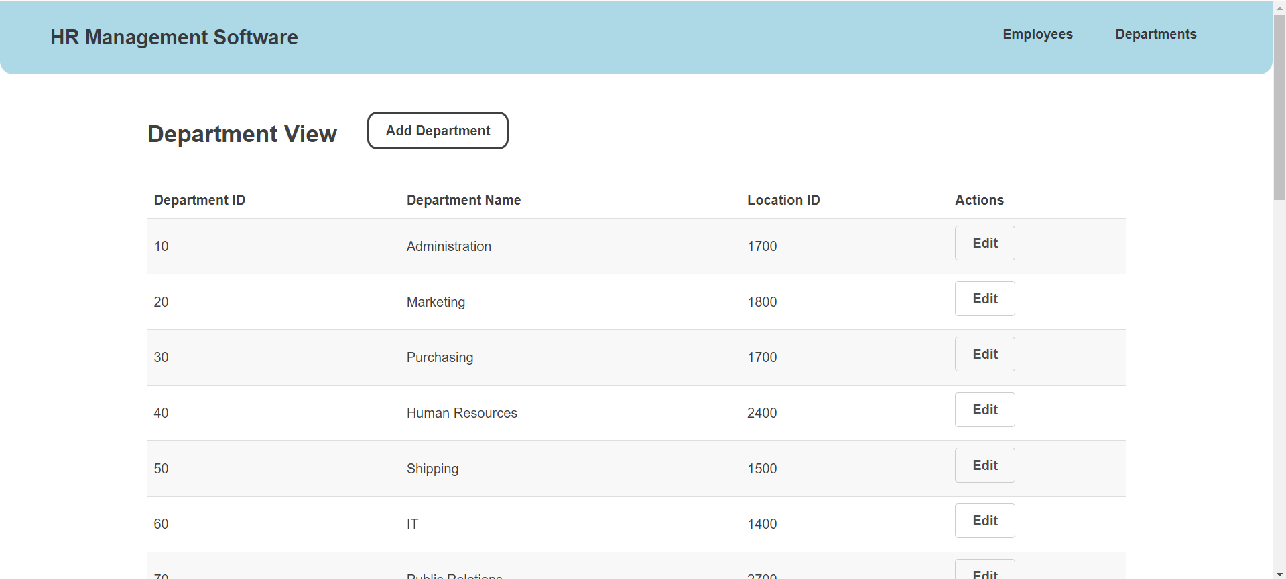

And it worked! Alhamdullilah.

Lets run it in postman:

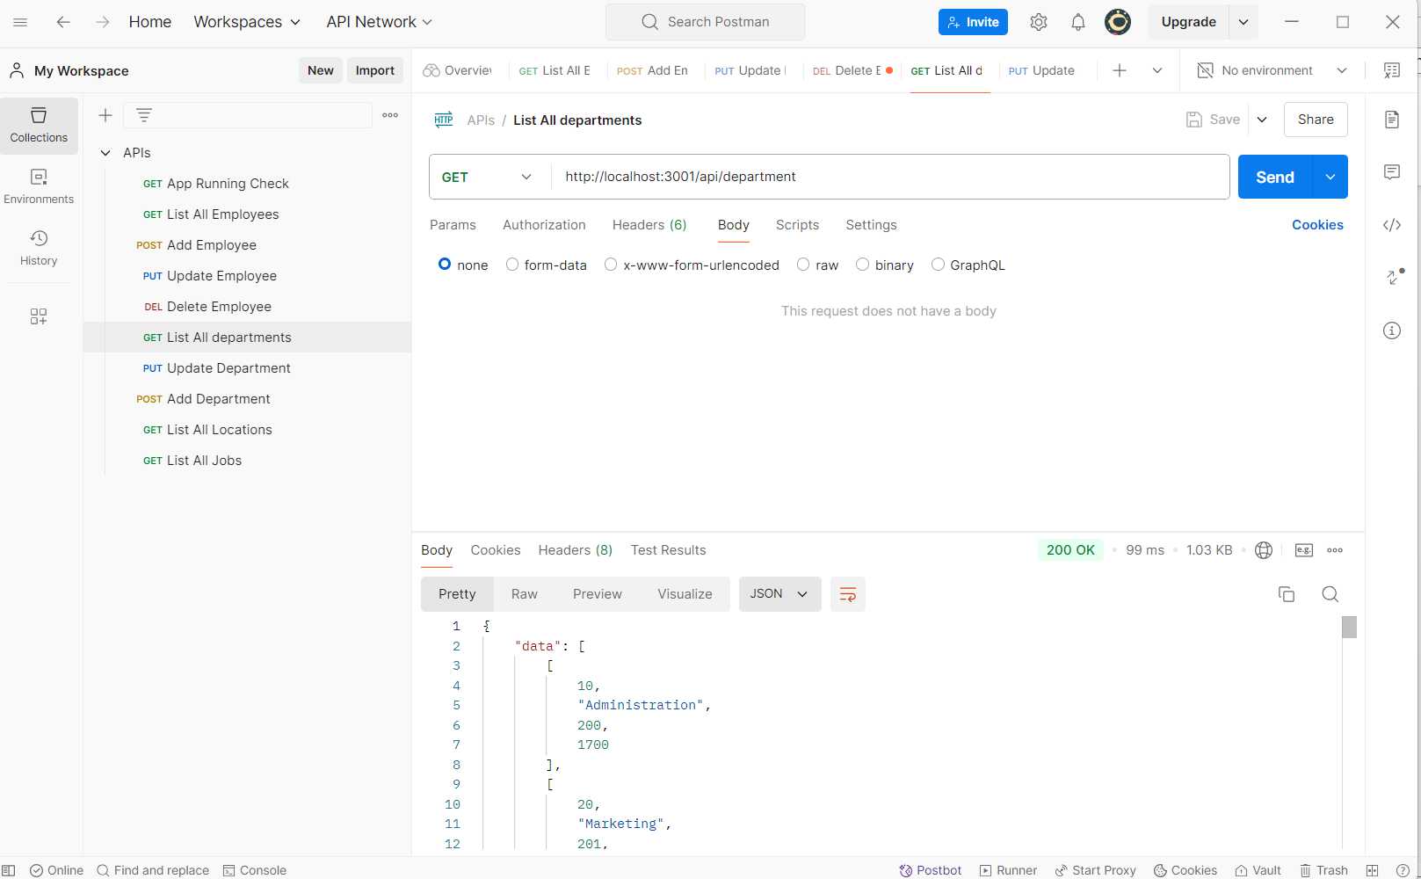

It worked!