ZUHA AQIB 26106

Part 1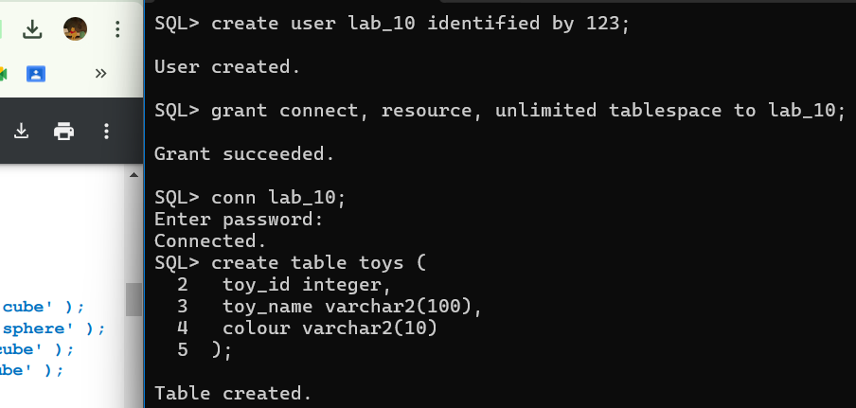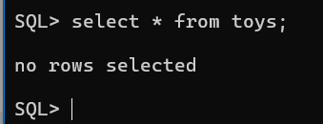

Even after inserting in toys and bricks in the session 01, we cannot retrieve them in session 02 as they are not committed.

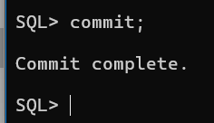

Yes, I can see them now, after committing

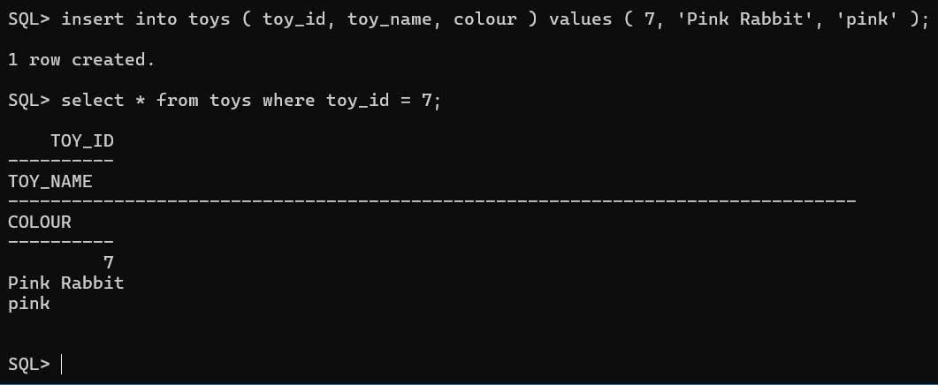

Hence the toyid=7 is removed successfully

# Part 3

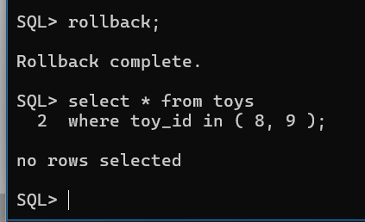

# Part 4:

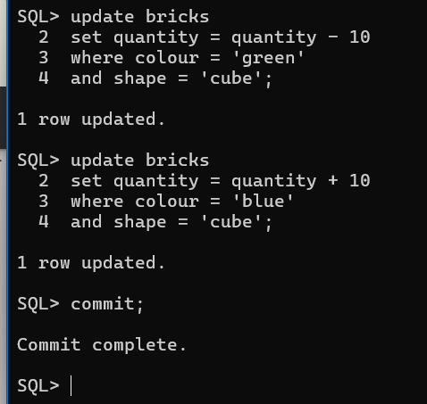

# Part 5:

It is hanged

Deadlocked! Foran session 01 came back

# Part 6:

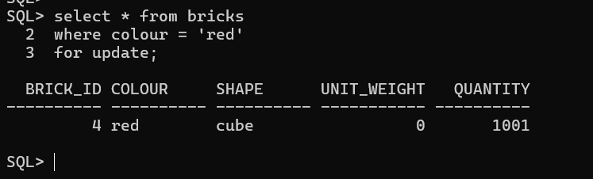

Now running this in session 02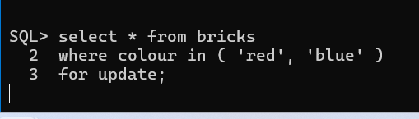

so both are locked.

We closed both sessions and reopened command prompt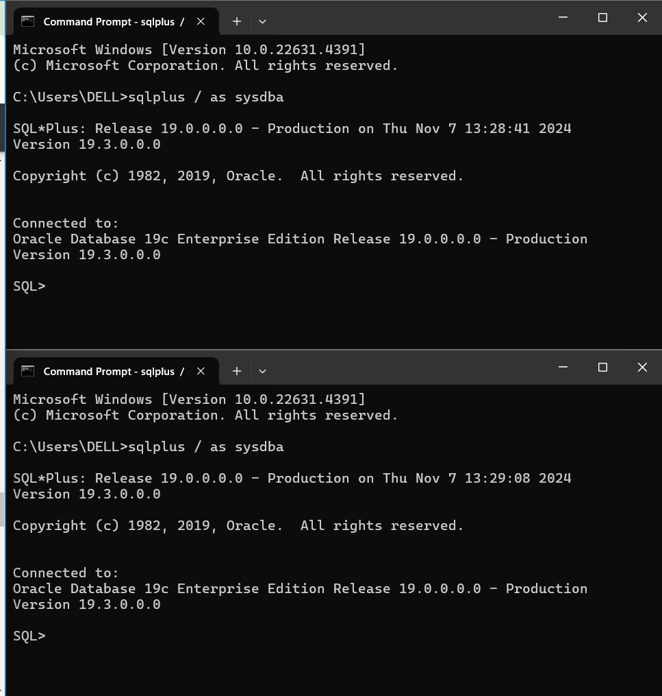

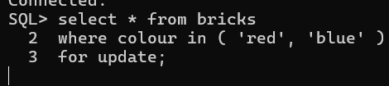

Session 02 is now in deadlock

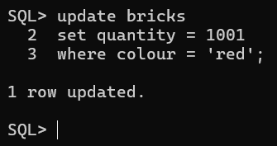

Done in both sessions

Part 7:

# Part 8:

We do require a commit in session 02 as we have to complete the changes we made

DONE