ZUHA AQIB 26106

1. 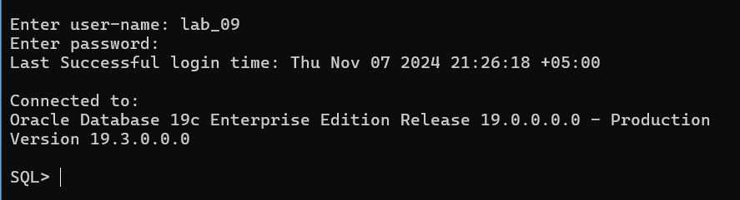
2. 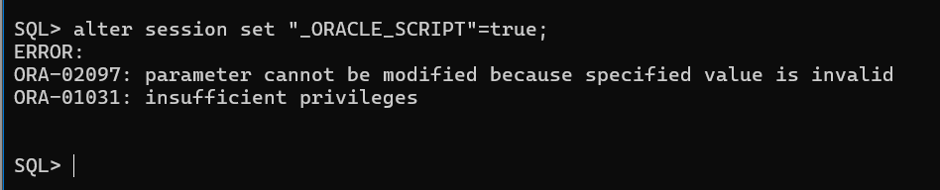
   1. 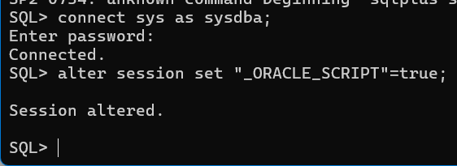
3. A computer screen with white text

   Description automatically generated
   1. 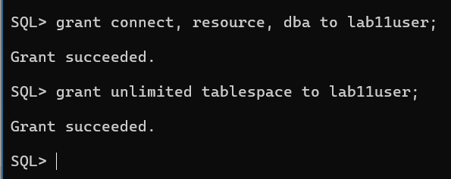
4. A black screen with white text

   Description automatically generated
5. A black screen with white text

   Description automatically generated
6. 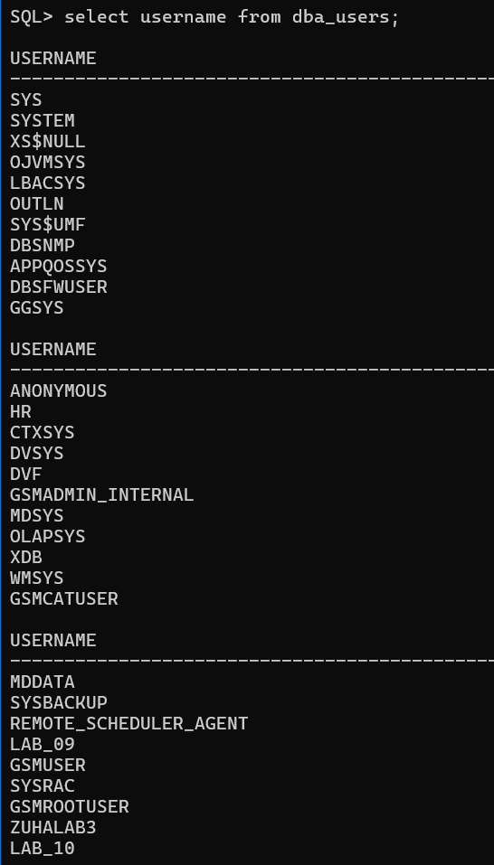
   1. A screenshot of a computer program

      Description automatically generated
7. A screen shot of a computer screen

   Description automatically generated
   1. Before we were connected to sys user (computer) and now we have connected to lab11user. We can verify this from
   2. A screen shot of a black screen

      Description automatically generated
   3. and hence confirmed, the lab11user is now connected
   4. UPDATE: it shouldn’t have done as it should give error as according to document we had not give it privilege to create session. So I had mistakenly given privilege before.
8. 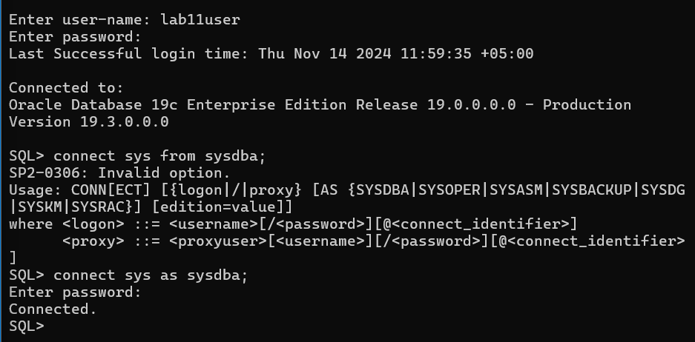
   1. Conn sysdba wasn’t working it was saying logon denied as incorrect password but when same password was entered after exit; and reopen, it worked
9. 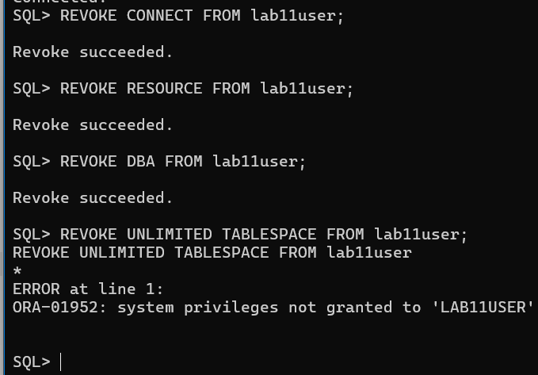
   1. All privelegs accidentally given were revoked
   2. We will now resume from the commands given
   3. A black screen with white text

      Description automatically generated
10. A black screen with white text

    Description automatically generated
11. A black screen with white text

    Description automatically generated
12. A black background with white text

    Description automatically generated
13. 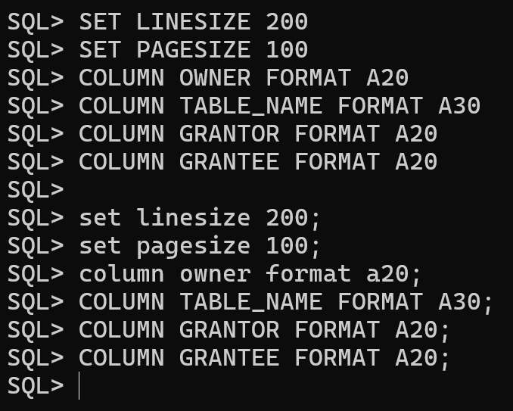
14. 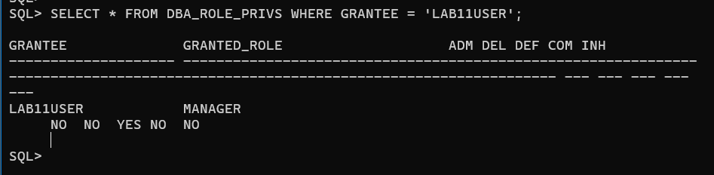
15. 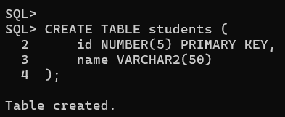
16. A screenshot of a computer program

    Description automatically generatedA black screen with white text

    Description automatically generated
17. A black screen with white text

    Description automatically generated
18. 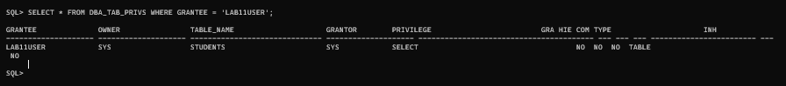
19. 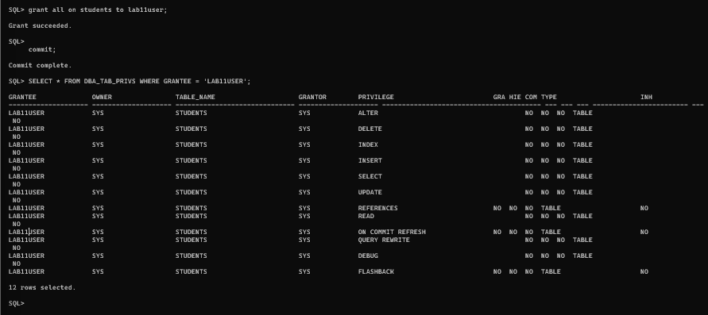
20. A screenshot of a computer screen

    Description automatically generated
21. 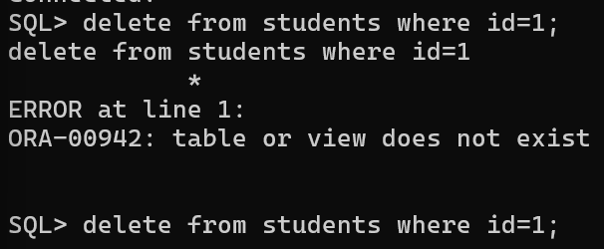A screen shot of a computer

    Description automatically generated
    1. I still cannot delete even with sys.students as I (lab11user) does not have enough privilege to delete a row
22. Now we will close sqlplus and shift to sqldeveloper