1. 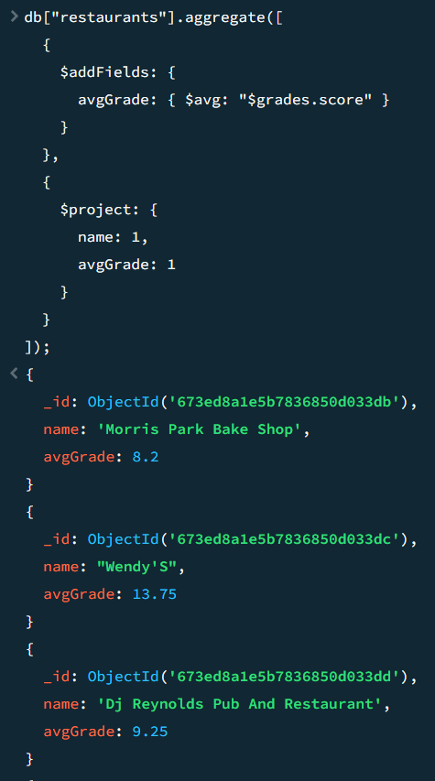
2. 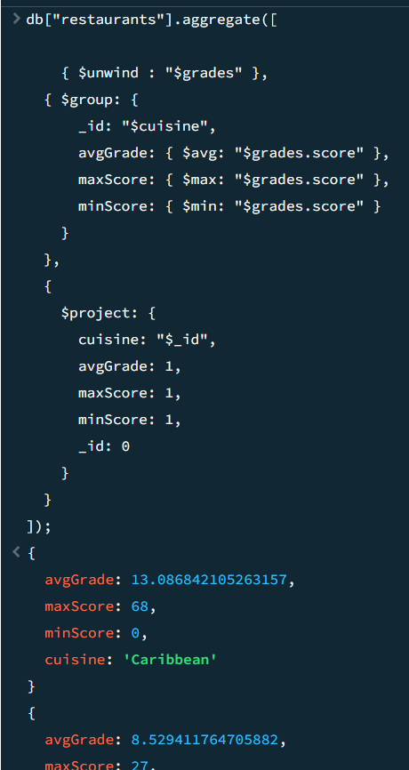
3. A computer screen shot of a program code

   Description automatically generated
4. A screen shot of a computer program

   Description automatically generated
5. A screen shot of a computer program

   Description automatically generated
6. 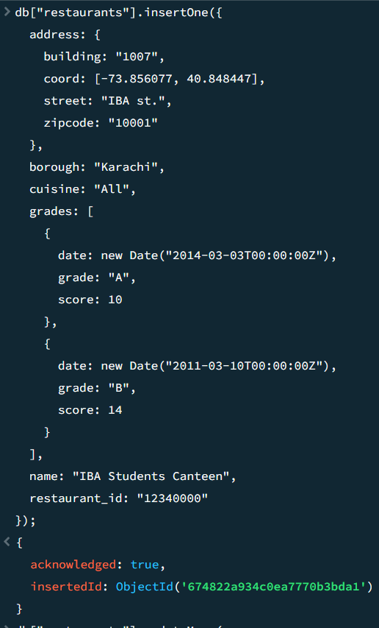
7. A screen shot of a computer code

   Description automatically generated
8. A computer screen shot of a computer code

   Description automatically generated
9. 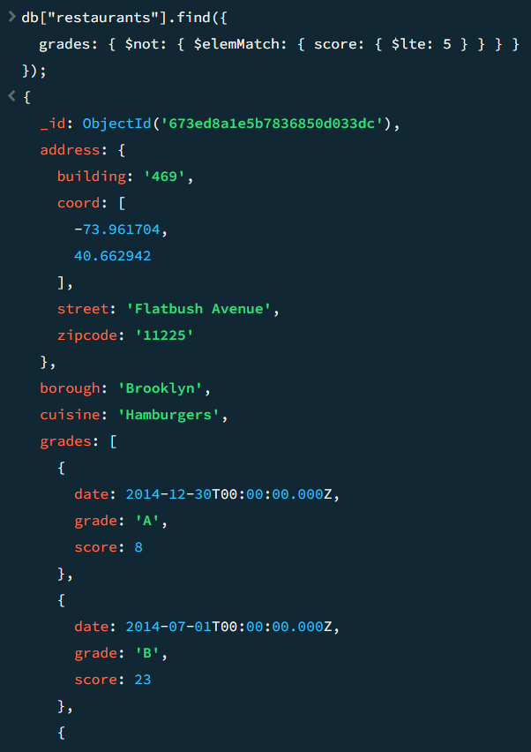
10. 1. 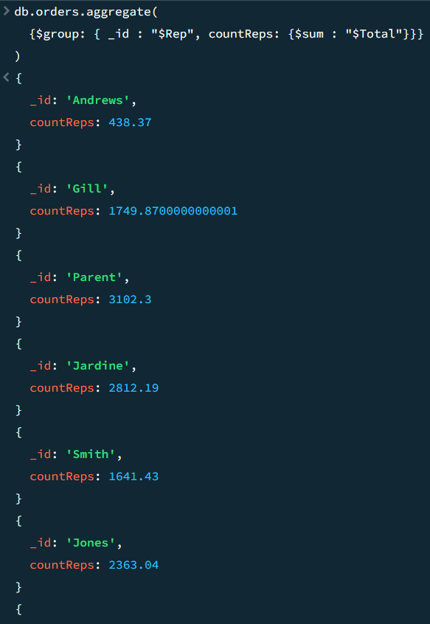
    2. 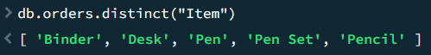
    3. A screen shot of a computer program

       Description automatically generated
    4. A screen shot of a computer

       Description automatically generated
    5. A screen shot of a computer program

       Description automatically generated
    6. A screenshot of a computer program

       Description automatically generated

Scenario

