ERP No: __________________________ Name:________________________________

Human Computer Interaction
CSE 407 Practice Exam Fall-2024
October 02, 2024
Max Marks: 20
Duration: 2 hours
Notes:
1. Attempt all questions. The paper comprises 5 questions.
2. You are suggested to try to attempt the questions in the given sequential order of the paper.

Q1) Figure1 is a dialogue box of google map. Your task is to explain how one of the direct manipulation principles “Rapid reversible actions with immediate feedback” is applied. (2 marks).

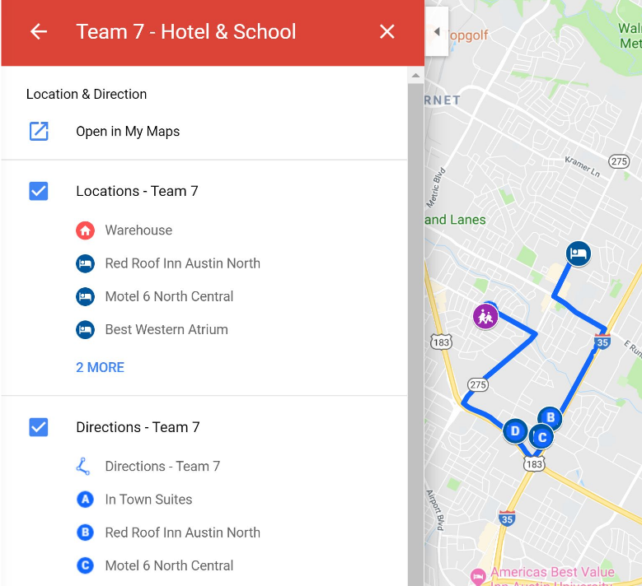
Figure 1: Dialogue Box for Q1 (google map)

Q2) Figure 2 is a dialogue box of an application that prints predefined ‘award certificates. Currently, the user can select a template from a list, and then is allowed to edit the text of the certificate only. For the new version, the company wants more options in this program. You have been hired as a design expert and tasked to redesign the interface with following options in the interface:

Select a picture for the logo to be printed on the certificate.

Select the logo location on the certificate.

Edit heading and subheading.

Enter Signature Space and edit the names of signatories. Two signatures can be added.

Your task is to sketch a prototype showing the screen designs, process flow and information flow. You can design more than one screen to best fit the options but must ensure proper navigation between the screens that you want to suggest. (6 marks)

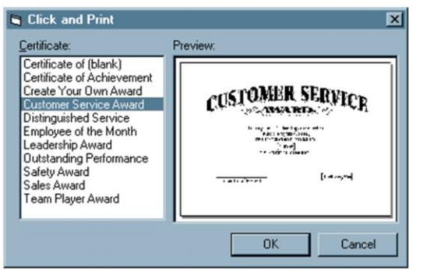
Figure 2: Original Dialogue box for Q2 (Certificate Printing)

Q3) Figure 3 is one of the screenshots of the WhatsApp. The design is centered and secure messaging. One of the issues that have been highlighted in this screen is the non-compliance with the golden ratio rule. Design a screen with the same options to ensure compliance with the golden ratio rule. Why did WhatsApp not prioritize design ratio? (4 marks)

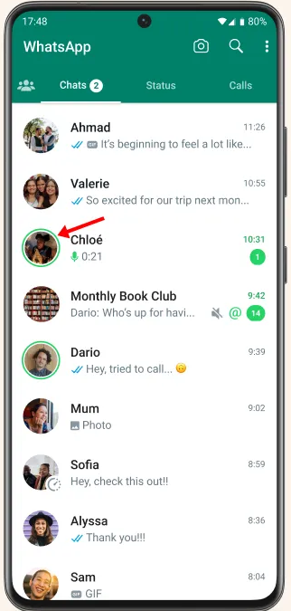

Figure 3: Dialogue box for Q3 (WhatsApp app)

Q4) The following figure is of Duolingo app where you can learn 40+ languages through quick, bite-sized lessons. The app provides learning lessons with clear instructions and several exercises. App also provides a chatbot for engaging the users, and a gamification element for learning through practice and challenge. Consider the given figure and map the four interaction types ‘Instructing’, ‘Conversing’, ‘Manipulating’, and ‘Exploring’ with a use case for each interacting mode. (4 marks)
‘
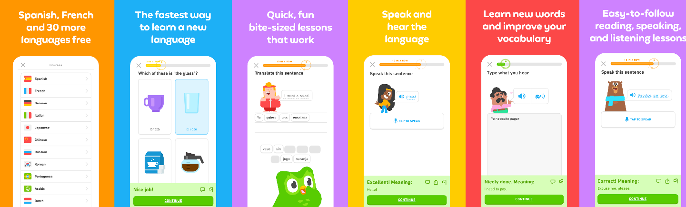

Figure 4: Dialogue box for Q4 (WhatsApp app)

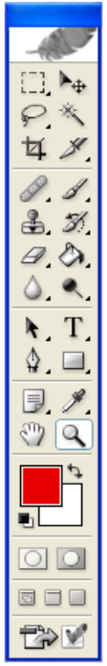

Q5)

The window shown to the left is the movable tool palette for selecting drawing tools in Adobe Photoshop. The user selects a tool by clicking on one of the icons in the palette. Assume the user is running Photoshop on a standard desktop machine using a mouse.
The Fitts’s formula for Movement Time (MT), is.
MT = a + b log2 (D/S + 1)
For each of the variables (a, b, D, and S), describe what it measures, and suggest how to redesign tool selection in Photoshop to decrease MT based on a change to that variable. (4 marks)

Figure 5: Dialogue box for Q5 (WhatsApp app)

