Process Reengineering using Data Analytics

Starbucks Coffee Serving Setup
Mahnoor Adeel | Maham Junaid | Maryam Ihsan
Zuha Aqib | Shaheer Shaikh | Anas
Instructor: Dr AbdulBasad Shaikh
Date: 6/10/2025

Table of Contents
Table of Contents 2
Objective 3
Executive Summary 4
Introduction 5
Current Process Analysis (As-Is) 6
Process Flow 6
Observations 6
Current KPIs 7
KPI Reframing 8
Technology Impact Analysis 9
Proposed Reengineered Process (To-Be) 10
Managerial Recommendations 11
Conclusion 12
References 13

Objective
The objective of this project is to reengineer Starbucks’ coffee-serving process to minimize human resource dependency and overall operational costs while using the least amount of new technology possible. The goal is not to automate the entire workflow but to selectively integrate lightweight, cost-effective digital tools that streamline key bottlenecks, primarily at the cashier and order management stages. By enabling digital ordering, automated payments, and real-time inventory updates through existing infrastructure, this project demonstrates how process efficiency and cost savings can be achieved with minimal technological investment and without compromising service quality.

Executive Summary
This report presents a comprehensive reengineering of Starbucks’ coffee-serving process using data analytics and targeted, low-cost technology to improve efficiency, reduce operational costs, and minimize human resource dependency with minimal technological investment.
The As-Is process currently relies on three major roles: customer, cashier, and barista, with high human dependency and manual data entry. Observations revealed that customers spend approximately 12–15 minutes from entry to exit, with the longest delays occurring during order taking and payment due to queue buildup and manual POS operations. Inventory management is also largely manual, leading to delays in stock updates and inefficiencies during peak hours.
To address these challenges, the To-Be process eliminates the cashier’s role by introducing a simple digital ordering and payment system through the Starbucks app, connected in real time to the barista’s workstation and the inventory system. Orders are placed, customized, and paid for digitally, enabling baristas to begin preparation immediately upon receipt. The redesigned workflow leverages only essential automation and real-time data synchronization, avoiding expensive machinery or complex technologies, to streamline operations and shorten total service time to approximately 6-7 minutes per customer.
By implementing this minimal-tech, cost-efficient digital model, Starbucks can operate with fewer staff members while maintaining quality and consistency. The reengineered process enhances customer satisfaction through reduced waiting times and supports the company’s long-term goals of cost efficiency, scalability, and sustainable workforce reduction without heavy technological dependence.

Introduction
The coffee-serving process at a retail chain like Starbucks involves multiple steps like order taking, preparation, quality checks, and delivery, all of which influence customer satisfaction and overall store performance. In such a fast-paced environment, even minor delays can accumulate into significant inefficiencies across thousands of transactions each day.
This report analyzes the coffee-serving process at Starbucks through the lens of data analytics and process optimization, focusing on identifying bottlenecks, reducing redundancies, and leveraging technology to create a seamless, efficient workflow. Optimizing these operations enhances customer satisfaction, improves staff productivity, and reduces operational costs while maintaining consistent product quality and service standards.
The primary goal of this reengineering initiative is to minimize staff requirements and operational costs through the strategic use of technology and data-driven decision-making. By integrating automation, predictive analytics, and workflow optimization tools, Starbucks can achieve a faster, leaner, and more sustainable coffee-serving process without compromising the customer experience.

Current Process Analysis (As-Is)
The current coffee-serving process at Starbucks involves three key roles — the customer, cashier, and barista — supported by a manual inventory system. The process begins when the customer enters the store and joins the queue. During busy hours, this waiting period can extend several minutes before they reach the counter. Once at the register, the cashier greets the customer, takes the order verbally, and enters it into the Point-of-Sale (POS) system. The cashier confirms any customizations (such as size, milk type, or flavor) to ensure accuracy before proceeding to payment.
After processing the payment through cash, card, or a mobile app, the order details are sent to the ba\rista, either verbally or automatically through the POS display. The barista then begins preparing the drink, often while completing previous orders. This involves brewing coffee, steaming milk, mixing ingredients, and final assembly. Once the beverage is ready, it is placed at the pickup counter for the customer. The customer waits nearby until their name or order is called, collects the drink, and exits the store.

Process Flow
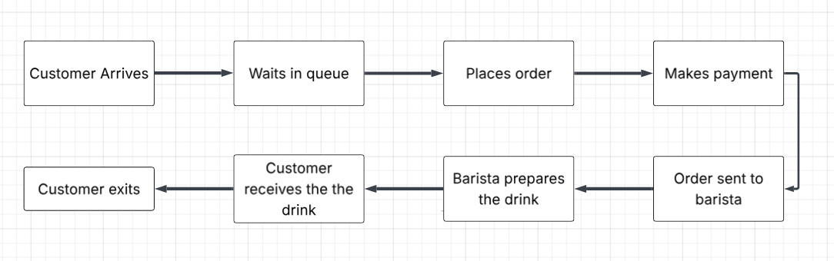

Observations
Observation | Details / Insights
Average total service time | Approximately 12–15 minutes per customer from entry to exit; may increase during peak hours.
Average waiting time | Around 5–7 minutes before reaching the cashier to place an order; longer queues observed during rush periods.
Longest delays | Occur mainly during queueing and drink preparation stages, especially when multiple customized orders are placed.
Manual data entry | Slows communication between cashier and barista; also causes delays in inventory updates due to lack of automation.
Staff dependency | Workflow relies heavily on staff coordination, leading to inconsistencies and slower throughput during busy hours.

Current KPIs
- Average waiting time per customer
- Total transaction time
- Number of staff on duty per shift
- Average queue length during peak hours

KPI Reframing
To align with the reengineering goal of reducing staff requirements and operational costs through technology, the focus shifts toward KPIs that capture efficiency, automation, and resource optimization. These metrics provide clearer insight into how technology-driven improvements impact both productivity and cost.
New KPI | Purpose / Relevance
Customer turnover rate | Measures the number of customers served per hour — higher values indicate better process flow and reduced bottlenecks.
Staff utilization rate | Evaluates how effectively employees’ active time is used, helping minimize idle time and optimize staffing levels.
Automation efficiency index | Tracks the proportion of automated tasks, reflecting progress toward reduced manual effort and operational costs.
Cost per transaction | Assesses overall cost-effectiveness by combining labor, equipment, and process expenses per order.
These KPIs support Starbucks’ goal of reducing staff requirements and operational costs through the smart use of technology.

Technology Impact Analysis
The redesigned process integrates digital ordering, automatic payment, and real-time inventory updates.
Technology | Impact on Process | KPIs Improved | Challenges / Costs
Digital Ordering App | Allows customers to order and pay remotely, reducing cashier dependency. | Waiting time, total process time | Development & maintenance costs
Automated Payment Gateway | Processes transactions instantly, eliminating manual handling. | Staff efficiency | Transaction fees, security compliance
Smart Inventory Sync | Automatically updates stock levels when ingredients are used. | Inventory turnover | Integration cost with POS system
Data Analytics Dashboard | Monitors peak hours, customer flow, and resource usage. | Efficiency, staff utilization | Training for managers
AI Demand Prediction | Predicts sales and adjusts staffing/inventory levels dynamically. | Cost efficiency, planning | Requires data collection maturity

Justification for Minimal Technology Integration
The reengineering approach deliberately prioritizes a low-cost digital app over hardware-heavy alternatives such as self-service kiosks. This decision aligns with the project’s objective of minimizing HR requirements using the least possible technological investment.
Kiosks, while effective in reducing cashier workload, involve significant upfront and maintenance costs, including physical installation, space allocation, and periodic servicing. In contrast, a mobile app leverages customers’ existing devices, requiring no additional hardware, store modifications, or long-term servicing expenses.
By using a digital app for ordering and payment, Starbucks can eliminate the cashier role, automate order transmission to the barista’s system, and maintain real-time inventory updates, all with minimal operational disruption and far lower capital cost. This approach achieves the same HR and efficiency benefits as a kiosk-based system but with greater scalability, lower overhead, and faster implementation.
Thus, the proposed digital app solution represents a leaner and more sustainable alternative, effectively balancing process automation with cost control — fulfilling the core reengineering goal of reducing human dependency with minimal technology adoption.

Proposed Reengineered Process (To-Be)

This chart shows the complete process of a mobile drink order from app to pickup. The customer browses the live menu, customizes the drink, reviews, and pays through the app. Once payment is made, the system confirms the order, sends details to the barista, and updates inventory in real time. The barista prepares the drink, places it at the pickup counter, and the customer collects it. Throughout, the system tracks ingredient usage and auto-adjusts reorder levels, ensuring a smooth and efficient order flow.

Process Flow Diagram
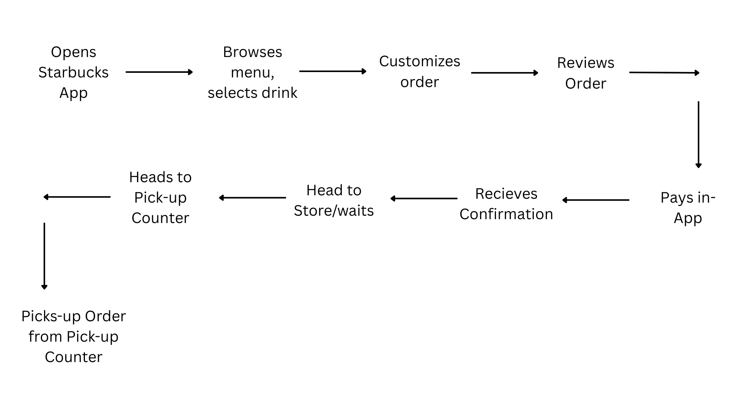

Managerial Recommendations:

To ensure the successful implementation of the reengineered process and achieve measurable cost and efficiency gains, several managerial actions are recommended.
- Adopt Digital Pre-Ordering and Payment Systems
Starbucks should expand the use of mobile applications for pre-ordering and digital payment. This initiative will reduce the dependency on front-line cashiers, minimize waiting lines, and enhance overall customer convenience. By shifting transactions to the app, the store can operate with fewer staff members while maintaining service quality.
- Integrate Real-Time Inventory Tracking Across Branches
A centralized, real-time inventory management system should be introduced to provide accurate visibility of stock levels across all outlets. This system will enable timely replenishment, reduce wastage, and optimize supply chain efficiency through data-driven decision-making.
- Utilize Predictive Analytics for Demand Forecasting and Staffing Optimization
Implementing analytics tools that predict customer demand based on historical sales patterns, time of day, and seasonal trends can support proactive planning. This approach ensures the right staffing levels and ingredient availability, reducing idle labor and overstocking costs.
- Pilot Semi-Automated Stores with Self-Pickup Counters
Starbucks can pilot semi-automated store formats where customers place orders via the app and collect their beverages from designated self-pickup counters. This model minimizes human supervision requirements and demonstrates scalability for high-traffic locations.
Quick Wins: Implement mobile app ordering, push notifications for order readiness, and digital queue visualization to deliver immediate customer experience improvements with minimal cost.
Long-Term Goals: Gradually invest in advanced automation technologies such as AI-driven demand forecasting and robotic beverage assembly to achieve sustained efficiency, consistency, and cost optimization across operations.

Conclusion
The reengineering of Starbucks’ coffee-serving process through digital integration signifies a major step toward operational excellence and cost efficiency. The redesigned TO-BE model leverages mobile technology, real-time data synchronization, and process automation to significantly reduce service time, labor dependency, and overall operational costs.
By eliminating redundant human roles, streamlining order flow, and integrating data-driven decision-making, Starbucks can enhance both the customer and employee experience. Customers benefit from faster service and convenience, while management gains improved visibility into operations, inventory, and demand patterns.
This technology-driven approach positions Starbucks to sustain its premium brand image with leaner staffing, optimized workflows, and higher profitability — demonstrating how process reengineering, when guided by data analytics, can achieve long-term competitive advantage in a service-oriented business.

References
Starbucks Coffee Serving Process (As-Is Process Image). (n.d.). Retrieved October 5, 2025, from https://sl.bing.net/eFPEqrezYui

