ZUHA AQIB 26106

KISA FATIMA

**ACTIVITY TODAY:**

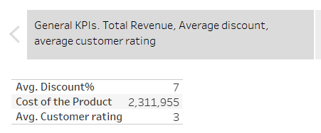

Started with analysing overall KPIs such as the total revenue and the average discount of 7%, and the average customer rating of 3/5

Then analysed the shipment mode and saw that ship mode has the highest amount of reaching on time, road was least.

Then analysed the product importance with shipment mode, and saw that shipment mode of Ship was used for low and medium priority products.

Then saw that the majority products of ours was LOW and medium.

Then saw that we offer the highest discount on low products but this was SUM so we then decided to go for %

Here we saw the percentage of cost of product and saw that the lower the cost of the product, the higher the discount, the more the expensive product, the lower the discount

Then we analysed what type of customers we have, majority of them have already purchased from us twice or thrice

And then finally we wanted to see which warehouse block was the best and saw that all of them were majority same of 2.

**Assignment 1 drill down**

  
