Design Analysis and Algorithm (DAA) Support RAG-based Question Answering System
Course: Introduction to Text Analytics– Spring 2025
Submitted By:
- Hamna Inam Abro -27113,
- Zuha Aqib- 26106,
- Zara Masood- 26928
Submission Date: 20th April 2025

Table of Contents
Table of Contents 2
1. Platform Details 3
2. Data Details 4
3. Algorithms, Models, and Retrieval Methods 5
Experimental Setup 5
Retrieval Methods Employed 5
LLMs and Embedding Models 5
Chunking Strategy Analysis 6
Impact of Chunking Strategy on Relevancy Score 6
4. Performance Metrics 8
Relevancy Score 9
Relevancy Score by Retrieval Type and Top-K 10
For rag_grid_2.csv and rag_grid_3.csv we observed, 11
Latency and System Efficiency Metrics 14
Impact of Retrieval type on Total time 14
5. Best Model Selection 16
6. Reproducibility 17
7. Summary of Code 19
1. Imports and Setup 19
2. Constants Definition 19
3. Document Processing Functions 19
4. Vector Store and Indexing 19
5. Retrieval Methods 19
6. Language Model Initialization 19
7. Prompt and Response Generation 19
8. Evaluation and Wrappers 20
9. Core RAGPipeline Class 20
10. Execution & Usage 20

1. Platform Details
The development and experimentation of this Retrieval-Augmented Generation (RAG) system was carried out using multiple platforms:

Task | Platform
Data scraping and preprocessing | Local machine (Windows), GitHub, Kaggle
Model experimentation and tuning | Kaggle
Evaluation and final reporting | Markdowns in ipynb notebook & Google Docs

2. Data Details

Source:
Lecture PDFs hosted at CMU 15-451: Design and Analysis of Algorithms – Fall 2011
https://www.cs.cmu.edu/~15451-f15/lectures/ (lectures 1, 2, 3, 4, 5, 8, 9 ,11)
Corpus Size: 8 lecture PDFs
Total Pages: ~101 pages combined
Average Document Size: ~500 KB

3. Algorithms, Models, and Retrieval Methods

Experimental Setup

Retrieval Methods Employed
We implemented and tested our DAA RAG system with three retrieval strategies:
- Semantic Search: Leverages sentence embeddings to retrieve contextually similar chunks.
- Keyword Search: Uses keyword matching for exact or partial term overlaps.
- Hybrid Search: Combines semantic and keyword-based methods, using equal weights (semantic_weight=0.5, keyword_weight=0.5).
This was to leverage the advantages of both the retrieval techniques, as semantic search offers improved understanding of contextual queries, while keyword search ensures precision. Hybrid search balances both, aiming to optimize both relevance and faithfulness

LLMs and Embedding Models
Model | Purpose | Justification
sentence-transformers/all-MiniLM-L6-v2 | Embeddings | Efficient and fast for computing dense vectors for retrieval, suitable for low-latency use cases
meta-llama/Llama-3.2-1B | QA Generation | Chosen for its balance of generation quality and speed in constrained environments.
TinyLlama/TinyLlama-1.1B-Chat-v1.0 | QA Generation | Lightweight model optimized for chat-style tasks; ideal for edge deployment and low-resource settings
microsoft/phi-2 | QA Generation | Known for its strong reasoning capabilities in compact size; useful for accurate yet efficient answer generation

Chunking Strategy Analysis
Chunking plays a pivotal role in RAG systems as it determines how textual context is divided before being passed into the retriever and subsequently the LLM. The strategies tested here vary across:
- Chunk Sizes: 250, 500, 800, 1000 tokens
- Chunk Overlaps: 100, 200 tokens
- Top-k Values: 3, 4, 5

Impact of Chunking Strategy on Relevancy Score
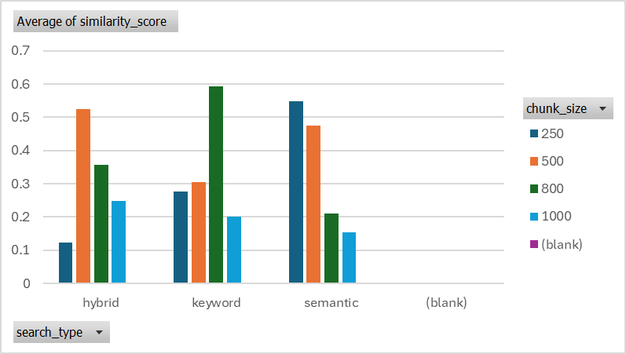
As shown in the bar chart above for rag_grid_1A.csv, semantic retrieval generally produced higher average relevancy scores than hybrid search. However, both retrieval methods responded similarly to changes in chunk size.
Our findings covered the following points:
- Smaller Chunks (250–500 tokens) with moderate overlap (100) yielded better retrieval fidelity, particularly with semantic search. Larger chunks may contain more information, reducing the number of retrievals but risk diluting relevance
- Keyword-based retrieval generally underperformed, suggesting that semantic embeddings handle nuanced queries more effectively.
- Larger chunks (750–1000) led to decreased performance, likely due to diluted relevance, especially when using hybrid or keyword searches.
- Overlaps of 100–200 tokens helped maintain answer context but increased redundancy in retrieval time.
Our Best Results were achieved at the following chunking strategy:
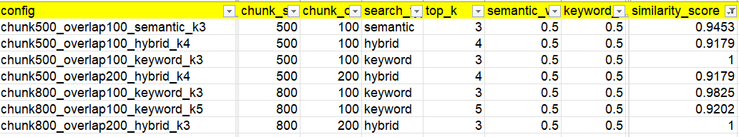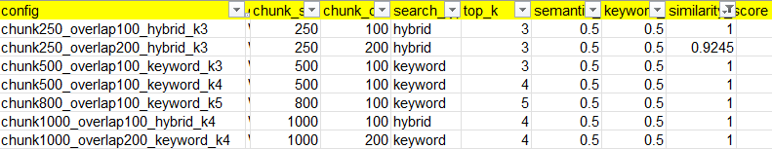
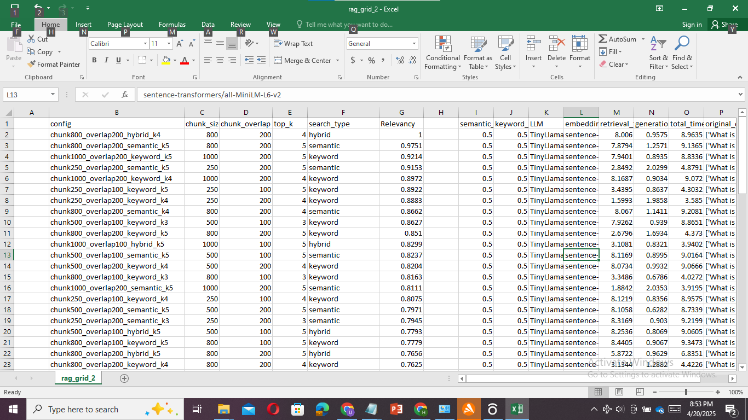

4. Performance Metrics

Faithfulness Score
In our evaluation grid, rag_grid_3 includes a faithfulness_score. Models evaluated with this metric provide a deeper insight into answer reliability. This can influence selection even if the system performs well in latency or similarity. Some strategies that resulted in a high relevancy score along with a decent faithfulness score are mentioned below.
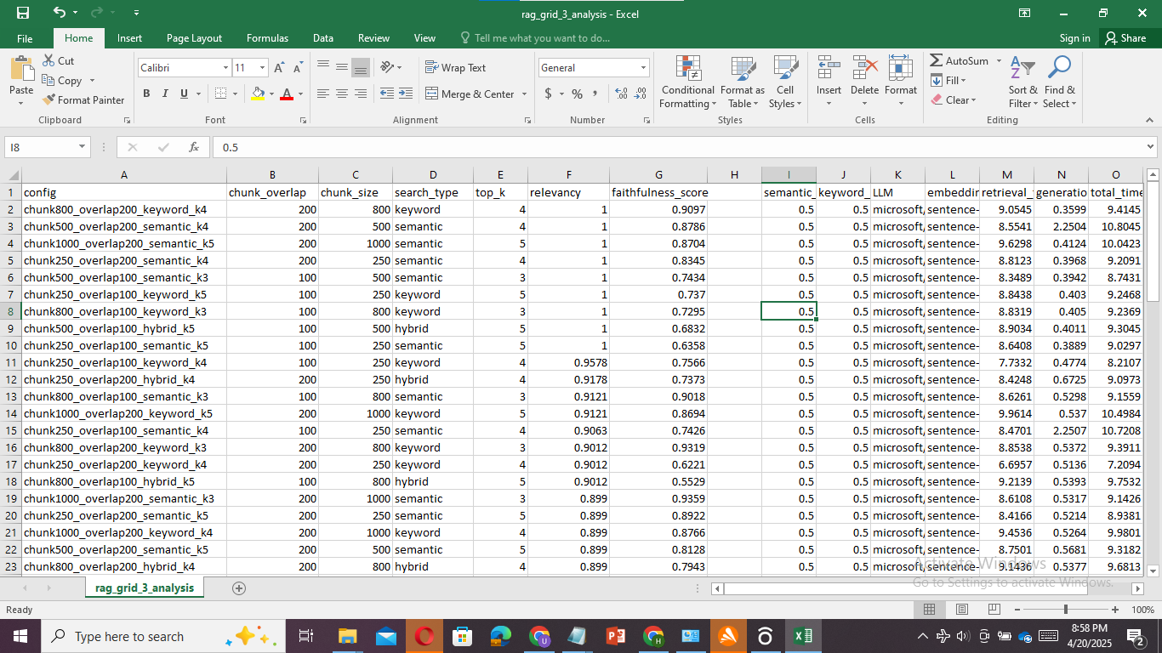

Avg Faithfulness based on LLM + chunking + search retrieval strategies is given below:
LLM | Chunk Size | Overlap | Search Type | Avg. Faithfulness
microsoft/phi-2 | 250 | 100 | hybrid | 0.83
microsoft/phi-2 | 250 | 100 | semantic | 0.74
microsoft/phi-2 | 250 | 100 | keyword | 0.72

Relevancy Score
A cosine-based Relevancy score between the original and regenerated question was used. RAGAS does not produce a faithfulness score, thus, to cater to this we give our generated response back to our LLM, generate relevant questions that could have possibly answered this response. Then we compute the relevancy of these questions with our original question, this is our computed Relevancy score.
We have summarized the numerical measures of these scores, to capture a
Metric | rag_grid_1.csv | rag_grid_1A.csv | rag_grid_2.csv | rag_grid_3.csv
Count of Combinations | 72 | 72 | 72 | 72
Mean | 0.393 | 0.334 | 0.6184 | 0.6760
Median | 0.283 | 0.266 | 0.663 | 0.824
Minimum | -0.0918 | -0.047 | 0.4174 | 0.0199
Maximum | 1.0 | 1.0 | 1.0 | 1.0
Count of 1-maximum | 6 | 2 | 1 | 9
Standard Deviation | 0.337 | 0.300 | 0.228 | 0.3078
Range | 1.0918 | 1.047 | 0.5826 | 0.9801
Variance | 0.11357 | 0.09000 | 0.052166 | 0.0947

We tested our RAG Q/A system across 4 kinds of hyper parameters, and stored our evaluations in 4 CSVs. While rag_grid_1.csv captured maximum performance potential (seen through a higher average Relevancy score), consistency and stability (smaller variation and standard deviation) were seen in rag_grid_1A.csv.

Relevancy Score by Retrieval Type and Top-K
Retrieval Type | Top-K | Average Relevancy Score
Keyword | 3 | 0.564
Keyword | 4 | 0.191
Keyword | 5 | 0.275
Hybrid | 3 | 0.426
Hybrid | 4 | 0.351
Hybrid | 5 | 0.162
Semantic | 3 | 0.406
Semantic | 4 | 0.347
Semantic | 5 | 0.287

To summarize the findings from the table above,
- Keyword (Top-K=3) performed best overall with a score of 0.564, indicating strong precision in top results.
- Hybrid retrieval (Top-K=3) also showed high effectiveness, outperforming semantic search at the same level.
- A drop in performance was observed across all types as Top-K increased, suggesting that higher retrieval counts introduce noise, which disturbed the Relevancy score.
This is also, contained in the bar chart below for rag_grid_1A.csv
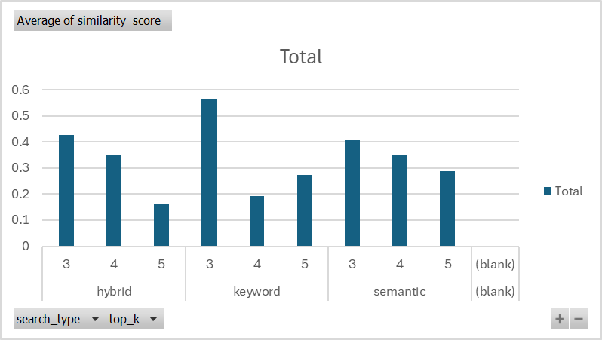

For rag_grid_2.csv and rag_grid_3.csv we observed,

Retrieval Type | Top-K | Avg. Similarity Score
hybrid | 5 | 0.625
keyword | 4 | 0.673
semantic | 4 | 0.511

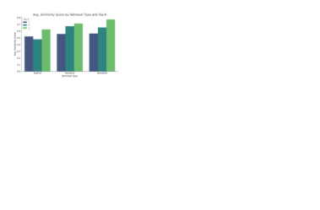
It can be concluded that: Keyword search with top_k=4 outperforms others in average similarity, indicating more relevant retrievals.
Hybrid retrieval at top_k=5 also performs well, showing the benefit of combining semantic + keyword.
Semantic retrieval at low top_k tends to underperform, likely due to its reliance on embedding similarity, which may lack precision at small contexts

A model wise Relevancy summary for rag_grid_2 and rag_grid_3 is given below:
LLM | Chunk Size | Overlap | Retrieval | Avg. Similarity
TinyLlama/TinyLlama-1.1B-Chat-v1.0 | 250 | 200 | keyword | 0.751
TinyLlama/TinyLlama-1.1B-Chat-v1.0 | 250 | 200 | hybrid | 0.700
TinyLlama/TinyLlama-1.1B-Chat-v1.0 | 250 | 100 | keyword | 0.595
microsoft/phi-2 | 250 | 100 | hybrid | 0.582

It is observed from the above table that:
- TinyLlama with 250/200 chunking and keyword retrieval gives the best relevancy performance overall.
- Reducing overlap to 100 slightly drops similarity, showing the benefit of higher overlap.

Latency and System Efficiency Metrics
Metric | Mean (s) | Std Dev (s) | Min (s) | Max (s)
Retrieval Time | 6.76 | 0.39 | 6.17 | 7.83
Generation Time | 1.75 | 0.29 | 0.48 | 2.01
Total Time | 8.51 | 0.49 | 6.87 | 9.65
To summarize the results from this table,
- Retrieval Time dominated the total time, constituting approximately 79% of total system latency, indicating it's the primary bottleneck.
- The generation process by the LLM is relatively stable and efficient, showing a low variance.
There could, however be a potential optimization and reasons for latency, that we discovered:
  - Retrieval efficiency could be significantly improved by integrating vector indexing,using approximate nearest neighbor (ANN) techniques.
  - Hybrid search methods may contribute to increased latency due to the computational overhead of chunk re-ranking or merging strategies.
  - Keyword searches, using the exact token comparison also contributed to a higher total time.

Impact of Retrieval type on Total time
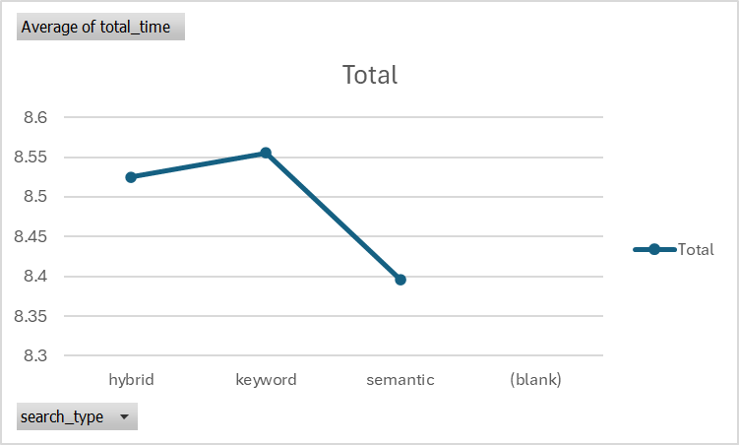
This line chart summarizes total time variation across different search types for rag_grid_1.csv.

For grid_3 and grid_2:
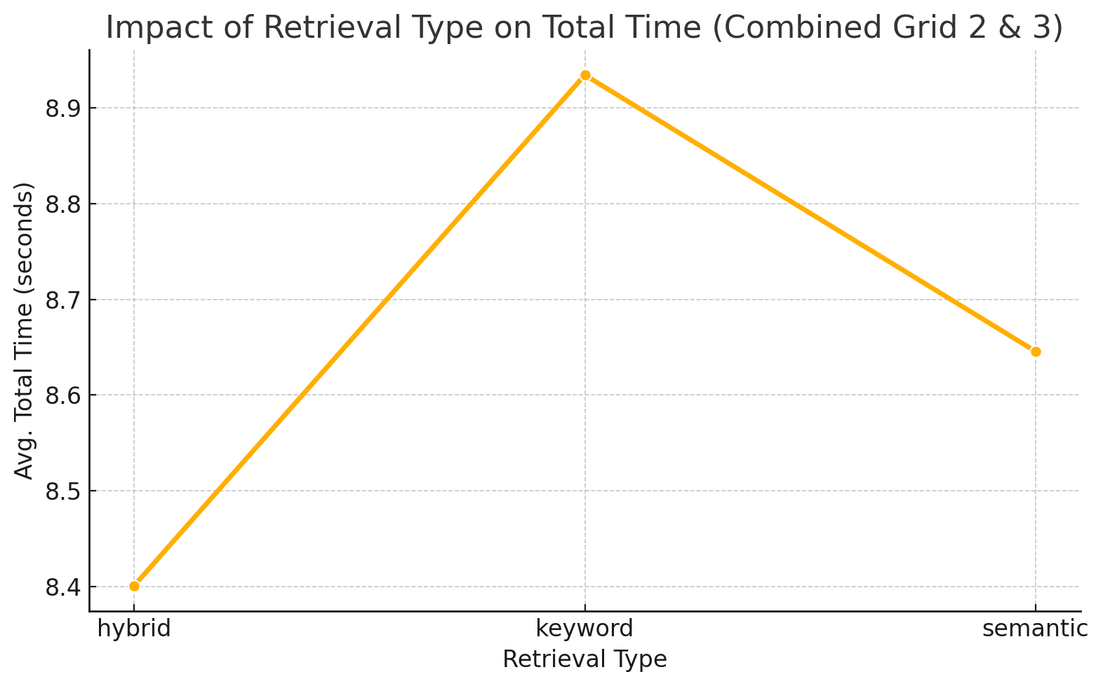

Retrieval Type | Avg. Total Time (s)
Hybrid | 8.40
Keyword | 8.93
Semantic | 8.65
- To optimize the RAG, we infer that: Hybrid retrieval is the most time-efficient method on average.
- Keyword retrieval, while high-performing in relevancy, has the highest latency overall.
- Semantic retrieval sits in the middle in terms of latency.

5. Best Model Selection
Based on faithfulness, latency, and relevancy, we can recommend two "best" configurations, depending on your system's priority:
Priority | Model | Retrieval | Chunking | Strength
Accuracy | microsoft/phi-2 | hybrid | 250 / 100 | High faithfulness (0.83)
Relevancy / Speed | TinyLlama | keyword | 250 / 200 | Top relevancy (0.75) & low latency

6. Reproducibility

We came up with a Python code that implements a comprehensive Retrieval-Augmented Generation (RAG) QA system using a custom pipeline that integrates document ingestion, chunking, semantic and keyword search, language model response generation, and performance evaluation. The documents (e.g., lecture PDFs) are first loaded and split into overlapping chunks using LangChain's text splitters. Two retrieval methods are supported: semantic search via FAISS (using HuggingFace embeddings) and lexical search via BM25. A hybrid retrieval method combines both using weighted scores.
For response generation, HuggingFace's transformer-based models (like Mistral or LLaMA) are loaded either through a local pipeline or HuggingFace Hub. The RAG pipeline uses the top-k retrieved document chunks to construct a context-aware prompt, which is then passed to the LLM to generate an answer.
The script also includes two main evaluators. RAGEvaluator leverages the RAGAS evaluation framework with metrics like faithfulness, answer relevancy, context recall, precision, and optionally answer correctness (when gold answers are provided). Visualization tools help inspect metric averages and retrieval stats, while a recommendation module suggests optimizations based on weak metric scores. An alternative evaluator, SimpleEvaluator, uses question regeneration and cosine similarity between original and generated questions as a proxy for evaluating faithfulness and semantic alignment.
Finally, the grid_search function systematically explores different combinations of chunk sizes, overlap values, retrieval types (semantic, keyword, hybrid), and top-k values. It executes the RAG pipeline for each configuration, logs response generation and evaluation metrics (e.g., faithfulness score, question similarity), and records everything in a CSV file. This enables fine-tuning the RAG system to achieve optimal performance.
Reproducing this RAG-based QA system is straightforward thanks to its modular structure and extensive in-line documentation. All required Python packages are explicitly installed at the beginning using pip, ensuring consistency across environments. The code is designed to run smoothly on platforms like Kaggle, Google Colab, or any GPU-enabled machine with HuggingFace access. Constants like chunk size, overlap, and model names are easily configurable, enabling users to tailor the system to their own document sets. Moreover, the modular class-based design (RAGPipeline, RAGEvaluator, SimpleEvaluator) allows researchers and developers to plug in different datasets or LLMs with minimal code changes. Built-in functions for evaluation, visualization, and automated grid search simplify experimentation, making this system ideal for both beginners exploring RAG and advanced users tuning performance on custom corpora. With a Hugging Face token and access to relevant documents, anyone can reproduce the results and extend the framework for academic, enterprise, or domain-specific applications.

7. Summary of Code
The system implements a full Retrieval-Augmented Generation (RAG) pipeline that supports document ingestion, vector and keyword retrieval, LLM-based answering, and automatic evaluation.

1. Imports and Setup
The code installs and imports necessary libraries including LangChain, HuggingFace, FAISS, BM25, PyPDF, etc. It also handles authentication with HuggingFace using a login token.

2. Constants Definition
Constants like chunk size, embedding model, LLM model, and document directory are defined for flexible tuning.

3. Document Processing Functions
- `load_documents`: Loads PDF documents using LangChain’s DirectoryLoader.
- `chunk_documents`: Splits large documents into overlapping chunks using RecursiveCharacterTextSplitter.

4. Vector Store and Indexing
- `create_vector_store`: Converts chunks into vector embeddings and stores them using FAISS.
- `create_bm25_index`: Creates a BM25 keyword index from document chunks for keyword-based retrieval.

5. Retrieval Methods
- `semantic_search`: Uses FAISS similarity search.
- `keyword_search`: Uses BM25 keyword-based scoring.
- `hybrid_search`: Combines semantic and keyword scores using weighted fusion.

6. Language Model Initialization
- `initialize_llm`: Loads a HuggingFace text generation model and tokenizer, wrapped into a pipeline.

7. Prompt and Response Generation
- `format_rag_prompt`: Formats a structured prompt by combining retrieved context and question.
- `generate_response`: Uses the model to generate an answer based on the formatted prompt.

8. Evaluation and Wrappers
- `RAGEvaluator`: Runs RAGAS-based evaluations using metrics like Faithfulness and Relevance.
- `SimpleEvaluator`: Custom evaluator that generates a reverse question and computes cosine similarity.
- `HuggingFaceLLMWrapper` and `HuggingFaceLLM`: Used to adapt HuggingFace pipelines for use in evaluation libraries.

9. Core RAGPipeline Class
Main class that combines all pipeline steps:
- `load_and_process_documents`
- `initialize_retrieval`
- `initialize_llm`
- `query`: Executes full RAG pipeline for a question.
- `experiment` and `grid_search`: Run various configurations for testing retrieval and generation performance.

10. Execution & Usage
The final part runs the pipeline step-by-step:
- Initialize embeddings and LLM
- Load documents and create indexes
- Run a sample query and evaluate it
- Conduct a grid search across different chunk sizes, search types, and k-values.

