Jonah Katz and Zachary Chenet

Sample Errors

1. Input:

var x, y;

begin   
 y = 3;  
 x := y + 56;  
 end.

Output:

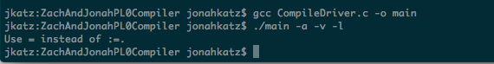

2. Input:

var x, y;  
begin   
 y := (-5 + 4);  
 x := y + 56;  
end.

Output:

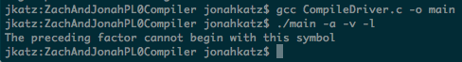

3. Input:

const;  
var x, y;  
begin   
 y 5;  
 x := y + 56;  
end.

Output:

SolidState:Users:jonahkatz:Desktop:Screen Shot 2014-10-19 at 2.58.32 PM.png

4. Input:

var x y;  
begin   
 y := 5;  
 x := y + 56;  
end.

Output:

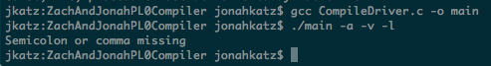

5. Input:

var x, y;  
begin   
 y := 5;  
 x := y + 56;  
end

Output:

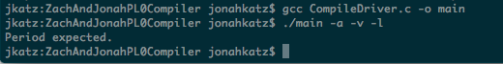

6. Input:

var x, y;  
begin   
 y := 5  
 x := y + 56;  
end.

Output: 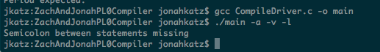

7. Input:

var x, y;  
begin   
 y := 5;  
 q := y + 56;  
end.

Output:

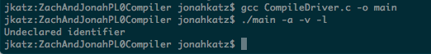

8.

Input:

var x, y;  
begin   
 y + := 5;  
 x := y + 56;  
end.

Output:

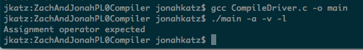

9. Input:

var x, y;  
begin   
 y := 5;  
 x := y + 56;

Output:

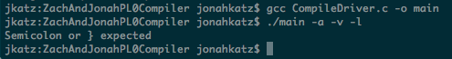

10.

Input:

var x, y;  
begin   
 y := (5 + 4;  
 x := y + 56;  
end.

Output:

