Research Methodology and Project Plan

1. Student Name / Number
- Student name: Zhiyuan Sun
- Student number: [To be added]

2. Project Title
Design and Evaluation of a Modular, Event-Driven Anti-Fraud Architecture for Fintech Transaction Data

3. Clearly Articulated Research Question

3.1 Main Research Question
How can a dedicated anti-fraud architecture support effective and efficient fraud detection in modern fintech transaction systems?

3.2 Sub-Research Questions
- RQ1 — Real-Time Detection: How can an anti-fraud system provide effective fraud detection while maintaining low latency for synchronous transaction processing?
- RQ2 — Adaptability: How can the system rapidly adapt to changing fraud patterns and detection requirements without tightly coupling fraud logic to core business services?
- RQ3 — Continuous Evolution: How can asynchronous analysis and feedback mechanisms enable the anti-fraud system to continuously improve its detection capabilities?
- RQ4 — Multi-Strategy Detection: How can rules, machine-learning models, and graph-based analysis be coordinated to detect different types of fraudulent behaviour?

3.3 Research Objectives and Scope
The main objective is to design, implement, and evaluate a dedicated anti-fraud prototype using events replayed from public fraud datasets and generated test scenarios, without requiring integration with a live transaction system. Specific objectives are to:
- Assess the latency implications of low-latency feature retrieval and precomputed aggregations.
- Explore how detection rules and features can be dynamically configured and updated without disrupting ongoing risk evaluation.
- Investigate how asynchronous feedback and anomaly analysis can improve detection.
- Compare individual and combined detection strategies.
The study focuses on software architecture and a research prototype, not a production-ready fraud platform. The questions will be answered within the available time and datasets; advanced graph learning and fully autonomous model evolution may be limited to proof-of-concept work.

4. Description and Justification of Chosen Research Methodology

4.1 Selected Methodology and Justification
The study will primarily use Experimental Research, supported by quantitative data analysis, a literature review, and iterative software prototyping. Experimental research compares selected variables under controlled conditions to examine how they affect measurable outcomes.
This methodology is appropriate because it allows different architectural approaches to be evaluated through controlled experiments and measurable results, rather than relying solely on theoretical analysis or implementation. For example, the use of precomputed features can be varied while measuring fraud-check latency. Repeated tests with controlled workloads will help identify performance and detection trade-offs (Kohavi et al., 2009).

4.2 Research Process and Data Collection
The research will follow an iterative experimental process involving three successive prototype versions, with initial research followed by repeated design, implementation, and evaluation cycles.

1. Initial Research
a. Define the research problem: Establish the research questions, objectives, and scope.
b. Review existing literature: Examine academic research and documented industrial anti-fraud architectures to identify gaps and feasible design alternatives.

2. Iterative Prototype Development and Evaluation
The following steps will be repeated for each prototype version:
a. Design or refine the research plan: Define hypotheses, comparison baselines, evaluation metrics, datasets, and experimental controls, incorporating previous findings.
b. Build or improve the prototype: Implement or refine architectural components and fraud-detection capabilities.
c. Collect experimental data: Conduct repeatable experiments using labelled fraud datasets, synthetic events, and system performance measurements.
d. Analyse and evaluate results: Compare outcomes against established baselines and research objectives.
e. Reflect and refine: Identify limitations and improvements to guide the next iteration.

3. Final Comparison and Evaluation
Compare results across the three prototype versions, evaluate architectural trade-offs, and draw conclusions addressing the research questions. Where feasible, comparisons will use consistent datasets, workloads, and test conditions.
A public fraud dataset, such as IEEE-CIS Fraud Detection (IEEE Computational Intelligence Society, 2019), may supply transaction labels. Dataset records will be transformed into replayable transaction events, and synthetic events will supplement login activity, wallet state, or other contextual fields where necessary. No live financial system integration is required. The provenance and limitations of each source will be recorded.
The overall research process is illustrated below:
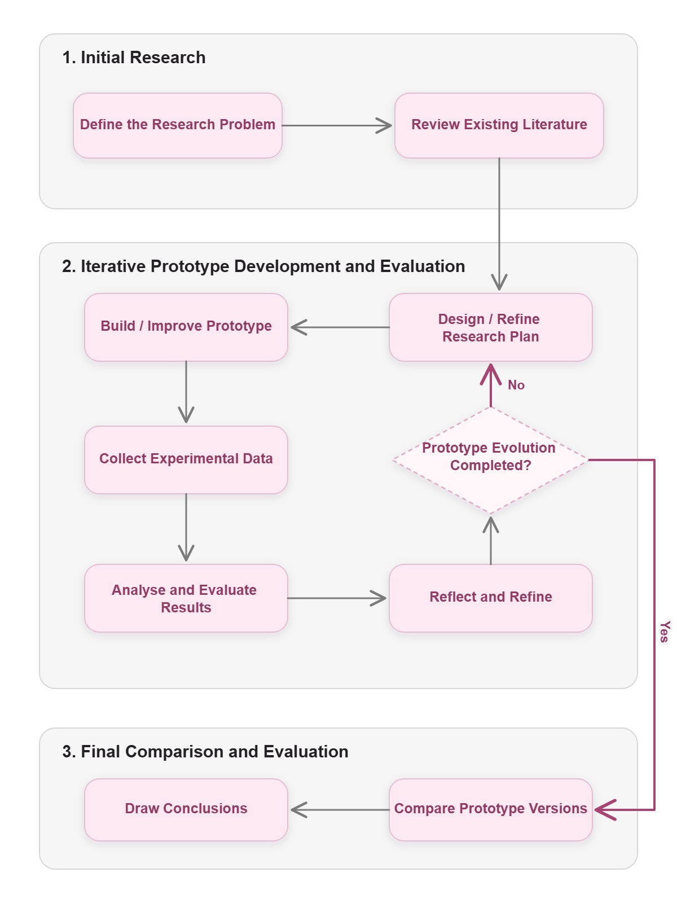
Figure 1. Research process, including the iterative feedback loop and final evaluation.

4.3 Analysis and Evaluation
The experimental plan will compare configurations using the same workload and test environment wherever possible, with repeated runs and documented settings.
Research area | Illustrative comparison | Evidence / measures
RQ1 | Live feature queries vs cached/precomputed features | P50/P95/P99 latency; throughput
RQ2 | Static or deployment-based rule/feature changes vs dynamic configuration updates | Time to activate changes; update propagation delay; risk-evaluation interruption
RQ3 | Detection before and after a feedback/update cycle | Precision, recall, F1-score, and false-positive rate (FPR) on separate evaluation data
RQ4 | Rules alone vs rules combined with ML or graph-derived signals | Precision, recall, F1-score, and false-positive rate (FPR)

Independent variables will be the architectural or detection configurations; dependent variables will be performance and detection measurements. Because fraud labels are often highly imbalanced, RQ3 and RQ4 will use precision, recall, F1-score, and FPR together, rather than relying on accuracy alone. Results will be tabulated and visualised, and unexpected findings will be discussed rather than excluded.

4.4 Limitations and Ethical Considerations
Public or synthetic datasets may not represent the complexity of real financial fraud, and limited computing resources may constrain scale. Model comparisons must avoid training/test leakage, and observed performance may not generalise to production environments. To minimise privacy risks, experiments will use public data subject to its usage conditions and synthetic or appropriately anonymised context records; no real customer credentials or sensitive wallet details are required. Assumptions, researcher choices, and limitations will be documented transparently.

5. Project Proposal

5.1 Background and Problem Statement
Fraud detection can draw on transaction history, login activity, and account or wallet state. When fraud logic is scattered across business services, updates can become harder to manage; synchronous checks can also introduce latency (Diao and Geracioti, 2017; Li et al., 2019). This project therefore investigates a dedicated, modular anti-fraud architecture that processes contextual events through well-defined interfaces, without requiring an operational financial platform for its evaluation.

5.2 Proposed Solution and Objectives
The project proposes Z-Anti-Fraud, an independent prototype that processes transaction and contextual events replayed from public datasets and synthetic scenarios. It will expose a synchronous risk API and support asynchronous event ingestion. A risk orchestrator will coordinate a feature service, configurable rules, and selected model/graph analysis (e.g., Fathony et al., 2023). A decision component will aggregate detection outputs into an overall fraud-risk assessment. An asynchronous pipeline will support outcome feedback and evaluation.
The aim is not to reproduce a commercial fraud platform but to investigate and measure key architectural trade-offs identified in RQ1–RQ4. Modular interfaces and event-based data ingestion support a non-invasive design without requiring integration with an operational financial platform.

5.3 Scope and Expected Deliverables
- In scope: working risk API; feature aggregation; configurable rules; at least one baseline ML detector; event-based context ingestion from dataset replay and synthetic event generation; automated experiments and results. V3 will protect a basic asynchronous feedback experiment and a combined rules + ML evaluation as minimum research deliverables.
- Optional / reduced scope: graph-based fraud detection, advanced unsupervised anomaly detection, automated model adaptation, a basic rule backtest or shadow mode, and an elementary monitoring interface where time permits.
- Out of scope: direct integration with Z-Exchange or another live financial system, production payment processing, full anti-money-laundering compliance, extensive fraud-analyst tooling, or deployment to a real financial institution.
- Deliverables: prototype and source code, architecture documentation, reproducible experimental setup, evaluation findings, and final report.

5.4 Work Breakdown, Resources, and Risks

5.4.1 Work Breakdown Structure (WBS)
The project will be organised into five work packages, including three iterative prototype versions. Each iteration includes research planning, implementation, experimentation, and evaluation. V1 and V2 target fixed demonstration milestones; V3 is best-effort for optional features, while retaining minimum experiments needed to address RQ3 and RQ4. The feature allocation may be refined as the research progresses.
Work package | Main activities | Expected deliverable
WP1 — Research and Design | Literature review, dataset investigation, architecture design, and experimental planning | Research plan and architecture design
WP2 — Prototype V1 | Implement event replay, core risk orchestration, feature retrieval, and basic rule-based detection; conduct baseline experiments | Baseline prototype and initial results
WP3 — Prototype V2 | Develop low-latency features and precomputed aggregations, configurable rules/features, and initial ML model training and inference; evaluate performance and adaptability | Enhanced prototype and comparative results
WP4 — Prototype V3 | Minimum: evaluate combined rules + ML detection and a basic asynchronous feedback cycle. Best-effort extensions: graph analysis, advanced anomaly detection, and automated adaptation; conduct V3 experiments and evaluation | Minimum RQ3/RQ4 experimental findings; extended prototype where feasible
WP5 — Final Evaluation and Documentation | Compare the three prototype versions, analyse architectural trade-offs, and complete the final report | Final evaluation and research report

5.4.2 Resources
The project is planned for approximately 10–14 hours of work per week and will use the following resources:
Resource | Purpose
Development environment | Java/Spring Boot, Python, and supporting libraries for implementing the anti-fraud prototype and ML experiments
Data and storage infrastructure | Databases, caching, and event-streaming technologies for storing and processing fraud-related data and events
Fraud datasets | Public labelled datasets and synthetic event generation for development and evaluation
Testing and monitoring tools | Load testing, application metrics, and statistical analysis tools to collect and analyse experimental results
Computing resources | Local development infrastructure and, if necessary, cloud resources for controlled experiments

5.4.3 Risk Assessment and Mitigation
Key risk | Impact | Mitigation
Insufficient or unsuitable fraud datasets | High | Evaluate datasets early and supplement them with clearly documented synthetic events where needed
Implementation complexity and scope expansion | High | Prioritise core components and introduce advanced detection capabilities incrementally
Limited development time | High | Set clear iteration milestones and reserve contingency time
Limited machine-learning expertise | Medium | Start with established algorithms and libraries before considering advanced models
Infrastructure or performance limitations | Medium | Use reproducible deployment configurations and scale experiments to available resources

Experimental consistency will be addressed through the controlled testing procedures described in Section 4, rather than treated as a separate project risk.

6. Project Timeline (Gantt Chart)

6.1 Phases and Dependencies
The project runs from 13 October 2026 to 15 April 2027. The internal completion target is 1 April 2027, with 2–15 April reserved as a contingency buffer for corrections and unexpected delays, rather than new feature development.
The research problem has already been defined. The literature review and initial experimental plan for V1 (with preliminary V2 planning) are scheduled for completion by 1 November 2026. Each prototype then follows an iterative cycle of design, implementation, data collection, analysis, and refinement. Research writing proceeds in parallel with implementation and evaluation.
Workstream | Phase | Target date | Deliverable
Initial research | Literature review and initial V1 / preliminary V2 research plan | 1 Nov 2026 | Research basis, hypotheses, baseline and evaluation plan
Prototype V1 | Implementation and baseline experiments | 26 Nov 2026 | Demo 1 and V1 experimental findings
Prototype V2 | Detailed design and experimental plan | 10 Dec 2026 | V2 design and planned comparisons
Prototype V2 | Implementation | 25 Jan 2027 | Working V2 prototype
Prototype V2 | Experiments, analysis and refinement | 11 Feb 2027 | Demo 2 and V2 comparative findings
Prototype V3 | Detailed design and experimental plan | 25 Feb 2027 | Prioritised V3 plan with protected minimum experiments
Prototype V3 | Best-effort implementation | 20 Mar 2027 | Minimum RQ3/RQ4 capabilities; optional features where feasible
Final evaluation | V3 experiments, cross-version comparison and conclusions | 1 Apr 2027 | Completed research results
Research writing | Dissertation draft, final editing and completion | 1 Apr 2027 | Completed research report
Contingency | Corrections, retesting and submission preparation | 15 Apr 2027 | Final submission

Dependencies: V1 establishes a reproducible baseline for subsequent comparison; V2 extends that baseline; V3 builds on working rules and ML capabilities from V2. V3 advanced features will be de-scoped if needed to protect the minimum feedback and combined-detection experiments. Equivalent datasets, workloads, and evaluation metrics will be used where feasible across the iterations.

6.2 Gantt Chart
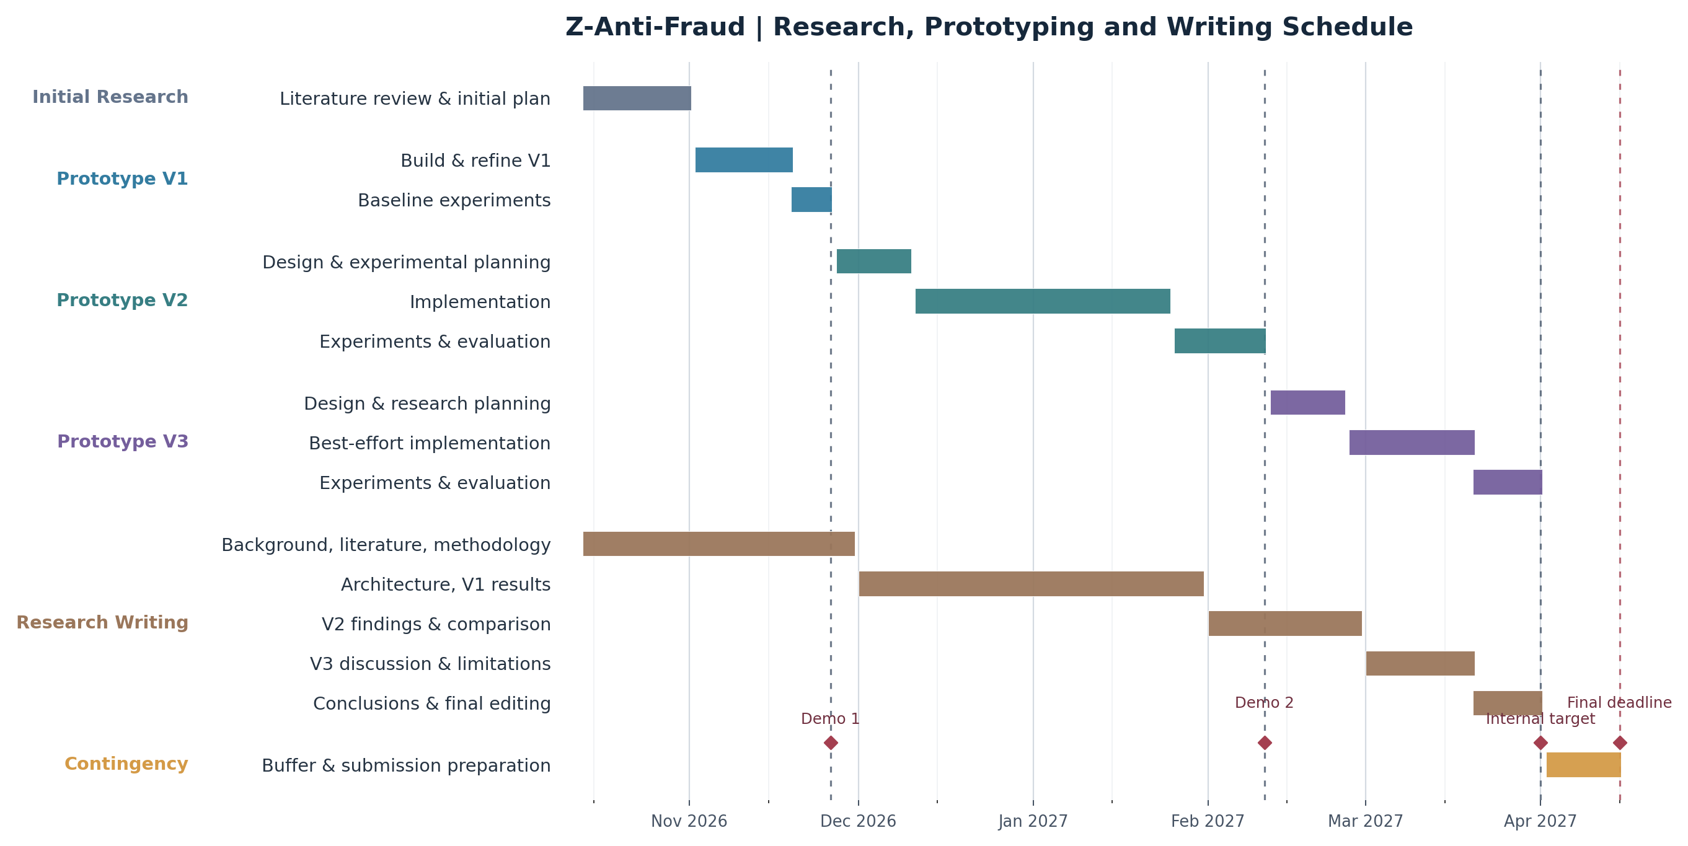
Figure 2. Project Gantt chart showing prototype, research writing, milestones and contingency.

6.3 Milestones and Contingency
- 1 November 2026: initial literature review and research plan completed (the research problem is already defined).
- 26 November 2026: V1 experiments completed and Demo 1 submitted.
- 10 December 2026: V2 design completed; 25 January 2027: V2 implementation completed.
- 11 February 2027: V2 evaluation completed and Demo 2 submitted.
- 25 February 2027: V3 design completed; 20 March 2027: V3 implementation completed to the feasible scope.
- 1 April 2027: minimum V3 experiments, comparison across versions, and research report completed.
- 2–15 April 2027: contingency, final corrections and submission preparation; 15 April: final deadline.
The Gantt chart will serve as the schedule baseline. Progress will be reviewed at each milestone, and optional V3 capabilities may be reduced if they threaten experimental evaluation or the final report.

7. References
- Kohavi, R., Longbotham, R., Sommerfield, D. and Henne, R.M. (2009). 'Controlled experiments on the web: Survey and practical guide.' Data Mining and Knowledge Discovery, 18, pp. 140–181. https://doi.org/10.1007/s10618-008-0114-1
- Diao, Y. and Geracioti, I. (2017). 'Mastermind: Using Uber Engineering to Combat Fraud in Real Time.' Uber Engineering. https://www.uber.com/us/en/blog/mastermind/
- Li, M., Allan, G. and Kansal, V. (2019). 'Griffin, an Anti-fraud Risk Rule Engine Making Billions of Predictions Daily.' Grab Engineering. https://engineering.grab.com/griffin
- Fathony, R., Ng, J. and Chen, J. (2023). 'Interaction-Focused Anomaly Detection on Bipartite Node-and-Edge-Attributed Graphs.' 2023 International Joint Conference on Neural Networks (IJCNN), pp. 1–10. https://doi.org/10.1109/IJCNN54540.2023.10191331
- IEEE Computational Intelligence Society (2019). IEEE-CIS Fraud Detection, Kaggle dataset. https://www.kaggle.com/competitions/ieee-fraud-detection/data

