**Non-heuristic searches results:**

|  |  |  |  |  |  |
| --- | --- | --- | --- | --- | --- |
| Problem | Search used | # of node expansions | # of goal tests | Time elapsed | Optimal? |
| air_cargo_p1 | Breadth_first_search | 43 | 56 | 0.029 | Y |
| air_cargo_p1 | Depth_first_graph_search | 21 | 22 | 0.013 | N |
| air_cargo_p1 | Uniform_cost_search | 55 | 57 | 0.037 | Y |
| air_cargo_p2 | Breadth_first_search | 3343 | 4609 | 7.990 | Y |
| air_cargo_p2 | Depth_first_graph_search | 624 | 625 | 3.327 | N |
| air_cargo_p2 | Uniform_cost_search | 4853 | 4855 | 11.527 | Y |
| air_cargo_p3 | Breadth_first_search | 14663 | 18098 | 40.940 | Y |
| air_cargo_p3 | Depth_first_graph_search | 408 | 409 | 1.735 | N |
| air_cargo_p3 | Uniform_cost_search | 18223 | 18225 | 50.167 | Y |

**A* search using three heuristics:**

|  |  |  |  |  |  |
| --- | --- | --- | --- | --- | --- |
| Problem | Heuristics used | # of node expansions | # of goal tests | Time elapsed | Optimal? |
| air_cargo_p1 | h_1 | 55 | 57 | 0.037 | Y |
| air_cargo_p1 | h_ignore_preconditions | 41 | 43 | 0.038 | Y |
| air_cargo_p1 | h_pg_levelsum | 11 | 13 | 0.909 | Y |
| air_cargo_p2 | h_1 | 4853 | 4855 | 11.066 | Y |
| air_cargo_p2 | h_ignore_preconditions | 1450 | 1452 | 4.032 | Y |
| air_cargo_p2 | h_pg_levelsum | 86 | 88 | 176.399 | Y |
| air_cargo_p3 | h_1 | 18223 | 18225 | 54.401 | Y |
| air_cargo_p3 | h_ignore_preconditions | 5040 | 5042 | 16.924 | Y |
| air_cargo_p3 | h_pg_levelsum | 315 | 317 | 1072.356 | Y |

**Heuristic Analysis:**

From the table above, h_ignore_preconditions is the best heuristic. It produces optimal solutions for all three problems. It is the most balanced one – it expands a moderate number of nodes and goal tests while costs the least amount of time. It is better than non-heuristic searches for problems 2 and 3 in terms of number of nodes expanded, number of goal tests and time cost. However, it is not as efficient as BFS for problem 1 in terms of time cost, but still manages to find optimal solution by visiting fewer nodes and performing fewer goal tests.

**Optimal solution for three problems:**

Since all A* searches using different heuristics produce optimal results, all optimal solutions listed below are from A* search using h_pg_levelsum heuristic.

Problem 1:

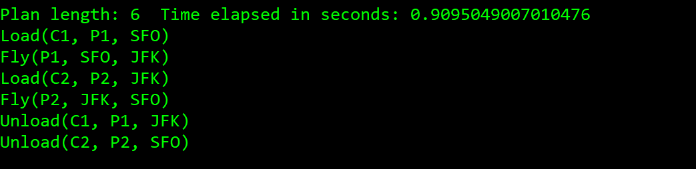

Problem 2:

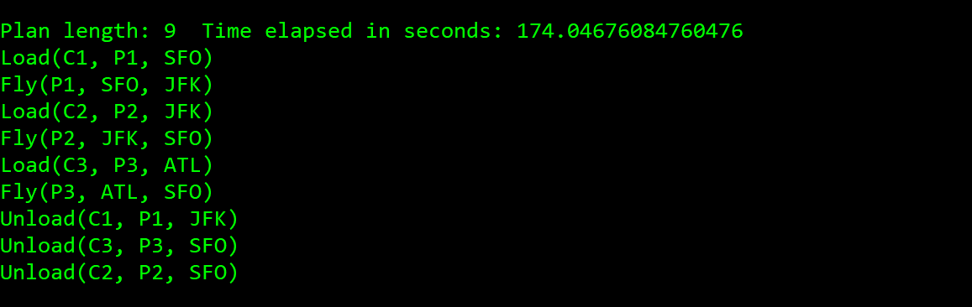

Problem 3:

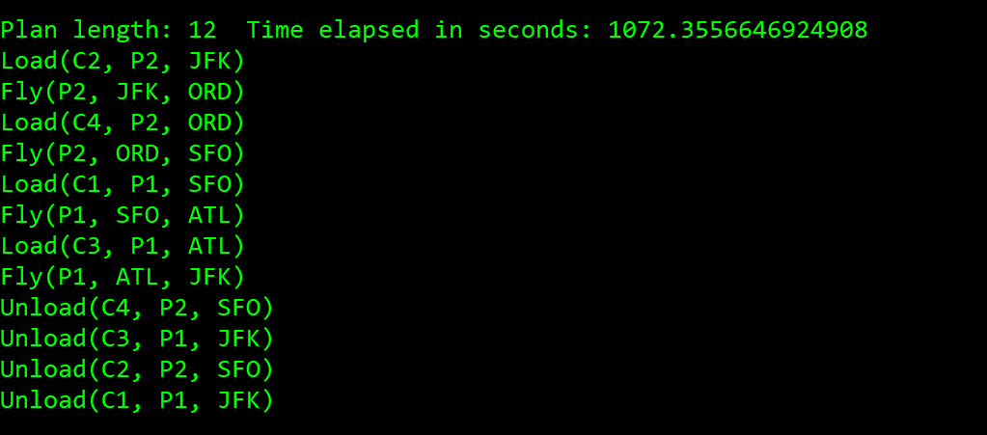

Problem 1 non-heuristic search metrics:

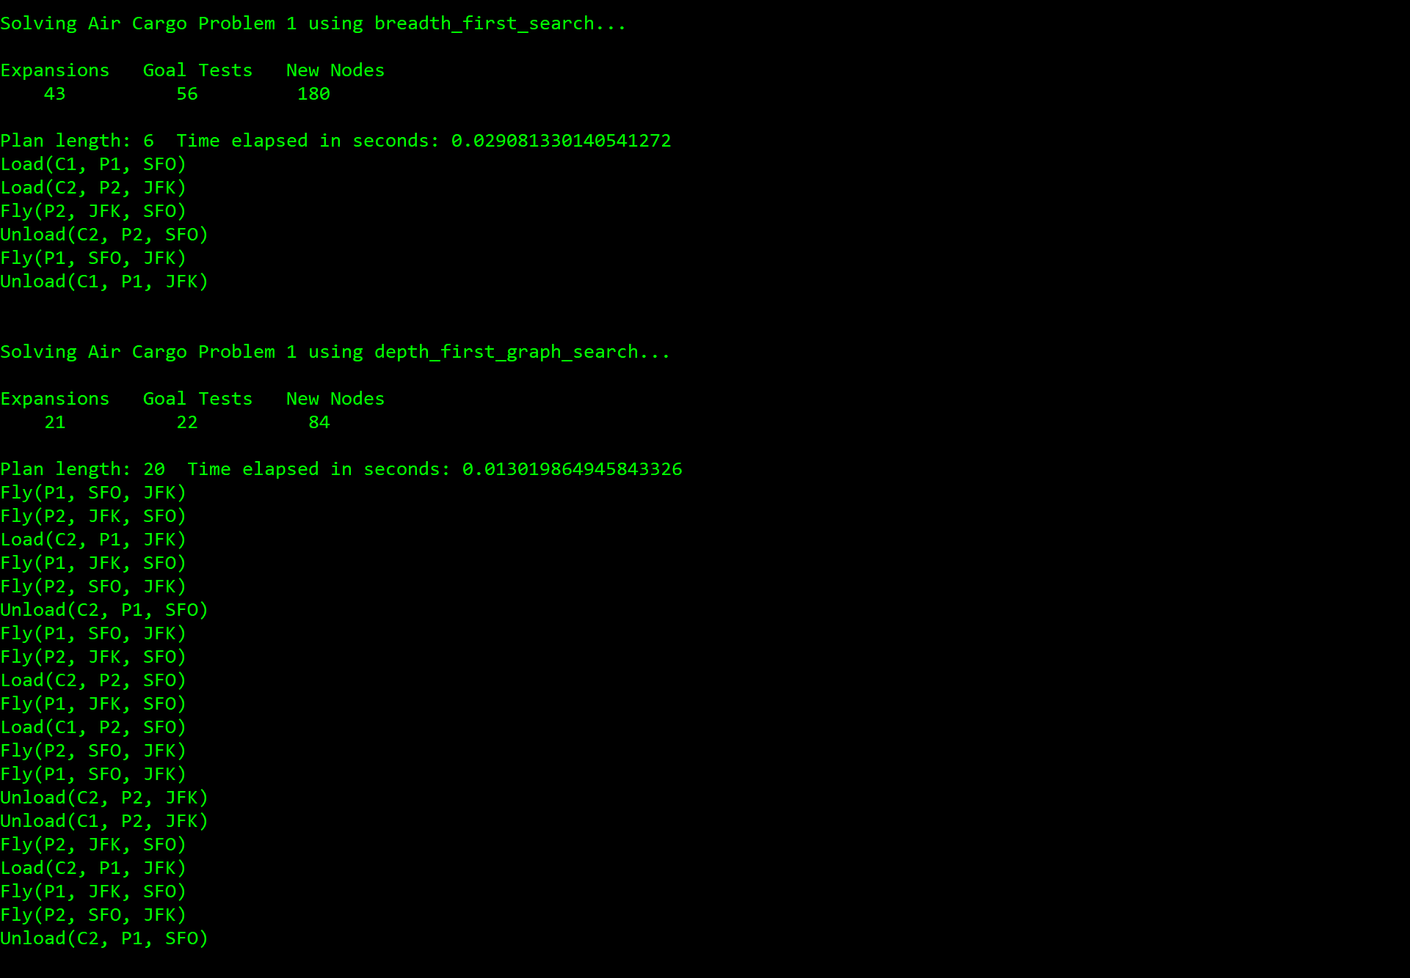

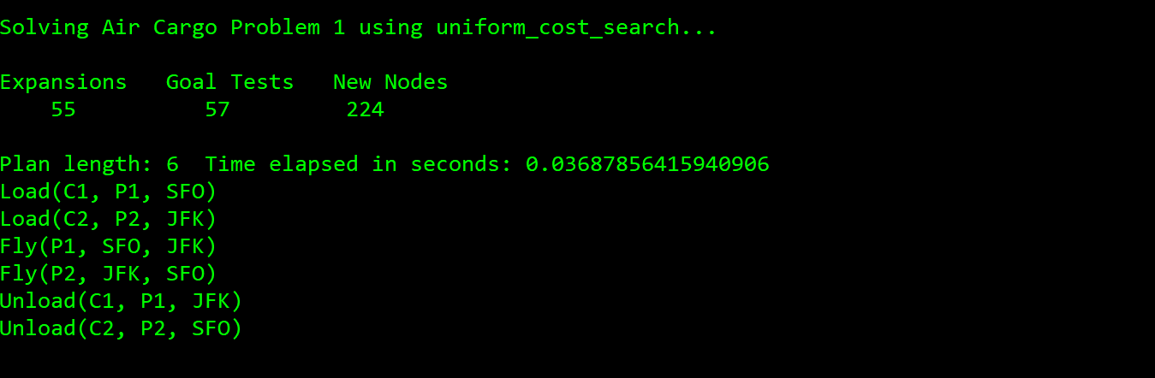

Problem 2 non-heuristic search metrics:

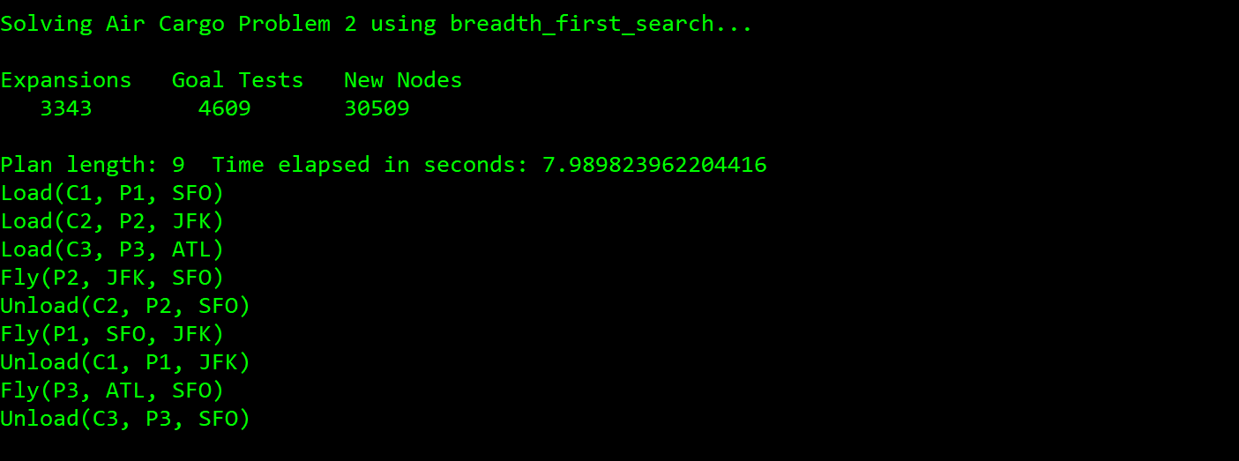

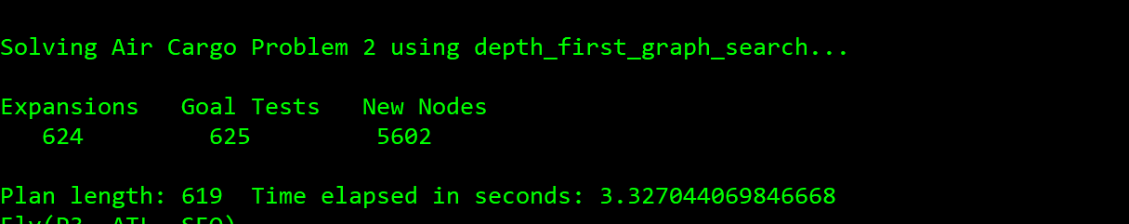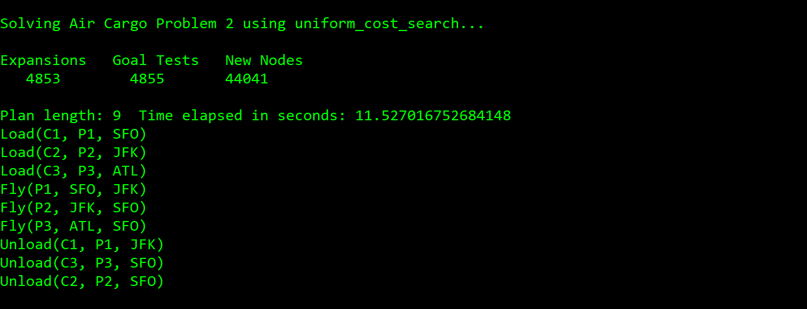

Problem 3 non-heuristic search metrics:

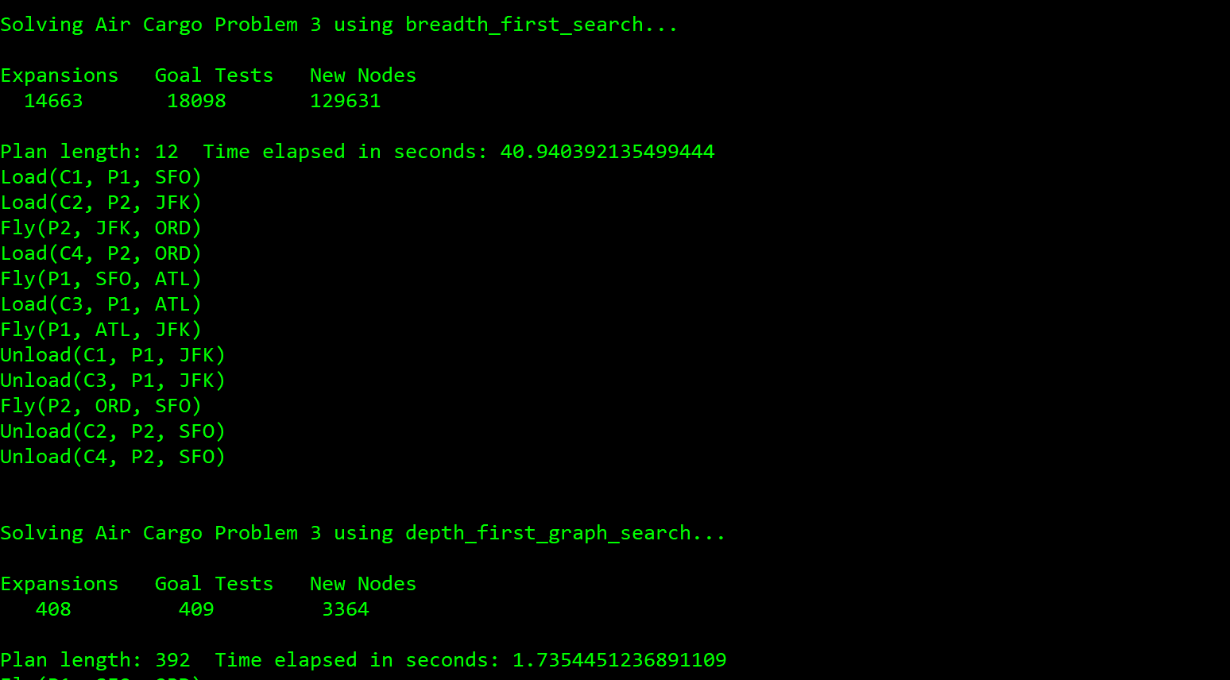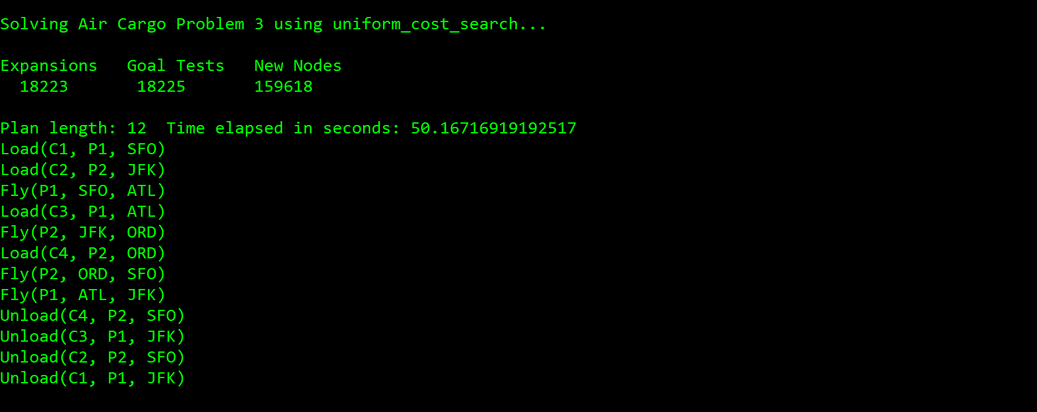

Problem 1 A* search using three heuristics:

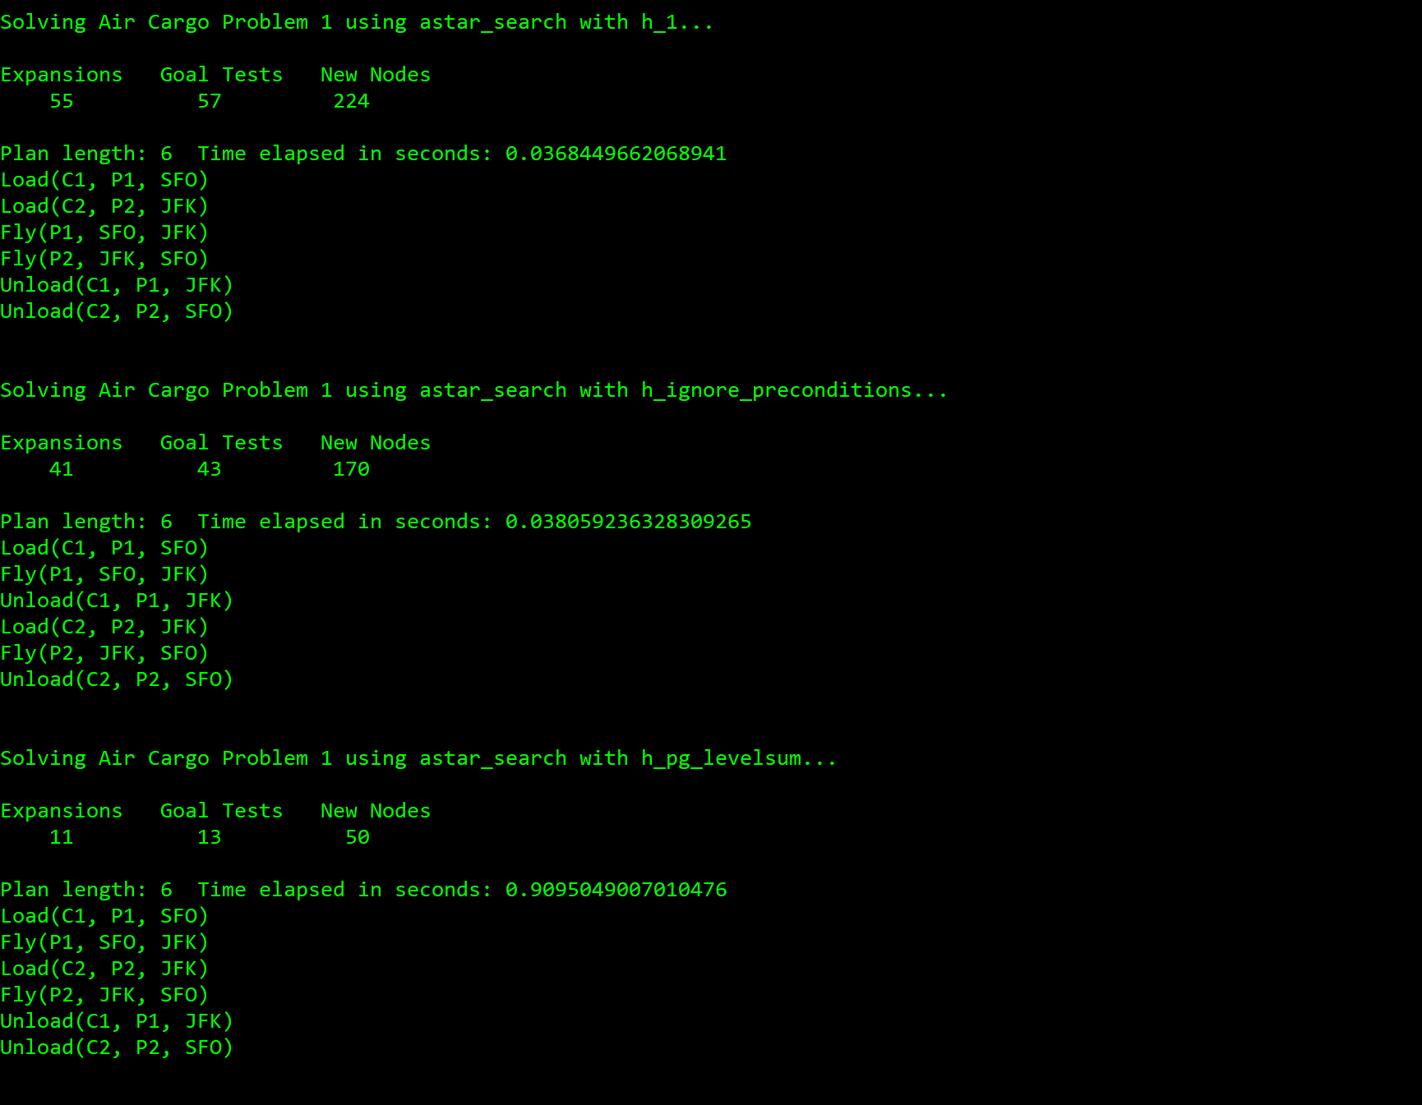

Problem 2 A* search using three heuristics:

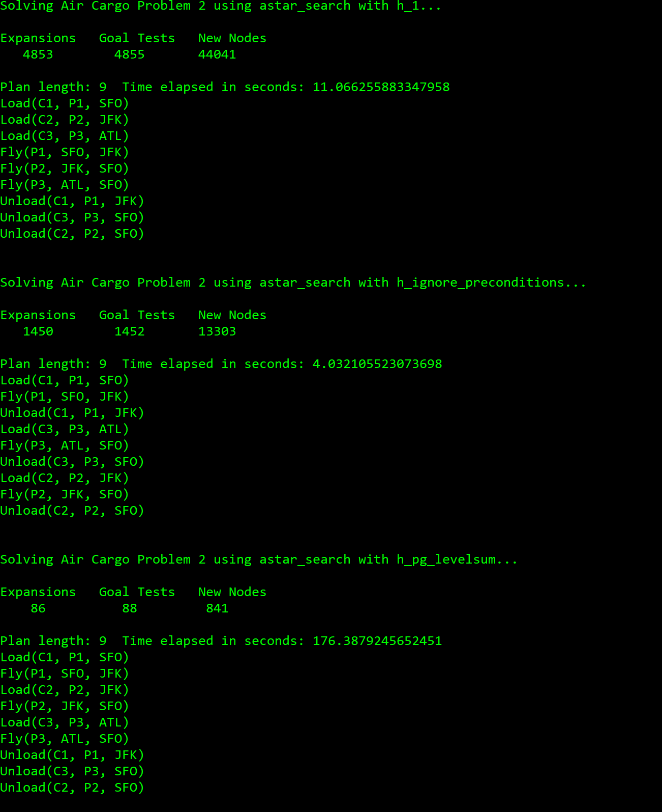

Problem 3 A* search using three heuristics:

