Quantifying Improvements When Lifting Subtour Elimination Constraints on a TSP-Based MILP Model for Medium-Term Planning of Single-Stage Continuous Multiproduct Plants

Qingyang Zhang

Engineering Department, Carnegie Mellon University

November 27th, 2019

1. **Introduction**
2. **Original Problem**

Many works in Production and Systems Engineering have addressed the medium-term planning and scheduling problem of single-stage continuous multiproduct plants with sequence-dependent changeovers. Most of their authors regarded time as a continuous variable, such as Erdirik-Dogan and Grossman (E-D&G). 1 By adopting a hybrid discrete-continuous approach to represent time, Liu et al. reduced computational time by several orders of magnitude, and returned solutions that bring higher profits, while running on the same sample data set as E-D&G with extra constraints. One objective of this report is to replicate Liu et al.’s results with the same data set and corroborate his findings.

Liu et al. used a Traveling Salesman Problem (TSP) -based Mixed Integer Linear Programming (MILP) model to formulate and solve the problem. Possibly in a bid to make their model easier to understand, Liu et al. settled on using the Miller-Tucker-Zemlin (MTZ) formulation to describe a type of constraints known as subtour elimination constraints. The MTZ formulation is among the oldest and simplest of its kind, and there is an abundance of literature presenting new formulations of subtour elimination constraints, that promise gains in space and time complexity over older methods in the family.

1. **Modifications to Liu et al.’s Approach**

An objective of this report is to explore the effect of alternative types of subtour elimination constraints on the objective function value (i.e. maximum profit that can be obtained from a schedule), as well as the time and memory usage of the solving process. To this end, we examine two modifications to Liu et al.’s original problem; the mathematical details will be laid out in the next section.

The first replaces the MTZ version of the subtour eliminations constraints by ones proposed by Desrochers and Laporte (DL). The new constraints are stronger, and introduce tighter Linear Programming (LP) upper and lower bounds for the objective function values. Solutions obtained from DL constraints nonetheless generally satisfy MTZ constraints. This suggests smaller branch-and-cut trees at each iteration, and fewer required iterations for the solutions to converge. The DL-modified model now has 1062 subtour elimination constraints to solve, as opposed to the 1070 used for the original. In short, we expect dramatic reductions in CPU time required to obtain a solution that lead to comparable profits.

The second modification reformulates the problem as a Multi-Commodity Flow (MCF) problem, and involves supplanting the MTZ version of the subtour eliminations constraints with MCF ones. The description of the model, rationale for using the model, the pros and cons of the model, and business applications will be discussed in detail in the Mathematical Formulation section below.

1. **Problem Formulation (cited from Liu et al.)**

The work considers the optimal medium-term planning of a single-stage plant. The plant manufactures several types of products in one processing machine over a planning horizon. The total available processing time is divided into multiple weeks.

The customers place orders for one or more products. These demands are allowed to be delivered only at the end of each week. If the demand is not fulfilled at the desired time, late delivery is allowed. At the same time, backlog penalties are imposed on the plant operation.

The plant can also manufacture a larger amount of products than the demand in a time period. The limited inventory is allowed for product storage before sales.

Sequence-dependent changeover times and costs occur when switching production between different products.

Given are the demands, prices, processing rates, changeover unit costs and times, unit penalty costs, and inventory costs for each product. Here, the main optimization variables include decisions on the products to be produced during each week, processing schedule, production times, production amounts, and inventory and backlog levels over the planning horizon.

1. **Mathematical Formulation**
2. **Liu et al.’s Original Model**
3. Sets

*C* = ['c1', 'c2', 'c3', 'c4', 'c5', 'c6', 'c7', 'c8', 'c9', 'c10'] = set of customers

*I,J* = ['A', 'B', 'C', 'D', 'E', 'F', 'G', 'H', 'I', 'J'] = set of products

*W* = ['w1','w2','w3','w4','w5','w6','w7','w8'] = set of weeks (if horizon is 8 weeks)

*W­*­a = W without the first element (‘w1’)

1. Parameters

*CBic* = unit backlog penalty cost of product *i* to customer *c*, defined as 20% of *PSic*

*CCij* = changeover cost from product *i* to product *j*, proportional to *τij* by a factor of 10

*CIi*= unit inventory cost of product *i*, defined as 10% of *PSic* when *c* = ‘c1’.

*Dciw* = demand of product *i* from customer *c* in week *w*

*M* = a large number, not specified by Liu et al., set to len(C) – 1 = 9 here

*PSic*= unit selling price of product *i* to customer *c*, given by Liu et al. in table form

*ri* = processing rate of product *I* = 0.6548 ton/hr for all products

*Vimax* = maximum storage of product *i*, not specified by Liu et al., set to 110 tons

*Vimin* = minimum storage of product I, not specified by Liu et al., set to 0 tons

θL = lower bound for processing time in a week = 5.0 hr/week

θU = upper bound for processing time in a week = 168.0 hr/week

*τij* = changeover time from product *i* to product *j* in hours, given by Liu et al. in table form

1. Binary Variables

Eiw = 1 if product i is processed during week w; 0 otherwise.

Fiw = 1 if product i is the first one in week w; 0 otherwise.

*Liw* = 1 if product i is the last one in week w; 0 otherwise.

*Zijw* = 1 if product i immediately precedes product j during week w; 0 otherwise.

*ZFijw* = 1 if the changeover between weeks w - 1 and w is from product *i* to *j*

1. Variables

*Oiw* = order index of product i during week w

*Piw* = amount of product i produced during week w

*Sciw* = sales volume of product i to customer c during week w

*Tiw* = processing time of product i during week w

*Viw* = inventory volume of product i at the end of week w

*Δciw* = backlog of product i to customer c at the end of week w

Π = total profit

1. Objective Function

We aim to maximize the objective function, i.e. the profit of the plant, or revenue minus costs.

|  |  |  |
| --- | --- | --- |
| $$Π =$$ | $$\sum_{c}{\sum_{i}{\sum_{w}{PS_{ic}⋅S_{ciw}}}}-\sum_{i}{\sum_{j≠i}{\sum_{w}{CC_{ij}⋅Z_{ijw}}}}-\sum_{i}{\sum_{j≠i}{\sum_{w∈W-\{1\}}{CC_{ij}⋅ZF_{ijw}}}}$$ | (1) |
|  | $$-\sum_{c}{\sum_{i}{\sum_{w}{CB_{ic}⋅Δ_{ciw}}}}-\sum_{i}{\sum_{w}{CI_{i}⋅V_{iw}}}$$ |  |

1. Assignment Constraints

|  |  |
| --- | --- |
| $$\sum_{i}{F_{iw}}=1, ∀ w∈W$$ | (2) |
| $$\sum_{i}{L_{iw}}=1, ∀ w∈W$$ | (3) |
| $$F_{iw}≤E_{iw}, ∀ i∈I, w∈W$$ | (4) |
| $$L_{iw}≤E_{iw}, ∀ i∈I, w∈W$$ | (5) |

1. Changeover Constraints

|  |  |
| --- | --- |
| $$\sum_{i≠j}{Z_{ijw}}=E_{jw}-F_{jw}, ∀ j∈J, w∈W$$ | (6) |
| $$\sum_{j≠i}{Z_{ijw}}=E_{iw}-L_{iw}, ∀ j∈J, w∈W$$ | (7) |
| $$\sum_{i}{{ZF}_{ijw}}=F_{jw}, ∀ j∈J, w∈W-\{1\}$$ | (8) |
| $$\sum_{j}{{ZF}_{ijw}}=L_{i, w-1}, ∀ i∈I, w∈W-\{1\}$$ | (9) |

1. Subtour Elimination Constraints (Original MTZ Form)

|  |  |
| --- | --- |
| $$O_{jw}-O_{iw}-1≥-M⋅\left(1-Z_{ijw}\right), ∀ i,j∈I, j≠i; ∀ w∈W$$ | (10) |
| $$O_{iw}≤M⋅E_{iw}, ∀ i∈I, w∈W$$ | (11) |
| $$F_{iw}≤O_{iw}≤\sum_{j}{E_{jw}}, ∀ i∈I, w∈W$$ | (12) |

1. Timing Constraints

|  |  |
| --- | --- |
| $$θ_{L}⋅E_{iw}≤T_{iw}≤θ_{U}⋅E_{iw}$$ | (13) |
| $$\sum_{i}{\left(T_{iw}+\sum_{j≠i}{Z_{ijw}⋅τ_{ij}}+\sum_{j}{ZF_{ijw}⋅τ_{ij}}\right)}≤θ_{U} ∀ w∈W-\{1\}$$ | (14) |
| $$\sum_{i}{\left(T_{iw}+\sum_{j≠i}{Z_{ijw}⋅τ_{ij}}\right)}≤θ_{U}, when w='w1'$$ | (15) |

1. Production Constraints

|  |  |
| --- | --- |
| $$P_{iw}=r_{i}⋅T_{iw}, ∀ i∈I, w∈W$$ | (16) |

1. Backlog Constraints

|  |  |
| --- | --- |
| $$Δ_{ciw}=Δ_{c,i,w-1}+D_{ciw}-S_{ciw}, ∀ c∈C, i∈I, w∈W$$ | (17) |

1. Inventory Constraints

|  |  |
| --- | --- |
| $$V_{iw}=V_{i,w-1}+P_{iw}-\sum_{c}{S_{ciw}}, ∀ i∈I, w∈W$$ | (18) |
| $$V_{i}^{min}≤V_{iw}≤V_{i}^{max}, ∀ i∈I, w∈W$$ | (19) |

1. **Modification with DL Subtour Elimination Constraints**

All parameters, variables and constraints remain unchanged from those described above, apart from Constraint 10 in section (h), which is replaced by the following stronger subtour elimination constraints. These are provided by Öncan et al.

|  |  |
| --- | --- |
| $$O_{iw}-O_{jw}+M⋅Z_{ijw}+\left(M-2\right)⋅Z_{jiw}≤M-1, ∀ i,j∈I, j≠i; ∀ w∈W$$ | (DL1) |
| $$O_{iw}≥1+\left(M-2\right)⋅Z_{iAw}+\sum_{j∈J-\left\{A\right\}, j≠i}{Z_{jiw}}, ∀ i∈I-\left\{A\right\}, ∀ w∈W$$ | (DL2) |
| $$O≤M-\left(M-2\right)⋅Z_{Aiw}-\sum_{j∈J-\left\{A\right\}, j≠i}{Z_{ijw}}, ∀ i∈I-\left\{A\right\}, ∀ w∈W$$ | (DL3) |

1. **Modification with MCF Subtour Elimination Constraints**

Suppose we wish to produce product A for 12 hours before every other product at the start of every week, and/or product B for 10 hours after every other product at the end of every week. This sub-problem can have many practical applications. For example, chemical precursors as diacetone alcohol is often used to produce a wide array of products, including lacquer thinners, wood stains, wood preservatives, and marker pen ink, and many precursors and products are so chemically similar that they use the same production lines. Another example where this modified problem comes into play is where a plant hires a contracted specialist who is key to the production of products A and J, and can only work during certain days of the week.

We propose solving this modified problem by adding Multi-Commodity Flow (MCF) subtour elimination constraints to Liu et al.’s original formulation, using constraint definitions provided by Wong et al. In the generalized definition of MCF problems, there is a given flow network graph, where the edges stand for the amount of commodity sent between depots, and each edge is assigned a maximum flow capacity.

The MCF formulation has the advantage of being straightforward, in the case that we need to define a product A we need to produce before all other products (formally called “flow sources”), and/or a product B we need to produce after all other products (formally called “flow sinks”). Technically, we can achieve the same effect with Liu et al.’s original model, by fixing the changeover times from product *i* to product A to a very large number *T*­A, and the changeover times from product B to product *i* to a very large number *T*J. However, in this case, a lot of manual input is required – fix *T*A and *T*­J too small, and the constraint will be too weak to prevent the solution from violating the rules; fix *T*­A and *T*­J too large and it will violate the timing constraints (specifically constraints 14 and 15) in the original model.

Rather than using the subtour elimination constraints to monitor the *Oiw* variable, as with the previous two methods, the constraint definitions provided by Wong et al. only allows monitoring the *Z­ijw* binary variable. *Z­ijw* takes a value of 1 if product *i* immediately precedes product *j* during week *w* and 0 otherwise; it can be seen as the edges of the graph that represents “commodity flow” in the MCF definition. To obtain the *Oiw* variable, which is essential for reconstructing the scheduling plan given in Figure 3, it is necessary to retain the MTZ constraints as is.

Our first new constraint says that for each product in any week, we can have only one other product to transition to and one other product to from. It is analogous to the law of “flow conservation on transit nodes” in Wong et al.’s paper.

|  |  |
| --- | --- |
| $$\sum_{j∈J, j≠i}{Z_{jiw}}-\sum_{j∈J, j≠i}{Z_{ijw}}=0, ∀ i∈I-\left\{A, B\right\}, ∀ w∈W$$ | (MCF1) |

The second and third new constraints states that in any week, we can transition from product A but not to it, and vice versa for product B.

|  |  |
| --- | --- |
| $$\sum_{j∈J-\{A\}, j≠i}{Z_{Ajw}}-\sum_{j∈J-\{A\}, j≠i}{Z_{jAw}}=1, ∀ w∈W$$ | (MCF2) |
| $$\sum_{j∈J-\{B\}, j≠i}{Z_{jBw}}-\sum_{j∈J-\{B\}, j≠i}{Z_{Bjw}}=1, ∀ w∈W$$ | (MCF3) |

The fourth new constraint explicitly prohibits a transition from any product to itself, since it would add changeover time and result in a suboptimal solution.

|  |  |
| --- | --- |
| $$Z_{iiw}=0, ∀ i∈I, ∀ w∈W$$ | (MCF4) |

In Liu et al.’s original version of the problem, all products are to be manufactured for a minimum of 5 hours; i.e. the parameter θL is fixed. But in the case, we wish to produce product A for 12 hours before every other product, and product B for 10 hours after every other product each week as described above, we need to redefine θL as dependent on the set of products *I*. We should let θL(A) = 12, θL(B) = 10, and leave θL for all other products at 5 hours. We eventually solved for the problem with MCF constraints with both the static θL given by Liu et al., and the new θL defined here.

1. **Results**
2. **Processing Speed**

In 2008, Liu et al. chose to implement the MTZ form of the problem in GAMS 22.6 using the CPLEX 11.0 solver on an Intel® Pentium 4 3.40 GHz, 1.00 GB RAM machine. In 2019, we chose to implement the same model and its extensions in Pyomo 5.6.7 using the CPLEX 12.9 solver with a Python API, on an Intel® Core i7-8650U 1.90 GHz, 24.0 GB RAM machine. The computational time consumed, as well as other solution metrics, as listed in Table X.

|  |  |  |  |
| --- | --- | --- | --- |
| Model | 4-week case [s] | 6-week case [s] | 8-week case [s] |
| Liu et al. (original model) | 3.5 | 28 | 160 |
| Replication of Liu et al. | 1.55 | 4.17 | 56.38 |
| DL | 0.34 | 0.92 | 1.73 |
| MCF (with static, orignl. θL) | 0.77 | 2.09 | 10.52 |
| MCF (with new θL) | - | - | 20.38 |

Table 1. Computation time consumed for different models and cases.

1. **Objective Function Values (Total Profit)**

All solutions converged when the optimality gap is fixed to less than 0.02%.

|  |  |  |  |
| --- | --- | --- | --- |
| Model | 4-week case [$] | 6-week case [$] | 8-week case [$] |
| Liu et al. (original model) | 5438.8 | 8134.8 | 10654.9 |
| Replication of Liu et al. | 5442.5 | 8146.7 | 10661.5 |
| DL | 5236.0 | 7824.9 | 10245.5 |
| MCF (with static, orignl. θL) | 5357.3 | 8034.8 | 10493.5 |
| MCF (with new θL) | - | - | 10332.9 |

Table 1. Total profits (objective function values) for different models and cases.

1. **Scheduling Specifics**
2. Results from Liu et al.’s exact constraints in MTZ form without modification

Since we are trying to replicate Liu et al.’s results in this case, we expect the resulting optimal production schedule to look like Figure 8 in their paper. However, while our results look identical to theirs for week 1, for other weeks the schedules are dramatically distinct. Even so, our replicated model satisfies all constraints posed in Liu et al.’s paper, and returned a better total profit. Interestingly, there are no transitions from one product to another for both results.

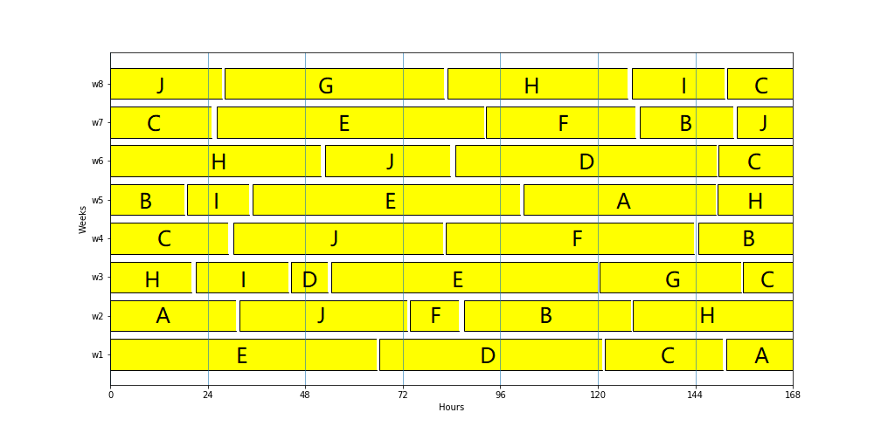

Figure 1. Optimal Production Schedule of an 8-week case, using Liu et al.’s exact constraints in MTZ form without modification. Compare with Figure 8 in Liu et al.

1. Results with DL subtour eliminations constraints

The production schedule obtained with DL subtour eliminations constraints look nothing like their MTZ counterparts. There are many transitions from one product to another, and the production line is used for only 5 hours (the minimum allowed by our model) for many products.

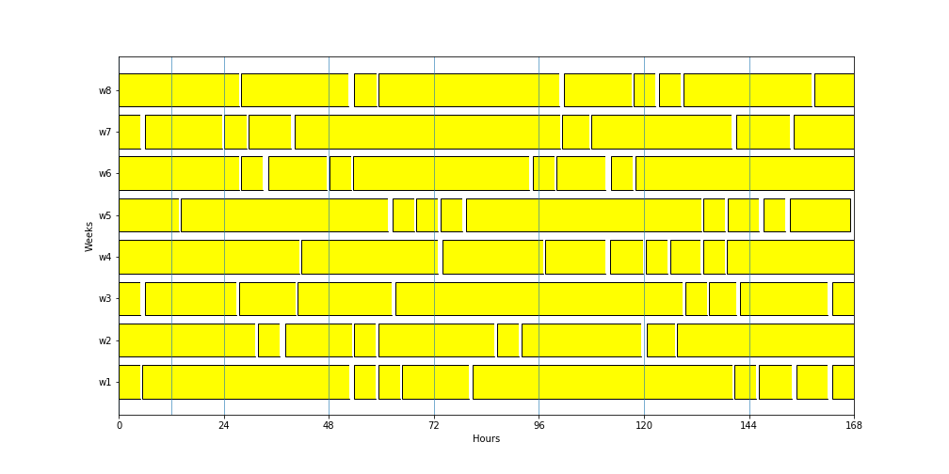

Figure 2. Optimal Production Schedule of an 8-week case, using DL constraints

1. Results with MTZ subtour elimination constraints and new θL

As we can see, the schedule below satisfies our new requirement that product A must be produced for 12 hours before all other products, and product B for 10 hours after every other product.

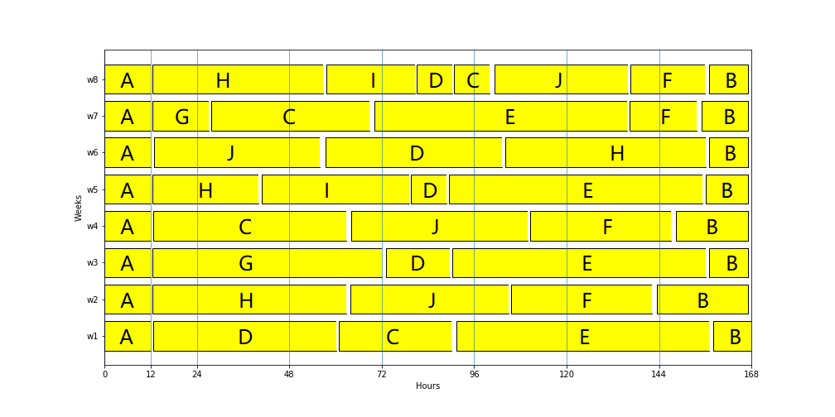

Figure 3. Optimal production schedule of an 8-week case that satisfies the additional MCF constraints.

1. **Comparisons of Other Variable Values with Liu et al.’s Results**

Liu et al. claimed in their solution of the 8-week case, only product J has an inventory of 0.42 tons at the end of week 4. In our attempt to replicate his results, we achieved far more cases of nonzero inventory usage. Details of our inventory levels could be found at the end of the TransitionPlanningUsingTSP_Original.ipynb file attached.

1. **Conclusions**

Mostly due to technological advancements in both software and hardware during the 11 years since the publication of Liu et al.’s results, we achieved a CPU time improvement by a factor of ~2.8 times (in the 8-week horizon case), and a marginally better objective function value when successfully replicating Liu et al.’s results. However, this also means we are unable to obtain the exact same results as Liu et al. regarding some by-product variables.

Replacing Liu et al.’s MTZ subtour elimination constraints with ones resulted in a CPU time improvement by a factor of ~92 times (in the 8-week horizon case), compared to Liu et al.’s results. There is a small sacrifice in the total profits achieved compared to both MTZ results (less than 4%), but the improvement should be recommended if numerous transitions is less of a concern.

Even with additional MCF constraints and constraints on θL, the minimum processing time parameter, the MCF model achieved CPU use times and objective function values between the MTZ and DL options. It also ran degree of magnitude faster than Liu et al.’s code, and satisfied our new requirements about production order. As such, we can declare all of the extension to Liu et al.’s proposed here improvements.

1. **References**
2. Erdirik-Dogan M., Grossmann I. E. “A Decomposition Method for the Simultaneous Planning and Scheduling of Single-Stage Continuous Multiproduct Plants”. *Ind. Eng. Chem. Res.* **2006**, 45, 299-315.
3. Liu S., Pinto J. M., Papageorgiou L. G. “A TSP-based MILP Model for Medium-Term Planning of Single-Stage Continuous Multiproduct Plants”, *Ind. Eng. Chem. Res.,***2008**, 47, 7733-7743.
4. Öncan T., Altınel I. K., Laporte G. A. “A Comparative Analysis of Several Asymmetric Traveling Salesman Problem Formulations”, *Comput. Oper. Res.*, **2009**, 36, 637-654.
5. Wong R. T. “Integer programming formulations of the traveling salesman problem.” *Proceedings of the IEEE international conference of circuits and computers*, **1980**, 149–52.