Systems Operational Dependency Analysis (SODA) GUI 2.2 manual

Start
Select “Systems Operational Dependency Analysis (SODA)” in the menu in the main GUI.
The following window opens. The user can choose among three possibilities.

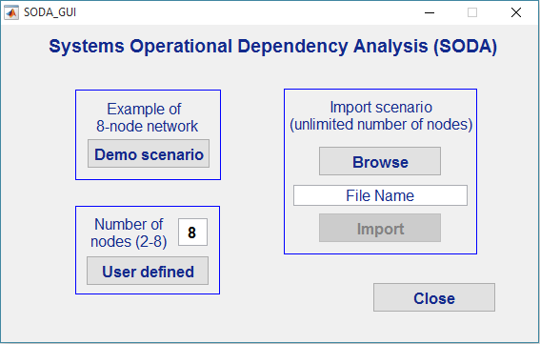

Demo Scenario

Loading the scenario
Click the “Demo Scenario” button. A Littoral Combat Warfare scenario, comprised of 8 nodes, will be loaded, and the main SODA window will appear. While the topology cannot be modified, inputs for the demo scenario are loaded, but can be modified by the user.

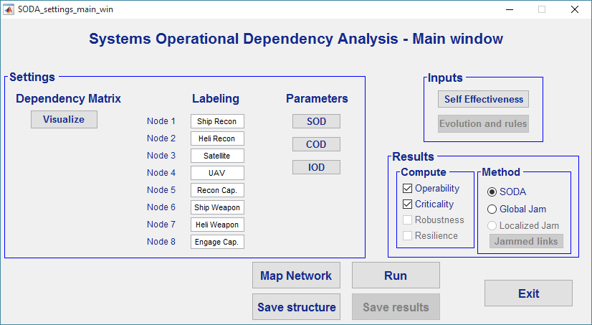

Settings and parameters

Dependencies
Click the “Visualize” button to visualize the matrix of dependencies. The whole window and the columns of the matrix are resizable. A tick in a cell means that the node in the corresponding column has an operational dependency on the node in the corresponding row.

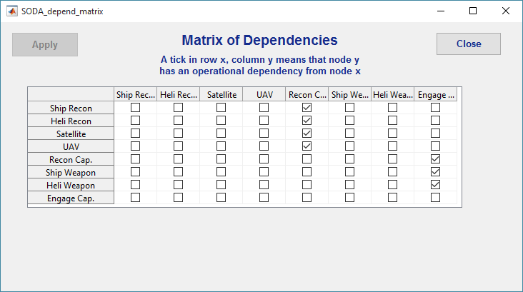

Labels
Labels of the nodes can be modified using the corresponding text boxes in the main window. The labels will appear in the matrices and results window.

Parameters of the dependency
Click the “SOD” (Strength of dependency), “COD” (Criticality of Dependency), and “IOD” (Impact of Dependency) buttons to visualize and modify the parameters of the operational dependencies. New windows will pop up.

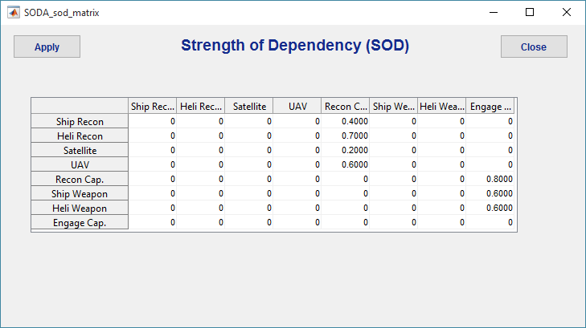
SOD values range between 0 and 1, and a SOD value must be given for each dependency in the dependency matrix. When the desired values have been input into the matrix, click the “Apply” button.

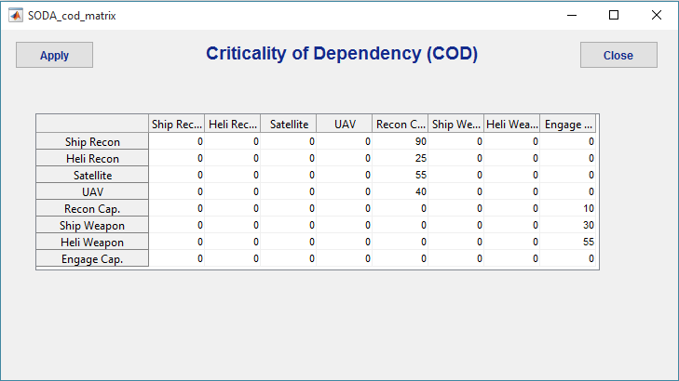

COD values range between 0 and 100, and a COD value must be given for each dependency in the dependency matrix. When the desired values have been input into the matrix, click the “Apply” button.

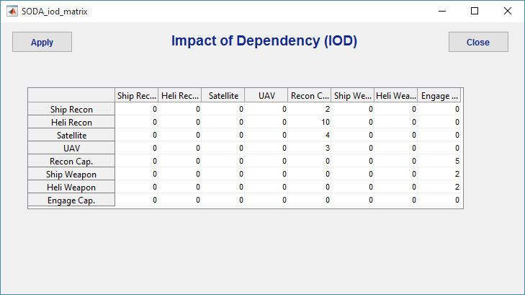

IOD values range between 1 and 100, and a IOD value must be given for each dependency in the dependency matrix When the desired values have been input into the matrix, click the “Apply” button.

SODA network mapping
Click the “Map Network” button to visualize a graphic representation of the operational dependency network under analysis. Each node represents a system or a capability, and each edge represents an operational dependency.

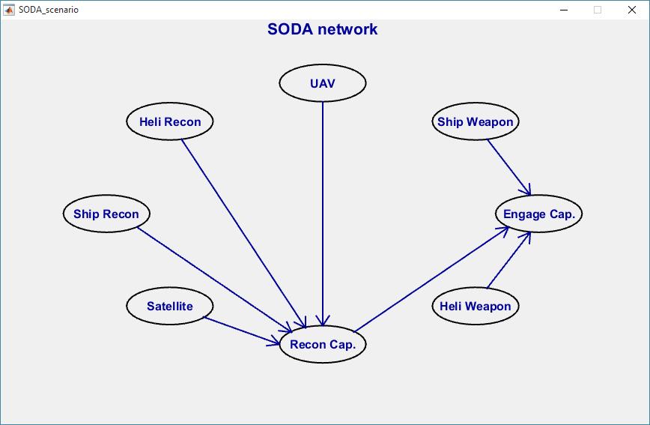

Node inputs
Click the “Self Effectiveness” button to visualize and modify the input regarding the internal status of each system. A new window will pop up:

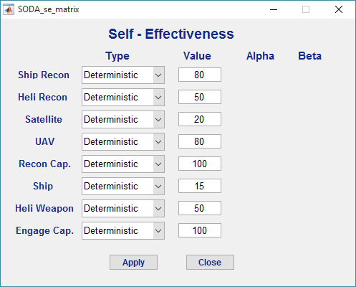
For each node, the internal status can be a deterministic value (as in the sample scenario showed above) ranging between 0 and 100, a uniform density between 0 and 100, or a beta density function, of which the user can specify the values of the parameters alpha and beta. When the desired values have been input, press the “Apply” button.

Results
Select the desired output. “Operability” will plot and list the operability levels of each node, given the topology, the parameters, and the current level of self-effectiveness. “Criticality” will rank the nodes by decreasing criticality (high criticality meaning that a disruption in that node will cause high loss in the overall operability), under various conditions.
Select the desired method. “SODA” performs the analysis with the basic SODA method. “Global Jam” performs the analysis in conditions where all the links between systems are partially disrupted (useful for cyber security considerations).
For both the computed outputs, and the method of analysis, more options might be added in future releases.

Running the analysis
Click the “Run” button to run the analysis and visualize the results. A new window pops up. If all the nodes have a deterministic value of Self-effectiveness, the result will show a plot of deterministic operabilities of each node (horizontal axis is the operability level), vertical axis has no meaning in this case.

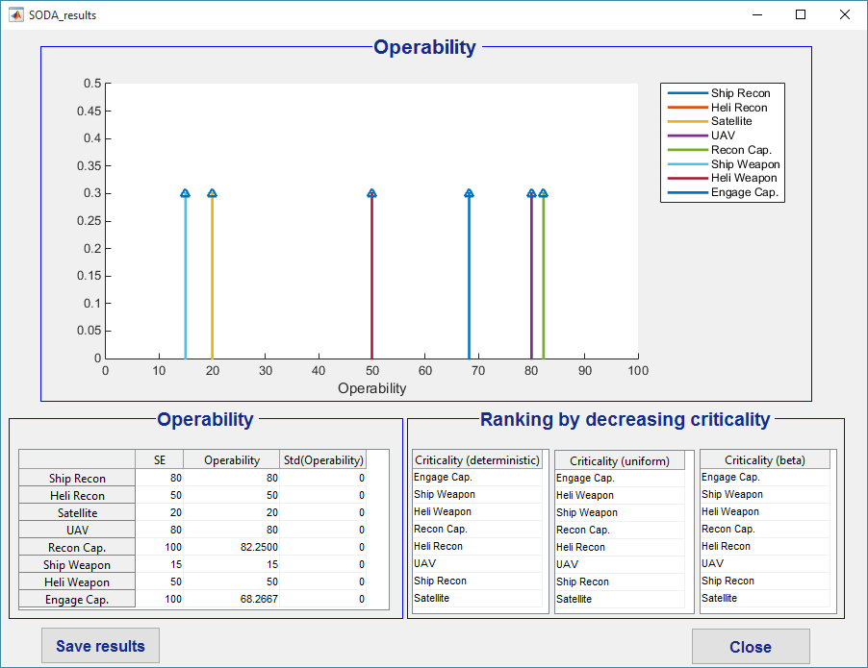
The self-effectiveness (internal status) and the operability (overall status, including the effect of dependencies) of each node is listed in the table in the bottom left. In the deterministic case, the standard deviation of the operability is 0. If the “criticality” check box is selected in the main window, the ranking of nodes by decreasing criticality is listed in the tables in the bottom right. The effect of disruption of each node’s self-effectiveness is computed for a failure to a deterministic value (self-effectiveness equals to 10), for a uniform density of self-effectiveness, and for a beta distribution of self-effectiveness (alpha equals to 5, beta equals to 2).
If at least one of the nodes has a probability density for its self-effectiveness, rather than a deterministic value, a Monte Carlo analysis is performed, simulating 20000 instances of the SODA model, with the corresponding probability density for the self-effectiveness of the nodes. The plot shows the probability density of the operability of each node having a non-deterministic value of operability, and the table on the bottom left reports the expected value and the standard deviation of the operability of each node.

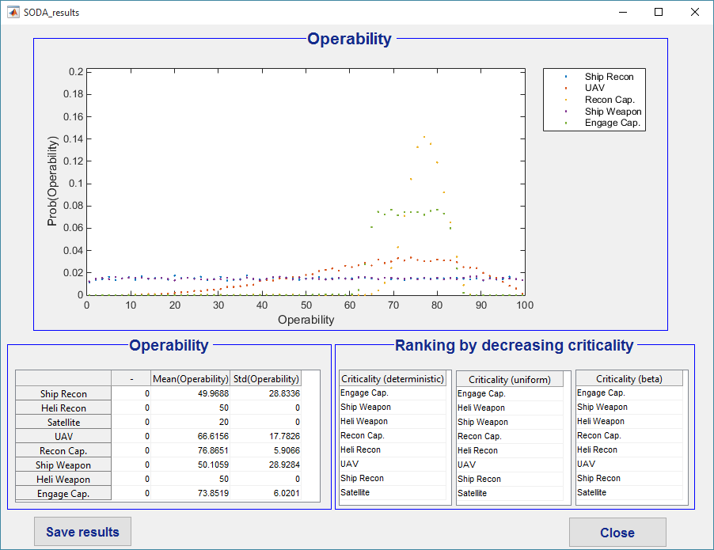

Saving the results
Once results have been generated, a “Save results” button will appear both in the main window, and in the results windows. Press the “Save results” button on either window and a dialogue window appears, to select an output MS Excel (.xlsx) file for the results.
If the results come from a deterministic analysis, the spreadsheet will list the node labels, and the value of the corresponding self-effectiveness and operability.

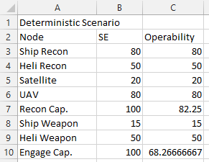

It the results come from a stochastic analysis, the spreadsheet will list the node labels, the type and value (or parameters) of the corresponding self-effectiveness, and the expected value and standard deviation of the operability.

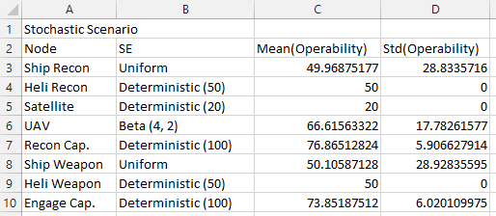

Saving the architecture
The user can save the dependency matrix, parameters matrices, self-effectiveness, and node labels for future use. Click the “Save structure” button in the main window and a dialogue window appears, to select an output MS Excel (.xlsx) file for the structure.
The file will have six spreadsheets, with the following information:
- Number of nodes
- Strength of Dependency matrix
- Criticality of Dependency matrix
- Impact of Dependency matrix
- Self-effectiveness (type, and value or parameters)
- Node labels

User-defined scenario
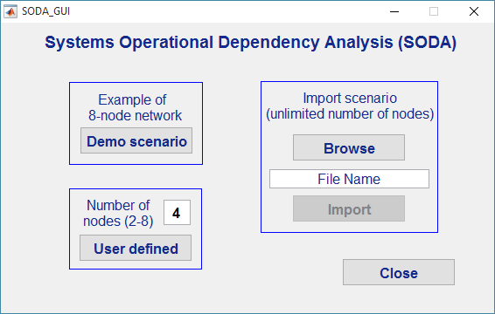

Loading the scenario
Select the number of nodes (2-8), and click the “User defined” button. An empty network, comprised of the number of nodes n defined by the user, will be loaded, and the main SODA windows will appear.

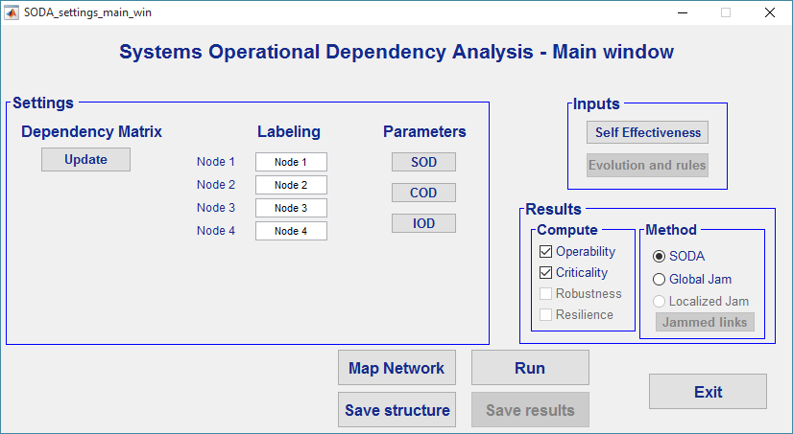

Settings and parameters

Dependencies
Click the “Update” button to input the matrix of dependencies. The network must be directed acyclic. Select the appropriate cells and click the “Apply” button.
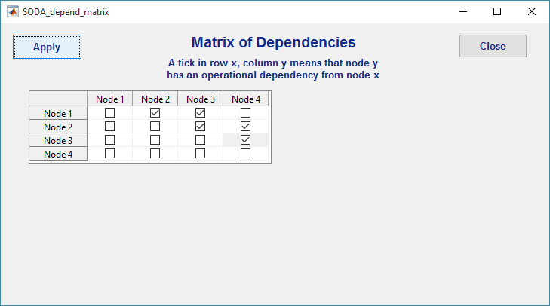

Labels
Labels of the nodes can be modified using the corresponding text boxes in the main window. The labels will appear in the matrices and results window.

Parameters of the dependency
Click the “SOD” (Strength of dependency), “COD” (Criticality of Dependency), and “IOD” (Impact of Dependency) buttons to input the parameters of the operational dependencies. New windows will pop up.

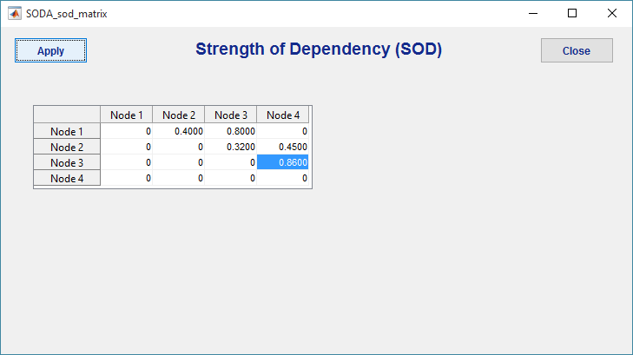
SOD values range between 0 and 1, and a SOD value must be given for each dependency in the dependency matrix. When the desired values have been input into the matrix, click the “Apply” button.
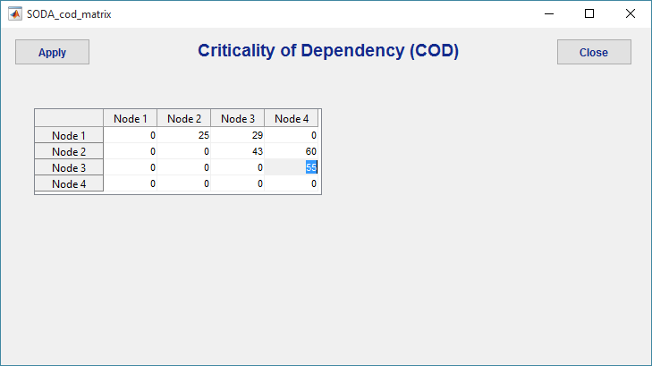

COD values range between 0 and 100, and a COD value must be given for each dependency in the dependency matrix. When the desired values have been input into the matrix, click the “Apply” button.

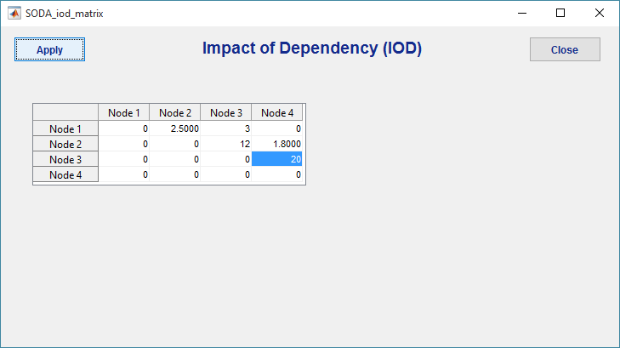

IOD values range between 1 and 100, and a IOD value must be given for each dependency in the dependency matrix When the desired values have been input into the matrix, click the “Apply” button.

SODA network mapping
Click the “Map Network” button to visualize a graphic representation of the operational dependency network under analysis. Each node represents a system or a capability, and each edge represents an operational dependency.

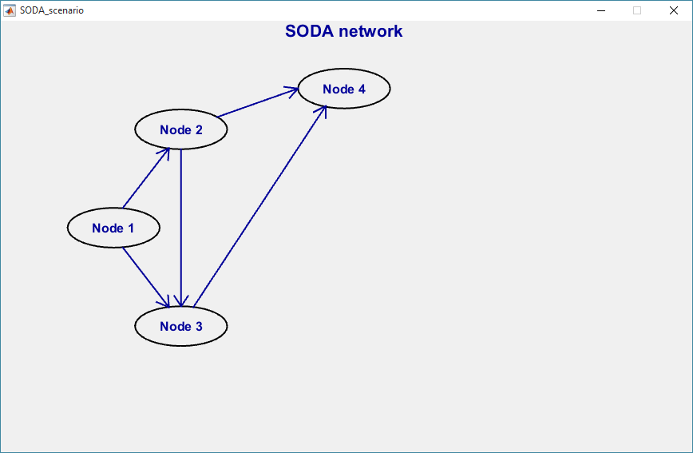

Node inputs
Click the “Self Effectiveness” button to visualize and modify the input regarding the internal status of each system. A new window will pop up:

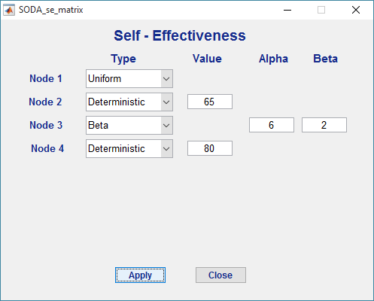

For each node, the internal status can be a deterministic value (nodes 2 and 4 in the figure above), ranging between 0 and 100, a uniform density (node 1 in the figure above) between 0 and 100, or a beta density function (node 3 in the figure above), of which the user can specify the values of the parameters alpha and beta.

Results
Select the desired output. “Operability” will plot and list the operability levels of each node, given the topology, the parameters, and the current level of self-effectiveness. “Criticality” will rank the nodes by decreasing criticality (high criticality meaning that a disruption in that node will cause high loss in the overall operability), under various conditions.
Select the desired method. “SODA” performs the analysis with the basic SODA method. “Global Jam” performs the analysis in conditions where all the links between systems are partially disrupted (useful for cyber security considerations).
For both the computed outputs, and the method of analysis, more options might be added in future releases.

Running the analysis
Click the “Run” button to run the analysis and visualize the results. A new window pops up. If all the nodes have a deterministic value of Self-effectiveness, the result will show a plot of deterministic operabilities of each node (horizontal axis is the operability level), vertical axis has no meaning in this case.

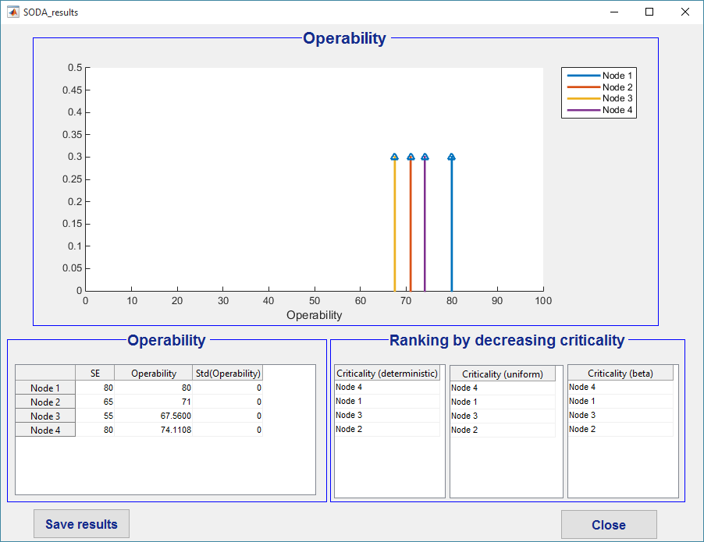
The self-effectiveness (internal status) and the operability (overall status, including the effect of dependencies) of each node is listed in the table in the bottom left. In the deterministic case, the standard deviation of the operability is 0. If the “criticality” check box is selected in the main window, the ranking of nodes by decreasing criticality is listed in the tables in the bottom right. The effect of disruption of each node’s self-effectiveness is computed for a failure to a deterministic value (self-effectiveness equals to 10), for a uniform density of self-effectiveness, and for a beta distribution of self-effectiveness (alpha equals to 5, beta equals to 2).
If at least one of the nodes has a probability density for its self-effectiveness, rather than a deterministic value, a Monte Carlo analysis is performed, simulating 20000 instances of the SODA model, with the corresponding probability density for the self-effectiveness of the nodes. The plot shows the probability density of the operability of each node having a non-deterministic value of operability, and the table on the bottom left reports the expected value and the standard deviation of the operability of each node.

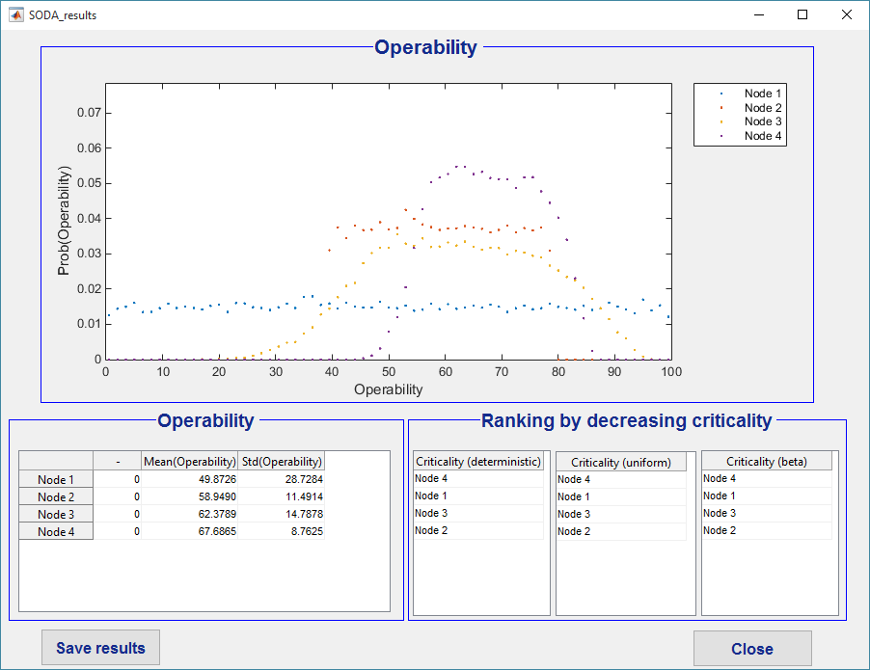

Saving the results
Once results have been generated, a “Save results” button will appear both in the main window, and in the results windows. Press the “Save results” button on either window and a dialogue window appears, to select an output MS Excel (.xlsx) file for the results.
If the results come from a deterministic analysis, the spreadsheet will list the node labels, and the value of the corresponding self-effectiveness and operability.

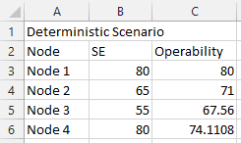

It the results come from a stochastic analysis, the spreadsheet will list the node labels, the type and value (or parameters) of the corresponding self-effectiveness, and the expected value and standard deviation of the operability.

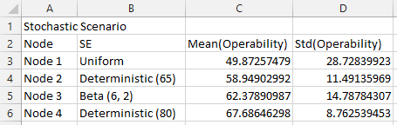

Saving the architecture
The user can save the dependency matrix, parameters matrices, self-effectiveness, and node labels for future use. Click the “Save structure” button in the main window and a dialogue window appears, to select an output MS Excel (.xlsx) file for the structure.
The file will have six spreadsheets, with the following information:
- Number of nodes
- Strength of Dependency matrix
- Criticality of Dependency matrix
- Impact of Dependency matrix
- Self-effectiveness (type, and value or parameters)
- Node labels

Import data from file
Version 2.1 of SODA Graphic User Interface allows the user to import data from an excel file, either created by the user or generated when saving the architecture during a previous run of the GUI. Importing from an excel file has two more advantages:
- the number of nodes is not limited to 8 (as it happens in the manual input)
- besides deterministic and stochastic values, a third type of input is available for the self-effectiveness: an array of deterministic values, that allow to perform analysis of the evolution of the operability over time, under variable conditions.

The Excel file
The data must be contained in an Excel (.xlsx) file, with five worksheets, and an optional sixth one. Files with .xls extension are not suitable for unix-based or Mac-OS-based machines.
The first sheet contains the number of nodes n, in the cell A1.

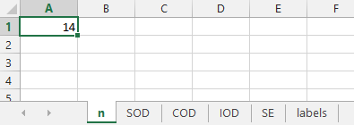

The second sheet contains the SOD matrix, of size n-by-n, starting in the cell A1. This matrix also defines the dependencies (non-zero terms), that must result in a directed acyclic network. For each dependency, SOD ranges between 0 and 1.

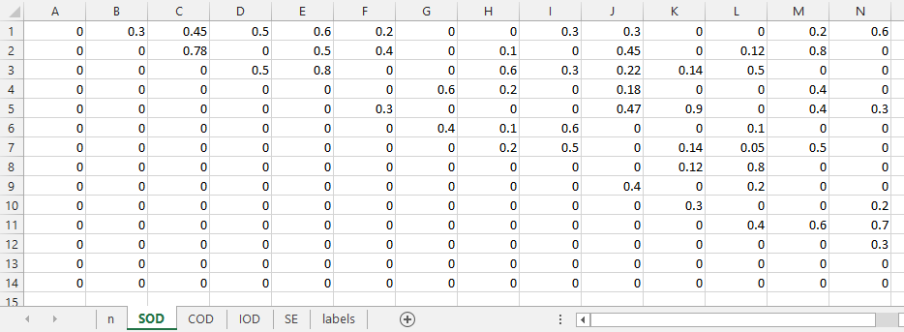

The third sheet contains the COD matrix, of size n-by-n, starting in the cell A1. The non-zero values correspond to non-zero values in the SOD matrix. For each dependency, COD ranges between 0 and 100.

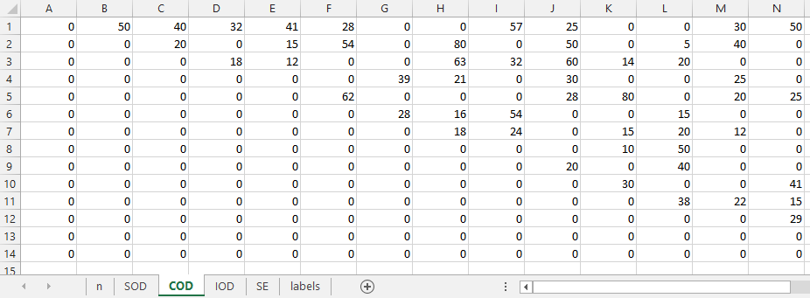
The fourth sheet contains the IOD matrix, of size n-by-n, starting in the cell A1. The non-zero values correspond to non-zero values in the SOD matrix. For each dependency, IOD ranges between 1 and 100.

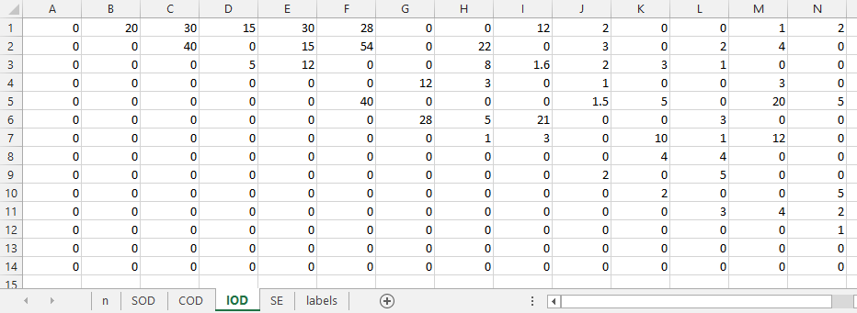

The fifth sheet contains the values for the Self-effectiveness. The first column is the type, that can be deterministic (the cell must contain “d”, “D”, “deterministic”, or “Deterministic”), uniform distribution (the cell must contain “u”, “U”, “uniform”, or “Uniform”), or beta distribution (the cell must contain “b”, “B”, “beta”, or “Beta”). If the type is uniform, no further data is needed. If the type is deterministic, a value ranging between 0 and 100 must be put in the corresponding cell in the second column. If the type is beta, two positive values must be put in the corresponding cells in the second and third column, for the alpha and beta parameters, respectively.

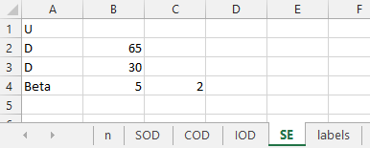

If the type is deterministic in each row, a third case (besides deterministic and partially or totally stochastic) can be used, that is an array of deterministic values. If needed, the last value of each row is copied to cells on the right, until all rows have the same length.

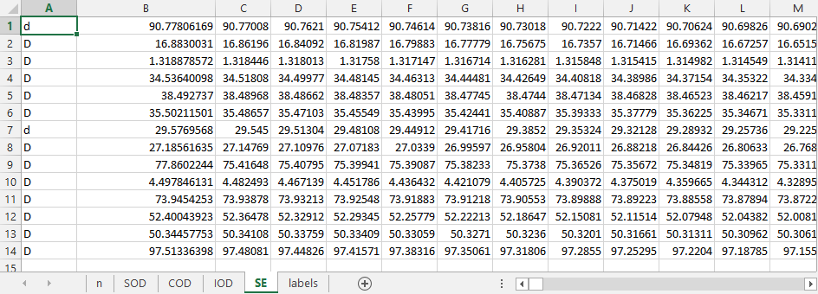

Loading the scenario
Click the “Browse” button. A browse windows will appear. Select the appropriate excel file. The name of the file will appear in the text box, and the “Import” button will become available.

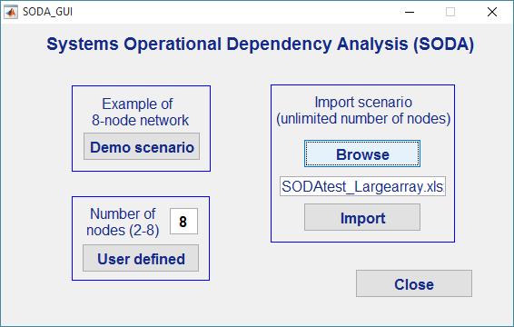

Click the “Import” button, to import the topology, the parameters, and the inputs. The main SODA window will appear. If the nodes are more than 8, the button to map the scenario, as well as text boxes to label nodes other than the first 8 will not be available. If the scenario is characterized by an array of deterministic values, the self-effectiveness button will not be available.

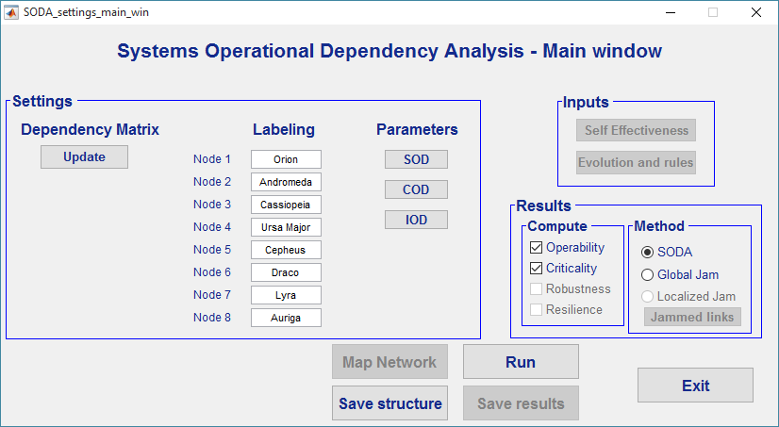

Settings and parameters

Dependencies
Click the “Update” button to visualize and modify the matrix of dependencies. The network must be directed acyclic. Select the appropriate cells and click the “Apply” button.

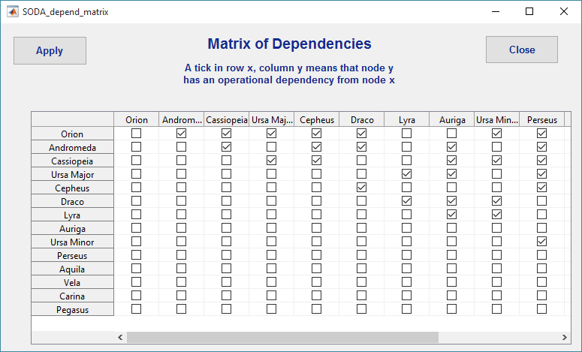

Labels
Labels of the first 8 nodes can be modified using the corresponding text boxes in the main window. The labels will appear in the matrices and results window.

Parameters of the dependency
Click the “SOD” (Strength of dependency), “COD” (Criticality of Dependency), and “IOD” (Impact of Dependency) buttons to visualize and modify the parameters of the operational dependencies. New windows will pop up.

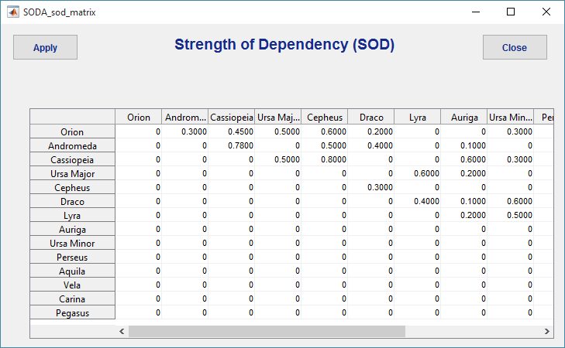

SOD values range between 0 and 1, and a SOD value must be given for each dependency in the dependency matrix. When the desired values have been input into the matrix, click the “Apply” button.

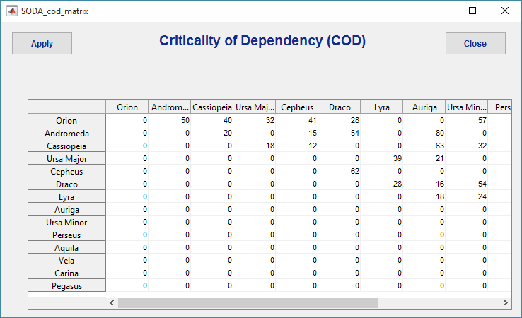

COD values range between 0 and 100, and a COD value must be given for each dependency in the dependency matrix. When the desired values have been input into the matrix, click the “Apply” button.

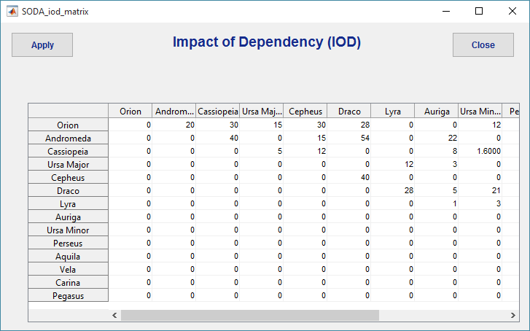

IOD values range between 1 and 100, and a IOD value must be given for each dependency in the dependency matrix When the desired values have been input into the matrix, click the “Apply” button.

SODA network mapping
Click the “Map Network” button to visualize a graphic representation of the operational dependency network under analysis. Each node represents a system or a capability, and each edge represents an operational dependency. Mapping is available only if the number of nodes is 8 or less.



Node inputs
Click the “Self Effectiveness” button to visualize and modify the input regarding the internal status of each system. A new window will pop up. This button is available only if the initial case is not an array of deterministic values, and only the first eight nodes can be treated.

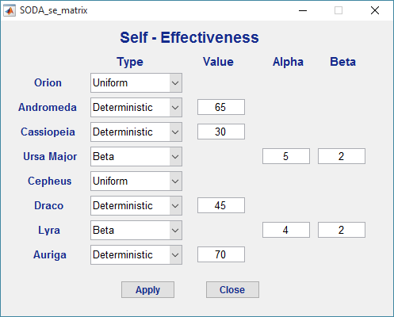

For each node, the internal status can be a deterministic value (nodes 2, 3, 6, and 8 in the figure above), ranging between 0 and 100, a uniform density (nodes 1 and 5 in the figure above) between 0 and 100, or a beta density function (nodes 4 and 7 in the figure above), of which the user can specify the values of the parameters alpha and beta.

Results
Select the desired output. “Operability” will plot and list the operability levels of each node, given the topology, the parameters, and the current level of self-effectiveness. “Criticality” will rank the nodes by decreasing criticality (high criticality meaning that a disruption in that node will cause high loss in the overall operability), under various conditions.
Select the desired method. “SODA” performs the analysis with the basic SODA method. “Global Jam” performs the analysis in conditions where all the links between systems are partially disrupted (useful for cyber security considerations).
For both the computed outputs, and the method of analysis, more options might be added in future releases.

Running the analysis
Click the “Run” button to run the analysis and visualize the results. A new window pops up. If all the nodes have a deterministic value of Self-effectiveness, the result will show a plot of deterministic operabilities of each node (horizontal axis is the operability level), vertical axis has no meaning in this case.

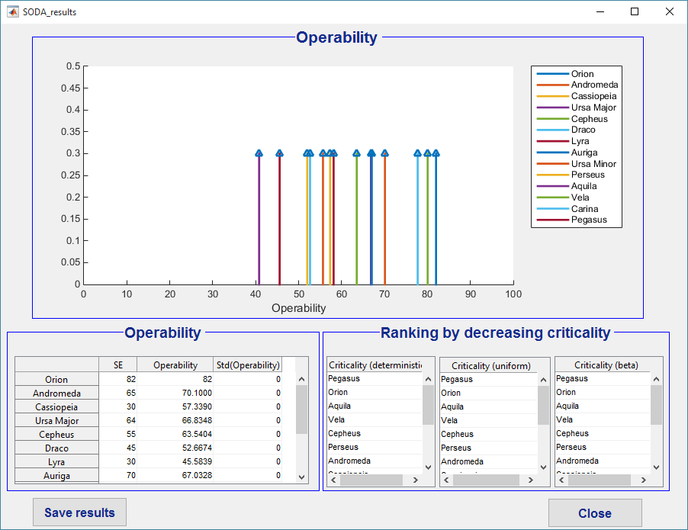
The self-effectiveness (internal status) and the operability (overall status, including the effect of dependencies) of each node is listed in the table in the bottom left. In the deterministic case, the standard deviation of the operability is 0. If the “criticality” check box is selected in the main window, the ranking of nodes by decreasing criticality is listed in the tables in the bottom right. The effect of disruption of each node’s self-effectiveness is computed for a failure to a deterministic value (self-effectiveness equals to 10), for a uniform density of self-effectiveness, and for a beta distribution of self-effectiveness (alpha equals to 5, beta equals to 2).
If at least one of the nodes has a probability density for its self-effectiveness, rather than a deterministic value, a Monte Carlo analysis is performed, simulating 20000 instances of the SODA model, with the corresponding probability density for the self-effectiveness of the nodes. The plot shows the probability density of the operability of each node having a non-deterministic value of operability, and the table on the bottom left reports the expected value and the standard deviation of the operability of each node.

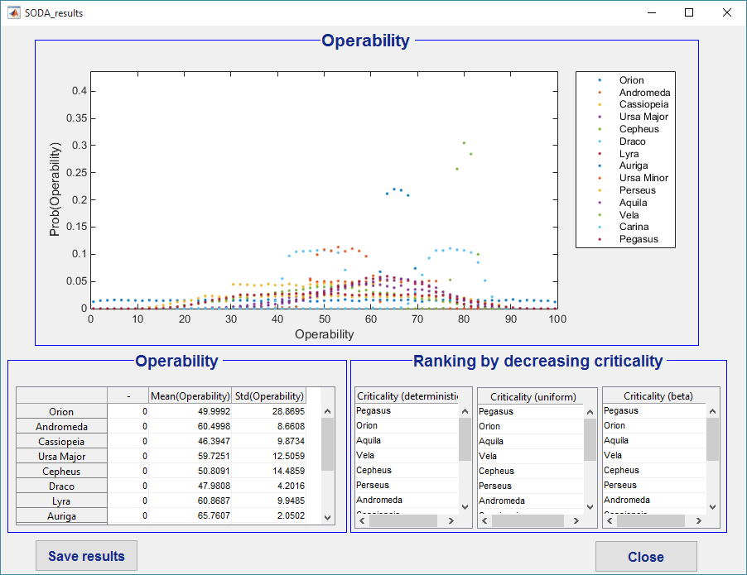

If the input is an array of deterministic value, the plot shows the evolution of operability over time, accounting for self-effectiveness and impact of the dependencies. The horizontal axis is time and the vertical axis is operability. The table on the bottom left reports the average self-effectiveness and operability of each node over time.

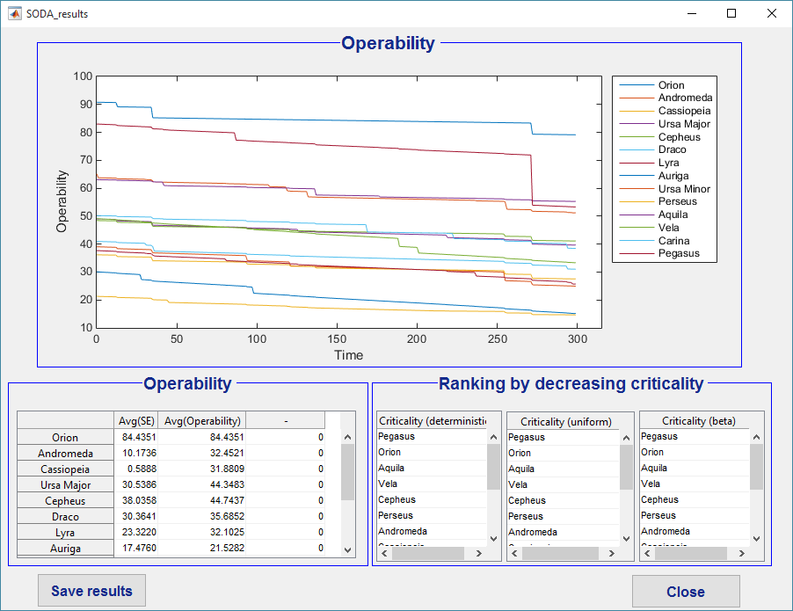

Saving the results
Once results have been generated, a “Save results” button will appear both in the main window, and in the results windows. Press the “Save results” button on either window and a dialogue window appears, to select an output MS Excel (.xlsx) file for the results.
If the results come from a deterministic analysis, the spreadsheet will list the node labels, and the value of the corresponding self-effectiveness and operability.

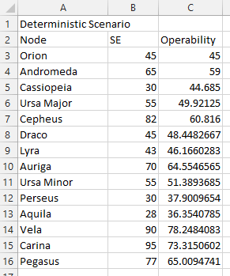

It the results come from a stochastic analysis, the spreadsheet will list the node labels, the type and value (or parameters) of the corresponding self-effectiveness, and the expected value and standard deviation of the operability.

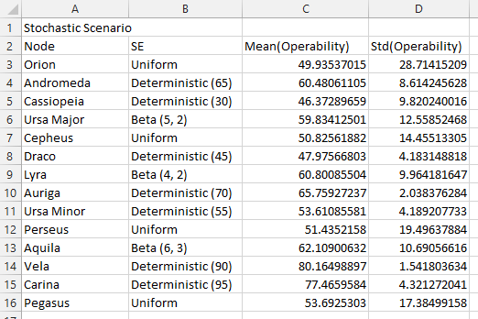

If the results come from an array of deterministic value, the spreadsheet will list the node labels, and the self-effectiveness and operability of each node at each time step.

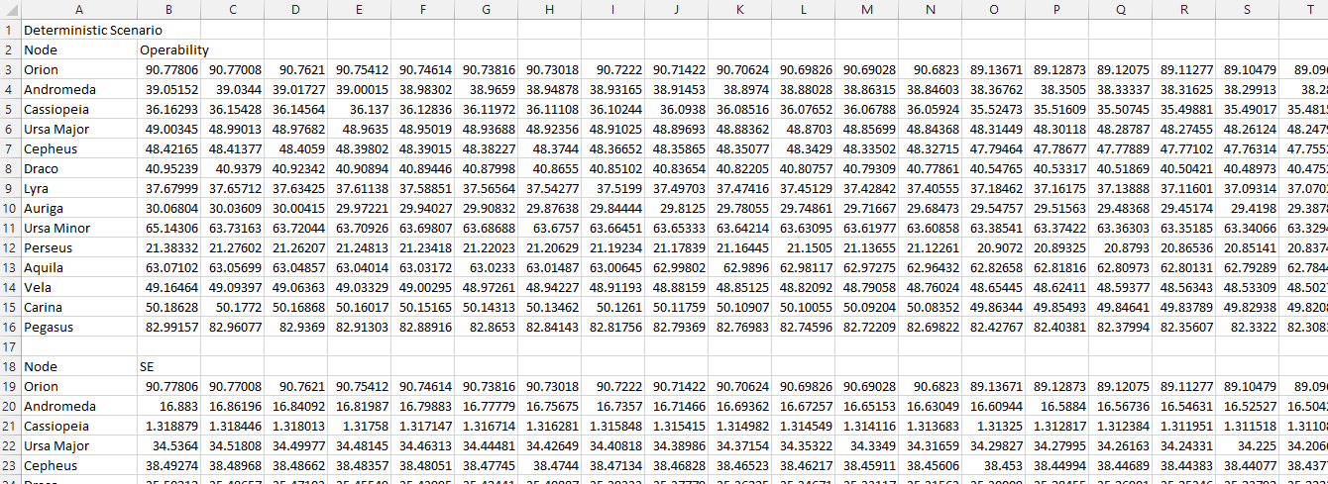

Saving the architecture
The user can save the dependency matrix, parameters matrices, self-effectiveness, and node labels for future use. Click the “Save structure” button in the main window and a dialogue window appears, to select an output MS Excel (.xlsx) file for the structure.
The file will have six spreadsheets, with the following information:
- Number of nodes
- Strength of Dependency matrix
- Criticality of Dependency matrix
- Impact of Dependency matrix
- Self-effectiveness (type, and value or parameters)
- Node labels
Index
1 Start 1
2 Demo Scenario 1
2.1 Loading the scenario 1
2.2 Settings and parameters 2
2.2.1 Dependencies 2
2.2.2 Labels 2
2.2.3 Parameters of the dependency 2
2.3 SODA network mapping 4
2.4 Node inputs 4
2.5 Results 5
2.6 Running the analysis 5
2.7 Saving the results 6
2.8 Saving the architecture 7
3 User-defined scenario 8
3.1 Loading the scenario 8
3.2 Settings and parameters 8
3.2.1 Dependencies 8
3.2.2 Labels 9
3.2.3 Parameters of the dependency 9
3.3 SODA network mapping 11
3.4 Node inputs 11
3.5 Results 12
3.6 Running the analysis 12
3.7 Saving the results 13
3.8 Saving the architecture 14
4 Import data from file 14
4.1 The Excel file 15
4.2 Loading the scenario 17
4.3 Settings and parameters 18
4.3.1 Dependencies 18
4.3.2 Labels 18
4.3.3 Parameters of the dependency 18
4.4 SODA network mapping 20
4.5 Node inputs 20
4.6 Results 21
4.7 Running the analysis 21
4.8 Saving the results 23
4.9 Saving the architecture 24

