线程使用vector创建

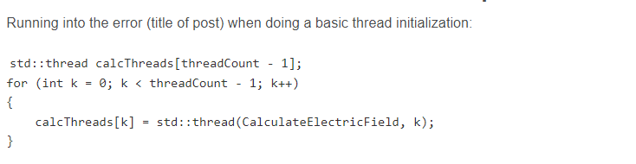



<https://github.com/XunzhiWen/ECE6122/blob/main/Lab1/main.cpp>

正则表达式

<https://cloud.tencent.com/developer/article/1560390>

vector清空

<https://www.cnblogs.com/zhanggaofeng/p/9338681.html>

计时器

<https://blog.csdn.net/weixin_42322256/article/details/124060870>

锁

<https://www.cnblogs.com/tdyizhen1314/p/16858048.html>

pair

<https://blog.csdn.net/sevenjoin/article/details/81937695>

四舍五入

<https://blog.csdn.net/Gary_ghw/article/details/125498414>