**ECE 4122/6122 Lab 2: Using OpenMP to Calculate the Electric Field Produced by Array of Point Charges**

Zhining Zhang (903942246/zzhang3180)

**Objective:**

To understand and apply the principles of OpenMP for parallel calculations in a computationally-intensive problem related to the Electric Field calculations.

**Results:**

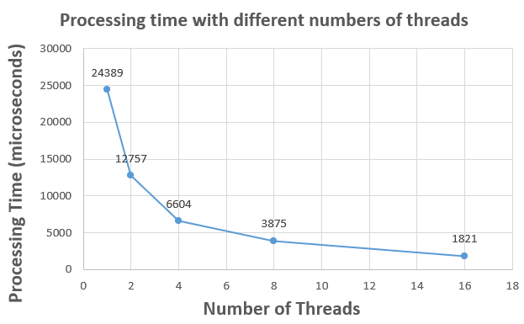

**Figure1**

As shown in Figure 1, as the number of threads increases, the processing time decreases, reducing the time to 1/2 of the original each time.

**Screenshots:**

