<https://blog.csdn.net/chen134225/article/details/107396923>

parallel内的变量为private，即每个线程互补干扰，外面的变量为share

以下2种方法结果相同

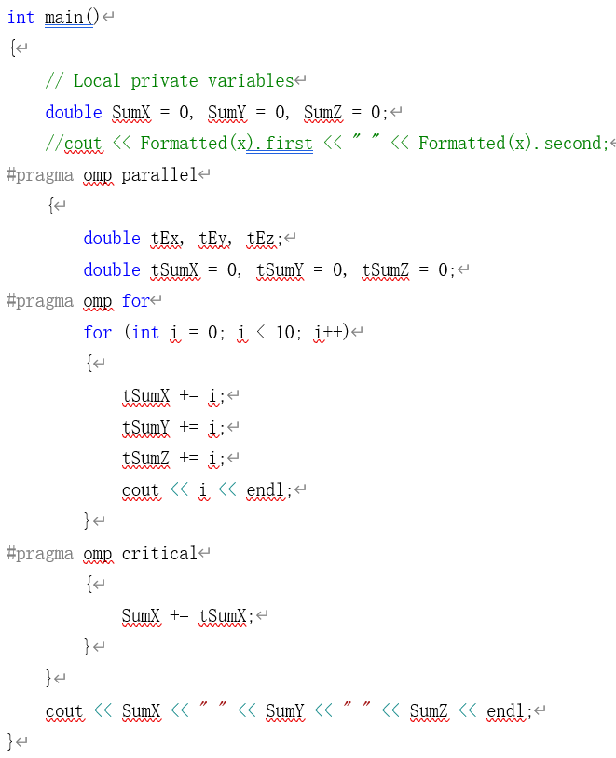 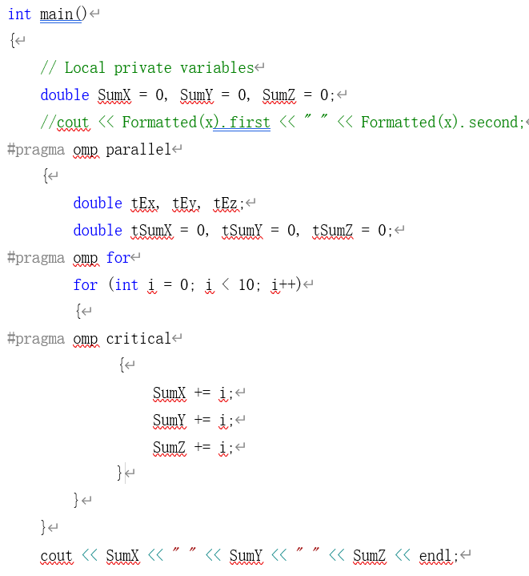

int main()

{

// Local private variables

double SumX = 0, SumY = 0, SumZ = 0;

//cout << Formatted(x).first << " " << Formatted(x).second;

#pragma omp parallel

{

double tEx, tEy, tEz;

double tSumX = 0, tSumY = 0, tSumZ = 0;

#pragma omp for

for (int i = 0; i < 10; i++)

{

#pragma omp critical

{

SumX += i;

SumY += i;

SumZ += i;

}

}

}

cout << SumX << " " << SumY << " " << SumZ << endl;