**python使用matlab**

https://blog.csdn.net/jcodery/article/details/118223812

**报错 AttributeError: module 'scipy' has no attribute 'io**

https://blog.csdn.net/qq_35860352/article/details/80209370

**anaconda环境**

https://www.cnblogs.com/brithToSpring/p/13494966.html

**matlab添加函数到路径**

https://blog.csdn.net/CRESPO_LYM/article/details/52061110

**警告：**

WARNING: You should compile the MEX version of "pointOp.c",

found in the MEX subdirectory of matlabPyrTools, and put it in your matlab path. It is MUCH faster.

根据github里面提示：

A few functions are actually MEX interfaces to C code. These are

contained in the subdirectory called MEX. The MEX files have been

tested on Sun (Solaris), LinuX (on an Intel platform), and Macintosh

OSX (on PowerPC and Intel), but should not be difficult to compile on

most other platforms. Source code is included in the MEX directory,

as well as Make files. Pre-compiled versions are included for a

number of platforms. To compile on your platform, simply run

compilePyrTools.m which is located in the MEX subdirectory.

运行compilePyrTools.m

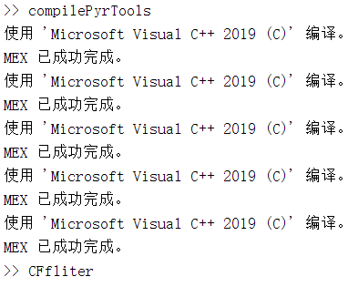

Anaconda 安装tqdm和pytorch(CPU)

<https://pytorch.org/get-started/locally/>

<https://zhuanlan.zhihu.com/p/319493995>

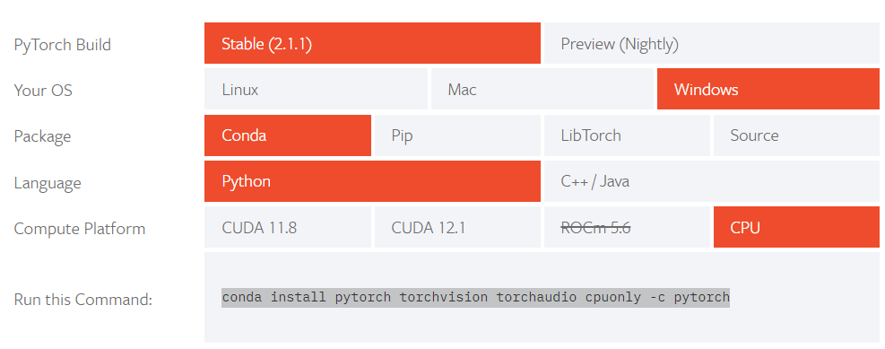

<https://blog.csdn.net/yuekangwei/article/details/113149382>

<https://blog.csdn.net/u014628771/article/details/80066624>

pycharm parse命令输入

<https://blog.csdn.net/oMoDao1/article/details/83316546>

sidd数据集提取

<https://github.com/open-mmlab/mmagic/blob/main/tools/dataset_converters/sidd/README_zh-CN.md>

