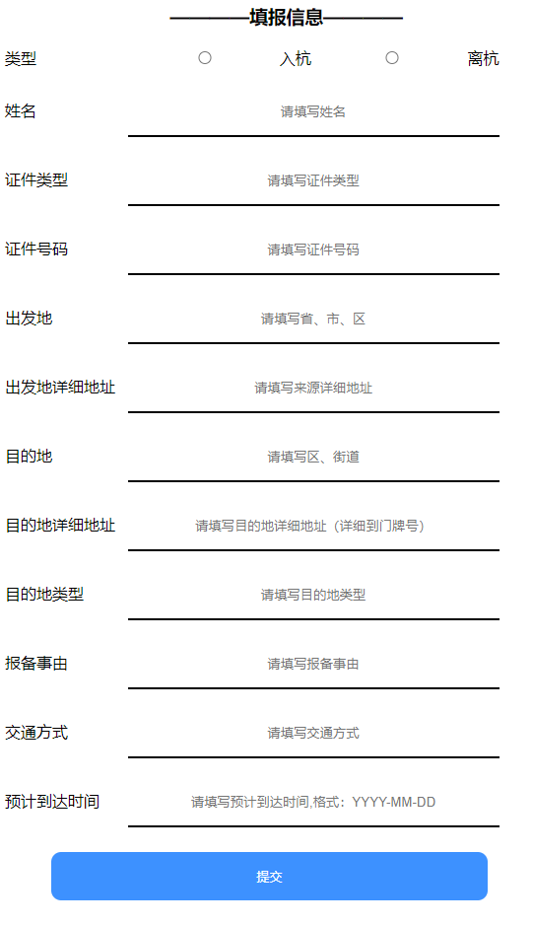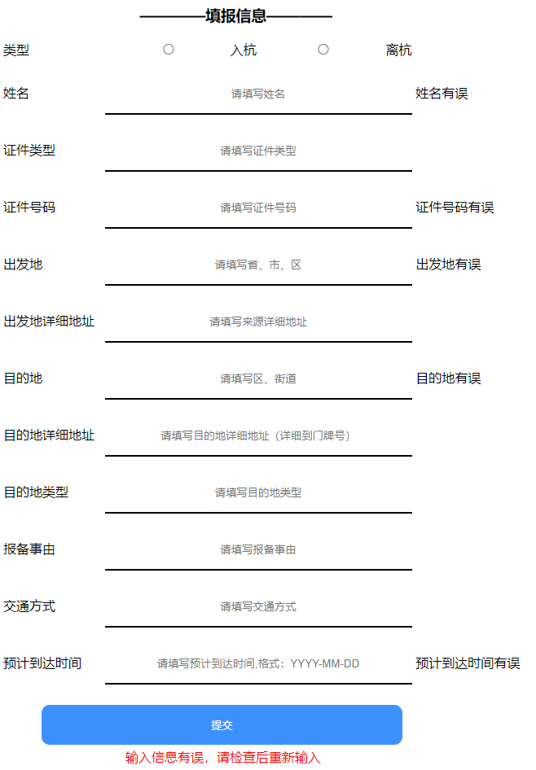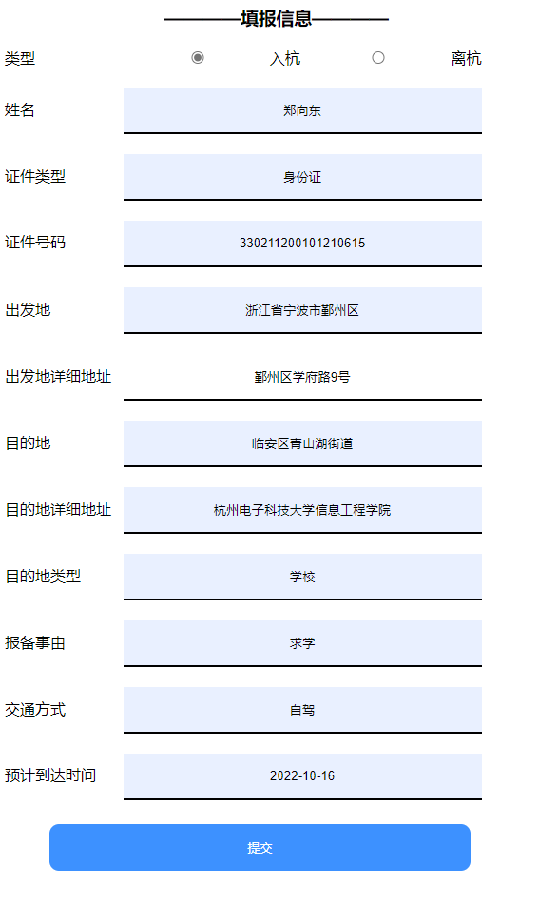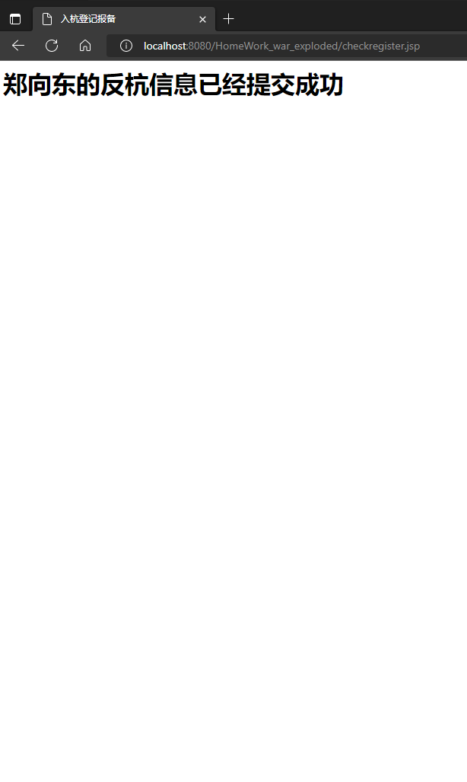

register.jsp代码

CSS部分：

<style>  
  
  
 input[type=text] {  
 padding: 16px 20px;  
 border: none;  
 border-bottom: 2px solid black;  
 width: 40%;  
 text-align-last: center;  
 }  
  
 input[type=radio] {  
 padding: 16px 20px;  
 border: none;  
 border-bottom: 2px solid black;  
 width: 15.5%;  
 text-align-last: center;  
 }  
  
 input[type=submit] {  
 background-color: dodgerblue;  
 border: none;  
 color: white;  
 padding: 16px 32px;  
 text-decoration: none;  
 margin: 4px 2px;  
 cursor: pointer;  
 border-radius: 10px;  
 width: 47%;  
 margin-left: 5%;  
  
 }  
  
  
 span {  
 width: 120px;  
 text-align: left;  
 display: inline-block;  
 }  
</style>

body部分：

<body>  
  
<h3 align="left">  
 &nbsp&nbsp&nbsp&nbsp&nbsp&nbsp&nbsp&nbsp&nbsp&nbsp&nbsp&nbsp&nbsp&nbsp&nbsp&nbsp&nbsp&nbsp&nbsp&nbsp&nbsp&nbsp&nbsp&nbsp&nbsp&nbsp&nbsp&nbsp&nbsp&nbsp————填报信息————</h3>  
<div style="width:100%;text-align:left">  
 <form action="checkregister.jsp" method="post" class="">  
  
 <label>  
 <span>类型</span>  
 <input type="radio" name="leixing" value="ruhang">入杭  
 <input type="radio" name="leixing" value="lihang">离杭  
 </label>  
  
 <br><br>  
  
  
 <label>  
 <span>姓名</span>  
 <input type="text" name="xingming" placeholder="请填写姓名">  
 <%=request.getAttribute("error_xingming") == null ? "" : request.getAttribute("error_xingming")  
 %>  
 </label>  
  
  
 <br><br>  
 <label>  
 <span>证件类型</span>  
 <input type="text" name="zhengjianleixing" placeholder="请填写证件类型">  
 </label>  
 <br><br>  
 <label>  
 <span>证件号码</span>  
 <input type="text" name="zhengjianhaoma" placeholder="请填写证件号码">  
 <%=request.getAttribute("error_zhengjianhaoma") == null ? "" : request.getAttribute("error_zhengjianhaoma")  
 %>  
 </label>  
 <br><br>  
 <label>  
 <span>出发地</span>  
 <input type="text" name="chufadi" placeholder="请填写省、市、区">  
 <%=request.getAttribute("error_chufadi") == null ? "" : request.getAttribute("error_chufadi")  
 %>  
 </label>  
 <br><br>  
 <label>  
 <span>出发地详细地址</span>  
 <input type="text" name="chufadixiangxidizhi" placeholder="请填写来源详细地址">  
 </label>  
 <br><br>  
 <label>  
 <span>目的地</span>  
 <input type="text" name="mudidi" placeholder="请填写区、街道">  
 <%=request.getAttribute("error_mudidi") == null ? "" : request.getAttribute("error_mudidi")  
 %>  
 </label>  
 <br><br>  
 <label>  
 <span>目的地详细地址</span>  
 <input type="text" name="mudidixiangxidizhi" placeholder="请填写目的地详细地址（详细到门牌号）">  
 </label>  
 <br><br>  
 <label>  
 <span>目的地类型</span>  
 <input type="text" name="mudidileixing" placeholder="请填写目的地类型">  
 </label>  
 <br><br>  
 <label>  
 <span>报备事由</span>  
 <input type="text" name="baobeishiyou" placeholder="请填写报备事由">  
 </label>  
 <br><br>  
 <label>  
 <span>交通方式</span>  
 <input type="text" name="jiaotongfangshi" placeholder="请填写交通方式">  
 </label>  
 <br><br>  
 <label>  
 <span>预计到达时间</span>  
 <input type="text" name="yujidaodashijian" placeholder="请填写预计到达时间,格式：YYYY-MM-DD">  
 <%=request.getAttribute("error_yujidaodashijian") == null ? "" : request.getAttribute("error_yujidaodashijian")  
 %>  
 </label>  
 <br>  
 <br>  
 <input type="submit" value="提交"/>  
 <div style="color: red;margin-left: 150px">  
 <%=request.getAttribute("error") == null ? "" : request.getAttribute("error")  
 %>  
 </div>  
  
 </form>  
</div>  
  
</body>

Checkregister.jsp代码

body部分：

<%  
 request.setCharacterEncoding("UTF-8");  
 String leixing1 = request.getParameter("leixing");  
 String xingming1 = request.getParameter("xingming");  
 String zhengjianleixing1 = request.getParameter("zhengjianleixing");  
 String zhengjianhaoma1 = request.getParameter("zhengjianhaoma");  
  
 String chufadi1 = request.getParameter("chufadi");  
 String chufadixiangxidizhi1 = request.getParameter("chufadixiangxidizhi");  
 String mudidi1 = request.getParameter("mudidi");  
 String mudidixiangxidizhi1 = request.getParameter("mudidixiangxidizhi");  
 String mudidileixing1 = request.getParameter("mudidileixing");  
 String baobeishiyou1 = request.getParameter("baobeishiyou");  
 String jiaotongfangshi1 = request.getParameter("jiaotongfangshi");  
 String yujidaodashijian1 = request.getParameter("yujidaodashijian");  
  
 boolean isxingming = false;  
 if (xingming1.matches("^[\\u4E00-\\u9FA5]+(·[\\u4E00-\\u9FA5]+)*$")) {  
 isxingming = true;  
 } else {  
 request.setAttribute("error_xingming", "姓名有误");  
 }  
 boolean iszhengjianleixing = true;  
  
 boolean iszhengjianhaoma = false;  
 if (zhengjianhaoma1.matches("^([1-6][1-9]|50)\\d{4}(18|19|20)\\d{2}((0[1-9])|10|11|12)(([0-2][1-9])|10|20|30|31)\\d{3}[0-9Xx]$") || zhengjianhaoma1.matches("/^([1-6][1-9]|50)\\d{4}\\d{2}((0[1-9])|10|11|12)(([0-2][1-9])|10|20|30|31)\\d{3}$")) {  
 iszhengjianhaoma = true;  
 } else {  
 request.setAttribute("error_zhengjianhaoma", "证件号码有误");  
 }  
 boolean ischufadi = false;  
 if (chufadi1.matches("^[\u4E00-\u9FA5]{9,45}$")) {  
 ischufadi = true;  
 } else {  
 request.setAttribute("error_chufadi", "出发地有误");  
 }  
 boolean ismudidi = false;  
 if (mudidi1.matches("^[\u4E00-\u9FA5]{7,45}$")) {  
 ismudidi = true;  
 } else {  
 request.setAttribute("error_mudidi", "目的地有误");  
 }  
  
 boolean isyujidaodashijian = false;  
 if (yujidaodashijian1.matches("((^((1[8-9]\\d{2})|([2-9]\\d{3}))([-\\/\\._])(10|12|0?[13578])([-\\/\\._])(3[01]|[12][0-9]|0?[1-9])$)|(^((1[8-9]\\d{2})|([2-9]\\d{3}))([-\\/\\._])(11|0?[469])([-\\/\\._])(30|[12][0-9]|0?[1-9])$)|(^((1[8-9]\\d{2})|([2-9]\\d{3}))([-\\/\\._])(0?2)([-\\/\\._])(2[0-8]|1[0-9]|0?[1-9])$)|(^([2468][048]00)([-\\/\\._])(0?2)([-\\/\\._])(29)$)|(^([3579][26]00)([-\\/\\._])(0?2)([-\\/\\._])(29)$)|(^([1][89][0][48])([-\\/\\._])(0?2)([-\\/\\._])(29)$)|(^([2-9][0-9][0][48])([-\\/\\._])(0?2)([-\\/\\._])(29)$)|(^([1][89][2468][048])([-\\/\\._])(0?2)([-\\/\\._])(29)$)|(^([2-9][0-9][2468][048])([-\\/\\._])(0?2)([-\\/\\._])(29)$)|(^([1][89][13579][26])([-\\/\\._])(0?2)([-\\/\\._])(29)$)|(^([2-9][0-9][13579][26])([-\\/\\._])(0?2)([-\\/\\._])(29)$))")) {  
 isyujidaodashijian = true;  
 } else {  
 request.setAttribute("error_yujidaodashijian", "预计到达时间有误");  
 }  
  
 if (isyujidaodashijian && iszhengjianhaoma && isxingming && ischufadi && iszhengjianleixing && ismudidi) {  
 } else {  
 request.setAttribute("error", "输入信息有误，请检查后重新输入");  
%>  
%>  
<**jsp:forward** page="register.jsp"/>  
<%  
 }  
%>  
  
<h1><%=xingming1%>的反杭信息已经提交成功</h1>  
  
</body>