源码：
Register.jsp
<%@ page import="cn.edu.hziee.model.User" %><%--
Created by IntelliJ IDEA.
User: z0701
Date: 2022/11/16
Time: 14:52
To change this template use File | Settings | File Templates.
--%>
<%@ page contentType="text/html;charset=UTF-8" language="java" %>
<html>
<head>
<title>Title</title>
</head>
<body>
<form action="abc.do" method="post">
<table width="279" border="0" align="center" cellpadding="0" cellspacing="1" bgcolor="#CCCCCC">
<tr>
<td colspan="2" align="center">用户注册</td>
</tr>
<tr>
<td width="64" bgcolor="#FFFFFF">用户名：</td>
<td bgcolor="#FFFFFF"><label><input type="text" name="username" size="10"></label></td>
</tr>
<tr>
<td bgcolor="#FFFFFF">性别：</td>
<td bgcolor="#FFFFFF"><label><input type="text" name="gender" size="10"></label></td>
</tr>
<tr>
<td bgcolor="#FFFFFF">年龄：</td>
<td bgcolor="#FFFFFF"><label><input type="text" name="age" size="10"></label></td>
</tr>
<tr>
<td colspan="2" align="center" style="color: red">
<input type="submit" value="注册">
<%=session.getAttribute("error") == null ? "" : session.getAttribute("error")%>
</td>
</tr>
</table>
</form>
</body>
</html>

User.java
package cn.edu.hziee.model;
public class User {
String userName;
String gender;
String age;
public User() {
}
public User(String userName, String gender, String age) {
this.userName = userName;
this.gender = gender;
this.age = age;
}
public String getUserName() {
return userName;
}
public void setUserName(String userName) {
this.userName = userName;
}
public String getGender() {
return gender;
}
public void setGender(String gender) {
this.gender = gender;
}
public String getAge() {
return age;
}
public void setAge(String age) {
this.age = age;
}
}

DBUtiles.java
package cn.edu.hziee.utils;
import java.sql.*;
import java.util.ArrayList;
import java.util.List;
public class DBUtils {
private static Connection conn = null;
private static PreparedStatement prestmt = null;
private static ResultSet rs = null;
public DBUtils() throws ClassNotFoundException, SQLException {
Class.forName("org.gjt.mm.mysql.Driver");
String url = "jdbc:mysql://127.0.0.1/demo?useUnicode=true&characterEncoding=utf8";
String user = "jsp";
String pwd = "jspjspjsp";
conn = DriverManager.getConnection(url, user, pwd);
System.out.println("success");
}
public static boolean insertData(String tableName,
String[] field,
String[] value) {
boolean flag = false;
System.out.println(value[0].length());
System.out.println(value[1].length());
if (field == null || value == null
|| field.length == 0 || value.length == 0 ||
field.length != value.length)
return flag;
String strField = "", strValue = "";
for (int i = 0; i < field.length; i++) {
strField += field[i] + ",";
strValue += "'" + value[i] + "',";
}
strField = strField.substring(0, strField.lastIndexOf(","));
strValue = strValue.substring(0, strValue.lastIndexOf(","));
try {
String sql = "insert into " + tableName;
sql += " (" + strField + ") values(";
sql += strValue + ")";
//关键的2行代码，实现数据添加
prestmt = conn.prepareStatement(sql);
int rscount = prestmt.executeUpdate();
if (rscount > 0)
flag = true;
} catch (SQLException e) {
e.printStackTrace();
}
return flag;
}
public boolean checkedRegister(String table, String column, String value) {
boolean flag = false;
try {
String sql = "select " + column + " from " + table + " where " + column + " = ?";
prestmt = conn.prepareStatement(sql);
prestmt.setString(1, value);
rs = prestmt.executeQuery();
if (rs.next()) {
flag = true;
}
} catch (SQLException e) {
e.printStackTrace();
}
return flag;
}
}

RegisterServlet.java
package cn.edu.hziee.servlet;
import cn.edu.hziee.model.User;
import cn.edu.hziee.utils.DBUtils;
import javax.servlet.RequestDispatcher;
import javax.servlet.ServletException;
import javax.servlet.http.HttpServlet;
import javax.servlet.http.HttpServletRequest;
import javax.servlet.http.HttpServletResponse;
import javax.servlet.http.HttpSession;
import java.io.IOException;
import java.io.PrintWriter;
import java.sql.SQLException;
import static cn.edu.hziee.utils.DBUtils.insertData;
public class RegisterServlet extends HttpServlet {
@Override
protected void doPost(HttpServletRequest request, HttpServletResponse response) throws ServletException, IOException {
request.setCharacterEncoding("UTF-8");
String userName = request.getParameter("username");
String gender = request.getParameter("gender");
String age = request.getParameter("age");
if (userName.length() == 0 | gender.length() == 0 | age.length() == 0) {
response.sendRedirect("register.jsp");
HttpSession session = request.getSession();
session.setAttribute("error", "输入信息有误请重新输入");
return;
}
try {
DBUtils db = new DBUtils();
if (!db.checkedRegister("user", "username", userName)) {
if (DBUtils.insertData("user", new String[]{"userName", "gender", "age"}, new String[]{userName, gender, age})) {
User user = new User(userName, gender, age);
HttpSession session = request.getSession();
session.setAttribute("user", user);
RequestDispatcher rd = request.getRequestDispatcher("success.jsp");
rd.forward(request, response);
} else {
response.sendRedirect("register.jsp");
HttpSession session = request.getSession();
session.setAttribute("error", "注册失败");
}
} else {
response.sendRedirect("register.jsp");
HttpSession session = request.getSession();
session.setAttribute("error", "用户名已存在");
}
} catch (ClassNotFoundException e) {
e.printStackTrace();
} catch (SQLException e) {
e.printStackTrace();
}
}
}

Success.jsp
<%@ page import="cn.edu.hziee.model.User" %><%--
Created by IntelliJ IDEA.
User: z0701
Date: 2022/11/16
Time: 14:59
To change this template use File | Settings | File Templates.
--%>
<%@ page contentType="text/html;charset=UTF-8" language="java" %>
<html>
<head>
<title>Title</title>
</head>
<body>
<%
User user = (User) session.getAttribute("user");
%>
恭喜<%=user.getUserName()%>注册成功 <br>
您的性别是:<%=user.getGender()%> <br>
您的年龄是:<%=user.getAge()%>
</body>
</html>

截图：
数据库表结构
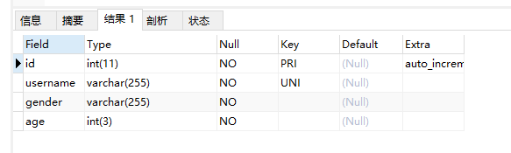
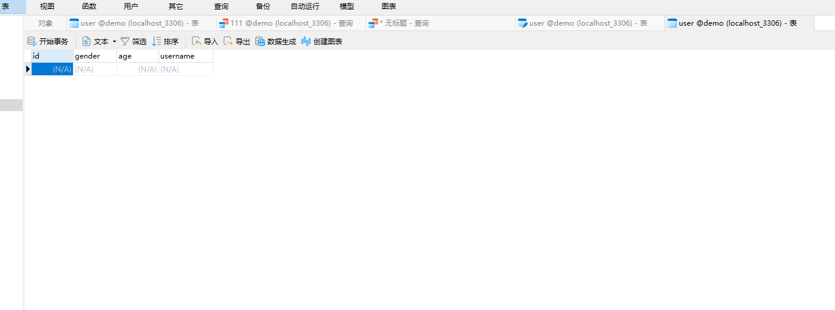
注册页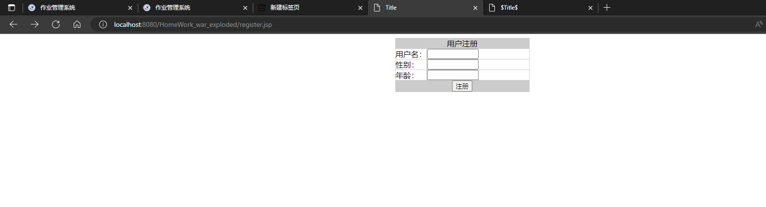
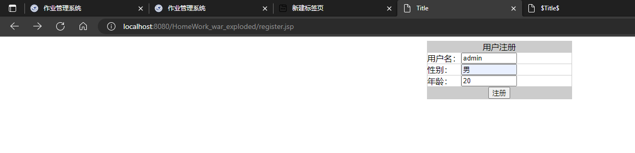
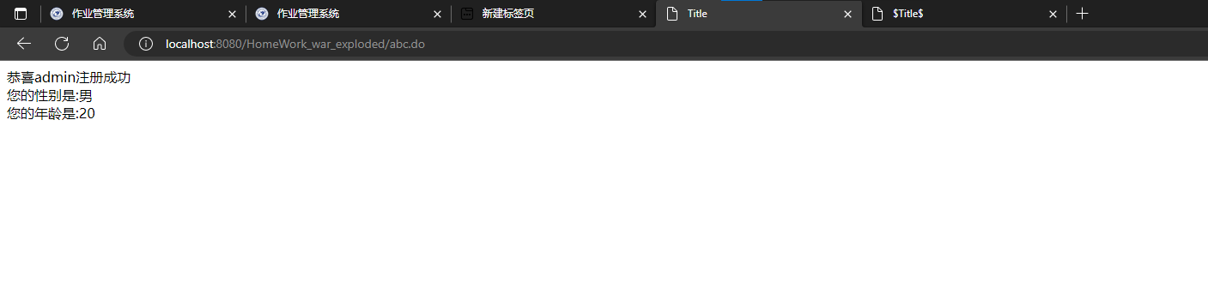
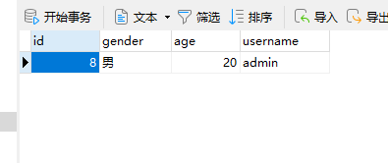

其他：
重复用户名检查
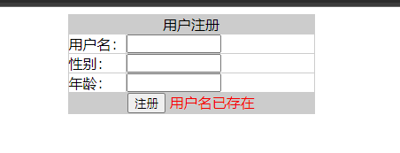
空值检查
