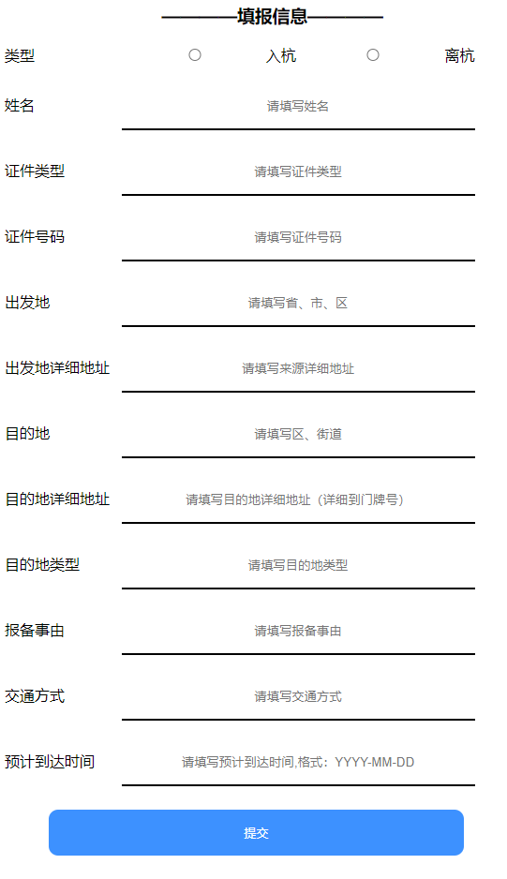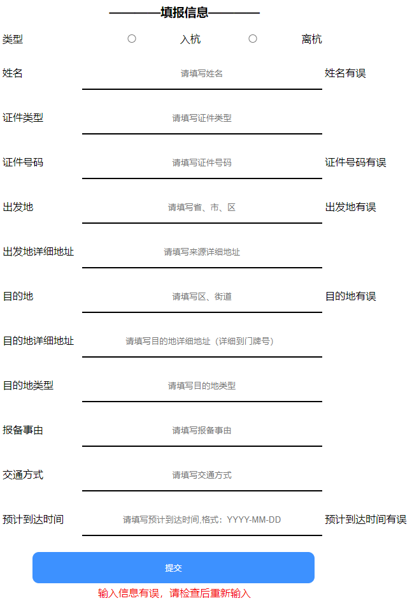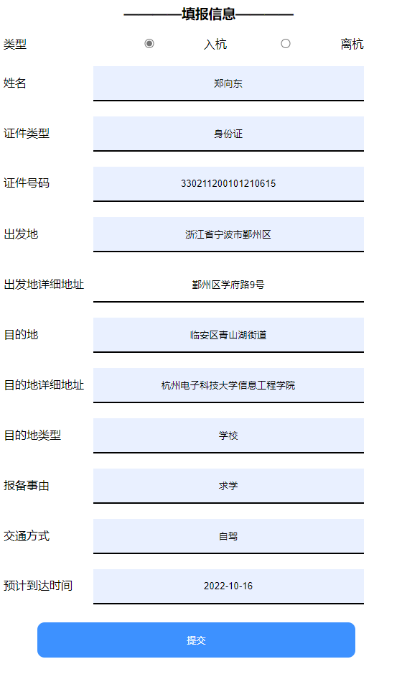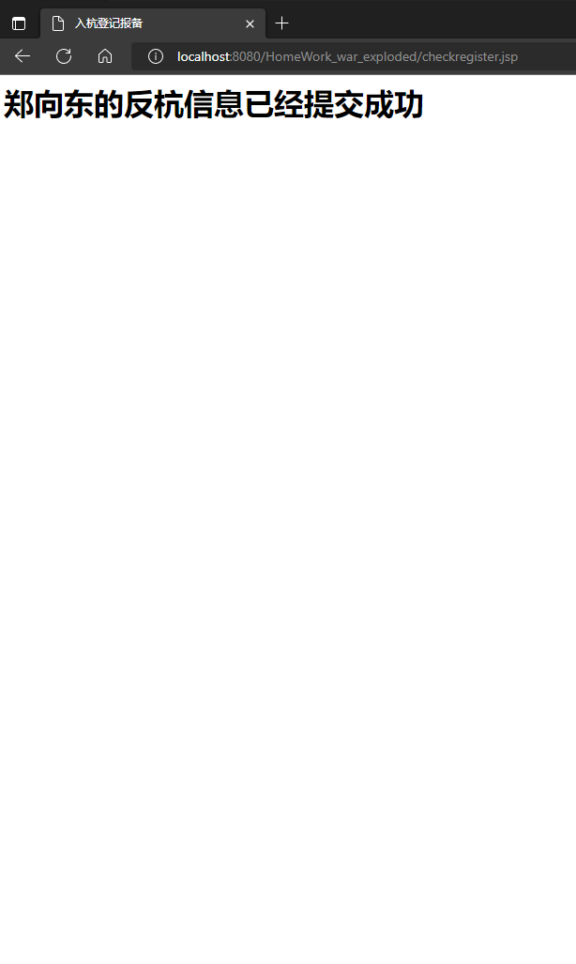
register.jsp代码
CSS部分：
<style>
input[type=text] {
padding: 16px 20px;
border: none;
border-bottom: 2px solid black;
width: 40%;
text-align-last: center;
}
input[type=radio] {
padding: 16px 20px;
border: none;
border-bottom: 2px solid black;
width: 15.5%;
text-align-last: center;
}
input[type=submit] {
background-color: dodgerblue;
border: none;
color: white;
padding: 16px 32px;
text-decoration: none;
margin: 4px 2px;
cursor: pointer;
border-radius: 10px;
width: 47%;
margin-left: 5%;
}
span {
width: 120px;
text-align: left;
display: inline-block;
}
</style>

body部分：
<body>
<h3 align="left">
&nbsp&nbsp&nbsp&nbsp&nbsp&nbsp&nbsp&nbsp&nbsp&nbsp&nbsp&nbsp&nbsp&nbsp&nbsp&nbsp&nbsp&nbsp&nbsp&nbsp&nbsp&nbsp&nbsp&nbsp&nbsp&nbsp&nbsp&nbsp&nbsp&nbsp————填报信息————</h3>
<div style="width:100%;text-align:left">
<form action="checkregister.jsp" method="post" class="">
<label>
<span>类型</span>
<input type="radio" name="leixing" value="ruhang">入杭
<input type="radio" name="leixing" value="lihang">离杭
</label>
<br><br>
<label>
<span>姓名</span>
<input type="text" name="xingming" placeholder="请填写姓名">
<%=request.getAttribute("error_xingming") == null ? "" : request.getAttribute("error_xingming")
%>
</label>
<br><br>
<label>
<span>证件类型</span>
<input type="text" name="zhengjianleixing" placeholder="请填写证件类型">
</label>
<br><br>
<label>
<span>证件号码</span>
<input type="text" name="zhengjianhaoma" placeholder="请填写证件号码">
<%=request.getAttribute("error_zhengjianhaoma") == null ? "" : request.getAttribute("error_zhengjianhaoma")
%>
</label>
<br><br>
<label>
<span>出发地</span>
<input type="text" name="chufadi" placeholder="请填写省、市、区">
<%=request.getAttribute("error_chufadi") == null ? "" : request.getAttribute("error_chufadi")
%>
</label>
<br><br>
<label>
<span>出发地详细地址</span>
<input type="text" name="chufadixiangxidizhi" placeholder="请填写来源详细地址">
</label>
<br><br>
<label>
<span>目的地</span>
<input type="text" name="mudidi" placeholder="请填写区、街道">
<%=request.getAttribute("error_mudidi") == null ? "" : request.getAttribute("error_mudidi")
%>
</label>
<br><br>
<label>
<span>目的地详细地址</span>
<input type="text" name="mudidixiangxidizhi" placeholder="请填写目的地详细地址（详细到门牌号）">
</label>
<br><br>
<label>
<span>目的地类型</span>
<input type="text" name="mudidileixing" placeholder="请填写目的地类型">
</label>
<br><br>
<label>
<span>报备事由</span>
<input type="text" name="baobeishiyou" placeholder="请填写报备事由">
</label>
<br><br>
<label>
<span>交通方式</span>
<input type="text" name="jiaotongfangshi" placeholder="请填写交通方式">
</label>
<br><br>
<label>
<span>预计到达时间</span>
<input type="text" name="yujidaodashijian" placeholder="请填写预计到达时间,格式：YYYY-MM-DD">
<%=request.getAttribute("error_yujidaodashijian") == null ? "" : request.getAttribute("error_yujidaodashijian")
%>
</label>
<br>
<br>
<input type="submit" value="提交"/>
<div style="color: red;margin-left: 150px">
<%=request.getAttribute("error") == null ? "" : request.getAttribute("error")
%>
</div>
</form>
</div>
</body>

Checkregister.jsp代码
body部分：
<%
request.setCharacterEncoding("UTF-8");
String leixing1 = request.getParameter("leixing");
String xingming1 = request.getParameter("xingming");
String zhengjianleixing1 = request.getParameter("zhengjianleixing");
String zhengjianhaoma1 = request.getParameter("zhengjianhaoma");
String chufadi1 = request.getParameter("chufadi");
String chufadixiangxidizhi1 = request.getParameter("chufadixiangxidizhi");
String mudidi1 = request.getParameter("mudidi");
String mudidixiangxidizhi1 = request.getParameter("mudidixiangxidizhi");
String mudidileixing1 = request.getParameter("mudidileixing");
String baobeishiyou1 = request.getParameter("baobeishiyou");
String jiaotongfangshi1 = request.getParameter("jiaotongfangshi");
String yujidaodashijian1 = request.getParameter("yujidaodashijian");
boolean isxingming = false;
if (xingming1.matches("^[\\u4E00-\\u9FA5]+(·[\\u4E00-\\u9FA5]+)*$")) {
isxingming = true;
} else {
request.setAttribute("error_xingming", "姓名有误");
}
boolean iszhengjianleixing = true;
boolean iszhengjianhaoma = false;
if (zhengjianhaoma1.matches("^([1-6][1-9]|50)\\d{4}(18|19|20)\\d{2}((0[1-9])|10|11|12)(([0-2][1-9])|10|20|30|31)\\d{3}[0-9Xx]$") || zhengjianhaoma1.matches("/^([1-6][1-9]|50)\\d{4}\\d{2}((0[1-9])|10|11|12)(([0-2][1-9])|10|20|30|31)\\d{3}$")) {
iszhengjianhaoma = true;
} else {
request.setAttribute("error_zhengjianhaoma", "证件号码有误");
}
boolean ischufadi = false;
if (chufadi1.matches("^[\u4E00-\u9FA5]{9,45}$")) {
ischufadi = true;
} else {
request.setAttribute("error_chufadi", "出发地有误");
}
boolean ismudidi = false;
if (mudidi1.matches("^[\u4E00-\u9FA5]{7,45}$")) {
ismudidi = true;
} else {
request.setAttribute("error_mudidi", "目的地有误");
}
boolean isyujidaodashijian = false;
if (yujidaodashijian1.matches("((^((1[8-9]\\d{2})|([2-9]\\d{3}))([-\\/\\._])(10|12|0?[13578])([-\\/\\._])(3[01]|[12][0-9]|0?[1-9])$)|(^((1[8-9]\\d{2})|([2-9]\\d{3}))([-\\/\\._])(11|0?[469])([-\\/\\._])(30|[12][0-9]|0?[1-9])$)|(^((1[8-9]\\d{2})|([2-9]\\d{3}))([-\\/\\._])(0?2)([-\\/\\._])(2[0-8]|1[0-9]|0?[1-9])$)|(^([2468][048]00)([-\\/\\._])(0?2)([-\\/\\._])(29)$)|(^([3579][26]00)([-\\/\\._])(0?2)([-\\/\\._])(29)$)|(^([1][89][0][48])([-\\/\\._])(0?2)([-\\/\\._])(29)$)|(^([2-9][0-9][0][48])([-\\/\\._])(0?2)([-\\/\\._])(29)$)|(^([1][89][2468][048])([-\\/\\._])(0?2)([-\\/\\._])(29)$)|(^([2-9][0-9][2468][048])([-\\/\\._])(0?2)([-\\/\\._])(29)$)|(^([1][89][13579][26])([-\\/\\._])(0?2)([-\\/\\._])(29)$)|(^([2-9][0-9][13579][26])([-\\/\\._])(0?2)([-\\/\\._])(29)$))")) {
isyujidaodashijian = true;
} else {
request.setAttribute("error_yujidaodashijian", "预计到达时间有误");
}
if (isyujidaodashijian && iszhengjianhaoma && isxingming && ischufadi && iszhengjianleixing && ismudidi) {
} else {
request.setAttribute("error", "输入信息有误，请检查后重新输入");
%>
%>
<jsp:forward page="register.jsp"/>
<%
}
%>
<h1><%=xingming1%>的反杭信息已经提交成功</h1>
</body>

