Data downloaded from Copernicus, monthly (1M) data for 2 years (jan 16, 2013 – jan 16, 2015)

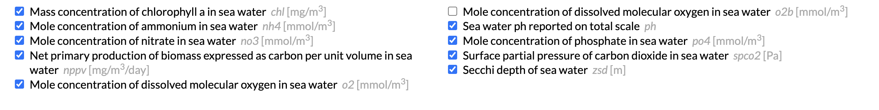

Plus T and Sal, temperature and salinity, from Phydical data

Note: NOT using spco2 because it does not show meaningful variation across Baltic

Note2: some variables were transformed by log(x+1,2) - “log” in the variable name

For log-transformed variables SDs were computed after log-transformed initial data.

Means (2014):

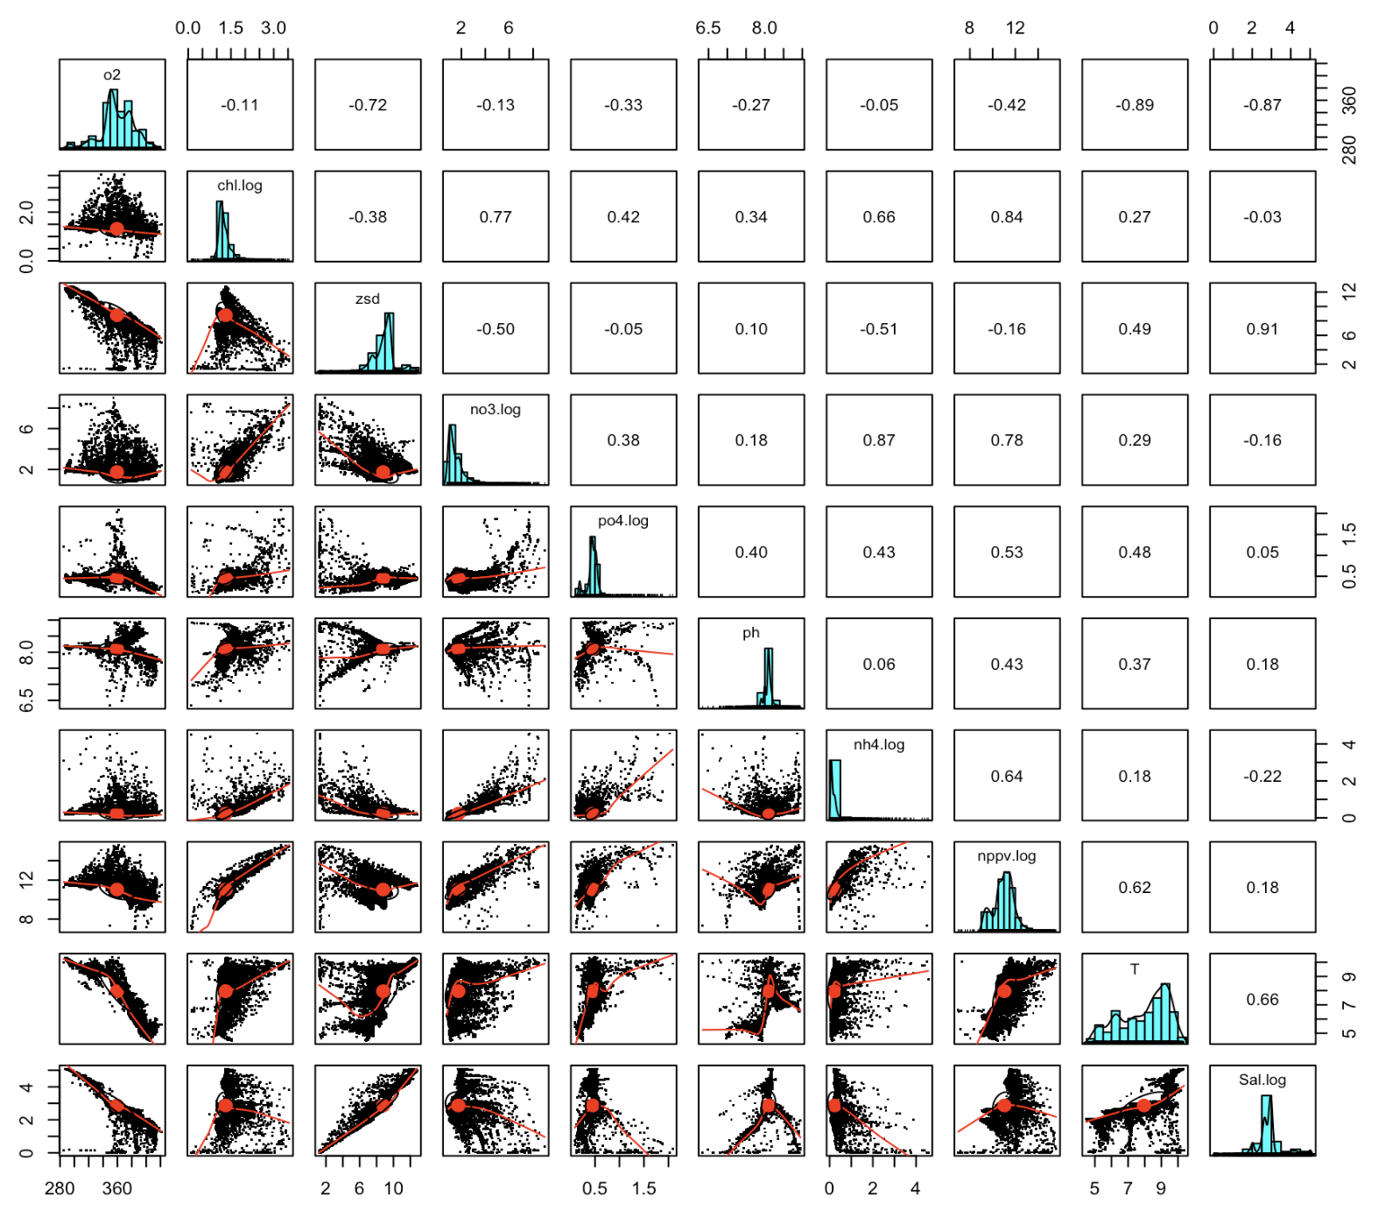

SDs:

