# Comp 3350: Computer Organization & Assembly Language

# HW # 6: Theme: Arithmetic and Procedures

*All main questions carry equal weight.*

*(Credit awarded to only those answers for which work has been shown.)*

1. [Arithmetic Expression] Write a program that computes y from the following arithmetic expression:

*y = mx + c.*  Use all values as signed words which are stored as variables in the memory. Show your results for different values of m, x and c.

**Signed Value Execution:**

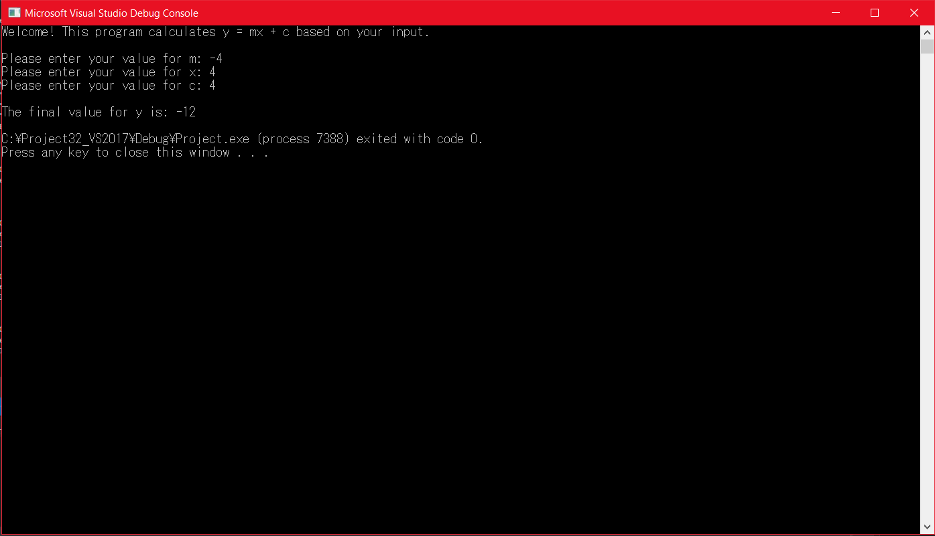

**Unsigned Value Execution:**

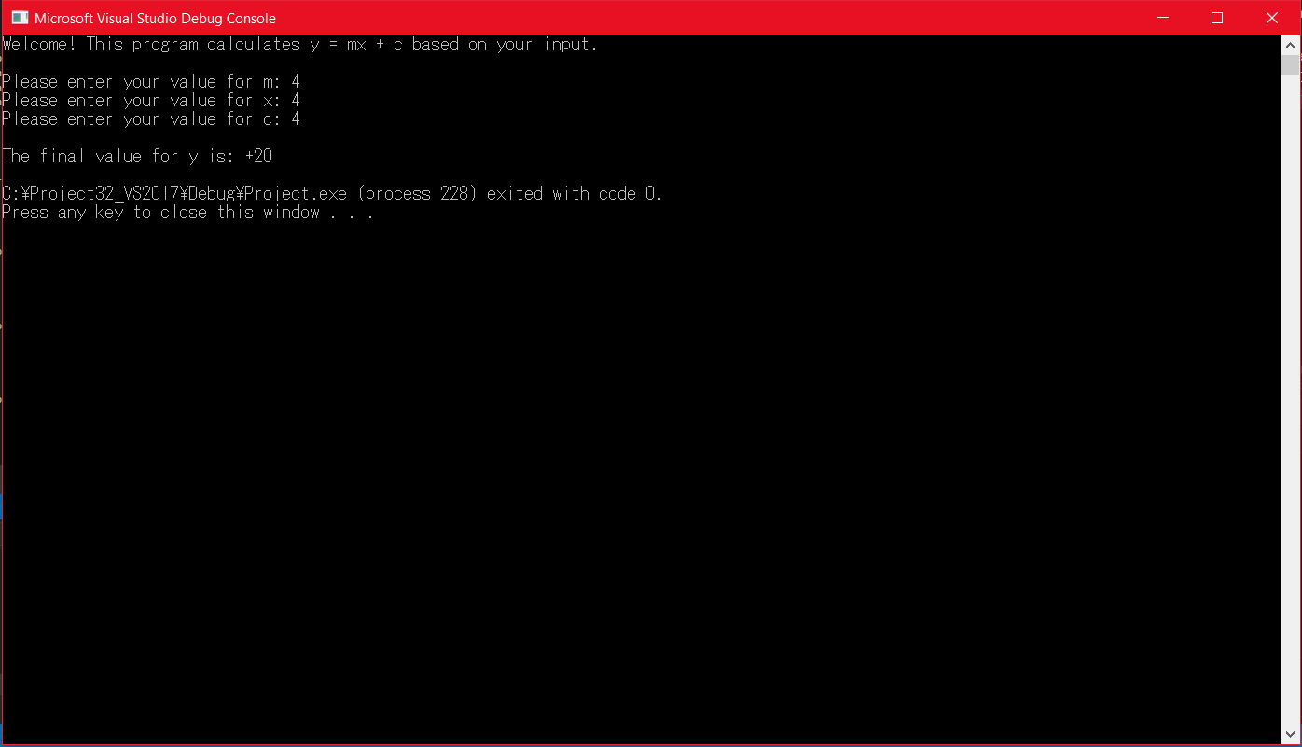

**Note:** The .asm file will be attached with the submission.

1. [Arrays] Write a program that:
2. Prompts the user for integer input 10 times
3. Stores these inputs in a stack
4. Displays the stored values on the screen using WriteInt (not DumpRegs).

In your submission, please embed the full program (.lst file) and one screen shot with at least one positive and one negative input value. Use the following:

.data

PromptUser BYTE "Please enter a value:", 0

**Screenshot:**

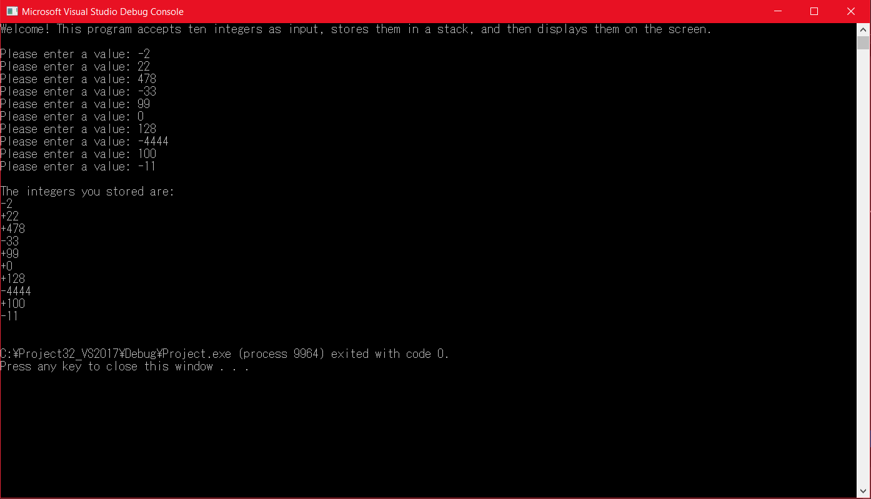

**Note:** The .asm file will be attached with the submission.

1. [Compares, Procedures] Write a procedure, *MinMax* that finds the minimum and maximum values stored in the stack in the previous program. Write a main program that calls *MinMax* and prints the values found. Also, print the indices at which the values were found, assuming that the first value was stored in index 0.

Use the following:

.data

prompt BYTE "Please input a value: ", 0

spacing BYTE ", ",0;

String1 BYTE "The minimum value is,” 0

String2 BYTE "The maximum value is,” 0

String2 BYTE “and is located at index: ",0

In your submission, please embed the full program (.lst file) and one screen shot showing the values found. Please test several sets of positive and negative values

**Screenshot:**

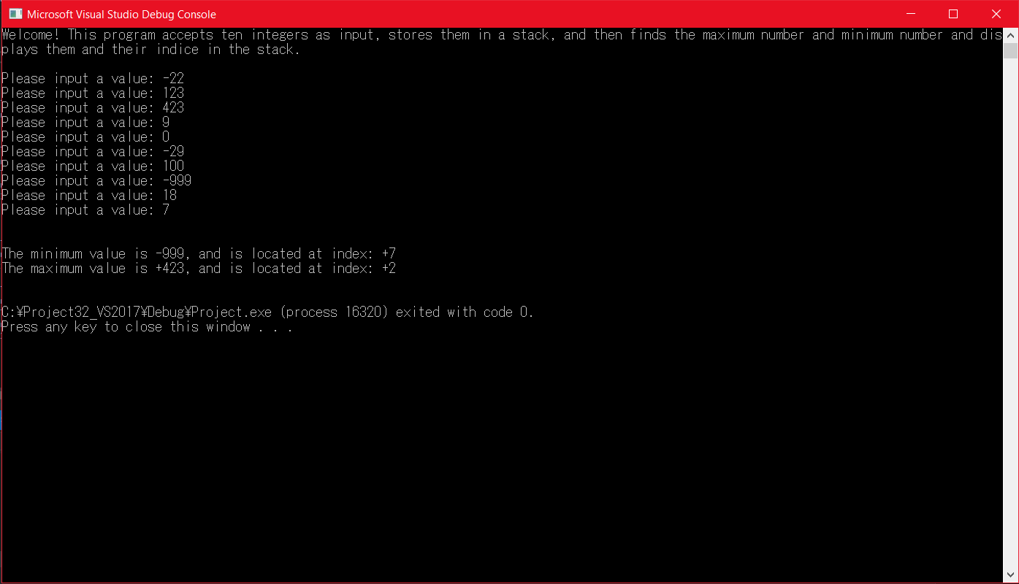

**Note:** The .asm file for this program will be included in the submission, alongside the other .asm files and the .lst file.