# Comp 3350: Computer Organization & Assembly Language

# HW # 9: Theme: Advanced Procedures, Stack Parameters, Locals and BCD

*(All main questions carry equal weight. Credit awarded to only those answers for which work has been shown.)*

**Table of Contents:**

* Question 1 is answered on page 1
* Question 2 is answered on page 2
* Question 3 is answered on page 3

1. Write a procedure named *ArraySeries* that fills an array of ten (10) numbers with the Fibonacci series. The procedure receives two arguments: the first is the offset of an array, and the second is an integer that specifies the array length. The first argument is passed by value and the second is passed by reference. In the main program, you should set the parameters of the array and print the array values before and after call to the procedure.

Please embed your code into your homework solution along with a screen shot of the run of the program.

**Screenshot:**

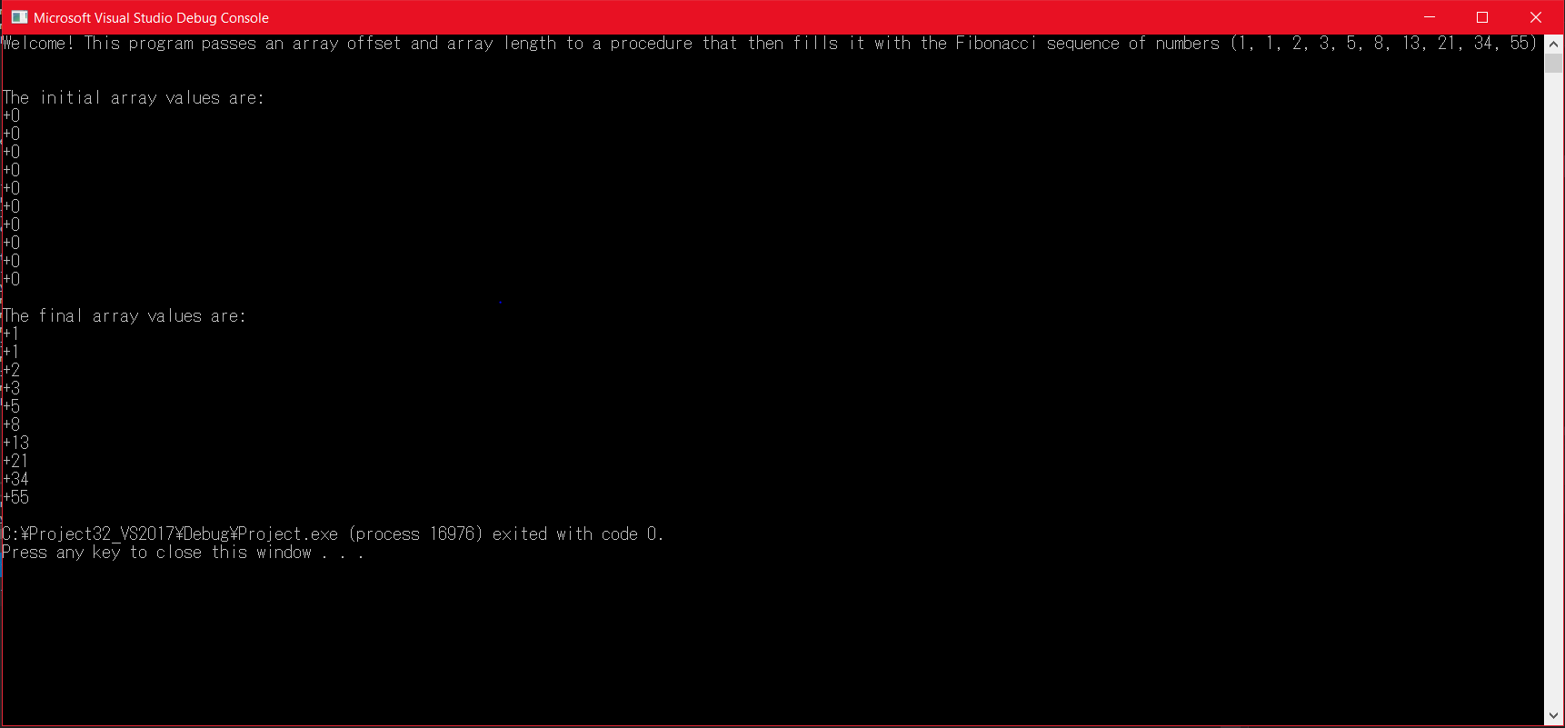

**Note:** The code will be provided in the submission as an asm file (named Question1HW9.asm).

1. Draft a program that adds two BCD numbers (10-digits each). The first BCD number is stored in an array named *myAuburnID*, and the second in an array named *myAurbunIdRev*. The first number is your actual Auburn ID (with a prefix single zero digit and the remaining digits as the 9-digits of your *Auburn ID*); the second is the value of *MyAuburnId* written backwards. Your program should do the following:
2. Use shifts/rotates using *myAuburnID* to fill the array *myAuburnIdRev*
3. Display contents of the memory locations in question
4. Add *myAuburnID and myAurbunIdRev* using BCD arithmetic
5. Store the sum in a variable named *Result*, and
6. Display contents of memory post execution.

Please embed your code into your homework solution along with a screen shot post execution.

**Screenshot:**

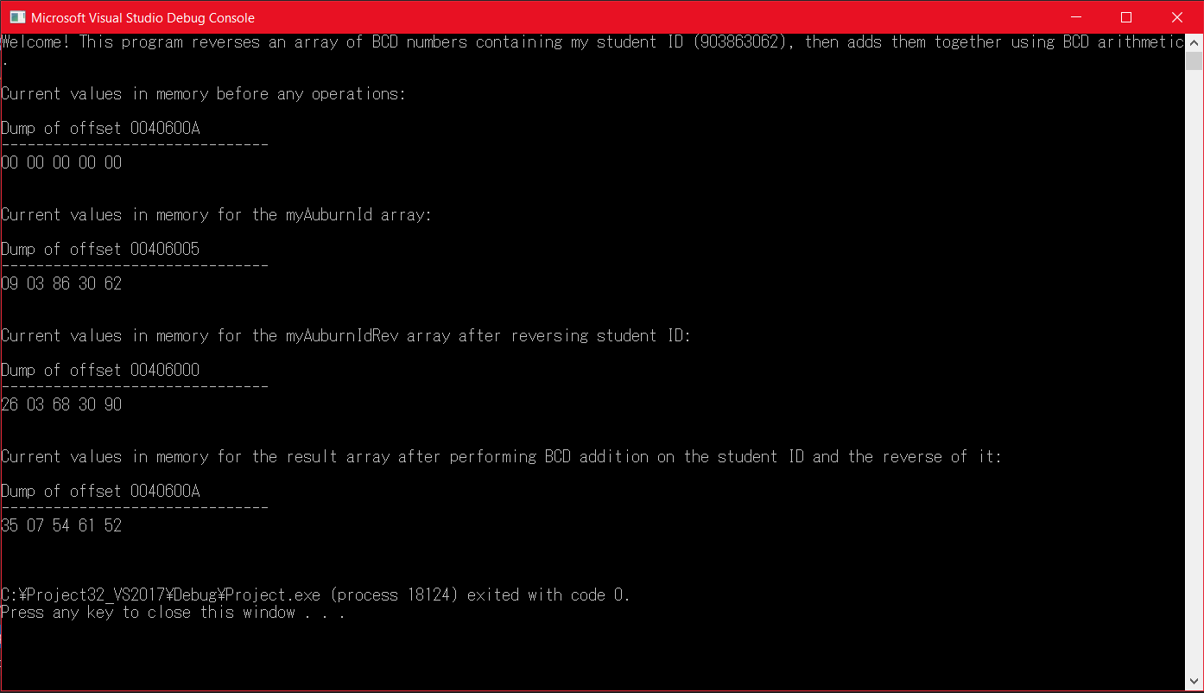

**Note:** The code will be provided in the submission as an asm file (named Question2HW9.asm).

1. Consider an isosceles triangle A with base 12 and height 20. Consider another triangle B formed using vertices which are the center of the sides of triangle A. Consider another triangle C whose vertices are similarly formed from B. Repeat this process ad infinitum. Express the sum of the areas of all such triangles using a series and its closed form sum. Compute the areas (a) by using only the first two terms of the series and (b) by using the closed form of the series sum. Write a program to find the sums and use shifts to compute. What is the difference in the two computed sums?

Please embed your code into your homework solution along with a screen shot post execution.

**Screenshot:**

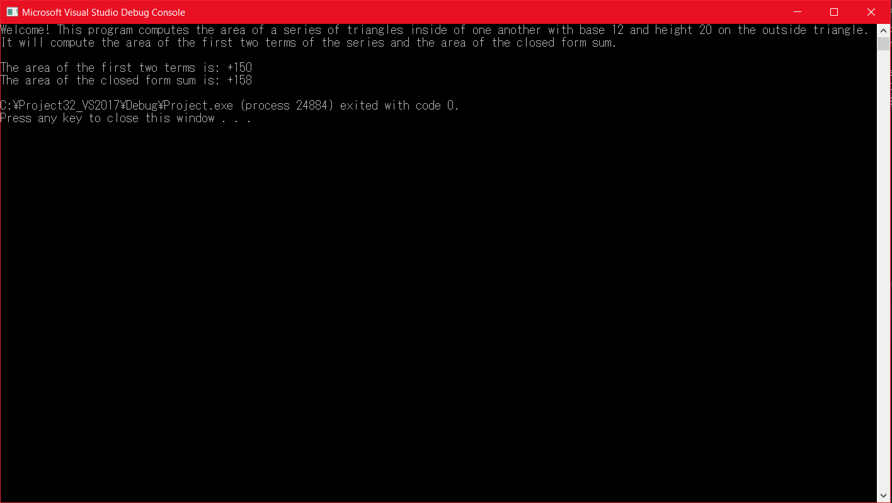

**Explanation:** The difference in the two computed sums is that the first is more accurate because the numbers and arithmetic is hardcoded while the second isn’t a correct estimation of the series sum. Instead of the estimation of 158, the number should be 160 according to math formulas we use.

**Note:** The code will be provided in the submission as an asm file (Question3HW9.asm).