COMP 3700
Software Modeling and Design
Homework 5
Due: Wednesday, March 27th, 2019 by 11:59PM (midnight)
This assignment has five questions and is worth 100 points.

Table of Contents:
- Question 1 is answered on pages 1 – 2.
- Question 2 is answered on pages 3 – 7.
- Question 3 is answered on page 8.
- Question 4 is answered on pages 9 – 10.

(1-20pts). For each of the following systems list the applicable structural and control style(s) of system
architecture covered in class (e.g., repository, client-server, service-oriented architecture, two-tier
/ three-tier / four-tier client server, abstract machine model, centralized, event-driven). Justify your answers.
- An electronic chess companion
  - Answer: Since implementing this would require a system that alternates control between the user sub-system & the AI sub-system, the best control model for this specific application would be the manager model. This would allow one sub-system to be in control of both other sub-systems and alternate control between the two, effectively implementing centralized control. After the user makes a move, the sub-system that it is using would be stopped while the AI sub-system is started; control will be returned after the AI completes a move. There would not be a need for co-ordination between the two sub-systems, so the “manager” sub-system would never need to co-ordinate any system processes.
- A floppy disk controller chip
  - Answer: The repository model would be the best fit for this system because large amounts of data would be commonly shared. This would allow for a centralized form of control over the CPU & the floppy disk. Any data that could be read would be held within the sub-system floppy disk database, while any data to be written would be held within the sub-system CPU database. This would also allow for centralized management by the controller chip, as it would have control over any read-write operations between the sub-systems (it is plural because a controller chip can control up to 4 floppy disks).
- An airplane flight simulator for a video game
  - Answer: The best control style for this application would be the Event-driven model, but particularly the broadcast model. This would allow for any event generated by the user to be broadcasted to every sub-system within the game, allowing for whichever corresponding one to take control. An example would be when the user decides to land the plane, they would press a few buttons & switches & the resulting action would be broadcasted to all sub-systems; the landing sub-system would be the one that would take control in this situation. This sub-system would then take control and bring the plane to a landing.
- A sonar system
  - Answer: The Event-driven model, or more specifically the interrupt-driven model, would be the most useful control system here. This would allow the sub-system to emit a pulse and then have the interrupt handler pass control off to a different sub-system when an echo is received. This is also important because this system would require fast response to events like spotting a ship, so that the approximate region could be displayed in real-time and improve detection capabilities.

(2-40pts) In a situational awareness system officers such as police officer or fire fighter, have access
to a wireless computer that enables them to interact with a correspondent. The correspondent can in
turn visualize the current status of all its resources, such as police cars or trucks and call a resource by
issuing commands from a workstation.
The first step of this assignment is to ensure that you have an appropriate set of objects to arrange
into a set of collaborations. The next step is to create collaborations that show how your objects work to handle various events within the following three scenarios that refine the basic use case above.
- John (field officer) submits an emergency report to the FRIEND system via his terminal. The report omits necessary details about the incident (i.e., location, type). Therefore, the system does not accept the report and it displays an error message explaining why.
- The correspondent is notified by the submission of an emergency report. The correspondent uses the terminal to visualize and check the current status of all the available resources, so that he can send the report and details about the incident to available responder team leaders. The correspondent chooses two team leaders. No team leader responds to the request (even though the incident falls within Matt and Dan’s area of expertise), so the system notifies the correspondent. He, in turn, assigns the incident to Sally.
- Sally, being a team leader, contacts Gary, Nick, and Mike asking if they are available to respond. Gary and Nick accept, but Mike declines. Sally then asks Tom if he is able to respond, and he accepts. Each responder acknowledges to the team leader when they arrive to the scene. After the incident is handled, each responder completes a report so that Sally can assemble a review report. Once all reviews are complete, Sally writes her summary report and sends using the system all four reviews to the correspondent. The correspondent sets the status of the incident to inactive and then closes the file.
You should create one interaction diagram (i.e. collaboration diagram) for each distinct event in the
scenarios above. These events are:
Evaluation: Your collaborations should make use of boundary, controller, domain objects, and other
new fabricated software objects (e.g., data structure components) necessary to completely handle each event. Your solution will be evaluated in terms of the quality of your design (i.e., modularity: low coupling and high cohesion), the explanation of the rationale for each object responsibility assignment in terms of the GRASP patterns and compliance with the interaction (collaboration) diagram notation.

1st Collaboration Diagram: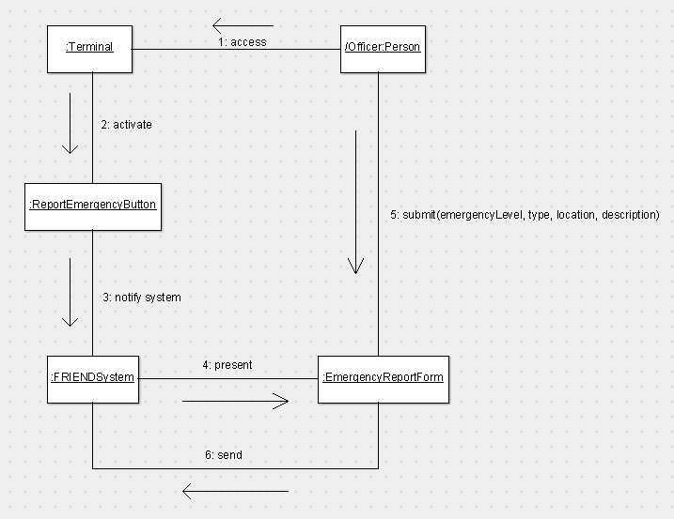
2nd Collaboration Diagram:
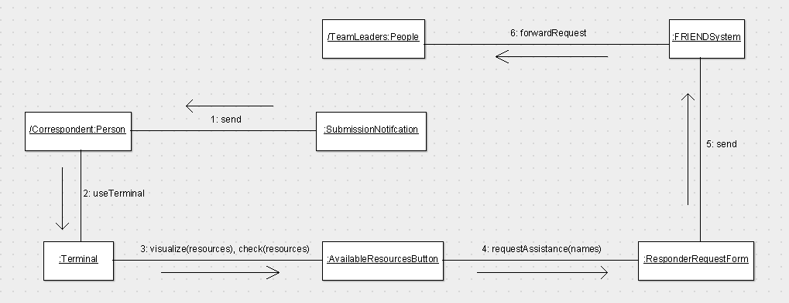

3rd Collaboration Diagram:
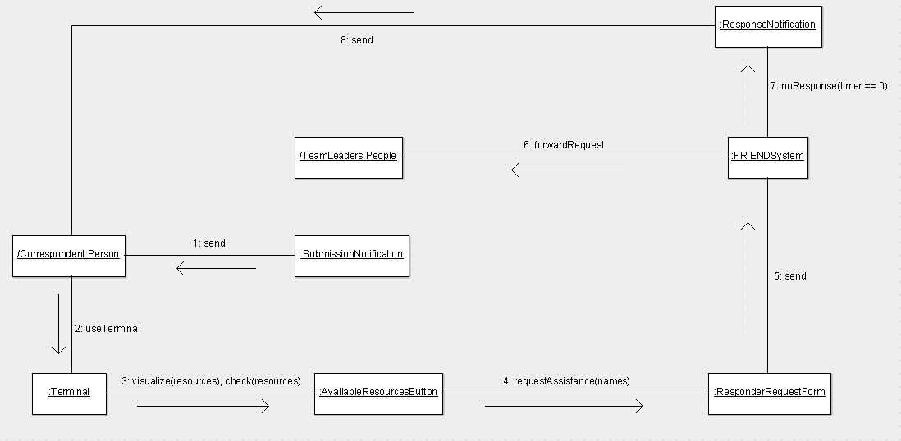

4th Collaboration Diagram:
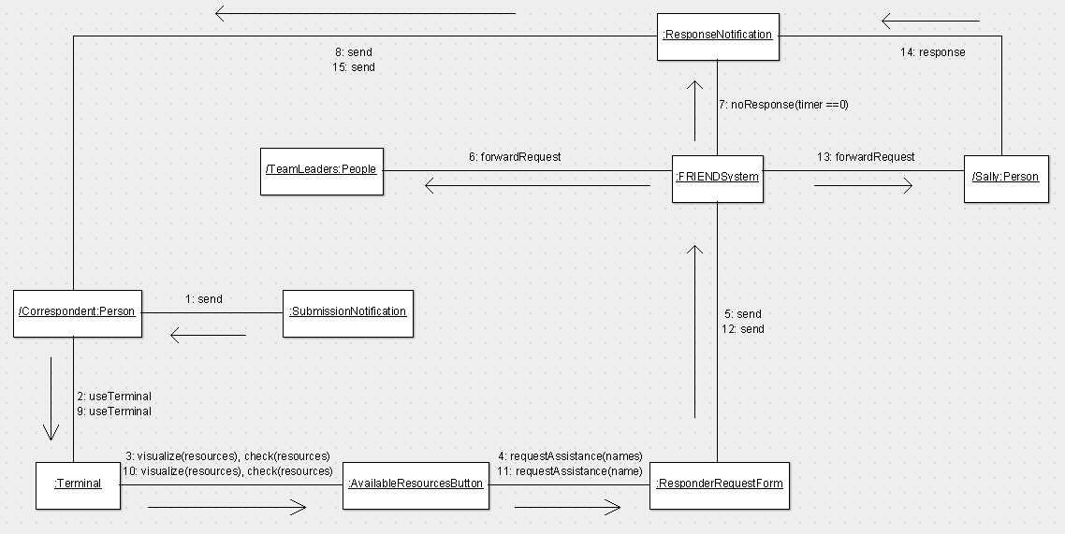
5th Collaboration Diagram:
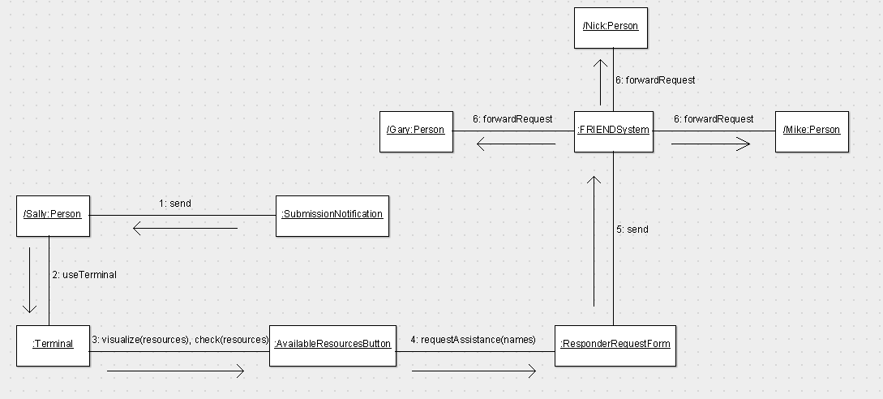

6th Collaboration Diagram:
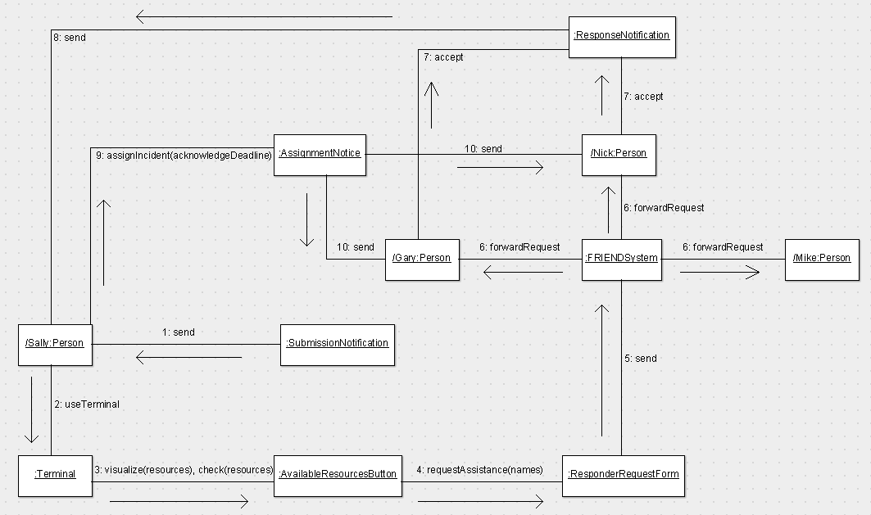

7th Collaboration Diagram:
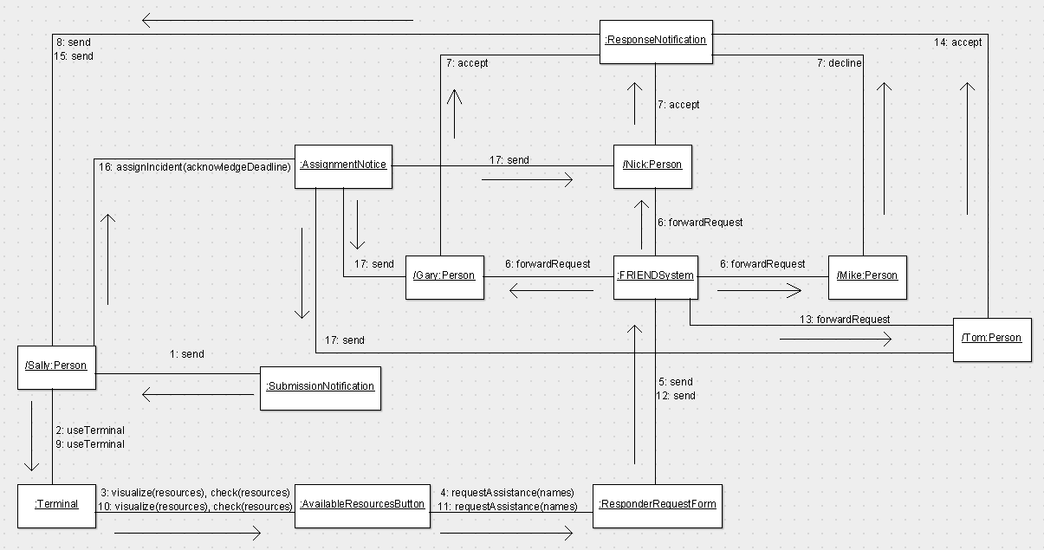
8th Collaboration Diagram:
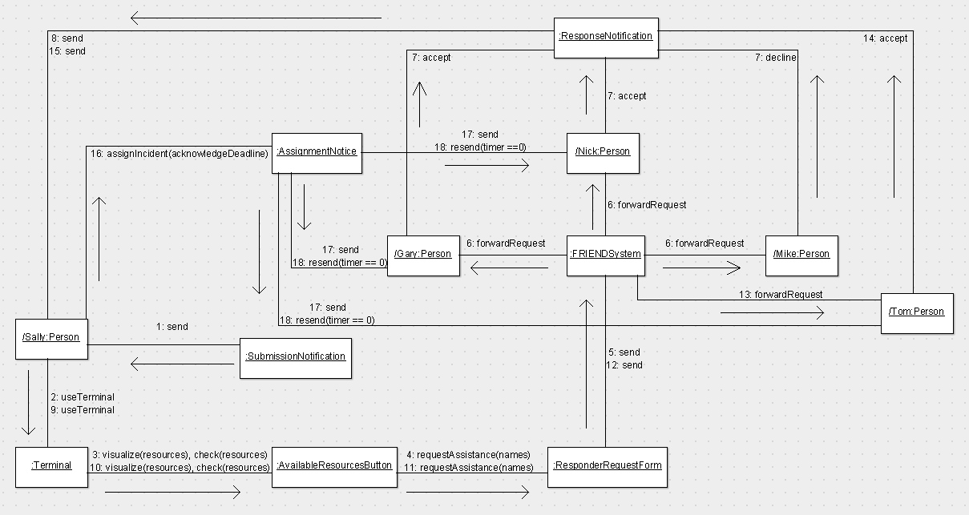

9th Collaboration Diagram:
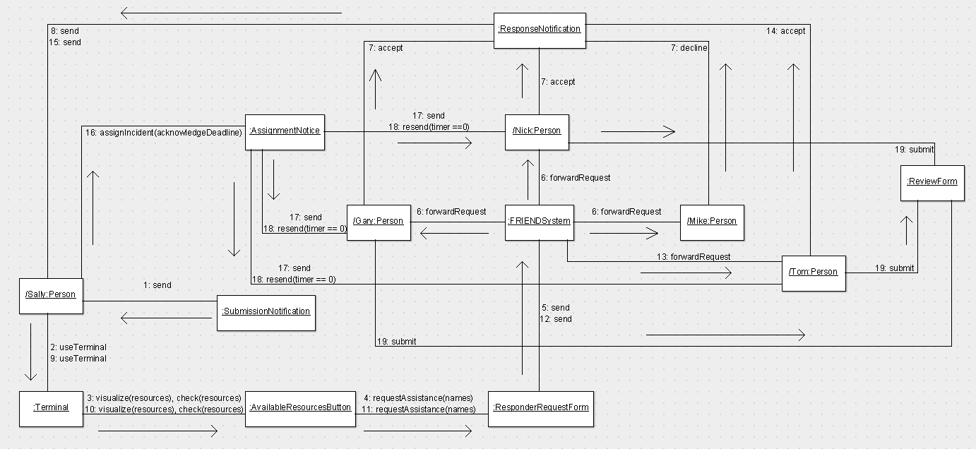

10th Collaboration Diagram:
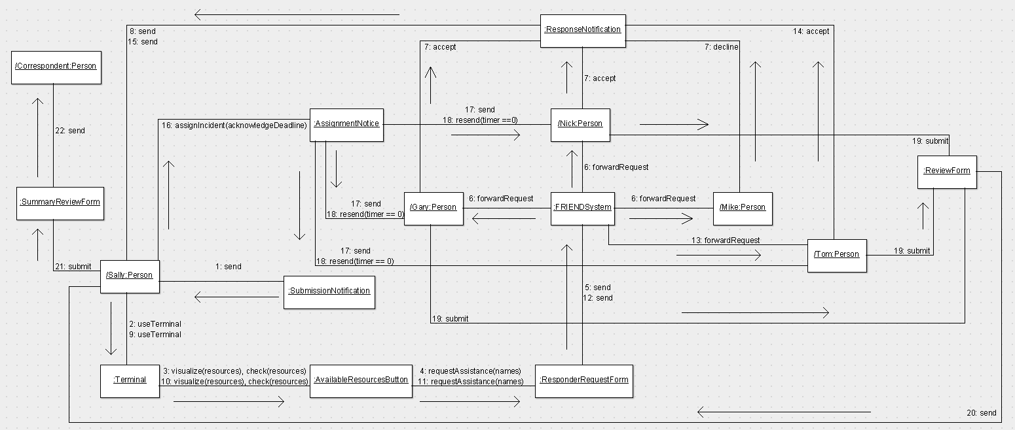
(3-15pts). Consider the following System Sequence Diagram
Design an equivalent Collaboration Design Diagram for the Valid Pin SSD shown above.
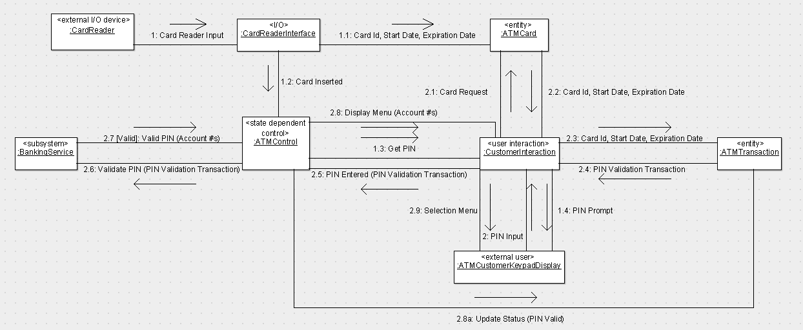

Note: Arrows cannot be displayed correctly over the associations within ArgoUML (due to the broken autocorrect features), so for simplicity purposes, I have made the general associations to have arrows and labeled the transitions above them with text boxes.

(4-25pts). Consider the following Collaboration Design Diagram (message numbering is intentionally
left out)
- For each message listed in the Collaboration Diagram, suggest one or more GRASP guidelines suitable for justifying the allocation of the responsibility to the recipient object.
- ATM Transaction: Controller, High Cohesion,
- Bank Response: Controller, Indirection, Creator, Pure Fabrication, High Cohesion
- Card Reader Input: Expert, Pure Fabrication, Low Coupling
- Card Reader Output: Expert, Creator
- Customer Input: Expert, Pure Fabrication, Low Coupling
- Display Information: Expert, Creator
- Dispenser Output: Expert, Creator
- Operator Information: Expert, Creator
- Operator Input: Expert, Indirection, Pure Fabrication, Low Coupling
- Printer Output: Expert, Creator
- Dispense (cashAmount): Expert, Indirection, Creator, Pure Fabrication
- withdrawCash (in cashAmount, out fivesToDispense, out tensToDispense, out twentiesToDispense): Expert, Polymorphism, Don’t Talk to Strangers
- startUp, closedown: Don’t Talk to Strangers, Low Coupling
- write (cardData): Expert, Polymorphism, Don’t Talk to Strangers
- cardInserted, cardEjected, cardConfiscated: Don’t Talk to Strangers, High Cohesion
- eject, confiscate: Indirection, Creator, High Cohesion, Low Coupling
- read (out cardData): Expert, Polymorphism, Don’t Talk to Strangers
- customerEvent (transactionDetails): Don’t Talk to Strangers
- addCash (in fivesAdded, in tensAdded, in twentiesAdded): Expert, Polymorphism, Don’t Talk to Strangers
- print (receiptInfo): Expert, Indirection, Pure Fabrication
- displayPrompts: Indirection, Creator, Low Coupling
- updateTransactionStatus (cashDetails), updatePINStatus (status): Expert, Polymorphism, Don’t Talk to Strangers, High Cohesion
- read (out transactionData): Expert, Polymorphism, Don’t Talk to Strangers
- updateCustomerInfo (cardData, PIN), updateCustomerSelection (in selection, out transactionDetails): Expert, Polymorphism, Don’t Talk to Strangers, High Cohesion
- Draw a UML Design Class Diagram, including classes, methods (based on the messages, which are interpreted as responsibilities of the recipient objects), and direction, as well as type of visibility. Based on your choice of visibility among the associated classes, indicate which dependencies are attribute, local, and parameter visibilities.

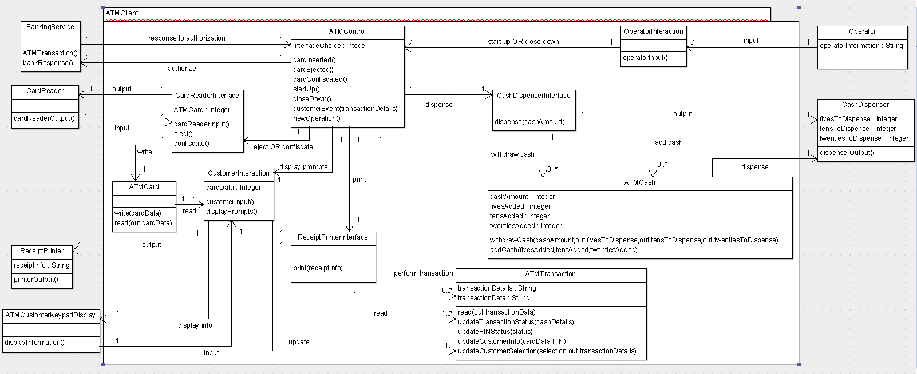
Visibilities:
- ReceiptPrinterInterface ReceiptPrinter: Parameter visibility
- CashDispenserInterface ATMCash: Parameter visibility
- ATMCard CustomerInteraction: Parameter visibility, Local visibility
- ATMControl ATMTransaction: Parameter visibility
- ReceiptPrinterInterface ATMTransaction: Local visibility
- ATMCash CashDispenser: Local visibility
- CardReaderInterface ATMCard: Attribute visibility
- All other dependencies have global visibility.

