**Name:** CENSORED

**Due Date:** 1/30/20

**Class:** COMP-4200

**Assignment:** HW2

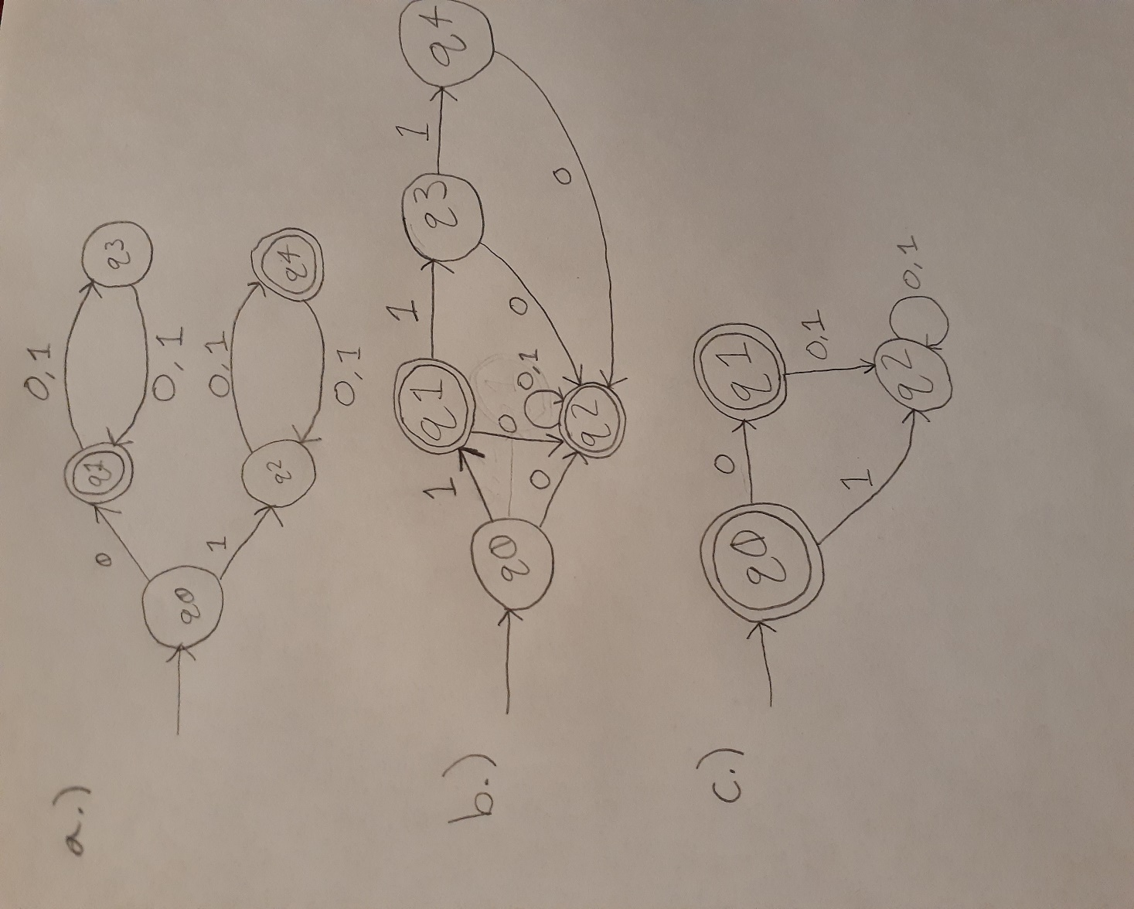

1. 