**Name:** CENSORED

**Due Date:** 2/20/20

**Assignment:** HW4

**Class:** COMP-4200

1a.)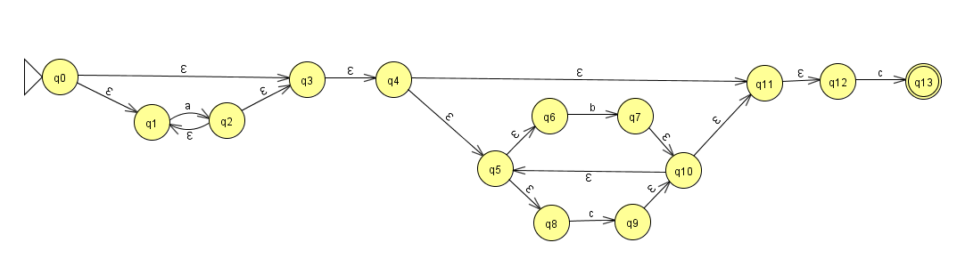

1b.)

2b.)

