**Name:** CENSORED

**Date:** 4/23/20

**Assignment:** HW7

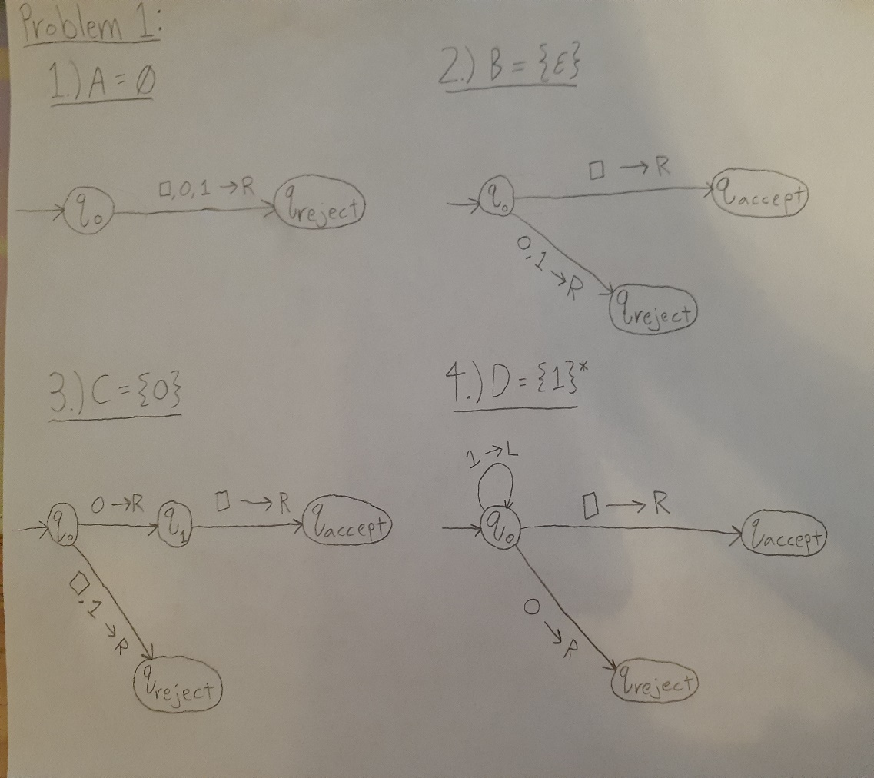**Class:** COMP-4200