**Z0b0t**

Created By: CENSORED

Date: 10/27/19

Class: COMP-5970

Assignment: Project 1

1.) **Executive Summary:**

2.) **Problem Description:** We were asked to design a program that would exfiltrate the password of every user on a Windows 10 machine through a HTTP Reverse Shell Connection. The malware that would do this needed to be uploaded to a Web Server so that it could be downloaded on the victim machine. The victim would go to the Web Server with their browser of choice and download the malware, then execute it with Admin Permissions on their computer. The malware would then extract the passwords from either the registry or the memory and send it back to the attacker machine through an HTTP Reverse Shell that was implemented in Python.

3.) **Python Code Explanation:**

a.) **Screenshots:**

z0b0tClient.py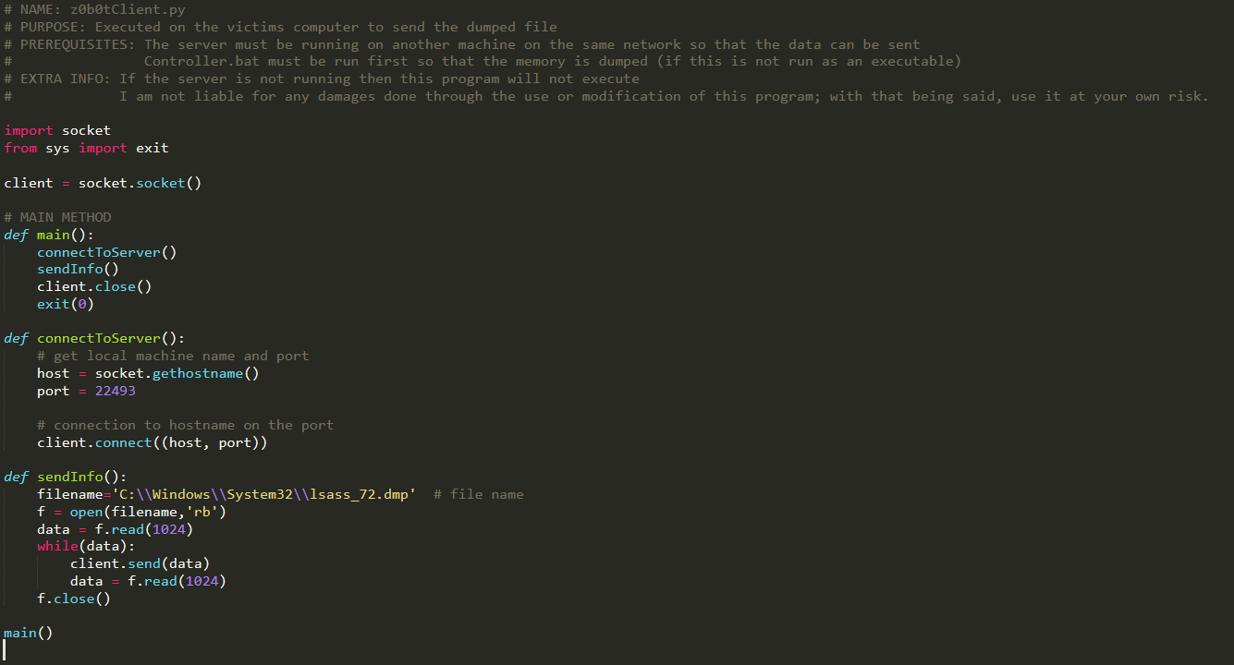

z0b0tServer.py

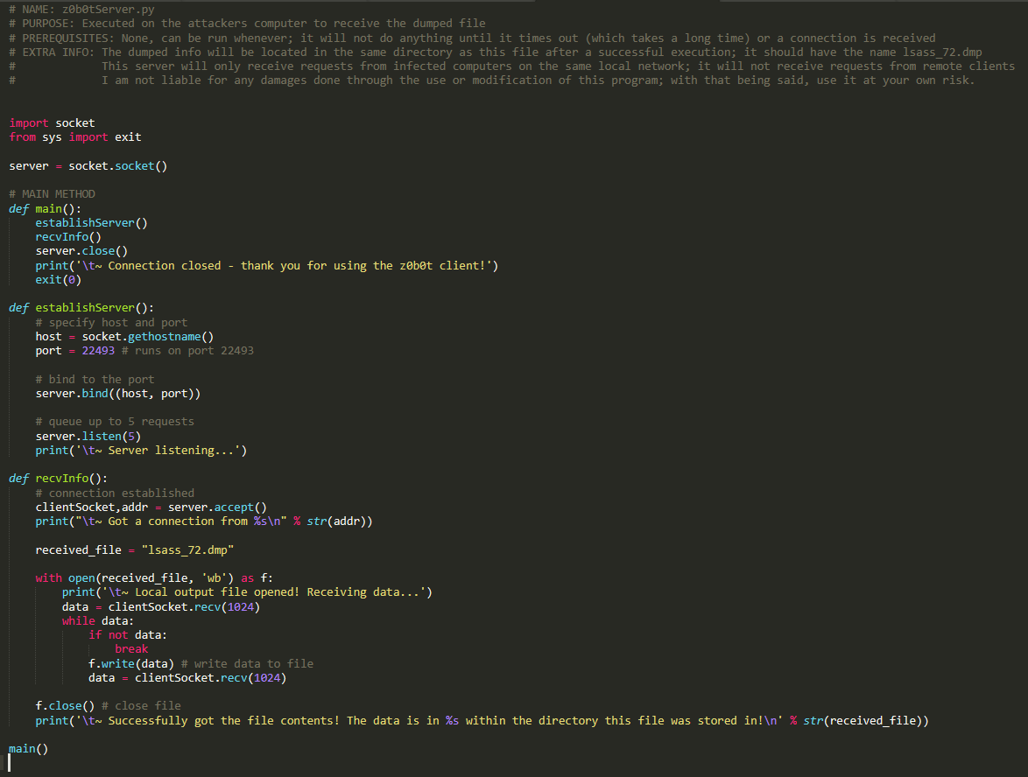

4.) **Conclusions:**

5.) **Recommendations:**