CENSORED

Assignment: HW1

Date: 6/25/19

1. R2.1: mystery = 1

mystery = 1 – 2 * mystery

mystery = mystery + 1

The value of mystery at the end of this sequence of statements will be 0. The value is initially 1, then reassigned the value 1 – 2 * 1 = -1, then finally reassigned the value -1 + 1 = 0.

1. R2.2: mystery = 1

mystery = mystery + 1

mystery = 1 – 2 * mystery

The value of mystery at the end of this sequence of statements will be -3. The value is initially 1, then reassigned the value of 1 + 1 = 2, then finally reassigned the value 1 – 2 * 2 = -3.

1. # P2.11

def main():

# typecast number of gallons input as int, since the input should be an integer

input1 = int(input("Please input the number of gallons of gas in the tank: "))

# typecast fuel efficiency input as int, since the input should be an integer

input2 = int(input("Please input the fuel efficiency in miles per gallon: "))

# typecast price as float, since the input should be a monetary value

input3 = float(input("Please input the price of gas per gallon: "))

# calculations for cost per 100 miles and the distance left in the trip

cost_per_100_miles = float((100 / input2) * input3)

distance_left = str(input1 * input2)

# round so the number looks like a cash value

cost_per_100_miles = str(round(cost_per_100_miles, 2))

# print the values to the screen

print("\nThe number of gallons of gas in the tank is " + str(input1) + ".")

print("The fuel efficiency of the vehicle (in miles per gallon) is " + str(input2) + ".")

print("The price of gas per gallon is $" + str(input3) + ".\n")

print("Therefore, the cost per 100 miles is $" + cost_per_100_miles + " and the distance left in the trip is " + distance_left + " miles.\n")

# main declaration, so the program runs

main()

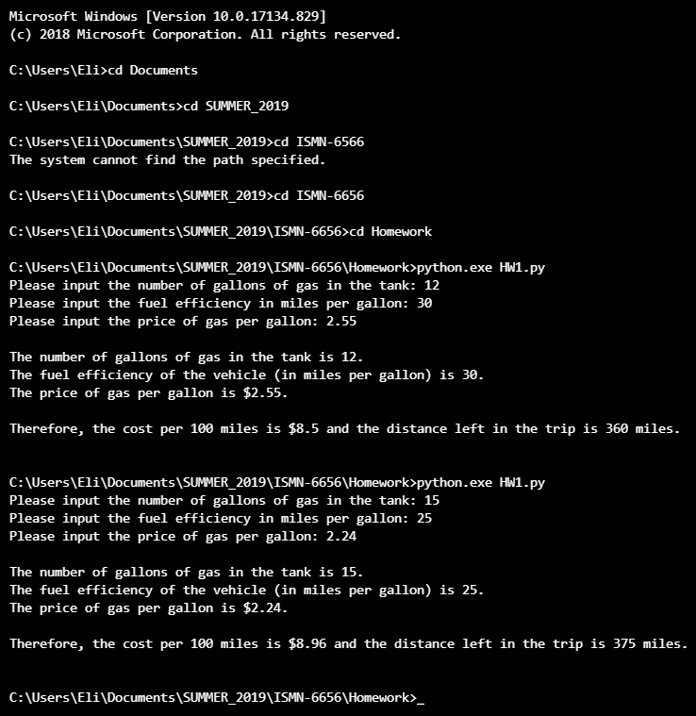Following are two screenshots of different runs of the program: