ISMN 5650 / 6650 / 6656

Paramjit Kahai

Homework #1

1. R2.1
2. R2.2
3. P2.11

**What to Turn-In?**

In ONE Word document, copy & paste

1. Answers to (1) & (2) above
2. The Python code for (3) above
3. The output of each program (screenshot will suffice)

**Formats**

1. Include a few comments with the program
2. Print statement(s) should include descriptive text (as done in class)
3. Word document:
   1. Homework # and Date at top
   2. Label each answer / program
   3. Single-space, please (especially the code)
   4. Place code for each program on a page by itself
   5. Click “Remove Space After Paragraph” (see below)
   6. Page number bottom-middle

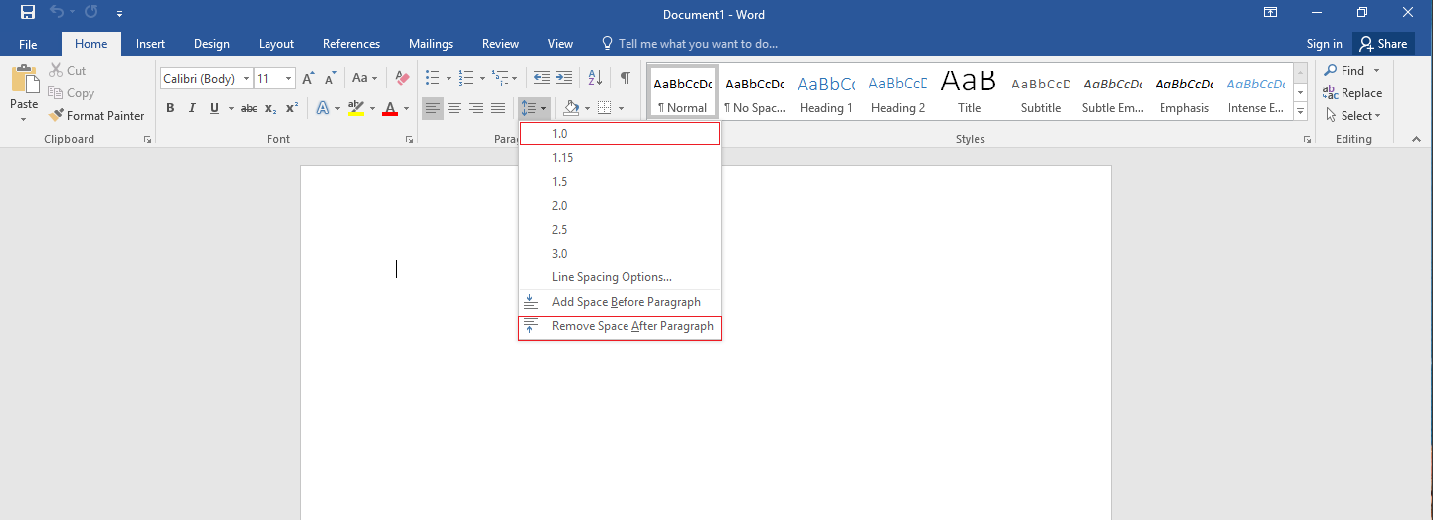

**The Exercises**

