ISMN 5650 / 6650 / 6656

Paramjit Kahai

Homework #2

## Tasks

1. P2-32
2. P2-35 (Graduate students only. Refer to the program *ch02/how_to_1/vending.py* in your text book)
3. Write a Python program to print the sample receipt shown on the following page:
4. Use short item names
5. Item prices should be between $100.01 & $999.99
6. Calculate and print sales tax amount based on a 7% tax rate
7. Total is the sum of subtotal and sales tax
8. Assume customers pay cash and an amount higher than the subtotal. Also assume that the customer uses a combination of only $100, $50, and $20 bills
9. Calculate and print the amount to be returned to customer
10. Use the format specifiers that were used in class programs

## What to Turn-In?

In ONE Word document, copy & paste on separate pages

1. Python code
2. The output of programs (screen snip will suffice)

## Program Format

1. Leave plenty of blank lines in program for readability
2. Have plenty of comments

## Word Document

1. Homework # and Date at top
2. Text headers as appropriate
3. Single-space, please (especially the code)
4. Click “Remove Space After Paragraph” (see below)
5. Page number bottom-middle

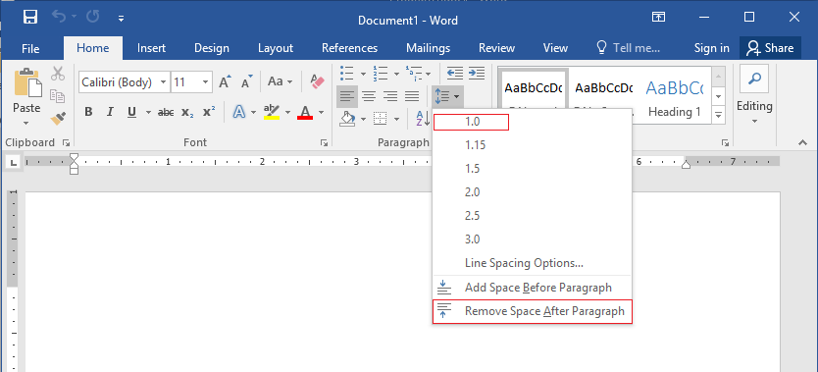

## Output Format: Receipt

Amounts align to the right

Receipt Header

SAMPLE RECEIPT

5 ITEMS PURCHASED

______________________________________

Labels align to the right

Item names align to the left

|  |  |
| --- | --- |
| Item 1 | $ ___.__ |
| Item 2 | $ ___.__ |
| Item 3 | $ ___.__ |
| Item 4 | $ ___.__ |
| Item 5 | $ ___.__ |
|  |  |
| Subtotal | $ ___.__ |
| Tax - 7% | $ ___.__ |
| Total | $ ___.__ |
|  |  |
| Customer Paid | $ ___.__ |
| Change to customer, if any | $ ___.__ |