Name: CENSORED

Date: 7/3/19

Assignment: HW3

Class: ISMN-6656

1. # P3.23  
     
   # gets user input for income amount for the year  
   income = float(input("Please enter your income for the year: $"))  
     
   # assigns tax value based on income range  
   if(income <= 50000):  
    tax = 0.01  
   elif(50000 < income <= 75000):  
    tax = 0.02  
   elif(75000 < income <= 100000):  
    tax = 0.03  
   elif(100000 < income <= 250000):  
    tax = 0.04  
   elif(250000 < income <= 500000):  
    tax = 0.05  
   else:  
    tax = 0.06  
     
   # type cast final income tax amount as string for print  
   finalIncome = str(round(income * tax, 2))

# final print statement  
print("The income tax amount you owe is: $" + finalIncome)

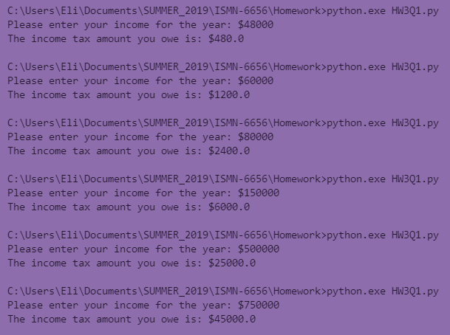

1. # P3.29  
     
   # starting value so while loop executes  
   value = 0  
     
   while(value == 0):  
    # get input for month  
    month = int(input("Please enter the desired month (1 = January, 2 = February, etc): "))  
     
    if(month in [1, 3, 5, 7, 8, 10, 12]):  
    days = "31"  
    value = 1 # terminate loop  
    elif(month in [4, 6, 9, 11]):  
    days = "30"  
    value = 1 # terminate loop  
    elif(month == 2):  
    days = "28 or 29 days"  
    value = 1 # terminate loop  
    else:  
    # error message, loop restarts  
    print("Please enter a number from 1 to 12!\n")  
     
   # final print statement  
   print("The number of days in your chosen month is " + days)

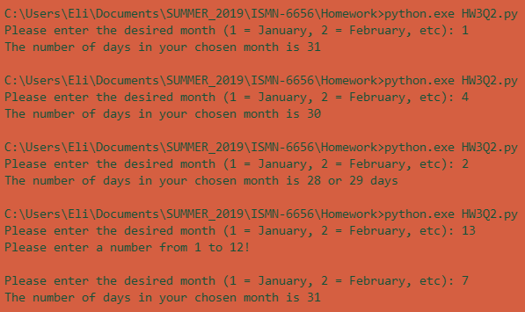

1. # P3.40  
     
   # get cost input  
   cost = float(input("Please enter the cost of your groceries: $"))  
     
   if(10 <= cost <= 60):  
    coupon = 8  
   elif(60 < cost <= 150):  
    coupon = 10  
   elif(150 < cost <= 210):  
    coupon = 12  
   elif(210 < cost):  
    coupon = 14  
   else:  
    coupon = 0  
     
   if(coupon == 0):  
    print("You do not win a coupon.")  
   else:  
    discount = str(round(cost * (coupon * 0.01), 2))  
    print("You win a discount coupon of $" + discount + " (" + str(coupon) + "% of your purchase)")

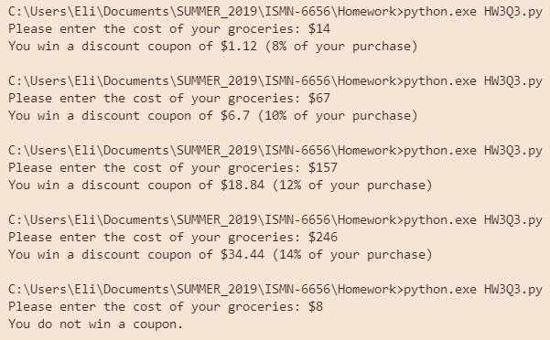

**NOTE:** All strings that encompass more than one line in the word document were written on one line in the coding application. This could not be adequately shown in the word document.