Name: CENSORED

Date: 7/12/19

Class: ISMN-6656

Assignment: HW4

1. # R4.1a  
   # get input number and set new values to placeholder values  
   n = int(input("a. Please enter the desired number: "))  
   i = 0  
   square = 0  
     
   # tell user that all squares less than entered number will be displayed  
   print("All squares less than your entered number are:")  
     
   # loops until squared number would be >= n  
   while (square < n):  
    square = i\*\*2  
    if(square < n):  
    print(str(square))  
    i += 1  
     
   #######################################################################  
     
   # R4.1b  
   # get input number and set new value to placeholder values  
   n = int(input("\nb. Please enter the desired number: "))  
   i = 10  
     
   # tell user that all positive numbers divisible by 10 and less than the  
   # entered number will be displayed  
   print("All positive numbers that are divisible by 10 and less than your entered number are:")  
     
   # loops until number is greater than given number  
   while (i < n):  
    print(i)  
    i += 10  
      
   #######################################################################  
     
   # R4.1c  
   # get input number and set new values to placeholder values  
   n = int(input("\nc. Please enter the desired number: "))  
   i = 1  
   powers = 1  
     
   # tell user that all powers of two less than entered number will be displayed  
   print("All powers of 2 that are less than your entered number are:")  
     
   # loops until number is greater than given number  
   while (i < n):  
    print(i)  
    i = 2\*\*powers  
    powers += 1

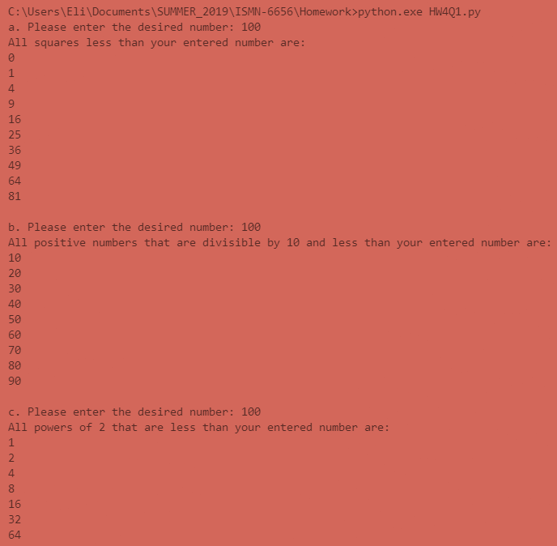

1. # R4.2a  
   # default values  
   x = 2  
   sumEven = 0  
     
   # stores each even number in x and total sum in SumEven; includes 2 & 100  
   while (x <= 100):  
    sumEven += x  
    x += 2  
     
   # print sum  
   print("a. The sum of all even numbers between 2 and 100 (inclusive) is: " + str(sumEven))  
     
   #######################################################################  
     
   # R4.2b  
   # default values  
   i = 1  
   sumSquares = 0  
   square = 0  
     
   # stores each square in square variable, and total in sumSquares; includes 1 & 100  
   while (square < 100):  
    sumSquares += square  
    square = i\*\*2  
    i += 1  
     
   # print sum  
   print("b. The sum of all squares between 1 and 100 (inclusive) is: " + str(sumSquares))  
     
   #######################################################################  
     
   # R4.2c  
   # default values  
   sum = 0  
   odd = 1  
     
   # gets user input for a and b  
   a = int(input("Please enter a value for a: "))  
   b = int(input("Please enter a value for b: "))  
     
   # if a is even, odd is the next number above it; if not, odd is a  
   if (a % 2 == 0):  
    odd = a + 1  
   else:  
    odd = a  
     
   # adds each odd number between a and b (including a and b) to a sum  
   while (odd <= b):  
    sum += odd  
    odd += 2  
     
   # print sum  
   print("c. The sum of all odd numbers between " + str(a) + " and " + str(b) + " (inclusive) is: " + str(sum))  
     
   #######################################################################  
     
   # R4.2d  
   # default values  
   sum = 0  
   val = 0  
     
   # gets user input for n  
   n = int(input("Please enter a value for n: "))  
     
   # gets each individual number in given number and adds each odd number to a sum  
   for d in str(n):  
    val = int(d)  
    if (val % 2 != 0):  
    sum += val  
      
   # print sum  
   print("d. The sum of all odd digits of " + str(n) + " is: " + str(sum))

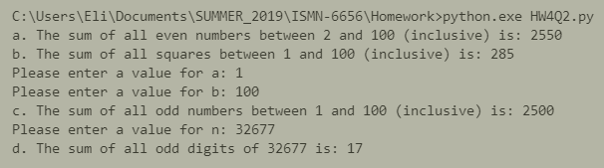

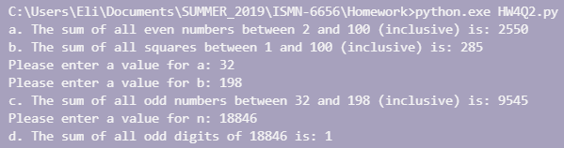

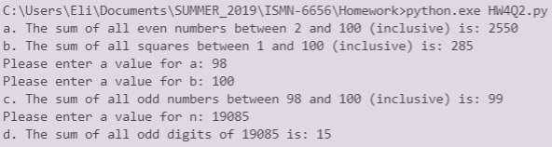

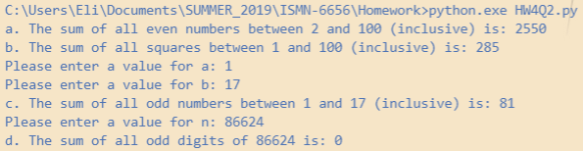

1. R4.4
   1. 1

2

3

4

5

6

7

8

9

* 1. 1

3

5

7

9

* 1. 10

9

8

7

6

5

4

3

2

* 1. 0

1

2

3

4

5

6

7

8

9

* 1. 2

4

6

8

1. R4.10
   1. 10
   2. 10
   3. 10
   4. 21
   5. 0
   6. 11
   7. 7
2. Below are value comparisons of the while loop and the given for loop:

