Quarterly Sales Report
This document summarizes Q1 2025 regional sales performance.

Regional Breakdown
North region achieved 320 units. South led with 480 units. East recorded 210 units. West delivered 390 units.
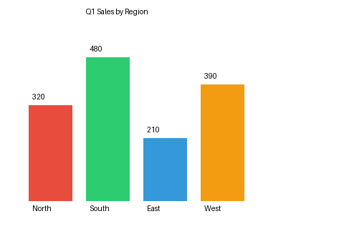
Figure 1: Q1 Sales by Region bar chart.

Conclusion
South region is the top performer this quarter with 480 units sold.

