**Causal Associations Between Chronic Liver Diseases and Type 2 Diabetes: A Two-Sample Mendelian Randomization Study**

The liver contributes to the metabolic processes of the body and especially plays a major role in the regulation of glucose homeostasis through decomposing and synthesizing glycogen. Two main types of chronic liver diseases (CLDs), nonalcoholic fatty liver disease (NAFLD) and hepatitis C virus (HCV), can lead to type 2 diabetes(T2D) mediated by insulin resistance (IR). However, due to confounding factors, it is difficult to confirm whether CLDs contributes to T2D. In order to investigate the effect of intermediate phenotypes on outcomes, we used independent genetic variants of CLDs obtained from the genome-wide association study (GWAS) as instrumental variables (IVs) to perform Mendelian randomization (MR) analysis on D2M. The relation between CLDs and T2D was evaluated by using inverse variance weighted method (IVW) and weighted median method (WM). Then the sensitivity test was analyzed. The MR results showed that there were high ORs (1.0770, 95%CI 1.0599 to 1.0943, P = 9.0999e-20 for NAFLD to T2D; 1.1434,95%CI 1.0741 to 1.2172, P=2.65E-05 for HCV to T2D) and low intercepts, which proved the causality between two main types of CLDs (NAFLD and HCV) and T2D. Furthermore, we explained the possible common mechanism for most CLDs lead to T2D.

**Key words:** Mendelian randomization, chronic liver disease, type 2 diabetes, causality, GWAS, SNPs

# 1.Introduction

Diabetes mellitus (DM) is a chronic metabolic disorder affecting humans worldwide which has a steadily increasing prevalence. There were approximately 463 million DM patients aged 20 to 79 years old until 2019, and it is estimated to be 578 million DM patients in 2030 and 700 million in 2045.[1] Diabetes mellitus can lead to several microvascular complications and macrovascular complications which can result in blindness, renal failure, myocardial infarction and stroke.[2]

The liver plays an important role in the body metabolic processes, especially in glucose homeostasis. Many chronic liver diseases (CLDs) such as nonalcoholic fatty liver disease (NAFLD) and Hepatitis C virus (HCV)are associated with insulin resistance (IR), which indicate the probable relation between CLDs and T2D.[4][5] PatientswithNAFLD have a high risk of T2D and vice versa[6][7]. It seems that they have a bi-directional relationship, but the causality between them is still not confirmed.[8][9]Similarly, HCV infection represents a well-known risk factor for T2D.[10] However, on account of the influence of confounding factors, it can not draw conclusion that there is a causality between CLDs and T2D directly. In addition, it is difficult to judge the sequence of exposure and outcome, which can lead to reverse causality.

In this study, we use Mendelian randomization (MR) to determine whether there is a causality between CLDs and T2D. MR uses genetic data to probe questions of causality in epidemiological research, usually single nucleotide polymorphisms (SNPs), as instrumental variables (IVs) in epidemiologic study.[11][12] Every person obtains an allele at the SNP locus before any confounders occur, which means there is no confounding or reverse causation. Thus, we can determine whether an observational association between exposures and outcomes exists and whether it is consistent with a causal effect.

# 2. Materials and methods

Two-sample MR uses data from publicly available GWAS, which has three main assumptions: (a) the instrumental variable is associated with the exposures, here we just select SNPs of genome wide significant association(p<5E-08); (b)the instrumental variable is not associated with confounders; and (c) the instrumental variable influences the outcomes only through the exposures. (Figure 1) Therefore, when performing MR analysis, we should consider potential violations of the instrumental variable assumptions such as instruments affect the outcomes directly, or through other ways (not affect the exposures) affect the outcomes. In other word, we should estimate the presence of horizontal pleiotropy, inheritance and linkage disequilibrium (LD).

## 2.1 Instrument variable selection

To satisfy three hypotheses above, we had a series of steps to select eligible SNPs from the GWAS. we selected only SNPs associated with Chronic liver diseases at a genome-wide association (p < 5E−08), with independent inheritance (r2< 0.01), and without LD in summary statistics.

We used publicly available summary-level data from GWAS. We selected SNPs associated with T2D from a consortium including 62,892 cases and 596,424 control subjects. Summary data for the association between SNPs and HCV were extracted from a large-scale genome-wide association study including 212,453 participants. [13][14]And thanks to FinnGen study, we obtained SNPs associated with NAFLD including 272 cases and 96,227 control subjects.

## 2.2 MR analysis and Sensitivity analysis

Inverse variance weighted (IVW) was used as the key method to calculate the causal effect between CLDs and T2D for Two-sample MR.[16] IVW method is calculated as follows:

$${\hat{β}}_{Y_{j}}=θ_{IVW}{\hat{β}}_{X_{j}}+ε_{{IVW}_{j}}$$

where ${\hat{β}}_{Y_{j}}$ represents the association effect of IVs on T2D, ${\hat{β}}_{X_{j}}$ defines the association effect of IVs on CLDs, and $θ_{IVW}$ represents the IVW estimate which is calculated as $w_{j}={se({\hat{β}}_{Y_{j}})}^{-2}$ and $ε_{{IVW}_{j}}$ is the residual term.

We performed several sensitivity analyses to exclude the impact of heterogeneity and pleiotropy within the genetic instruments, which can bias the MR results. MR-Egger[17] was performed to assess and adjust for horizontal pleiotropy:

$${\hat{β}}_{Y_{j}}=θ_{I}+θ_{E}{\hat{β}}_{X_{j}}+ε_{E_{j}}$$

where ${\hat{β}}_{Y_{j}}$ represents the effect between IVs and T2D; $θ_{I}$ represents the intercept term, $θ_{E}$ represents the MR-Egger estimate, and $ε_{E_{j}}$ represents the residual term. The intercept $θ_{I}$ can represent the estimated average value of horizontal pleiotropic. Then we conducted the Cochran Q statistics and I2 statistics, which represent the size of heterogeneity. The Cochran Q statistic was calculated as the weighted sum of the squared differences between individual SNP effects and the pooled effect across all SNPs. Weighted median estimator, penalized weight median, simple mode, and weight mode were performed to account for potential violations of the instrumental variable assumptions, presence of horizontal pleiotropy, heterogeneity, and error in the instrument-exposure associations. [18]

In addition, we conducted the global test implemented in the “MR-PRESSO” R package to evaluate the presence of pleiotropy among the genetic instruments.[19] If the global test was significant (P-value <0.05), we removed outlying genetic variants (P-value <0.05) and performed the IVW analysis again. MR analysis were performed with “TwoSampleMR”, “MendelianRandomization”, “MRPRESSO”, and “Meta” packages in R version 3.5.3.

# 3. Results

## 3.1 The influence of chronic liver diseases on the risk of type 2 diabetes

We extracted 4 genome-wide significant SNPs of NAFLD and 5 of HCV, which excluded pleiotropic SNPs identified statistically by MR-PRESSO (Table 1, Table 2). By using IVW analysis, we obtained ORs (1.0770; 95%CI 1.0599 to 1.0943; P = 9.0999e-20) for NAFLD on T2D and ORs (1.1434; 95%CI 1.0741 to 1.2172; P=2.65E-05) for HCV on T2D, respectively. The results certify that NAFLD and HCV are considerably related to the high risk of type 2 diabetes separately. Since there was no significant heterogeneity between genetic variants (P= 0.9885 for NAFLD to T2D; P=0.2296 for HCV to T2D), we chose fixed model for MR analysis. In addition, we use 3 other methods to analyze, including MR Egger, Weighted median, and MR-PRESSO test, and found similar results. (Table 3)

## 3.2 Sensitivity analysis

Leave-one-out cross validation was used to estimate whether a single SNP can affect the MR results. For both NAFLD to T2D and HCV to T2D, no matter which genetic variants was removed, the β value was always located to the right of zero, which indicated every point had the same direction effect on the result, and there was no significant offset. Furthermore, we made forest plots to evaluate the heterogeneity of these genetic variants, and we calculated the Cochran Q statistics and I2 statistics (Figure 2, Figure 3). All the results indicated that there were no sensitive genetic variants among the IVs.

# 4. Discussion

In this study, we designed a two-sample Mendelian randomization study to explore the causal relationship between Chronic liver diseases and type 2 diabetes. We found high ORs (1.0770, 95%CI 1.0599 to 1.0943, P = 9.0999e-20 for NAFLD to T2D; 1.1434,95%CI 1.0741 to 1.2172, P=2.65E-05 for HCV to T2D) by using IVW method. It provided potentially credible evidence that some CLDs(nonalcoholic fatty liver disease and hepatitis C virus) likely increase the risk of T2D.

In previous studies, researchers have discovered the correlation between CLDs and T2D. The connection between HCV and T2D relation is supported and mediated by insulin resistance (IR). It is induced both by the direct effects of the HCV proteins, and by the indirect effects mediated by chronic inflammation, oxidative stress and hepatic steatosis.[4] IR also mediate the association between NAFLD and T2D.[5] HCV promotes IR status, if it lasts for a long time, pancreatic beta-cell disfunction occurs , ultimately leading to irreversible damage and development of T2D.[20]The process of NAFLD leading to T2D has similar pathophysiology mechanism, while it has some differences. NAFLD patients can regulate peripheral insulin concentration to compensate the increased muscle IR while most of CHC patients have an impairment in insulin response to oral glucose tolerance test which increases their risk to developing T2D.[21]Therefore, we speculate that CLDs may cause T2D through IR, although the mechanism of inducing IR may be different. There has been a study on confirming the causality between NAFLD and T2D using MR method, [22]but the causality between HCV and T2D is still not confirmed. And the causal relation between CLDs and T2D is also unexplored overall.

Our study benefits from both the GWAS data and MR method. It is noteworthy that heterogeneity among causal estimates derived from multiple genetic variations may violate the necessary IVs assumptions. In our MR study, we obtained values of I2 and Q in the forest plot (0%, P=1 for NAFLD to T2D ;46%, P=0.09 for HCV to T2D), which indicated that there was no heterogeneity for causal estimate of NAFLD to T2D. But for HCV to T2D, though the values (46%<50%,0.09>0.05) were acceptable, [23]they showed that slight heterogeneity existed. Meanwhile, due to the lack of relevant data, we didn’t explore the effect of type 2 diabetes to Chronic liver diseases.

To the best of our knowledge, it is the first to reveal the causality between HCV and T2D by using MR method. We confirmed the causal relationship between most CLDs and T2D. It helps researchers to understand the relationship between chronic liver diseases and diabetes mellitus better from the perspective of wholeness. In addition, it may give a theoretical foundation to a new strategy for better management of diabetes. It has found that effective control of cirrhosis might be a good way of better management of diabetes and may be more effective if using different therapeutic methods to different etiologies of liver cirrhosis. [24]

1. Saeedi P, Petersohn I, Salpea P, Malanda B, Karuranga S, Unwin N, Colagiuri S, Guariguata L, Motala AA, Ogurtsova K, Shaw JE, Bright D, Williams R; IDF Diabetes Atlas Committee. Global and regional diabetes prevalence estimates for 2019 and projections for 2030 and 2045: Results from the International Diabetes Federation Diabetes Atlas, 9th edition. Diabetes Res Clin Pract. 2019 Nov;157:107843. doi: 10.1016/j.diabres.2019.107843. Epub 2019 Sep 10. PMID: 31518657.
2. Kanter JE, Bornfeldt KE. Impact of Diabetes Mellitus. Arterioscler Thromb Vasc Biol. 2016 Jun;36(6):1049-53. doi: 10.1161/ATVBAHA.116.307302. PMID: 27225786; PMCID: PMC4972454.
3. Olokoba AB, Obateru OA, Olokoba LB. Type 2 diabetes mellitus: a review of current trends. Oman Med J. 2012 Jul;27(4):269-73. doi: 10.5001/omj.2012.68. PMID: 23071876; PMCID: PMC3464757.
4. Nevola R, Acierno C, Pafundi PC, Adinolfi LE. Chronic hepatitis C infection induces cardiovascular disease and type 2 diabetes: mechanisms and management. Minerva Med. 2020 Nov 18. doi: 10.23736/S0026-4806.20.07129-3. Epub ahead of print. PMID: 33205641.
5. Tanase DM, Gosav EM, Costea CF, Ciocoiu M, Lacatusu CM, Maranduca MA, Ouatu A, Floria M. The Intricate Relationship between Type 2 Diabetes Mellitus (T2DM), Insulin Resistance (IR), and Nonalcoholic Fatty Liver Disease (NAFLD). J Diabetes Res. 2020 Jul 31;2020:3920196. doi: 10.1155/2020/3920196. PMID: 32832560; PMCID: PMC7424491.
6. Yi M, Chen RP, Yang R, Chen H. Increased prevalence and risk of non-alcoholic fatty liver disease in overweight and obese patients with Type 2 diabetes in South China. Diabet Med. 2017 Apr;34(4):505-513. doi: 10.1111/dme.13174. Epub 2016 Sep 15. PMID: 27334577.
7. Amiri Dash Atan N, Koushki M, Motedayen M, Dousti M, Sayehmiri F, Vafaee R, Norouzinia M, Gholami R. Type 2 diabetes mellitus and non-alcoholic fatty liver disease: a systematic review and meta-analysis. Gastroenterol Hepatol Bed Bench. 2017 Winter;10(Suppl1):S1-S7. PMID: 29511464; PMCID: PMC5838173.
8. Lonardo A, Nascimbeni F, Mantovani A, Targher G. Hypertension, diabetes, atherosclerosis and NASH: Cause or consequence? J Hepatol. 2018 Feb;68(2):335-352. doi: 10.1016/j.jhep.2017.09.021. Epub 2017 Nov 6. PMID: 29122390.
9. Mantovani A, Byrne CD, Bonora E, Targher G. Nonalcoholic Fatty Liver Disease and Risk of Incident Type 2 Diabetes: A Meta-analysis. Diabetes Care. 2018 Feb;41(2):372-382. doi: 10.2337/dc17-1902. PMID: 29358469.
10. Negro F, Forton D, Craxì A, Sulkowski MS, Feld JJ, Manns MP. Extrahepatic morbidity and mortality of chronic hepatitis C. Gastroenterology. 2015 Nov;149(6):1345-60. doi: 10.1053/j.gastro.2015.08.035. Epub 2015 Aug 28. PMID: 26319013.
11. Davey Smith G, Hemani G. Mendelian randomization: genetic anchors for causal inference in epidemiological studies. Hum Mol Genet. 2014 Sep 15;23(R1):R89-98. doi: 10.1093/hmg/ddu328. Epub 2014 Jul 4. PMID: 25064373; PMCID: PMC4170722.
12. Bowden J, Del Greco M F, Minelli C, Davey Smith G, Sheehan N, Thompson J. A framework for the investigation of pleiotropy in two-sample summary data Mendelian randomization. Stat Med. 2017 May 20;36(11):1783-1802. doi: 10.1002/sim.7221. Epub 2017 Jan 23. PMID: 28114746; PMCID: PMC5434863.
13. Ishigaki K, Akiyama M, Kanai M, Takahashi A, Kawakami E, Sugishita H, Sakaue S, Matoba N, Low SK, Okada Y, Terao C, Amariuta T, Gazal S, Kochi Y, Horikoshi M, Suzuki K, Ito K, Koyama S, Ozaki K, Niida S, Sakata Y, Sakata Y, Kohno T, Shiraishi K, Momozawa Y, Hirata M, Matsuda K, Ikeda M, Iwata N, Ikegawa S, Kou I, Tanaka T, Nakagawa H, Suzuki A, Hirota T, Tamari M, Chayama K, Miki D, Mori M, Nagayama S, Daigo Y, Miki Y, Katagiri T, Ogawa O, Obara W, Ito H, Yoshida T, Imoto I, Takahashi T, Tanikawa C, Suzuki T, Sinozaki N, Minami S, Yamaguchi H, Asai S, Takahashi Y, Yamaji K, Takahashi K, Fujioka T, Takata R, Yanai H, Masumoto A, Koretsune Y, Kutsumi H, Higashiyama M, Murayama S, Minegishi N, Suzuki K, Tanno K, Shimizu A, Yamaji T, Iwasaki M, Sawada N, Uemura H, Tanaka K, Naito M, Sasaki M, Wakai K, Tsugane S, Yamamoto M, Yamamoto K, Murakami Y, Nakamura Y, Raychaudhuri S, Inazawa J, Yamauchi T, Kadowaki T, Kubo M, Kamatani Y. Large-scale genome-wide association study in a Japanese population identifies novel susceptibility loci across different diseases. Nat Genet. 2020 Jul;52(7):669-679. doi: 10.1038/s41588-020-0640-3. Epub 2020 Jun 8. PMID: 32514122.
14. Xue A, Wu Y, Zhu Z, Zhang F, Kemper KE, Zheng Z, Yengo L, Lloyd-Jones LR, Sidorenko J, Wu Y; eQTLGen Consortium, McRae AF, Visscher PM, Zeng J, Yang J. Genome-wide association analyses identify 143 risk variants and putative regulatory mechanisms for type 2 diabetes. Nat Commun. 2018 Jul 27;9(1):2941. doi: 10.1038/s41467-018-04951-w. PMID: 30054458; PMCID: PMC6063971.
15. Burgess S, Small DS, Thompson SG. A review of instrumental variable estimators for Mendelian randomization. Stat Methods Med Res. 2017 Oct;26(5):2333-2355. doi: 10.1177/0962280215597579. Epub 2015 Aug 17. PMID: 26282889; PMCID: PMC5642006.
16. Burgess S, Butterworth A, Thompson SG. Mendelian randomization analysis with multiple genetic variants using summarized data. Genet Epidemiol. 2013 Nov;37(7):658-65. doi: 10.1002/gepi.21758. Epub 2013 Sep 20. PMID: 24114802; PMCID: PMC4377079.
17. Bowden J, Davey Smith G, Burgess S. Mendelian randomization with invalid instruments: effect estimation and bias detection through Egger regression. Int J Epidemiol. 2015 Apr;44(2):512-25. doi: 10.1093/ije/dyv080. Epub 2015 Jun 6. PMID: 26050253; PMCID: PMC4469799.
18. Bowden J, Davey Smith G, Haycock PC, Burgess S. Consistent Estimation in Mendelian Randomization with Some Invalid Instruments Using a Weighted Median Estimator. Genet Epidemiol. 2016 May;40(4):304-14. doi: 10.1002/gepi.21965. Epub 2016 Apr 7. PMID: 27061298; PMCID: PMC4849733.
19. Verbanck M, Chen CY, Neale B, Do R. Detection of widespread horizontal pleiotropy in causal relationships inferred from Mendelian randomization between complex traits and diseases. Nat Genet. 2018 May;50(5):693-698. doi: 10.1038/s41588-018-0099-7. Epub 2018 Apr 23. Erratum in: Nat Genet. 2018 Aug;50(8):1196. PMID: 29686387; PMCID: PMC6083837.
20. Ballestri S, Nascimbeni F, Romagnoli D, Baldelli E, Targher G, Lonardo A. Type 2 Diabetes in Non-Alcoholic Fatty Liver Disease and Hepatitis C Virus Infection--Liver: The "Musketeer" in the Spotlight. Int J Mol Sci. 2016 Mar 9;17(3):355. doi: 10.3390/ijms17030355. PMID: 27005620; PMCID: PMC4813216.
21. Svegliati-Baroni G, Gaggini M, Carli F, Barbieri C, Cucco M, Youne R, Rosso C, Bugianesi E, Gastaldelli A. Mechanisms for increased risk of diabetes in chronic liver diseases. Liver Int. 2020 Oct;40(10):2489-2499. doi: 10.1111/liv.14556. Epub 2020 Jul 2. PMID: 32515880.
22. De Silva NMG, Borges MC, Hingorani AD, Engmann J, Shah T, Zhang X, Luan J, Langenberg C, Wong A, Kuh D, Chambers JC, Zhang W, Jarvelin MR, Sebert S, Auvinen J; UCLEB consortium, Gaunt TR, Lawlor DA. Liver Function and Risk of Type 2 Diabetes: Bidirectional Mendelian Randomization Study. Diabetes. 2019 Aug;68(8):1681-1691. doi: 10.2337/db18-1048. Epub 2019 May 14. PMID: 31088856; PMCID: PMC7011195.
23. Higgins JP, Thompson SG, Deeks JJ, Altman DG. Measuring inconsistency in meta-analyses. BMJ. 2003 Sep 6;327(7414):557-60. doi: 10.1136/bmj.327.7414.557. PMID: 12958120; PMCID: PMC192859.Yi M, Chen RP, Yang R, Chen H. Increased prevalence and risk of non-alcoholic fatty liver disease in overweight and obese patients with Type 2 diabetes in South China. Diabet Med. 2017 Apr;34(4):505-513. doi: 10.1111/dme.13174. Epub 2016 Sep 15. PMID: 27334577.
24. Zhao Y, Xing H, Wang X, Ou W, Zhao H, Li B, Li Y, Duan Y, Zhuang L, Li W, Cheng D, Quan M, Zhang Y, Ji S. Management of Diabetes Mellitus in Patients with Chronic Liver Diseases. J Diabetes Res. 2019 Dec 14;2019:6430486. doi: 10.1155/2019/6430486. PMID: 31915709; PMCID: PMC6931017.

**TABLE 1 |** Associations of genetic variants between NAFLD and T2D

|  |  |  |  |  |  |  |
| --- | --- | --- | --- | --- | --- | --- |
| **SNP** | **beta.exposure** | **se.exposure** | **pval.exposure** | **beta.outcome** | **se.outcome** | **pval.outcome** |
| rs11090617 | 0.636 | 0.1145 | 2.78E-08 | 0.1585 | 0.0105 | 6.38E-06 |
| rs12484700 | -0.6375 | 0.1132 | 1.80E-08 | 0.8410 | 0.0106 | 4.08E-06 |
| rs4823173 | -0.6361 | 0.1145 | 2.76E-08 | 0.8418 | 0.0106 | 4.15E-06 |
| rs738409 | 0.6061 | 0.107 | 1.49E-08 | 0.2182 | 0.0094 | 7.11E-06 |

**TABLE 2 |** Associations of genetic variants between HCV and T2D

|  |  |  |  |  |  |  |
| --- | --- | --- | --- | --- | --- | --- |
| **SNP** | **beta.exposure** | **se.exposure** | **pval.exposure** | **beta.outcome** | **se.outcome** | **pval.outcome** |
| rs1042148 | 0.1494 | 0.02733 | 4.549E-08 | 0.0243 | 0.0090 | 0.0066 |
| rs2523608 | 0.1139 | 0.01955 | 5.633E-08 | -0.0022 | 0.0080 | 0.7845 |
| rs3094199 | 0.1502 | 0.02734 | 3.901E-08 | 0.0241 | 0.0089 | 0.0067 |
| rs3130981 | 0.1497 | 0.02733 | 4.311E-08 | 0.0231 | 0.0082 | 0.0047 |
| rs3132555 | 0.1493 | 0.02733 | 4.650E-08 | 0.0248 | 0.0089 | 0.0053 |

**TABLE 3 |** MR estimates from each method of assessing the causal effects of NAFLD and HCV on T2D risk

|  |  |  |  |  |  |
| --- | --- | --- | --- | --- | --- |
| **Exposure traits** | **MR methods** | **Type 2 Diabetes** | | |  |
|  |  | **OR(95%CI)** | **SE** | **MR**  **P-value** | **P-value of Global Test in MR-PRESSO** |
| NAFLD | MR Egger | 1.2235(0.5948,2.5166) | 0.367944 | 0.638461 | 0.993 |
| Weighted median | 1.0783(1.0531,1.1042) | 0.012075 | 4.11E-10 |
| Inverse variance weighted | 1.077(1.0599,1.0943) | 0.008153 | 9.10E-20 |
| HCV | MR Egger | 2.0800(1.2628,3.426) | 0.254599 | 0.0637 | 0.388 |
| Weighted median | 1.1736(1.0913,1.2622) | 0.037113 | 1.60E-05 |
| Inverse variance weighted | 1.1434(1.0741,1.2172) | 0.031909 | 2.65E-05 |

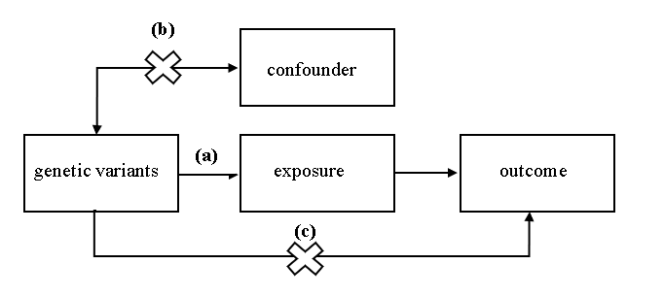

**FIGURE 1 |** A directed acyclic graph of MR model.

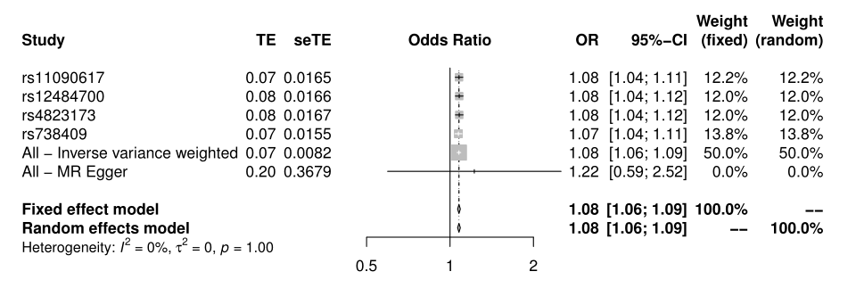

**FIGURE 2 |** Forest plot of HCV on T2D.

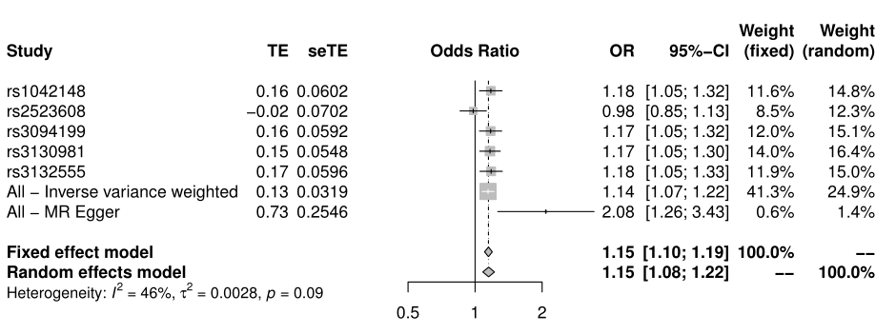

**FIGURE 3 |** Forest plot of HCV on T2D.

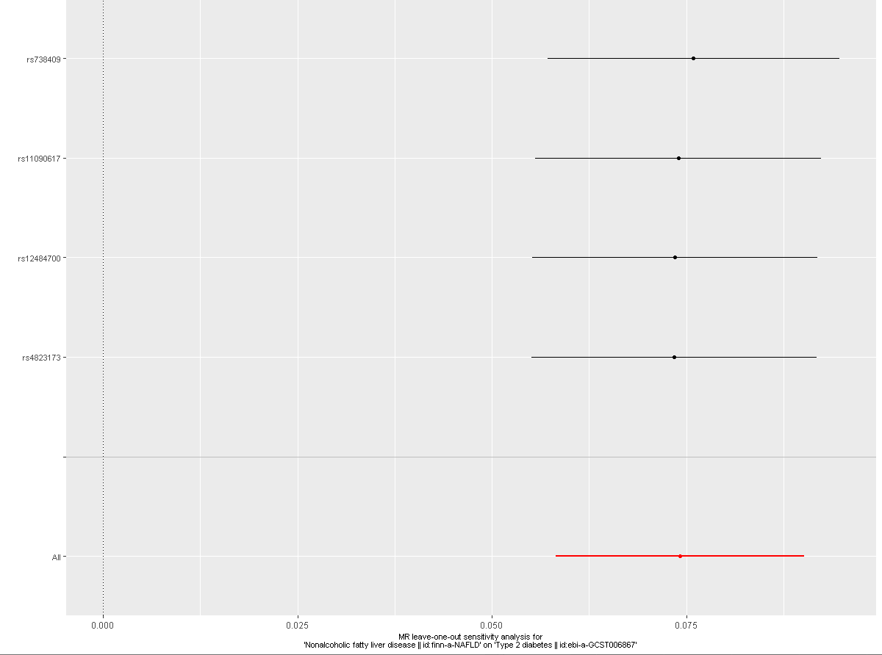

**Supplementary FIGURE 1 |** Leave-one-out cross validation of NAFLD on T2D. The red line is the average of all β values after leave-one-out

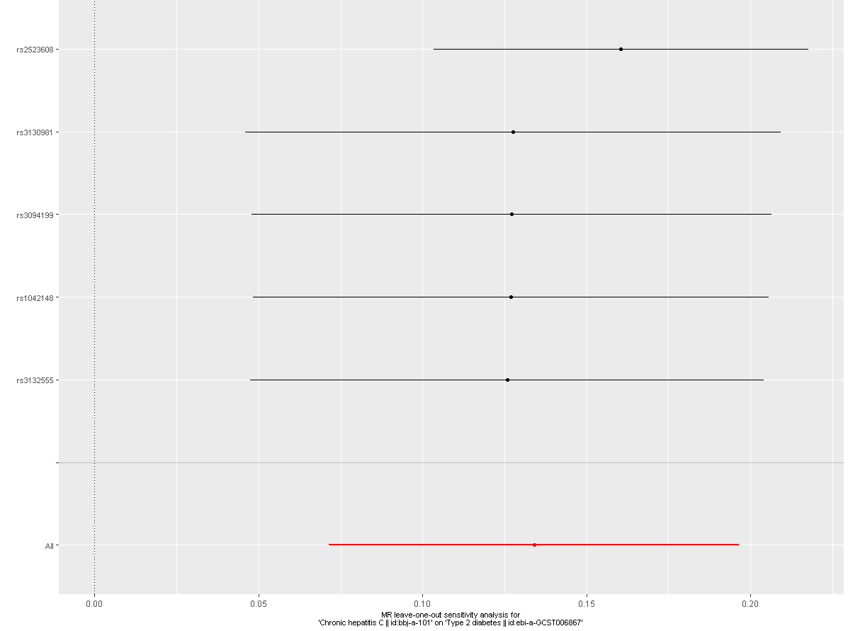

**Supplementary** **FIGURE 2 |** Leave-one-out cross validation of HCV on T2D. The red line is the average of all β values after leave-one-out