**Homework 8**

**Answers should be in your own words. Any indication of cheating or copying directly from anything on the internet or other students in the class will result in a ZERO on the assignment. **

Ryan Walkup

Z1761348

1. **Produce an E-R Diagram for the following scenario. List the attributes for each table. Underline the identifier for each table.**

**Jellystone Park Campground**

Jellystone Park Campground has asked you to model the data requirements for a reservation and marketing system. The R&M system needs to keep track of the campsites available. Specific information needed would include the campsite identifier (CID), the type of campsite, the location of the campsite, and the price for the campsite. Campsite reservations are assigned a unique number (Rnum). In addition to keeping track of campsite reservations, Jellystone wants to keep information on customers to use for marketing purposes. Many customers return to Jellystone year after year, and some visit nearly every weekend. However, Jellystone would like to find ways to increase their repeat customer business. For the next several years, Jellystone will be trying out various types of promotional materials. They will select customers to receive each promotion. Each customer will receive only one promotion. At the end of the trial, Jellystone will analyze this data to determine which promotion was most successful.

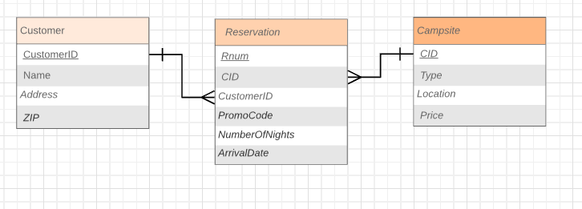

**Jellystone Campground Reservation Form**

Customer name*: _____________________

Street address: _________________

City: __________ State: ____ Zip: _________

Arrival Date: ____________ Number of nights: ___

Type of campsite (RV, tent, or handicapped): _____

*Please do not write below this line____________________________*

FOR JELLYSTONE PARK CAMPGROUND USE ONLY:

RNUM: ___________ PROMO CODE:___________

*Just one name per campsite, please. For multiple campsites, please use multiple forms.

1. Consider the following functional dependencies:

Applicant_ID🡪Applicant_Name

Applicant_ID🡪Applicant_Address

Position_ID🡪Position_Title

Position_ID🡪Data_Position_Opens

Position_ID🡪Department

Applicant_ID + Position_ID🡪Date_Applied

Applicant_ID+ Position_Id🡪Date_Interviewed

* 1. Represent these attributes with 3NF relations. Provide meaningful relation names.

Applicant (Applicant_ID, Applicant_Name, Applicant_Address)

Position (Position_ID, Position_Title, Data_Position_Opens, Department)

Process (Table_ID, Date_Interviewed, Date_Applied)

* 1. Represent these attributes using an E-R diagram. Provide meaningful entity and relationship names.

