Newest Report from World Gold Council: Generation Z Customer Don’t Have Interest in Gold

According to the newest research, Generation Z consumer may spend more money on luxury goods. However, comparing with the last generation, Generation Z have less interest on gold.

As the newest report <Gold Retail Market Insight 2019> from World Gold Council (WGC) indicates, only 12% of young group among 18 to 22 are planning to purchase gold in the next 12 months, the ratio of which is far lower than the group of the Millennial Generation (37%) and group over 39-year-old (42%).

As the largest purchasing country of gold products, the change of preference of Chinese young consumer group maybe the forecast to the gold industry. There is some indication that the global demand of gold is pushed by exchanges, exchange funds and investors rather than purchasing jewelry goods.

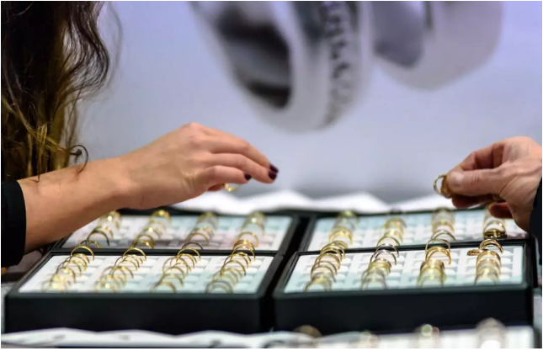

One of the reasons is Generation Z owns lower disposable income. In addition, WGC expressed that, comparing with other countries, Chinese young group age from 18 to 24 have weak emotional connection with gold, as they don’t believe gold will bring any good luck. 40% of the Chinese fashion customers which age from 18 to 24 agree gold may bring good luck while 88% of which are aged from 55 to 65.

Furthermore, among the Chinese fashion customers age from 18 to 24, 40% believe that wearing gold will contribute to the fashion taste while 50% may treat gold as a reward for success. Meanwhile, among the gold customers age from 55 to 65, the corresponding ratio are 88% and 86%.

The Below Picture shows the opinions of consumer with different ages in China and India towards gold (Contribute to Fashion, Bringing Good luck, As Reward for Success)

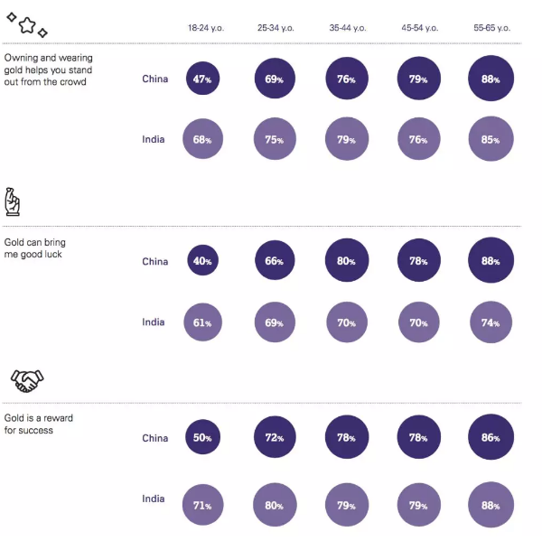

Alistair Hewitt, Director of Market Intelligence from WGC, said “It’s undoubtedly a huge challenge for the Chinese jewelry industry to interact with the young generation”. He said that Chinese young consumer may keep distance with gold, as gold has been connected to older generation for a long period, although young consumer’s opinions may change when they grow older.

In the second largest gold purchasing country, India, the difference of gold purchasing intention of different generations is not that obvious as in China. The proportions of millennials aged 18-22, 23-38, and the group over 38 who plan to purchase gold products in the next 12 months are: 24%, 33%, and 36%. The proportions of these three major age groups in the United States are: 11%. 19%, 18%

This research was based on the samples of 18,000 persons. With a series of markets of China, India, North America, Germany and Russia, this research mainly introduces the attitudes and opinions towards gold products as well as the reasons of purchasing or not purchasing gold products.

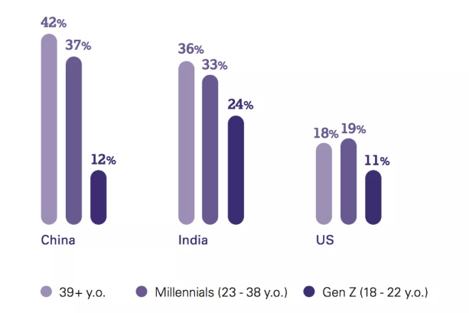

The report includes five aspects:

The confidence of people towards gold products. Once become gold products owners, they will be loyal consumer.

There is nonconfidence in the industry. Nonconfidence prevents some consumer from buying gold products.

Consumer of different generations have totally different attitudes towards gold products.

Technology innovation can lead a way to new consumer.

Potential gold buyers need to be educated with more knowledge of gold.

The report indicates that gold is still the third most popular investment target in the world and 46% of retail investors worldwide would choose gold products, second only to saving accounts (78%) and life insurance (54%). As to jewelry, the report shows that 56% of consumers buy gold jewelry, while 34% of consumers buy platinum jewelry.

In addition, the new research also shows that one third (38%) of retail investors and fashion followers have not purchased gold products before. However, they have optimistic opinions about this as it also indicates the huge growth potential of gold market. WGC said, although young people wish to gain prompt rewards, they generally believe that buying gold products is a way for long-term wealth keeping.

From the region speaking, great difference of gold demand exists among global consumer. Gold interest of Chinese and Indian consumer is stronger than that in Germany, Canada, etc.

David Tait said: To interact with the potential buyers, there are two issues to deal with, which are Trust and Awareness. If we can build trust in various gold products for sale and raise the awareness of consumer towards gold products in playing positive role on wealth preservation, then this market will flourish.