2019年中国新消费趋势报告

2019 China's New Consumption Trend Report

近日，在主题为“新消费·心服务”的2019联商网大会上，联商网顾问厉玲代表联商网发

布“**2019年新消费趋势报告**”。

Recently, the Linkshop’s adviser Liling on behalf of Linkshop to publish “2019 China's New Consumption Trend Report” at the 2019 Linkshop conference with the theme “New Consumer Service”.

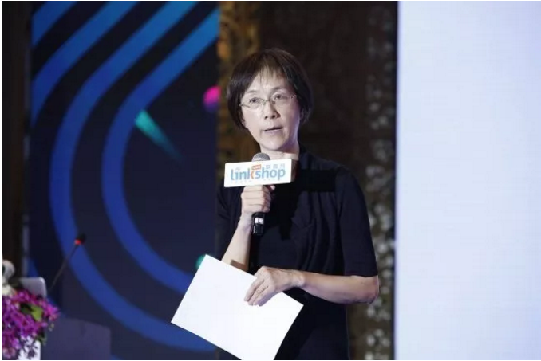

▲联商网顾问厉玲

Linkshop’s adviser Liling

**以下是报告内容摘要：**

The following is a summary of the report:

首先，这次是联商第一次做这样的报告，可能有点自不量力。但是我们非常想为零售企

业和零售行业多做一些事情，所以在看了很多研究报告后，我提议在这次会议上第一次

做出我们自己的报告。我们做这个报告的目的就是想从这些数据中，找出对我们零售企

业和零售行业的机会与挑战，这是我们的出发点。

First of all, this is the first time that Linkshop has made such a report, which maybe to bite off more than you can chew. But we really want to do something for retail enterprises and retail industry, so I propose that made our own report for first time in this conference after reading a lot of research reports. The purpose of the report that find the opportunity & challenge of retail enterprises and retail industry.

**这个报告有七大趋势，包括：零售社区化、零售渠道下沉、大单身崛起、银发经济、95**

**后消费、个性化消费和M型消费。**

There are seven major trends in this report, including: retail communitization, retail channel sinking, single economy, silver economy, lazy economy, personalize consumption and M-type consumption.

**一零售社区化**

- Retail Communitization

零售社区化有很重要的四个原因：

Retail communitization have four important reasons:

1. **中心城市的功能下降。**以第二中心、第三中心、社区为中心的生活圈，已经开始了，特别是在一二线城市，甚至在三线城市也开始出现这个情况。

Firstly, the core cities is declining. The second, third, and community-centered living circles have begun, especially in first- and second-tier cities, and even in third-tier cities.

1. **购物要日常化和便利化。**便利到什么？便利到家里线上就可以买，这也是一种趋势。

Secondly, shopping need routinization and facilitation. What’s the convenient? That’s a trend that you can online shopping at home.

**第三，社区生活多样化。**原来我们社区店比较集中在杂货铺，烟酒店，买生活必需品，现在则更集中于网上**。**社区生活的多样化促使着社区商店业态、内容服务项目需更丰富。

Thirdly, Diversified community life. Originally, our community store is more concentrated in the grocery store and cigarette and liquor store to buy [daily necessaries](http://www.youdao.com/w/daily%20necessaries/#keyfrom=E2Ctranslation), but now they are more concentrated on the Internet. With the diversification of community life, the content services of community stores need to be colorful.

**第四，社区商业的亲情化。**你走到社区店以后，你就有感觉到像回家一样。服务员都可以跟你打招呼说，张阿姨你有几天没来了，王叔叔今天你喜欢的牛油果到了，这可不是线上做得到的。我们到大百货商店就是顾客和商家之间的关系，可是到社区的就不是这样了，更像一个亲情互动的关系。

Fourthly, the kinship of community business. You will feel like go back to home when you go into the community store. The shop assistant will greet to you, maybe will say: “Aunt Zhang, you haven't been here for a few days.” or “ Uncle Wang, your favorite avocado arrived today.” These can’t be achieve at online shopping. When we go to a shopping mall, it is the relationship between the customer and the business, but it is not the case to the community, it is more like an interactive relationship.

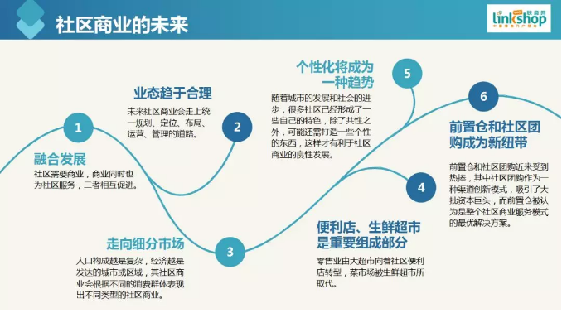

城市的扩大，生活的多样性，以及人们对情感需求的增加，使得零售要开始社区化，市中心的功能就削弱了。

The expansion of the city, the diversity of life and people's emotional needs is increasing. So the retail have to communitization and the center of city is weakened.

**二零售渠道下沉**

- Retail Channel Sinking

首先是城市化率不断提高，而城市建设带动了商业地产的蓬勃发展。

The first that the urbanization rate is constantly increasing, and urban construction has promoted the vigorous development of commercial real estate.

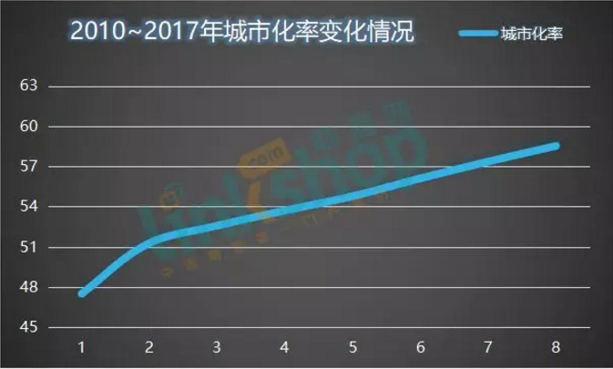

一方面表现是购物中心下沉。零售能够迅速下沉，要感谢商业零售商的建设和房地产开

发商，是他们带着许许多多的零售商走到了二线、三线、四线，甚至五线、六线城市去。

On the one hand express the centre of shopping is sinking. The retail can rapid sinking is benefit by the construction of commercial retailers and real estate developers, they took many retailers to the second-, third-, fourth-, and even fifth- and sixth-tier cities.

另一方面是小城镇人民生活富裕了，有需求了，城里打工挣了很多钱，回到家也得改善改

善生活。

On the other hand is the small-town’s people life are getting better, so that they will more demands for life. They working in the city to earning a lot of money, and go home to improve their living quality.

另外是零售企业自身做大做强的需求。这一点很重要，你要想做大，做强，做出全国影响

的品牌来，你就必须去重视一些二线、三线甚至四线城市。

In addition, it is the demand of retail enterprises to make themselves bigger and stronger. That’s a important ideal that if you want to be the biggest and stronger and influence all country’s brand, you have to pay attention to second-tier, third-tier and even fourth-tier cities.

**三大单身崛起**

- Single Economy

目前年轻人选择单身越来越多，民政部数据显示：2018年，全国结婚登记人数

为1010.8万对，同比下降4.9%；这是自2013年以来连续5年下降。

At present, more and more young people chose be single. In 2018, the number of marriage registrations nationwide was 10.108 million, down 4.9% year-on-year, dropping for the fifth consecutive year, according to the Civil Affairs Bureau.

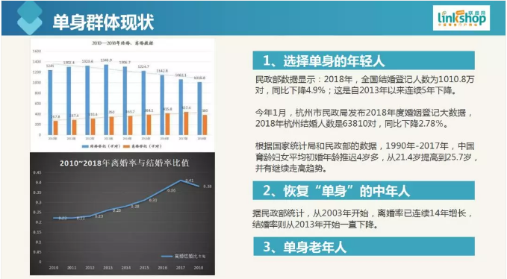

第一个原因是我发觉很多年轻人尤其是女孩子选择单身，她觉得那是一种风格；第二是

恢复单身的中年人，也就是离婚。现在中年人的离婚率也在急剧攀升；第三，单身的老

年人在增加。

The first reason that I found many young people select be single, especially the young women. The second is the divorce rate in middle age is on the sharp upward trend now and being single again. The third that the single of senior citizens are increasing.

这三个族群构成了一个大单身经济，所以单身不仅仅是年轻人的菜，中年人，甚至老年人

也很多。日本最新调查表明2018年在东京和大阪这些大城市当中，单身的老人家庭占总数

11.8%。如果一个城市20%，甚至25%的家庭都是单身老人，那这预示着怎么样的消费市

场？预示着怎么样的零售功能？所以我们觉得单身群体要把它专门提出来。那么单身就有一

些对商品的要求，比如说要求数量少、品种多、质量要求相对高。

The three ethnic groups constitute the Single Economy, so being single not only belong to young, but also for the middle age even the senior citizens. According the latest survey of Tokyo show that in big cities such as Tokyo and Osaka, the single elderly families accounted for 11.8% of the total in 2018. If one city have 20%,even 25% families are the single elderly. What does this foreshadow for consumer market and retail function, so we should pay more attention to single group and they have some requirements of commodity. For example: small quantity, varieties, high quality.

比如美国有一个超市，那个老板就在店里面发现一个老奶奶拿那个香蕉拿上拿下好几次，问

他你为什么不买？其实挺便宜的。她就说，多么太多，一个又不好掰，我也不知道一个你们

允不允许。从那之后，超市的香蕉就可以单个卖了。韩国人还有七个香蕉一个一个包装，从

青到黄，以便你每天吃一个的时候都是熟的。

Such as a supermarket of America where boss discovered a old woman picked and putted the banana many times, so he asked: “why you didn’t buy it? Actually this not expensive.” She responded: “That’s too much or one is not easy to break, and I don’t know whether you’re allowed sell one.” Since then, supermarket’s banana can be sold individually. Koreans also pack seven bananas one by one, from green to yellow, so that when you eat one every day, they are ripe.

单身对购物场所也有要求，单身人一般来讲需要私密性，私密对他们来讲更为重要，所以对

购物场所的环境要求很高。另外还有对服务的要求也是讲究便利性和私密性。

Singles also have requirements for shopping places. Singles generally need privacy which is very important to them, so the environment for shopping places is very high. In addition, there are requirements for service that focus on convenience and privacy.

最后是其他商品的开发。一些创业青年曾问我能不能做单人餐厅？我说：能。为什么？

单身经济正在崛起，单身要求又特殊，所以你有可能做起来。

The last is the development of others commodity production. Some young entrepreneurs have asked me can we open a single-person restaurant? I said: Yes. Why not? The single economy is on the rise, and single requirements are special, so you may succeed.

**四银发经济**

- Silver Economy

银发经济其实也就是老年经济，其实老年经济我们之前也提到了。中国的老龄化会引起消

费结构很大很大的变化。老龄人口的增长那是很明显的，老年人的需求也是会有一些变化的。

Silver Economy actually is the senior citizens economy and we mentioned before. China's aging will cause great changes in consumption structure. The aging of population had an obvious growth and the requirements also have change.

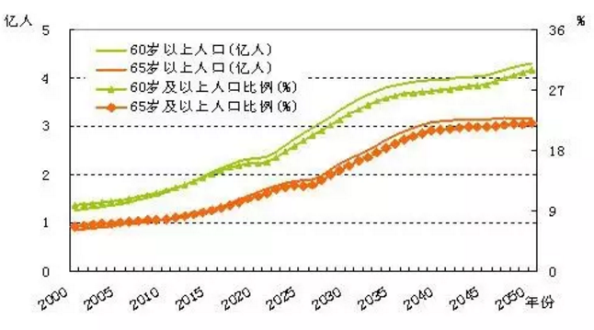

▲来源：《国家人口发展战略研究·人口发展预测》课题

Source:《National population development strategy research· population development forecast》

首先老年人会对性价比要求会更高一些。老年人对价格更为敏感，因为挣钱不容易啊。然后对于健康产品的关注也会更多，对体验也更讲究。

The elderly will have higher requirements on the cost performance. They are very sensitive about price, because it is not easy to earn money. Then there will pay more attention to health products and the experience.

我一直觉得日本人的今天很可能是我们的明天。日本的老龄化现象也会在未来的北京、上

海、杭州到来。

I've always felt that what the Japanese are today is likely to be our tomorrow. The aging phenomenon of Japan will appear in Beijing and Shanghai and Hangzhou in the future.

比如日本有一个永旺购物中心，它叫“永旺G.G Mall”，2013年进行重新装修，专做老年人

，70%以上是老年人，商业面积16145平米，一共有五层。

Such as G.G Mall, is a shopping mall in AEON of Japan and was refurbished in 2013 year. The mall specially for the elderly and over 70% consumers are the elderly, where the commercial area is 16,145 square meters with five floors.

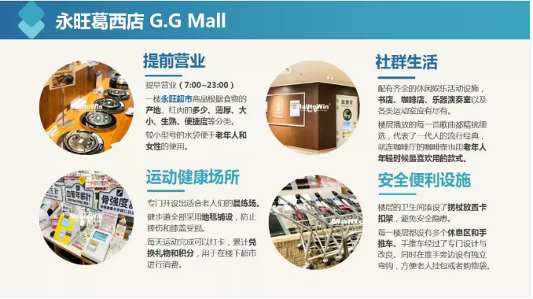

值得注意的是，大家别觉得老年化离你很远。社区居民老龄化的速度其实非常非常快。

那么到时候做社区店怎么办？所以你得面临着老龄化的挑战。

It’s worth noting that everyone should not think the aging is far away from you. The ageing of community residents is actually very fast. So what should we do as a community store at that time? Therefore, you have to face the challenge of aging.

这些业态对我们零售人其实是有一些提示的，我非常推荐大家多看看日本零售的现状来

预测我们的未来。

Actually, these phenomenons of industry have some hints for retailer. I highly recommend that you look at the current status of Japanese retail to predict our future.

**五95后消费**

-Lazy Economy

所谓95后消费，就是年轻人消费，一般讲就是15-30岁左右的消费者。虽然数量正在下

降，但是总量还是不少。

Lazy economy means the after 1995 consumer which generally is 15-30age consumer. Although the number is falling, the total is still quite large.

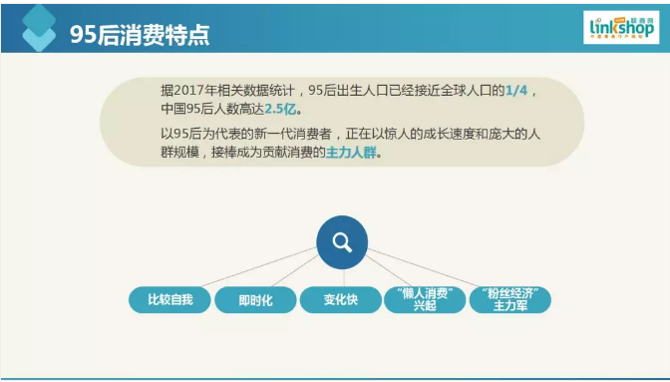

1. 作为年轻人有特点，他（她）很自我；第二，他（她）想要很快，非常渴望购物

即时化；第三，他（她）的需求变化也很快；第四，95后是懒人，所以对外卖、

1. 送货的要求高；第五，他们是粉丝经济主力军，粉丝经济因此兴起。

Firstly, the young people have a characteristic that very self-centered. Secondly is the fast that they are eager to real time of shopping. Thirdly, their requirements change quickly. Fourthly, most of after 1995 are lazy, so they have highly requirement for takeout and delivery. The last is the main force of fan economy, so the fan economy has risen.

**六个性化消费**

- Personalize Consumption

个性化消费很难具体说明，因为个性化可以个性到一个人，个性化有各种各样的特点。

《华丽志》发布《2017年度中国时尚消费调查报告》显示，近95%的受访者对个性化

定制感兴趣。其中，55%对服装定制感兴趣，近50%对珠宝首饰感兴趣。

Personalized consumption is difficult to specify because personalisation can be personalized to a person, and that has various characteristics. 《Luxe》 published 《the 2017 China Fashion Consumption Survey Report》, showing that nearly 95% of respondents are interested in personalized customization. Among them, 55% are interested in clothing customization, and nearly 50% in jewelry.

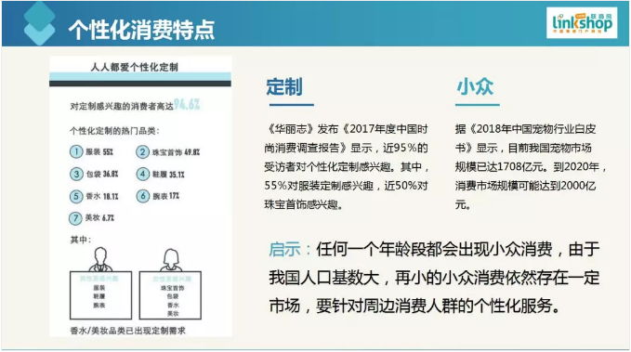

我这里特别要提出就是社区商店的个性化，一定要根据你所在的社区去定制你的商业，

去销售你的商品，去提供你的服务。

What I particularly want to propose here is the personalisation of community stores. Be sure to customize your business according to your community, to sell your goods and provide your services.

比方说你的销售范围全是豪宅，那就销售包装食品，他要求快你就快一点。但是要是

都是老年人社区你就不能这样，这也叫个性化定制。对于商品来讲，现在各种个性化

很厉害了。

For example, if your sales scope are the luxury houses, then you can sell packaged foods. If they asked you to be quick. But if you are in an elderly community, you can't be same. This is called personalized customization. For the goods, the various personalisation are very powerful now.

**七M型消费**

- M-type consumption

最后一条，就是M型消费。这是日本经济学家大前研一在2005年前后提出，他是根

据1995年整个日本消费市场、金融市场之后提出日本已经进入了M型社会。

type consumption was proposed by Japanese economist Ohmae Kenichi around 2005. According to the 1995 Japanese consumer market and financial market, he proposed that Japan has entered the M-type society

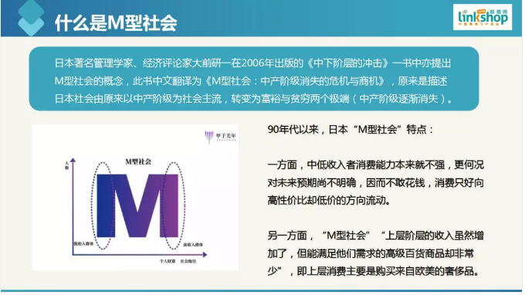

所谓M型社会原来是描述日本社会由原来以中产阶级为社会主流，转变为富裕与贫穷两

个极端(中产阶级逐渐消失)。我们根据大前研一文章之后，对照今天的发展，我们觉得中

国的M型社会也到了。

M-type consumption was originally used to describe the transition of Japanese society from the middle class to the extremes of wealth and poverty (the middle class gradually disappeared). After we researched the article of Ohmae Kenichi and contrast the current development of China, the M-type consumption of China is coming soon.

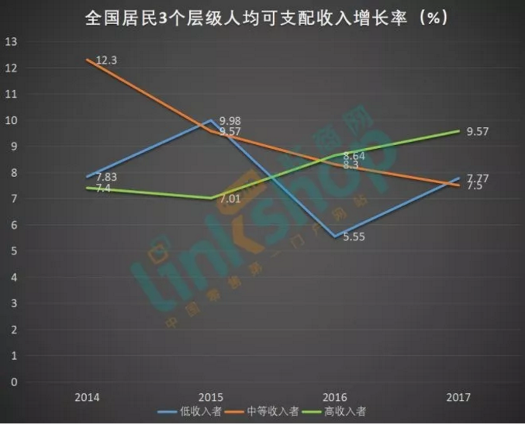

或者我们今天说，中国的M型社会到来了吗？一个提问，大家去看，去对照。当然我是

比较赞成中产阶级在逐渐消失这个观点的。

Perhaps we can say: “ Has China's M-type society arrived?” We can propose the question and go to contrast them. But I prefer the view that the middle class is gradually disappearing.

拼多多现象非常能说明这个问题。作为一个现象，说明低端消费人迅速增长，也就是M

型社会整个中产消失往低端走的现象。那么另一个极端就是高端，据说奢侈品在去年中国

增长20%，去年中国最高端的百货店SKP销售了120个亿，雄踞全亚洲第一。高端在涨，

低端在涨，谁没涨？中间没涨，中间为什么没涨？因为收入没希望，我不敢说经济好坏，

反正范剑平老师说经济不太好。

The appearance of Pinduoduo is a good illustration of this question. As a phenomenon, it shows that the low-end consumers are growing rapidly, that is the phenomenon that the entire middle class in M-type society disappears and goes to the low-end. The other extremes is the high-end, It is said that luxury goods increased by 20% in China last year. Last year, China’ s highest-end department store SKP sold 12 billion, ranks No.1 in Asia. The high-end and low-end is going up. What hasn't? Why didn't go up in the middle? Because there is no hope for income, I dare not say that the economy is good or bad. Anyway, Mr. Fan Jianping said that the economy is not good.

中国经济会影响我们的零售，所以每个做零售的人，我们只有认清形势，取长补短，才能

找出我们自己所要的市场份额来。

Chinese economy will influence our retail, so every retailer grasp the situation and learn from each other, and then find out the what we want of the market shares.

大会的主题叫做“新消费·心服务”，我希望零售人能够真正用心对得起我们的消费者，对得

起我们的顾客，让逛街更从容，让消费更优雅。

The conference topic called: “New Consumer Service”, I hope that the retailer can treat our consumers and customers with heart, make shopping more relaxed and elegant.