**First testing from my machine**

1-verify DNS resolution: from another linux machine type "nslookup internal.example.com"

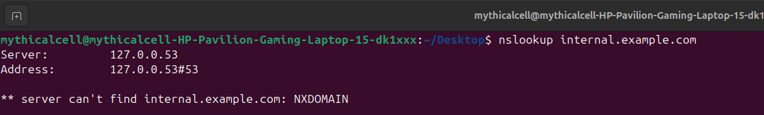

2-check which server is configured for DNS in resolv.conf "can be internal or external like 8.8.8.8" and check if its working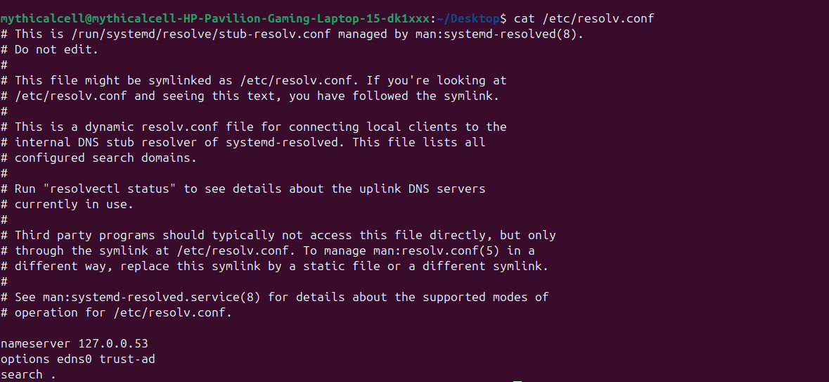

3-for testing only we can add the IP-fqdn entry in the /etc/hosts in the machine we are testing from if this will resolve the issue (if its a DNS issue) **(Bonus)**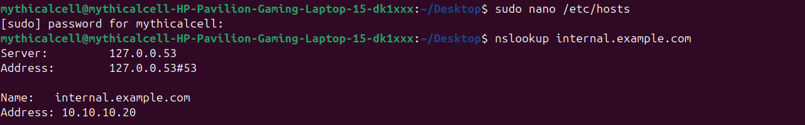

4-the service can be running but on another port or the port can be blocked by the firewall, so we will test the connectivity with command "curl http://internal.example.com:80" or "curl [https://internal.example.com:443"](https://internal.example.com:443%22)

**Testing from the server**

5-we can also check on which port the service is listening "sudo ss -tulnp | grep servicename" If the port can be not open in the server itself we can use

sudo firewall-cmd --add-port=80/tcp

and

sudo firewall-cmd reload

Commands

**To persist DNS server settings using systemd-resolved or NetworkManager (Bonus).**

sudo nmcli connection modify "<connection-name>" ipv4.dns "192.168.1.1"

sudo nmcli connection modify "<connection-name>" ipv4.dns-search "internal.example.com"