

Twitter Registration Instructions

Registering for Twitter is free, easy and can be completed in a few minutes. All you will need is an email address and an Internet connection. Having a Twitter account setup before attending #PS114 will help you get more out of the session including the interactive Q&A, back channel conversation and the ability to contribute to the live TwitterFall.

In addition to registering on the Twitter website you can use the American College of Surgeons apps for Android and iOS. Links to the apps are posted online at http://z1g1.net/projects/acs2012



- Visit Twitter.com and complete the “New to Twitter” form and click “Sign Up for Twitter”|
 | - Full name: Information that you enter in this box will help people find your profile  - Email: Twitter uses your email to authenticate your account  - Password: Choose a strong password unique to Twitter which contains a mix of upper and lowercase letters, numbers and symbols

- You will be taken to another page to complete the registration process.
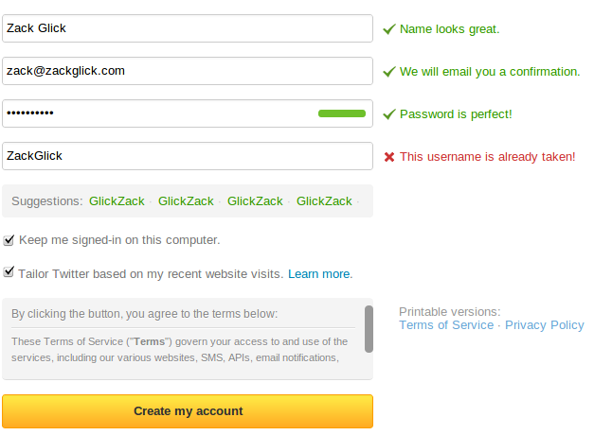 | - Your full name, and email will be validated  - Your password will be graded, try to get a perfect score  - You need to accept the Twitter Terms of Service to use their service  - Keeping the “Tailor Twitter based on my recent website visits.” will utilize Twitter's ad network to help you find followers  - If your desired username is taken try a variation ZackGlick was taken but ZackGlickCISSP was fine
- If all your information is correct you will be taken to a quick Twitter tour. If you have time this is a nice introductions to the service.
- Continue to https://twitter.com/settings/profile to customize your profile. Uploading an image, adding a bio and entering your location and website address can help other people find you and make your profile more appealing
- To help you fine people at ACS we have created a Twitter List at http://twitter.com/z1g1/acs/members
- You can also enter the ACS 2012 Hashtag #ACS2012 or the session Hashtag at http://search.twitter.com

