Dynamic QR Code

20240719

[https://www.qrcode-monkey.com/#](https://www.qrcode-monkey.com/)

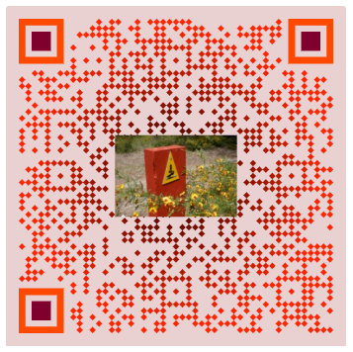

20240708 Google Account: bravo168   
https://qrfy.com/app/my-qr-codes

