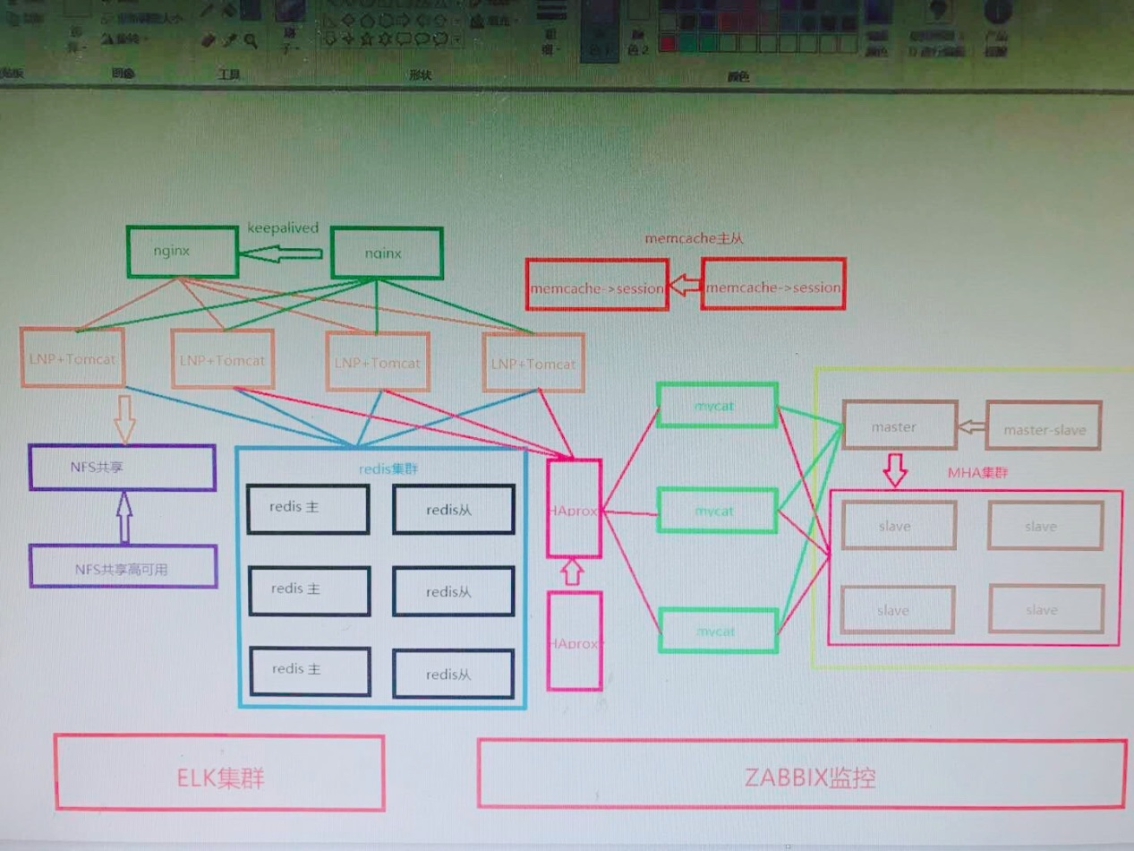

MHA集群：

MHA的manager服务器：192.168.1.20

MHA的VIP地址：192.168.1.203

[root@mha ~]# vim /etc/mha_manager/app1.cnf

[server default]

manager_log=/etc/mha_manager/manager.log

manager_workdir=/etc/mha_manager

master_ip_failover_script=/usr/local/bin/master_ip_failover

password=123456

ping_interval=1

remote_workdir=/etc/mha_manager

repl_password=123456

repl_user=repluser

ssh_port=22

ssh_user=root

user=root

[server1]

candidate_master=1

hostname=192.168.1.21

[server2]

candidate_master=1

hostname=192.168.1.22

[server3]

candidate_master=1

hostname=192.168.1.23

[server4]

hostname=192.168.1.24

no_master=1

[server5]

hostname=192.168.1.25

no_master=1

[server6]

hostname=192.168.1.26

no_master=1