A/C UNIT REMOVAL/INSTALLATION

Installation position
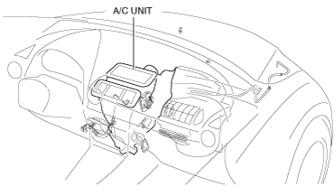
am2zzw00009857
Warning
• Handling the driver-side air bag module improperly can accidentally deploy the air bag module, which may seriously injure you. Read the air bag system service warnings and cautions before handling the air bag module. (See AIR BAG SYSTEM SERVICE WARNINGS [TWO-STEP DEPLOYMENT CONTROL SYSTEM].) (See AIR BAG SYSTEM SERVICE CAUTIONS [TWO-STEP DEPLOYMENT CONTROL SYSTEM].)(See AIR BAG SYSTEM SERVICE WARNINGS [STANDARD DEPLOYMENT CONTROL SYSTEM].) (See AIR BAG SYSTEM SERVICE CAUTIONS [STANDARD DEPLOYMENT CONTROL SYSTEM].)
Note
• When removing the driver-side air bag module, it is necessary to rotate the steering wheel. If the ignition has been switched OFF (LOCK) with the driver's door closed, the steering wheel will be locked. Perform the procedure from Steps 1-3 so that the steering wheel will not be locked.
1. Switch the ignition ON (engine off or on).
2. Open the driver's door.
3. Switch the ignition off.
4. Disconnect the negative battery cable. (See NEGATIVE BATTERY CABLE DISCONNECTION/CONNECTION.)
5. Discharge the refrigerant. (See REFRIGERANT RECOVERY.)(See REFRIGERANT CHARGING.)
6. Drain the engine coolant. (See ENGINE COOLANT REPLACEMENT [SKYACTIV-G 1.3, SKYACTIV-G 1.5].)(See ENGINE COOLANT REPLACEMENT [SKYACTIV-D 1.5].)
7. Remove the following parts:
(1) Plug hole plate (See PLUG HOLE PLATE REMOVAL/INSTALLATION [SKYACTIV-G 1.3, SKYACTIV-G 1.5].)
(2) Engine cover (See ENGINE COVER REMOVAL/INSTALLATION [SKYACTIV-D 1.5].)
(3) Windshield wiper arm and blade (See WINDSHIELD WIPER ARM AND BLADE REMOVAL/INSTALLATION.)
(4) Cowl grille (See COWL GRILLE REMOVAL/INSTALLATION.)
(5) Windshield wiper motor and link (See WINDSHIELD WIPER MOTOR AND LINK REMOVAL/INSTALLATION.)
(6) Side cowl grille (See SIDE COWL GRILLE REMOVAL/INSTALLATION.)
(7) Front scuff plate (See FRONT SCUFF PLATE REMOVAL/INSTALLATION.)
(8) Front side trim (See FRONT SIDE TRIM REMOVAL/INSTALLATION.)
(9) A-pillar trim (See A-PILLAR TRIM REMOVAL/INSTALLATION.)
(10) Driver-side air bag module (See DRIVER-SIDE AIR BAG MODULE REMOVAL [TWO-STEP DEPLOYMENT CONTROL SYSTEM].)(See DRIVER-SIDE AIR BAG MODULE INSTALLATION [TWO-STEP DEPLOYMENT CONTROL SYSTEM].)(See DRIVER-SIDE AIR BAG MODULE REMOVAL [STANDARD DEPLOYMENT CONTROL SYSTEM].)(See DRIVER-SIDE AIR BAG MODULE INSTALLATION [STANDARD DEPLOYMENT CONTROL SYSTEM].)
(11) Steering wheel (See STEERING WHEEL AND COLUMN REMOVAL/INSTALLATION.)
(12) Upper column cover (See COLUMN COVER REMOVAL/INSTALLATION.)
(13) Meter hood (See METER HOOD REMOVAL/INSTALLATION.)
(14) Instrument cluster (See INSTRUMENT CLUSTER REMOVAL/INSTALLATION.)
(15) Lower column cover (See COLUMN COVER REMOVAL/INSTALLATION.)
(16) Clock spring (See CLOCK SPRING REMOVAL/INSTALLATION [TWO-STEP DEPLOYMENT CONTROL SYSTEM].)(See CLOCK SPRING REMOVAL/INSTALLATION [STANDARD DEPLOYMENT CONTROL SYSTEM].)
(17) Wiper and washer switch (See WIPER AND WASHER SWITCH REMOVAL/INSTALLATION.)
(18) Light switch (See LIGHT SWITCH REMOVAL/INSTALLATION.)
(19) Bonnet release lever (See BONNET RELEASE LEVER AND RELEASE CABLE REMOVAL/INSTALLATION.)
(20) Fuel-filler lid opener lever (See FUEL-FILLER LID OPENER AND LEVER REMOVAL/INSTALLATION.)
(21) Driver-side lower panel (See DRIVER-SIDE LOWER PANEL REMOVAL/INSTALLATION.)
(22) Joint cover (See STEERING WHEEL AND COLUMN REMOVAL/INSTALLATION.)
(23) Steering shaft (See STEERING WHEEL AND COLUMN REMOVAL/INSTALLATION.)
(24) Glove compartment (See GLOVE COMPARTMENT REMOVAL/INSTALLATION.)
(25) Center panel (See CENTER PANEL REMOVAL/INSTALLATION.)
(26) Dashboard under cover (See DASHBOARD UNDER COVER REMOVAL/INSTALLATION.)
(27) Passenger-side lower panel (See PASSENGER-SIDE LOWER PANEL REMOVAL/INSTALLATION.)
(28) Center console tray (See CENTER CONSOLE TRAY REMOVAL/INSTALLATION.)
(29) Shift bezel (See SHIFT BEZEL REMOVAL/INSTALLATION.)
(30) Upper panel (See UPPER PANEL REMOVAL/INSTALLATION.)
(31) Selector lever knob (ATX) (See AUTOMATIC TRANSAXLE SHIFT MECHANISM REMOVAL/INSTALLATION.)
(32) Shift lever knob (MTX) (See MANUAL TRANSAXLE SHIFT MECHANISM REMOVAL/INSTALLATION [F65M-R].)(See MANUAL TRANSAXLE SHIFT MECHANISM REMOVAL/INSTALLATION [F66M-R].)
(33) Shift panel (See SHIFT PANEL REMOVAL/INSTALLATION.)
(34) Console side panel (See CONSOLE SIDE PANEL REMOVAL/INSTALLATION.)
(35) Front console box (See FRONT CONSOLE BOX REMOVAL/INSTALLATION.)
(36) CD player (with CD player) (See CD PLAYER REMOVAL.)(See CD PLAYER INSTALLATION.)
(37) DVD/CD player (with DVD/CD player) (See DVD/CD PLAYER REMOVAL.)(See DVD/CD PLAYER INSTALLATION.)
(38) Front console (See FRONT CONSOLE REMOVAL/INSTALLATION.)
(39) Side wall (See SIDE WALL REMOVAL/INSTALLATION.)
(40) Rear console (See REAR CONSOLE REMOVAL/INSTALLATION.)
(41) Center lower panel (See CENTER LOWER PANEL REMOVAL/INSTALLATION.)
(42) Climate control unit (See CLIMATE CONTROL UNIT REMOVAL/INSTALLATION [FULL-AUTO AIR CONDITIONER].) (See CLIMATE CONTROL UNIT REMOVAL/INSTALLATION [MANUAL AIR CONDITIONER].)
(43) Audio panel No.2 (See AUDIO PANEL No.2 REMOVAL/INSTALLATION.)
(44) Audio panel No.1 (See AUDIO PANEL No.1 REMOVAL/INSTALLATION.)
(45) Audio unit (without center display) (See AUDIO UNIT REMOVAL/INSTALLATION.)
(46) Center display (with center display) (See CENTER DISPLAY REMOVAL/INSTALLATION.)
(47) Selector lever component (ATX) (See AUTOMATIC TRANSAXLE SHIFT MECHANISM REMOVAL/INSTALLATION.)
(48) Shift lever component (MTX) (See MANUAL TRANSAXLE SHIFT MECHANISM REMOVAL/INSTALLATION [F65M-R].)(See MANUAL TRANSAXLE SHIFT MECHANISM REMOVAL/INSTALLATION [F66M-R].)
(49) Dashboard (See DASHBOARD REMOVAL.)(See DASHBOARD INSTALLATION.)
(50) Foot support (See FOOT SUPPORT REMOVAL/INSTALLATION.)
(51) Front heat duct (See FRONT HEAT DUCT REMOVAL/INSTALLATION.)
(52) Blower unit (See BLOWER UNIT REMOVAL/INSTALLATION.)
8. Remove the cooler hose (LO) bracket installation nut. (See REFRIGERANT LINE REMOVAL/INSTALLATION [SKYACTIV-G 1.3, SKYACTIV-G 1.5].)(See REFRIGERANT LINE REMOVAL/INSTALLATION [SKYACTIV-D 1.5].)
9. Remove the bolt, then disconnect the cooler hose (LO) and cooler pipe.
Caution
• If moisture or foreign matter enters the refrigeration cycle, cooling ability will be lowered and abnormal noise or other malfunctions could occur. Always plug open fittings immediately after removing any refrigeration cycle parts.
10. Disconnect heater hose A and B.
11. Disconnect the drain hose.
12. Remove the nuts.
13. Remove the A/C unit. Do not allow compressor oil to spill.
14. Install in the reverse order of removal. (See A/C Unit Installation Note.)(See Drain Hose Installation Note.)
15. Inspect for engine coolant leakage. (See ENGINE COOLANT LEAKAGE INSPECTION [SKYACTIV-G 1.3, SKYACTIV-G 1.5].)(See ENGINE COOLANT LEAKAGE INSPECTION [SKYACTIV-D 1.5].)
16. Perform the refrigerant system performance test. (See REFRIGERANT SYSTEM PERFORMANCE TEST.)
A/C UNIT DISASSEMBLY/ASSEMBLY

id071100800300

L.H.D. (Full-auto Air Conditioner)
1. Disassemble in the order indicated in the table.
Caution
• If a non-specified grease is used, it may result in abnormal noise or an operation malfunction of the links. Use only a grease coating agent on each link and do not wipe off or add additional grease.
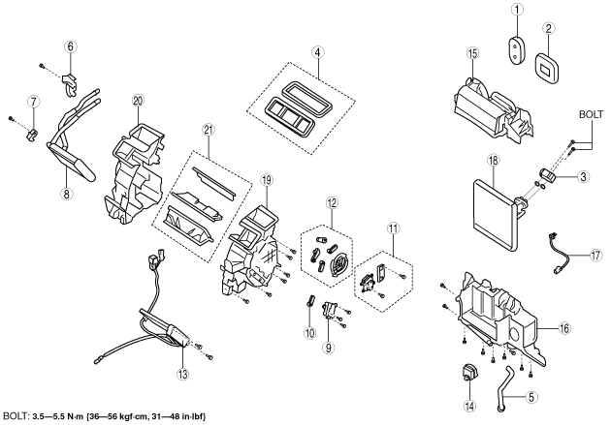
am2zzw00012919
×: Applicable
—: Not applicable
Step | Part name | Disassembly/assembly of main parts
Step | Part name | Heater core | Evaporator temperature sensor | Evaporator
1 | Polyurethane foam A | × | × | ×
2 | Polyurethane foam B | — | × | ×
3 | Expansion valve | — | — | ×
4 | Adhesive polyurethane | — | — | —
5 | Drain hose | — | — | —
6 | Plate A | × | × | ×
7 | Plate B | × | × | ×
8 | Heater core | × | × | ×
9 | Air mix actuator | — | — | —
10 | Air mix link | — | — | —
11 | Airflow mode actuator | — | — | —
12 | Airflow mode link set | — | — | —
13 | PTC heater (With PTC heater) | — | — | —
14 | Blower fan controller | — | — | —
15 | A/C case A | — | × | ×
16 | A/C case B | — | × | ×
17 | Evaporator temperature sensor (See Evaporator temperature sensor assembly note.) | — | × | ×
18 | Evaporator | — | — | ×
19 | A/C case C | — | — | —
20 | A/C case D | — | — | —
21 | Door damper | — | — | —
2. Assemble in the reverse order of disassembly.

Evaporator temperature sensor assembly note
1. Assemble the evaporator temperature sensor as shown in the figure.
Caution
• If the evaporator temperature sensor is assembled to its previous installation position, it may not function due to poor contact of the evaporator fin surface with the sensor detection area caused by fin deformation. When replacing only the evaporator sensor, shift the evaporator temperature sensor installation position from the current position and assemble.
Note
• If an evaporator temperature sensor cannot be correctly positioned on the evaporator, replace the evaporator.

L.H.D. (Manual Air Conditioner)
1. Disassemble in the order indicated in the table.
Caution
• If a non-specified grease is used, it may result in abnormal noise or an operation malfunction of the links. Use only a grease coating agent on each link and do not wipe off or add additional grease.
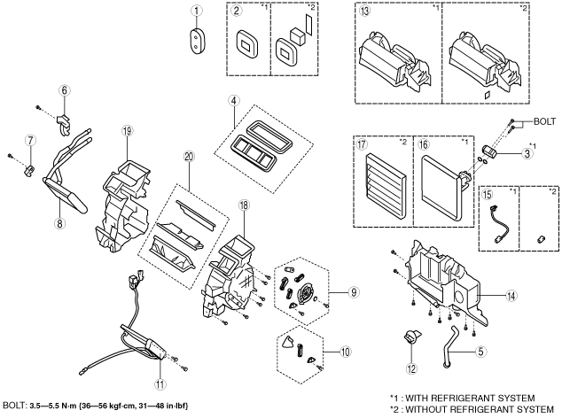
am2zzw00012920
×: Applicable
—: Not applicable
Step | Part name | Disassembly/assembly of main parts
Step | Part name | Heater core | Evaporator temperature sensor | Evaporator
1 | Polyurethane foam A | × | × | ×
2 | Polyurethane foam B | — | × | ×
3 | Expansion valve ^{*1} | — | — | ×
4 | Adhesive polyurethane | — | — | —
5 | Drain hose | — | — | —
6 | Plate A | × | × | ×
7 | Plate B | × | × | ×
8 | Heater core | × | × | ×
9 | Airflow mode link set | — | — | —
10 | Air mix link | — | — | —
11 | PTC heater (With PTC heater) | — | — | —
12 | Resistor | — | — | —
13 | A/C case A | — | × | ×
14 | A/C case B | — | × | ×
15 | Evaporator temperature sensor ^{*1} (See Evaporator temperature sensor assembly note.) | — | × | ×
16 | Evaporator ^{*1} | — | — | ×
17 | Case ^{*2} | — | — | —
18 | A/C case C | — | — | —
19 | A/C case D | — | — | —
20 | Door damper | — | — | —
*1 :With refrigerant system
*2 :Without refrigerant system
2. Assemble in the reverse order of disassembly.

Evaporator temperature sensor assembly note
1. Assemble the evaporator temperature sensor as shown in the figure.
Caution
• If the evaporator temperature sensor is assembled to its previous installation position, it may not function due to poor contact of the evaporator fin surface with the sensor detection area caused by fin deformation. When replacing only the evaporator sensor, shift the evaporator temperature sensor installation position from the current position and assemble.
Note
• If an evaporator temperature sensor cannot be correctly positioned on the evaporator, replace the evaporator.

R.H.D. (Full-auto Air Conditioner)
1. Disassemble in the order indicated in the table.
Caution
• If a non-specified grease is used, it may result in abnormal noise or an operation malfunction of the links. Use only a grease coating agent on each link and do not wipe off or add additional grease.
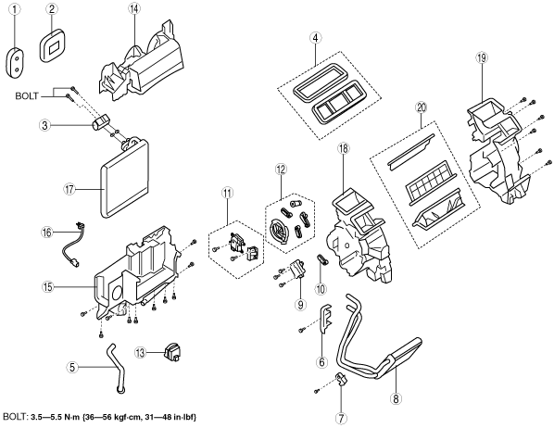
am2zzw00009585
×: Applicable
—: Not applicable
Step | Part name | Disassembly/assembly of main parts
Step | Part name | Heater core | Evaporator temperature sensor | Evaporator
1 | Polyurethane foam A | × | × | ×
2 | Polyurethane foam B | — | × | ×
3 | Expansion valve | — | — | ×
4 | Adhesive polyurethane | — | — | —
5 | Drain hose | — | — | —
6 | Plate A | × | × | ×
7 | Plate B | × | × | ×
8 | Heater core | × | × | ×
9 | Air mix actuator | — | — | —
10 | Air mix link | — | — | —
11 | Airflow mode actuator | — | — | —
12 | Airflow mode link set | — | — | —
13 | Blower fan controller | — | — | —
14 | A/C case A | — | × | ×
15 | A/C case B | — | × | ×
16 | Evaporator temperature sensor (See Evaporator temperature sensor assembly note.) | — | × | ×
17 | Evaporator | — | — | ×
18 | A/C case C | — | — | —
19 | A/C case D | — | — | —
20 | Door damper | — | — | —
2. Assemble in the reverse order of disassembly.
Evaporator temperature sensor assembly note
1. Assemble the evaporator temperature sensor as shown in the figure.
Caution
• If the evaporator temperature sensor is assembled to its previous installation position, it may not function due to poor contact of the evaporator fin surface with the sensor detection area caused by fin deformation. When replacing only the evaporator sensor, shift the evaporator temperature sensor installation position from the current position and assemble.
Note
• If an evaporator temperature sensor cannot be correctly positioned on the evaporator, replace the evaporator.
R.H.D. (Manual Air Conditioner)
1. Disassemble in the order indicated in the table.
Caution
• If a non-specified grease is used, it may result in abnormal noise or an operation malfunction of the links. Use only a grease coating agent on each link and do not wipe off or add additional grease.
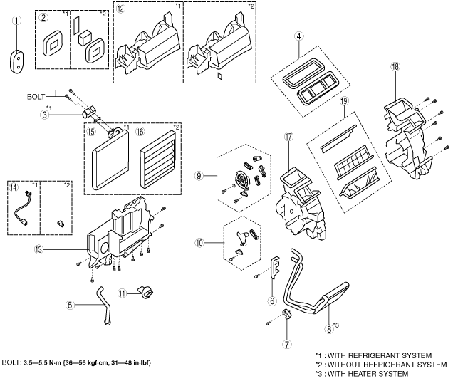
am2zzw00009587
×: Applicable
—: Not applicable
Step | Part name | Disassembly/assembly of main parts
Step | Part name | Heater core | Evaporator temperature sensor | Evaporator
1 | Polyurethane foam A | × | × | ×
2 | Polyurethane foam B | — | × | ×
3 | Expansion valve ^{*1} | — | — | ×
4 | Adhesive polyurethane | — | — | —
5 | Drain hose | — | — | —
6 | Plate A | × | × | ×
7 | Plate B | × | × | ×
8 | Heater core^{*3} | × | × | ×
9 | Airflow mode link set | — | — | —
10 | Air mix link | — | — | —
11 | Resistor | — | — | —
12 | A/C case A | — | × | ×
13 | A/C case B | — | × | ×
14 | Evaporator temperature sensor ^{*1} (See Evaporator temperature sensor assembly note.) | — | × | ×
15 | Evaporator ^{*1} | — | — | ×
16 | Case ^{*2} | — | — | —
17 | A/C case C | — | — | —
18 | A/C case D | — | — | —
19 | Door damper | — | — | —
*1 :With refrigerant system
*2 :Without refrigerant system
*3 :With heater system
2. Assemble in the reverse order of disassembly.
Evaporator temperature sensor assembly note
1. Assemble the evaporator temperature sensor as shown in the figure.
Caution
• If the evaporator temperature sensor is assembled to its previous installation position, it may not function due to poor contact of the evaporator fin surface with the sensor detection area caused by fin deformation. When replacing only the evaporator sensor, shift the evaporator temperature sensor installation position from the current position and assemble.
Note
• If an evaporator temperature sensor cannot be correctly positioned on the evaporator, replace the evaporator.

