Build a Career in Data Science
Emily Robinson and Jacqueline Nolis
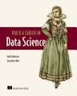

----------------------------------------------------------------------------------------

Introducing Data Science: Big Data, Machine Learning, and more, using Python tools
Davy Cielen, Arno Meysman, Mohamed Ali
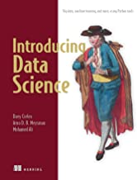
4.5 (45)

----------------------------------------------------------------------------------

Data Science Projects with Python
Stephen Klosterman
4.5 (69)
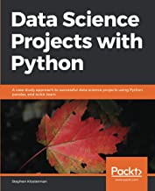

---------------------------------------------------------------------------------

A Hands-On Introduction to Data Science
Chirag Shah
5 (30)
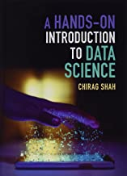

--------------------------------------------------------------------------------

Practical Statistics for Data Scientists (50 essential concepts)
Peter Bruce, Andrew Bruce
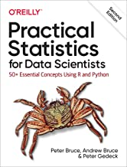

-----------------------------------------------------------------------------

Understanding Machine Learning: From Theory to Algorithms
Shai Shalev-Shwartz
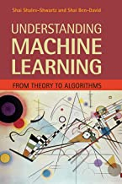
4.5 (135)

---------------------------------------------------------------------------------

Applied Predictive Modeling
Max Kuhn
4.5 (190)
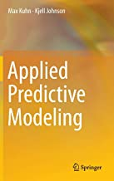

------------------------------------------------------------------------------

Deep Learning with Python and Keras
Francois Chollet
4.5 (866)
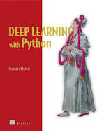

-------------------------------------------------------------------------------------------------

Deep Learning
Ian Goodfellow
4.5 (1345)
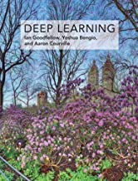

------------------------------------------------------------------------------------------

Deep Learning Illustrated
Jon Krohn
4.5 (123)
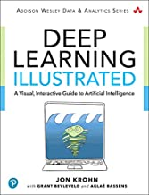

-----------------------------------------------------------------------------------

Neural Networks and Deep Learning
Michael Nielsen

---------------------------------------------------------------------------------

Neural Networks and Deep Learning
Charu C. Aggarwal
4.5 (109)
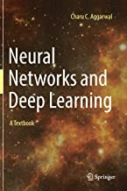

--------------------------------------------------------------------------------------

Python Deep Learning: Exploring deep learning techniques and neural network architectures
Ivan Vasilev
4.5 (16)
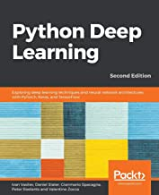

-----------------------------------------------------------------------------------

Python Machine Learning: Machine Learning and Deep Learning with Python, scikit-learn
Sebastian Raschka
4.5 (235)
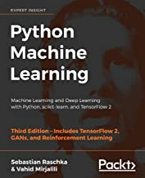

----------------------------------------------------------------------------------

Introduction to Machine Learning with Python
Andreas C. Müller, Sarah Guido
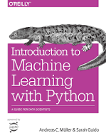
4.5 (364)

------------------------------------------------------------------------------------

Hands-On Machine Learning with Scikit-Learn, Keras
Aurelien Geron
5 (2000)
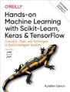

--------------------------------------------------------------------------------------

Python Data Science Handbook
Jake VanderPlas
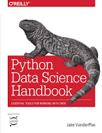
4.5 (422)

-----------------------------------------------------------------------------------------

Data Science from Scratch First Principles with Python
Grus, Joel
4.5 (370)
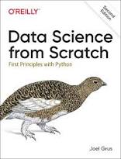

-----------------------------------------------------------------------------------------------

AI Crash Course (reinforcement learning)
Hadelin de Ponteves
4.5 (54)
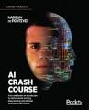

-----------------------------------------------------------------------------------

Classic Computer Science Problems in Python
David Kopec
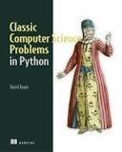
4.5 (80)

--------------------------------------------------------------------------------------------------

Problem Solving with Algorithms and Data Structures Using Python
Bradley N. Miller
4.5 (85)
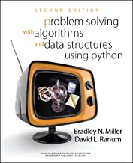

-------------------------------------------------------------------------------

No bullshit guide to linear algebra
Ivan Savov
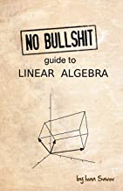
4.5 (110)

-----------------------------------------------------------------------------------------

Linear Algebra Done Right
Sheldon Axler
4.5 (290)
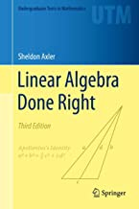

--------------------------------------------------------------------------------

Introduction to Linear Algebra
Gilbert Strang
4.5 (270)
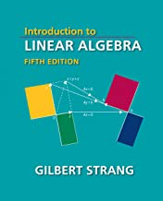

-------------------------------------------------------------------------------

Mathematics for Machine Learning
Marc Peter Deisenroth, A. Aldo Faisal, and Cheng Soon Ong.
4.5 (260)
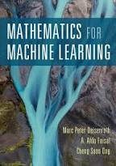

----------------------------------------------------------------------------------

Data Science and Machine Learning: Mathematical and Statistical Methods
Dirk P. Kroese
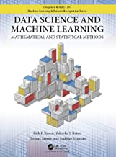
4.5 (20)

---------------------------------------------------------------------------------------

Linear Algebra and Optimization for Machine Learning
Charu C. Aggarwal
4.5 (40)
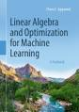

------------------------------------------------------------------------------------

Linear Algebra and Learning from Data
Gilbert Strang
4.5 (130)
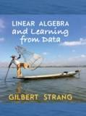

----------------------------------------------------------------------------------

The Elements of Statistical Learning
Trevor Hastie, Robert Tibshirani, Jerome Friedman
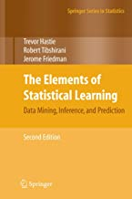
4.5 (690)

---------------------------------------------------------------------------------

The Ultimate Data and AI Guide: 150 FAQs About Artificial Intelligence, Machine Learning
Alexander Thamm
4.5 (51)
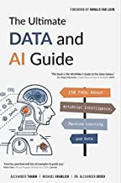

-------------------------------------------------------------------------------

Artificial Intelligence in the 21st Century
Stephen Lucci
4 (13)
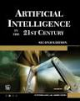

---------------------------------------------------------------------------------------------

Artificial Intelligence: A Modern Approach
Stuart Russell and Peter Norvig
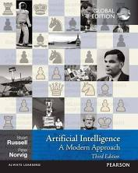
4.5 (1000)

----------------------------------------------------------------------------------------

Reinforcement Learning
Richard S. Sutton
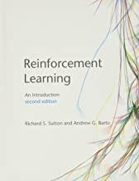
4.5 (280)

------------------------------------------------------------------------------------------

Deep Reinforcement Learning Hands-On
Maxim Lapan
4.5 (78)
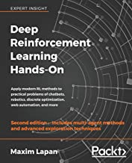

------------------------------------------------------------------------------

Pattern Recognition and Machine Learning
Christopher M. Bishop
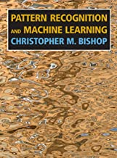
4.5 (400)

-----------------------------------------------------------------------------------

Fundamentals of Machine Learning for Predictive Data Analytics
John D. Kelleher
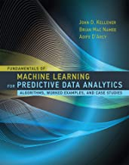
4.7 (90)

----------------------------------------------------------------------------

Data Mining: Practical Machine Learning Tools and Techniques
Ian H. Witten
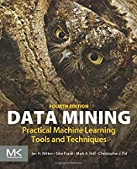
4.4 (180)

----------------------------------------------------------------------------------

Data Mining: Concepts and Techniques
Jiawei Han
4.5 (166)
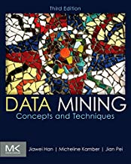

------------------------------------------------------------------------------------

Data Mining: The Textbook
Charu C. Aggarwal
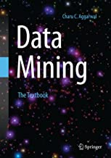
4 (28)

------------------------------------------------------------------------

Python Machine Learning Cookbook: Practical solutions from preprocessing to deep learning
Chris Albon
4.5 (86)
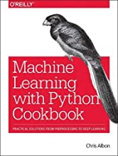

--------------------------------------------------------------------------

Data Analysis with Open Source Tools
Philipp K. Janert
4.5 (47)
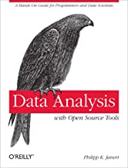

------------------------------------------------------------------

Machine Learning Refined
Jeremy Watt
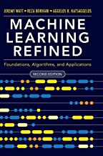
4.5 (22)

--------------------------------------------------------------------------

Konkrete Mathematik (nicht nur) für Informatiker
Edmund Weitz
5 (70)
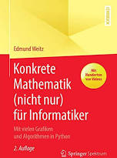

----------------------------------------------------------------------------------------

Learning from Data: A Short Course
Hsuan-Tien Lin, Malik Magdon-Ismail, and Yaser Abu-Mostafa
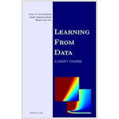
4.5 (214)

----------------------------------------------------------------------------------------

Complex Network Analysis in Python
Dmitry Zinoviev
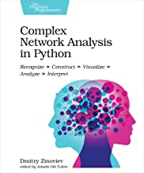
4.5 (30)

---------------------------------------------------------------------------------

Python Tricks A Buffet of Awesome Python Features
Dan Bader
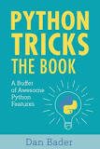
4.5 (800)

----------------------------------------------------------------------------------

Effective Python: 90 Specific Ways to Write Better Python
Brett Slatkin
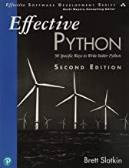
4.5 (300)

---------------------------------------------------------------------------------

Python 3 Object-Oriented Programming
Dusty Phillips
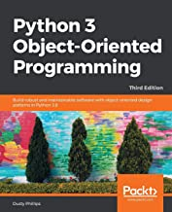
4.5 (150)

-------------------------------------------------------------------------------------

Data Structures and Algorithms in Python
Michael T. Goodrich
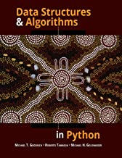
4 (155)

---------------------------------------------------------------------------------

1. Fluent Python Clear, Concise, and Effective Programming
Luciano Ramalho
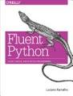

2. Python Cookbook

-------------------------------------------------------------------------------------
3. Think Python
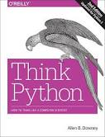

------------------------------------------------------------------------

4. Learning Python

5. Programming Python

+ other books on Python programming (see my Amazon)

STATISTICS:

Data Mining for Business Analytics: Concepts, Techniques and Applications in Python
Galit Shmueli, Nitin R. Patel, and Peter C. Bruce
4.5 (25)
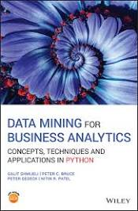

------------------------------------------------------------------------------------------

Statistics The Art and Science of Learning From Data
Agresti
4.5 (90)

Statistics in a Nutshell A Desktop Quick Reference
Sarah Boslaugh, Paul Andrew Watters
5 (81)
