MORNING:
Languages

MORNING EXERSICES

MUSCLE BITS (TILL 12:00)
Savvateyev

1. math exercises and problems
2. mental arithmetic
3. chinese characters
4. recitation (belles-letters) // Savvateev

1. puzzles
2. wikium
3. history, belle-lettres, poetry
4. reading 15

1. Tangrams
2. wooden ship

BITS:
(active) spaced revision of my notebooks
video (Multivariate Calculus Khan)
konkrete Mathematik
reading (15 pages)
video(s)
SH
ML/AI (current: Introduction to ML with Python pdf)
ANN Deep Learning with Python – F.Challet
python programming
data wrangling & visualisation (i.e. “hands-on data science”)

FUNDAMENTAL
PRACTICAL
CERTIFICATE

Book/Tutorial/Reading(the_book)
(HardCore)Maths

SAMSTAG
tengrams, wooden crafts
wikium

WO (13:00 – 15:00 Ruhe!)

DEUTSCHE DOKUS

TODO: sort all the books (which I have to read) by difficulty (and relevance)

BITS:

CHUNKS:
math passive revision (currently my Linear Algebra notebook)
maths (“Mathematics for ML” – currently, afterwards – “konkrete Mathematik”)
german grammar, german audio (e.g. dialogue)
history, belle-lettre
meta-learning

MUSCLE-DAY: (+ classical music)
A.Savvateyev maths
discreet maths https://www.youtube.com/watch?v=-drdeNMoe8w&list=PLDDGPdw7e6Aj0amDsYInT_8p6xTSTGEi2&index=11
math exercises (at the desk) (Satturday)
mental arithmetic (Satturday)
active maths revision (select a topic from my notebooks and explain that topic to myself) (Pomodoro)
konkrete Mathematik (optional)
board games / puzzles (Chess, Tangram) (Satturday)
wikium
puzzles https://foxford.ru/wiki/matematika/invariant
calligraphy, dictation (Pomodoro)
hieroglyphs (Satturday)
rubucs cube (Satturday)
guitar (evening)
meta-learning
https://mozgportal.ru/razvitie-mozga/sajty-dlya-razvitiya-intellekta.html

VIDEOS: (try the BITS system?)
AI (MIT Lectures)
ML/ANN
statistics (Khan app), calculus (Khan)
ann (A.Ng)
other videos

CHUNKS: (any of these activities can be skipped if a current topic corresponds to one of these activities)
ML/AI (current: Introduction to ML with Python pdf)
ANN Deep Learning with Python – F.Challet
python programming
data wrangling & visualisation (i.e. “hands-on data science”)
CS (algorithms, simulations, etc)
konkrete Mathematik (optional)
video(s)

Latent Dirichlet Allocation
https://www.youtube.com/watch?v=UrOXRvG9oYE
https://www.youtube.com/watch?v=yOlaa7he2qk
https://www.youtube.com/watch?v=VlVDKA9pg4A
https://www.youtube.com/watch?v=n7K8s4vryCQ
https://www.youtube.com/watch?v=c7_F4P71E2E
https://www.youtube.com/watch?v=v1uUgTcInQk
https://www.youtube.com/watch?v=_e0ugNro0Rc
https://www.youtube.com/watch?v=nfBNOWv1pgE

gibbs sampling:
https://www.youtube.com/watch?v=ER3DDBFzH2g
https://www.youtube.com/watch?v=9e4uqODjooo

https://www.youtube.com/watch?v=DWJYZq_fQ2A
https://www.youtube.com/watch?v=fCmIceNqVog&list=PLegWUnz91Wftp1CsVFQaCgZAILUslEVhF&index=28
https://www.youtube.com/watch?v=u7l5hhmdc0M&list=PLegWUnz91Wftp1CsVFQaCgZAILUslEVhF&index=27
https://www.youtube.com/watch?v=rfHCronRgQU&list=PLegWUnz91Wftp1CsVFQaCgZAILUslEVhF&index=26
https://www.youtube.com/watch?v=yK7nN3FcgUs
https://www.youtube.com/watch?v=o22cA1DhSMQ

articles:
https://towardsdatascience.com/dirichlet-distribution-a82ab942a879
https://towardsdatascience.com/latent-dirichlet-allocation-lda-9d1cd064ffa2
https://www.mygreatlearning.com/blog/understanding-latent-dirichlet-allocation/

Monte Carlo
https://www.youtube.com/watch?v=5nM5e2_1OQ0
https://www.youtube.com/watch?v=EaR3C4e600k
https://www.youtube.com/watch?v=3gcLRU24-w0
https://www.youtube.com/watch?v=OgO1gpXSUzU

Misc
https://www.youtube.com/watch?v=UTW530-QVxo
https://www.youtube.com/watch?v=XV4yj4T4PBQ
https://www.youtube.com/watch?v=yApmR-c_hKU
https://www.youtube.com/watch?v=yCv2N7wGDCw
https://www.youtube.com/watch?v=-1dYY43DRMA
https://www.youtube.com/watch?v=12eZWG0Z5gY
https://www.youtube.com/watch?v=4sXiCxZDrTU
https://www.youtube.com/watch?v=h1NOS_wxgGg

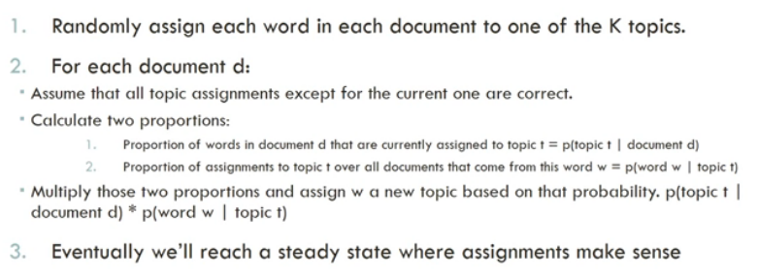
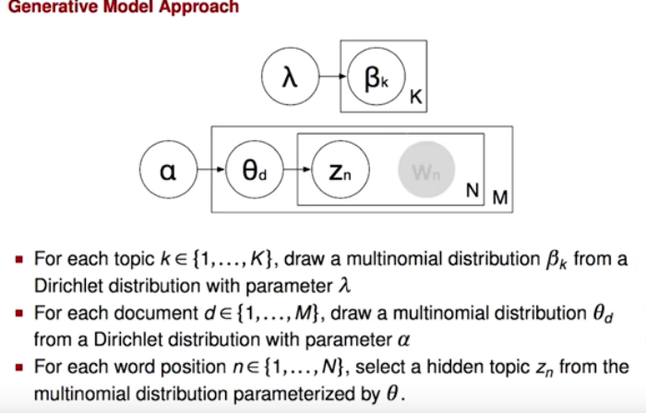
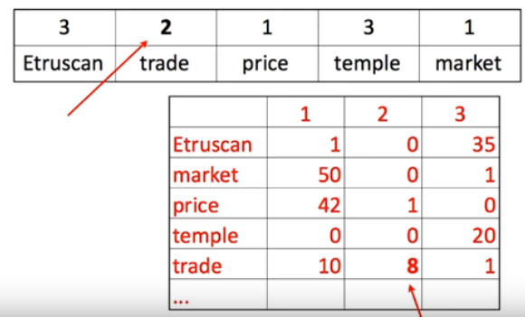
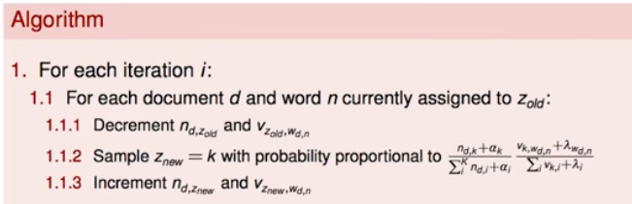

GERMAN:
song
just watch
audio dialog
grammar, vocabulary
book (science book)

ENGLISH:
video
audio
grammar
belles-lettre / science book

CHINESE
youtube

BLOCK:
AI, ML, ANN, RS, Edx

TERRACE:
chinese
german
terrace videos

BED:
HH (hand healing)

BREAKS: german videos

REMEMBER to revise last session’s material

ML:
https://www.youtube.com/watch?v=TjZBTDzGeGg&list=PLUl4u3cNGP63gFHB6xb-kVBiQHYe_4hSi&ab_channel=MITOpenCourseWare

ANN:
https://www.youtube.com/playlist?list=PLkDaE6sCZn6Gl29AoE31iwdVwSG-KnDzF

https://www.youtube.com/watch?v=vT1JzLTH4G4&list=PL3FW7Lu3i5JvHM8ljYj-zLfQRF3EO8sYv&index=1&ab_channel=StanfordUniversitySchoolofEngineering

AI
https://www.youtube.com/watch?v=zOI6Oll1Zrg&list=WL&index=2&t=5s&ab_channel=TuitionsTonight

https://www.youtube.com/watch?v=gMUSqKaBBm0&list=PLjF7dMeHalL8GU2Xh7vY6xn8kPlaKhpGw&index=2&ab_channel=LifelongLearning

CS
https://www.youtube.com/watch?v=GqdW9Abi2gE&list=PLSVu1-lON6LwaLkn1J4slNQEp2oEjWCqX&ab_channel=AlgorithmswithAttitude

subject | done | where | notes
morning revision | ☐ | bed | spaced repetition
after wake up sleep assertion | ☐ | bed
RL + exotic ML | ☐ | bed | 25 min
AI video | ☐ | bed | try to remember the key points
AI reading | ☐ | bed | try to remember the key points
linear algebra (the pdf-book) | ☐ | bed | 25 min
machine learning (alternate) | ☐ | desk | theory / practice
deep learning (alternate) | ☐ | desk | theory / practice
computer science | ☐ | desk | 25 min
reinforcement learning (practice) | ☐ | desk | 25 min
WO + eye exercises | ☐ | desk | 12:0
nap | ☐ | bed | 40 min
worries time | ☐ | bed
guitar @20:00 | ☐ | desk | 25 min
(all-round cognitive development)
meta-learning | ☐ | bed | go over the old notes
puzzles | ☐ | bed | german mp3
maths exercises | ☐ | desk | chinese folk music
wikium | ☐ | desk | 25 min
dictation, calligraphy, hieroglyphs | ☐ | desk | https://librivox.org/men-like-gods-by-h-g-wells/
german (just listen or watch) | ☐ | bed | die Prinzen
german (grammar) | ☐ | bed | go over the key points in your head
english (audio) | ☐ | bed | Surviver
english (grammar) | ☐ | bed | go over the key points in your head
belles-lettre (Wells) | ☐ | bed | mp3
science book (history) | ☐ | terrace | go over the key points in your head
(if time permits)
ML video | ☐ | terrace | go over the key points in your head
ANN video | ☐ | terrace | go over the key points in your head
time series, data science | ☐ | terrace | go over the key points in your head
programming (Python) | ☐ | desk | to chinese folk music
statistics | ☐ | desk | “50 concepts”
maths: current advanced discreet calculus etc. | ☐ | bed | art and craft …
(before bedtime)
therapy |  |  | relaxation, glorification, assertions
eye exercises |  |  | to classical music
classical music |  |  | Mozart
(for the future)
history, science books | ☐ | terrace | go over the key points in your head
discrete maths (video lecture) | ☐ | bed | go over the key points in your head
terrace videos german | ☐ | terrace | go over the key points in your head
assertions before bedtime, glorification | ☐ | bed
eye exercises in bed | ☐ | bed

ASSERTION BEFORE EVERY ACTIVITY - CONNECT TO THE RESPECTIVE Egregor BEFOR EACH ACTIVITY

Tips:
- special revision
- use a book only as an instructions manual – read and then explain + do
- otherwise prefer a video (with visualizations)
- anyway – explain new material to yourself while drawing, gesticulating and/or programming it
- concentrate on solving a problem before falling asleep – the problem will be solved during the sleep, insight in the morning
- 40 min nap (after WO)
- aerobic exercises between activities (to classical or folk music)
- try 25 minute rule + reward!
- listen to German/Chinese during chores
- connect to the respective agregor before an activity (german: listen to speech in a relaxed state)
- rewards: Chinese; humour; sweet; web; denTV; wikium; music w/out words; travel videos

Regularly:
- UV
- airing the rooms

Chines:
- pronunciation (youtube, book)
- --- skip: pinyin, grammar, characters, vocabulary
- comprehension (120 vocabulary, tales)

Eye exercises:
https://econet.ru/articles/179729-5-volshebnyh-tochek-na-litse-dlya-ozdorovleniya-glaz

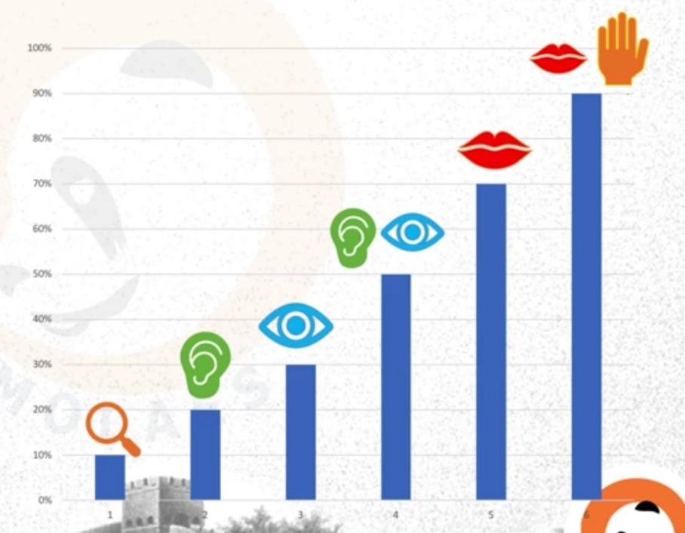

- assertion!!!
- puzzles, brain training: wikium
- belle letter – Wells
- reading – AI
- meta-learning (the book)
- art and craft of solving problems (TTC)

- maths exercises (or integer sequences) + classical music

- linear algebra (Khan Academy) (try 25 minute rule)
- programming light
- computer science
- ML theory https://www.youtube.com/watch?v=gXbThCXjZFM&list=PLMrJAkhIeNNSVjnsviglFoY2nXildDCcv

LANGUAGES 2 hours (try 25 minute rule)
- German 30 min
- English 30 min
- Chinese 30 min

optional:
- science books – history of the world
- TTC / Reinforcement learning (no time for that)
- algebra (bedtime)

- WO + Eye exercises
- guitar
- terrace videos
- terrace deutsch

- glorification, … concentrate on solving a problem
- assertion and sh on a certain subject
- eye exercises in bed

3-DAY ROUTINE

TRY:
BLOCK system
1. statistical learning
2. maths (urgent: the linear algebra videos in my MATHS folder in my YouTube); numerical analysis
3. neural networks
4. algorithms & computer science (graph theory; discreet maths; etc; TIC-TAC-TOE) + advanced Python

TRY:
swift reading before studying a book

TRY:
swift reading & revision (e.g. for Python)

EVERYDAY:
reading (easy reading / swift reading on machine learning)
maths (doing sums) + puzzle
german
ML (start at 11:00)
terrace videos
python, etc (bite-size topics)

EVERYDAY OTHER:
languages
reading (short – on a particular subject, e.g. logic, science, history)
WO
UV + DÄNAS + classical music or german
Terrace + german
Guitar

bite-size videos
Python

Data Wrangling

NumpyPandasMatplotlib:
plotly 0:00
https://www.youtube.com/watch?v=7WkTbPzamaA&list=PLE50-dh6JzC4onX-qkv9H3HtPbBVA8M94&index=3

bokeh 18:40
https://www.youtube.com/watch?v=2TR_6VaVSOs

Java

Data Science and Statistics with R

books for “swift reading” (easy reading)
Learning Python
Raschka
Practical Statistics for Data Scientists – 50 concepts…
Data Wrangling with Python (J.Kazil)
Python Data Analysis Cookbook (Ivan Idris)
AI

ML learning plan
Incremental PCA – Hands-on
Sparse PCA – Handbook
Randomized PCA – Hands-on
Kernel PCA

-> done

SVD and movie recommender system
https://www.youtube.com/watch?v=gXbThCXjZFM&list=PLMrJAkhIeNNSVjnsviglFoY2nXildDCcv

linear
Non-Negative Matrix Factorization (NMF) - Introduction p.156
Signal Analysis with NMF – Introduction
Latent Dirichlet Allocation
Locally Linear Embedding (LLE) – Hands-on
Linear Discriminant Analysis (LDA)

non-linear
Kernal PCA – Hands-on
t-SNE – Introduction

Clustering…

TOPICS PRIORITIES

MATHEMATICS:
mathematics basics [Grundwissen Mathematik; Konkrete Matehmatik=mathes_in_general | neded maths]
linear algebra [Khan Academy]
statistics
calculus

MACHINE LEARNING:
statistical learning
neural networks (tensorflow, keras)
association analysis, recommender systems and others
reinforcement learning

DATA WRANGLING & VIZUALIZATION
data wrangling (e.g. with pandas) [Wes McKinney]
data visualization (matplotlib, plotly, ggplot, tableau etc) [plotly]

TIME SERIES AND OTHER TOPICS:
time-series analysis
robotics [youtube playlist]
reinforcement learning [youtube playlist]
numerical analysis, optimization

COMPUTER SCIENCE:
algorithms, graphs, simulations [David Kopec]
discreet mathematics [Konkrete Mathematik]
programming: patterns etc [Python OOP]
python advanced [Pythin Tricks]

PROGRAMMING LANGUAGES:
R
Java [revision; Lynda]
JavaScript
Linux [youtube playlist]

DATA BASES AND CLOUD-BASED SERVICES
SQL
NoSQL
DB Mongo
Hadoop, Spark
Big Data
AWS, MS Azure etc

WEB DEVELOPMENT
JavaScript

one bit a day
MATHS PRACTICE (Grundwissen Mathematik)
Konkrete Mathematik
Paper reading (sklearn)

Java

Python

Algorithms, CodeClinic, Graphs, Simulations, other discreet mathamatics
https://runestone.academy/runestone/books/published/pythonds/Graphs/ImplementingBreadthFirstSearch.html

NumpyPandasMatplotlib (visualization in Python and R):
current 0:00
https://www.youtube.com/watch?v=Gj-prU8aEgg&list=PLE50-dh6JzC7X8VFX40yoIXnhctF2bR8F&index=4

bokeh
https://www.youtube.com/watch?v=2TR_6VaVSOs

plotly
https://www.youtube.com/watch?v=j0wvKWb337A&list=PLE50-dh6JzC4onX-qkv9H3HtPbBVA8M94

Data Science and Statistics with R and RapidMiner
Data Wrangling (Numpy Pandas R) – revision or later (later: finish those Lyndas on data wrangling)

DAILY ROUTINE
DAY 1: Statistical Learning
German
Classical Guitar

TODO:
Stacking (Hands-on)

routine
Learning: URGENT videos or material

Practice: books

Theory: math, coding algorithms, A.Ng: https://www.youtube.com/watch?v=BpgnnS7mKKU&list=PLLssT5z_DsK-h9vYZkQkYNWcItqhlRJLN&index=59

NOTES
…

Recourses
Python Data Science Handbook
Introduction to ML
Hands-On
A-Z (and then the Kane tutorials)
the “RapidMiner etc” turorial

Andrew Ng
https://www.youtube.com/watch?v=sZSKGNbrwus&list=PLLssT5z_DsK-h9vYZkQkYNWcItqhlRJLN&index=58

Alexander Ihler
https://www.youtube.com/playlist?list=PLaXDtXvwY-oDvedS3f4HW0b4KxqpJ_imw

Lavrenko
https://www.youtube.com/user/victorlavrenko/playlists

StatQuest
https://www.youtube.com/watch?v=Q81RR3yKn30&list=PLblh5JKOoLUICTaGLRoHQDuF_7q2GfuJF&index=18

Jordan Boyd-Graber
https://www.youtube.com/watch?v=AP02CgqS6Hc&list=PLegWUnz91Wftp1CsVFQaCgZAILUslEVhF

Siraj
https://www.youtube.com/watch?v=xRJCOz3AfYY&list=PL2-dafEMk2A7mu0bSksCGMJEmeddU_H4D

Derek Kane
https://www.youtube.com/watch?v=KDJDzeKM8DI&list=PLJCxPrb5_0ylk7NssyDN-zVZIXi31LwzF

The math you should know
https://www.youtube.com/watch?v=K_EH2abOp00&list=PLTl9hO2Oobd-_5sGLnbgE8Poer1Xjzz4h

DAY 2: Neural Networks
English
Electric Guitar

TODO:
Andrew Ng – Tensorflow tutorial
make a MLP with SGD+Momentum / RMSprop / Adam

routine
URGENT 2 (videos or urgent theoretical material)

PRACTICE: Book: Deep Learning with Python and Keras

(MATHEMATICAL) THEORY: A.Ng
https://www.youtube.com/watch?v=5qefnAek8OA&list=PLkDaE6sCZn6Hn0vK8co82zjQtt3T2Nkqc&index=30

VIDEO (JUST WATCH):
deeplizard(keras course#2)
https://www.youtube.com/watch?v=INaX55V1zpY&list=PLZbbT5o_s2xrwRnXk_yCPtnqqo4_u2YGL&index=14

FOR LATER
GeoffreyHinton(theory) https://www.youtube.com/watch?v=cbeTc-Urqak&list=PLoRl3Ht4JOcdU872GhiYWf6jwrk_SNhz9&index=1
Michael Nielson: theory
Hands-On: tensorflow
Image ML: Handbook page 506 (HOG)
A-Z: MLP & CNN (with keras and R)

LATER THOROUGH
A.Ng: gradient checking tips etc
https://www.youtube.com/watch?v=QrzApibhohY&list=PLkDaE6sCZn6Hn0vK8co82zjQtt3T2Nkqc&index=13

derivation of softmax function
https://eli.thegreenplace.net/2016/the-softmax-function-and-its-derivative/

deeplizard
https://www.youtube.com/watch?v=gmBfb6LNnZs&list=PLZbbT5o_s2xq7LwI2y8_QtvuXZedL6tQU&index=32

NOTES:
CNN:
Dropout (after a fully-connected layer) provides for regularization and prevents overfitting.
Another method to reduce overfitting is image augmentation

LINUX:
source ~/anaconda3/bin/activate root

TERRACE VIDEOS

Calculus (prof Edwards)
https://www.youtube.com/watch?v=UdWKtR6BlvA&list=PLez3PPtnpncTm_7_0xUIKompR_16btUmK&index=21

https://www.youtube.com/watch?v=RnlZ-kwUL1E&list=PLvBnQVOJXCUF-in9Nu-6PUJcHGd48RE6w
https://www.youtube.com/watch?v=kGXr1SF3WmA&list=PLJHszsWbB6hpk5h8lSfBkVrpjsqvUGTCx

Linear Algebra
https://www.youtube.com/watch?v=53KDr8y7VnQ&list=PLdciPPorsHuk3Hp7QPPAtTkpW0o1UXQB6&index=23
https://www.youtube.com/watch?v=l2ETAUcJjWA&list=PLvBnQVOJXCUEXWVK7xqimMfg0A-fPo9q_&index=1
https://www.youtube.com/watch?v=X4oTwBusjMk&list=PLvBnQVOJXCUEd5Zc4Y5ZcvQkCCglGLXkQ
https://www.youtube.com/watch?v=csgNflj69-Y&list=PLybg94GvOJ9En46TNCXL2n6SiqRc_iMB8
https://www.youtube.com/watch?v=HAoL5fPmgrw&list=PLNr8B4XHL5kGDHOrU4IeI6QNuZHur4F86
https://www.youtube.com/watch?v=lkx2BJcnyxk&list=PLGAnmvB9m7zOBVCZBUUmSinFV0wEir2Vw
https://www.youtube.com/watch?v=im83dM34fAU&list=PLNr8B4XHL5kEWw9YH2oFeYZCosj1qsBVi
https://www.youtube.com/watch?v=rNSRcZ18i_4&list=PLHXZ9OQGMqxfUl0tcqPNTJsb7R6BqSLo6&index=16
https://www.youtube.com/watch?v=CdpFu7t0dJ4&index=18&list=PLAFEC355DFEADC30C
https://www.youtube.com/watch?v=Fnfh8jNqBlg&list=PLlXfTHzgMRUKXD88IdzS14F4NxAZudSmv&index=1
https://www.youtube.com/channel/UCoOjTxz-u5zU0W38zMkQIFw/playlists
https://www.youtube.com/watch?v=6K7QqgTE1hw&list=PL5E46D91C0B8EA957&index=46 (revise: 32,33, 34(PCA),36,44,45)

Mathematics in General
https://www.youtube.com/watch?v=GufQYkMkdpw&list=PLiaHhY2iBX9ihLasvE8BKnS2Xg8AhY6iV&index=6

Statistics
baysean statistics:
https://www.youtube.com/watch?v=lJzSgAVKvcU&list=PLwJRxp3blEvZ8AKMXOy0fc0cqT61GsKCG&index=19

https://www.youtube.com/watch?v=5Pc076Yz5Ww&list=PL-i8do33HJoutVeQXSO1Qly92hThW2jbJ&index=19
statsquest:
https://www.youtube.com/watch?v=67zCIqdeXpo&list=PLblh5JKOoLUK0FLuzwntyYI10UQFUhsY9&index=11

https://www.youtube.com/channel/UCKA0um-cA0cB1amUUzM7Jrg/playlists?view=50&sort=dd&shelf_id=7
https://www.youtube.com/watch?v=aq8VU5KLmkY&list=PLTNMv857s9WUI1Nz4SssXDKAELESXz-bi

https://www.youtube.com/watch?v=J-yMiTaai4c&list=PLqzoL9-eJTNBZDG8jaNuhap1C9q6VHyVa&index=17
https://www.youtube.com/watch?v=ZQ_KKIO8l_k&list=PL7ty7J3owknnaYgu9wm_R8S1dIDT-GIc7&index=3

Graph and Network Theory (for later)
https://www.youtube.com/watch?v=2QKnMQz7_mg&list=PLDDGPdw7e6Aj0amDsYInT_8p6xTSTGEi2&index=38
https://www.youtube.com/watch?v=bTXUJQhEqL0&list=PLsJWgOB5mIMAuH3cHa-MXukX6-RPpDXgl&index=16

=========================================

TOPIC RECOURSES

SVM
https://www.youtube.com/watch?v=-Z4aojJ-pdg&list=PLVZqlMpoM6kZH34Ly114R_lomuUuf6GNq&index=4

Decision Trees
https://www.youtube.com/watch?v=9w16p4QmkAI&list=PLVZqlMpoM6kZH34Ly114R_lomuUuf6GNq

Optimization (Gradient Descent / Linear Models?)
https://www.youtube.com/watch?v=x6f5JOPhci0&list=PLVZqlMpoM6kZBJBSJLAJ9STSRlbLHGNYL

Time Series Analysis
Autocorrelation

Image ML
Image ML: Handbook page 506 (HOG)

Neural Networks Recourses
A.Ng:
https://www.youtube.com/watch?v=1waHlpKiNyY&list=PLkDaE6sCZn6Hn0vK8co82zjQtt3T2Nkqc

deeplizard (keras)
https://www.youtube.com/watch?v=hfK_dvC-avg&list=PLZbbT5o_s2xq7LwI2y8_QtvuXZedL6tQU&index=3
https://www.youtube.com/watch?v=sRF_-bwxru4&list=PLZbbT5o_s2xrwRnXk_yCPtnqqo4_u2YGL&index=2

Deep Learning with Python and Keras
Michael Nielson: theory
Linux + bash commands
A-Z; Introduction to ML page 104 (tanh and relu)
Hands-On: tensorflow

TODO:
https://www.youtube.com/watch?v=bxe2T-V8XRs&list=PLiaHhY2iBX9hdHaRr6b7XevZtgZRa1PoU

-----------------------------------------------------------------------------------------------------------------------

MUST DO:
Data Science from Scratch: First Principles with Python (book)

OPTIONAL
Java
SQL / Hadoop
Computer Architecture, Computer Networks
https://www.youtube.com/watch?v=cyqrPUHoeUc&list=PL2jykFOD1AWZ9hilipUxGNQA-opxjdbgo&index=12
https://www.youtube.com/watch?v=svkGASq8mNM
https://www.youtube.com/watch?v=5D67Qy1tPLY&list=PLLFIgriuZPAcCkmSTfcq7oaHcVy3rzEtc&index=1
-----------------------------------------------------------------------------------------------------------------------

Calculus & Optimization & Differential Equations
https://www.khanacademy.org/math/ap-calculus-bc/bc-differential-equations-new/bc-7-9/v/solving-logistic-differential-equation-part-1

https://www.youtube.com/channel/UCKA0um-cA0cB1amUUzM7Jrg/playlists?view=50&sort=dd&shelf_id=8
https://www.youtube.com/watch?v=TgKwz5Ikpc8&list=PLZHQObOWTQDPD3MizzM2xVFitgF8hE_ab&index=14
https://www.youtube.com/watch?v=3d6DsjIBzJ4&list=PLZHQObOWTQDMsr9K-rj53DwVRMYO3t5Yr&index=11
(optimization word problems)
https://www.youtube.com/watch?v=yP3fd3Yy2dM&list=PLHWguCqFb_CZrd8r8fq0mSvj_3eaXJgI_
https://www.youtube.com/watch?v=NXoQPnxx-9c&list=PLB2FE9786A4ABC83B

differential equasions:
https://www.youtube.com/watch?v=p_di4Zn4wz4&list=PLZHQObOWTQDNPOjrT6KVlfJuKtYTftqH6
https://www.youtube.com/watch?v=-_POEWfygmU&list=PL96AE8D9C68FEB902
https://www.youtube.com/watch?v=ngN2vzywW08&list=PLee24bbe4wKTdWQY7qEkc4fjTUcfs7Zgc

Multivariable Calculus
KhanAcademy
https://www.youtube.com/watch?v=asyIsn59Lnc&list=PLSQl0a2vh4HC5feHa6Rc5c0wbRTx56nF7&index=160

intrigano
https://www.youtube.com/watch?v=_EHYTrJOkAQ&list=PL2jykFOD1AWaL4_-bdidPfIWe765jOgfL&index=24

Prof. Edwards
https://www.youtube.com/watch?v=qWkWb_UB72g&index=31&list=PLpYEaNSrmq871pp-SsMXGuax0imu7mLyy
https://www.youtube.com/channel/UCoOjTxz-u5zU0W38zMkQIFw/playlists
https://www.youtube.com/watch?v=-BtQlJpWz5c&list=PLNr8B4XHL5kGAG_8vLF1o0G9RqrLN_tbj

==========================================================

playlists (neural networks):
https://www.youtube.com/watch?v=9Hz3P1VgLz4&list=PLoYCgNOIyGABWLy_XoLSxTVRe2bltV8GM
https://www.youtube.com/watch?v=gZmobeGL0Yg&list=PLZbbT5o_s2xq7LwI2y8_QtvuXZedL6tQU&index=1
https://www.youtube.com/watch?v=RznKVRTFkBY&list=PLZbbT5o_s2xrwRnXk_yCPtnqqo4_u2YGL
https://www.youtube.com/watch?v=UNmqTiOnRfg&list=PLs8w1Cdi-zvavXlPXEAsWIh4Cgh83pZPO

https://www.youtube.com/watch?v=aiDv1NPdXvU&list=PLWi7UcbOD_0vc_rSRgHAyKig2eMdMTRyo

https://www.youtube.com/watch?v=bH6VnezBZfI&list=PLaXDtXvwY-oDvedS3f4HW0b4KxqpJ_imw&t=0s&index=26

https://www.youtube.com/watch?v=GvQwE2OhL8I&list=PLoYCgNOIyGABWLy_XoLSxTVRe2bltV8GM&index=3

https://www.youtube.com/watch?v=bVQUSndDllU&list=PLFt_AvWsXl0frsCrmv4fKfZ2OQIwoUuYO

https://www.youtube.com/watch?v=aircAruvnKk&list=PLZHQObOWTQDNU6R1_67000Dx_ZCJB-3pi

https://www.youtube.com/watch?v=bxe2T-V8XRs&list=PLiaHhY2iBX9hdHaRr6b7XevZtgZRa1PoU

https://www.youtube.com/watch?v=gZmobeGL0Yg&list=PLZbbT5o_s2xq7LwI2y8_QtvuXZedL6tQU

https://www.youtube.com/watch?v=1ZhtwInuOD0&index=43&list=PLLssT5z_DsK-h9vYZkQkYNWcItqhlRJLN

https://www.youtube.com/watch?v=OVwEeSsSCHE&list=PLLssT5z_DsK_gyrQ_biidwvPYCRNGI3iv

https://www.youtube.com/results?search_query=Neural+Networks

https://www.youtube.com/results?search_query=multilayer+perceptron

https://www.youtube.com/watch?v=P2HPcj8lRJE&index=2&list=PLjJh1vlSEYgvGod9wWiydumYl8hOXixNu

uni lectures (neural networks):
https://www.youtube.com/watch?v=d14TUNcbn1k
https://www.youtube.com/watch?v=uXt8qF2Zzfo
https://www.youtube.com/watch?v=O5xeyoRL95U

==========================================
Discrete Mathamatics, Graph Theory

https://www.youtube.com/watch?v=7HkXkAZye1Y&list=PLsJWgOB5mIMAuH3cHa-MXukX6-RPpDXgl
https://www.youtube.com/watch?v=eQA-m22wjTQ&list=PLDV1Zeh2NRsDGO4--qE8yH72HFL1Km93P
https://www.youtube.com/watch?v=ZHqQDA3be-k&list=PLrDKnVFIisLfKVHEr2rUx0RjFm58pX4BG&index=1
https://www.youtube.com/watch?v=VG9ft4_dK24&list=PLHXZ9OQGMqxersk8fUxiUMSIx0DBqsKZS&index=42

==========================================

-----------------------------------------------------------------------------------------------------------------------

Other Topics Playlists
fiance and data
https://www.youtube.com/user/bionicturtledotcom/playlists

==========================================
==============================================================

General Overview
github, overall info
https://vas3k.com/blog/machine_learning/
https://www.youtube.com/watch?v=gHMTzdbpQTw&list=PLvxOuBpazmsND0vmkP1ECjTloiVz-pXla&index=4

-----------------------------------------------------------------------------------------------------------------------

Statistical Learning / Machine Learning
Math4IQB
https://www.youtube.com/user/Math4IQB/videos?sort=da&view=0&flow=grid

Machine Learning — Andrew Ng, Stanford:
https://www.youtube.com/watch?v=GtSf2T6Co80&list=PLLssT5z_DsK-h9vYZkQkYNWcItqhlRJLN&index=10

Foundations of Machine Learning - Bloomberg
https://www.youtube.com/watch?v=MsD28INtSv8&list=PLnZuxOufsXnvftwTB1HL6mel1V32w0ThI&index=1

Statistical Machine Learning CMU:
https://www.youtube.com/watch?v=zcMnu-3wkWo&list=PLTB9VQq8WiaCBK2XrtYn5t9uuPdsNm7YE

Machine Learning Theory – mathematicalmonk:
https://www.youtube.com/watch?v=qX7n53NWYI4&list=PLD0F06AA0D2E8FFBA&index=47

The Math of Intelligence - Siraj Raval
https://www.youtube.com/watch?v=ov_RkIJptwE&index=7&list=PL2-dafEMk2A7mu0bSksCGMJEmeddU_H4D

Statistical Learning with Applications in R:
https://www.youtube.com/watch?v=3jQs02dbfrI&list=PL06ytJZ4Ak1rXmlvxTyAdOEfiVEzH00IK&index=1

https://www.youtube.com/channel/UCpyPuMAyBvERU8YMngGy11g/playlists

-----------------------------------------------------------------------------------------------------------------------

Discrete Math / Higher Maths
https://www.youtube.com/watch?v=ubgRYEwlU-4&index=6&list=PLw8gwdX8oi1UIeyhpWFPcsP2BkgE2afit
https://www.youtube.com/watch?v=L5uBeAGJV1k&index=14&list=PLUl4u3cNGP60UlabZBeeqOuoLuj_KNphQ
https://www.youtube.com/watch?v=PifpQXYSot4&index=2&list=PLkyBCj4JhHt8CID9Kz9dcxnoK9rg6f9hW
https://www.youtube.com/watch?v=CMWFmjlB8v0&list=PLZzHxk_TPOStgPtqRZ6KzmkUQBQ8TSWVX&index=1
https://www.youtube.com/watch?v=FHL4udeLf9Q&list=PLZzHxk_TPOStgPtqRZ6KzmkUQBQ8TSWVX&index=14

-----------------------------------------------------------------------------------------------------------------------

Big Data & Hadoop (Terrace)
xx:00
https://www.youtube.com/watch?v=ggWmwacbdqU&index=9&list=PLwwk4BHih4fgJxD7b_hMWfNxVyFLObU5U

finish Lynda
Udacity(ok one)
https://www.youtube.com/watch?v=YoNKbqRyxRY&index=64&list=PLAwxTw4SYaPkXJ6LAV96gH8yxIfGaN3H-

##############################################################################

PROGRAMMING SKILLS

Hands-On ML with Python

Machine Learning A-Z - Hands On Python and R In Data Science

========================================================
Statistics with R 60 min
revision
book
video

later: ggplot&tidyverse
---------------------------------------------------------------------------------------
Computer Science
------------------------------------------------------------------------------------------
Programming: Python
revision
book
(video)
------------------------------------------------------------------------------------------
Programming: Java
----------------------------------------------------------------------------------------
SQL, Hadoop
---------------------------------------------------------------------------------------
Hands-On Data Wrangling and Visualization: NumpyPandas (and later with R ggplot+tidverse)
book
video
---------------------------------------------------------------------------------------

Practical Data Wrangling+Analysis

---------------------------------------------------------------------------------------

Neural Networks

https://www.youtube.com/watch?v=BR9h47Jtqyw

https://www.youtube.com/watch?v=uXt8qF2Zzfo

https://www.youtube.com/watch?v=ILsA4nyG7I0

https://www.youtube.com/watch?v=d14TUNcbn1k

playlists:

https://www.youtube.com/watch?v=UNmqTiOnRfg&list=PLs8w1Cdi-zvavXlPXEAsWIh4Cgh83pZPO

https://www.youtube.com/watch?v=aiDv1NPdXvU&list=PLWi7UcbOD_0vc_rSRgHAyKig2eMdMTRyo

https://www.youtube.com/watch?v=bH6VnezBZfI&list=PLaXDtXvwY-oDvedS3f4HW0b4KxqpJ_imw&t=0s&index=26

https://www.youtube.com/watch?v=GvQwE2OhL8I&list=PLoYCgNOIyGABWLy_XoLSxTVRe2bltV8GM&index=3

https://www.youtube.com/watch?v=bVQUSndDllU&list=PLFt_AvWsXl0frsCrmv4fKfZ2OQIwoUuYO

https://www.youtube.com/watch?v=aircAruvnKk&list=PLZHQObOWTQDNU6R1_67000Dx_ZCJB-3pi

https://www.youtube.com/watch?v=bxe2T-V8XRs&list=PLiaHhY2iBX9hdHaRr6b7XevZtgZRa1PoU

https://www.youtube.com/watch?v=gZmobeGL0Yg&list=PLZbbT5o_s2xq7LwI2y8_QtvuXZedL6tQU

https://www.youtube.com/watch?v=1ZhtwInuOD0&index=43&list=PLLssT5z_DsK-h9vYZkQkYNWcItqhlRJLN

https://www.youtube.com/watch?v=OVwEeSsSCHE&list=PLLssT5z_DsK_gyrQ_biidwvPYCRNGI3iv

https://www.youtube.com/results?search_query=Neural+Networks

https://www.youtube.com/results?search_query=multilayer+perceptron

https://www.youtube.com/watch?v=P2HPcj8lRJE&index=2&list=PLjJh1vlSEYgvGod9wWiydumYl8hOXixNu

GUITAR

Tutorial (video/book)
GuitraPro track
Impovisation (over a backing track)
Scales (standing up – pick one string or position for a day)
Exercises (guitar pro)

Classical guitar piece
Song with chords
Chords
Progressions

MUISC THEORY
https://www.youtube.com/watch?v=kvGYl8SQBJ0&list=PLGOyFbrsO-NkmwbjDHNtyJoI8pY2-2a6o
https://www.youtube.com/watch?v=6zyv0O7kfcc&list=PL5j5H06QkhxE0RK-Ormp3zgf5SGJ28zsj

