MACHINE LEARNING

polynomial regression pipeline
# data
import numpy as np, pandas as pd
df = pd.DataFrame(np.random.randn(100, 3), columns=["x"+str(i) for i in range(1,4)])
ww = np.array(range(1, 3*2+1)).reshape(2,3)
df['Y'] = sum(df**p * w for p,w in zip(range(1, 3), ww)).sum(axis=1)

# Pipeline
from sklearn.preprocessing import PolynomialFeatures, StandardScaler
from sklearn.linear_model import LinearRegression, Ridge
from sklearn.pipeline import Pipeline
# polynomial regression usually uses ridge regression
steps = [('scaler', StandardScaler()),
('poly', PolynomialFeatures(degree=2, include_bias=False)),
('ridge', Ridge(alpha=1.0))]
pipe = Pipeline(steps)
pipe.fit(df.loc[:, 'x1':'x3'], df['Y'])
ypred = pipe.predict(df.loc[:, 'x1':'x3'])

# Inspect
import re
poly = pipe.named_steps['poly']
poly_feature_names = poly.get_feature_names() # x0 is actually x1
poly_feature_names = [re.sub(r"[0-9]", lambda m: str(int(m.group())+1), s) for s in poly_feature_names]

ridge = pipe.named_steps['ridge']
ww = ridge.coef_ # note that the interaction weights are (close to) zero !
print(poly_feature_names, ww.round(), sep="\n\n", end="\n\n")

# Evaluate
from sklearn.metrics import mean_squared_error, r2_score
mse = mean_squared_error(df['Y'], ypred)
r_sq = pipe.score(df.loc[:, 'x1':'x3'], df['Y'])
r_sq = r2_score(df['Y'], ypred)

print("MSE =", mse.round(5))
print("R squared =", r_sq.round(5))

Chronologically logical order of ML algorithm types:
REGRESSION
Linear Models (including Logistic regression)
(Kernel Density Estimation - regression)
Logistic Regression (classification)

CLASSIFICATION
Naive Bayes
SVM (+ SVM regression)
Decision Trees (+ tree regression)

kNN
Gaussian Mixture models (for classification)? clustering?
(Kernel Density Estimation - regression) ?Gaussian Process regression?
...
Time Series
(Python Data Science Hand-Book page 400)
...
CLUSTERING
kMeans
Hierarchical Cluster Analysis (HCA)
Expectation Maximization
...
DIMENSIONALITY REDUCTION
PCA, LDA, LLE, t-SNE, other Matrix Factorization methods
...
RECOMMENDER SYSTEM
...
ANOMALY DETECTION
outlier detection
...
ASSOCIATION RULE LEARNING
Apriori, Eclat
...
SEMISUPERVISED LEARNING
deep belief networks (DBNs), restricted Boltzmann machines (RBMs)
...
REINFORCEMENT LEARNING
...
NLP
...
NERUAL NETWORKS

ML ALGORITHMS:
Python Data Science Handbook
Introduction to ML
Cookbook
Hands-On
A-Z

DEEP LEARNING:
(Introduction to ML)
Hands-On
Deep Learning with Python
Cookbook
A-Z

checklist
GET THE DATA
- split or stratify-split into train/validation and test sets (80/20)
- shuffle the train-set (if not series-data)
EXPLORE THE DATA
- study features and their characteristics (type – categorical / discreet etc; % of missing values; outliers; distribution)
- visualize the data
- build quick-and-dirty models; test with cross-validation
- plot learning curves to identify bias/variance and whether more observations or features may be needed
- Error analysis: examine the observations that your algorithm made errors on
- identify the promising transformations you may want to apply
- preliminary feature selection - the attributes that provide no useful information

PREPARE THE DATA
- fix/remove ouliers
- impute missing values on the train set (and use the model on the test and new sets as well)
- feature transformation (tucking in the data into a bell-shape by log, sqrt, square)
- feature engeneering (polynomial expansion, feature-ratio)
- scale (scaling the target values is not required)
- discretize continuous features (if necessary)
- categorical features labeling (one-hot encoding)
- feature selection e.g. by correlation, random-forest, L1-regulirization etc (also in oder to avoid overfitting)
- make a Pipeline, Union (for the above transformations)

SHORTLIST PROMISING MODELS
- train many quick and dirty models from different categories (e.g., linear, naïve Bayes, SVM, Random Forests, neural net, etc.) using standard parameters
- analyze the types of errors the models make
- choose how you’ll measure success on your problem. Which metrics will you monitor on your validation data?
- Determine your evaluation protocol: hold-out validation? K-fold validation? Which portion of the data should you use for validation?
- Develop a first model that does better than a basic baseline: a model with statistical power.
- Develop a model that overfits.
- Regularize your model and tune its hyperparameters, based on performance on the validation data.

FINE-TUNE THE MODEL
- check bias/variance: if high bias (on training set) → feature engineering / bigger network; if high variance (on validation set) → get more observations; use regularization
- adjust the complexity of the model i.e. tweak the regularization, polynomial degree etc. perhaps with the help of validation curve(optional)
- grid-search for other hyperparameters (use random search or Bayesian optimization approach e.g. Gaussian process priors)
- also: treat your data transformation choices as hyperparameters, especially when
you are not sure about them (e.g., should I replace missing values with zero or
with the median value? Or just drop the rows?)
- try Ensemble methods. Combining your best models will often perform better than running them individually
- for batch learning: make a learning curve (in order to find out how many data-points are needed for the learning process)

FINAL ASSESSMENT
- train the model with selected hyperparameters on the entire training set (in practice this means: get the best model/pipeline from the meta-estimator)
- final assessment on the test set, i.e. estimate the generalization error (aka out-ofsample error)
- save the model (and your utility functions)
- predict (on the new-data-set)

open soursse datasets
Popular open data repositories:
UC Irvine Machine Learning Repository
Kaggle datasets
Amazon’s AWS datasets
Meta portals (they list open data repositories):
http://dataportals.org
http://opendatamonitor.eu
http://quandl.com
StatLib repository
Other pages listing many popular open data repositories:
Wikipedia’s list of Machine Learning datasets
Quora.com question
Datasets subreddit

UNSORTED

=END=

GENERAL TOPICS

Naïve Bayes Classifier = probabilistic generative model
Logistic Classifier = probabilistic discriminative model

A model is a simplified version of the observations. The simplifications are meant to discard the superfluous details that are unlikely to generalize to new instances. However, to decide what data to discard and what data to keep, you must make assumptions. For example, a linear model makes the assumption that the data is fundamentally linear and that the distance between the instances and the straight lines just noise, which can safely be ignored.

Therefore first you need to make assumptions about the data (No Free Lunch theorem)
Then select a suitable algorithm (Linear, Neural Networks etc) that supports your assumptions.
Then build a model

Root Mean Square Error
RMSE is a cost function. It measures the standard deviation of the errors. For example, (if a model predicts price) an RMSE equal to 50 means that about 68% of the system’s predictions fall within $50 of the actual value, and about 95% of the predictions fall within $100 of the actual price.
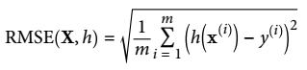

X,y = np.split(df.values, axis=1, indices_or_sections=[-1])
X = df.drop("target", axis=1).values
y = df['target'].values

If the training set and test set scores are very close we are most likely underfitting.

If the training set score is close to 1.0 but the test set score is quite low, we are overfitting.

If the training set score is below 1.0 and the test set score is a bit lower than the training set score, we have built an optimal model.

the Iris dataset
df = seaborn.load_dataset("iris") # gets the dataset from the internet
d = sklearn.datasets.load_iris()

pickle a model
import numpy as np, pandas as pd
import sklearn.tree
import pickle
l = [(1,1),(1.5,1.5),(2,1.25), (3.5,2),(4,2),(4.5,2.5), (7,3.75),(7.5,4),(8,4),(8.5,4.25)]
xx,yy = np.array(l).T
"""Regression Tree"""
md = sklearn.tree.DecisionTreeRegressor(max_depth=2, min_samples_leaf=3)
md = md.fit(xx[:,None], yy[:,None])
"""Pickel a model"""
with open('model.pkl', mode='wb') as f:
pickle.dump(md, file=f)
del md
with open('model.pkl', mode='rb') as f:
md = pickle.load(f)
"""Test the Tree"""
xx_test = np.array(range(10), dtype=np.uint8)
yy_pred = md.predict(xx_test[:,None])
df = pd.DataFrame({'test value':xx_test, 'predicted value':yy_pred.round(2)}, columns=['test value','predicted value'])
print(df)

There are two different functions in scikit-learn that can be used to obtain uncertainty estimates from classifiers: decision_function and predict_proba
Most (but not all) classifiers have at least one of them

If you set the regularization hyperparameter to a very large value, you will get an almost flat model (a slope close to zero)
high regularization hyperparameter = high restriction = almost flat model

X = np.random.RandomState(1).rand(10,3) * 10
W = [2, -3, 0.5]; i = 0 # weights and intercept
y = (X*W).sum(1) + i
y = np.dot(X,W) + i #same

modify an sklearn-transformer to provide for the error-message:
fit_transform() takes 2 positional arguments but 3 were given (when used in a pipeline)
from sklearn.preprocessing import LabelBinarizer
class LabelBinarizerModified(LabelBinarizer):
def fit_transform(self, X, y=None):
self.fit(X)
X = self.transform(X)
return X

clone an estimator
import numpy as np
X,y = np.random.randint(0,10, size=(10,3)), np.random.randint(0,3, size=10)

import sklearn.base
class Estimator(sklearn.base.BaseEstimator, sklearn.base.ClassifierMixin):
def fit(self, X, y): #ClassifierMixin brings in the score-method
self._mode = __import__('scipy.stats').stats.mode(y).mode[0] #predict the most frequent value
return self
def predict(self, X):
if '_mode' not in self.__dict__: raise Exception("you must fit the model first")
return [self._mode]*X.shape[0]

md = Estimator().fit(X,y)
ypred = md.predict(X)

#clone the estimator...
est = sklearn.base.clone(md)
est.fit(X,y) # error if this line is omitted
score = est.score(X,y)

turn an estimator into a multioutput classifier
from sklearn.naive_bayes import GaussianNB
from sklearn.multioutput import MultiOutputClassifier
est = GaussianNB()
md = MultiOutputClassifier(est).fit(X,Y) #where Y = [m by k matrix of integers]

PIPELINE, FEATURE UNION

FeatureUnion
from sklearn.pipeline import FeatureUnion
fu = FeatureUnion([('pipe1',pl1),('pipe2',pl2)])
fu = make_union(pl1, pl2) # same
md = LogisticRegression(solver='lbfgs')
pl = make_pipeline(fu, md)
pl = Pipeline([('features',fu),('estimator',md)]) # same

get_feature_names of PolynomialFeatures
tr = sklearn.preprocessing.PolynomialFeatures(degree=3, interaction_only=False, include_bias=True)
X = tr.fit_transform(X)
fnames = tr.get_feature_names()
fnames = tr.get_feature_names(['x1','x2']) # in effect almost the same
fnames = tr.get_feature_names(['FeatureA','FeatureB'])

pipeline
PL = sklearn.pipeline.make_pipeline(PolynomialFeatures(degree=3), LinearRegression())
PL.fit(X,y)
y_pred = PL.predict(X)
md = PL.steps[1][1]
weights = md.coef_ ; intercept = md.intercept_

FeatureUnion out of paralel PipeLines
class Subset(object):
def __init__(self, columns=None):
self.columns = columns

def fit(self, X, y=None):
return self

def transform(self, X):
X_cols = X[:,self.columns]
return X_cols

PL1 = make_pipeline(Subset([0,1]),
Imputer(strategy='mean'),
StandardScaler(),
PolynomialFeatures(degree=3, include_bias=False, interaction_only=False),
SelectPercentile(percentile=50),
SelectKBest(k=1))
PL2 = make_pipeline( Subset([2]), OneHotEncoder(sparse=False))
FU = make_union(PL1, PL2) #FeatureUnion
PL = make_pipeline(FU, Ridge())

PL = PL.fit(X_train, y_train)
score = PL.score(X_test, y_test)
MD = PL.steps[-1][1]
weights = MD.coef_

transformers in a Pipeline run in sequence.
transformers in a ColumnTransformer run in parallel. The resulting features are assembled at the end of this process.
FeatureUnion concatenates the features which are results of different transformers (?)

sklearn.compose.ColumnTransformer
import numpy as np, pandas as pd
#MAKE DATA
nd = np.random.randint(0, 3, size=(10,3))
df = pd.DataFrame(nd, columns=list("ABC"))
df['B'] = np.array(tuple("abc"))[df['B'].values]
df['C'] = pd.Categorical(np.array(tuple("äöü"))[df['C'].values], ordered=True)
df.iloc[[3,5,7,9],:] = np.nan

from sklearn.impute import SimpleImputer
from sklearn.preprocessing import OneHotEncoder
from sklearn.preprocessing import StandardScaler
from sklearn.compose import ColumnTransformer
from sklearn.pipeline import Pipeline

im = SimpleImputer(strategy='most_frequent') #affects all columns
nd = X = im.fit_transform(df) #note the input is df
modes = im.statistics_ #the most frequent values per column

oh = OneHotEncoder(sparse=False) # affects all columns, to subset columns use ColumnTransformer
sc = StandardScaler() #column-transforming is going on in parallell, not in sequence!
ct = ColumnTransformer([('onehot', oh, [1,2]), ('scaler', sc, [0])])
Xtr = ct.fit_transform(X) #note the input is X

#DISEPT THE ColumnTransformer
oh = ct.named_transformers_['onehot']
oh = ct.transformers_[0][1] #same
cats = oh.categories_
nd = oh.inverse_transform(Xtr[:,:-1])

#MAKE A PIPELINE
pl = Pipeline([('imputer',im),('columntransformer',ct)])
Xtr = pl.fit_transform(df)

How to apply Polynomial Transformation to subset of features
https://stackoverflow.com/questions/47664061/how-to-apply-polynomial-transformation-to-subset-of-features-in-scikitlearn/47664583
from sklearn.pipeline import FeatureUnion
from sklearn.preprocessing import PolynomialFeatures, OneHotEncoder, LabelEncoder
from sklearn.linear_model import LogisticRegression
from sklearn.pipeline import Pipeline

X = pd.DataFrame({'cat_var': ['a', 'b', 'c'], 'num_var': [1, 2, 3]})

class ColumnExtractor(object):
def __init__(self, columns=None):
self.columns = columns

def fit(self, X, y=None):
return self

def transform(self, X):
X_cols = X[self.columns]

return X_cols

pipeline = Pipeline([
('features', FeatureUnion([
('num_var', Pipeline([
('extract', ColumnExtractor(columns=['num_var'])),
('poly', PolynomialFeatures(degree=2))
])),
('cat_var', Pipeline([
('extract', ColumnExtractor(columns=['cat_var'])),
('le', LabelEncoder()),
('ohe', OneHotEncoder()),
]))
])),
('estimator', LogisticRegression())
])

class Subset(object):
def __init__(self, columns=None):
self.columns = columns

def fit(self, X, y=None):
return self

def transform(self, X):
X_cols = X[:,self.columns]
return X_cols

pickle a model, save a model
sklearn.externals.joblib.dump(md, r'model.pkl')
md = sklearn.externals.joblib.load('model.pkl')
import sklearn.externals

d = sklearn.datasets.load_files(r"D:\Working\Bunch")

PL = make_pipeline(TfidfVectorizer(), LogisticRegression())
d = {'logisticregression__C':[0.001, 0.01, 0.1, 1, 10], 'tfidfvectorizer__stop_words':[None, 'english']}
ME = GridSearchCV(PL, param_grid=d, cv=2) #ME = meta-estimator
ME.fit(l,y)
score = ME.best_score_
d = ME.best_params_
PL = ME.best_estimator_
MD = PL.steps[1][1]
MD = PL.named_steps['logisticregression'] #same

MD = PL.steps[1][1]
MD = PL.named_steps['logisticregression'] #same

BaseEstimator

When using BaseEstimator from Scikit-Learn, it is important that initialization contains no operations (other than assigning the passed values by name to self).
All arguments to __init__ should be explicit; that is, *args or **kwargs should be avoided.

Building Your Own Estimator
from sklearn.base import BaseEstimator, TransformerMixin
class MyTransformer(BaseEstimator, TransformerMixin):
def __init__(self, first_parameter=1, second_parameter=2):
# All parameters must be specified in the __init__ function
self.first_parameter = 1
self.second_parameter = 2
def fit(self, X, y=None):
# fit should only take X and y as parameters
# Even if your model is unsupervised, you need to accept a y argument!
# Model fitting code goes here
print("fitting the model right here")
# fit returns self
return self
def transform(self, X):
# transform takes as parameter only X
# Apply some transformation to X
X_transformed = X + 1
return X_transformed

Implementing a classifier or regressor works similarly, only instead of TransformerMixin you need to inherit from ClassifierMixin or RegressorMixin. Also, instead of implementing transform, you would implement predict.

sklearn.base.BaseEstimator brings in get_params and set_params methods
sklearn.base.TransformerMixin brings in fit_transform method
sklearn.base.RegressorMixin
sklearn.base.ClassifierMixin

pca = PCA(n_components=150, whiten=True, random_state=42)
svc = SVC(kernel='rbf', class_weight='balanced')
pl = make_pipeline(pca, svc)

Xtrain,Xtest, ytrain, ytest = train_test_split(X,y, stratify=y, random_state=42)
pl.fit(Xtrain,ytrain)
y_pred = pl.predict(Xtest)
score = pl.score(Xtest, ytest)

sklearn.pipeline.Pipeline
from sklearn.preprocessing import MinMaxScaler
from sklearn.svm import SVC
from sklearn.pipeline import Pipeline

sc = MinMaxScaler(feature_range=[0,1], copy=True)
md = SVC(C=1.0, kernel='linear')
pl = Pipeline([('scaler', sc), ('svm', md)])
pl.fit(X,y)

score = pl.score(X,y)
y_pred = pl.predict(X)
mx = pl.decision_function(X)
y_pred = mx.argmax(axis=1)

subset, transform and then unify columns; make all these steps into a pipeline
from sklearn.pipeline import FeatureUnion
from sklearn.preprocessing import PolynomialFeatures, OneHotEncoder, LabelEncoder
from sklearn.linear_model import LogisticRegression
from sklearn.pipeline import Pipeline, make_pipeline
from pandas import DataFrame
X = DataFrame({'cat_var': ['a', 'b', 'c'], 'num_var': [1, 2, 3]})
y = [0,0,1]
class ColumnExtractor(object):
def __init__(self, columns=None):
self.columns = columns
def fit(self, X, y=None):
return self
def transform(self, X):
X_cols = X[self.columns]
return X_cols.values
class Subset: # same as ColumnExtractor
def __init__(self, columns=None):
self.columns = columns
def fit(self, X, y=None):
return self
def transform(self, X):
X_cols = X.loc[:,self.columns]
return X_cols.values
pl = Pipeline([
('features', FeatureUnion([
('num_var', Pipeline([
('extract', ColumnExtractor(columns=['num_var'])),
('poly', PolynomialFeatures(degree=2))
])),
('cat_var', Pipeline([
('extract', Subset(columns=['cat_var'])),
('oh', OneHotEncoder(sparse=False)),
]))
])),
('estimator', LogisticRegression(solver='lbfgs'))
])
pl.fit(X,y)
"""same as above but more verbose:"""
#make pipeline 1
cs = ColumnExtractor(columns=['num_var']) # cs = column subsetter
pf = PolynomialFeatures(degree=3)
pl1 = make_pipeline(cs, pf)
#make pipeline 2
cs2 = Subset(columns=['cat_var'])
oh = OneHotEncoder(sparse=False)
pl2 = make_pipeline(cs2, oh)
#make union
fu = FeatureUnion([('pipe1',pl1),('pipe2',pl2)])
#estimator
md = LogisticRegression(solver='lbfgs')
#make unified pipeline
pl = make_pipeline(fu, md) # same as the next line
pl = Pipeline([('features',fu),('estimator',md)]) # same as above
#fit, predict, analyze...
pl.fit(X,y)
y_pred = pl.predict(X)
score = pl.score(X,y)
nd = pl.decision_function(X)
d = pl.get_params()
d = pl.named_steps
est = d['estimator']
nd = est.coef_ # for example – to get the learned details
lt = pl.steps

grid search (with cross validation) of a pipeline
from sklearn.preprocessing import PolynomialFeatures
from sklearn.linear_model import LogisticRegression
from sklearn.pipeline import Pipeline, make_pipeline
from sklearn.model_selection import GridSearchCV, LeaveOneOut
from numpy import array, uint8

X = (1,2,3,4,5); X = array(X, dtype=uint8).reshape(-1,1)
y = [0,1,0,1,1]

pl = make_pipeline(PolynomialFeatures(), LogisticRegression(solver='lbfgs'))
d = {'polynomialfeatures__degree':[2,3,4],
'logisticregression__C':[0.1, 1, 10],
'logisticregression__random_state':[1,2,42]}
me = GridSearchCV(pl, param_grid=d, cv=LeaveOneOut())
me.fit(X,y)

d = me.cv_results_
scores = d['mean_test_score']

md = me.best_estimator_
nd = me.best_estimator_.named_steps["logisticregression"].coef_ # access some learned detailed

grid-searching which model to use
import numpy as np
from sklearn.svm import SVC
from sklearn.ensemble import RandomForestClassifier
from sklearn.preprocessing import StandardScaler
from sklearn.pipeline import Pipeline
from sklearn.model_selection import GridSearchCV

#data
Σ = [[2,2],
[2,5]]
m = 500
mx = np.random.multivariate_normal(mean=[0,0], cov=Σ, size=m)
X = mx[np.argsort(mx[:,0])]
y = y_true = ((mx**2).sum(axis=1) < 1).astype(np.uint8)

#model
tre = RandomForestClassifier(n_estimators=100).fit(X,y) # you can fit the data, because the model will be refitted in the grid search
sc = StandardScaler()
svm = SVC(kernel='rbf', C=10, gamma=10000)
svm.fit(X,y)
y_pred = svm.predict(X); score = svm.score(X,y) # you can see how this model performs

pl = Pipeline([('preprocessing', sc),('classifier', svm)])
ld = [{'classifier':[svm], 'preprocessing':[sc, None], 'classifier__C':[1,10], 'classifier__gamma':[100,1000,10000]},
{'classifier':[tre], 'preprocessing': [None], 'classifier__max_features': [1, 2]}]

me = GridSearchCV(pl, param_grid=ld, cv=5)
me.fit(X,y)

d = me.best_params_
score = me.best_score_
pl = me.best_estimator_
svm = pl.named_steps['classifier']

sklearn.base.BaseEstimator adds get_params and set_params methods
from sklearn.base import BaseEstimator
class Model(BaseEstimator):
def __init__(self, hyperparameter=None):
pass
md = Model()
md.set_params(hyperparameter='new value') #changes the hyperparameter
d = md.get_params('hyperparameter') #{'hyperparameter': 'new value'}

from sklearn.base import TransformerMixin
class Transformer(TransformerMixin):
def fit(self, X, y=None):
return self
def transform(self, X):
return X*2
X = []
tr = Transformer()
X = tr.fit_transform(X)

#one set of settings:
d = {'transformer__hyperparameter':[(0,1), [(0,2)], [(0,1),(0,2)]], 'model__fit_intercept':[True,False]}
#two sets of settings (the total number of possible combinations of settings is 8):
ld = [{'model__fit_intercept':[True], 'transformer__hyperparameter':[(0,1), [(0,2)], [(0,1),(0,2)]], 'model__normalize':[False,True]},
{'transformer__hyperparameter':[None], 'model__fit_intercept':[True,False]}]

me = GridSearchCV(pl, param_grid=ld, cv=5).fit(X,y)

d = me.best_params_
pl = me.best_estimator_
weights = pl.named_steps['model'].coef_
scores = cross_val_score(me, X,y, cv=5) #nested cross validation
scores = cross_val_score(pl, X,y, cv=5) #X,y = train sets (?)
score = pl.score(Xtest, ytest)
ypred = pl.predict(Xnew)

#make a table of scores and params
scores = me.cv_results_['mean_test_score']
dd = me.cv_results_['params']
d = {k:v for k,v in zip(scores,dd)} ;from pandas import Series
sr = Series(d).sort_index(ascending=False)

CUSTOM TRANSFORMERS

how to use a utility function as a Transformer-class for a pipeline
import numpy as np, pandas as pd; np.set_printoptions(precision=2, suppress=True)

#MAKE DATA
nd = np.random.randint(-10,100, size=(10,3)).astype(np.float16)
nd[[1,3,5,7,9],[0,1,2,0,1]] = np.nan

df = pd.DataFrame(nd, columns=['x1','x2','y'])
df.iloc[[2,4,6],[0,-1]] = np.NAN

#A utility function for your ML data preprocessing
def drop_na_in_target(df, column=None, *args, **kwargs):
column = column or df.columns.values[-1]
df = df.dropna(subset=[column,])
return df

#ready-made Transformer
from sklearn.base import BaseEstimator, TransformerMixin
class Transformer(BaseEstimator, TransformerMixin):
def __init__(self, function, **kwargs):
self.function = function if callable(function) else (lambda*args,**kwargs:None)
self.__dict__.update(kwargs)
def fit(self, X, y=None, *args, **kwargs):
return self
def transform(self, X, y=None, *args, **kwargs):
hyperparameters = self.__dict__
output = self.function(X, **hyperparameters)
return(output)

#DEMO
tr = Transformer(function=drop_na_in_target, column='y')
df = tr.fit_transform(df)

from sklearn.pipeline import make_pipeline
from sklearn.impute import SimpleImputer
im = SimpleImputer(strategy='median')
pl = make_pipeline(tr, im)
X = pl.fit_transform(df)

verify the format of a hyperparameter when being set
from sklearn.base import BaseEstimator, TransformerMixin
class Transformer(BaseEstimator, TransformerMixin):
def __init__(self, hyperparameter=None):
self.hyperparameter = hyperparameter or [(0,1),(2,3)]

@property
def hyperparameter(self):
return self.__hyperparameter
@hyperparameter.setter
def hyperparameter(self, new):
from numbers import Integral
b = hasattr(new, '__len__') and all(hasattr(e, '__len__')and len(e)==2 and all(isinstance(n,Integral) and n>=0 for n in e) for e in new)
if not b: raise ValueError("hyperparameter must be of format [(0,1),(2,3), ...]")
self.__hyperparameter = new

def fit(self, X, y=None, *args, **kwargs):
return self
def transform(self, X, y=None, *args, **kwargs):
return X

import numpy as np
X = np.random.randint(-10,10, size=(10,5))

tr = Transformer()
tr = tr.set_params(hyperparameter=[(1,2),(0,2),[1,2]]) #self.set_params(...) returns the self
X = tr.fit_transform(X)

PREPROCESSING, TRANSFORMING

Stratified Split
x1 = [10,20,30,40,50,60,70,80,90,99]
x2 = [ 1, 2, 3, 1, 2, 3, 1, 2, 3, 3] # categorical feature (can also be used to stratify-split on)
y = [ 0, 1, 0, 1, 0, 1, 0, 1, 0, 1] # 50% zeros and 50% ones

X = np.array([x1,x2], dtype=np.uint8).T
y = np.array(y, dtype=np.uint8)

from sklearn.model_selection import StratifiedShuffleSplit
ss = StratifiedShuffleSplit(n_splits=3, test_size=0.4) # 3 folds
g = ss.split(X,y) #stratify-split on the target-feature
for i, (nx_train, nx_test) in enumerate(g):
nx_train, nx_test # indeces for train set and test set for fold i
print("fold {}: train set y-values: {}, test set y-values: {}".format(i, y[nx_train], y[nx_test]))

stratify-split on a certain (categorical) feature in the data set
g = StratifiedShuffleSplit(n_splits=1, test_size=0.3).split(X, x2)
nx_train, nx_test = tuple(g)[0]
print("x2 values in the train set:", X[nx_train, 1]) # the proportion of the three classes (1,2,3) is roughly equal
print("x2 values in the test set: ", X[nx_test, 1])

stratify-split on an engineered feature
import numpy, random; from pandas import DataFrame

m = 30
location = ["abc"[random.randint(0,2)] for _ in range(m)] #shop location ranking
bottles = [random.randint(5,50) for _ in range(m)] #number of bottles sold per day
y = [0,1]*(m//2) #wine shop went bancrupt?

df = DataFrame([location, bottles, y], index=['x1','x2', 'y']).T
df = DataFrame({'x1':location, 'x2':bottles, 'y':y}) #same

sr = numpy.ceil(df['x2'] / 12).astype('i') # a box can contain a dozen bottles i.e. discretize on that
cat = sr.values

from sklearn.model_selection import StratifiedShuffleSplit
ss = StratifiedShuffleSplit(n_splits=1, test_size=0.2)
g = ss.split(df, cat)
for nx_train, nx_test in g:
nx_train, nx_test = nx_train, nx_test

Splitting

stratify-split into train/test and shuffle the train set
import numpy as np
#MAKE DATA
m,n = 100, 3
y = [1]*30 + [2]*30 + [3]*40; y = np.array(y, dtype=np.uint8)
X = y[:,None] * [10,100]

#STRATIFY-SPLIT INTO TRAIN/TEST STES
from sklearn.model_selection import StratifiedShuffleSplit
g = StratifiedShuffleSplit(n_splits=1, test_size=0.15).split(X,y)
nx_train, nx_test = tuple(g)[0]
Xtrain, Xtest, ytrain, ytest = X[nx_train], X[nx_test], y[nx_train], y[nx_test]

#SHUFFLE THE TRAIN-SET (necessary for cross-validation and cross-predict)
nx = np.random.permutation(Xtrain.shape[0])
Xtrain, ytrain = (nd[nx] for nd in (Xtrain, ytrain))

Outliers, Mising values

three options of dealing with missing values
from pandas import DataFrame; from numpy import nan
df = DataFrame([[ 1, nan,nan, 10],
[nan,nan, 1, 20],
[ 3, 30, 2, 30],
[nan,nan, 3, 40],
[ 5, nan, 3, 45]], columns=['x1','x2','x3','y'])

df.dropna(subset=['x1'], axis=0, inplace=True) # remove certain observations
df.drop('x2', axis=1, inplace=True) # remove an entire column
value = df['x3'].median()
df['x3'].fillna(value, inplace=True) # fill missing values with a value

Scaling

standardization vs normalization
import numpy as np
v = np.sort(np.random.randint(1,10, size=10)) # vector

r = v.max() - v.min() # range
a = (v - v.min()) / r # classic min-max normalization (the values are between 0 and 1)

l2 = np.linalg.norm(v) # L2-norm, same as: np.sqrt(np.square(v).sum())
a = (v - v.mean()) / l2 # L2-normalization

σ = np.std(v) # standard deviation
a = (v - v.mean()) / σ # standardization

if there are extreme outliers in a vector, do not use normalization. Use standardization instead.

As with imputation, the scaling must be done on the train set and then the same parameters (mean, range, standatd deviation)

Some algorithms, like neural networks and SVMs, are very sensitive to the scaling of the data. Therefore, a common practice is to adjust the features so that the data representation is more suitable for these algorithms. Often, this is a simple per-feature rescaling and shift of the data

nd = sklearn.preprocessing.StandardScaler().fit_transform(X)
a = (a – mean(a)) / std(a)

nd = sklearn.preprocessing.RobustScaler().fit_transform(X)
a = (a – median(a)) / iqr(a) the RobustScaler uses the median and quartiles instead of mean and variance

nd = sklearn.preprocessing.MinMaxScaler().fit_transform(X) # aka Normalization ?
a = (a – min(a)) / (max(a)-min(a)) as a result all values are between 0 and 1

nd = sklearn.preprocessing.Normalizer().fit_transform(X)
projects all data points onto the unit circle or unit hypersphere

RobustScaler uses the median and quartiles instead of mean and variance like StandardScaler. This makes the RobustScaler ignore data points that are very different from the rest (like measurement errors).

StandardScaler
import numpy as np
np.random.seed(0)
import sklearn.preprocessing
class MyStandardScalar():
def __init__(self):
pass
def fit_transform(self, X):
from numpy import ndarray, zeros_like, float_
assert isinstance(X, ndarray), "X must be an ndarray!"
X_output = zeros_like(X.T, dtype=float_)
for i,a in enumerate(X.T):
mu, sigma = a.mean(), a.std(ddof=0)
X_output[i] = (a - mu) / sigma
return X_output.T
#=========================================================================
n = 25 #no. of data points
nd = np.array(
[np.random.randint(low=1, high=i, size=n, dtype=np.uint8) for i in (10,23)]
).T
print(nd, nd.dtype, nd.shape)
X = nd
md = sklearn.preprocessing.StandardScaler()
nd = md.fit_transform(X)
print(nd, type(nd))
md = MyStandardScalar()
nd2 = md.fit_transform(X)
print((nd2==nd).all())

RobustScaler
#how does RobustScaler work?
import numpy as np
np.random.seed(0)
import sklearn.preprocessing
a = np.array([1,2,2,3,3, 3,4,4,4,4, 5,5,5,6,6, 7,8,9,10,100])
print(a.size, np.median(a), a.mean())
nd = np.percentile(a, [25,50,75])
IQR = np.subtract.reduce(np.delete(nd,1)[::-1])
print(nd, IQR)
nd1 = ((a - np.median(a)) / IQR).reshape(-1,1) #same as:
nd = sklearn.preprocessing.RobustScaler().fit_transform(a[:,None])
print(nd, (nd==nd1).all())
#compare with:
nd = sklearn.preprocessing.StandardScaler().fit_transform(a[:,None])
print(nd)

Normalizer
import numpy as np
np.random.seed(0)
import sklearn.preprocessing
import matplotlib.pyplot as plt
plt.style.use('classic')
from math import hypot
def magnitude(X):
l = [None,]*len(X)
for i,t in enumerate(X):
l[i] = hypot(*t)
return l
#=========================================
l = [(1,1), (-1,2), (0.25, -2.75), (-0.5, -0.4), (1,0)]
X = np.array(l)
y = np.array(magnitude(X)).reshape(-1,1)
X_normalized = X / y
print(X,y,X_normalized, sep="\n\n", end="\n"*3)
#figsize
plt.rcParams['figure.figsize'] = (5,5)
plt.gcf().set_figheight(5)
plt.gcf().set_figheight(5)
plt.axis([-3,3,-3,3])
plt.scatter(*X.T, marker='.')
plt.scatter(*X_normalized.T, marker='.', color='red')
[(plt.text(x,y, '({}, {})'.format(x,y), fontdict={'fontsize':'xx-small'}), plt.plot([0,x],[0,y], color='gray', linestyle='-', linewidth=0.5)) for x,y in l]
plt.axvline(0, color='k', alpha=0.4, linewidth=0.5); plt.axhline(0, color='k', alpha=0.4, linewidth=0.5)
plt.gca().add_patch(plt.Circle((0,0),1, edgecolor='gray', facecolor='none'))
plt.show()
#sklearn
nd = sklearn.preprocessing.Normalizer().fit_transform(X)
print(nd, (nd==X_normalized).all())

make a scaler on the train set and use it to stransform the train, test and new sets
from sklearn.preprocessing import MinMaxScaler
sc = MinMaxScaler().fit(Xtrain)
Xtrain = sc.transform(Xtrain)
Xtest = sc.transform(Xtest)
Xnew = sc.transform(Xnew)

fit, score, predict ON train, test, new data-sets (respectively)
pl = Pipeline([('imputer',im), ('scaler', sc),('model', md)])
pl.fit(Xtrain, ytrain)
scores = pl.cross_val_score(Xtrain, ytrain)
score = pl.score(Xtest, ytest)
ypred = pl.predict(Xnew)

Encoding/Discretization etc.

encoder / factorizer
from pandas import DataFrame
df = DataFrame({'discipline':['maths','stats','ml','maths','ml'],
'course':[101,102,101,103,104],
'mean grade':['A','B','C','A','B']})

from sklearn.preprocessing import LabelEncoder #for a single array
y = sr = df['mean grade']
en = LabelEncoder().fit(y)
classes = en.classes_ #['A', 'B', 'C']
y = en.transform(y) #[0, 1, 2, 0, 1]
y = en.inverse_transform(y) #['A', 'B', 'C', 'A', 'B']
y,classes = sr.factorize() #[0, 1, 2, 0, 1], ['A', 'B', 'C']

from sklearn.preprocessing import OrdinalEncoder #for multiple features
X = df = df[['discipline', 'course']]
en = OrdinalEncoder(categories='auto').fit(X)
classes = en.categories_ #['maths', 'ml', 'stats'], [101, 102, 103, 104]
X = en.transform(X)
X = en.inverse_transform(X)

one-hot
from pandas import DataFrame
df = DataFrame({'gender':['Male','Female','Male','Female','Male'],
'type':[101, 102, 103, 101, 102],
'result':['yes','no','yes','no','yes']})

from sklearn.preprocessing import LabelBinarizer #for a single array
y = sr = df['result']
en = LabelBinarizer().fit(y)
classes = en.classes_ #['no', 'yes']
y = en.transform(y) #[1,0,1,0,1] as vertical 2D nd-array
y = en.inverse_transform(y) #['yes', 'no', 'yes', 'no', 'yes']
y,classes = sr.factorize()

cat = df["type"] #for a single array (multiclass)
X = en.fit_transform(cat)

from sklearn.preprocessing import OneHotEncoder #for multiple features
X = df = df[['gender','type']]
en = OneHotEncoder(sparse=False).fit(X)
classes = en.categories_ #['Female', 'Male'], [101, 102, 103]
X = en.transform(X)
X = en.inverse_transform(X)

many-hot
from sklearn.preprocessing import MultiLabelBinarizer
movies = [('thriller', 'drama', 'comedy'), ('thriller','drama'), ('comedy',)]
en = MultiLabelBinarizer().fit(movies)
classes = en.classes_ #['comedy', 'drama', 'thriller'] in alphabetical order
X = en.transform(movies) #3x3 many-hot mx
lt = en.inverse_transform(X) #[('comedy', 'drama', 'thriller'), ('drama', 'thriller'), ('comedy',)]

combinations = [(101, 102, 103, 104), (103,102,101), (104,)] #combinations w/out replacement (e.g. courses a student takes)
en = MultiLabelBinarizer().fit(combinations)
classes = en.classes_ #[101, 102, 103, 104]
X = en.transform(combinations) #3x4 many-hot mx
lt = en.inverse_transform(X) #[(101, 102, 103, 104), (101, 102, 103), (104,)]

get_dummies function automatically transforms all columns that have object type (like strings) or are categorical
import pandas as pd
lt = [(10, "string 1", 'F'),
(20, "string 2", 'M'),
(30, "string 3", 'F'),
(20, "string 2", 'M'),
(10, "string 1", 'M')]

df = pd.DataFrame(lt, columns=['number','string','cat'])
df['string'] = df['string'].values.astype('<S')
df['cat'] = pd.Categorical(df['cat'], ordered=False)
df['cat'] = df['cat'].astype('category') # same effect

df = pd.get_dummies(df) # dummy_na : Add a column to indicate NaNs, if False NaNs are ignored

binning aks discretization of continuous data
from sklearn.preprocessing import KBinsDiscretizer
import numpy as np
#data:
m = 30
x = np.linspace(0, 10, m) + np.random.normal(0, scale=0.2, size=m) # 15 data-points

#numpy.digitize equivelent:
X = x.reshape(-1,1)
nx = KBinsDiscretizer(n_bins=10, encode='ordinal', strategy='uniform').fit_transform(X)
# nx = m x 1 matrix
X = KBinsDiscretizer(n_bins=10, encode='onehot-dense', strategy='uniform').fit_transform(X)
# X = m x 10 one-hot matrix

#simulate sklearn behaviour with numpy:
breaks = np.linspace(min(x), max(x), num=10+1)
nx = np.digitize(x, bins=breaks) - 1
nx[-1] = nx[-2]

#data:
X = np.c_[x, x*-2]

#multiple columns
mx = KBinsDiscretizer(n_bins=10, encode='ordinal', strategy='uniform').fit_transform(X)
#mx = m x 2 matrix of discretized labels
X = KBinsDiscretizer(n_bins=10, encode='onehot', strategy='uniform').fit_transform(X)
#X = m x 20 one-hot matrix (sparse)

One-Hot

get_dummies by default only dummifies string/categorical features and leaves numerical features untouched. To dummify integer features use the keyword: columns=[…]

OneHotEncoder can only dummify integer features (not string or categoricals) NO!!

DictVectorizer transforms a list of dictionaries into a matrix and dummifies string features in the process

Do not confuse with:
sklearn.feature_extraction.text.CountVectorizer
sklearn.feature_extraction.text.TfidfVectorizer
sklearn.feature_extraction.text.TfidfTransformer

TfidfTransformer takes in a sparse matrix produced by CountVectorizer and transforms it. TfidfVectorizer takes in text data and does both the bag-of-words feature extraction and the tf–idf transformation.

get_dummies
dumify only the columns containing strings/categoricals
df = pd.get_dummies(df)
if you want to dummify integer features as well
df = pd.get_dummies(df, columns=['Integer Categorical', 'String Categorical'])

OneHotEncoder (if you need to dummify integer features)
md = sklearn.preprocessing.OneHotEncoder(categorical_features=[0,1], sparse=False)
md.fit(mx) # only takes in an ndarray / matrix, not df
mx = md.transform(mx)

DictVectorizer transforms a list of feature-value mappings to vectors
md = sklearn.feature_extraction.DictVectorizer(dtype=int, sparse=False)
nd = md.fit_transform(ld) #ld = list of dictionaries
names = md.feature_names_
df = pd.DataFrame(nd, columns=md.feature_names_)

import sklearn.feature_extraction
import numpy as np, pandas as pd

ld = [
{'price': 850000, 'rooms': 4, 'neighborhood': 'Queen Anne'},
{'price': 700000, 'rooms': 3, 'neighborhood': 'Fremont'},
{'price': 650000, 'rooms': 3, 'neighborhood': 'Wallingford'},
{'price': 600000, 'rooms': 2, 'neighborhood': 'Fremont'}]

"""dummify with DictVectorizer""" #DictVectorizer transforms lists of feature-value mappings to vectors
md = sklearn.feature_extraction.DictVectorizer(dtype=int, sparse=False)
mx = md.fit_transform(ld) #ndarry is returned
names = md.feature_names_
df = pd.DataFrame(mx, columns=md.feature_names_)
df = df.reindex(columns=df.columns.values[[0,1,2,4,3]])

X,y = np.split(df.values, axis=1, indices_or_sections=[-1])
print(X, y) # y.shape=(4,1)

"""dummify with pandas"""
df = pd.DataFrame(ld, columns="neighborhood rooms price".split())
df = pd.get_dummies(df, columns=['neighborhood'])
X = df.drop("price", axis=1).values
y = df['price'].values
print(X, y) #y.shape = (4,)

sklearn.preprocessing.OneHotEncoder
import sklearn.preprocessing
mx = [[3, 0, 10],
[1, 1, 12],
[0, 2, 15],
[2, 0, 16]]
md = sklearn.preprocessing.OneHotEncoder(categorical_features=[0,1], sparse=False)
md.fit(mx)
mx = md.transform(mx)
print(mx)

import pandas as pd
pd.options.display.width = 250
from myutils import print
df = pd.DataFrame({'Integer Categorical': [3, 1, 2, 1], 'String Categorical': ['socks', 'fox', 'socks', 'box']})
print(df)
df_onehot = pd.get_dummies(df) # dumifies only the columns containing strings/categoricals
print(df_onehot)
df_onehot = pd.get_dummies(df, columns=['Integer Categorical', 'String Categorical']) # if you want to dummify integer features
print(df_onehot)

sklearn.preprocessing.Imputer deprecated?
sklearn.impute.SimpleImputer new

split a dateset into the train and test subsets
from sklearn.model_selection import train_test_split
Xtrain, Xtest, ytrain, ytest = train_test_split(X, y, random_state=1)
sklearn.cross_validation is depricated

st = sklearn.feature_extraction.text.ENGLISH_STOP_WORDS

TF-IDF
from urllib.request import urlopen
from sklearn.feature_extraction.text import CountVectorizer, TfidfVectorizer, ENGLISH_STOP_WORDS
import numpy as np, pandas as pd
pd.options.display.width= 300
def download_multiple_txt(array_of_urls):
a = array_of_urls
l = [None,]*len(a)
for i,sURL in enumerate(a):
g = urlopen(sURL)
if g.getcode() != 200:
raise Exception(f'Failed to download text from {sURL}')
l[i] = g.read().decode('utf-8')
return l
#====================================================================
"""download the documents"""
url1 = r"https://www.cs.cmu.edu/~spok/grimmtmp/020.txt"
url2 = r'http://hca.gilead.org.il/vt/princess.txt'
url3 = r'http://hca.gilead.org.il/vt/tin_sold.txt'
url4 = r'http://hca.gilead.org.il/vt/ugly_duc.txt'
url5 = r'http://hca.gilead.org.il/vt/snow_que.txt'
t = (url1, url2, url3, url4, url5)
l = download_multiple_txt(t)
md = CountVectorizer()
nd = md.fit_transform(l).toarray()
aTerms = md.get_feature_names()
st = ENGLISH_STOP_WORDS.intersection(md.get_feature_names())
haystack = md.get_feature_names()
needles = sorted(st)
nxStopWords = np.searchsorted(haystack, needles)
nxInverse = sorted(set(range(nd.shape[-1])).difference(nxStopWords))
aTerms = np.array(aTerms)[nxInverse]
nd = nd[:,nxInverse]
n = 20
nx = np.argsort(nd.sum(axis=0))[::-1][:n]
df = pd.DataFrame(nd[:,nx], columns=aTerms[nx])
print(df)

X_trans = sklearn.preprocessing.MinMaxScaler().fit_transform(X)
#same
md = sklearn.preprocessing.MinMaxScaler()
md = md.fit(X)
X_trans = md.transform(X)

the correct way to transform the train and test sets
md = sklearn.preprocessing.MinMaxScaler()
md.fit(X_train) ; md.fit(X) #is the second one also correct?
X_train_trans = md.transform(X_train)
X_test_trans = md.transform(X_test)

import numpy as np, pandas as pd
from numpy import nan
from numpy import nan as NA

X = np.array([[ nan, 0, 3 ],
[ 3, 7, 9 ],
[ 3, 5, 2 ],
[ 4, NA, 6 ],
[ 8, 8, 1 ]])
print(X)

sr = pd.Series(np.nanmean(X, axis=0),index=[0,1,2])
df = pd.DataFrame(X).fillna(value=sr)
print(df)

from sklearn.impute import SimpleImputer
im = SimpleImputer(strategy='median')
im = SimpleImputer(strategy='mean')
X = im.fit_transform(X) #same as the df above
μμ = im.statistics_
print(X)

from sklearn.impute import SimpleImputer
im = SimpleImputer(strategy='median')
im = SimpleImputer(strategy='mean')

im.fit(Xtrain) # impute on the train set!
μμ = im.statistics_ # the imputed means must be used on the test and new sets
Xtrain = im.fit_transform(Xtrain)

Xtest = im.transform(Xtest)
Xnew = im.transform(Xnew)

pandas.factorize & sklearn.preprocessing.LabelEncoder
import pandas, sklearn.preprocessing
a = ['France','Germany','UK','France']
nx, classes_list = pandas.factorize(a)
#same as:
LE = sklearn.preprocessing.LabelEncoder().fit(a)
nx = LE.transform(a) #[0 1 2 0]
classes_list = LE.classes_ #['France' 'Germany' 'UK']

factorize descreet data
a = ['a','b','c','a','b']

enc = sklearn.preprocessing.LabelEncoder().fit(a)
nx = enc.transform(a) # integer ndarray
classes_list = enc.classes_

#equivelent to:
nx, classes_list = pandas.factorize(a)

one-hot dummify an array
a = ['a','b','c','a','b']

v = numpy.array(a, dtype='<U1').reshape(-1,1) # vertical vector of descrete data
oh = sklearn.preprocessing.OneHotEncoder(sparse=False).fit(v)
mx = oh.transform(v) # mx = 2D-ndarrays with one-hot values
#equivelent to:
df = pandas.get_dummies(a) # equivelent to the result above

oh = sklearn.preprocessing.OneHotEncoder(categorical_features=[3,5,-1], sparse=False).fit(X)
X = oh.transform(X)
classes_list = oh.categories_
v = oh.inverse_transform(X[:,:3]) # vertical vector

Train / Test set scaling (two ways)
scaler = MinMaxScaler().fit(X_train)
X_train_scaled = scaler.transform(X_train)
X_test_scaled = scaler.transform(X_test)
#same as:
scaler = MinMaxScaler()
X_train_scaled = scaler.fit_transform(X_train)
X_test_scaled = scaler.transform(X_test)

wrong and correct scaling
import numpy as np
from sklearn.model_selection import train_test_split
from sklearn.preprocessing import MinMaxScaler
from functools import partial
print = partial(print, sep="\n\n", end=('\n'+'='*50+'\n\n'))

a = (3,4,5,6,7,8,9,10,20,30)
X = np.reshape(a, (-1,1))
y = [0,1]*(len(a)//2)

X_train, X_test, y_train, y_test = X[:7], X[7:], y[:7], y[7:]

scaler = MinMaxScaler().fit(X)
X_whole_dataset_scaled = scaler.transform(X)
print("whole set scaled:", X_whole_dataset_scaled)

scaler = MinMaxScaler().fit(X)
X_train_scaled = scaler.transform(X_train)
X_test_scaled = scaler.transform(X_test)
print("scaled on the parameters of the whole set (wrong)", X_train_scaled, X_test_scaled)

scaler = MinMaxScaler().fit(X_train)
X_train_scaled = scaler.transform(X_train)
X_test_scaled = scaler.transform(X_test)
print("correct scaling", X_train_scaled, X_test_scaled)

scaler = MinMaxScaler()
X_train_scaled = scaler.fit_transform(X_train)
X_test_scaled = scaler.transform(X_test)
print("correct scaling, also", X_train_scaled, X_test_scaled)

FEATURE ENGINEERING

one-hot interactions
import numpy as np, pandas as pd
from sklearn.preprocessing import OneHotEncoder
from sklearn.linear_model import LinearRegression
from sklearn.preprocessing import PolynomialFeatures

"""DATA"""
#f1={S,M,L} f2={f,m} f3=interaction
X =\
[[10, 1, 0],
[20, 1, 5],
[30, 1, 1],
[10, 2, 4],
[20, 2, 2],
[30, 2, 5]]

X = np.array(X)
y = X.sum(1)

df = pd.DataFrame(X[:,:2], columns=["f1", "f2"])
df = pd.get_dummies(df, columns=["f1", "f2"])
Xoh = df.values # inv(Xoh.T @ Xoh) = singular matrix (by the way)

"""MODEL WITHOUT INTERACTION"""
md = LinearRegression(fit_intercept=False).fit(Xoh, y)
R2 = md.score(Xoh, y) # 96% - doesnt capture the interaction

#drop redundant features and use a global bias
df = pd.DataFrame(X[:,:2], columns=["f1", "f2"])
df = pd.get_dummies(df, columns=["f1", "f2"], drop_first=True)
Xoh = df.values
md = LinearRegression(fit_intercept=True).fit(Xoh, y) # Xoh (with the added bias) is invertable
R2 = md.score(Xoh, y) # 96% - same result as above

"""MODEL WITH INTERACTION"""
poly = PolynomialFeatures(degree=2, interaction_only=True, include_bias=False)
Xpoly = poly.fit_transform(Xoh)
column_names = df.columns.values
features = poly.get_feature_names(column_names)

md.fit(Xpoly, y)
R2 = md.score(Xpoly, y) #100% !!!

FEATURE SELECTION

Feature Selection based on Univariate Statistics vs Model-Based Feature Selection

Univariate Statistics
fs = sklearn.feature_selection.SelectPercentile(percentile=50).fit(X, y)
fs = sklearn.feature_selection.SelectKBest(k=2).fit(X, y) #select two best features
mask = fs.get_support()
X_subset = fs.transform(X)

Feature Selection based on Univariate Statistics
F_values, p_values = sklearn.feature_selection.f_regression(X,y)
F_values, p_values = sklearn.feature_selection.f_classif(X,y)
larger F-value corresponds to a smaller p-value which corresponds to a high r correlation value
meaning the features with small p-values (and hence high r values) are the best
sklearn.feature_selection.f_classif Compute the ANOVA F-value for the provided sample
sklearn.feature_selection.f_regression
sklearn.feature_selection.SelectPercentile
sklearn.feature_selection.SelectKBest

Model-Based Feature Selection
md = sklearn.ensemble.RandomForestClassifier(n_estimators=100, random_state=42)
fs = sklearn.feature_selection.SelectFromModel(md, threshold='median').fit(X,y)
mask = fs.get_support()
X_subset = fs.transform(X)

Iterative Feature Selection
md = sklearn.ensemble.RandomForestClassifier(n_estimators=100, random_state=42)
fs = sklearn.feature_selection.RFE(md, n_features_to_select=2).fit(X,y)
mask = fs.get_support()
X_subset = fs.transform(X)

import sklearn.feature_selection
from sklearn.datasets import load_iris
d = load_iris()
X = d.data
y = d.target
"""Feature Selection based on Univariate Statistics"""
F_values, p_values = sklearn.feature_selection.f_classif(X,y) #the selection is based on this function
print(F_values, p_values)
#larger F-value corresponds to a smaller p-value which corresponds to a high r correlation value
#meaning the features with small p-values (and hence high r values) are the best
fs = sklearn.feature_selection.SelectPercentile(percentile=50).fit(X, y) #select the best half of the features
fs = sklearn.feature_selection.SelectKBest(k=2).fit(X, y) ; print(fs) #select two best features
mask = fs.get_support()
X_subset = fs.transform(X)
print(mask)
print(X[:5]); print(X_subset[:5]);print()
"""Model-Based Feature Selection"""
import sklearn.ensemble
md = sklearn.ensemble.RandomForestClassifier(n_estimators=100, random_state=42)
fs = sklearn.feature_selection.SelectFromModel(md, threshold='median').fit(X,y)
mask = fs.get_support()
X_subset = fs.transform(X)
print(mask)
print(X[:5]); print(X_subset[:5])
"""Iterative Feature Selection"""
md = sklearn.ensemble.RandomForestClassifier(n_estimators=100, random_state=42)
fs = sklearn.feature_selection.RFE(md, n_features_to_select=2).fit(X,y)
mask = fs.get_support()
X_subset = fs.transform(X)
print(mask)
print(X[:5]); print(X_subset[:5])

my Feature Selector based on correlation
from sklearn.base import BaseEstimator,TransformerMixin
class CorrelationFeatureSelector(BaseEstimator,TransformerMixin):
def __init__(self, k_best=None, proportion=None):
self.k_best, self.proportion = k_best, proportion
self.__nx = None

def fit(self, X, y, *args):
n = self.k_best or int(round(self.proportion*X.shape[1]))
assert isinstance(n, int)and n<X.shape[1],"error1"
from numpy import corrcoef, c_
r = corrcoef(c_[X,y].T).round(3)[:-1,-1] #r = correlation coefficients
self.__nx = r.argsort()[:-(n+1):-1]
return self

def transform(self, X, y=None, *args):
if self.__nx is None: raise Exception("you must fit the model first")
return X[:,self.__nx]

make a pipeline with a transformer, features-selector and estimator
import numpy as np; np.set_printoptions(suppress=True, precision=4); np.random.seed(0)
from scipy.stats import binom
from sklearn.feature_selection import SelectKBest, SelectPercentile
from sklearn.linear_model import LinearRegression, Ridge, LogisticRegression
from sklearn.pipeline import make_pipeline
from sklearn.preprocessing import MinMaxScaler, StandardScaler

"""MAKE DATA"""
m,n = 100, 10
X = binom.rvs(n=[*range(10, n*10+1, 10)], p=0.5, size=(m,n)) # symetric distributions with
X = np.c_[np.ones(m, dtype=np.uint8)[:,None], X] #add x0
X = np.matrix(X) # 100x11 numpy-matrix

θ = np.matrix([30000, *range(n)], dtype=np.int32).T #weights
y = np.array(X@θ).ravel() #target
X = X[:,1:] #eliminate x0 from X

"""MAKE A PIPELINE WITH A TRANSFORMER, FEATURES-SELECTOR AND ESTIMATOR"""
sc = StandardScaler()
fs = SelectKBest(k=n//2) # n//2 means drop half of features
md = LinearRegression()
pl = make_pipeline(sc, fs, md).fit(X,y)

weights = [pl.steps[-1][1].intercept_.round(2), *pl.steps[-1][1].coef_.round(2)]
nx = fs.get_support().nonzero()[0]
score = pl.score(X,y)
ypred = pl.predict(X)

demo on making a pipeline with a feature-selection class
import numpy as np; np.random.seed(0)
from scipy.stats import binom
from sklearn.feature_selection import SelectKBest
from sklearn.linear_model import LinearRegression, Ridge, LogisticRegression
from sklearn.pipeline import make_pipeline

"""MAKE DATA"""
m,n = 100, 10
X = binom.rvs(n=[20]*n, p=0.5, size=(m,n)) # symetrical distributions with mu's = [1.5, 10, 50]
Xoriginal = X.copy()
X = np.c_[np.ones(m, dtype=np.uint8)[:,None], X] #add x0
X = np.matrix(X)

w = np.matrix([1000]+[*range(n)], dtype=np.uint16).T #weights = [1000, 0, 1, 2, 3, 4, 5, 6, 7, 8, 9]
y = X@w # target array

X_1 = np.linalg.inv(X.T@X)@X.T # (pseudo)inverse of X
w = X_1 @ y # same weights as above

ε = np.matrix(np.random.randn(m)).T #vertical vector of errors
y = y + ε # note: at this stage the weights (above) do not describe the best fitting hyperplane (because the errors have been just added)
y = ytrue = np.array(y, dtype=np.float32).ravel() #make into a 1D target-array

"""eliminate x0 from X"""
X = X[:,1:]

"""SELECT BEST FEATURES"""
fs = SelectKBest(k=n//2)
fs.fit(X,y)
mask = fs.get_support()
nx = mask.nonzero()[0] # not surprisingly [5, 6, 7, 8, 9]

"""transform the X and add x0 to it"""
X = fs.transform(X) # sklearn return an ndarray, not numpy-matrix
X = np.c_[np.ones(m, dtype=np.uint8)[:,None], X]

"""calculate inverse and weights through Normal Equasion"""
X_1 = np.linalg.pinv(X)
w = X_1 @ y #[1085.42, 5.72, 6.15, 6.89, 8.49, 9.08]

"""check with LInearRegression"""
X = X[:,1:] #eliminate x0
md = LinearRegression().fit(X, y)
ypred = md.predict(X)
score = md.score(X, y) #0.92
w = [md.intercept_.round(2), *md.coef_.round(2)] #[1085.42, 5.72, 6.15, 6.89, 8.49, 9.08] same as above

"""AUTOMATE THE PROCESS ABOVE"""
X = Xoriginal
pl = make_pipeline(fs, md).fit(X,y)
score = pl.score(X,y) #0.92 - same result as above
ypred = pl.predict(X)
w = [md.intercept_.round(2), *md.coef_.round(2)] # same as above [1085.42, 5.72, 6.15, 6.89, 8.49, 9.08]

"""TEST MY CORRELATION-BASED-SELECTOR"""
from sklearn.base import BaseEstimator,TransformerMixin
class CorrelationBasedFeatureSelector(BaseEstimator,TransformerMixin):
def __init__(self, k_best=None, proportion=None):
self.k_best, self.proportion = k_best, proportion
self.nx = None

def fit(self, X, y, *args):
n = self.k_best or int(round(self.proportion*X.shape[1]))
assert isinstance(n, int)and n<X.shape[1],"error1"
from numpy import corrcoef, c_
r = corrcoef(c_[X,y].T).round(3)[:-1,-1] #r = correlation coefficients
self.nx = r.argsort()[:-(n+1):-1]
return self

def transform(self, X, y=None, *args):
if self.nx is None: raise Exception("you must fit the model first")
return X[:,self.nx]

fs = CorrelationBasedFeatureSelector(k_best=n//2)
pl = make_pipeline(fs, md).fit(X,y)
nx = pl.steps[0][1].nx #[7, 8, 9, 6, 1]
score = pl.score(X,y) #0.84
ypred = pl.predict(X)
w = [md.intercept_.round(2), *md.coef_.round(2)] #[1138.16, 6.9, 8.18, 8.83, 5.66, 1.55]

Types of Feature selection
- univariate feature selection (correlation-coefficient bzw. anova and their p-values)
- recursive feature elimination aka backward step elimination
- model-based feature selection (Decision-Trees, Lasso)

SelectPercentile, f_regression, f_classif (univariate test based feature selection)
from sklearn.linear_model import LinearRegression, LogisticRegression
from sklearn.feature_selection import SelectPercentile, f_regression, f_classif
from sklearn.pipeline import make_pipeline # regression # classification
select = SelectPercentile(score_func=f_regression, percentile=50) # select half of the features
md = LinearRegression()
pl = make_pipeline(select, md).fit(Xtrain, ytrain)
mask = pl.steps[0][1].get_support() # select.get_support()
R2 = pl.score(Xtest, ytest)

recursive feature selection (classification with Decision Tree example)
from sklearn.model_selection import train_test_split
from sklearn.ensemble import RandomForestClassifier
from sklearn.feature_selection import RFE #RFE is often used with SVM
from sklearn.pipeline import make_pipeline
import matplotlib.pyplot as plt, numpy as np

def data(m=100, n=2, k=3, synthetic_importance=True):
from numpy.random import normal, uniform; from numpy import c_, ones, bincount, matmul
assert m>=10 and n>=1 and k>1,"m,n,k bad"
sigmas = tuple(range(n,0,-1)) if synthetic_importance else 1
X = normal(loc=0, scale=sigmas, size=(m,n))
X_w_bias = c_[ones(shape=(m,1)), X].astype('float16')

while(True):
W = uniform(-10, 10, size=(n+1, k))
y = matmul(X_w_bias, W).argmax(axis=1)
if len(bincount(y))==k and min(bincount(y)) >= max(m/k*0.1, 1): break
return(X,y)

#=============================================================================

X,y = data(m=1000, n=10, k=3)
Xtrain,Xtest,ytrain,ytest = train_test_split(X,y, test_size=0.2)

md = DecisionTreeClassifier() # a model that provides features importances
select = RFE(md, n_features_to_select=5)
select.fit(Xtrain, ytrain) # fit on the train set
mask = select.get_support()

Xselect = select.transform(Xtrain) # shape = 800x5 (you can use Xselect in a different model)
accuracy = select.score(Xtest, ytest) # use the same model
ypred = select.predict(Xnew) # use the same model for predictions

Recursive Feature Elimination / Backward Step Elimination
from sklearn.model_selection import train_test_split
from sklearn.preprocessing import StandardScaler
from sklearn.linear_model import LinearRegression
from sklearn.feature_selection import RFE
import numpy as np

def data(m=1000, n=10):
weights = np.logspace(-1, 1, num=10, base=10)[::-1].round(1)
X = np.random.normal(loc=0, scale=1, size=(m,n))
y = np.matmul(X, weights) + 100 # + bias
error = np.random.uniform(0, y.std()*1.5, size=m)
y = y + error
return(X,y.round(2))

#=============================================================================

X,y = data(m=100, n=10)
Xtrain,Xtest,ytrain,ytest = train_test_split(X,y, test_size=0.2)

"""Backward Step Elimination with the Recursive Feature Elimination"""
md = LinearRegression()
select = RFE(md, n_features_to_select=5)
select.fit(Xtrain, ytrain)
mask = select.get_support() # good features
R2 = select.score(Xtest, ytest)
ypred = select.predict(Xtest) # pretend Xnew = Xtest

"""Backward Step Elimination"""
import statsmodels.formula.api as sm
Xbse = np.c_[np.ones(shape=(len(Xtrain),1)), StandardScaler().fit_transform(Xtrain)] # add bias and standardize
n_features_to_select = 5

while Xbse.shape[1] > n_features_to_select:
md = sm.OLS(ytrain, Xbse).fit() # the X must contain the bias-column
ix = md.pvalues.argmax()
Xbse = np.delete(Xbse, ix, axis=1) # drops a column from an nd-matrix
s = md.summary().as_text()

"""Backward Step Elimination (using a pandas-data-frame)"""
from pandas import DataFrame # will allow you to use columns by name
df = DataFrame(np.c_[np.ones(shape=(len(Xtrain),1)), StandardScaler().fit_transform(Xtrain)],
columns=["x{}".format(i) for i in range(Xtrain.shape[1]+1)])
n_features_to_select = 5

while True:
md = sm.OLS(ytrain, df).fit() # the df must contain the bias-column
s = md.summary().as_text()
ix = md.pvalues.idxmax() # name of the feature with the currently highets p-value
if df.shape[1] == (n_features_to_select+1):break
df.drop(ix, axis=1, inplace=True)
selected_features = df.columns.values[1:]

(implicit) features’ importance in different models
import numpy as np
from sklearn.linear_model import LinearRegression, Lasso
from sklearn.preprocessing import StandardScaler
from sklearn.feature_selection import SelectFromModel
from sklearn.tree import DecisionTreeRegressor

"""DATA"""
m = 1000
X = np.random.normal(loc=20, scale=[1,1,1,1,1,1,2,3,4,5], size=(m,10))
w = [1,2,3,4,5,1,1,1,1,1] # weights
y = np.matmul(X,w).round(2) + 1000 # bias will be ignored for simplicity
Xscaled = StandardScaler().fit_transform(X)

"""TREE-BASED""" #trees do not necesserely need scaling
md = DecisionTreeRegressor().fit(Xscaled, y) # score = 100%
feature_importance = md.feature_importances_ #[0.02, 0.04, 0.1 , 0.16, 0.23, 0.01, 0.03, 0.07, 0.14, 0.21]

"""LASSO REGRESSION""" # features must be scaled because of the addition of weight-norms in the regularization term
md = Lasso(alpha=1.0, fit_intercept=True, normalize=False).fit(Xscaled, y)
feature_importance = md.coef_ # [0 1 2 3 4 0 1 2 3 4]

"""LINEAR REGRESSION""" # features must be scaled for the weights to indicate meaningful (relative) importance
md = LinearRegression(fit_intercept=True, normalize=False).fit(Xscaled, y)
feature_importance = md.coef_ # [1. 2. 3. 4. 5. 1. 2. 3. 4. 5.]

select the best features from a model built on all features (model-based feature selection)
from sklearn.model_selection import train_test_split
from sklearn.tree import DecisionTreeClassifier
from sklearn.feature_selection import SelectFromModel
from sklearn.pipeline import make_pipeline
from sklearn.preprocessing import StandardScaler
from sklearn.linear_model import LogisticRegression
import matplotlib.pyplot as plt, numpy as np

def data(m=100, n=2, k=2, synthetic_importance=True):
from numpy.random import normal, uniform; from numpy import c_, ones, bincount, matmul
assert m>=10 and n>=1 and k>1,"m,n,k bad"
sigmas = tuple(range(n,0,-1)) if synthetic_importance else 1
X = normal(loc=0, scale=sigmas, size=(m,n))
X_w_bias = c_[ones(shape=(m,1)), X].astype('float16')

while(True):
W = uniform(-10, 10, size=(n+1, k))
y = matmul(X_w_bias, W).argmax(axis=1)
if len(bincount(y))==k and min(bincount(y)) >= max(m/k*0.1, 1): break
return(X,y)

#=============================================================================

X,y = data(m=100, n=10, k=3)
Xtrain,Xtest,ytrain,ytest = train_test_split(X,y, test_size=0.2)

"""DEMO ON HOW SelectFromModel WORKS"""
md1 = DecisionTreeClassifier() # a model that provides features importances
select = SelectFromModel(md1, threshold='median') # will select half of the features
select.fit(Xtrain, ytrain) # no need to fit if you're gonna use this slect-object in a pipe-line
mask = select.get_support() # see what features have been selected
plt.matshow(mask.reshape(1,-1), cmap=plt.cm.binary)
X_select = select.transform(Xtrain) # just to show how you can manually subset the good features

"""MAKE A PIPELINE"""
sc = StandardScaler() # needed for the actual model (Logistic Regression)
md2 = LogisticRegression(fit_intercept=True, solver='sag', multi_class='multinomial')

pl = make_pipeline(select, sc, md2)
pl.fit(Xtrain, ytrain) # fit and learn on the train data!

W = np.vstack([pl.steps[-1][1].intercept_, pl.steps[-1][1].coef_.T]) # 6x3 Weights panel

ypred = pl.predict(Xtest)
accuracy = pl.score(Xtest, ytest)

MODEL EVALUATION

confusion matrix yet again
import numpy, itertools
import sklearn.model_selection, sklearn.linear_model, sklearn.metrics

def data():
X = numpy.array(tuple(itertools.product(range(10), range(10))), dtype='float16')
y = X.sum(axis=1)
y = y > numpy.percentile(y, 90)
return (X + numpy.random.randn(*X.shape), y.astype('uint8'))

#data
X,y = data()
Xtrain, Xtest, ytrain, ytest = sklearn.model_selection.train_test_split(X,y, test_size=0.2)

#model
md = sklearn.linear_model.LogisticRegression(solver="liblinear", C=1e9)

#stratified folds; cross-validated estimates
cv = sklearn.model_selection.StratifiedKFold(n_splits=3, shuffle=True)
ypred = sklearn.model_selection.cross_val_predict(md, Xtrain,ytrain, cv=cv)
ytrue = ytrain

#confusion matrix
mx = sklearn.metrics.confusion_matrix(ytrue, ypred)
totals = mx.sum(axis=1, keepdims=True) # row marginal totals
mx = mx / totals ; mx = mx.round(2)

Cross-Validation

Note: cross-validation also allows you to get a measure of how precise the model’s score is (i.e. the standard deviation)

Cross validation

two-fold cross-validation
import sklearn.model_selection
X1, X2, y1, y2 = sklearn.model_selection.train_test_split(X, y, random_state=0, train_size=0.5)

md = KNeighborsClassifier(n_neighbors=1)
y2_pred = md.fit(X1, y1).predict(X2)
y1_pred = md.fit(X2, y2).predict(X1)

y1_true = y1
y2_true = y2
accuracy_score(y1_true, y1_pred), accuracy_score(y2_true, y2_pred)
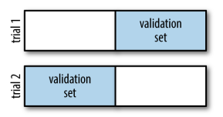

n-fold cross-validation
a = sklearn.model_selection.cross_val_score(md, X, y, cv=5) ndarray of 5 score-values
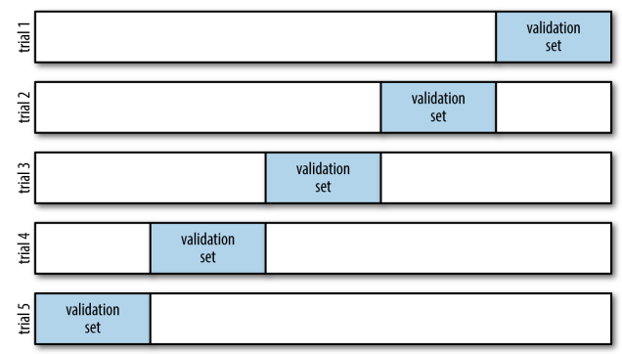

leave-one-out cross-validation
from sklearn.model_selection import LeaveOneOut
a = sklearn.model_selection.cross_val_score(md, X, y, cv=LeaveOneOut(len(X)))
μ = a.mean()

by default sklearn.model_selection.cross_val_score implements stratified k-fold cross-validation if the target array indicates a classification problem, but it implements non-stratifed k-fold cross-validation on a regression task.

If you need to implement non-stratifed k-fold cross-validation on a classification problem (bad idea) use sklearn.model_selection.KFold(n_splits=n):

ShuffleSplit, StratifiedKFold, StratifiedShuffleSplit
import numpy
from sklearn.model_selection import ShuffleSplit, StratifiedKFold, StratifiedShuffleSplit

#data
X = numpy.array(tuple(range(1,11))*2, dtype=numpy.uint8).reshape(-1,10).T
y = numpy.array([0,1,2]*3+[0,], dtype=numpy.uint8)

#non-stratified split (just shuffled)
g = ShuffleSplit(n_splits=3, test_size=0.3).split(X)
nx = list(g) # length = 3, pairs of tarin / test indeces
nx_train, nx_test = nx[0] # train and test indeces of the firts split

for nx_train, nx_test in nx:
print(numpy.c_[X[nx_train], y[nx_train, numpy.newaxis]], end="\n")
print(numpy.c_[X[nx_test], y[nx_test, numpy.newaxis]], end="\n"*2)
else: print("-"*50)

#stratified split with k folds (not shuffled)
g = StratifiedKFold(n_splits=3).split(X,y)
nx = list(g) # length = 3, pairs of tarin / test indeces

for nx_train, nx_test in nx:
print(numpy.c_[X[nx_train], y[nx_train, numpy.newaxis]], end="\n")
print(numpy.c_[X[nx_test], y[nx_test, numpy.newaxis]], end="\n"*2)
else: print("-"*50)

#stratified and shuffled split with k folds
g = StratifiedShuffleSplit(n_splits=3, test_size=0.3).split(X,y)
nx = list(g) # length = 3, pairs of tarin / test indeces

for nx_train, nx_test in nx:
print(numpy.c_[X[nx_train], y[nx_train, numpy.newaxis]], end="\n")
print(numpy.c_[X[nx_test], y[nx_test, numpy.newaxis]], end="\n"*2)

non-stratified classification cross validation
cv = sklearn.model_selection.KFold(n_splits=5)
scores = sklearn.model_selection.cross_val_score(MD, X,y, cv=cv)

shuffle the data instead of stratifying it
cv = sklearn.model_selection.KFold(n_splits=3, shuffle=True, random_state=0)
scores = sklearn.model_selection.cross_val_score(MD, X,y, cv=cv)

leave one out
cv = sklearn.model_selection.LeaveOneOut()
scores = sklearn.model_selection.cross_val_score(MD, X,y, cv=cv)
score = scores.mean()

shuffle-split cross-validation
cv = sklearn.model_selection.ShuffleSplit(test_size=.5, train_size=.5, n_splits=10)
scores = sklearn.model_selection.cross_val_score(MD, X,y, cv=cv)
score = scores.mean()
you can use integers for train_size and test_size to use absolute sizes for these sets, or floating-point numbers to use fractions of the whole dataset

stratified shuffle-split cross-validation
cv = sklearn.model_selection.StratifiedShuffleSplit(test_size=100, train_size=10, n_splits=3)
scores = sklearn.model_selection.cross_val_score(MD, X,y, cv=cv)
score = scores.mean()

cross-validation with groups
cv = sklearn.model_selection.GroupKFold(n_splits=2)
scores = sklearn.model_selection.cross_val_score(md, X,y, groups=[1,1,2,2,3,3,3], cv=cv)
score = scores.mean()

implementing cross-validation
import numpy, itertools
from sklearn.model_selection import ShuffleSplit, StratifiedKFold, StratifiedShuffleSplit
from sklearn.linear_model import LogisticRegression
from sklearn.base import clone

def data():
X = numpy.array(tuple(itertools.product(range(10), range(10))), dtype='int16')
y = X.sum(axis=1)
y = y > numpy.percentile(y, 90)
X = X + numpy.random.randn(*X.shape)*5
return X, y.astype('uint8')

X,y = data()

g = StratifiedKFold(n_splits=5, shuffle=True).split(X,y)
model = LogisticRegression(fit_intercept=False, solver='liblinear')

for nx_train, nx_test in g:
Xtrain,ytrain = X[nx_train], y[nx_train]
Xtest,ytest = X[nx_test], y[nx_test]
accuracy = clone(model).fit(Xtrain, ytrain).score(Xtest, ytest); print(accuracy)

#mechanically equivelent to the above
cv = StratifiedKFold(n_splits=5, shuffle=True)
accuracies = cross_val_score(model, X,y, cv=cv, scoring="accuracy")

import pandas as pd
from collections import OrderedDict
import sklearn.model_selection
from sklearn.linear_model import LogisticRegression

person = [1,1,2,2,3,3,3]
pixel1 = [0,1,0,1,0,1,0]
pixel2 = [3,4,3,4,3,4,3]
pixel3 = [1,2,1,2,1,2,1]
emotion = ['smile','frown','smile','frown','smile','frown','smile']

d = OrderedDict([('person',person), ('pixel1',pixel1), ('pixel2',pixel2), ('pixel3',pixel3), ('emotion', emotion)])
df = pd.DataFrame(d, dtype='object')

X = df.iloc[:,1:4]
y, classes_names = pd.factorize(df['emotion'])

md = LogisticRegression()
cv = sklearn.model_selection.GroupKFold(n_splits=2)
scores = sklearn.model_selection.cross_val_score(md, X,y, groups=[1,1,2,2,3,3,3], cv=cv)
score = scores.mean()

scores on cross-validation / train / test sets
import numpy as np, math
from sklearn.linear_model import LinearRegression
from sklearn.model_selection import StratifiedShuffleSplit
from sklearn.model_selection import cross_val_predict, cross_val_score

#data
X = np.ones(shape=(12,2), dtype='i') * [100,10]
y = (X * sum([[[1,1]]*4, [[2,2]]*4, [[3,3]]*4], [])).sum(axis=1)

#split
g = StratifiedShuffleSplit(n_splits=1, test_size=0.25).split(X,y)
nx_train, nx_test = tuple(g)[0]
Xtrain,Xtest, ytrain,ytest = X[nx_train], X[nx_test], y[nx_train], y[nx_test]

#initialize the preferred model
md = LinearRegression() #at this stage the estimator must not necesserily be fitted

#fit (on kfolds in the train set), score and predict
scores_train = cross_val_score(md, Xtrain, ytrain, cv=3, scoring='r2') #clean fits and 3 accuracy-scores on 3 folds
ypred_train = cross_val_predict(md, Xtrain, ytrain, cv=3, method='predict') #clean fits and predictions on 3 folds

#fit (on the entire train set), score and predict
md.fit(Xtrain, ytrain)
score_train = md.score(Xtrain, ytrain)
ypred_train = md.predict(Xtrain) # this, in practice, may not have any use

#final score and prediction on the test set (remember: the test set mustnot be touched before this stage)
score_test = md.score(Xtest, ytest)
ypred_test = md.predict(Xtest) # overall fit and prediction on the tset set

#compare score_train and score_test (the percentage-values below are pretty arbitrary)
b = score_train > 0.98 and score_train/score_test > 1.25 # if score_train is much larger that means OVERFIT
b = score_train < .70 and math.isclose(score_train, score_test, abs_tol=0.03) # UNDERFIT

the same (but more consise) as above - for classification
from sklearn.neighbors import KNeighborsClassifier
from sklearn.model_selection import cross_val_predict, cross_val_score

knn = KNeighborsClassifier(n_neighbors=5)
accuracies_train = cross_val_score(knn, Xtrain,ytrain, cv=3, scoring='accuracy')
ypred_train = cross_val_predict(knn, Xtrain,ytrain, cv=3, method='predict')

knn.fit(Xtrain, ytrain)
accuracy_train = knn.score(Xtrain, ytrain)

accuracy_test = knn.score(Xtest, ytest)
ypred_test = knn.predict(Xtest)

cross_val_score(scoring=) and cross_val_predict(method=)
import numpy as np; custom_scoring_func=lambda model,X,ytrue:123
#DATA
X = np.arange(1,11).reshape(-1,1)
y = np.zeros(shape=len(X), dtype=np.uint8); y[[4, *range(6, len(X))]] = 1

#MODEL (just for demonstartion purposes it will be used as though it is a Linear model too)
from sklearn.linear_model import LogisticRegression
md = LogisticRegression(C=10, solver='liblinear') # note that at this stage the estimator doesn’t have to be fitted

#CROSS VALIDATION SCORE FOR CLASSIFICATION AND REGRESSION
from sklearn.model_selection import cross_val_score
accuracies = cross_val_score(md, X,y, cv=3, scoring='accuracy') #for classification
scores = cross_val_score(md, X,y, cv=3, scoring='r2') #for regression
scores = cross_val_score(md, X,y, cv=3, scoring='neg_mean_squared_error') #for regression
scores = cross_val_score(md, X,y, cv=3, scoring=custom_scoring_func)

#CROSS PREDICTION (CLEAN PREDICTION ON K-FOLDS)
from sklearn.model_selection import cross_val_predict
ypred = cross_val_predict(md, X,y, cv=3, method="predict") #method="predict" is the default
logit = cross_val_predict(md, X,y, cv=3, method="decision_function") # decision-function-scores
probs = cross_val_predict(md, X,y, cv=3, method="predict_proba")[:,-1] #probabilities

Grid-Search

different formats of param_grid dictionary/list
tr = Transformer(hp=3)
md = Model(hp1='type1', hp2=20, hp3=True)
pl = Pipeline([('tr',tr), ('md',md)])

#one set of settings
d = {'hp2':[10,20,30], 'hp3':[True,False]}
me = GridSearchCV(md, d, cv=5)

#different sets of settings
ld = [{'hp2':[10,20], 'hp3':[True]}, #try this set of settings...
{'hp2':[20,30], 'hp3':[False]}] #...and then this set of setting
me = GridSearchCV(md, ld, cv=5)

#different sets of settings for different solver/kernel
ld = [{'hp1':['type1'], 'hp2':[10,20,30]}, #try this set of settings...
{'hp1':['type2'], 'hp3':[False,True]}] #...and then this set of setting
me = GridSearchCV(md, ld, cv=5)

#when using a pipeline
d = {'tr__hp':[1,2,3], 'md__hp2':[10,20]}
me = GridSearchCV(pl, d, cv=5)

#different sets of settings (also for different solver/kernel) when using a pipeline
ld = [{'md__hp1':['type2'], 'md__hp2':[10,20,30]}, #try this set of settings...
{'tr__hp':[1,2]], 'md__hp2':[20,30], 'md__hp3':[False]}] #...and then this set of setting
me = GridSearchCV(md, ld, cv=5)
me.fit(Xtrain,ytrain)
d = me.cv_results_
df = pd.DataFrame(me.cv_results_)

grid search with cross-validation
import sklearn.model_selection, sklearn.svm
md = sklearn.svm.SVC()
d = {'C': [0.001, 0.01, 0.1, 1, 10, 100], 'gamma': [0.001, 0.01, 0.1, 1, 10, 100]} #param_grid
X_train, X_test, y_train, y_test = sklearn.model_selection.train_test_split(X, y, random_state=0)
me = sklearn.model_selection.GridSearchCV(md, d, cv=5) # me = meta-estimator
me.fit(X_train, y_train)
d = me.best_params_
d = me.cv_results_ # df = pd.DataFrame(me.cv_results_)
score = me.best_score_
md = me.best_estimator_
score = me.score(X_test, y_test)
score = md.score(X_test, y_test) #same

Similarly to cross_val_score, GridSearchCV uses stratified k-fold cross-validation by default for classification, and k-fold cross-validation for regression.

example
import numpy as np, matplotlib.pyplot as plt
import sklearn.pipeline
from sklearn.preprocessing import PolynomialFeatures
from sklearn.linear_model import LinearRegression
from sklearn.model_selection import GridSearchCV

def make_data(n=50):
from numpy.random import RandomState
RS = RandomState(1)
X = RS.rand(n, 1) ** 2
y = 10 - 1. / (X.ravel() + 0.1)
y += 1 * RS.randn(n) # 1 = error
return(X,y)

def Make_Pipeline(degree=1):
PL = sklearn.pipeline.make_pipeline(PolynomialFeatures(degree=degree), LinearRegression())
return PL

X, y = make_data(40)
X_test = np.linspace(*sorted(X.ravel())[::len(X)-1], 100)[:,None]

"""Grid Search meta-estimator"""
d = {'polynomialfeatures__degree': np.arange(21),
'linearregression__fit_intercept': [True, False],
'linearregression__normalize': [True, False]}

me = GridSearchCV(Make_Pipeline(), d, cv=7) # me = meta-estimator
me.fit(X,y)
d = me.best_params_

"""Get the best model from the meta-estimator"""
pl = me.best_estimator_ # pl = pipeline
pl = pl.fit(X,y)
y_pred = pl.predict(X_test)

"""Get the model itself from the best pipeline"""
md = pl.steps[1][1] # md = LinearRegression of degree 4 i.e. that takes in X of shape (m,4) / or rather (m,5)
#md.fit(X,y) # X must be of shape (m,5) : 4 columns + 1 column of ones (the first column)
#y_pred = md.predict(X)

#PLOT
%matplotlib inline
plt.scatter(X,y, marker='.')
plt.plot(X_test.ravel(), y_pred)
plt.plot(0,0,'.r');
print(d, pl, md, sep="\n\n")

pl = make_pipeline(StandardScaler(), LogisticRegression())
me = sklearn.model_selection.GridSearchCV(pl, param_grid=d, cv=5) # me = meta-estimator
me.fit(X_train, y_train)

#HOW sklearn.utils.resample FUNCTIONS
import numpy, pandas, sklearn; from sklearn import linear_model
X = numpy.arange(1,11, dtype=int).reshape(5,2)
y = X[:,0]*100
X,y = sklearn.utils.resample(X,y) # (re)sample of m observations done with replacement

#HOW TO GET THE WEIGHTS DEVIATIONS (SLOPE ERRORS)
X = numpy.arange(1,11, dtype=int).reshape(5,2)
y = X.sum(axis=1)*2
md = linear_model.LinearRegression(fit_intercept=True) # meaning: the bias column must be added
md.fit(X,y) # fit the entire dataset
sr = pandas.Series(md.coef_, index=["x1","x2"], name="weights")

slopes = list()
for i in range(100):
Xsample, ysample = sklearn.utils.resample(X,y) # samples from X,y (with replacement)
md.fit(Xsample, ysample)
weights = md.coef_
slopes.append(weights)

coefs_deviations = numpy.std(slopes, axis=0) # standard coefficient error (cell #2 in R)
df = pandas.DataFrame({"weights":sr, "deviations":coefs_deviations})

observations resampling with replacement
X,y = sklearn.utils.resample(X,y)

slope errors via bootstrap resampling
weights_errors = np.std([MD.fit(*sklearn.utils.resample(X,y)).coef_ for _ in range(100)], axis=0)

import numpy as np
np.set_printoptions(suppress=True, precision=2)
import sklearn.utils, sklearn.linear_model
a = np.arange(1,11)
X = np.array([a**0, a**1, a**2]).T
y = a**2 + 10 + np.random.standard_normal(size=len(X)) # add some noise
MD = sklearn.linear_model.LinearRegression().fit(X, y)
y_pred = MD.predict(X)
print(MD.coef_, y_pred)
l = []
for _ in range(100):
X_resample, y_resample = sklearn.utils.resample(X,y)
MD = sklearn.linear_model.LinearRegression().fit(X_resample, y_resample)
l.append(MD.coef_)
weights_errors = np.std(l, axis=0)
print(weights_errors)
#in one line
MD = sklearn.linear_model.LinearRegression()
weights_errors = np.std([MD.fit(*sklearn.utils.resample(X,y)).coef_ for _ in range(1000)], axis=0)
print(weights_errors)

same in R
a <- 1:10
df <- data.frame(feature0=a^0,
feature1=a^1,
feature2=a^2,
target=a^2+10 + rnorm(length(a)))
MD <- lm(target ~ feature0 + feature1 + feature2, data=df)
MD <- lm(target ~ ., data=df) #same
summary(MD)

grid search with cross validation
md = SVC()
ld = [ {'kernel': ['linear'], 'C': [0.001, 0.01, 0.1, 1, 10, 100]},
{'kernel': ['rbf'], 'C': [0.001, 0.01, 0.1, 1, 10, 100], 'gamma': [0.001, 0.01, 0.1, 1, 10, 100]},
{'kernel': ['poly'], 'degree': [2,3], 'C':np.logspace(-2,2,5, base=10)}]
me = GridSearchCV(md, ld, cv=5).fit(X,y) # X,y = must be train set ???
md = me.best_estimator_ # me = meta-estimator
d = me.best_params_
score = me.best_score_
cross validation
from sklearn.model_selection import cross_val_score, StratifiedShuffleSplit
scores = cross_val_score(md, X,y, cv=5) # stratified cv for classification - by default
cv = StratifiedShuffleSplit(n_splits=5, test_size=0.1) # stratify explicetly
scores = cross_val_score(md, X,y, cv=cv) # X,y = must be train set ???
Nested cross-validation
md = SVC()
ld = [ {'kernel': ['linear'], 'C': [0.001, 0.01, 0.1, 1, 10, 100]},
{'kernel': ['rbf'], 'C': [0.001, 0.01, 0.1, 1, 10, 100], 'gamma': [0.001, 0.01, 0.1, 1, 10, 100]},
{'kernel': ['poly'], 'degree': [2,3], 'C':np.logspace(-2,2,5, base=10)}]
me = GridSearchCV(md, ld, cv=5)
scores = cross_val_score(me, X,y, cv=5)
score = scores.mean()
The result of our nested cross-validation can be summarized as “SVC can achieve 98% mean cross-validation accuracy on the iris dataset”

RandomizedSearchCV
from sklearn.model_selection import RandomizedSearchCV; import scipy.stats
d = {'criterion':["gini","entropy"],
'max_depth':scipy.stats.randint(1,5), #uniform int
'max_leaf_nodes':scipy.stats.binom(n=20, p=0.5), #must have rvs()
'min_samples_leaf':scipy.stats.poisson(5), #must have rvs()
'min_impurity_decrease':scipy.stats.uniform(0,1)}

me = RandomizedSearchCV(md, param_distributions=d, cv=5)
me.fit(X,y)
d = me.best_params_
score = me.best_score_
md = me.best_estimator_
scores = me.cv_results_['mean_train_score']
demo on randomized grid-search
"""MAKE DATA"""
def makedata(n_blobs=5, n_points_in_each_blob=10):
import random; from numpy import vstack
l = [[],[],[]]
for blob in range(n_blobs):
[l[i].extend([random.gauss(mu, 0.5) for _ in range(n_points_in_each_blob)]) for i,mu in enumerate(random.randint(2,9) for _ in range(2))]
l[2].extend([blob]*n_points_in_each_blob)
X = vstack([*l[:2]]).T
return(X,l[2]) #l[2]=y

"""VIZUALIZE DATA"""
X,y = makedata()
import matplotlib.pyplot as plt
sp = plt.subplot()
sp.axis([0,10, 0,10])
sp.scatter(*X.T, marker='s', c=y, cmap=plt.cm.get_cmap('jet'))

"""DECISION TREE"""
from sklearn.tree import DecisionTreeClassifier
md = DecisionTreeClassifier(criterion='gini',
max_depth=3,
max_leaf_nodes=10,
min_samples_leaf=5,
min_samples_split=3,
min_impurity_decrease=0.1).fit(X,y)
score = md.score(X,y); print("DecisionTree score:", score)
ypred = md.predict(X)

"""RANDOMIZED SEARCH"""
from sklearn.model_selection import RandomizedSearchCV
import scipy.stats

d = {'criterion':["gini","entropy"],
'max_depth':scipy.stats.randint(1,5), #uniform int
'max_leaf_nodes':scipy.stats.binom(n=20, p=0.5),
'min_samples_leaf':scipy.stats.poisson(5),
'min_impurity_decrease':scipy.stats.uniform(0,1)}

me = RandomizedSearchCV(md, param_distributions=d, cv=5)
me.fit(X,y)

d = me.best_params_ ; print("best parameters", d)
score = me.best_score_ ; print("RandomizedSearch score:", score)
md = me.best_estimator_

scores = me.cv_results_['mean_train_score']

how to get the correct parameter names for param_grid
param_grid = {'transfromer__numericals__scaler__scale':[True,False]}
me = GridSearchCV(pl, param_grid=param_grid, cv=5)
l = list( pl.get_params().keys() ) # list of parameters, like 'transfromer__numericals__scaler'

Metrics for imbalanced classification datasets

same
y_pred = md.predict(X)
y_true = y
score = md.score(X,y) #same as:
score = accuracy_score(y_true, y_pred)

confusion matrix, heatmap (for classification)
mx = sklearn.metrics.confusion_matrix(y_true, y_pred) #2D ndarray
sns.heatmap(mx, square=True, annot=True, cbar=False, fmt='n', cmap=cm.Purples, ax=gca())
plt.xlabel('predicted') ; gca().set_ylabel('true')
fmt="%.3f"
Note that ytrue and ypred inputs for the confusion matrix come from either:
ypred_train = sklearn.model_selection.cross_val_predict(md, Xtrain, ytrain, cv=3, method='predict')
OR
ypred_test = md.predict(Xtest)

where
ytrue_train = ytrain
ytrue_test = ytest

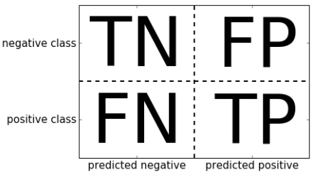

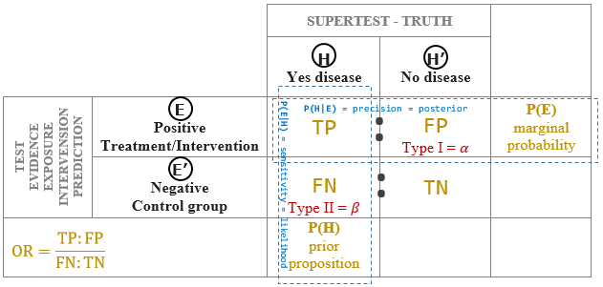

Imbalanced dataset metrics

DummyClassifier classifier is useful as a simple baseline to compare with other (real) classifiers.

sklearn.dummy.DummyClassifier
from sklearn.dummy import DummyClassifier
X = np.random.uniform(size=5).reshape(-1,1)
y = [0,0,0,1,1]

MD = DummyClassifier(strategy='most_frequent').fit(X,y)
y_pred = MD.predict(X) #[0 0 0 0 0]

MD = DummyClassifier(strategy='stratified').fit(X,y)
y_pred = MD.predict(X) #[1,0,1,0,0] random but follows the class distribution in the training set

MD = DummyClassifier(strategy='uniform').fit(X,y)
y_pred = MD.predict(X) #[0 1 0 1 0] absolutely random

from sklearn.metrics import confusion_matrix, accuracy_score, precision_score, recall_score, f1_score, classification_report
y_true, y_pred = [0,1,0,1], [0,0,1,1]
mx = confusion_matrix(y_true, y_pred)
accuracy = accuracy_score(y_true, y_pred)
precision = precision_score(y_true, y_pred)
sensitivity = recall_score(y_true, y_pred)
f = f1_score(y_true, y_pred)
s = classification_report(y_true, y_pred, target_names=["negatives", "positives"])

Note that ytrue and ypred inputs for the confusion matrix come from either:
ypred_train = sklearn.model_selection.cross_val_predict(md, Xtrain, ytrain, cv=3, method='predict')
OR
ypred_test = md.predict(Xtest)

where
ytrue_train = ytrain
ytrue_test = ytest

my code for:
from sklearn.metrics import accuracy_score, precision_score, recall_score, f1_score
class TestMetrics:
def __init__(self, *args:"matrix OR y_true, y_pred", **kwargs):
from numpy import ndarray, array, uint16
if len(args)==1:
mx = args[0]
if not isinstance(mx, ndarray):
mx = array(mx, dtype=uint16)
elif len(args)==2:
assert all(hasattr(o, '__iter__') for o in args) \
and len(args[0])==len(args[1]) \
and set(args[0]).union(args[1]) == {0,1}, "bad arguments"
l = list(zip(args[0], args[1]))
from collections import Counter
d = Counter(l)

from operator import itemgetter
l = [v for k,v in sorted(d.items(), key=itemgetter(0))]
mx = ndarray((2,2), dtype=uint16) # (2,2) = shape, filled with zeros
mx_temp = mx.ravel()
mx_temp[:] = l
else: raise ValueError("bad argumants")
#assert (mx.sum(0)==mx.sum(1)).all().__bool__(), "inconsistent matrix"
self.matrix = mx
self.TN = self[0,0] # the sklearn format
self.FP = self[0,1]
self.FN = self[1,0]
self.TP = self[1,1]

def __str__(self):
from re import compile
pt = compile(r"\[\[|\]\]|\]| \[")
s = pt.sub(r'|', self.matrix.__str__())
return s

def __repr__(self):
return self.__str__()

def __getitem__(self, ix):
if isinstance(ix, int):
return int(self.matrix.ravel()[ix-1])
elif hasattr(ix, '__iter__') and len(ix)==2:
return int(self.matrix[ix])
else: raise TypeError("bad index")

def _assign_the_four_working_values(self):
from operator import itemgetter # returns FN, FP, TN, TP (they are in alphabetical order)
g = (v for k,v in sorted(self.__dict__.items(), key=itemgetter(0)) if k in ("TP","FP","FN","TN"))
return g

@property
def accuracy_score(self):
FN, FP, TN, TP = self._assign_the_four_working_values()
score = (TP+TN) / (TP+TN+FP+FN)
return score

@property
def precision(self):
FN, FP, TN, TP = self._assign_the_four_working_values()
posterior = TP / (TP + FP)
return posterior

@property
def sensitivity(self):
FN, FP, TN, TP = self._assign_the_four_working_values()
recall = TP / (TP + FN)
return recall

@property
def f_measure(self):
FN, FP, TN, TP = self._assign_the_four_working_values()
p,s = self.precision, self.sensitivity
f = (p*s) / (p+s) * 2
return f

def print_summary(TestMetrics_object):
o = TestMetrics_object
print("\nSummary:")
print("accuracy acore =", o.accuracy_score)
print("precision =", o.precision)
print("sensitivity =", o.sensitivity)
print("F-measure =", o.f_measure)
print()

#########################################################################################

mx = [[401,2],
[8,39]]
mx = TestMetrics(mx)
print(mx)
print_summary(mx)

y_true, y_pred = [0,1,0,1,0], [0,0,1,1,1]
test = TestMetrics(y_true, y_pred)
print_summary(test)

#compare your code with sklearn:
from sklearn.metrics import accuracy_score, precision_score, recall_score, f1_score
score = accuracy_score(y_true, y_pred); print("accuracy score =", score)
precision = precision_score(y_true, y_pred); print("precision =", precision)
sensitivity = recall_score(y_true, y_pred); print("sensitivity =", sensitivity)
f = f1_score(y_true, y_pred); print("F-measure =", f)

Information Entropy

information entropy of a distribution
H = scipy.stats.entropy([0.5, 0.3, 0.2], base=2)
[0.5, 0.3, 0.2] = the probabilities of three values

import scipy.stats
H = scipy.stats.entropy([0.5, 0.3, 0.2], base=2)

def entropy(a):
assert hasattr(a, '__iter__'), "bad argument"
from math import log2 as log
a = list(a) if not isinstance(a, list) else a
unique_values = frozenset(a)
n = len(a)
pp = (a.count(v)/n for v in unique_values)
E = -sum(p * log(p) for p in pp)
return E

def information_gain(a,f): # a = discreet vector; f = factor vector to partition a on
assert all(hasattr(o, '__iter__') for o in (a,f)) and len(a)==len(f), "bad arguments"
n = len(a)
E = entropy(a)
partitions = ([x1 for x1,x2 in zip(a,f) if x2==v] for v in set(f))
weighted_average_of_entropies_partitioned = sum(entropy(a)*(len(a)/n) for a in partitions)
I = E - weighted_average_of_entropies_partitioned
return(I)

a = (1,2,3,1,2,3,3)
f = (0,1,0,1,0,1,1)
E = entropy(a) ;print(E)
I = information_gain(a,f) ;print(I)

demo on manipulating recall and precision by moving the threshold for the probabilities returned by the decision function
from sklearn.metrics import precision_score, recall_score, f1_score

ytrue = [0]*90 + [ 0, 0, 0, 0, 0, 1, 1, 1, 1, 1]
probs = [0]*90 + [0.05, 0.1, 0.2, 0.3, 0.4, 0.5, 0.6, 0.7, 0.8, 0.9]
threshold = 0.5 # experiment with p=0.3 (e.g cancer), p=0.8 (e.g. content suitable for kids)
ypred = [1 if p >= threshold else 0 for p in probs]

precision = precision_score(ytrue, ypred)
recall = recall_score(ytrue, ypred)
F1 = f1_score(ytrue,ypred)
print(precision, recall, F1)

a classifier with a movable threshold
import numpy as np; np.set_printoptions(suppress=True, precision=6)
#MAKE DATA
lt = list(__import__('itertools').product([0,1], [1,2,3])); lt = lt + lt[:4]
X = np.array(lt) # x1 = hightened heartbeat; x2 = body temperature
mu = X.sum(1).mean() # threshold
y = ytrue = X.sum(1) > mu # y = has desease

from sklearn.naive_bayes import GaussianNB
class BinaryClassifierWithThreshold(GaussianNB):
def __init__(self, threshold=0.5):
self.threshold = threshold
super().__init__()

def predict(self, X, y=None, *args, **kwargs):
probs = self.predict_proba(X)[:,-1]
ypred = probs > self.threshold
return ypred

def print_metrics(self, X, y:"y-true"):
from sklearn.metrics import recall_score, precision_score, f1_score
ytrue, ypred = y, self.predict(X)
self.accuracy = self.score(X,y)
self.recall, self.precision, self.F1 = (f(ytrue, ypred) for f in (recall_score, precision_score, f1_score))
d = self.__dict__
l = "accuracy|recall|precision|F1".split('|')
s = f"Metrics for threshold {self.threshold}:\n"
g = ("{0:}: {1:.2f}\n".format(s, d[s]) for s in l)
s += str.join('', g)
print(s); return(s)

#THRESHOLD 50/50
md = BinaryClassifierWithThreshold()
md.fit(X,y)
ypred = md.predict(X)
md.print_metrics(X,ytrue)

#THRESHOLD 20% (e.g. cancer test)
md.set_params(threshold=0.2).fit(X,y)
ypred = md.predict(X)
md.print_metrics(X,ytrue)

#THRESHOLD 0.996 (e.g. cancer test)
md = BinaryClassifierWithThreshold(threshold=0.996).fit(X,y)
ypred = md.predict(X)
md.print_metrics(X,ytrue)

demo on decision function
import numpy as np

#DATA
X = np.arange(1,11).reshape(-1,1)
y = np.zeros(shape=len(X), dtype=bool); y[[4, *range(6,10)]] = True
ytrue = y

#MODEL
from sklearn.linear_model import LogisticRegression
md = LogisticRegression(solver='liblinear', C=10).fit(X,y)
ypred = md.predict(X)
logits = md.decision_function(X)
probs = md.predict_proba(X)[:,-1].round(2)

#VERIFY LOGITS AND PROBABILITIES MANUALLY
β0,β1 = md.intercept_[0].tolist(), md.coef_[0,0].tolist()
logits = n = β0 + β1 * X.ravel() #same as above
ypred = logits > 0 #same as above

e = np.exp(1)
probs = 1 / (1 + e**-n) #same as above
ypred = probs > 0.5 #same as above
ypred = probs > 0.25 #use a different threshold

#METRICS
TP = (ytrue & ypred).sum()
TN = (~ytrue & ~ypred).sum()
FP = (~ytrue & ypred).sum()
FN = (ytrue & ~ypred).sum()

accuracy = (ytrue==ypred).sum() / len(y)
recall = TP / (TP+FN)
precision = TP / (TP+FP)

PR-curve, ROC-curve
import numpy as np; import matplotlib.pyplot as plt; plt.style.use("seaborn")
#DATA
X = np.arange(1,11).reshape(-1,1)
y = np.zeros(shape=len(X), dtype=bool)
y[[2,4, 6,7,8,9]] = True
X = np.vstack([X, *(X+f for f in np.linspace(0.1, 1, 20, endpoint=False))])
ytrue = y = list(y)*21

#MODEL
from sklearn.linear_model import LogisticRegression
md = LogisticRegression(solver='liblinear', C=10).fit(X,y)

#PRECISION bzw. RECALL VS THRESHOLD CURVES
from sklearn.model_selection import cross_val_predict
from sklearn.metrics import precision_recall_curve

#based on logits (i.e. decision function scores)
logits = cross_val_predict(md, X,ytrue, cv=3, method="decision_function")
precisions, recalls, thresholds = precision_recall_curve(ytrue, logits)
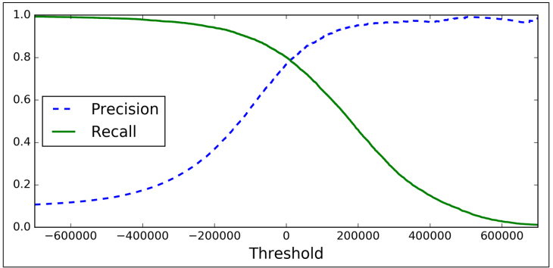
precisions = precisions[:-1]
recalls = recalls[:-1]

#plot
fig = plt.figure(figsize=(10,10))
sp = fig.add_subplot(221)
sp.plot(thresholds, precisions, 'blue', label="precision")
sp.plot(thresholds, recalls, 'red', label="recall")
sp.legend()

#based on probabilities
probs = cross_val_predict(md, X,ytrue, cv=3, method="predict_proba")[:,-1]
precisions, recalls, thresholds = precision_recall_curve(ytrue, probs)
precisions = precisions[:-1]
recalls = recalls[:-1]

#plot
sp = fig.add_subplot(222, sharey=sp)
sp.plot(thresholds, precisions, 'blue', label="precision")
sp.plot(thresholds, recalls, 'red', label="recall")
sp.legend()

#PRECISION VS RECALL CURVE aka PR CURVE (when dataset classes are imbalanced)
sp = fig.add_subplot(223)
sp.plot(recalls, precisions, 'm', label="recall vs precision")
sp.set(title="PR curve", xlabel="recall", ylabel="precision", xlim=fig.get_axes()[1].get_xlim())

#ROC-curve (when dataset classes are balanced)
from sklearn.metrics import roc_curve
FPR, TPR, thresholds = roc_curve(ytrue, logits)
FPR, TPR, thresholds = roc_curve(ytrue, probs) #same

sp = fig.add_subplot(224)
sp.plot(FPR, TPR); sp.plot([0,1],[0,1], 'k--', lw=0.5)
sp.set(title="ROC", xlabel="False Positive Rate", ylabel="True Positive Rate")

#AUC
from sklearn.metrics import roc_auc_score
AUC = roc_auc_score(ytrue, logits)
AUC = roc_auc_score(ytrue, probs) #same
sp.text(0.5, 0.5, f"AUC = {round(AUC,2)}", size=12, ha='center')

note these details about the confusion matrix
from sklearn.metrics import confusion_matrix
mx = confusion_matrix(ytrue, ypred)
TRUE = mx.diagonal().sum() # all predicted correctly
accuracy = mx.diagonal().sum() / mx.sum()
mx.sum(axis=1) == np.bincount(y_train)

Note that ytrue and ypred inputs for the confusion matrix come from either:
ypred_train = sklearn.model_selection.cross_val_predict(md, Xtrain, ytrain, cv=3, method='predict')
OR
ypred_test = md.predict(Xtest)

where
ytrue_train = ytrain
ytrue_test = ytest

misclassification rates matrix (confusion matrix)
import numpy, seaborn
numpy.random.seed(1); __import__('random').seed(1)

#MAKE fake ytrue, ypred
ytrue = [0,1,2,3,4] * 300
__import__('random').shuffle(ytrue)
nx = numpy.random.permutation(len(ytrue))[:int(len(ytrue)*0.25)]
ytrue = numpy.array(ytrue, dtype='int8')
ypred = ytrue.copy()
ytrue[nx], ypred[-nx] = ytrue[-nx], ypred[nx]

#get confusion matrix
from sklearn.metrics import confusion_matrix
mx = confusion_matrix(ytrue, ypred); print(mx)

#make misclassification matrix out of the confusion matrix
totals = mx.sum(axis=1, keepdims=True)
mx = mx / totals ; mx = mx.round(2)
numpy.fill_diagonal(mx, 0); print(mx)

#find the worst rate
ix = mx.argmax()
r,c = divmod(ix, mx.shape[0])
nx = r,c
theworstrate = mx[nx]

#vizualize
from matplotlib.pyplot import matshow, show, title, xlabel, ylabel, figure
matshow(mx, cmap='gray_r') # blck = bad white = good
title("misclasification rates matrix"); xlabel("PREDICTED"); ylabel("ACTUAL")

figure() # creates a new figure in order to place the following plot on it
seaborn.heatmap(mx, annot=True, cmap='viridis_r', cbar=False, square=True)
title("misclasification rates matrix"); xlabel("PREDICTED"); ylabel("ACTUAL")

average precision
from sklearn.metrics import average_precision_score
probs = md.predict_proba(Xtest)[:,1]
average_precision = average_precision_score(ytrue, probs)
scores = md.decision_function(Xtest)
average_precision = average_precision_score(ytrue, scores)

f-score for multiclass
from sklearn.metrics import f1_score, classification_report
ytrue = [0,0,0,0,1,1,1,2,2]
ypred = [0,0,0,1,1,1,2,2,1]

f1 = f1_score(ytrue, ypred, average="micro") # if you care about each sample equally much
f1 = f1_score(ytrue, ypred, average="macro") # if you care about each class equally much*
f1 = f1_score(ytrue, ypred, average="weighted") # in multilabel classification use ‘macro’ or ‘weighted’
s = classification_report(ytrue, ypred)

grid-search and cross-validation for an imbalanced binary dataset
Xtrian, Xtest = imbalanced binary classification data; must be split by stratification!

#model
model = LogisticRegression(max_iter=1000)
d = dict(C=[0.001, 0.1, 1, 10], solver=['liblinear','saga'], penalty=['l2','l1'])

#accuracy = bad for imbalanced data
me = GridSearchCV(model, param_grid=d, scoring='accuracy', cv=3)
md = me.fit(Xtrain, ytrain).best_estimator_
accuracies = cross_val_score(md, Xtrain, ytrain, scoring='accuracy', cv=3)

#AUC (area under the ROC-curve) = good for imbalanced data
me = GridSearchCV(model, param_grid=d, scoring='roc_auc', cv=3)
md = me.fit(Xtrain, ytrain).best_estimator_
AUCs = cross_val_score(md, Xtrain, ytrain, scoring='roc_auc', cv=3)

#AP = area under the PR-curve
me = GridSearchCV(model, param_grid=d, scoring='average_precision', cv=3)
md = me.fit(Xtrain, ytrain).best_estimator_
APs = cross_val_score(md, Xtrain, ytrain, scoring='average_precision', cv=3)

#final evaluation
from sklearn.metrics import accuracy_score, recall_score, precision_score
ytrue = ytest
ppred = md.predict_proba(Xtest)[:,-1]
ypred = ppred >= 0.45 #arbitrary or calculated threshold

accuracy = accuracy_score(ytrue, ypred)
recall = recall_score(ytrue, ypred)
precision = precision_score(ytrue, ypred)

Validation & Learning Curves

Validation vs Learning Curves

Validation curve is the function of model complexity (e.g. polynomial degree, regularization term etc.)
Learning curve is the function of the number of data-points.
Both graphs have actually two curves: training curve and validation set curve

poly = PolynomialFeatures(degree=1)
md = LinearRegression(normalize=True)
pl = make_pipeline(poly, md)
degrees = range(2,11)
from sklearn.model_selection import validation_curve
training_scores, validation_scores = validation_curve(pl, X,y, scoring="r2",
param_name="polynomialfeatures__degree", param_range=degrees, cv=3)
training_scores, validation_scores = (mx.median(axis=1) for mx in (training_scores, validation_scores))

n_datapoints, training_scores, validation_scores = learning_curve(md, X,y,
train_sizes=np.linspace(0.1,1, 10), cv=7)
plt.plot(dataset_sizes, trainingset_scores.mean(1), ‘b’, dataset_sizes, validationset_scores.mean(axis=1), ‘r’)

Bias vs Variance

too simple a model = High bias = underfitting
too complex a model = High variance = overfitting

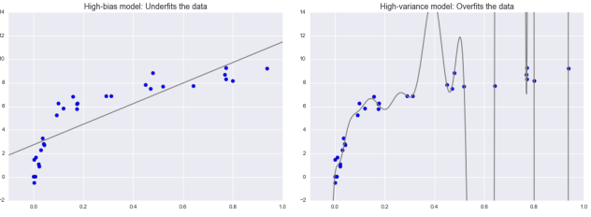
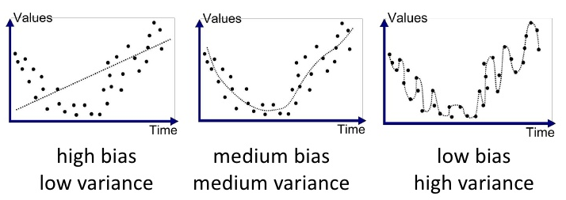

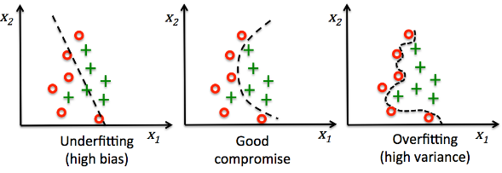

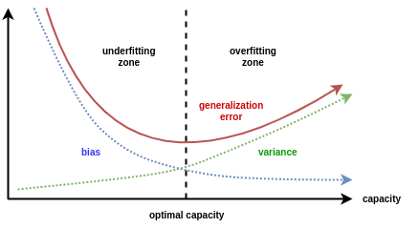

Coefficients plot
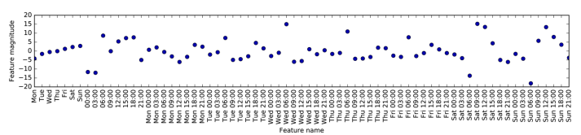
import numpy as np, pandas as pd
import matplotlib.pyplot as plt
np.set_printoptions(suppress=True, precision=4)
n = 100
np.random.seed(0)
salaries = np.random.randint(800, 5000, size=n)
salaries += np.random.normal(0, salaries.std(), size=n).astype('i')
bonus_payments = salaries // 100
bonus_payments += np.random.normal(0, bonus_payments.std()//2, size=n).astype('i')
from operator import sub
experience_years = [int((salaries[i] - min(salaries)) / -sub(*sorted(salaries)[::len(salaries) - 1]) * 30) for i in
range(len(salaries))]
experience_years = np.array(experience_years, dtype='i')
years_born = np.random.randint(1950, 1980, size=n)
education_levels = [int((salaries[i] - min(salaries)) / -sub(*sorted(salaries)[::len(salaries) - 1]) * 2) + 1 for i in
range(len(salaries))]
education_levels = np.array(education_levels, dtype='i')
genders = nd = np.random.binomial(n=1, p=0.5, size=n)
y = 120 * bonus_payments + 200 * experience_years + 1500 * education_levels + 1000 * genders + 1.05 * years_born - 1900 # FORMULA
y = y.round(-2).astype('i') + np.random.normal(0, 2000, size=n).astype('i')
from collections import OrderedDict
d = OrderedDict([
('experience', experience_years),
('education', education_levels),
('yearborn', years_born),
('bonus', bonus_payments),
('sex', genders),
('salary', y)])
df = pd.DataFrame(d)
df['education'] = df['education'].astype('category')
df['sex'] = df['sex'].astype('category')
print(df.head())
df = pd.get_dummies(df)
print(df.head())
X = df.drop('salary', axis=1).values
y = df['salary'].values
fnames = df.drop('salary', axis=1).columns.values
from sklearn.linear_model import LinearRegression, Ridge, Lasso
fig,sp = plt.subplots(figsize=(10,6), gridspec_kw=dict(wspace=0.005, hspace=0.0055))
fig.subplots_adjust(wspace=0.005, hspace=0.005, left=0.06)
for md in (LinearRegression(), Ridge(), Lasso()):
md = md.fit(X,y)
weights = md.coef_
print(weights)
sp.plot(weights, 'o', label="{} $R^2=${}".format(md.__class__.__name__, md.score(X,y).round(2)))
sp.axhline(0, color='gray', linewidth=0.5, linestyle='--')
plt.xticks(range(len(fnames)), fnames, rotation=45, fontsize='small', ha='right')
sp.legend(loc=(1.01, 0), fontsize=9)
plt.show()

Validation curve = changing a hyperparameter (incl. degree of regression)
Learning curve = adding more data points
Grid Search = change multiple hyperparameters (dataset size remains static)

Validation curve

import numpy as np; np.set_printoptions(suppress=True, precision=4, linewidth=250)
from pylab import show, semilogx, legend; import seaborn; seaborn.set()
from sklearn.svm import SVC
from sklearn.datasets import load_iris
d = load_iris() ; X,y = d.data, d.target
import sklearn.model_selection
sklearn.model_selection.validation_curve ; sklearn.model_selection.learning_curve
r = np.logspace(start=-2, stop=2, num=4, endpoint=True, base=10.0, dtype='f')
print(r)
train_scores, val_scores = sklearn.model_selection.validation_curve(SVC(), X,y, param_name="gamma", param_range=r, cv=5)
print(val_scores.shape, val_scores, sep="\n\n", end="\n\n") #(4, 5) = 4 gamma values x 5 folds
train_scores, val_scores = (np.median(nd, axis=1) for nd in (train_scores, val_scores))
print(val_scores) #(4,)
Y = np.array([train_scores,val_scores]).T
legend(semilogx(r, Y), ['training scores','validation scores'], frameon=True); # l = semilogx(r, Y) (2 in 1 line)
show()
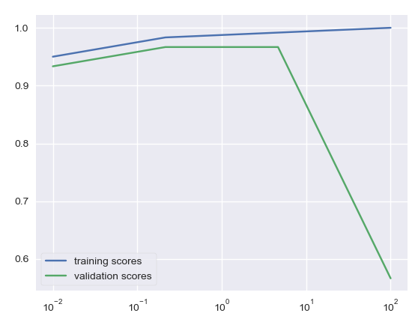

sklearn.model_selection.validation_curve
train_scores, val_scores = sklearn.model_selection.validation_curve(SVC(), X,y,
param_name="gamma", param_range=[0.001, 0.01, 0.1, 1, 5], cv=5)

Learning Curve

sklearn.model_selection.learning_curve
n_datapoints, training_scores, validation_scores = learning_curve(md, X,y,
train_sizes=np.linspace(0.1,1, 10), cv=7)

plt.plot(dataset_sizes, trainingset_scores.mean(1), ‘b’, dataset_sizes, validationset_scores.mean(axis=1), ‘r’)

Probabilities of predictions

Estimates and probabilities of predictions

There are two different functions in scikit-learn that can be used to obtain uncertainty estimates from classifiers: decision_function and predict_proba

The output of predict_proba is a probability for each class, and is often more easily understood than the output of decision_function

a = MD.decision_function(X) #negatives = less than .50 positives = greater .50
pp = 1 / (1 + np.exp(-a)) #put them through the Logistic Activation function to get the probabilities

mx = MD.predict_proba(X) #m x n matrix with probabilities. n = number of classes
a = MD.decision_function(X) #put these values through the Logistic Activation Function
pp = 1 / (1 + np.exp(-a)) #probabilities
pp == mx[:,1] #all True

A model that is more overfitted tends to make more certain predictions, even if they might be wrong. A model with less complexity usually has more uncertainty in its predictions

overfitted model = higher probabilities (although not neceserily correct)
less complex model = lower probabilities

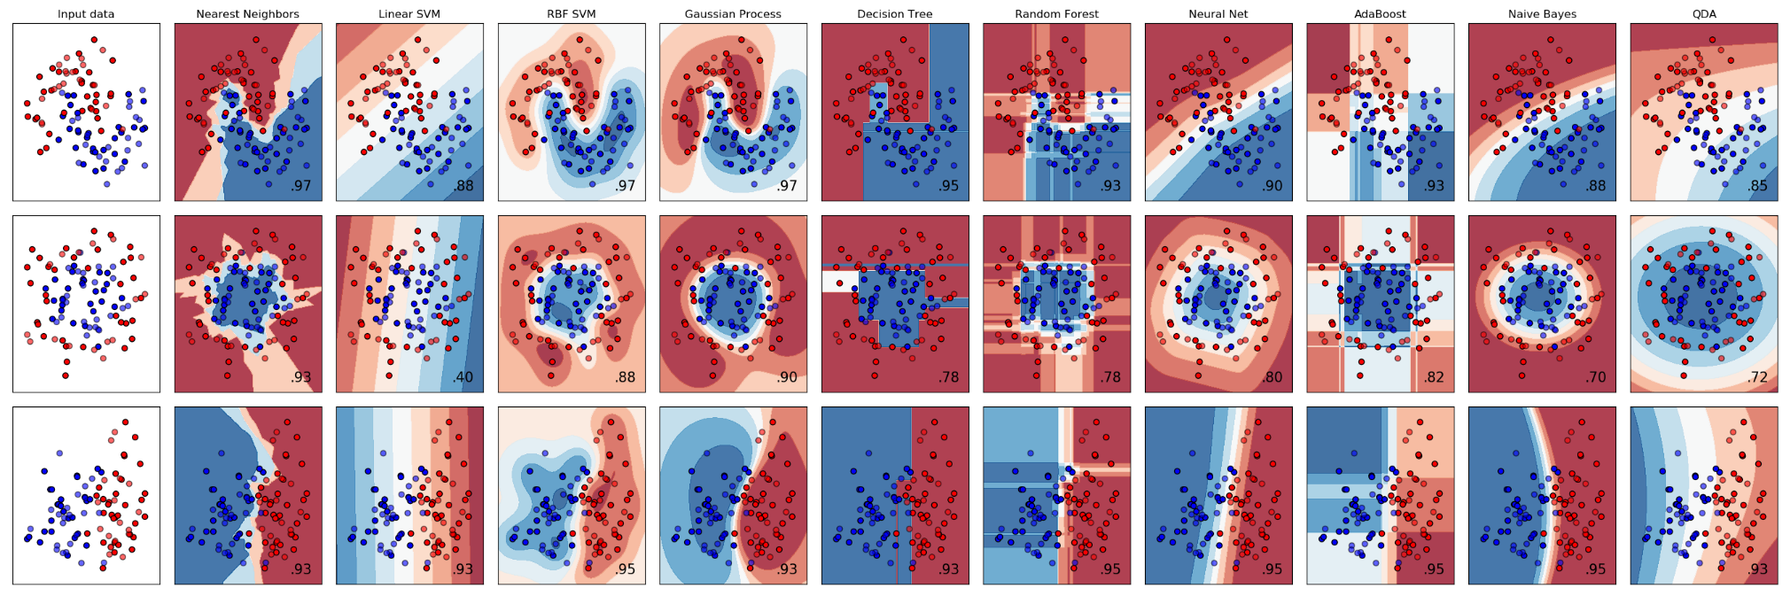
comparison of models and what their uncertainty estimates look like

mx = MD.decision_function(X)
mx = MD.predict_proba(X)
mx = MD.predict_log_proba(X)
the shape of mx is m by n where m = number of samples, n = number of features

nx = np.argmax(mx, axis=1)
nx = array of predicted labels

np.exp(MD.predict_log_proba(X)) == MD.predict_proba(X)

classification_report & confusion_matrix
ytrue = [0,1,2,0,1,2,0,1,2,0,1,2]
ypred = [0,1,1,0,1,1,0,1,1,0,1,2]
s = sklearn.metrics.classification_report(ytrue, ypred, target_names=['ClassA','ClassB','ClassC'])
mx = sklearn.metrics.confusion_matrix(ytrue, ypred)
sp = seaborn.heatmap(mx, square=True, annot=True, fmt='d', cbar=False,
xticklabels=['ClassA','ClassB','ClassC'], yticklabels=['ClassA','ClassB','ClassC'])
sp.set(xlabel="PREDICTED", ylabel="TRUE")

Note that ytrue and ypred inputs for the confusion matrix come from either:
ypred_train = sklearn.model_selection.cross_val_predict(md, Xtrain, ytrain, cv=3, method='predict')
OR
ypred_test = md.predict(Xtest)

where
ytrue_train = ytrain
ytrue_test = ytest

CLASSIFICATION

OvR vs OvO
def makedata(n_classes=3, scale=False):
from numpy import array, linspace, digitize; from numpy.random import permutation
from itertools import product
X = array(tuple(product(range(0,10), range(0,10))), dtype='int8')
z = (X*[0.5, 2]).sum(1)-10 #immitate linear relationship with x0=-10, x1=0.5, x2=2
y = labels = digitize(z, bins=linspace(min(z), max(z)+0.1, n_classes+1)) - 1 #classes = {0,1,2,3}
nx = permutation(len(y))
X,y = (nd[nx] for nd in (X,y))
if scale:
from sklearn.preprocessing import StandardScaler
sc = StandardScaler().fit(X.astype('float32'))
makedata.scaler = sc
X = sc.transform(X)
return(X, y)
#==========================================================================

X,y = makedata(4, scale=True) # 4 classes

from sklearn.linear_model import SGDClassifier
from sklearn.multiclass import OneVsRestClassifier, OneVsOneClassifier

lgr = SGDClassifier(loss='log', tol=1e-3, max_iter=1e5) # logistic regression (regularized, OvR)
svm = SGDClassifier(loss='hinge', tol=1e-3, max_iter=1e5) # a linear SVM (OvO in theroy, OvR in reality)

ovr = OneVsRestClassifier(lgr).fit(X,y) # remember that you must use Xtrain to fit a model
ovo = OneVsOneClassifier(svm).fit(X,y)

l = ovr.estimators_ # [4 estimators]
l = ovo.estimators_ # [6 estimators] = 4(4-1)/2

Ypred = ovr.predict_proba(X) # (m,4) matrix of propabilities
Ypred = ovr.decision_function(X) # (m,4) matrix of scores-z
Ypred = ovo.decision_function(X) # (m,4) matrix of SVM-scores

Multilabel Classification with KNeighbors
def make_2D_clusters(n_clusters_per_row=2, n_clusters_per_column=3, n_points_per_cluster=100, xlim=10, ylim=6):
"""make 2D data for multilabel classification"""
from itertools import product; from random import shuffle
from numpy import array, linspace; from numpy.random import normal, uniform, permutation
m = n_points_per_cluster
classes = list(product(range(n_clusters_per_row), range(n_clusters_per_column)))
shuffle(classes)

vertical_centers, vertical_step = linspace(0, ylim, n_clusters_per_row+2, retstep=True)
horizontal_centers, horizontal_step = linspace(0, xlim, n_clusters_per_column+2, retstep=True)
horizontal_centers, vertical_centers = (a[1:-1] for a in (horizontal_centers, vertical_centers))

leeway = min(horizontal_step, vertical_step) / 2

centers = array(list(product(horizontal_centers, vertical_centers)), dtype='f')
errors = uniform(low=-leeway, high=leeway, size=centers.shape)
centers += errors

pn = normal(loc=0, scale=leeway/2, size=(len(centers), m, 2))
pn += centers[:,None]
X = pn.reshape(-1,2)

y = sum([[label]*m for label in classes],[])

#make single integer labels for colors
S = {hash(t) for t in y}
hashes = sorted(S)
color_labels = [hashes.index(hash(t)) for t in y]

#convert to ndarrays
y = array(y, dtype='int8')
color_labels = array(color_labels, dtype='int8')

#shuffle
nx = permutation(len(y))
X,y,color_labels = (nd[nx] for nd in (X,y,color_labels))

make_2D_clusters.labels = color_labels
make_2D_clusters.xlim, make_2D_clusters.ylim = xlim,ylim

return(X,y)

def encode_multiclass_labels_into_single_digit_labels(y):
l = [tuple(e) for e in y]
S = {hash(y) for y in l}
hashes = tuple(sorted(S))
labels = [hashes.index(hash(e)) for e in l]
return labels
#===========================================================================

X,y = make_2D_clusters()

#PLOT
import matplotlib.pyplot as plt
sp = plt.subplot()
color_labels = encode_multiclass_labels_into_single_digit_labels(y)
sp.scatter(*X.T, c=color_labels, s=40)

#MODEL
from sklearn.neighbors import KNeighborsClassifier
md = KNeighborsClassifier(n_neighbors=5).fit(X,y)
ypred = md.predict(X)

accuracy = ((y==ypred).sum(1)==2).sum() / len(y)
print(accuracy)

#PREDICT
Xtest, _ = make_2D_clusters(2,3, 50)
ytest_pred = md.predict(Xtest)

color_labels = encode_multiclass_labels_into_single_digit_labels(ytest_pred)
sp.scatter(*Xtest.T, c=color_labels, edgecolor='k')

KNN

KNN Classification

KNN Regression

KNeighborsRegressor
md = sklearn.neighbors.KNeighborsRegressor(n_neighbors=3).fit(X,y)
y_pred = md.predict(X_test)
R2 = md.score(X_test, y_test) # R-squared
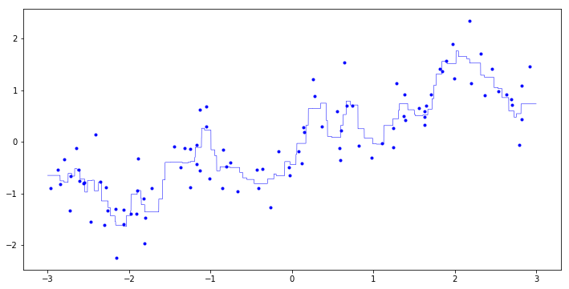

Using knn is a good baseline method to try before considering more advanced techniques.
However it does not perform well on datasets with many features (hundreds or more), and it does particularly badly with datasets where most features are 0 most of the time (so-called sparse datasets).

C vs alpha
The main parameter of linear models is the regularization parameter, called alpha in the regression models and C in LinearSVC and LogisticRegression. Large values for alpha or small values for C mean simple models.
Usually C and alpha are searched for on a logarithmic scale.
what about gamma (e.g. in SVC)?

simpler model:
LARGE SMALL
alpha=1000 C=0.001

Polynomial transformation of the input matrix as input into a multidimentional linear regression model (aka basis function regression) is akin to kernel functions in SVM models.

KMEANS

colour compression with mini-batch k-means (discretization of colors into only 16 distinct colors)
import sklearn.datasets, sklearn.cluster, matplotlib.pyplot as plt
pn = sklearn.datasets.load_sample_image("china.jpg")
X = pn.reshape(-1,3)

md = sklearn.cluster.MiniBatchKMeans(n_clusters=16)
y = md.fit_predict(X)
centoids = md.cluster_centers_
pn16 = centoids[y].reshape(pn.shape).astype("uint8")

fig,ax = plt.subplots(1,2, figsize=(10,5), subplot_kw={'xticks':[], 'yticks':[]})
ax[0].imshow(pn)
ax[1].imshow(pn16)

kernelized k-means
"""One version of kernelized k-means is SpectralClustering.
It uses the graph of nearest neighbors to compute a higher-dimensional representation
of the data, and then assigns labels using a k-means algorithm"""
import sklearn.datasets, sklearn.preprocessing, sklearn.cluster
X,y = sklearn.datasets.make_moons(n_samples=500, noise=0.1)
X = sklearn.preprocessing.StandardScaler().fit_transform(X)

md = sklearn.cluster.SpectralClustering(n_clusters=2, affinity="nearest_neighbors", n_init=3)
md = sklearn.cluster.SpectralClustering(n_clusters=2, affinity="rbf", gamma=10, n_init=3)
ypred = md.fit_predict(X)
__import__("matplotlib").pyplot.scatter(*X.T, c=ypred, marker='.')

k-Means
ndCentroids,f = scipy.cluster.vq.kmeans(nd, k_or_guess=3)
ndCentroids, ndLabels = scipy.cluster.vq.kmeans2(nd, k=3)
ndLabels = sklearn.cluster.KMeans(n_clusters=3).fit(nd).labels_

LINEAR MODELS

default L2 or L1 ?
If you assume that only a few of your features are actually important, you should use L1. Otherwise, you should default to L2.

Linear models often perform well when the number of features is large compared to the number of samples. They are also often used on very large datasets, simply because it’s not feasible to train other models. However, in lower-dimensional spaces, other models might yield better generalization performance.

Linear regression – different methods
import scipy; scipy.set_printoptions(precision=2); from statistics import pstdev as std
#make data
m,n = 5,2
X = A = T = scipy.array( # Ax = b
[[1, 1, 2], # Xw = y
[1, 2, 2], # Tθ = y
[1, 3, 3],
[1, 4, 3],
[1, 5, 4]], dtype=scipy.int16)

w = θ = [100, 20, -30.] # weights
y = b = X @ w # ground truth

#add errors
σ = std(y)
ε = scipy.random.normal(loc=0, scale=σ/12)
y += ε

#SCIPY TOOLS (note: the next line will cause an error)
θ = scipy.linalg.solve(X,y) # uses closed-form solution (Normal Equasion?) but X must be a square matrix
θ, *_ = scipy.linalg.lstsq(X,y) # uses the Normal Equasion or iterative algorithm?
θ = scipy.linalg.pinv(X).dot(y) # via the Normal Equasion

λ = 0.1 # regularization term scalar
I = scipy.eye(n+1, dtype=scipy.uint8); I[0,0]=0 # id mx
θ = scipy.linalg.inv(X.T @ X + λ*I) @ X.T @ y # Normal Equasion with Regularization

#SKLEARN TOOLS
X = X[:, 1:] # drop the bias column

from sklearn.linear_model import LinearRegression # linear regression without regularization
md = LinearRegression() # wrapper of scipy.linalg.lstsq (uses closed-form or iterative solution? - IDK)
md.fit(X,y); θ = [md.intercept_] + md.coef_.tolist()

from sklearn.linear_model import Ridge #linear regression with regularization
md = Ridge(alpha=λ, solver='cholesky') # closed-form solution
md.fit(X,y); θ = [md.intercept_] + md.coef_.tolist()

md = Ridge(alpha=λ, solver='sag', tol=1e-3, max_iter=epochs) # Stochastic Average Gradient descent
md.fit(X,y); θ = [md.intercept_] + md.coef_.tolist()
# note: When using Gradient Descent, ensure that all features have a similar scale e.g. using StandardScaler

from sklearn.linear_model import SGDRegressor # Stochastic Gradient Decent
λ = 0.1 # regularization term scalar
η = 0.01 # learning rate
ϵ = 1e-3 # tolerance
epochs = 1000 # maximum number of epochs
md = SGDRegressor(loss='squared_loss', penalty='l2', alpha=λ,
learning_rate='constant', eta0=η, max_iter=epochs, tol=ϵ)
md.fit(X,y); θ = md.intercept_.tolist() + md.coef_.tolist()

When using Gradient Descent, ensure that all features have a similar scale e.g. using StandardScaler

Ridge Regression via the Normal Equasion vs Gradient Descent
from sklearn.linear_model import Ridge #linear regression with regularization
md = Ridge(alpha=0.1, solver='cholesky') # closed-form solution

md = Ridge(alpha=0.1, solver='sag') # Stochastic Average Gradient descent
# note: When using Gradient Descent, ensure that all features have a similar scale e.g. using StandardScaler

from sklearn.linear_model import SGDRegressor # Stochastic Gradient Decent
md = SGDRegressor(penalty='l2', alpha=0.1, loss='squared_loss')

Ridge Regression with Cross Validation
def data(m=100):
from numpy import sin, cos, meshgrid, linspace, c_
r = linspace(0, 10, int(m**0.5))
X,Y = meshgrid(r,r)
x,y = X.ravel(), Y.ravel()
z=sin((0.75*x-3)**2) + 0.25*x + 2*cos(y) + 3
X = c_[x,y]
return X,z

from sklearn.linear_model import RidgeCV
from sklearn.preprocessing import PolynomialFeatures, StandardScaler
from sklearn.pipeline import make_pipeline; from numpy import logspace

X,y = data()
alphas = logspace(-6, 3, num=10, base=10)

poly = PolynomialFeatures(degree=8, interaction_only=False, include_bias=False)
scaler = StandardScaler()
ridge = RidgeCV(alphas=alphas, cv=6)
pl = make_pipeline(poly, scaler, ridge)
pl.fit(X,y)
score = pl.score(X,y) # ca. 93%
best_alpha = pl.named_steps['ridgecv'].alpha_ # 0.000001

Lasso Regression
from sklearn.linear_model import Lasso, SGDRegressor
λ = 1
scaler = StandardScaler()
md = Lasso(alpha=λ)
md = SGDRegressor(penalty="l1", alpha=λ) # equivelent to the above
pl = make_pipeline(scaler, md)

Elastic Net
from sklearn.linear_model import ElasticNet
λ = 1
r = 0.5 # ratio between the two penalizers
scaler = StandardScaler()
md = ElasticNet(alpha=λ, l1_ratio=r)
pl = make_pipeline(scaler, md)

the meaning of fit_intercept
import numpy as np
from sklearn.linear_model import LinearRegression
X = [[1,2,2], [1,3,2], [1,4,3], [1,5,3]]
w = [100, -3, 20]
y = np.matmul(X,w)

md = LinearRegression(fit_intercept=False) # means X has the bias-column
md.fit(X,y)
weights = md.coef_

X = np.array(X)[:, 1:] # drop the bias column
md = LinearRegression(fit_intercept=True) # means X doesnt have a bias columns
md.fit(X,y)
weights = md.intercept_, md.coef_

Multiclass Logistic Classification
from sklearn.linear_model import LogisticRegression
#one-versus-rest
md = LogisticRegression(multi_class="ovr", solver="liblinear", penalty='l2', C=1e9).fit(X,y)
Θ = np.vstack([md.intercept_, md.coef_.T])

#softmax with lbfgs
md = LogisticRegression(multi_class="multinomial", solver="lbfgs", max_iter=1000, penalty='l2', C=1e9)

#softmax with stochastic gradient descent
md = LogisticRegression(multi_class="multinomial", solver="sag", max_iter=2000, penalty='l2', C=1e9)

make the linear model summary (ala R)
#HOW sklearn.utils.resample FUNCTIONS
import numpy, pandas, sklearn; from sklearn import linear_model
m,n = 10,3
X = numpy.random.randn(m,n).round(2) # making some data
y = (X * [2, 0.5, -1]).sum(axis=1) + 100 # round() adds some error (implicetely)
y = y + numpy.random.normal(loc=0, scale=numpy.std(y)/2, size=m)
X_resample, y_resample = sklearn.utils.resample(X,y) # (re)sample of m observations done with replacement

#get the weights (by building a linear model using the entire dataset)
md = linear_model.LinearRegression(fit_intercept=True) # meaning: the bias column must be added
md.fit(X,y) # fit the entire dataset
weights = [md.intercept_, *md.coef_]
sr = pandas.Series(weights, index=["bias","x1","x2","x3"], name="weights").round(2)

# estimating the standard deviations of the estimates by resampling
slopes = list()
for i in range(100):
X_resample, y_resample = sklearn.utils.resample(X,y) # samples from X,y (with replacement)
md.fit(X_resample, y_resample)
weights = [md.intercept_, *md.coef_]
slopes.append(weights)

weights_deviations = numpy.std(slopes, axis=0) # standard coefficient error (cell #2 in R)
df = pandas.DataFrame({"weights":sr, "deviations":weights_deviations}) #deviations = standard error of coefficients

# estimating the standard deviations of estimates via formula
from math import sqrt
ytrue = y
ypred = md.predict(X)
SSE = ((ytrue - ypred)**2).sum()
sd_of_resuduals = sqrt(SSE/(m-2)) #standard deviation of residuals
sd_of_estimates = [sd_of_resuduals/sqrt(((x-x.mean())**2).sum()) for x in X.T]
df["deviations"] = [df["deviations"][0], *sd_of_estimates]
df["t"] = df["weights"] / df["deviations"]

from scipy.stats import t
pt = t.cdf
pvalue = lambda t: (pt(t, df=m-2) if t<0 else (1-pt(t, df=m-2)))*2
df["p-value"] = df["t"].apply(pvalue).round(4)

Backward elimination (needs to be done manually)
from statsmodels.formula.api import OLS
md = OLS(y, X).fit() # the X must contain the bias-column
md.summary()
s = md.summary().as_text()

OLS

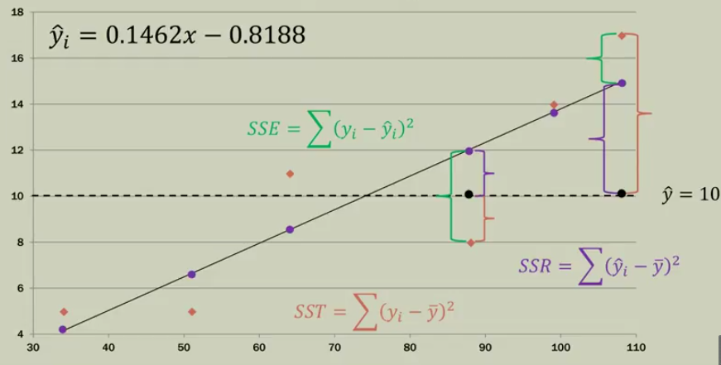

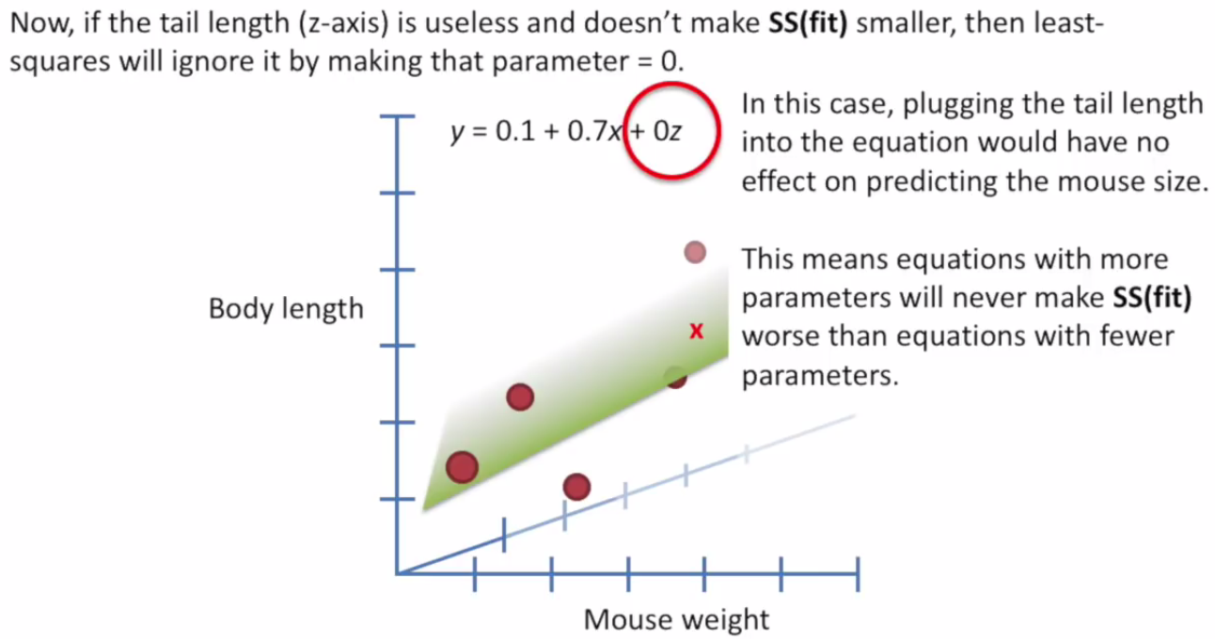
demo on the above picture
import matplotlib.pyplot as plt
from mpl_toolkits.mplot3d import Axes3D
import numpy as np; np.set_printoptions(suppress=True, precision=3, linewidth=250)
sp = plt.axes(projection='3d')
n = 100 # when the number of datapoints is large (say 10,000) you will see that one weight in this example will be close to zero
x = np.random.randint(0,10, size=n)
y = noise = np.random.randn(n)
β0 = 3
β1 = 4
β2 = 5
z = β0 + β1*x + β2*y
"""X,y"""
X = np.hstack([x[:,None], y[:,None], z[:,None]])
X = X[np.argsort(X[:,0])]
X,y = np.split(X, axis=1, indices_or_sections=[-1])
y = y.ravel()
"""LINEAR REGRESSION"""
from sklearn.linear_model import LinearRegression
MD = LinearRegression().fit(X,y)
W = MD.coef_
w0 = MD.intercept_
sp.scatter(*X.T, y, label="z = {:{fmt}} + {:{fmt}}x + {:{fmt}}y".format(w0, *W, fmt='.1f'))
"""DRAW PLANE"""
r1 = sorted(X[:,0])[::len(X)-1]
r2 = sorted(X[:,-1])[::len(X)-1]
XX,YY = np.meshgrid(r1,r2)
ZZ = XX*W[0] + YY*W[1] + w0
sp.plot_surface(XX,YY,ZZ, alpha=0.2, color='red')
"""MAKE ONE FEATURE USELESS"""
X[:,-1] = noise
MD = LinearRegression().fit(X,y)
W = MD.coef_
w0 = MD.intercept_
sp.scatter(*X.T, y, label="z = {:{fmt}} + {:{fmt}}x + {:{fmt}}y".format(w0, *W, fmt='.1f'))
r1 = sorted(X[:,0])[::len(X)-1]
r2 = sorted(X[:,-1])[::len(X)-1]
XX,YY = np.meshgrid(r1,r2)
ZZ = XX*W[0] + YY*W[1] + w0
sp.plot_surface(XX,YY,ZZ, alpha=0.2, color='gray')
sp.set_xlabel("x-axis");sp.set_ylabel("y-axis");sp.set_zlabel("z-axis")
sp.legend()
plt.show()

An equasion with more parameters will not make the fit worse than an equation with fewer parameters because noisy features will be assigned weights close to zero.

demo of the above-said
import numpy as np; np.set_printoptions(suppress=True, precision=3)
"""4D DATASET"""
m = 10 # even this small dataset will demonstrate that noise features will be assigned close-to-zero weights
x1 = np.random.randint(0,10, size=m)
x2 = np.random.rand(m)
x3 = np.random.randn(m)
X = np.hstack([x1[:,None], x2[:,None], x3[:,None]])
β0 = 5
β1 = 1
β2 = 10
β3 = 100
y = x1*β1 + x2*β2 + x3*β3 + β0
y = (X * np.array([β1,β2,β3])).sum(axis=1) + β0 #same
"""FIT LINEAR HYPERPLANE"""
from sklearn.linear_model import LinearRegression
MD = LinearRegression().fit(X,y)
W = MD.coef_
i = MD.intercept_
R2 = MD.score(X,y)
print(i, W)
print(R2) #100%
"""ADD NOISE FEATURES"""
x4 = np.random.randn(m)
x5 = np.random.rand(m)
X = np.hstack([X, x4[:,None], x5[:,None]])
"""FIND WEIGHTS FOR THE NOISY DATASET"""
MD = LinearRegression().fit(X,y)
W = MD.coef_ # weights: 1. 10. 100. 0. 0. The noise features get the weights of (close to) zero
i = MD.intercept_
R2 = MD.score(X,y)
print(i, W)
print(R2)

Adding more noisy (random) features actually improves the fit (and hence R²)
Because if a feature is useless and worsens the fit (and SSE) then the OLS will assign a weight close to zero, but it can happen that due to pure chance a random feature contributes to the improvement of the fit. In this case the OLS will assign a sizable weight to that feature and the R² will be improved.

import numpy as np; np.set_printoptions(suppress=True, precision=3)
np.random.seed(1)
"""4D DATASET"""
m = 10
x1 = np.random.randint(0,10, size=m)
x2 = np.random.rand(m)
x3 = np.random.randn(m)
X = np.hstack([x1[:,None], x2[:,None], x3[:,None]])
β0 = 5
β1 = 1
β2 = 10
β3 = 100
y = x1*β1 + x2*β2 + x3*β3 + β0
y = (X * np.array([β1,β2,β3])).sum(axis=1) + β0 #same
ε = np.random.normal(0, np.std(y)/2, size=m)
y += ε #add noise to the target
"""FIT LINEAR HYPERPLANE"""
from sklearn.linear_model import LinearRegression
MD = LinearRegression().fit(X,y)
W = MD.coef_
w0 = MD.intercept_
R2 = MD.score(X,y)
print(w0, W)
print(R2)
"""ADD ONE NOISE FEATURE"""
x4 = np.random.randn(m)
X = np.hstack([X, x4[:,None]])
MD = LinearRegression().fit(X,y)
W = MD.coef_
w0 = MD.intercept_
R2 = MD.score(X,y)
print(w0, W)
print(R2)
"""ADD ANOTHER NOISE FEATURE"""
x5 = np.random.rand(m)
X = np.hstack([X, x5[:,None]])
MD = LinearRegression().fit(X,y)
W = MD.coef_
w0 = MD.intercept_
R2 = MD.score(X,y)
print(w0, W)
print(R2)

Adjusted R² is scaled by the number of parameters to account for the number of features used:

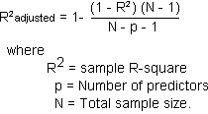

If you have more features than training data points, any target y can be perfectly modeled as a linear function (which can be easily demonstrated with linear algebra)
in other words:
If you have m samples and m-1 features (meaning you have an m by m matrix with the last column being the target vector) then the hyperplane can be perfectly fit to those m data-points, so that R² will be 100% !
This will stand of course as long as there are fewer samples than features.

proof of the above
from sklearn.linear_model import LinearRegression
import numpy as np
from myutils import print
n = 4 # n can be any positive integer, and the R-squared will be 100% !!!
mx = np.random.randint(-100,100, size=(n,n))
X,y = np.split(mx, axis=1, indices_or_sections=[n-1])
y = y.ravel()
md = LinearRegression().fit(X, y)
y_pred = md.predict(X)
score = md.score(X,y)
b = np.allclose(y_pred, y) # y = y_true
print(score, b) # 100% True
print("dataset:", X)
print("target:", y)
print("the whole matrix:", mx)

With high-dimensional datasets (especially when the number of features is greater than the number of samples) there’s a chance of overfitting, (in other words you get a high R² on the training data-set and a low R² on the test data-set). In this situation you should consider using a linear regression with a regularization parameter (e.g. Ridge or Lasso)

demo of the above-said
from sklearn.linear_model import LinearRegression
from sklearn.model_selection import train_test_split
import numpy as np
m = 100
n = 75-1 # n=75 would result in 100% R-squared
mx = np.random.randint(0,100, size=(m,n))
X,y = np.split(mx, axis=1, indices_or_sections=[n-1])
y = y.ravel()
X1,X2,y1,y2 = train_test_split(X,y, random_state=0, test_size=0.25)
"""Linear"""
md = LinearRegression().fit(X1, y1) #X1 = 75 x 73 matrix
y_pred = md.predict(X2) #X2 = 25 x 73 matrix
score1 = md.score(X1,y1) #close to 100% i.e. overfitting
score2 = md.score(X2,y2) #very low
print(score1, score2)
"""Ridge""" #to avoid overfitting, use a linear model with regularization
from sklearn.linear_model import Ridge
md = Ridge(alpha=1e4).fit(X1, y1) # alpha=0 would be identical to using LinearRegression()
y_pred = md.predict(X2) #
score1 = md.score(X1,y1) # R2 on the training dataset is lower but
score2 = md.score(X2,y2) # R2 on the test set is higher
print(score1, score2)

Ridge(alpha=0) is identical to LinearRegression()

regularization in Ridge regression
from sklearn.linear_model import LinearRegression
from sklearn.model_selection import train_test_split
import numpy as np
from pylab import plot, scatter, show, legend, grid, axhline
m = 100
n = 75-1 # n=75 would result in 100% R-squared
mx = np.random.randint(0,100, size=(m,n))
X,y = np.split(mx, axis=1, indices_or_sections=[n-1])
y = y.ravel()
X1,X2,y1,y2 = train_test_split(X,y, random_state=0, test_size=0.25)
"""Linear"""
md = LinearRegression().fit(X1, y1) #X1 = 75 x 73 matrix
weights = md.coef_
scatter(range(1,len(weights)+1), weights, label="LinearRegression()", color='blue')
y_pred = md.predict(X2) #X2 = 25 x 73 matrix
score1 = md.score(X1,y1) #close to 100% i.e. overfitting
score2 = md.score(X2,y2) #very low
print(score1, score2)
"""Ridge""" #to avoid overfitting, use a linear model with regularization
from sklearn.linear_model import Ridge
md = Ridge(alpha=1e4).fit(X1, y1) # alpha=0 would be identical to using LinearRegression()
weights = md.coef_
scatter(range(1,len(weights)+1), weights, label="Ridge(alpha=1e4)", color='red')
y_pred = md.predict(X2) #
score1 = md.score(X1,y1) # R2 on the training dataset is lower but
score2 = md.score(X2,y2) # R2 on the test set is higher
print(score1, score2)
axhline(0, color='gray', linewidth=0.5)
legend()
grid(True)
show()

import numpy as np, matplotlib.pyplot as plt
from sklearn.linear_model import LinearRegression, Ridge
from sklearn.preprocessing import PolynomialFeatures
"""MAKE DATA"""
xx = np.linspace(-1, 2.8, 100)
fn = lambda x : 3 + 0.5*x + 0.1*x**2 - 0.9*x**3 + 0.3*x**4 #y=3+0.5x+.1x^2+-.9x^3+.3x^4
fn = np.vectorize(fn)
yy = fn(xx)
X = xx.reshape(-1,1)
y = yy
plt.plot(xx,yy, color='red', linewidth=5, alpha=0.4, label="original polynomial curve")
"""FEATURE ENGENEERING"""
TR = PolynomialFeatures(degree=4, include_bias=True, interaction_only=False).fit(X,y)
fnames = TR.get_feature_names()
X = TR.transform(X)
print(fnames)
print(X[:5])
"""LINEAR REGRESSION"""
MD = LinearRegression().fit(X,y)
W = MD.coef_ # the weights are 100% equal to the original ones
y_pred = MD.predict(X)
print(W, "linear regression")
plt.plot(xx,y_pred, color='k', linewidth=1, alpha=0.6, label="linear", linestyle='--') # perfectly follows the true curve !
"""RIDGE REGRESSION ALPHA=1"""
MD = Ridge(alpha=1).fit(X,y)
W = MD.coef_ #
y_pred = MD.predict(X)
print(W, "ridge alpha=1")
plt.plot(xx,y_pred, color='magenta', linewidth=1, alpha=0.6, label="ridge 1")
"""RIDGE REGRESSION ALPHA=10"""
MD = Ridge(alpha=10).fit(X,y)
W = MD.coef_ # the weights are even closer to zero
y_pred = MD.predict(X)
print(W, "ridge alpha=10")
plt.plot(xx,y_pred, color='blue', linewidth=1, alpha=0.6, label="ridge 10")
"""RIDGE REGRESSION ALPHA=100"""
MD = Ridge(alpha=100).fit(X,y)
W = MD.coef_ # the weights are even closer to zero
y_pred = MD.predict(X)
print(W, "ridge alpha=100")
plt.plot(xx,y_pred, color='lightblue', linewidth=1, alpha=0.8, label="ridge 100")
"""PLOT"""
plt.legend()
plt.show()

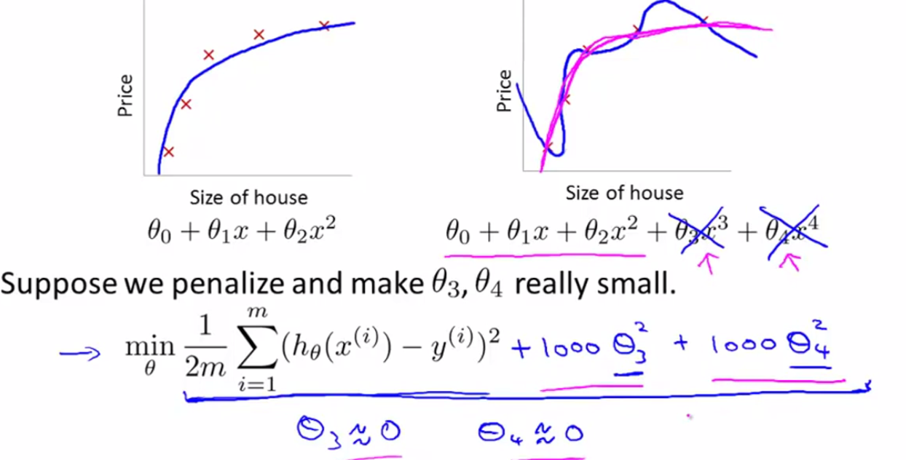
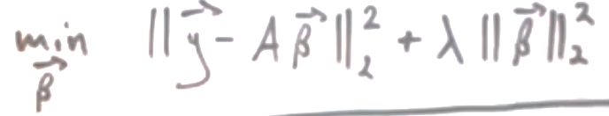
import numpy as np, matplotlib.pyplot as plt
from sklearn.linear_model import LinearRegression, Ridge
from sklearn.preprocessing import PolynomialFeatures
np.set_printoptions(suppress=True, precision=4, linewidth=250)
"""MAKE DATA"""
xx = np.linspace(-3, 1, 100)
fn = lambda x : 5 + x + 4*x**2 + 4*x**3 + x**4 #y=5+x+4x^2+4x^3+1x^4
fn = np.vectorize(fn)
yy = fn(xx)
X = xx.reshape(-1,1)
y = yy
plt.plot(xx,yy, color='red', linewidth=5, alpha=0.4, label="original polynomial curve")
"""FEATURE ENGENEERING"""
TR = PolynomialFeatures(degree=4, include_bias=True, interaction_only=False).fit(X,y)
fnames = TR.get_feature_names()
X = TR.transform(X)
print(fnames)
"""LINEAR REGRESSION"""
MD = LinearRegression().fit(X,y)
W = MD.coef_ # the weights are 100% equal to the original ones
y_pred = MD.predict(X)
print(W, "linear regression")
plt.plot(xx,y_pred, color='k', linewidth=1, alpha=0.6, label="linear", linestyle='--') # perfectly follows the true curve !
"""RIDGE REGRESSION ALPHA=1"""
MD = Ridge(alpha=1).fit(X,y)
W = MD.coef_ #
y_pred = MD.predict(X)
print(W, "ridge alpha=1")
plt.plot(xx,y_pred, color='magenta', linewidth=1, alpha=0.6, label="ridge 1")
"""RIDGE REGRESSION ALPHA=10"""
MD = Ridge(alpha=10).fit(X,y)
W = MD.coef_
y_pred = MD.predict(X)
print(W, "ridge alpha=10")
plt.plot(xx,y_pred, color='blue', linewidth=1, alpha=0.6, label="ridge 10")
"""PLOT"""
plt.axis("equal")
plt.legend()
plt.show()

Cost functions for OLS, Ridge, Lasso
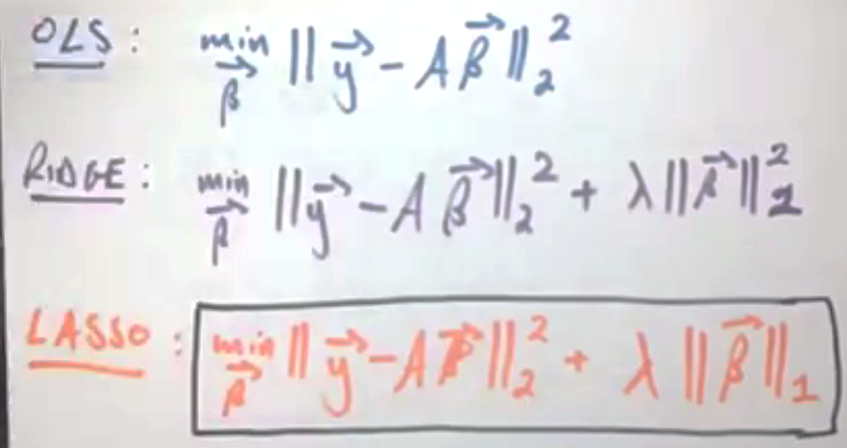

cost function visualized
import numpy as np, matplotlib.pyplot as plt
from mpl_toolkits import mplot3d
fig = plt.figure(figsize=(8,8))
m = 100
Σ = [[16,1],
[1,1]]
rs = np.random.RandomState(2)
data = rs.multivariate_normal(mean=[2,3], cov=Σ, size=m)
def J(θ0,θ1): # cost function
global data
m = len(data)
X,Y = data.T
h = lambda x : θ0 + θ1 * x
Ŷ = [h(x) for x in X]
MSE = sum((y - ŷ)**2 for y,ŷ in zip(Y,Ŷ)) / (2*m)
return MSE
J = np.frompyfunc(J, 2, 1)
θ0range = np.linspace(-11,12, 100)
θ1range = np.linspace(-3,4, 100)
Xgrid, Ygrid = np.meshgrid(θ0range, θ1range)
mx = np.c_[Xgrid.ravel(), Ygrid.flatten()]
Zgrid = J(*mx.T).reshape(Xgrid.shape)
#plot1
sp = fig.add_subplot(221)
sp.scatter(*data.T)
sp.set(xlim=(0,10), ylim=(0,10))
#plot2
sp = fig.add_subplot(222, projection='3d')
sp.plot_surface(Xgrid, Ygrid, Zgrid, cmap='viridis')
sp.set(xlabel=r"$\theta_0$", ylabel=r"$\theta_1$", zlabel=r"$J(\theta_0, \theta_1)$")
#plot3
sp = fig.add_subplot(223)
sp.contour(Xgrid, Ygrid, Zgrid, cmap='viridis')
plt.show()

OLS

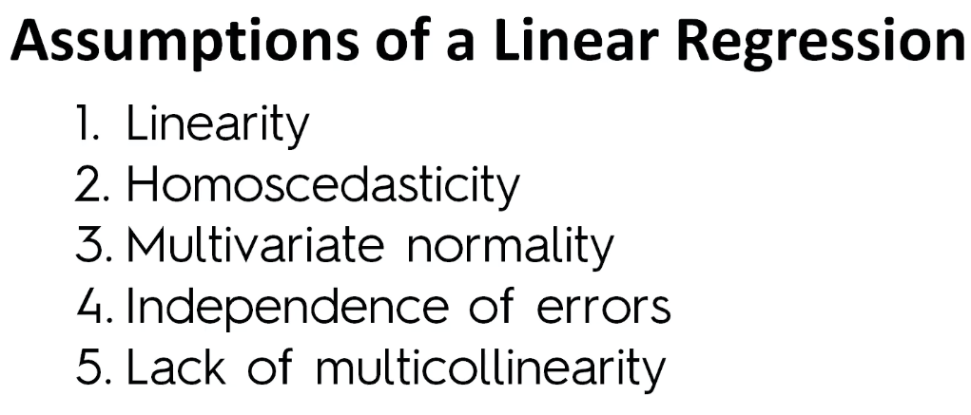

Standardized Regression

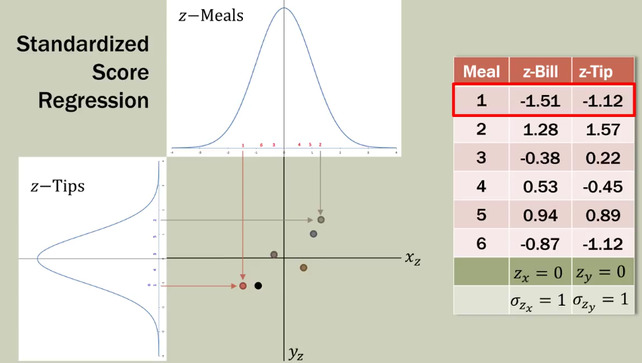

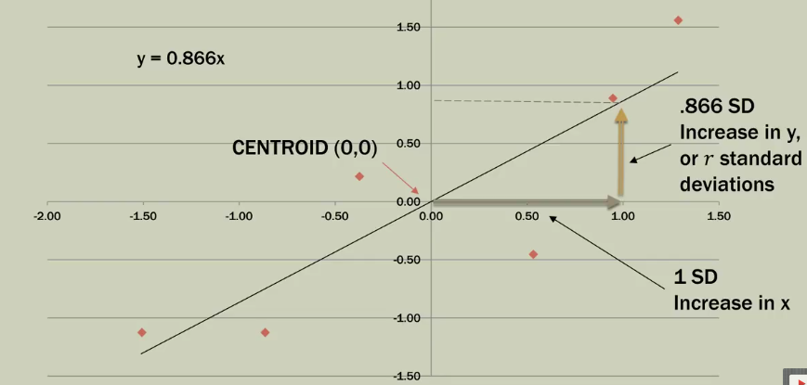

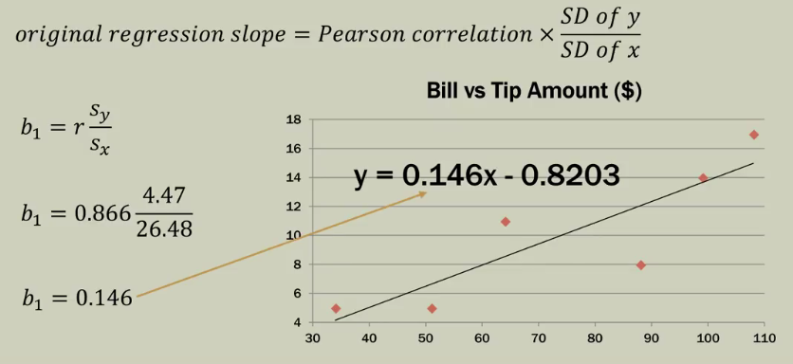

(?)
For simple linear regression the p-value (Hypothesis Test for the Regression Slope
) can be calculated either via t-test or F-statistic:

t-test
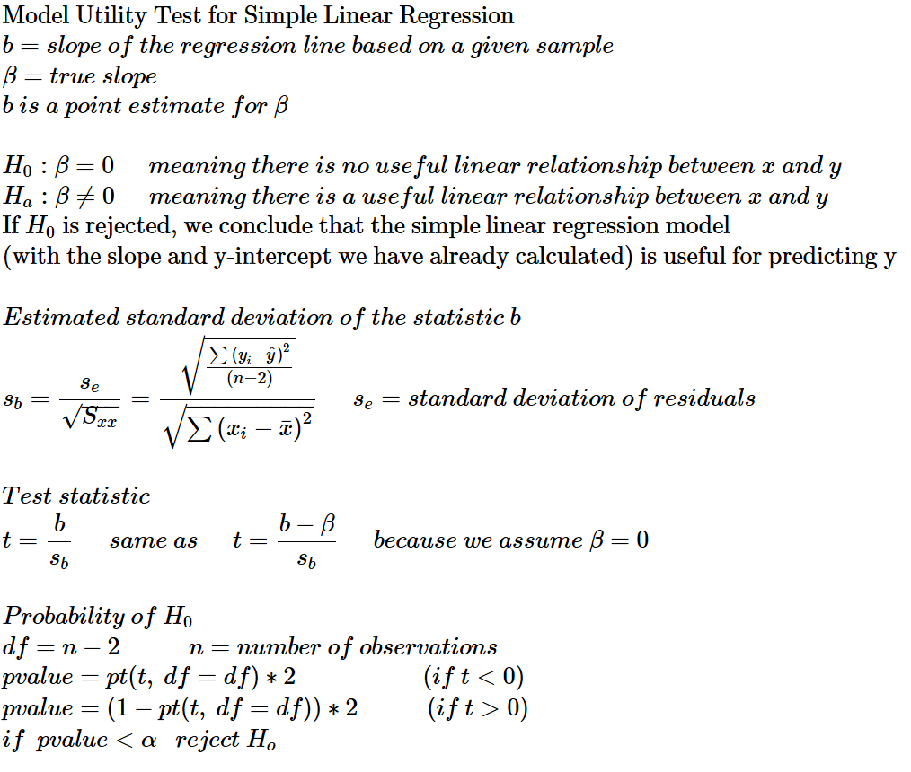

F-statistic
Conceptual similarity between R² and F:

n = number of data-points
k = number of predictors
SSR = sum of squared (explained) regressions (i.e. predicted by the line)
SSE = sum of squared errors / residuals
SST = sum of squared total deviations from the mean line

F value is comparable to odds =

if meaning this large number will be located at the far right end of the F-curve, whereas smaller numbers will be located at the lower/left tail of the curve.
Small numbers are numerous and large numbers are rare, that’s why the F curve tapers to the right. We measure the probability of our large number or even larger numbers by figuring out the area under the F-curve from our large number to the right end. This area will be of course a small portion of the curve (since our number is large):
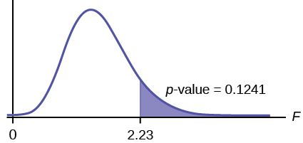
That area under the curve is the p-value which is calculated as follows:

p <- 1 - pf(F, df1 = k, df2 = n-(k+1))
p <- pf(F, df1, df2, lower.tail = FALSE)

p = probability of our (large) F value or even larger F values if null hypothesis is true
So, we need a large R² and a small p for our model to be of any use. If the p-value is small (<0.05) then we reject the null hypothesis and come to a conclusion that our model is useful.

demonstration of the above
n <- 10
x <- sort(round(runif(n=n, min=0, max=10)))

w0 <- 10 #y-intercept
b <- 0.85 #slope

y <- x*b + w0 + rnorm(n)

MD <- lm(y ~ x)
summary(MD) # F-statistic: 116.5 on 3 and 6 DF, p-value: 1.045e-05
b <- MD$coefficients[2] # actual slope

#MANUAL CALCULATION OF F-STATISTIC AND P-VALUE:
fn <- function(xx, md){
mx <- t(t(cbind(rep(1,n),xx)) * md$coefficients)
y_pred <- rowSums(mx)
return(y_pred)}

y_mean <- mean(y)
y_true <- y
y_pred <- fn(x,MD)

SSE <- sum((y_true - y_pred)**2)
SST <- sum((y_true - y_mean)**2)
SSR <- SST - SSE

k <- 3 #number of predictors
df1 <- k
df2 <- n-(k+1)

F <- (SSR/df1)/(SSE/df2)
p <- pf(F, df1, df2, lower.tail=FALSE)
print(p)

#T-TEST: Hypothesis Test for Regression Slope
Se <- sqrt(SSE/(n-2)) #Standard Error
SDx <- sqrt(sum((x-mean(x))**2))
SDb <- Se / SDx #estimated standard deviation of the slope
t <- b / SDb #test statistic
df <- n-2
p <- pt(t, df, lower.tail=FALSE)*2
print(p)

#COMPARE
print(summary(MD))

Confidence Interval bands

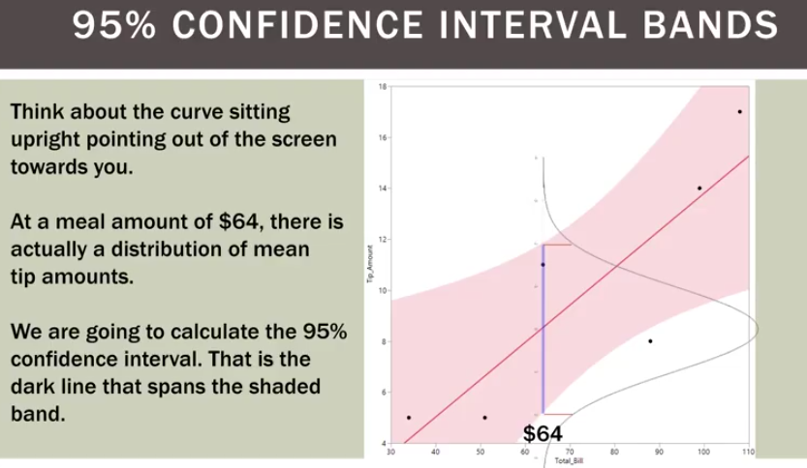

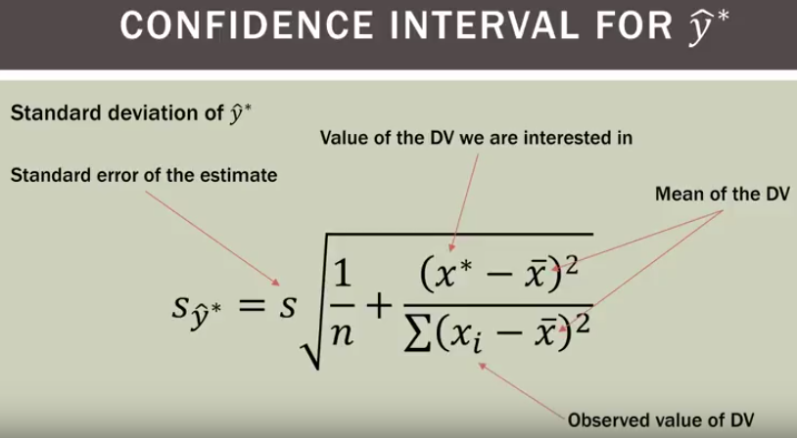
DV=dependent variable

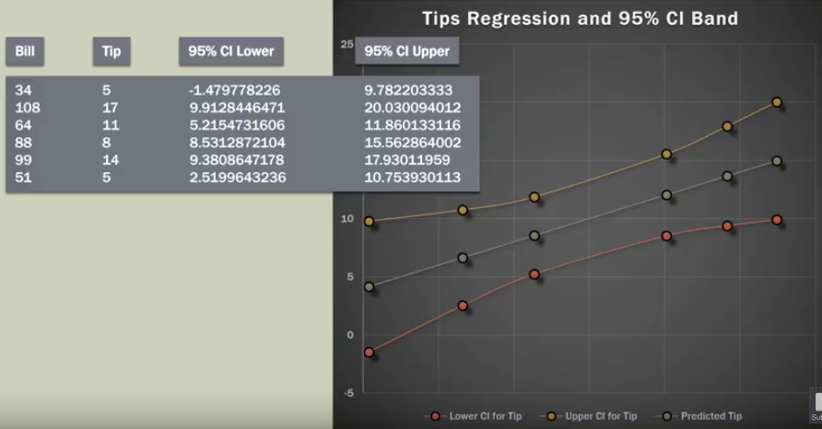

df <- datasets::cars
library(ggplot2)
ggplot(cars, aes(x=speed, y=dist)) +
geom_point(color='#2980B9', size = 4) +
geom_smooth(method=lm, color='#2C3E50')

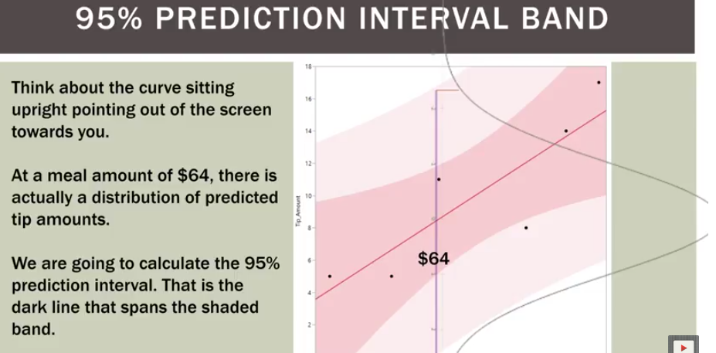

simple Linear Regression with sklearn
from sklearn.linear_model import LinearRegression
md = LinearRegression() #instantiate a model
X = x[:, np.newaxis] #if x is a 1D array transform it into a 2D ndarray of shape=(n, 1)
md.fit(X, y) #fit the model
Slope,Intercept = md.coef_[0], md.intercept_ #get the coefficients
XTest = np.linspace(1,11,5)[:, np.newaxis] #test the model
YFitted = md.predict(XTest) #fit the test data

fit intercept = True vs False
import matplotlib.pyplot as plt, numpy as np
from matplotlib.pyplot import plot, scatter
plt.figure(figsize=(5,5))
plt.gca().set_aspect('equal')
"""MAKE A DATASET"""
l = [(1,1),(2,3),(3,2)]
nd = np.array(l, dtype=np.uint8)
X = nd[:,0][:,None]
y = nd[:,1][:,None]
X_test = np.linspace(0, max(X[:,0]), 100, endpoint=True)[:,None] #test dataset
plot(*nd.T, 'o')
plot(*nd.mean(axis=0), 'or', label='mean')
"""FIT A LINEAR MODEL WITH INTERCEPT TRUE (DEFAULT)"""
from sklearn.linear_model import LinearRegression
md = LinearRegression(fit_intercept=True)
md.fit(X,y)
y_pred = md.predict(X_test)
plot(X_test[:,0], y_pred, 'b', label='fit_intercept=True (default)')
"""FIT A LINEAR MODEL WITH INTERCEPT FALSE"""
md = LinearRegression(fit_intercept=False)
md.fit(X,y)
y_pred = md.predict(X_test)
plot(X_test[:,0], y_pred, 'g', label=f'fit_intercept={md.fit_intercept}')
"""SHOW"""
plt.legend()
plt.xticks(range(int(max(X[:,0]))+1))
plt.yticks(range(int(max(y))+1))
plt.xlim([0,int(max(X[:,0]))+0.1])
plt.ylim([0, int(max(y))+0.1])
plt.show()

Linear Regression with binned input array
from sklearn.linear_model import LinearRegression
from sklearn.preprocessing import OneHotEncoder
import numpy as np; np.random.seed(0)
import matplotlib.pyplot as plt; from matplotlib.pyplot import plot, scatter
plt.figure(figsize=(10,7))
"""CREATE A DATASET"""
xx = np.linspace(0, np.pi*5, 70, endpoint=True) #70 datapoints
yy = np.sin(xx) + xx/3 + np.random.randn(len(xx))/1.1
plot(xx,yy, '.k')
X = xx[:,None]
y = yy
"""BIN THE INPUT ARRAY"""
nbins = 10
mn,mx = sorted(X[:,0])[::len(X[:,0])-1]
breaks = np.linspace(mn, mx+0.0001, nbins+1, endpoint=True) # 10 bins = 11 breaks; 0.001 is added in order to fit the last datapoint into the last bin instead of into the right extreme bin
ca = np.digitize(X[:,0], bins=breaks, right=False) # ca is an nd-array but functionally it is a catagorical array
"""DUMMIFY THE BINNED INPUT ARRAY"""
tr = OneHotEncoder(sparse=False).fit(ca[:,None])
X_onehot_matrix = tr.transform(ca[:,None])
"""MAKE A LINEAR MODEL"""
md = LinearRegression()
md.fit(X_onehot_matrix, y)
"""CREATE A TEST DATASET"""
X_test = np.linspace(0, np.pi*5, 1000)[:,None] #1000 datapoints
"""BIN THE TEST DATASET"""
ca = np.digitize(X_test[:,0], bins=breaks, right=False)
"""DUMMIFY THE TEST DATASET"""
X_test_onehot_matrix = tr.transform(ca[:,None])
"""PREDICT THE y VALUES ON THE TEST DATASET"""
y_pred = md.predict(X_test_onehot_matrix)
"""DRAW THE PREDICTION LINE"""
plot(X_test[:,0], y_pred, label='multi-dim linear regression from binned x values')
"""DRAW VIRTICAL LINES DENOTING BINS"""
plt.vlines(breaks, ymin=min(y), ymax=max(y), color='gray', linewidth=0.5, label='bin breaks')
plt.gca().set_aspect('equal')
plt.legend(frameon=True, edgecolor='gray', facecolor='#EBEBEB');
plt.show()

A Gaussian Basis Function is a Radial Basis Function (RBF)
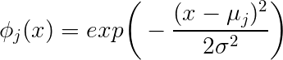

Normal Distribution Curve formula
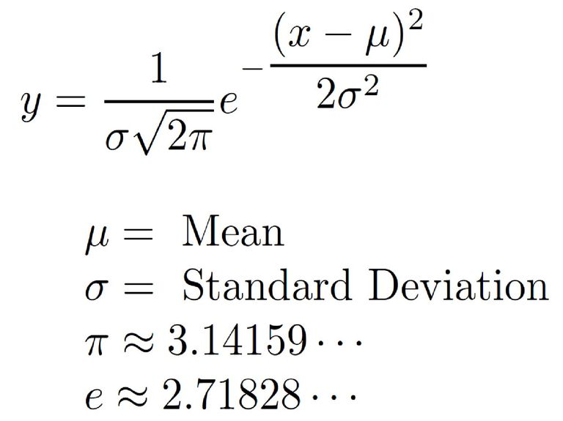
import numpy as np, matplotlib.pyplot as plt
xx = np.arange(0,101)
μ = 25
σ = 10
yy = np.exp(-(xx-μ)**2/(2*σ**2))
plt.plot(xx,yy, label=r"$y=e^{-\frac{(x-\mu)^2}{2\sigma^2}}$")
yy = yy * (1 / σ * np.sqrt(2*np.pi))
plt.plot(xx,yy, label=r"$y= \frac{1}{\sigma\sqrt{2\pi}} e^{-\frac{(x-\mu)^2}{2\sigma^2}}$")
plt.legend(fontsize=18)
plt.show()

Gaussian curve
xx = np.arange(0,101)
μ = 25 ; σ = 10
yy = np.exp(-(xx-μ)**2/(2*σ**2)) #simplified
yy = yy * (1 / σ * np.sqrt(2*np.pi)) #integrated to one

slopes of a quadratic regression
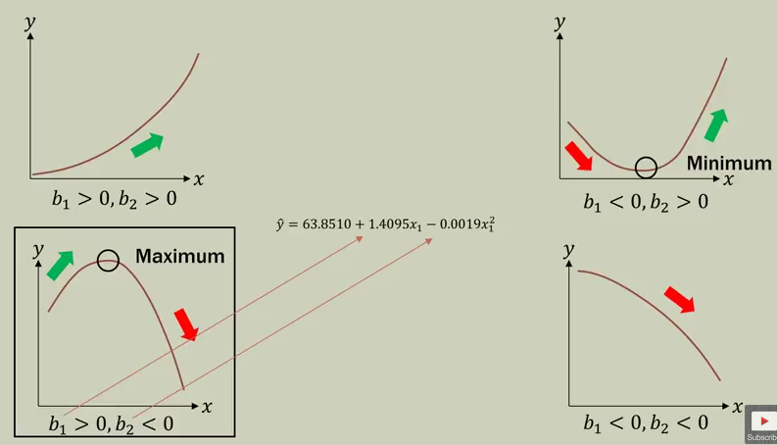

quadratic regression
import numpy as np
from pylab import plot, scatter, show
from sklearn.linear_model import LinearRegression
from sklearn.preprocessing import PolynomialFeatures
xx = np.linspace(0,6,100)
yy = -(xx-3)**2 + 9
X = PolynomialFeatures(degree=2).fit_transform(xx[:,None])
y = yy ; print(X[:10])
MD = LinearRegression().fit(X,y)
i = MD.intercept_
W = MD.coef_
R2 = MD.score(X,y) #100%
print(i, W) # 0 [0 6 -1]
W = np.polyfit(xx,yy, deg=2)
print(W) # [-1 6 0]
plot(xx, yy, color='red')
show()
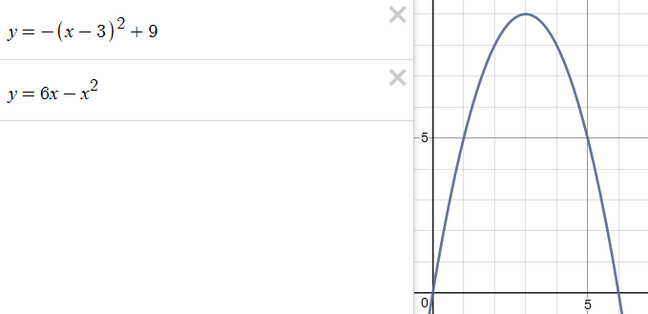

Linear Regression (multivariate)

regression metrics
ytrue = (10, 20, 30, 40, 50)
ypred = (10.1, 20.2, 30.3, 45.4, 49.8)
from sklearn.metrics import r2_score, mean_absolute_error, mean_squared_error
RSq = r2_score(ytrue, ypred) #0.97 scoring function
MAE = mean_absolute_error(ytrue, ypred) #1.24 (MAE is used when there are many outliers)
MSE = mean_squared_error(ytrue, ypred) #5.86 cost function
RMSE = MSE ** 0.5 #2.42 (68% of predictions will fall within +/- 2.42)

scoring functions in sklearn
https://scikit-learn.org/stable/modules/model_evaluation.html

a custom scoring-function for cross-validation
from sklearn.model_selection import cross_val_score # k-fold cross-validation
from sklearn.linear_model import LinearRegression
import numpy; from random import gauss

x = range(10,101,10)
y = [2*x+gauss(0,1) for x in x]
X = numpy.array(x)[:,None] ; X = numpy.matrix(x).T #the shape is the same

def scoring_function(model, X, ytrue):
ypred = model.predict(X)
MSE = sum((ytrue - ypred)**2) / len(ytrue) #mean squared error is a cost function (i.e. the lower the better)
score = -MSE # turn the cost function into a scoring function (i.e. the greater the better)
return score

md = LinearRegression()
scores = cross_val_score(md, X,y, cv=5, scoring=scoring_function) #same as ...
scores = cross_val_score(md, X,y, cv=5, scoring='neg_mean_squared_error') #same
RMSE = numpy.sqrt(-scores) #turn the scoring function's results into a cost function results

Gradient Descent

Gradient Descent for Linear Regression of 2D data
def make_data(n_points=30, random_state=None):
from numpy import random
T = [[2,1],[1,1]]
M = (random if random_state is None else random.RandomState(random_state)).randn(n_points, 2)
x,y = (T @ M.T)
return x,y
def ols(x,y):
from collections.abc import Sequence
from numbers import Real
assert all(isinstance(o, Sequence) or hasattr(o, '__iter__') for o in (x,y)) \
and len(x)==len(y)\
and all(isinstance(n, Real) for n in tuple(x)+tuple(y)), "bad arguments"
n = len(x)
xbar,ybar = (sum(a)/n for a in (x,y))
slope = sum(x*y for x,y in zip((x - xbar for x in x),(y - xbar for y in y))) / sum((x - xbar)**2 for x in x)
intercept = ybar - slope*xbar
return intercept,slope
def gradient_descent(x,y, alpha=None, max_iter=1000): #determine y-intercept and slope with gradient descent
from numpy import allclose; from collections import deque; from statistics import mean
θ0 = θ1 = 0 #initialize the θ's at zero
θ0_list = deque(maxlen=3) #list of the last θ's to determine convergence
θ1_list = deque(maxlen=3)
m = len(x)
α = alpha or 0.01 #learning rate
h = lambda x : θ0 + θ1 * x # hypothesis h(x)
def residuals(x=None,y=None, func=None): #vectorized function
if func is None: func = globals()['h']
if x is None: x = globals()['x']
if y is None: y = globals()['y']
return [func(x)-y for x,y in zip(x,y)]
for i in range(max_iter): # repeat until convergence with simultanious update
θ0 = θ0 - α * (1/m) * sum(residuals(x,y,h))
θ1 = θ1 - α * (1/m) * sum(r*x for r,x in zip(residuals(x,y,h),x))
θ0_list.append(θ0)
θ1_list.append(θ1)
if len(θ0_list)>=3 and all(allclose(arr, mean(arr)) for arr in (θ0_list,θ1_list)):
print("breaking out after loop#", i)
break
else: raise Exception("failed to converge in {} loops".format(i))
return θ0,θ1
def J(θ0, θ1):
global x,y # given data
mse = sum((θ0 + θ1*x - y)**2 for x,y in zip(x,y)) / (2*len(x))
return mse
from numpy import frompyfunc
cost_function = frompyfunc(J, 2, 1)
###################################################################################
x,y = make_data(random_state=None)
θ0_true, θ1_true = ols(x,y)
print("true θ0,θ1 =", θ0_true, θ1_true)
θ0,θ1 = gradient_descent(x,y)
print("gradient descent θ0,θ1 =", θ0,θ1)
from numpy import meshgrid, linspace
θ0_grid, θ1_grid = meshgrid(linspace(-35,35, 100), linspace(-20,20, 100))
Z = cost_function(θ0_grid, θ1_grid)
#plots
from matplotlib.pyplot import figure, show; from mpl_toolkits import mplot3d
fig = figure(figsize=(10,7))
sp = fig.add_subplot(221)
sp.scatter(x,y, s=10)
sp.plot([min(x),max(x)], [θ0_true + θ1_true *x for x in (min(x),max(x))])
sp.plot([min(x),max(x)], [θ0 + θ1 *x for x in (min(x),max(x))])
sp.set(xlabel="x", ylabel="y", title="regression line fitted by gradient descent")
sp.axis('equal')
sp = fig.add_subplot(222, projection='3d')
sp.plot_surface(θ0_grid, θ1_grid, Z, cmap='jet')
sp.set(xlabel=r"$\theta_0$", ylabel=r"$\theta_1$", zlabel=r"$J(\theta_0,\theta_1)$", title="cost function")
sp = fig.add_subplot(223)
sp.contour(θ0_grid, θ1_grid, Z, cmap='jet')
sp.set(xlabel=r"$\theta_0$", ylabel=r"$\theta_1$", title="cost function as contours")
show()

Gradient Descent
def gradient_descent(X,y, α=0.05, max_iter=1e+5) -> "vector of weights":
from numpy import array, ndarray, ones_like, hstack, dot, allclose, matmul
X,y = (array(a, dtype='f') if not isinstance(a, ndarray) else a for a in (X,y))
if not (X[:,0]==1).all():
X = hstack([ones_like(y).reshape(-1,1), X])
m,n = X.shape; n-=1
θ = array([0,]*(n+1), dtype='f')
εε = [0]*(n+1)
for i in range(int(max_iter)+1):
for j in range(n+1):
d = dot(matmul(X,θ)-y, X[:,j]) / len(y)
θ[j] -= α * d # d = partial derivative's slope
εε[j]=d
if allclose(εε,0, atol=0.000001):break
else:
from warnings import warn
warn(f"maximum number of iterations reached: {i}", Warning)
return θ

Linear Regression with Feature Engineering

Avoiding Dummy Variable Trap
import numpy as np
from pandas import DataFrame, get_dummies
from random import gauss, choices

#simulate a dataset
m = 10
x1 = [int(gauss(mu=10, sigma=7)) for _ in range(m)] # house's distance from the city-center
x1 = [x if x >=0 else 0 for x in x1]
x2 = choices(['small','middle','large'], k=m)
assert len(np.unique(x2))==3, "x2 has only 2 unique values!"

#df
df = DataFrame({'vicinity':x1, 'size':x2}, dtype='object')
df = get_dummies(df, columns=['size'], prefix='', prefix_sep='').iloc[:,:-1]
print(df)

β0 = 90000 # basic price for a house is $100,000-$10,000 if the house is small
β1 = -1000 # a house loses $1,000 for each mile further from city-center
β2 = 20000 # add $20,000 if the house is large
β3 = 10000 # add $10,000 if the house is middle (note that middle = $100,000)

w = [β0, β1, β2, β3]
w = np.array(w, dtype=np.int32).reshape(-1,1) # column vector
X = df.values
X = np.hstack([np.ones(shape=(len(X),1), dtype=np.uint8), X])
X = X.astype(np.int16)

yhat = np.matmul(X, w)

sigma_error = yhat.std() / 4
ε = [gauss(mu=0, sigma=sigma_error) for _ in range(m)]
ε = np.array(ε, dtype=np.float32).reshape(-1,1).round(2)
y = yhat + ε

SSR = ((yhat - y.mean()) ** 2).sum()
SST = ((y - y.mean()) ** 2).sum()
RSq = SSR/SST

#fit
from sklearn.linear_model import LinearRegression
MD = LinearRegression().fit(X,y)
w = [MD.intercept_[0], *MD.coef_[0,1:]]
print("weights:", w)
print("score:", MD.score(X,y))

OneHotEncoder
import pandas as pd
from sklearn.preprocessing import OneHotEncoder

lt = [(10, 1, "string1", "cat2"),
(20, 2, "string2", "cat5"),
(30, 1, "string1", "cat1"),
(20, 2, "string2", "cat2"),
(10, 3, "string3", "cat5")]

df = pd.DataFrame(lt, columns=['number','integer-categorical', 'string','cat'])
nx,classes = pd.factorize(df['string'])
df['string'] = nx

df['cat'] = pd.Categorical(df['cat']).rename_categories([1,2,3])

X = df.values.astype('uint8')
X = OneHotEncoder(categorical_features=[1,2,3], sparse=False).fit_transform(X)

binning / discretization of linear regression models

One way to make linear models more powerful on continuous data is to use binning (also known as discretization) of the feature to split it up into multiple features

from sklearn.linear_model import LinearRegression
from sklearn.preprocessing import OneHotEncoder
import numpy as np; np.random.seed(0)
import matplotlib.pyplot as plt; from matplotlib.pyplot import plot, scatter

plt.figure(figsize=(10,7))

"""CREATE A DATASET"""
xx = np.linspace(0, np.pi*5, 70, endpoint=True) #70 datapoints
yy = np.sin(xx) + xx/3 + np.random.randn(len(xx))/1.1
plot(xx,yy, '.k')
X = xx[:,None]
y = yy

"""BIN THE INPUT ARRAY"""
nbins = 10
mn,mx = sorted(X[:,0])[::len(X[:,0])-1]
breaks = np.linspace(mn, mx+0.0001, nbins+1, endpoint=True) # 10 bins = 11 breaks; 0.001 is added in order to fit the last datapoint into the last bin instead of into the right extreme bin
ca = np.digitize(X[:,0], bins=breaks, right=False) # ca is an nd-array but functionally it is a catagorical array

"""DUMMIFY THE BINNED INPUT ARRAY"""
tr = OneHotEncoder(sparse=False).fit(ca[:,None])
X_onehot_matrix = tr.transform(ca[:,None])

"""MAKE A LINEAR MODEL"""
md = LinearRegression()
md.fit(X_onehot_matrix, y)

"""CREATE A TEST DATASET"""
X_test = np.linspace(0, np.pi*5, 1000)[:,None] #1000 datapoints

"""BIN THE TEST DATASET"""
ca = np.digitize(X_test[:,0], bins=breaks, right=False)

"""DUMMIFY THE TEST DATASET"""
X_test_onehot_matrix = tr.transform(ca[:,None])

"""PREDICT THE y VALUES ON THE TEST DATASET"""
y_pred = md.predict(X_test_onehot_matrix)

"""DRAW THE PREDICTION LINE"""
plot(X_test[:,0], y_pred, label='multi-dim linear regression from binned x values')

"""DRAW VIRTICAL LINES DENOTING BINS"""
plt.vlines(breaks, ymin=min(y), ymax=max(y), color='gray', linewidth=0.5, label='bin breaks')
plt.gca().set_aspect('equal')
plt.legend(frameon=True, edgecolor='gray', facecolor='#EBEBEB');
plt.show()

Polynomial Regression

polynomial regression
from sklearn.linear_model import LinearRegression
from sklearn.preprocessing import PolynomialFeatures, StandardScaler
from sklearn.pipeline import make_pipeline

poly = PolynomialFeatures(degree=60)
sc = StandardScaler()
md = LinearRegression()
pl = make_pipeline(poly, sc, md)
pl.fit(X,y)
weights = pl.steps[-1][1].coef_
y_pred = pl.predict(X)

demo on polynomial regression
import numpy as np
import matplotlib, matplotlib.pyplot as plt
from numpy import sin

f = lambda x : (0.1*(x-3)*sin((x-9)**2) + 0.25*(x-3))+1 # vectorized

x = np.linspace(1,14, 300)
y = f(x)

# make a mask
n = 5 # to select every n'th value
mask1 = [False]*len(x)
mask1[::n] = [True] * len(mask1[::n]) # to select every n'th value

dd = np.abs(y[1:] - y[:-1]) # diff
mn = dd.mean() # mn = mean
mask2 = (dd > mn).tolist() + [True,] # add one missing pocket (because of diff)
mask = [b1^b2 for b1,b2 in zip(mask1, mask2)] #XOR

#data
X = x[mask].reshape(-1,1)
y = y[mask]

#model
from sklearn.linear_model import LinearRegression
from sklearn.preprocessing import PolynomialFeatures, StandardScaler
from sklearn.pipeline import make_pipeline

poly = PolynomialFeatures(degree=70)
sc = StandardScaler()
md = LinearRegression()
pl = make_pipeline(poly, sc, md)
pl.fit(X,y)
weights = pl.steps[-1][1].coef_

X_new = np.linspace(1,14, 300)[:,None]
y_new = f(np.linspace(1,14, 300))
y_pred = pl.predict(X_new)
score = pl.score(X_new, y_new)
print("RSq =", score) #99%

#plot
plt.axis([0, 15, 0, 5])
sp = plt.gca()
sp.plot(X.flatten(), y, '.b')
sp.plot(X_new.ravel(), y_pred)
#plt.show()

Linear regression with a Gaussian Basis Function

Python Data Science Handbook
p.392

from sklearn.base import BaseEstimator, TransformerMixin
import numpy as np
class GaussianFeatures(BaseEstimator, TransformerMixin):
"""Uniformly spaced Gaussian features for one-dimensional input"""
def __init__(self, N, width_factor=2.0):
self.N = N
self.width_factor = width_factor
@staticmethod
def _gauss_basis(x, y, width, axis=None):
arg = (x - y) / width
return np.exp(-0.5 * np.sum(arg ** 2, axis))
def fit(self, X, y=None):
# create N centers spread along the data range
self.centers_ = np.linspace(X.min(), X.max(), self.N)
self.width_ = self.width_factor * (self.centers_[1] - self.centers_[0])
return self
def transform(self, X):
return self._gauss_basis(X[:, :, np.newaxis], self.centers_, self.width_, axis=1)
#TEST
from sklearn.pipeline import make_pipeline
from sklearn.linear_model import LinearRegression
import matplotlib.pyplot as plt
rng = np.random.RandomState(1)
x = 10 * rng.rand(50)
X = x[:,None] # one column table
y = np.sin(x) + 0.1 * rng.randn(50)
Xtest = np.linspace(0, 10, 1000)[:,None]
X_tr = GaussianFeatures(3).fit_transform(X)
print(X_tr[:5])
PL = make_pipeline(GaussianFeatures(3), LinearRegression()) # experiment with 3 - 20
PL.fit(X, y)
ypred = PL.predict(Xtest)
plt.scatter(x, y)
plt.plot(Xtest.ravel(), ypred)
plt.xlim(0, 10);
plt.show()

Ridge & Lasso

Ridge regression is used when there are more features than observations



Difference between Ridge regression and Laso regression:
Ridge uses L2 norm for weights selection/regularization
Lasso uses L1 norm, which results into the weights vector being sparse

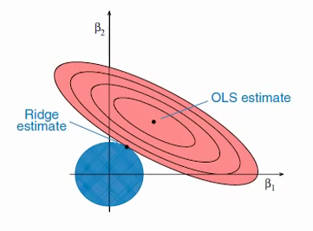

OLS = ordinary linear regression

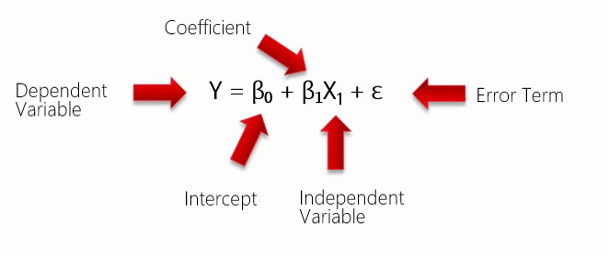

analizing Ridge regression
from MyUtilities import print
import numpy as np
from mpl_toolkits.mplot3d import Axes3D
import matplotlib.pyplot as plt
from sklearn.linear_model import LinearRegression, Ridge
np.random.seed(2) #2
mu = [10,10,10]
cov=\
[[ 3, 2, 1.5],
[ 2, 8, 3.5],
[ 1.5,3.5,10]]
mx = np.random.multivariate_normal(mean=mu, cov=cov, size=100)
#covariance matrix
mxCov = np.cov(mx.T)
print("covariance matrix:", mxCov)
def XYZLinear(mx, HowManyPoints=10):
X = mx[:, :-1]
y = mx[:, -1]
md = LinearRegression().fit(X, y)
a = np.linspace(mx[:, :-1].min(), mx[:, :-1].max(), HowManyPoints)
X, Y = np.meshgrid(a, a)
Z = X*md.coef_[0] + Y*md.coef_[1] + md.intercept_
print("Linear model intercept and slopes:", md.intercept_, md.coef_)
return X,Y,Z
def XYZRidge(mx, HowManyPoints=10):
X = mx[:, :-1]
y = mx[:, -1]
md = Ridge(alpha=200).fit(X, y)
a = np.linspace(mx[:, :-1].min(), mx[:, :-1].max(), HowManyPoints)
X, Y = np.meshgrid(a, a)
Z = X*md.coef_[0] + Y*md.coef_[1] + md.intercept_
print("Ridge model intercept and slopes:", md.intercept_, md.coef_)
return X,Y,Z
#make subsets
nx = np.random.choice(len(mx), size=int(len(mx)*0.25), replace=False)
nxInversed = sorted(set(range(len(mx))).difference(nx))
mxSubset = mx[nx]
mxTheRest = mx[nxInversed]
sp = plt.axes(projection='3d')
sp.scatter(*mxSubset.T, color='b', marker='o')
sp.scatter(*mxTheRest.T, color='k', alpha=0.3, marker='.')
sp.plot_wireframe(*XYZLinear(mx), color="gray", alpha=0.5, label="(true) Linear regression of the whole set")
sp.plot_wireframe(*XYZLinear(mxSubset), color="green", alpha=0.5, label="Linear Regression of the subset")
sp.plot_wireframe(*XYZRidge(mxSubset), color="m", alpha=0.5, label="Ridge Regression of the subset")
sp.set_xlabel("x-axis");sp.set_ylabel("y-axis");sp.set_zlabel("z-axis")
sp.legend(fontsize="x-small", frameon=False)
plt.show()

demo on Polynomial Regression with Regularization
import numpy as np, matplotlib.pyplot as plt
import random; random.seed(40)
from sklearn.linear_model import LinearRegression,Ridge
from sklearn.preprocessing import PolynomialFeatures
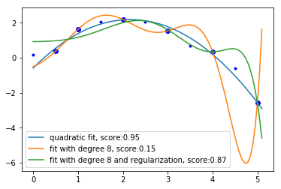
from sklearn.pipeline import make_pipeline

"""CURVE FORMULA"""
f = lambda x : 2 - (0*x**1 + 0.5*(x-2)**2)
ε = lambda : random.gauss(0, 0.25) #error

"""DATA"""
x = (0.5, 1, 2, 3, 4, 5)
y = [f(x)+ε() for x in x]

xtest = (0, 1.5, 2.5, 3.5, 4.5)
ytest = [f(x)+ε() for x in xtest]

plt.plot(x,y, 'bo')
plt.plot(xtest, ytest, 'b.')

"""ARRANGE DATA SETS"""
X = np.c_[x].T #X = Xtrain
Xtest = np.c_[x + xtest].T #Xtest = X + xtest
ytest = y + ytest #combine two lists
Xline = np.linspace(0, max(x)+0.1, 100)[:,None] #for the curves

"""QUADRATIC MODEL (degree=2 is the appropriate degree here)"""
poly = PolynomialFeatures(degree=2)
md = LinearRegression()
pl = make_pipeline(poly, md).fit(X,y)
ypred = pl.predict(Xline)
score = pl.score(Xtest,ytest)
plt.plot(Xline, ypred, label='quadratic fit, score:%.2f'%score)

"""MODEL WITH DEGREE 8"""
pl.steps[0][1].set_params(degree=8)
pl.fit(X,y)
ypred = pl.predict(Xline)
score = pl.score(Xtest,ytest)
plt.plot(Xline, ypred, label='fit with degree 8, score:%.2f'%score)

"""MODEL WITH REGULARIZATION"""
poly = PolynomialFeatures(degree=pl.steps[0][1].get_params()['degree']) #8
md = Ridge(alpha=10.0) #if alpha (aka lambda) == 0 then the curve is the same as above
pl = make_pipeline(poly, md).fit(X,y)
ypred = pl.predict(Xline)
score = pl.score(Xtest,ytest)
plt.plot(Xline, ypred, label='fit with degree 8 and regularization, score:%.2f'%score)

plt.legend()
#plt.show()

Linear Regression via Normal Equasion
#data
m,n = 10,4
A = np.random.normal(loc=[5,10,20,100], scale=[1,3,5,10], size=(m,n)).round(2)
X = np.c_[np.ones(A.shape[0]).reshape(-1,1), A] #add x0
det = np.linalg.det(X.T @ X) #det must not be close to zero - the farther from zero the better

#target + errors
y = X @ [100, 3, 2, -1, 0.5] + np.random.randn(m) #target + errors

#caluclete the inverse
X_1 = np.linalg.inv(X.T @ X) @ X.T
X_1 = np.linalg.pinv(X) #same

#calculate weights
weights = X_1 @ y # weights ≈ [100, 3, 2, -1, 0.5]

Linear Regression via Normal Equasion (demo)
import numpy as np
np.set_printoptions(suppress=True, precision=8)

#make data
A = np.zeros(shape=(5,3), dtype=np.int16)
A[:,0] = [1,2,3,4,5] #feature 1
A[:,1] = A[:,0] * 2 #colinear feature
A[:,2] = A[:,1]**2 #immitate polynomial relashionship
A[-1,1] += 1 #remove colinearity

#add x0
x0 = np.ones(5, dtype=np.uint8).reshape(-1,1)
X = np.c_[x0,A]

#make weights, render target, add errors
w = [100, 0, 0.1, 10]
y = X@w #withou errors - will result in perfect fit and weights
y = X@w + np.random.normal(0, 0.1, 5) # with errors - not perfect fit but best fit, instead

#make sure the determinent is not zero
det = np.linalg.det(X.T @ X) #det must not be close to zero - the farther from zero the better

#caluclete the inverse
X_1 = np.linalg.inv(X.T @ X) @ X.T
X_1 = np.linalg.pinv(X) #same

#calculate weughts
weights = X_1 @ y

Linear Regression via Normal Equasion (another demo)
import numpy as np; np.set_printoptions(suppress=True, precision=2)

#make data
rs = np.random.RandomState(0)
A = rs.randint(-10, 10, size=(20, 5)).astype('f')

x0 = np.ones(A.shape[0], dtype=np.uint8).reshape(-1,1) #x0 = <1,1,1,..>
X = np.c_[x0,A] #add x0

X[:, 1] /= 100 #change the scaling of feature 1
X[:, 3] = X[:, 2] #make feature 3 colinear with feature 2
X[-1,3] = -X[-1,3] #eliminate colinearity
X[:,5] = X[:,4]**2 #immitate polinomial relationship
X = np.matrix(X)

#make weights, render target, add errors
w = [200, 100, 20, -20, 0, 0.5]
y = X@w #withou errors - will result in perfect fit and weights
y = X@w + np.random.normal(0, 0.1, X.shape[0]) # with errors - not perfect fit but the best fit, instead

#make sure the determinent is not zero
det = np.linalg.det(X.T @ X) #det must not be close to zero - the farther from zero the better

#caluclete the inverse
X_1 = np.linalg.inv(X.T @ X) @ X.T
X_1 = np.linalg.pinv(X) #same

#calculate weughts
weights = X_1 @ y.T #(n+1)x1 mx, close to [200, 100, 20, -20, 0, 0.5]

demo on Linear Regression via Normal Eqiasion with Regularization
from numpy import matrix, matmul, ones, c_, diag
from scipy.stats import binom
from scipy.linalg import inv, pinv
from sklearn.linear_model import Ridge
from random import gauss

#make data
m,n = 10, 3
X = binom.rvs(n=[n*10 for n in range(1,n+1)], p=0.5, size=(m,n))
X = c_[ones(m, dtype='i').reshape(-1,1), X]
X = matrix(X, dtype='i')

#come up with weights, calculate the target-array
θ = matrix([100, -5, 5, 1]).T #weights
y = matmul(X,θ) #without errors (perfect fit)
y = X@θ + matrix([gauss(0,1) for _ in range(m)]).T #with errors (best fit)
θ = inv(X.T@X)@X.T@y # the original weights

#Regularizer
λ = 10
I = diag([0]+[1]*n)

#Normal Equasion with Regularization
θ = inv(X.T@X + λ*I)@X.T@y #[89.11, -2.24, 3.53, 1.7 ]

#verify with sklearn
md = Ridge(alpha=10.0, fit_intercept=True).fit(X,y)
θ = [md.intercept_[0], *md.coef_[0][1:]] #same result as above

Logistic Regression

defaults(?)
MD = LogisticRegression(solver='lbfgs', multi_class='auto')

fit a polynomial with the help of multidimensional linear regression
from sklearn.preprocessing import PolynomialFeatures
from sklearn.linear_model import LinearRegression
from sklearn.pipeline import make_pipeline
"""MAKE DATA"""
from numpy import arange
x = arange(0,4, 0.1)
X = x[:,None]
y = y_true = (x-3)**3 + 3*(x-3)**2 + x #polinomial of degree 3
"""TRANSFORM DATA"""
X_poly = PolynomialFeatures(degree=3).fit_transform(X)
"""MULTIDIM LINEAR REGRESSION"""
y_pred = LinearRegression().fit(X_poly,y).predict(X_poly)
"""COMBINE THE ABOVE INTO A PIPELINE"""
PL = make_pipeline(PolynomialFeatures(degree=3), LinearRegression()) # you can use the PL as a normal md with the raw input of X,y
"""USE THE PIPELINE MODEL"""
MD = PL.fit(X,y)
y_pred = MD.predict(X)
"""EVALUATE THE PIPELINE MODEL"""
score = MD.score(X,y_pred) # 100% in this case i.e. perfectly describes the curve of a 3-degree polinomial!
"""PLOT"""
from pylab import plot, show, legend
plot(x,y, linewidth=6, color='red', alpha=0.6, label='original polinomial')
plot(X.ravel(), y_pred, color='k', linestyle='--', label='predicted')
legend()
show()

"""SAVE THE MODEL"""
import sklearn.externals
sklearn.externals.joblib.dump(MD, r'model.pkl')
MD = sklearn.externals.joblib.load(r'model.pkl')
print(MD)

LogisticRegression

LogisticRegression
md = LogisticRegression(C=1e5)

β0 = md.intercept_[0]
β1 = md.coef_[0,0]
curve = 1 / (1 + np.exp(-(xx*β1+β0)))

break even point
xFiftyFifty = -β0 / β1

import numpy as np
from pylab import plot, scatter, legend
from sklearn.linear_model import LogisticRegression

"""DATA"""
xx = (1,2,3,4,5)
yy = (0,0,1,0,1)
X = np.array(xx, dtype=np.uint8)[:,None]
y = np.array(yy, dtype=np.uint8)
plot(xx,yy, 'bo', label='descreet data with two classes')

"""BUILD A MODEL"""
md = LogisticRegression(C=1e5).fit(X,y)

"""SCORE"""
score = md.score(X,y)

"""PREDICT"""
y_pred = md.predict(X)
scatter(xx,y_pred, s=120, facecolor='none', edgecolor='gray', label="predicted classes (accuracy={:.0%})".format(score))

"""DRAW THE LOGISTIC SIGMOID"""
X_test = np.arange(0,8,0.1)[:,None]
xx = X_test.ravel()

β0 = md.intercept_[0]
β1 = md.coef_[0,0]

curve = np.exp(xx*β1+β0) / (1+np.exp(xx*β1+β0))
curve = 1 / (1 + np.e**-(xx*β1+β0)) # same
curve = 1 / (1 + np.exp(-(xx*β1+β0)))
plot(xx, curve, label="logistic sigmoid");

"""BREAK EVEN POINT"""
xFiftyFifty = -β0 / β1
plot(xFiftyFifty, 0.5, 'or', label="break even point: {:.2f}".format(xFiftyFifty))
legend(fontsize=9, loc=(0.6,0.3));

"""OR"""
OR = np.exp(β1)

LogisticRegression
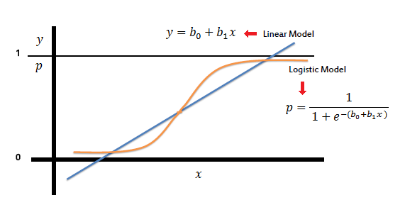
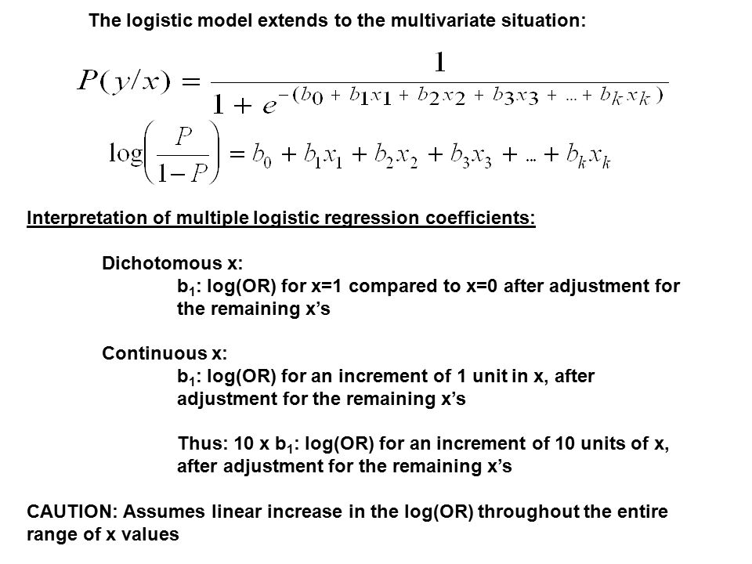

MD = LogisticRegression(C=1.0).fit(X,y)
y_true = y
y_pred = MD.predict(X)
score = MD.score(X,y)

β0 = MD.intercept_[0]
β1,β2 = MD.coef_[0]
a = MD.decision_function(X) #positive numbers = class 1 negative numbers = class 0
nd = MD.predict_proba(X) # m x 2 matrix with probabilities for class 0 and class 1

For LogisticRegression and LinearSVC the trade-off parameter that determines the strength of the regularization is C.

Higher values of C correspond to less regularization. In other words, when you use a high value for the parameter C, LogisticRegression and LinearSVC try to fit the training set as best as possible, while with low values of the parameter C, the models put more emphasis on finding a coefficient vector (w) that is close to zero.
There is another interesting aspect of how the parameter C acts. Using low values of C will cause the algorithms to try to adjust to the “majority” of data points, while using a higher value of C stresses the importance that each individual data point be classified correctly.

Lower C = more regularization = a simpler model = finds the underlying structure = underfitting
Higher C = less regularization = a more complex model = try to classify each datapoint correctly = overfitting

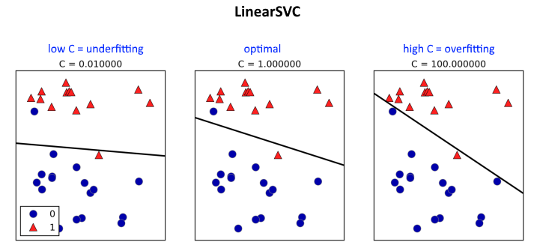

If the training set and test set scores are very close we are most likely underfitting.

If the training set score is close to 1.0 but the test set score is quite low, we are overfitting.

If the train set score is below 1.0 and the test set score is a bit lower than the train set score, we have built an optimal model.

decision boundry for LinearSVC, LogisticRegression and others
plt.scatter(*X.T, c=y, cmap=plt.cm.RdBu)
XX,YY = np.meshgrid(*(np.linspace(*sorted(X[:,i])[::len(X)-1],100) for i in (0,1)))
ZZ = MD.decision_function(np.c_[XX.ravel(),YY.ravel()]).reshape(XX.shape)
plt.contour(XX,YY,ZZ, levels=[0], cmap=plt.cm.binary_r)

If the number of observations is equal (or less than) the number of features + 1 target array, then the LogisticRegression or LinearSVC can fit a hyperplane to all these data-points so that the score is 100%

demo of the above-said
import numpy as np
from sklearn.linear_model import LogisticRegression
from sklearn.svm import LinearSVC
n = 10 # the score will be 100%
X = np.random.randint(0,100, size=(n,n))
y = np.random.binomial(n=1, p=0.5, size=n)
assert len(set(y))>1, "the y array containst onlyone class labels"
MD = LogisticRegression(C=1).fit(X,y)
score = MD.score(X,y)
print(score)
MD = LinearSVC(C=1).fit(X,y)
score = MD.score(X,y)
print(score)

the C parameter and L1 vs. L2 penalty in LogisticRegression
from sklearn.linear_model import LogisticRegression
import numpy as np, matplotlib.pyplot as plt
np.set_printoptions(linewidth=290, precision=2, suppress=True)
#from myutils import print
m = 100
n = 25
X = np.random.normal(loc=np.random.randint(low=0, high=100, size=n),
scale=np.random.uniform(1,3, size=n),
size=(m,n))
X1 = np.c_[[1,]*len(X), X]
print(X1[:10])
W = np.random.randint(-10,10, size=n+1) # +1 = y-intercept
xx = (X1*W).sum(axis=1)
y = np.where(xx >= xx.mean(), 1, 0)
"""LOGISTIC REGRESSION"""
'''C = high penalty=L2'''
MD = LogisticRegression(C=1e3).fit(X,y)
w0 = MD.intercept_[0]
W = MD.coef_[0]
score = MD.score(X,y)
print(w0, W)
print("score:", score)
plt.scatter(range(1,len(W)+1), W, label='C = {} penalty=L2'.format(MD.C), marker="o")
'''C = low penalty=L2'''
MD = LogisticRegression(C=1).fit(X,y)
w0 = MD.intercept_[0]
W = MD.coef_[0]
score = MD.score(X,y)
print(w0, W)
print("score:", score)
plt.scatter(range(1,len(W)+1), W, label='C = {} penalty=L2'.format(MD.C), marker="o")
'''C = high penalty=L1'''
MD = LogisticRegression(C=1e3, penalty='l1').fit(X,y)
w0 = MD.intercept_[0]
W = MD.coef_[0]
score = MD.score(X,y)
print(w0, W)
print("number of zeros:", (W==0).sum(), "or", str((W==0).sum()/len(W)*100)+"%")
print("score:", score)
plt.scatter(range(1,len(W)+1), W, label='C = {} penalty=L1'.format(MD.C), marker="d")
'''C = low penalty=L1'''
MD = LogisticRegression(C=1, penalty='l1').fit(X,y)
w0 = MD.intercept_[0]
W = MD.coef_[0]
score = MD.score(X,y)
print(w0, W)
print("number of zeros:", (W==0).sum(), "or", str((W==0).sum()/len(W)*100)+"%")
print("score:", score)
plt.scatter(range(1,len(W)+1), W, label='C = {} penalty=L1'.format(MD.C), marker="d")
"""PLOT"""
plt.axhline(0, color='gray')
plt.xticks(range(1,len(W)+1))
plt.legend()
plt.show()

Large values for alpha or small values for C mean
high regularization
simpler model

Logistic Regression, again

logit is a natural logarithm of odds
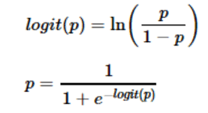

logistic regression formula:

remember:

because:
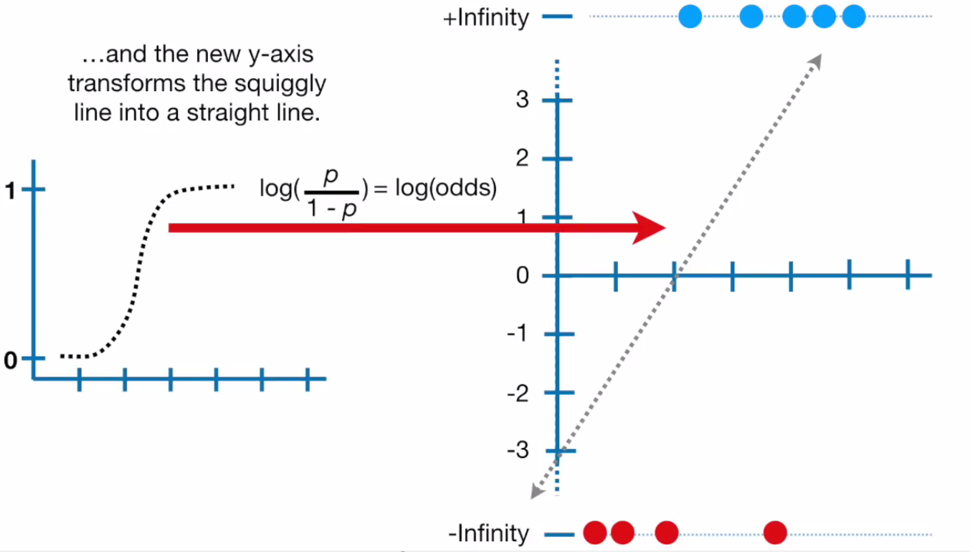
Logistic function is not linear, while the logit function is linear

probability --> odds --> logit
from math import log as ln
p = (1/3, 2/3, 1/4, 3/4, 1/11, 10/11, 0.5)
odds = [p/(1-p) for p in p] #odds = (1/2, 2/1, 1/3, 3/1, 1/10, 10/1, 1/1)
logit = [ln(odds) for odds in odds]
print(p, odds, logit, sep="\n")

demo on Logistic Regression with polynomial expansion
import numpy as np
import matplotlib.pyplot as plt
from mpl_toolkits import mplot3d
d = plt.rcParams
d['figure.subplot.top'] = 0.99
d['figure.subplot.bottom'] = 0.04
d['figure.subplot.right'] = 0.96
d['figure.subplot.left'] = 0.04
d['figure.subplot.hspace'] = 0.07
d['figure.subplot.wspace'] = 0.07
fig = plt.figure(figsize=(9,9))
plt.tight_layout()
#DATA
t = np.linspace(-2, 2, 100)
x1,x2 = np.meshgrid(t,t)
z = -1 + 2*x1**2 + -x2**2 + -0.1*x2**3 + x2**4 + 1.5*x1*x2 + -0.25*x1**2*x2**3
w = [-1, 0, 0, 2, 1.5, -1, 0, 0, 0, -0.1, 0, 0, 0, 0, 1, 0, 0, 0, -0.25, 0, 0] #polynomial weights (degree=5)
#PLOT 1 & 2
sp = fig.add_subplot(221, projection='3d')
sp.plot_surface(x1,x2,z)
sp = fig.add_subplot(222)
cs = sp.contour(x1,x2,z, 20)
sp.clabel(cs, inline=True, fontsize=8, fmt='%d')
sp.set_title("contour plot", va='baseline', pad=-15, fontsize=20, fontweight='bold', family='Times New Roman')
#SUBSET THE DATA
mask = (x1**2+x2**2).ravel() <= 2**2
x1,x2,z = (a.ravel()[mask] for a in (x1,x2,z))
m = 2500
nx = np.random.choice(len(x1), size=m, replace=False)
x1,x2,z = (a[nx] for a in (x1,x2,z))
labels = z >= 0
#ADD NOISE
x1 += np.random.normal(loc=0, scale=0.01, size=len(x1)) #add some noise
x2 += np.random.normal(loc=0, scale=0.1, size=len(x2)) #add some noise
#FAKE ESTIMATOR (BASED ON POLYNOMIAL EXPANSION)
class LogisticRegressionFake:
def __init__(self, solver='polinomial'):
pass
def fit(self, X,y):
from sklearn.preprocessing import PolynomialFeatures; from numpy import array, float16, newaxis
poly = PolynomialFeatures(degree=5, interaction_only=False, include_bias=True).fit(X)
X = poly.transform(X)
#suppose this 'algorithm' finds the following weights
θ = [-1, 0, 0, 2, 1.5, -1, 0, 0, 0, -0.1, 0, 0, 0, 0, 1, 0, 0, 0, -0.25, 0, 0]
self.θ = array(θ, dtype=float16)[:,newaxis]
self.weights = θ
return self
def predict(self, X):
from sklearn.preprocessing import PolynomialFeatures
X = PolynomialFeatures(degree=5, interaction_only=False, include_bias=True).fit_transform(X)
z = n = (X @ self.θ).ravel()
labels = y = (z >= 0)
return y
X = np.vstack([x1,x2]).T
y = labels
md = LogisticRegressionFake().fit(X,y)
ypred = labels = md.predict(X)
score = (y == ypred).sum() / len(y) # 100% if no noise is added
print("fake predictor score =", score)
print("eights found by the fake LogisticRegression\n", md.weights)
#PLOT 3
sp = fig.add_subplot(223)
sp.scatter(*X.T, c=ypred, marker='.')
sp.set_title("fake Logistic Regression", va='baseline', pad=-20, fontsize=15, fontweight='bold', family='Times New Roman')
#PREDICT WITH REAL LOGISTIC REGRESSION
from sklearn.preprocessing import PolynomialFeatures
from sklearn.linear_model import LogisticRegression
Xpoly = PolynomialFeatures(degree=5, include_bias=True, interaction_only=False).fit_transform(X)
md = LogisticRegression(solver='liblinear', C=100).fit(Xpoly,y)
weights = md.intercept_.round(1).tolist() + md.coef_.ravel().round(1).tolist()
score = md.score(Xpoly,y) # 99% if no noise is added
ypred = md.predict(Xpoly)
print("linear LogisticRegression with polynomial expansion score =", score)
print("weights found by the LogisticRegression with polinomial expansion\n", weights)
#PLOT 4
sp = fig.add_subplot(224)
sp.scatter(*X.T, c=ypred, marker='.')
sp.set_title("Logistic Regression\nwith polinomial expansion", va='baseline', pad=-25, fontsize=15, fontweight='bold', family='Times New Roman')
#PREDICT WITH LOGISTIC MODEL (WITHOUT POLYNOMIAL EXPANSION)
md = LogisticRegression(solver='lbfgs', C=100).fit(X,y)
score = md.score(X,y) # only 66%
ypred = md.predict(X)
print("LogisticRegression without polinomial expansion score =", score)
plt.show()

vizualize Logistic Regression with polynomial expansion (with 4D data: 3 features + target)
import numpy as np
from math import pi
import matplotlib.pyplot as plt
from mpl_toolkits import mplot3d

#MAKE DATA (4D = 3 features + target)
t = np.linspace(-pi, pi, 30)
X1,X2,X3 = np.meshgrid(t,t,t)

Y = -2 + X1**2 + 2*X2**2 + 0.5*X3**2 + 1.5*X1*X2 #3D blob
Y = Y >= 0 #labels

#ADD NOISE
X1,X2,X3 = (X+np.random.normal(loc=0, scale=0.1, size=X1.shape) for X in (X1,X2,X3))

#PLOT THE BLOB ONLY (i.e. y==0)
fig = plt.figure()
sp = fig.add_subplot(111, projection='3d')

nx = Y.ravel() == 0 #scatter-plot the blob only and not all the points
x1,x2,x3,y = (M.ravel()[nx] for M in (X1,X2,X3,Y))
sp.scatter(x1,x2,x3, marker='.', alpha=0.7)

#ARRANGE INTO ONE MATRIX
g = (X.ravel() for X in (X1,X2,X3))
X = np.vstack(list(g)).T
y = labels = Y.ravel().astype(np.uint8)

#LOGISTIC REGRESSION WITH POLYNOMIAL EXPANSION
from sklearn.preprocessing import PolynomialFeatures
from sklearn.linear_model import LogisticRegression
from sklearn.pipeline import make_pipeline
poly = PolynomialFeatures(degree=2, interaction_only=False, include_bias=True)
md = LogisticRegression(solver='liblinear', C=1.0)
pl = make_pipeline(poly, md)
pl.fit(X,y)

score = pl.score(X,y)
print("score =", score)

weights = pl.steps[1][1].coef_.ravel().round(1).tolist()
print("weights =", weights)
print("poly's =", pl.steps[0][1].get_feature_names())
plt.show()

#FYI
weights = [-4.2, -0.1, 0.0, 0.0, 4.2, 5.9, 0.0, 8.3, 0.0, 2.2]
polys = ['1', 'x0', 'x1', 'x2', 'x0^2', 'x0 x1', 'x0 x2', 'x1^2', 'x1 x2', 'x2^2']

small demo on LogisticRegression
import numpy as np

y = [1,2,3]*3 + [1]
y = np.array(y, dtype=np.uint8)

x0 = np.ones(len(y), dtype=np.uint8)
x1 = np.arange(1, len(y)+1)
x2 = x1 / y #linear relationshicp
x2 = y / x1 #non-linear
X = np.vstack([x1,x2]).T

from sklearn.linear_model import LogisticRegression
from sklearn.preprocessing import PolynomialFeatures
Xpoly = PolynomialFeatures(degree=2, interaction_only=True, include_bias=True).fit_transform(X)
md = LogisticRegression(C=10, solver='liblinear', multi_class='ovr')
md.fit(Xpoly,y)
score = md.score(Xpoly,y)
print(score)

import matplotlib.pyplot as plt
plt.scatter(x1,x2, c=y)

demo on the inverse-regularizer hyperparameter in LogisticRegression C = 1/λ
import numpy as np; e = np.exp(1)
from matplotlib.pyplot import show, plot, axhline, text
from sklearn.linear_model import LogisticRegression

x = (1,2,5,6,7,8,9)
X = np.array(x, dtype=np.uint8).reshape(-1,1); x = X.ravel()
y = [0,0,1,0,1,1,1]; ytrue = y

""" λ close to zero means almost no regularisation (i.e. LogRegression w/out Regularization)
Try other values for λ for example: 0.1, 1, 10, 100
Note that for this particular model the optimal values for λ are for example 0.1 and 1 """
λ = 1E-10 # very close to zero
lgr = LogisticRegression(C=1/λ, solver='liblinear').fit(X,y)
accuracy = lgr.score(X,y)

β0 = lgr.intercept_[0]
β1 = lgr.coef_[0,0]

z = β0 + β1*x
p = 1 / (1 + e**-z)
y = p > 0.5 # this is ypred

p = lambda x : 1 / (1 + e**-(β0 + β1*x))

xlin = np.linspace(-5, 15, 100)
ppred = [p(x) for x in xlin]

plot(xlin, ppred)
plot(x, ytrue, 'ob')
plot(x, [p(x) for x in x], 'o')
axhline(y=0.5, color='gray', lw=0.5, ls='--')
text(2,0.8, "accuracy = {:.2f}".format(accuracy))

Non-GLM models

The two most common linear classification algorithms are logistic regression and linear support vector machines

LinearSVC

Equasion for the line of intercection between a plane and the xy plane
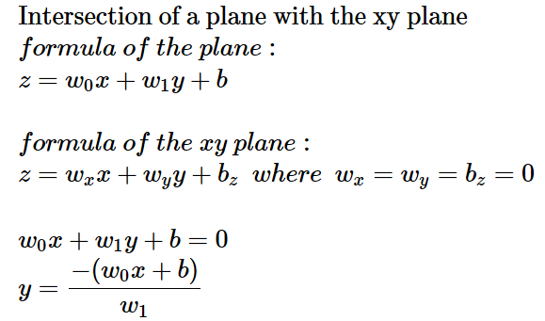

Batch learning

SGDClassifier = regularized linear models with stochastic gradient descent (SGD). (SVM, logistic regression, a.o. with SGD training)

svm = sklearn.linear_model.SGDClassifier(loss='hinge') #a linear SVM
lgr = sklearn.linear_model.SGDClassifier(loss='log') #logistic regression (regularized)

batch learning with a stochastic gradient descent (SGD) classifier
from sklearn.linear_model import SGDClassifier, LogisticRegression
from sklearn.preprocessing import StandardScaler
from numpy import matrix, linspace, c_, ones, exp, set_printoptions; set_printoptions(suppress=True, precision=4)
from numpy.random import seed; seed(42)
from scipy.stats import binom
#independent features
m,n = 100,5
nn = [n*20000 for n in range(1, n+1)]
pp = linspace(0, 1, n+2)[1:-1]
M = binom.rvs(n=nn, p=pp, size=(m,n))
#define weights
w = linspace(-1, 2, n)
w0 = -round((M@w).mean())
w = [w0, *w.tolist()]
#full matrix (design-matrix)
X = c_[ones(m, dtype='i')[:,None], M]
X = matrix(X, dtype='i')
#calculate the target-array
y = n = X@w
labels = y >= 0
#same as...
p = 1 / (1 + exp(1)**-n)
labels = p >= 0.5
y = labels.tolist()[0]
#the whole data set
XX,yy = M.astype('f'), y
"""MODEL"""
sc = StandardScaler()
lgr = SGDClassifier(loss='log') #regularized logistic regression
"""INITIAL BATCH"""
X,y = XX[:10], yy[:10]
sc.fit(X) # this fitted scaler will have to be used on each new batch
X = sc.transform(X)
XXtr = sc.transform(XX) #just for the scoring purpuses
lgr.partial_fit(X, y, classes=[0, 1]) #classes must be provided on the first partial_fit
score = lgr.score(XXtr, yy)
print("score after the initial batch = ", score)
"""BATCH LEARNING"""
batchsize = 5 # 5 samples
for batch,ix in enumerate(range(10, 56, batchsize)):
X,y = XX[ix:ix+batchsize], yy[ix:ix+batchsize] #current batch
X = sc.transform(X) #scale using the scaler fitted on the initial batch
lgr.partial_fit(X, y)
score = lgr.score(XXtr, yy) #score on the whole data-set to see the current fit
print("score after batch {} =".format(batch+1), score)

SVM

import numpy as np, pandas as pd; from pandas import DataFrame, Series
import matplotlib.pyplot as plt; from matplotlib.pyplot import plot, scatter
import seaborn as sns; sns.set(font_scale=1.25)
from sklearn.svm import SVC

n=11
X = np.random.RandomState(4).uniform(-1,1, size=(n,2))
X = X[np.argsort(X[:,0])]
l = ["a"]*(len(X)//2) + ["b"]*(len(X)-(len(X)//2))

df = DataFrame({'A':X[:,0], 'B':X[:,1], 'C':l})
sns.lmplot(x='A', y='B', hue='C', data=df, fit_reg=False, palette='Set1', scatter_kws={'s':50}, markers=['v','p'])

"""linear binary SVM classifier"""
X = df.loc[:,'A':'B'].values
y = df['C'].astype('category').cat.rename_categories([0,1]).values.astype(np.int8)
md = SVC(kernel='linear', C=1e10).fit(X,y)
y_pred = md.predict(X)

"""mark the support vectors on the plot"""
nd = md.support_vectors_
sp = plt.gca()
sp.scatter(*nd.T, s=150, facecolor='none', edgecolor='gray', linewidth=1.5, alpha=0.7)
[sp.text(*(nd+0.045), "support vector", fontsize=10, style='italic', family='Arial') for nd in nd]

"""DRAW THE SVC MARGINS"""
XX,YY = np.meshgrid(*[np.linspace(*np.sort(a)[[0,-1]],100) for a in X.T])
ZZ = md.decision_function(np.c_[XX.ravel(),YY.ravel()]).reshape(XX.shape)
plt.contour(XX,YY,ZZ, levels=[-1,0,1], colors='gray', linestyles=['--','-','--'])

"""DRAW THE SEPARATION LINE"""
xx = np.sort(X[:,0])[::len(X)-1]
w = md.coef_[0] # the weights are given in parametric form (?)
a = -w[0] / w[1]
yy = a * xx - (md.intercept_[0]) / w[1]
t = plt.ylim()
plot(xx,yy, color='0.3', linestyle='-', lw=3)
plt.ylim(*t);

one vs rest for multiclass classification ???
import numpy as np, pandas as pd; from pandas import DataFrame, Series
import matplotlib.pyplot as plt; from matplotlib.pyplot import plot, scatter
import seaborn as sns; sns.set(font_scale=1.25)

n=20
X = np.random.RandomState(4).uniform(-1,1, size=(n,2))
X = X[np.argsort(X[:,0])]
l = ["a"]*(len(X)//3) + ["b"]*(len(X)//3) +["c"]*(len(X)-(len(X)//3*2))

df = DataFrame({'A':X[:,0], 'B':X[:,1], 'C':l})
sns.lmplot(x='A', y='B', hue='C', data=df, fit_reg=False, scatter_kws={'s':50}, col_order=['red','green','blue'])

"""linear binary SVM classifier"""
X = df.loc[:,'A':'B'].values
y = df['C'].astype('category').cat.rename_categories([0,1,2]).values.astype(np.int8)
from sklearn.svm import SVC
md = SVC(kernel='linear', decision_function_shape='ovr').fit(X,y)
y_pred = md.predict(X)
sp = plt.gca()
sp.scatter(*X[y==0].T, s=120, facecolor='none', edgecolor='b', linewidth=1.5, alpha=0.7)
sp.scatter(*X[y==1].T, s=120, facecolor='none', edgecolor='g', linewidth=1.5, alpha=0.7)
sp.scatter(*X[y==2].T, s=120, facecolor='none', edgecolor='r', linewidth=1.5, alpha=0.7)
#[sp.text(*(nd+0.045), "support vector", fontsize=10, style='italic', family='Arial') for nd in md.support_vectors_]
sp.set_title("decision_function_shape='ovr' (one vs rest)", fontweight='bold', fontsize=12);

custom kernel for SVM
def pseudo_rbf(x1,x2):
n = len(mx) # shape = (n_samples, n_samples) kernel matrix
return np.ones(shape=(n,n))

from sklearn.svm import SVC
md = SVC(kernel=pseudo_rbf).fit(X,y)

SVC

md = SVC(kernel='linear', C=1e10).fit(X,y)
nd = md.support_vectors_

support vectors are also those points that lie within the margins of the SVM “street”
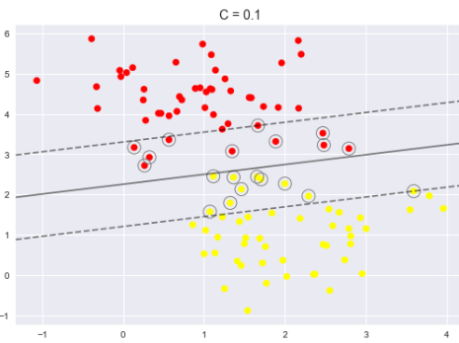



My YouTube playlist on SVM
https://www.youtube.com/watch?v=N1vOgolbjSc&index=11&list=PL-sf6rj93rjIOJxdcMvMABiqfXaXdnCw_&pbjreload=10

exploring RBF’s

my example of an rbf
def scale_and_add_rbf_dimension(X): #transforms the input matrix by adding an adittional dimension
from numpy import exp, c_
assert "ndarray" in str(type(X)), "Must be an ndarray"
X = X.__sub__(X.mean(axis=0)) / ((X.max(axis=0) - X.min(axis=0))/2) #scaler
a = (X**2).sum(axis=1) # self-dot-products
a = exp(-a) # rbf array
X = c_[X,a[:,None]] # adds the rbf array
return X

Example of Linear SVC with 3D data, which is to be transformed into 4D data via RBF (with a single landmark) before applying Linear SVC
import matplotlib.pyplot as plt
from mpl_toolkits import mplot3d
import numpy as np
import seaborn as sns
sns.set(font_scale=0.7)
plt.rcParams['image.cmap'] = 'RdBu'
from math import pi as π
from itertools import product
from numpy import cos, sin
#make a sphere
n = 50*2
θ = φ = np.linspace(-π,π, n)
g = product(θ, φ)
l = list(g) # list of tuples
xx = [cos(θ)*sin(φ) for θ,φ in l]
yy = [sin(θ)*sin(φ)/1.5 for θ,φ in l]
zz = [cos(φ) for θ,φ in l]
#add some noise
rg = np.random.RandomState(0)
[globals().__setitem__(s, globals()[s]+rg.randn(len(xx))/10) for s in ('xx','yy','zz')]
X = np.c_[xx,yy,zz]
#remove some points from the north and south pole
def is_point_near_pole(a):
from numpy import percentile, logical_or, array
if "ndarray" not in str(type(a)): a = array(a, dtype='f')
percentiles = percentile(a, np.linspace(0, 100, 10))
mask = logical_or((a >= percentiles[0]) & (a <= percentiles[2]), (a >= percentiles[-3]) & (a <= percentiles[-1]))
return mask
#==============================
mask = is_point_near_pole(X[:,-1])
mask[mask==True] = rg.binomial(1, p=0.5, size=len(mask[mask==True]))
X = X[~mask]
#target array
y = [-1,]*len(X)
#make the inner blob
cm = [[4,1,1],
[1,2,1],
[1,1,3]] ; cm=np.array(cm)
nd = rg.multivariate_normal(mean=[0,0,0], cov=cm/250, size=n*5)
y = y + [1,]*len(nd) ; y = np.array(y, dtype='i8') # append to the target array
X = np.vstack([X,nd])
#sort the data
nx = np.argsort(X[:,0])
X = X[nx]
y = y[nx]
#rescale the data
mn = X.min()
X = X + abs(mn)
X = X * 10
#the toy data is now ready to use
#draw the data
sp = plt.subplot(projection='3d')
sp.scatter(*X.T, marker='.', alpha=0.15, c=y)
sp.set_xlabel('x-axis');sp.set_ylabel('y-axis');sp.set_zlabel('z-axis')
sp.axis('equal');
#$$$$$$$$$$$$$$$$$$$$$$$$$$$$$$$$$$$$$$$$$$$$$$$$$$$$$$$$$$$$$$$$$$$$$$$$$$$$$$$$$$$$
#transform the data
def scale_and_add_rbf_dimension(X): #transforms the input matrix by adding an adittional dimension of rdf
from numpy import exp, c_
assert "ndarray" in str(type(X)), "Must be an ndarray"
X = X.__sub__(X.mean(axis=0)) / ((X.max(axis=0) - X.min(axis=0))/2) #scaler
a = (X**2).sum(axis=1) # self-dot-products
a = exp(-a) # rbf array
X = c_[X,a[:,None]] # adds the rbf array
return X
#===========================================================
X = scale_and_add_rbf_dimension(X) # the X is now 4D data
print("data shape:", X.shape, y.shape)
#apply linear SVC
from sklearn.svm import SVC
MD = SVC(kernel='linear', C=1).fit(X,y) #if C=1e5 then score=100%
p = MD.score(X,y)
print("score:",p)
plt.show()

Kernels
kernels are in essence similarity functions e.g.
Gaussian kernel:

Kernels are sometimes notated as:

radial basis function kernel == Gaussian kernel

terminology:
RBF kernel SVC = radial basis function kernel support vector classifier

visualize Gaussian kernel in 3D
import matplotlib.pyplot as plt
from mpl_toolkits import mplot3d
import numpy as np
#%matplotlib inline
def gaussian_kernel(data, landmark='mean'):
from numpy import array, exp
X = data
landmark = X.mean(axis=0) if landmark=='mean' else array(landmark)
assert landmark.shape == (2,), "bad landmark"
n = len(X)
a = ((X-landmark)**2).sum(1)
sqrt_a = a**0.5
mu = sqrt_a.mean()
sigma_squared = ((sqrt_a - mu)**2).sum() / (n-1)
a = exp(-(a / (2*sigma_squared))) # gaussian similarity of the datapoints with the landmark
return a
XX,YY = np.meshgrid(*[np.linspace(-5,5,100) for _ in range(2)])
X = np.c_[XX.ravel(), YY.ravel()]
feature = gaussian_kernel(X, landmark='mean')
ZZ = feature.reshape(XX.shape)
sp = plt.subplot(projection='3d', elev=30, azim=30)
sp.plot_surface(XX,YY,ZZ, cmap='jet');
plt.show()

almost the same
MD = sklearn.svm.LinearSVC(C=1e10, random_state=0).fit(X,y)
MD = sklearn.svm.SVC(kernel='linear', C=1.0, random_state=0).fit(X,y)

demo on Linear SVC
import matplotlib.pyplot as plt
from mpl_toolkits.mplot3d import Axes3D, axes3d
from sklearn.datasets import make_blobs
from sklearn.svm import LinearSVC, SVC
import numpy as np
#DATA
X,y = make_blobs(centers=4, random_state=8)
y = y%2
#TRANSFORM THE DATA FROM 2D INTO 3D
f0,f1,f2 = *X.T, X[:,1]**2
X = np.c_[f0,f1,f2]
#LINEAR SVC
MD = LinearSVC(C=1.0).fit(X,y) ; print("score:",MD.score(X,y))
#SEPARATOR PLANE
a,b,c = MD.coef_.ravel()
d = MD.intercept_.ravel()[0] #ax+by+cz = d z = (ax + by + d) / -c
XX,YY = np.meshgrid(*[np.linspace(*t*1.1, 100) for t in np.sort(X[:,:2],axis=0)[[0,-1]].T])
ZZ = (XX*a + YY*b + d) / -c
#3D PLOT
fig = plt.figure(figsize=(12,5))
sp = fig.add_subplot(121, projection='3d')
sp.scatter3D(*X.T, c=y)
sp.plot_surface(XX,YY,ZZ, rstride=8, cstride=8, color='gray', alpha=0.5)
d = dict(fontweight='bold', fontsize=12, color='blue')
sp.set_xlabel(r"$x_1$",**d); sp.set_ylabel(r"$x_2$",**d); sp.set_zlabel(r"$x_2^2$", **d)
#SUPPORT VECTORS
nd = SVC(kernel='linear', C=1.0).fit(X,y).support_vectors_ #just 2 support vectors
sp.scatter3D(*nd.T, facecolor='none', s=75, edgecolors='gray')
#2D PLOT
ZZ = YY ** 2
ZZ = MD.decision_function(np.c_[XX.ravel(),YY.ravel(),ZZ.ravel()]).reshape(XX.shape)
sp = fig.add_subplot(122)
mask = y==0
sp.scatter(*X[mask,:2].T, marker=',', color='r')
sp.scatter(*X[~mask,:2].T, marker='v', color='b')
sp.contourf(XX,YY,ZZ, levels=[ZZ.min(),0,ZZ.max()], cmap='RdBu', zorder=-1)
sp.scatter(*nd.T[:2], facecolor='none', s=125, edgecolors='k', linewidths=0.5)
sp.set_xlabel(r"$x_1$",**d); sp.set_ylabel(r"$x_2$",**d)
plt.show()

Drawing a plane: from the general form to slopes-intercept form
MD = LinearSVC(C=1.0).fit(X,y)
a,b,c,d = *MD.coef_[0], MD.intercept_[0] #ax+by+cz = d z = (ax + by + d) / -c
XX,YY = np.meshgrid(*[np.linspace(*t*1.1, 100) for t in np.sort(X[:,:2],axis=0)[[0,-1]].T])
ZZ = (XX*a + YY*b + d) / -c
sp.plot_surface(XX,YY,ZZ, rstride=8, cstride=8, color='gray', alpha=0.5)

the gamma hyperparameter is used for non-linear kernels
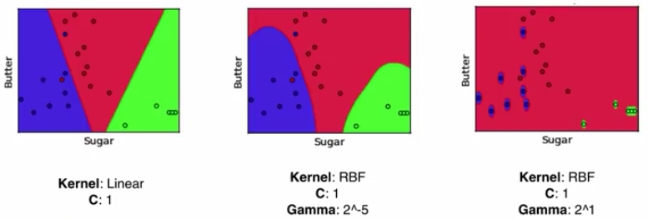

the C hyperparameter aka slack penalty
The optimal C should be tuned via cross-validation.
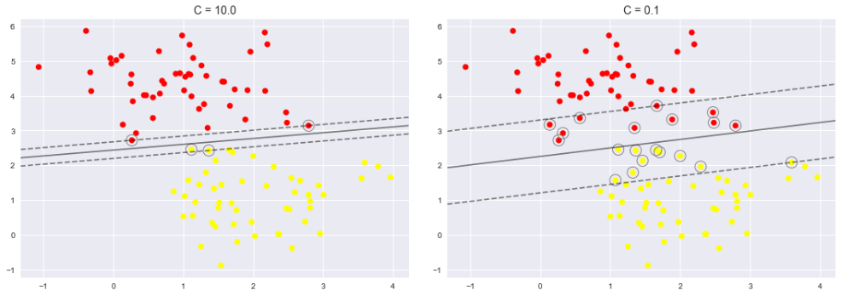
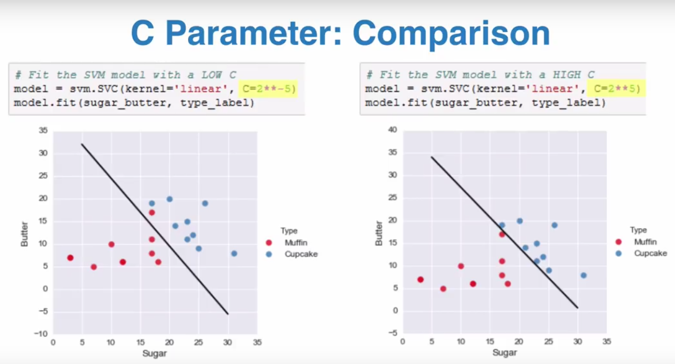

Demo of the above-said
import numpy as np, matplotlib.pyplot as plt
import seaborn as sns; sns.set(font_scale=1.1)
from sklearn.svm import SVC
from sklearn.datasets.samples_generator import make_blobs
X, y = make_blobs(n_samples=100, centers=2, random_state=0, cluster_std=0.85)
fig,SP = plt.subplots(nrows=1, ncols=3, figsize=(15,5))
[sp.scatter(X[:, 0], X[:, 1], c=y, s=50, cmap=plt.cm.RdBu) for sp in SP.flat]
for c,sp in zip([0.01, 1, 100], SP.flat):
MD = SVC(kernel='linear', C=c).fit(X,y)
XX,YY = np.meshgrid(*[np.linspace(*np.sort(a)[[0,-1]], 100) for a in X.T])
ZZ = MD.decision_function(np.c_[XX.ravel(),YY.ravel()]).reshape(XX.shape)
sp.contour(XX,YY,ZZ, levels=[-1,0,1], linestyles=['--','-','--'], colors='gray')
sp.set_title("C="+str(MD.C))
plt.show()

import numpy as np, pandas as pd; from pandas import DataFrame, Series
import matplotlib.pyplot as plt; from matplotlib.pyplot import plot, scatter
import seaborn as sns; sns.set(font_scale=1.25)
from sklearn.svm import SVC

n=11
X = np.random.RandomState(4).uniform(-1,1, size=(n,2))
X = X[np.argsort(X[:,0])]
l = ["a"]*(len(X)//2) + ["b"]*(len(X)-(len(X)//2))

df = DataFrame({'A':X[:,0], 'B':X[:,1], 'C':l})
sns.lmplot(x='A', y='B', hue='C', data=df, fit_reg=False, palette='Set1', scatter_kws={'s':50}, markers=['v','p'])

"""linear binary SVM classifier"""
X = df.loc[:,'A':'B'].values
y = df['C'].astype('category').cat.rename_categories([0,1]).values.astype(np.int8)
md = SVC(kernel='linear', C=1e10).fit(X,y)
y_pred = md.predict(X)

"""mark the support vectors on the plot"""
nd = md.support_vectors_
sp = plt.gca()
sp.scatter(*nd.T, s=150, facecolor='none', edgecolor='gray', linewidth=1.5, alpha=0.7)
[sp.text(*(nd+0.045), "support vector", fontsize=10, style='italic', family='Arial') for nd in nd]

"""DRAW THE SVC MARGINS"""
XX,YY = np.meshgrid(*[np.linspace(*np.sort(a)[[0,-1]],100) for a in X.T])
ZZ = md.decision_function(np.c_[XX.ravel(),YY.ravel()]).reshape(XX.shape)
plt.contour(XX,YY,ZZ, levels=[-1,0,1], colors='gray', linestyles=['--','-','--'])

"""DRAW THE SEPARATION LINE"""
xx = np.sort(X[:,0])[::len(X)-1]
w = md.coef_[0] # the weights are given in parametric form (?)
a = -w[0] / w[1]
yy = a * xx - (md.intercept_[0]) / w[1]
t = plt.ylim()
plot(xx,yy, color='0.3', linestyle='-', lw=3)
plt.ylim(*t);

C
The C parameter is a regularization parameter. C means how much the SVM model should care about getting all data-points right.

A smaller C means a wider margin and more misclassified data-points. With a smaller C, the margin is softer, and allows for a better fit (at the cost of a few points that will be sacrificed and end up being incorrectly classified)

For large C, the margin is hard, and points cannot lie in it. A large C therefore means a narrower street but less wrongly classified points

gamma
gamma is the inverse of the width of the Gaussian kernel:

A small gamma means a large radius for the Gaussian kernel (i.e. large standard deviation), which means that many points are considered close by. A low value of gamma means that the decision boundary will vary slowly, which yields a model of low complexity.

A high value of gamma yields a more complex model. A high gamma means a smaller standard deviation.

By default, C = 1 and gamma = 1/n_features

import matplotlib.pyplot as plt
from mpl_toolkits.mplot3d import Axes3D, axes3d
from sklearn.svm import SVC
from numpy import linspace, meshgrid, c_
from itertools import product
def make_data():
from sklearn.datasets import make_blobs
from numpy import array, ones, bool
X, y = make_blobs(centers=2, random_state=4, n_samples=30)
y[array([7, 27])] = 0
mask = ones(len(X), dtype=bool)
mask[array([0, 1, 5, 26])] = 0
X, y = X[mask], y[mask]
return X, y
X,y = make_data()
mask = y==0
C = [0.1, 1, 1000]
γ = [0.1, 1, 10]
g = product(C,γ)
fig = plt.figure(figsize=(10,7))
fig.subplots_adjust(wspace=0.2, hspace=0.2)
d = dict(s=50, edgecolor='k')
for i,(C,γ) in enumerate(g):
fig.add_subplot(3,3,i+1)
plt.scatter(*X[~mask].T, marker='^', color='r', **d)
plt.scatter(*X[mask].T, marker='o', color='b', **d)
plt.xticks([]);plt.yticks([])
#FIT SVC MODEL
MD = SVC(kernel='rbf', C=C, gamma=γ).fit(X,y)
p = MD.score(X,y)#; print("score:", round(p,3))
#DRAW THE SEPARATOR
XX,YY = meshgrid(*[linspace(*t,100) for t in (plt.xlim(),plt.ylim())])
ZZ = MD.decision_function(c_[XX.ravel(),YY.ravel()]).reshape(XX.shape)
plt.contour(XX,YY,ZZ, colors='gray', linestyles='-', zorder=-2)
plt.contour(XX,YY,ZZ, levels=[-1,0,1], colors='k', linestyles=['--','-','--'], linewidths=3, zorder=-1)
#INFO
plt.title("C={0:.1f}, {gamma}={1:.1f}".format(MD.get_params()['C'],MD.get_params()['gamma'], gamma='\u03B3'),
fontsize=10, loc='center',
fontdict={'fontweight': 'bold', 'verticalalignment': 'bottom'})
continue
#SUPPORT VECTORS
sv = MD.support_vectors_
im = MD.dual_coef_.ravel() # importance of the support vectors
#mask = im>0 # important support vectors
plt.scatter(*sv[im>0].T, marker='o', s=270, facecolor='none', edgecolor='k', linewidth=3, zorder=1, label='important support vectors')
plt.scatter(*sv[~(im>0)].T, marker='o', s=270, facecolor='none', edgecolor='gray', linewidth=3, zorder=1, label='unimportant support vectors')
plt.title("score={:.3f}".format(MD.score(X,y)))
plt.legend(fontsize=10);
plt.show()

SVM’s are very sensitive to the settings of the parameters and to the scaling of the data. They require all the features to vary on a similar scale. A common rescaling method for kernel SVMs is to scale the data such that all features are between 0 and 1.

scalar
import numpy as np
np.set_printoptions(precision=4, suppress=True)
from myutils import print
rg = np.random.RandomState(0)
n =10
X = np.array([rg.randint(1,100, size=n),
rg.normal(10,3, size=n),
rg.uniform(-1,1, n)]).T
print(X)
def split_data(data, proportion=0.75):
from random import shuffle
from numpy import array
l = [True,]*int(n*proportion) + [False]*(n-int(n*proportion))
shuffle(l)
nx = array(l, dtype='bool')
train_data, test_data = data[nx], data[~nx]
return train_data, test_data
def scaler(data, scalar=None): #TRANSFORM SO THAT MIN=0 MAX=1
assert 'ndarray' in str(type(data)) and (scalar is None or 'Scalar' in str(type(scalar)))
from collections import namedtuple
X = data
mn = X.min(axis=0) if scalar is None else scalar.min
rn = (X.max(axis=0) - mn) if scalar is None else scalar.range
X = (X - mn) / rn
nt = namedtuple('Scalar', "min range")(mn, rn)
return X, nt
Xtrain, Xtest = split_data(X)
print(Xtrain, Xtest)
Xtrain, nt = scaler(Xtrain)
print(Xtrain, nt)
Xtest, _ = scaler(Xtest, nt)
print(Xtest)

import numpy as np, matplotlib.pyplot as plt
#make data
Σ = [[1,1,1,1,0],
[0,2,1,1,1],
[0,0,3,1,1],
[0,0,0,4,1],
[0,0,0,0,5]]
Σ = np.array(Σ).T.__or__(Σ) # make a symetrical matrix from a triangular matrix
n = 500
μ = [10,15,20,25,5]
X_class_0 = np.random.multivariate_normal(mean=μ, cov=Σ, size=n)
X_class_1 = np.random.multivariate_normal(mean=np.array(μ)+3, cov=Σ, size=n)
X = np.concatenate([X_class_0, X_class_1], axis=0)
n_features = X.shape[1]
nx = np.argsort(X[:,0])
X = X[nx]
y = [0,]*n + [1,]*n
y = np.array(y)[nx]
#make plots
X_class_0 = X[y==0] #mask = y==0
X_class_1 = X[~(y==0)] #~mask
fig, SP = plt.subplots(3,2, figsize=(10,7), sharey=True, facecolor='0.9')
fig.subplots_adjust(hspace=0.5)
for i,sp in enumerate(SP.flat):
if i == len(SP.flat)-1:
sp.axis('off')
break
counts, breaks = np.histogram(X[:,i], bins=50)
sp.hist(X_class_0[:,i], bins=breaks, color='blue', alpha=0.5, density=True, label="class 0")
sp.hist(X_class_1[:,i], bins=breaks, color='red', alpha=0.5, density=True, label="class 1")
sp.axvline(X[:, i].mean(), color='0.4', lw=0.5, ls=':')
sp.set(facecolor='0.8')
sp.set_title(f"feature {i+1}")
SP[0,0].legend(loc='best')
"""PCA"""
from sklearn.preprocessing import StandardScaler
from sklearn.decomposition import PCA
Xscaled = StandardScaler().fit_transform(X)
Xtransformed = PCA().fit_transform(Xscaled) # all 5 features are kept
Xscaled = StandardScaler().fit_transform(X)
pca = PCA(n_components=2)
Xpca = pca.fit_transform(Xscaled)
#plot PCA
fig, sp = plt.subplots(1,1, facecolor='0.9')
sp.scatter(*Xpca.T, c=y, cmap=plt.cm.RdBu, alpha=0.6, s=10)
"""SVM"""
from sklearn.svm import SVC
svm = SVC(kernel='linear', C=1e4).fit(Xpca, y)
#draw decision boundry
t = sp.axis()
X,Y = np.meshgrid(*(np.linspace(start,end,100) for start,end in [t[:2],t[2:]]))
Z = svm.decision_function(np.c_[X.ravel(),Y.ravel()]).reshape(Y.shape)
sp.contour(X,Y,Z, alpha=0.5, zorder=-3, levels=[-1,0,1], linestyles=['--','-','--'], colors='k')
sp.set_title(f"linear SVM model score = {svm.score(Xpca,y)}")
plt.show()

LinearSVC
import numpy as np, matplotlib.pyplot as plt

def make_data(m=10, n=2, minmax=False, noise=False, seed=None):
from random import randint

#random state #692, 998, 377
seed = seed or randint(0,1000)
print("seed =", seed)
np.random.seed(seed)

#data
X = np.random.uniform(-1,1, size=(m,n))

#labels (ground truth)
random = randint(0,1)
if n==2:
f = lambda x,y : ((x+y-0)if random==1 else (x-y+0)) >= 0
y = [int(f(x,y)) for x,y in X]
else:
nx = X.sum(1).argsort()
X = X[nx]
y = np.zeros(shape=m).astype(int)
y[m//2:] = 1
y = np.array([(-1,1)[int(y)] for y in y], dtype='int8')

#add a gap between the classes
mask = np.array(y)==1
gap = 0.25
X[mask] += gap if random==1 else (gap, -gap) if n==2 else 0

#add noise, standerdize, normalize
noise = True
if noise: X += np.random.randn(m,n)*0.25
X = (X-X.mean(0)) / X.std(axis=0, ddof=0) # data must be centered
if minmax: X = (X - X.min(0)) / (X.max(0)-X.min(0))
return(X,y)

###############################################################################

X,y = make_data(20)

from sklearn.svm import LinearSVC, SVC
from sklearn.linear_model import SGDClassifier
from sklearn.preprocessing import StandardScaler
from sklearn.pipeline import make_pipeline

(m,n) = X.shape
C = 1.0

sc = StandardScaler() # The LinearSVC class regularizes the bias term, so you should center the training set

md = LinearSVC(dual=False, # False means gradient descent (?)
C=1.0, # C = 0 >>> hard margins?
loss='squared_hinge', # default = 'squared hinge'
penalty='l2', # the standard is L2 for SVM's)
multi_class='ovr',
fit_intercept=True, # if False then the data is expected to be already centered
max_iter=5) # because this is Gradient Descent (?))

md = LinearSVC(dual=True, # if n > m
C=1.0, # C = 0 >>> hard margins?
loss='hinge', # default = 'squared hinge'
penalty='l2', # the standard is L2 for SVM's)
multi_class='ovr',
fit_intercept=True) # if False then the data is expected to be already centered

md = SVC(kernel="linear", C=1.0) # slower than LinearSVC

md = SGDClassifier(loss="hinge", alpha=1/(m*C)) # Stochastic Gradient Descent, for large data-sets and online training
# SGDClassifyer (same as LinearSVC) doesn’t support kernel trick

pl = make_pipeline(sc, md)
pl.fit(X,y)

acc = pl.score(X,y)
print("accuracy =", acc.round(2))

w1,w2 = md.coef_.ravel()
b = md.intercept_[0]
slope = -w1/w2
intercept = -b/w2

xline = (-3,3)
yline = np.array([slope*x+intercept for x in xline])
plt.plot(xline, yline)
plt.plot(xline, yline+1, '--', color='gray')
plt.plot(xline, yline-1, '--', color='gray')

plt.plot(*X[y==+1].T, '^r', ms=10)
plt.plot(*X[y==-1].T, 'sb', ms=10)
plt.xlim(*np.sort(X[:,0])[[0,-1]]+[-.5,.5])
plt.ylim(*np.sort(X[:,1])[[0,-1]]+[-.5,.5])

Kernelized SVC
import numpy as np, matplotlib.pyplot as plt

def make_data(m=1000, n=2):
X = np.random.randn(m,n)
f = lambda x,y : y > (x*0.75)**4-0.5
y = np.array([f(x,y) for x,y in X] , dtype='uint8')
X[y==1, 1] += 0.75
X[y==0, 0] *= 1.2
X += np.random.normal(loc=0, scale=0.1, size=(m,n))
a = np.deg2rad(-45)
R = [[np.cos(a), -np.sin(a)],[np.sin(a), np.cos(a)]]
X = np.matmul(R,X.T).T
X = (X - X.mean(0)) / X.std(0, ddof=0)
return(X,y)

X,y = make_data(500) # the data is already centered

from sklearn.svm import SVC
#SVC with Polynomial kernel
md = SVC(C=1.0, # uses Lagrangian Dual Objective function
kernel='poly', # poly, rbf, sigmoid
gamma=0.5, # the scaler term c in (c(xi·xj)+b)^p
coef0=1, # the bias term in (c(xi·xj)+b)^p
degree=2) # the power term in (c(xi·xj)+b)^p

#SVC with RBF
md = SVC(C=1.0, # uses Lagrangian Dual Objective function with C (?)
kernel='rbf',
gamma=0.5, # the gamma term in -γ||xi-xj||^2 where γ=1/(2*σ)^2
coef0=1, # ignored in RBF
degree=0) # ignored in RBF

#SVC with Perceptron kernel
md = SVC(C=1.0, # uses Lagrangian Dual Objective function with C (?)
kernel='sigmoid',
gamma=0.5, # the scaler term c in tanh(c(xi·xj)+b)
coef0=-2, # the bias in tanh(c(xi·xj)+b)
degree=0) # ignored in Perceptron kernel

"""
gamma='scale' >>> 1/(n_features*var(X)) (default)
gamma='auto' >>> 1 / n_features
"""

md.fit(X,y)
acc = md.score(X,y)
print("accuracy =", acc.round(2))

#visualize
plt.scatter(*X.T, c=y, marker='o', cmap='RdBu')
r = np.linspace(-4,4, 100)
XX,YY = np.meshgrid(r,r)
XXX = np.c_[XX.ravel(), YY.flatten()]
ZZ = np.sign(md.decision_function(XXX).reshape(XX.shape))
plt.contourf(XX,YY,ZZ, alpha=0.5)

PCA in combination with kernelized SVC (with balanced class weights for the parameter C)
import matplotlib.pyplot as plt
from sklearn.datasets import fetch_lfw_people
plt.rcParams['image.cmap'] = 'bone'

#get the data
d = fetch_lfw_people(min_faces_per_person=60)
pn = d.images #3D data
X = d.data #2D data
y = d.target
l = names = d.target_names #names list = target names

#split the data
from sklearn.model_selection import train_test_split
X1,X2, y1,y2 = train_test_split(X,y, random_state=42, stratify=None) #startify=None means stratify = yes please

#make a pipeline
from sklearn.decomposition import PCA
from sklearn.svm import SVC
from sklearn.pipeline import make_pipeline
pca = PCA(n_components=150, whiten=True, svd_solver='randomized', random_state=42)
svc = SVC(kernel='rbf', class_weight='balanced') # C and gamma will be grid-searched for
pl = make_pipeline(pca, svc)

#grid search
from sklearn.model_selection import GridSearchCV
d = {'svc__C': [1,5,10,50], 'svc__gamma': [0.0001, 0.0005, 0.001, 0.005]}
me = GridSearchCV(pl, param_grid=d, cv=3, scoring="accuracy")
me.fit(X1,y1)
d = me.best_params_
md = me.best_estimator_
d = me.cv_results_

#evaluate
best_acc = me.best_score_ #best validtation accuracy
test_acc = md.score(X2,y2)
print("best val accuracy = {:.0%}\ttest accuracy = {:.0%}".format(best_acc, test_acc))

#predict
ypred = md.predict(X2)

#recall and precision
from sklearn.metrics import classification_report, confusion_matrix
s = classification_report(y2, ypred, target_names=names)
print(s)

#confusion matrix
from seaborn import heatmap
mx = confusion_matrix(y2, ypred)
mx = ((mx / mx.sum()) * 100).round(0).astype('uint8')
sp = heatmap(mx, square=True, annot=True, fmt='d', cbar=False,
xticklabels=names, yticklabels=names, cmap='OrRd')
sp.set_ylabel("ACTUAL"); sp.set_xlabel("PREDICTED");
sp.set_title("confusion matrix\n(percentages)")

get the support vectors and dual values (the alphas)
import numpy as np, matplotlib.pyplot as plt
from sklearn.datasets import make_blobs

#DATA
(m,n) = 100,2
X,y = make_blobs(n_samples=m, n_features=n, centers = 4, cluster_std=1.5, random_state=42)
y = y%2

#MODEL
from sklearn.svm import SVC
C = 1.0
γ = 0.05
md = SVC(C=C, kernel="rbf", gamma=γ)
md.fit(X,y)

#EVALUATE
acc = md.score(X,y)
print("accuracy =", acc)

#GET SUPPORT VECTORS AND ALPHAS
nx = md.support_ #indeces of the support vectros
l = md.n_support_ #number of support vectors for each class
S = md.support_vectors_ #matrix of support vectors
αα = md.dual_coef_.flatten().__abs__() # alphas (originally they're αi*yi)
mask = np.logical_and(0 < αα, αα < C).flatten() # the support vectros lying in the street's gutters

#KERNEL
def rbf(xi,xj, γ):
similarity = np.exp(-γ * sum((xi-xj)**2))
return similarity
K = rbf

#PREDICT
y = np.array([-1 if y==0 else 1 for y in y], dtype='int8') # transform y∈{0,1} into y∈{-1,1}

b = sum([1 - yi* sum([αj*yj*K(xi,xj,γ) for αj,yj,xj in zip(αα[mask], y[nx][mask], X[nx][mask])])
for yi,xi in zip(y[nx][mask], X[nx][mask])]) / len(S[mask])
b = 0 # set to zero because there must be a bug in the bias formula
predict = lambda xj: np.sign(sum([αi*yi*K(xi,xj,γ) for αi,yi,xi in zip(αα, y[nx], X[nx])]) + b)
ypred = np.array([predict(x) for x in X], dtype='int8') # same labels as in y (almost)

#VISUALIZE
plt.scatter(*X.T, c=y, cmap='RdBu')
plt.plot(*X[nx][mask].T, 'o', ms=12, mec='g', mew=2, fillstyle="none", label="support vectors lying in the gutters")
plt.plot(*X[nx][~mask].T, 'o', ms=10, mec='k', mew=1.5, fillstyle="none", label="support vectors lying within the margin")
plt.legend(fontsize='small')

t = plt.axis()
XX,YY = np.meshgrid(*(np.linspace(*t, 100) for t in (t[:2],t[2:])))
ZZ = md.decision_function(np.c_[XX.ravel(), YY.flatten()]).reshape(XX.shape)
plt.contourf(XX,YY,ZZ, cmap='RdBu', alpha=0.5, zorder=-3)

another visual example of the above
import numpy as np, matplotlib.pyplot as plt

def make_data():
from sklearn.datasets import make_blobs
from numpy import array, ones, bool
X, y = make_blobs(centers=2, random_state=4, n_samples=30)
y[array([7, 27])] = 0
mask = ones(len(X), dtype=bool)
mask[[0, 1, 5, 26]] = 0
X, y = X[mask], y[mask]
return X, y

X,y = make_data()

#FIT SVC MODEL
from sklearn.svm import SVC
C = 10
γ = 0.1
md = SVC(kernel='rbf', C=C, gamma=γ).fit(X,y)
acc = md.score(X,y)

#GET SUPPORT VECTORS AND ALPHAS
nx = md.support_ #indeces of the support vectros
l = md.n_support_ #number of support vectors for each class
S = md.support_vectors_ #matrix of support vectors
αα = md.dual_coef_.flatten().__abs__() # alphas (originally they're αi*yi)
mask = np.logical_and(0 < αα, αα < C).flatten() # the support vectros lying in the street's gutters

#KERNEL
def rbf(xi,xj, γ):
similarity = np.exp(-γ * sum((xi-xj)**2))
return similarity
K = rbf

#PREDICT
yy = np.array([-1 if y==0 else 1 for y in y], dtype='int8') # transform y∈{0,1} into y∈{-1,1}

b = sum([1 - yi* sum([αj*yj*K(xi,xj,γ) for αj,yj,xj in zip(αα[mask], yy[nx][mask], X[nx][mask])])
for yi,xi in zip(yy[nx][mask], X[nx][mask])]) / len(S[mask])
b = 0 # set to zero because there must be a bug in the bias formula
predict = lambda xj: np.sign(sum([αi*yi*K(xi,xj,γ) for αi,yi,xi in zip(αα, yy[nx], X[nx])]) + b)
ypred = np.array([predict(x) for x in X], dtype='int8') # same labels as in y (almost)

#VISUALIZE
mask = y==0
d = dict(s=90, edgecolor='k')
plt.scatter(*X[~mask].T, marker='^', color='r', **d)
plt.scatter(*X[mask].T, marker='s', color='b', **d)
plt.xticks([]);plt.yticks([])

#DRAW THE SEPARATOR
XX,YY = np.meshgrid(*[np.linspace(*t,100) for t in (plt.xlim(),plt.ylim())])
ZZ = md.decision_function(np.c_[XX.ravel(),YY.ravel()]).reshape(XX.shape)
plt.contour(XX,YY,ZZ, colors='gray', linestyles='-', zorder=-2)
plt.contour(XX,YY,ZZ, levels=[-1,0,1], colors='k', linestyles=['--','-','--'], linewidths=3, zorder=-1)

#DRAW SUPPORT VECTORS
S = md.support_vectors_
alphas = md.dual_coef_.__abs__().ravel()
mask = np.logical_and(0 < alphas, alphas < C)
plt.scatter(*S[mask].T, marker='o', s=270, facecolor='none', edgecolor='k', linewidth=3, zorder=1, label='support vectors lying in the gutters')
plt.scatter(*S[~mask].T, marker='o', s=270, facecolor='none', edgecolor='gray', linewidth=3, zorder=1, label='support vectors lying within the margin')
plt.title("accuracy = {:.3f}".format(md.score(X,y)))
plt.legend(fontsize=8);

Kernelized SVM

non-linear SVM binary classifier demo
import sklearn.svm
import numpy as np
import matplotlib.pyplot as plt
from matplotlib.pyplot import plot, scatter
from mpl_toolkits.mplot3d import Axes3D
def make_dataset(n=1000):
m=n
cm = [[10,2],
[2,10]]
m = 1000
X = np.random.RandomState(1).multivariate_normal(mean=[0,0], cov=cm, size=m)
mask = np.logical_and((X**2).sum(axis=1)**0.5 > 2, (X**2).sum(axis=1)**0.5 <= 2.5)
X = X[~mask]
mask = (X**2).sum(axis=1)**0.5 > 6
X = X[~mask]
y = np.zeros(shape=len(X), dtype=np.uint8)
mask = (X**2).sum(axis=1)**0.5 < 2 #Euclidiean distance
y[mask] = 1
nx = np.argsort(X[:,0])
X = X[nx]; y = y.take(nx)
return X,y
#===========================================================================================
X,y = make_dataset()
"""PLOT 1"""
plt.subplot(221)
scatter(*X.T, marker='.', c=y, cmap=plt.cm.RdBu)
scatter((),(), marker='.', color='darkred', label='class 0')
scatter((),(), marker='.', color='darkblue', label='class 1')
sp = plt.gca()
sp.set_aspect('equal')
sp.set_facecolor('0.98')
sp.set_title('original dataset with 2 classes', fontdict={'fontsize':8, 'fontweight':'bold'})
sp.legend(loc='upper left', fontsize='xx-small', frameon=False, scatterpoints=3)
"""SVM"""
md = sklearn.svm.SVC(kernel='rbf')
md.fit(X,y)
y_pred = md.predict(X)
"""PLOT 2"""
plt.subplot(222, projection='3d')
sp = plt.gca()
sp.scatter(*X.T, marker='.', c=y_pred, cmap=plt.cm.RdBu)
sp.set_aspect('equal')
sp.set_title('SVM classifier', fontdict={'fontsize':8, 'fontweight':'bold'})
[eval("sp.set_{0:}label(('{0:}-label'), fontsize=8)".format(s)) for s in "xyz"]
sp.set_zticklabels(())
sp.set_facecolor('09')
"""PLOT 3"""
y_pred = md.decision_function(X) # elevation along the z axis
xx,yy = md.support_vectors_.T
plt.subplot(223, projection='3d')
sp = plt.gca()
sp.scatter(*X.T, y_pred, marker='.', c=y_pred, cmap=plt.cm.RdBu)
sp.set_aspect('equal')
sp.set_title("kernel='rbf'", fontdict={'fontsize':8, 'fontweight':'bold'})
[eval("sp.set_{0:}label(('{0:}-label'), fontsize=8)".format(s)) for s in "xyz"]
sp.set_facecolor('09')
sp.scatter(xx,yy, marker='.', s=10, label='support vectors', color='gray')
sp.legend(loc='lower left', fontsize='xx-small', frameon=False, scatterpoints=3)
"""PLOT 4 - a different kernel"""
md = sklearn.svm.SVC(kernel='sigmoid').fit(X,y)
y_pred = md.predict(X)
sp = plt.subplot(224, projection='3d')
sp.scatter(*X.T, y_pred, marker='.', c=y_pred, cmap=plt.cm.RdBu)
sp.set_aspect('equal')
sp.set_title("kernel='{}'".format(md.kernel), fontdict={'fontsize':8, 'fontweight':'bold'})
[eval("sp.set_{0:}label(('{0:}-label'), fontsize=8)".format(s)) for s in "xyz"]
sp.set_facecolor('09')
sp.scatter(xx,yy, marker='.', s=10, color='gray')
plt.tight_layout()
plt.subplots_adjust(wspace=0.001, hspace=0.001)
plt.gcf().set_facecolor('0.95')
plt.show()

a kernel is a function that takes in some arguments and spits out a similarity value.
examples of a kernel functions:

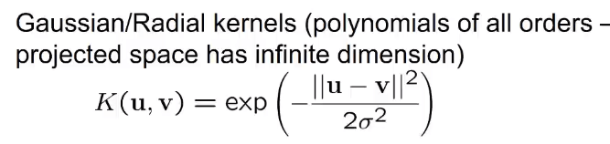
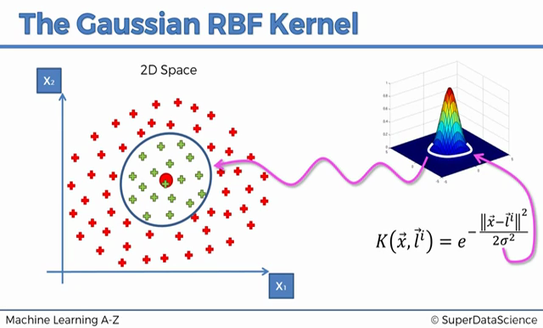

low C = allow misclassification for the sake of a wider ‘street’
high C = more correct classification but sacrifice the width of the street

SVR

Support Vector Regression
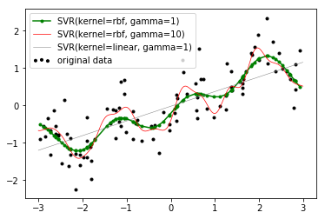

using linear kernel in SVR is basically equivalent to linear regression.
hence use RBF for support vector regression.

Support Vector Regression
import numpy as np, matplotlib.pyplot as plt
from sklearn.svm import LinearSVR, SVR

def make_data(m=100):
x = np.random.uniform(-7,7, size=m)
y = np.sin(x)/2 + 0.05*x + np.random.randn(m)/20
x = (x - x.mean()) / x.std(ddof=0); y = (y - y.mean()) / y.std(ddof=0)
return(x,y)

#data
x,y = make_data(m=100)
X = x.reshape(-1,1)

#models
md = LinearSVR(epsilon=1, C=1.0, dual=False, loss='squared_epsilon_insensitive')
md = LinearSVR(epsilon=1, C=1.0, dual=True, loss='epsilon_insensitive')
md = SVR(kernel="linear", C=1.0, epsilon=1)
md = SVR(kernel="rbf", gamma=10, C=1.0, epsilon=0.1)
md.fit(X,y)
R2 = md.score(X,y)

#visualize
plt.plot(x,y, '.')
plt.text(0.1, 0.9, "$R^2$ = {:.2f}".format(R2), transform=plt.gca().transAxes)

r = np.sort(X.ravel())[[0,-1]]
xline = np.linspace(*r, 100)
Xline = xline.reshape(-1,1)
ypred = md.predict(Xline)

plt.plot(xline, ypred, color='b', lw=2)
plt.plot(xline, ypred+1, "--", color='gray') # 1 = epsilon
plt.plot(xline, ypred-1, "--", color='gray')

SVM for Anomaly Detection

One-class SVM with non-linear kernel (RBF) for novelty detection
import numpy as np; import matplotlib.pyplot as plt
def make_data():
Σ = [[ 9,-4], [-4, 4]]
m = 1000
X = np.random.multivariate_normal(mean=[0,0], cov=Σ, size=m//2)
X = (X-X.mean(0)) / X.std(axis=0, ddof=0)
#standardize:
μ = X.mean(0); Σ = np.cov(X.T)

mahalanobis = lambda x : np.sqrt( (x-μ).T @ np.linalg.inv(Σ) @ (x-μ))
Xoutliers = np.random.uniform(-4,4, size=(500,2))
mahalanobis_distances = [mahalanobis(x) for x in Xoutliers]
mask = mahalanobis_distances > np.quantile(mahalanobis_distances, 0.5)
Xoutliers = Xoutliers[mask]

y = [0]*len(X) + [1]*len(Xoutliers)
X = np.concatenate([X,Xoutliers])
return(X,y)

#===========================================================================

X,y = make_data()
mask = np.array(y)==1

from sklearn.svm import OneClassSVM
md = OneClassSVM(kernel='rbf', gamma=0.5, nu=0.5).fit(X)
ypred = md.predict(X) == -1

#vizualize
fig,sp = plt.subplots(1,2, figsize=(10,5), sharex=True)
sp[0].plot(*X[~mask].T, '.b'); sp[0].plot(*X[mask].T, '.r')
sp[1].plot(*X[ypred==0].T, '.b'); sp[1].plot(*X[ypred==1].T, '.r')

DECISION TREES

Trees, Forest, Bagging, Boosting

md = DecisionTreeClassifier(max_depth=4, random_state=0)
md.fit(X_train, y_train)
a = md.feature_importances_
p = md.score(X_train, y_train)
p = md.score(X_test, y_test)

md = sklearn.tree.DecisionTreeClassifier(
max_depth=4, max_leaf_nodes=10, min_samples_leaf=50, random_state=0)

Decision Tree

md = DecisionTreeRegressor(min_samples_split=10)
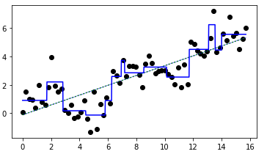

md = DecisionTreeRegressor(min_samples_split=5)
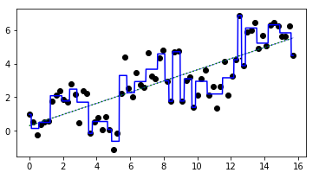

Decision Trees, again

graphviz in Jupyter
from sklearn.tree import export_graphviz; from graphviz import Source
s = export_graphviz(MD, out_file=None, filled=True, impurity=True,
class_names=d.target_names, feature_names=d.feature_names)
GR = Source(s) #Source(s, filename='filename', format='png') - saves a png file
GR.view() #opens a pdf
GR.render("DecisionTree") #saves a pdf
GR #shows in Jupyter

graphviz in IDE
#data
from sklearn.datasets import load_iris
d = load_iris()
X = d.data
y = d.target
#model
from sklearn.tree import DecisionTreeClassifier
tree = DecisionTreeClassifier().fit(X, y)
#make the .dot-string with the help of the sklearn utility function
from sklearn.tree import export_graphviz
string = export_graphviz(tree, out_file=None,
feature_names=d.feature_names, class_names=d.target_names,
impurity=True, rounded=True, filled=True, special_characters=True)
#save and view
import graphviz
gr = graphviz.Source(string, filename='image', format='png')
gr.view()
#use plt to show the saved tree-graph
import matplotlib, matplotlib.pyplot as plt
pn = matplotlib.image.imread('image.png')
plt.imshow(pn)
plt.show()

Pre-pruning:
maximum depth of the tree max_depth
maximum number of leaves max_leaf_nodes ???
minimum number of points in a node to keep splitting it min_samples_split
minimum number of samples required to be at a leaf node min_samples_leaf

scikit-learn only implements pre-pruning, not post-pruning
demo of the above
import numpy as np, pandas as pd
from sklearn.tree import DecisionTreeClassifier, export_graphviz
from graphviz import Source
from pylab import plot, scatter, show

"""MAKE DATA"""
RS = np.random.RandomState(0)
n=500
df = pd.DataFrame({'x1':RS.randn(n), 'x2':RS.rand(n)}).sort_values(by='x1', axis=0).reset_index(drop=True)
df['y'] = pd.cut(df['x1'].values, bins=np.percentile(df['x1'].values, [0,25,50,75,100]), right=True, include_lowest=True).rename_categories([0,2,4,6]).astype(int)
mask = df['x2'] > 0.5
df.loc[mask, 'y'] += 1
df.plot(kind='scatter', x='x1', y='x2', c='y', colormap='Set1');
#-------------------------------
"""MODEL"""
X = df[['x1','x2']].values
y = df['y'].values

MD = DecisionTreeClassifier() #comment the next line out and compare with this one
MD = DecisionTreeClassifier(max_depth=3, max_leaf_nodes=4, min_samples_split=300)
MD.fit(X,y)
s = export_graphviz(MD, out_file=None, filled=True, impurity=True, feature_names=['x1','x2'], class_names=[str(i) for i in range(8)])
GR = Source(s)
GR
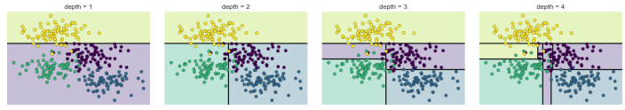
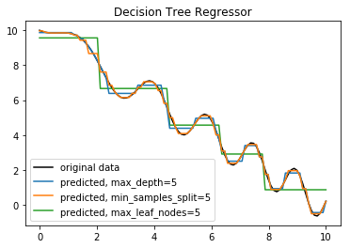

Setting either max_depth, max_leaf_nodes, or min_samples_leaf is sufficient to prevent overfitting.

sklearn.tree.DecisionTreeClassifier arguments
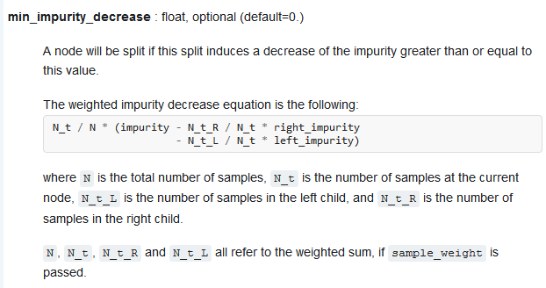
Requiring each split to make a large reduction in impurity helps a tree from being overfit

Feature importance in trees
feature importance rates how important each feature is for the decision a tree makes. It is a number between 0 and 1 for each feature, where 0 means “not used at all” and 1 means “perfectly predicts the target.” The feature importances always sum to 1:
MD.feature_importances_.sum() == 1

Demo
#three features that can perfectly predict the labels. See how the Decision Tree slects and uses them
from sklearn.tree import DecisionTreeClassifier
from io import StringIO
from pandas import read_table
import matplotlib.pyplot as plt
from mpl_toolkits.mplot3d import Axes3D
from numpy import set_printoptions
set_printoptions(precision=2)
s = r"""
1 1 1 0
2 2 1 0
3 2 1 0
5 4 2 1
6 5 2 1
6 6 2 1
8 4 3 1
9 5 3 1
10 6 3 1
12 7 4 0
13 8 4 0
14 7 4 0"""
df = read_table(StringIO(s), header=None, sep=r"\s", engine='python', names=['x1','x2','x3','y'])
print(df, "\n")
"""PLOT THE DATA"""
sp = plt.subplot(projection='3d')
xx,yy,zz = df.loc[:,'x1':'x3'].values.T
sp.scatter(xx,yy,zz, c=df['y'].values);
#plt.show()
X = df.loc[:,'x1':'x3'].values
y = df['y'].values
"""See how the Decision Tree uses the three features on each iteration"""
st = set()
for _ in range(25):
MD = DecisionTreeClassifier().fit(X,y)
st.add(str(MD.feature_importances_.round(2).tolist()))
print(*st, sep="\n")

Nowadays DecisionTrees are not used alone, instead in ensembles (Random Forset, Bagging, Boosting)

Random Forest, again

Bagging = bootstrapping the data (to build trees) and using aggregate to make a decision (i.e. soft vote for classification or mean for regression)

RandomForestClassifier arguments
MD = sklearn.ensemble.RandomForestClassifier(
#forest related arguments:
n_estimators=10, #number of trees in the forest
bootstrap=True, #of course
max_features='auto', #number of features to consider when looking for the best split
#tree related arguments:
criterion='gini', #impurity measure
max_depth=None, #maximum depth of the tree (i.e. the number of tiers in a tree)
max_leaf_nodes=None, #maximum number of leaves (i.e. in the lowest tier of the tree)
min_samples_split=2, #minimum number of samples a node must have before it can be split
min_samples_leaf=1, #minimum number of samples required to be at a leaf node
min_weight_fraction_leaf #same as min_samples_leaf but expressed as a fraction of the total
#...number of weighted instances
min_impurity_decrease=0.0, #A node will be split if this split induces a decrease of the impurity greater than this value
min_impurity_split=None, #related to the preceeding argument (?)
random_state=None)

nd = TREE.decision_path(X).toarray() #decision_path returns a sparse matrix

get a particular tree from a forest
FOREST = RandomForestClassifier(n_estimators=5, ...)
y_pred = FOREST.predict(X)

l = FOREST.estimators_ #list containing DecisionTrees
TREE = FOREST.estimators_[0] #the first tree from the forest
y_pred = TREE.predict(X)

probabilities of labels
mx = MD.predict_proba(X) #2D ndarray

s = sklearn.metrics.classification_report(ypred, ytrue)
s = sklearn.metrics.classification_report([0,1,2,0,2], [0,1,2,0,0])
precision recall f1-score support
0 0.67 1.00 0.80 2
1 1.00 1.00 1.00 1
2 1.00 0.50 0.67 2
avg / total 0.87 0.80 0.79 5

In practice we use hundreds or even thousands of trees in a forest

In general, it’s a good rule of thumb to use the default values: max_features=sqrt(n_features) for classification
max_features=log2(n_features) for regression

data in form of a sinusoid for a nonparametric random forest model
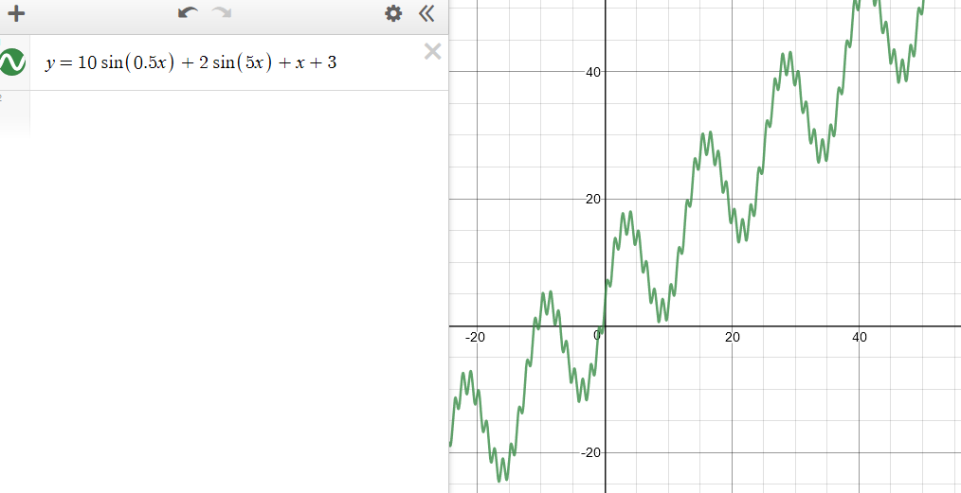

Trees Regression

graphviz for decision trees
import graphviz
s = """
digraph G{
edge [dir=forward]
node [shape=plaintext]
0 [label="0 (None)"]
0 -> 5 [label="root"]
1 [label="1 (Hello)"]
2 [label="2 (how)"]
2 -> 1 [label="advmod"]
3 [label="3 (are)"]
4 [label="4 (you)"]
5 [label="5 (doing)"]
5 -> 3 [label="aux"]
5 -> 2 [label="advmod"]
5 -> 4 [label="nsubj"]
}
"""
ob = graphviz.Source(s, filename="png_image", format="png")
ob.view()
#Show an image in matplotlib
import matplotlib.pyplot as plt
import matplotlib.image
nd = matplotlib.image.imread('png_image.png')
plt.imshow(nd)
plt.axis('off')
plt.show()

Demo on how Regression Trees work
#Demo on how Regression Trees work
import numpy as np, pandas as pd
import sklearn.tree
import matplotlib.pyplot as plt
import matplotlib.image
import graphviz
from scipy.stats import linregress
l = [(1,1),(1.5,1.5),(2,1.25),
(3.5,2),(4,2),(4.5,2.5),
(7,3.75),(7.5,4),(8,4),(8.5,4.25)]
nd = np.array(l)
xx,yy = nd.T
plt.subplot(121)
plt.scatter(xx,yy)
"""Regression Line"""
slope, intercept, *_ = linregress(xx,yy)
print(slope, intercept)
x1,x2 = np.sort(xx)[[0,-1]]
y1,y2 = (x*slope+intercept for x in (x1,x2))
plt.plot([x1,x2],[y1,y2], color="gray")
"""Regression Tree"""
md = sklearn.tree.DecisionTreeRegressor(max_depth=2, min_samples_split=5)
md = sklearn.tree.DecisionTreeRegressor(max_depth=2, min_samples_leaf=3) #returns the same result (for this particular dataset)
md.fit(xx[:,None], yy[:,None])
"""graphviz"""
s = sklearn.tree.export_graphviz(md, out_file=None, filled=True, rounded=True, special_characters=True)
print(s)
ob = graphviz.Source(s, filename='DecisionTree', format='png')
print(ob, type(ob))
ob.view() #opens the png file
plt.subplot(122)
nd = matplotlib.image.imread('DecisionTree.png')
plt.imshow(nd)
plt.axis('off')
"""Test the Tree"""
xx_test = np.array(range(10), dtype=np.uint8)
yy_pred = md.predict(xx_test[:,None])
df = pd.DataFrame({'test value':xx_test, 'predicted value':yy_pred.round(2)}, columns=['test value','predicted value'])
df.index.name = 'observation no.'
print("\n\n", df)
plt.show()

ENSEBMLE METHODS

VotingClassifier
from sklearn.ensemble import VotingClassifier
md1 = LogisticRegression(solver='lbfgs', C=1e6)
md2 = GaussianNB()
md3 = DecisionTreeClassifier()
estimators = [('logistic', md1), ('bayes', md2), ('tree', md3)]
md = VotingClassifier(estimators=estimators, voting='hard')
md.fit(X,y)
accuracy = md.score(X,y)

BAGGING, ADABOOST

difference between BaggingClassifier and RandomForestClassifier
In Random forest, only a subset of features is selected at random out of the total and the best split feature from the subset is used to split each node in a tree.
In bagging all features are considered for splitting a node.

voting vs bagging vs random forest
#DATA
import numpy as np
from sklearn.model_selection import train_test_split
m,n,k = 10000,5,3
X = np.random.randn(m,n)
y = (X * np.random.uniform(-1,1, size=n)).sum(1)
q = np.quantile(y, q=np.linspace(start=0, stop=1, num=k+1)[1:-1])
y = np.digitize(y, bins=q)
Xtrain,Xtest,ytrain,ytest = train_test_split(X,y, random_state=42)

#HARD VOTING
from sklearn.ensemble import VotingClassifier
from sklearn.tree import DecisionTreeClassifier
estimators = [("tree1", DecisionTreeClassifier(criterion='gini')),
("tree2", DecisionTreeClassifier(criterion='entropy')),
("tree3", DecisionTreeClassifier(max_depth=10))]
voting = VotingClassifier(estimators=estimators, voting='hard')
voting = VotingClassifier(estimators=estimators, voting='soft') # because decision trees can calculate probabilities
voting.fit(Xtrain, ytrain)

#BAGGING
from sklearn.tree import DecisionTreeClassifier
from sklearn.ensemble import BaggingClassifier
md = DecisionTreeClassifier()
bag = BaggingClassifier(base_estimator=md, n_estimators=100, max_samples=0.8,
bootstrap=True, oob_score=True)
# bagging uses a subset of the original dataset; uses soft-voting if the estimator outputs probabilities
bag.fit(Xtrain, ytrain)
P = bag.oob_decision_function_ # matrix of robabilities of the oob samples

#RANDOM FOREST
from sklearn.ensemble import RandomForestClassifier
forest = RandomForestClassifier(n_estimators=100, criterion='gini',
max_features=5, max_depth=10, min_samples_split=5, min_samples_leaf=3)
forest.fit(Xtrain, ytrain)
acc = forest.score(Xtest, ytest)

The BaggingClassifier automatically performs soft voting instead of hard voting if the base classifier can estimate class probabilities (i.e., if it has a predict_proba() method)

bagging vs pasting
#DATA
import numpy as np
from sklearn.model_selection import train_test_split
m,n,k = 10000,5,3
X = np.random.randn(m,n)
y = (X * np.random.uniform(-1,1, size=n)).sum(1)
y = np.digitize(y, bins=np.quantile(y, q=np.linspace(start=0, stop=1, num=k+1)[1:-1]))
Xtrain,Xtest,ytrain,ytest = train_test_split(X,y, random_state=42)

#IMPORTS
from sklearn.tree import DecisionTreeClassifier
from sklearn.ensemble import BaggingClassifier
md = DecisionTreeClassifier()

#BAGGING (bagging uses a subset of the original dataset; uses soft-voting if the estimator outputs probabilities)
bag = BaggingClassifier(base_estimator=md, n_estimators=100, max_samples=0.8,
bootstrap=True, oob_score=True)
bag.fit(Xtrain, ytrain)
P = bag.oob_decision_function_ # matrix of robabilities of the oob samples
acc = bag.score(Xtest, ytest)
print("bag acc =", acc)

#PASTING
paste = BaggingClassifier(base_estimator=md, n_estimators=100, max_samples=0.8,
bootstrap=False)
paste.fit(Xtrain, ytrain)
acc = paste.score(Xtest, ytest) # the pasting accuracy (at least in these settings) is lower than bagging
print("paste acc =", acc)

With BaggingClassifier you usually use an estimator other than DecisionTree because for Decision Tree you use RandomForest

bagging regression
import numpy as np
from sklearn.model_selection import train_test_split
#data
m,n = 1000, 5
X = np.random.randn(m,n)
y = (X * np.random.randn(n)).sum(1) + np.random.randn(m)/4 + 10
Xtrain,Xtest, ytrain,ytest = train_test_split(X, y)

#BAGGING REGRESSION
from sklearn.linear_model import LinearRegression
from sklearn.ensemble import BaggingRegressor
md = BaggingRegressor(LinearRegression(), n_estimators=10,
max_samples=0.8, max_features=1.0,
bootstrap=True, bootstrap_features=False,
oob_score=True, n_jobs=-1, warm_start=False, verbose=3, random_state=42)
md.fit(Xtrain, ytest)
rsq = md.score(Xtest, ytest)

AdaBoost classifier
#data
import numpy as np
from sklearn.model_selection import train_test_split
m,n,k = 10000,5,3
X = np.random.randn(m,n)
y = (X * np.random.uniform(-1,1, size=n)).sum(1)
q = np.quantile(y, q=np.linspace(start=0, stop=1, num=k+1)[1:-1])
y = np.digitize(y, bins=q)
Xtrain,Xtest,ytrain,ytest = train_test_split(X,y, random_state=42)

#AdaBoost
from sklearn.tree import DecisionTreeClassifier
from sklearn.ensemble import AdaBoostClassifier

stump = DecisionTreeClassifier(max_depth=1)
md = AdaBoostClassifier(base_estimator=stump, n_estimators=200, algorithm='SAMME.R')
md.fit(Xtrain, ytrain)

acc_train = md.score(Xtrain, ytrain)
acc_test = md.score(Xtest, ytest)

Gradient Boost Regressor
import numpy as np, matplotlib.pyplot as plt
#data
m = 200
X = np.random.uniform(-0.5, 0.5, size=m)[:,None]
y = X.ravel()**2*3 + np.random.normal(loc=0, scale=0.05, size=m)
X, Xnew = X[m//4:], X[:m//4]; y, ynew = y[m//4:], y[:m//4]

from sklearn.ensemble import GradientBoostingRegressor
md = GradientBoostingRegressor(n_estimators=200, max_depth=3, learning_rate=0.1)
md.fit(X,y)
Ypred = np.array(tuple(md.staged_predict(Xnew)))

Gradient Boost Classifier
#data
from sklearn.datasets import load_breast_cancer
d = load_breast_cancer()
X,y = d.data, d.target
from sklearn.model_selection import train_test_split
Xtrain, Xtest, ytrain, ytest = train_test_split(X,y, random_state=42)

#model
from sklearn.ensemble import GradientBoostingClassifier
md = GradientBoostingClassifier(n_estimators=100, learning_rate=0.1, max_depth=3) # max_depth must be from 1 to 5
md.fit(Xtrain, ytrain)

#report
acc_train = md.score(Xtrain, ytrain)
acc_test = md.score(Xtest, ytest)
print(acc_train, acc_test)

a = md.feature_importances_
L = md.staged_predict(Xtest) # list of nd-arrays
loss = md.loss_(Xtest[0], ytest[0])

sklearn.datasets.make_classification
from sklearn.datasets import make_classification
m,n,k = 100,5,3
X,y = make_classification(m, n, n_informative=n-2, n_redundant=1, n_repeated=0,
n_classes=k, n_clusters_per_class=1)
from pandas import DataFrame
from seaborn import pairplot
df = DataFrame([*X.T,y]).T; df.columns = ["x"+str(i) for i in range(1,n+1)]+["y"]
pairplot(data=df, hue="y")

XGBoost (a basic example)
from sklearn.datasets import load_iris
from sklearn.model_selection import train_test_split
#data
d = load_iris()
X = d.data
y = d.target
Xtrain, Xtest, ytrain, ytest = train_test_split(X,y, test_size=0.2, random_state=0)

#XGBoost model
import xgboost as xgb
train = xgb.DMatrix(Xtrain, label=ytrain)
test = xgb.DMatrix(Xtest, label=ytest)

params = {"max_depth": 3,
"eta": 0.3,
"objective": "multi:softmax",
"num_class": 3}
epochs = 10
md = xgb.train(params, train, epochs)

#predict and evaluate
ypred = md.predict(test)
from sklearn.metrics import accuracy_score
acc = accuracy_score(ytest, ypred)

another XGBoost example
from sklearn.datasets import make_classification
from sklearn.model_selection import train_test_split
m,n,k = 100_000, 100, 2
X,y = make_classification(m, n, n_informative=n//2, n_redundant=n//10, n_repeated=0,
n_classes=k, n_clusters_per_class=1)
Xtrain,Xtest,ytrain,ytest = train_test_split(X,y, test_size=0.2, random_state=42)

#XGBoost model
import xgboost as xgb
train = xgb.DMatrix(Xtrain, label=ytrain)
test = xgb.DMatrix(Xtest, label=ytest)

params = {"verbosity": 2,
"eta": 0.3, #learning rate
"max_depth": 5,
"tree_method": "hist",
"objective": "binary:logistic",
"eval_metric": "map"} #Mean Average Precision

epochs = 10
md = xgb.train(params, train, epochs)
info = md.eval(test)

XGBoost parameters
https://xgboost.readthedocs.io/en/latest/parameter.html

NON-LINEAR DATA REDUCTION, MANIFOLDS

Data Reduction algorithms can be linear (e.g. PCA) and non-linera (e.g. manifolds)

Manifold Algorithms

non-linear dimension reduction algorithms for manifolds include:
Isomap, Locally Linear Embedding, t-SNE, MDS

Comparison of Manifold Learning methods
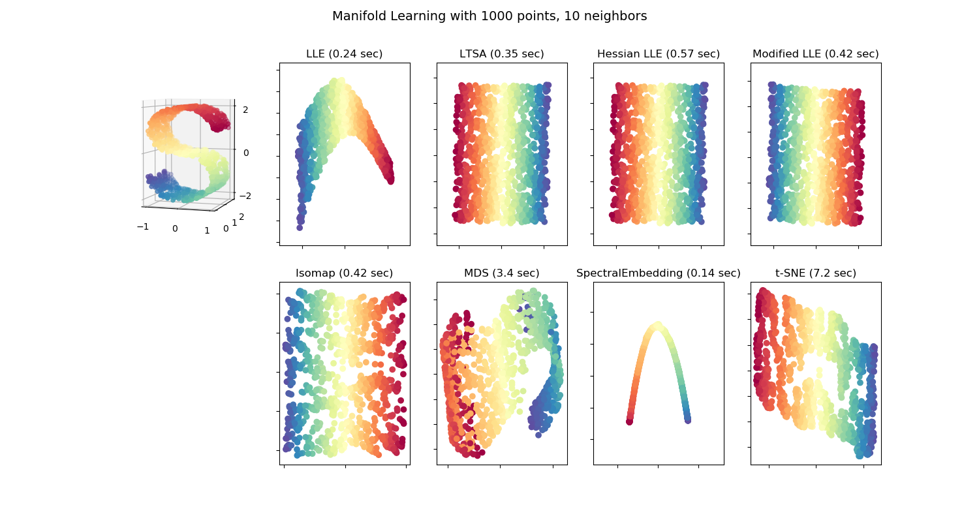
unroll a Swiss Roll / S-curve manifold with Locally Linear Embedding (and other manifold algoruthms)
from sklearn.datasets import make_s_curve, make_swiss_roll
from sklearn.manifold import LocallyLinearEmbedding, TSNE, Isomap
import matplotlib.pyplot as plt
from mpl_toolkits import mplot3d
#data
X,y = make_swiss_roll(n_samples=1500, random_state=42) # comment one of these out
X,y = make_s_curve(n_samples=1500, random_state=42) # comment one of these out
#LLE
lle = LocallyLinearEmbedding(n_components=2, n_neighbors=12, random_state=42).fit(X)
X_lle = lle.transform(X)
#t-SNE
X_tsne = TSNE(n_components=2, random_state=42).fit_transform(X,y)
#ISO
X_iso = Isomap(n_components=2, n_neighbors=12).fit_transform(X,y)
#plot
fig = plt.figure(num="num", figsize=(9,9))
fig.suptitle("suptitle")
d = dict(cmap=plt.cm.Spectral, c=y)
sp = fig.add_subplot(221, projection='3d')
sp.scatter(*X.T, **d)
sp.set_title("original 'Swiss Roll'/'S-curve' data", fontsize=9)
sp = fig.add_subplot(222)
sp.scatter(*X_lle.T, **d)
sp.set_title("data projected into {} \nwith Locally Linear Embedding".format(u'\u211D\u00B2'), fontsize=9)
sp = fig.add_subplot(223)
sp.scatter(*X_iso.T, **d)
sp.set_title("data projected into {} \nwith Isomap".format(u'\u211D\u00B2'), fontsize=9)
sp = fig.add_subplot(224)
sp.scatter(*X_tsne.T, **d)
sp.set_title("data projected into {} \nwith t-SNE".format(u'\u211D\u00B2'), fontsize=9)
plt.subplots_adjust(wspace=0.2, left=0.05)
plt.show()

Best manifold algorithms for different tasks
to unravel a 1D manifold-line, rolled into a spiral in 3D: Isomap, LocallyLinearEmbedding

exersise
import numpy as np, pandas as pd
from math import pi as π
import matplotlib.pyplot as plt
from mpl_toolkits.mplot3d import Axes3D
from scipy.io import wavfile
from sklearn.decomposition import NMF
from sklearn.tree import DecisionTreeRegressor
from sklearn.model_selection import train_test_split
from sklearn.manifold import Isomap

def vizualize_data(M):
fig = plt.figure(figsize=(10,4))
sp = fig.add_subplot(131)
sp.plot(M)
sp.set_title("three signals\nplotted together in 2D")

sp = fig.add_subplot(132)
sp.plot(*M[:,:-1].T)
sp.set_title("2D parametric plot of x and y")
sp.axis('equal')

sp = fig.add_subplot(133, projection='3d')
sp.plot(*M.T)
sp.set_title("3D parametric plot of x,y,z")

#make an audio file of the three signals
a = M.sum(axis=0)
a = np.int16(a/np.max(np.abs(a)) * 32767)
a = np.int16(a.tolist() * 1000)
wavfile.write(filename='sound.wav', rate=len(S), data=a)
return fig
##################################################################

#make data
n = 10 # n cycles
t = np.linspace(0, 2*π*n, 100*n)
x = np.sin(t) * np.exp(0.05 * t)**0.5
y = np.cos(t) * np.exp(0.05 * t)**0.5
z = np.sin(t) * np.cos(t)
S = np.c_[x,y,z] # S = signals matrix

fig = vizualize_data(S)

#scramble the signals
d = 3 #number of signals
n = 100 # number of mixes-up signals
scrambler = np.random.rand(d,n)

M = S @ scrambler
scalar = np.abs(np.min(M))
M += scalar
nmf = NMF(n_components=d).fit(M)
U = nmf.transform(M)

fig = vizualize_data(U)

#machine learning
df = pd.DataFrame(U, columns=['x1','x2','x3'])
X =df.values
y = t

Xtrain,Xtest, ytrain,ytest = train_test_split(X,y)
tree = DecisionTreeRegressor().fit(Xtrain, ytrain)
print("score:", tree.score(Xtest, ytest))

#manifolds
data = X[:,:2]
manifold = Isomap(n_components=1, n_neighbors=2).fit(data)
X_1D = manifold.transform(data)
y = list(range(1, len(t)+1))
plt.scatter(X_1D, [0,]*len(t), c=y, cmap='viridis', s=15)

data = X
manifold = Isomap(n_components=2, n_neighbors=2).fit(data)
X_2D = manifold.transform(data)
plt.scatter(*X_2D.T, c=y, cmap='viridis', s=15)

project a 2D manifold into 4D and then decompose into 2D with Isomap
from sys import path as l
s = r"D:\HPPavilion\PYCHARM"
l.append(s)

from myutils.datasets import make_swiss_roll
import matplotlib.pyplot as plt
from mpl_toolkits.mplot3d import Axes3D
import numpy as np
from sklearn.manifold import Isomap, LocallyLinearEmbedding

X,y = make_swiss_roll()

new_dimension = np.array(y, dtype=np.float_)
X = np.hstack([X,new_dimension.reshape(-1,1)])

manifold = Isomap(n_components=2, n_neighbors=5).fit(X)
X_2D = manifold.transform(X)

plt.scatter(*X_2D.T, c=y, cmap='viridis')

Multidimensional Scaling (MDS)

M = [[1,0,0,1,1], # 5 points; 3 dimensions
[0,1,0,1,2],
[0,0,1,1,3]]

M = np.array(M, dtype=np.int8).T # m x n matrix : m points, n features
mx = sklearn.metrics.pairwise_distances(M) # 5 x 5 matrix of mutual distances

import numpy as np, matplotlib.pyplot as plt
from sklearn.metrics import pairwise_distances
from math import cos, sin, radians

M = np.sort(np.random.randint(0,10, size=(5,2)), axis=0)
mx = pairwise_distances(M)

θ = radians(45)
T = [[cos(θ),-sin(θ)],
[sin(θ), cos(θ)]]

M_ = np.dot(M,T) # rotate through matrix multiplication
mx_ = pairwise_distances(M_) # distances maintain of course the same

b = np.allclose(mx, mx_) #True

Multidimensional scaling seeks a low-dimensional representation of the data in which the distances respect well the distances in the original high-dimensional space.
In general, is a technique used for analyzing similarity or dissimilarity in data. MDS attempts to model similarity or dissimilarity as distances in geometric space(s). The data can be ratings of similarity between objects, interaction frequencies of molecules, or trade indices between countries.
(MDS is best used for linear data)

sklearn.manifold.MDS
While computing a distance matrix from the (x, y) coordinates is straight‐forward, transforming the distances back into x and y coordinates is rather difficult. This is exactly what the multidimensional scaling algorithm aims to do: given a distance matrix between points, it recovers a D-dimensional coordinate representation of the data.
(use the precomputed dissimilarity to specify that we are passing a distance matrix)

same
D = sklearn.metrics.pairwise_distances(X) # distance matrix; X = e.g. 3D data
X_2D = sklearn.manifold.MDS(n_components=2, dissimilarity='precomputed').fit_transform(D)
X_2D = sklearn.manifold.MDS(n_components=2, dissimilarity= 'euclidean').fit_transform(X)

demo
import numpy as np, matplotlib.pyplot as plt
plt.rcParams['figure.figsize'] = (12,5)
from mpl_toolkits.mplot3d import Axes3D
from sklearn.datasets import make_s_curve
from sklearn.metrics import pairwise_distances
from sklearn.manifold import MDS
from sklearn.preprocessing import MinMaxScaler

X,y = make_s_curve(100)
X = MinMaxScaler().fit_transform(X) #this supposedly makes the job harder for the MDS algorith

sp = plt.subplot(131, projection='3d')
sp.scatter(*X.T, c=y, cmap='viridis')
sp.axis('equal')

D = pairwise_distances(X)
X_2D = MDS(n_components=2, dissimilarity='precomputed', random_state=0).fit_transform(D)
sp = plt.subplot(132)
sp.scatter(*X_2D.T, c=y, cmap='viridis')
sp.axis('equal')

X_2D = MDS(n_components=2, random_state=0).fit_transform(X)
sp = plt.subplot(133)
sp.scatter(*X_2D.T, c=y, cmap='viridis')
sp.axis('equal')
#plt.show()

demo
import numpy as np, matplotlib.pyplot as plt
#data
from myutils.datasets import draw_random_pixels_from_image
X,y = draw_random_pixels_from_image("HELLO", n_points=1000)
#imbed the 2D manifold into 4D
R = np.random.rand(4,4)
Σ = R @ R.T
λ, E = np.linalg.eigh(Σ)
E = E[:2]
X_4D = X @ E
#MDS
from sklearn.manifold import MDS
X_2D = MDS(n_components=2, dissimilarity='euclidean').fit_transform(X_4D)
#plot
plt.scatter(*X_2D.T, c=y, cmap='viridis')
plt.show()

Hermitian matrix
import numpy as np
from sympy import Matrix, init_printing
init_printing(use_unicode=True)
from numpy.linalg import eigh

A = [[1, 2+3j, 1j],
[2-3j, -2, 4],
[complex(0, -1), 4, 3]]

A = Matrix(A)
B = A.conjugate().T
b = A == B #True - therefore A is a Hermitian matrix
C = A * A.transpose() # symetric matrix (but not identity)

A = np.array(A.tolist(), dtype=np.complex64)
λ, E = eigh(A) # eigenvalues, eigenvectors (vertical)

make a covariance mx
import numpy as np
from numpy.linalg import eig, eigh

n = 10
p = 0.5
μ = n*p
σ = (n*p*(1-p))**.5

R = np.random.binomial(n, p=p, size=9).reshape(3,3) # square mx of random integers from a standard distribution
Σ = R @ R.T # symetrical mx, serves as a covariance mx

λ, E = eigh(Σ) # eigenvalues and eigenvectors (vertical) unordered (eigh = same as eig but for symetrical matreces)
λ, E = eig(Σ) # eigenvalues and eigenvectors (vertical) ordered

E1 = E[:,:2] # truncated eigenvector mx (i.e. with the first two eigenvectors)
E2 = E[:2] # all eigenvectors without the last basis (i.e. the k-basis vecor-values are cut off)

X = np.random.multivariate_normal(mean=[0,0,0], cov=Σ, size=100)
X = (X - X.mean(axis=0)) / X.std(axis=0, ddof=0) #scale
X_PCA = X @ E1

#reconstruct back into 3D
X_inverse_transformed = X_PCA @ E1.T # this is the usual way
X_inverse_transformed_alternative = X_PCA @ E2 # the alternative way, IDK what exactly it means, but the reconstructed blob will look similar to the result in the preceeding line

make a covariance mx
R = numpy.random.randn(3,3)
Σ = R @ R.T # symetrical matrix

λ, E = numpy.linalg.eigh(Σ) # eigenvalues and eigenvectors unordered, (eigh = same as eig but for symetrical mx)
λ, E = numpy.linalg.eig(Σ) # eigenvalues and eigenvectors (vertical) ordered

import numpy as np, matplotlib.pyplot as plt
plt.rcParams['figure.figsize'] = (10,9)
from mpl_toolkits.mplot3d import Axes3D
from numpy.linalg import eig, eigh

R = np.random.randn(3,3)
Σ = R @ R.T # symetrical matrix

λ, E = eigh(Σ) # eigenvalues and eigenvectors (vertical) unordered, (eigh = same as eig but for symetrical matreces)
λ, E = eig(Σ) # eigenvalues and eigenvectors (vertical) ordered

E1 = E[:,:2] # truncated eigenvector mx (i.e. with the first two eigenvectors)
E2 = E[:2] # all eigenvectors without the last basis (i.e. the k-basis vecor-values are cut off)

#toy dataset
X = np.random.multivariate_normal(mean=[0,0,0], cov=Σ, size=100)
#scale
X = (X - X.mean(axis=0)) / X.std(axis=0, ddof=0)
#sort
nx = np.argsort(X[:,0])
X = X[nx]
y = np.arange(1, len(X)+1, dtype=np.uint8)
X_PCA = X @ E1

sp = plt.subplot(221, projection='3d')
sp.scatter(*X.T, c=y, cmap='viridis')
sp.set_title("original 3D data")

sp = plt.subplot(222)
sp.scatter(*X_PCA.T, c=y, cmap='viridis')
sp.set(title="PC1 and PC2")
sp.axis('equal')

X_inverse_transformed = X_PCA @ E1.T # back to 3D data
sp = plt.subplot(223, projection='3d')
sp.scatter(*X_inverse_transformed.T, c=y, cmap='viridis')
sp.set_title("inverse-transformed")

X_inverse_transformed_alternative = X_PCA @ E2
sp =plt.subplot(224, projection='3d')
sp.scatter(*X_inverse_transformed_alternative.T, c=y, cmap='viridis')
sp.set(title="inverse-transformed with the eigenvector mx\nwith all eigenvectors but the last basis cut off")
#plt.show()

log-fold change between two values
from math import log as ln
x1,x2 = 2, 5.5
logΔ = ln(x1/x2)
ln(x1/x2) == -ln(x2/x1)

LLE

locally linear embedding
Rather than preserving all distances, LLE instead tries to preserve only the distances between neighboring points, for example the nearest 100 neighbors of each point.

Unfolding an imbedded HELLO by MDS vs LLE:

LLE hyperparameters used to unfold an embedded HELLO
MD = sklearn.manifold.LocallyLinearEmbedding(n_neighbors=100, n_components=2, method='modified', eigen_solver='dense')
X_2D = MD.fit_transform(X_3D)

For high-dimensional data from real-world sources, LLE often produces poor results, and isometric mapping (Isomap) seems to generally lead to more meaningful embeddings.

For data that is highly clustered, t-distributed stochastic neighbor embedding (tSNE) seems to work very well,

Isomap

Isomap is one representative of isometric mapping methods, and extends metric multidimensional scaling (MDS) by incorporating the geodesic distances imposed by a weighted graph. To be specific, the classical scaling of metric MDS performs low-dimensional embedding based on the pairwise distance between data points, which is generally measured using straight-line Euclidean distance. Isomap is distinguished by its use of the geodesic distance induced by a neighborhood graph embedded in the classical scaling. This is done to incorporate manifold structure in the resulting embedding. Isomap defines the geodesic distance to be the sum of edge weights along the shortest path between two nodes

Isomap with faces
#imports
import numpy as np, matplotlib.pyplot as plt
import matplotlib
from myutils.productivity import nearest_points_to_grid
from sklearn.datasets import fetch_lfw_people
from sklearn.manifold import Isomap

#data
d = fetch_lfw_people(min_faces_per_person=20)
pl = d.images
data = d.data
y = d.target

#model
MD = Isomap(n_components=2)
mx_2D = MD.fit_transform(data) # 2D data
np.save('mx_2D.npy', mx_2D)
mx_2D = np.load('mx_2D.npy')

#grid
nrows = 10
nx = nearest_points_to_grid(mx_2D, nrows)
mx_select = mx_2D[nx]

#plot
fig,sp = plt.subplots(subplot_kw={'aspect':'equal'}, figsize=(10,10))
sp.scatter(*mx_2D.T, s=5)

#add photos to the plot
for ix in nx:
im = pl[ix, ::2, ::2]
ob = matplotlib.offsetbox.OffsetImage(im, cmap='bone', zoom=1)
ob = matplotlib.offsetbox.AnnotationBbox(ob, xy=mx_2D[ix], pad=0.2)
sp.add_artist(ob)

If you use t-SNE and then KMeans on the digits dataset, the clustering score will be much highers if you cluster the hi-dimensional data with KMeans

demo on the above said
import numpy as np, matplotlib.pyplot as plt
from sklearn.manifold import TSNE
from sklearn.cluster import KMeans
from sklearn.datasets import load_digits
from sklearn.metrics.cluster import adjusted_rand_score, adjusted_mutual_info_score, silhouette_score

d = load_digits()
pl = d.images
X = d.data
y_true = y = d.target
clases_list = d.target_names

#KMeans on hi-dim data
MD = KMeans(n_clusters=10).fit(X)
y_pred = MD.labels_

score = adjusted_rand_score(y_true, y_pred) #67%
print("adjusted_rand_score:", score)

score = adjusted_mutual_info_score(y_true, y_pred) #74%
print("adjusted_mutual_info_score:", score)

#t-SNE
tsne = TSNE(n_components=2)
X_2D = tsne.fit_transform(X)

MD = KMeans(n_clusters=10).fit(X_2D)
y_pred = MD.labels_

score = adjusted_rand_score(y_true, y_pred) #88%
print("adjusted_rand_score:", score)

score = adjusted_mutual_info_score(y_true, y_pred) #90%
print("adjusted_mutual_info_score:", score)

#plot
X = X_2D[::3]
pl = d.images[::3]
y_true = d.target[::3]
fig, sp = plt.subplots(subplot_kw={'aspect':'equal'}, figsize=(10,10))
colors = ["#476A2A", "#7851B8", "#BD3430", "#4A2D4E", "#875525", "#A83683", "#4E655E", "#853541", "#3A3120", "#535D8E"]
[sp.text(x,y,y_true[i], color = colors[y_true[i]], fontdict={'weight': 'bold', 'size': 8})
for i,(x,y) in enumerate(X)];

sp.set(xlim=(min(X[:,0]), max(X[:,0])), ylim=(min(X[:,1]), max(X[:,1])+1))

#grid
from myutils.productivity import nearest_points_to_grid
from matplotlib.offsetbox import OffsetImage, AnnotationBbox

nrows=10
nx = nearest_points_to_grid(X, nrows)

for ix in nx:
mx = pl[ix]
ob = OffsetImage(mx, zoom=1, cmap='gray_r')
ob = AnnotationBbox(ob, xy=X[ix], pad=0.3)
sp.add_artist(ob)

#plt.show()

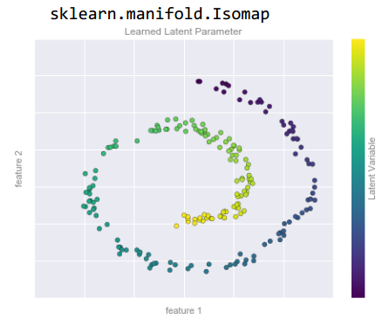

Isomap is a manifold algorithm
import sklearn.manifold
import numpy as np, matplotlib.pyplot as plt
from matplotlib.pyplot import plot, scatter
np.set_printoptions(suppress=True)
np.random.seed(0)

"""parametric equasion for a spiral"""
t = np.linspace(0, 2*np.pi*1.5, 250)
x = 0.63 * np.exp(0.1*t) * np.cos(t)
y = 0.63 * np.exp(0.1*t) * np.sin(t)

"""add noise"""
x = x + np.random.randn(len(x))/30
y = y + np.random.randn(len(y))/30
scatter(x,y, marker='.', c=t, cmap=plt.cm.viridis_r)
plt.gca().set_aspect("equal")
#display(plt.gcf()) #forces to display this plot

"""make a dataset"""
X = np.array([x,y]).T

md = sklearn.manifold.Isomap(n_components=1, n_neighbors=5)
md.fit(X)
a = md.transform(X)
a = a.ravel()
a = a + np.abs(a.min())
if ((a[1:] - a[:-1])>0).sum() / len(a) < 0.5:
a = a[::-1]
scatter(a, [0,]*len(a), c=a, cmap=plt.cm.viridis_r, s=10)

"""check the encreasing tendency"""
p = ((a[1:] - a[:-1])>0).sum() / len(a)
print(f'proportion of potentially correct values: {p} (calculated with the assumption that the values in the output array must be constantly increasing)')
#plt.show()

demo
from sklearn.datasets import load_digits
from sklearn.manifold import Isomap
from sklearn.naive_bayes import GaussianNB
from sklearn.metrics import accuracy_score, confusion_matrix
import seaborn as sns
from matplotlib.pyplot import show, gca, cm
from numpy import set_printoptions
set_printoptions(suppress=True)
d = load_digits()
X = d.data
y = d.target
"""reduce dimentionality with Isomap"""
md = Isomap(n_components=2).fit(X)
X = md.transform(X)
print(X.shape)
"""predict with Gaussian Naive Bayes"""
md = GaussianNB().fit(X,y)
y_pred = md.predict(X)
y_true = y
score = md.score(X,y) #same as:
score = accuracy_score(y_true, y_pred)
print(score)
"""Confusion Matrix"""
nd = confusion_matrix(y_true, y_pred)
print(nd)
"""Heatmap"""
sns.heatmap(nd, square=True, annot=True, cbar=False, fmt='n', cmap=cm.Purples, ax=gca())
gca().set_xlabel('predicted')
gca().set_ylabel('true')
show()

KernelPCA

import numpy as np
import pandas as pd
import matplotlib.pyplot as plt

df = pd.read_csv(r"D:\Documents\Social_Network_Ads.csv")
df = df[['Age','EstimatedSalary','Purchased']]
df.columns = ['Age','Salary','Purchased']

X = df[['Age','Salary']].values.astype(np.float64)
y = df['Purchased'].values

#make a pipeline
from sklearn.pipeline import make_pipeline
from sklearn.preprocessing import StandardScaler
from sklearn.decomposition import KernelPCA
from sklearn.linear_model import LogisticRegression

PL = make_pipeline(StandardScaler(),
KernelPCA(n_components=2, kernel='rbf'),
LogisticRegression())
PL.fit(X,y)
y_pred = PL.predict(X)
print("score:", PL.score(X,y))

plt.scatter(*X.T, c=y, cmap=plt.cm.RdBu, s=10)
xlim,ylim = np.sort(X, axis=0)[[0,-1]].T
XX,YY = np.meshgrid(*[np.linspace(*lim,100) for lim in (xlim,ylim)])
ZZ = PL.predict(np.c_[XX.ravel(),YY.ravel()]).reshape(XX.shape)
plt.contourf(XX,YY,ZZ, cmap=plt.cm.RdBu, alpha=0.5, zorder=-3)

on the left image: PC1, PC2 and linear separation,
on the right image: original data and linear separation after transforming the data with Kernel PCA

t-SNE

t-SNE
import matplotlib.pyplot as plt, numpy as np
from mpl_toolkits.mplot3d import Axes3D
np.random.seed(0)
import sklearn.manifold
import sklearn.cluster
def make_3D_dataset():
from sklearn.preprocessing import Normalizer
n = 100
cm = [[3,3,4],
[3,5,6],
[4,6,8]]
blob1 = np.random.multivariate_normal(mean=[10,10,10], cov=cm, size=n)
blob2 = np.random.multivariate_normal(mean=[-10,-10,-10], cov=cm, size=n)
blob3 = np.random.multivariate_normal(mean=[10,10,-10], cov=cm, size=n)
blob4 = np.random.multivariate_normal(mean=[10,-10,10], cov=cm, size=n)
blob5 = np.random.multivariate_normal(mean=[-10,-10,10], cov=cm, size=n)
X = np.concatenate([blob1, blob2, blob3, blob4, blob5])
X = Normalizer().fit_transform(X)
X = X*10
cm = [[3,2,3],
[2,3,2],
[3,2,4]]
blob = np.random.multivariate_normal(mean=[0,0,0], cov=cm, size=n*2)
X = np.concatenate([X, blob])
X = X + 20
return X
#--------------------------------------------------------------------------------------
X = make_3D_dataset()
fig = plt.figure(figsize=(9,9))
d = dict(marker='.', s=9)
"""KMeans"""
sp = fig.add_subplot(221, projection='3d')
md = sklearn.cluster.KMeans(n_clusters=6)
md = md.fit(X)
y = md.labels_
sp.scatter(*X.T, c=y, **d)
sp.set_title("k-means")
"""DBSCAN"""
sp = fig.add_subplot(222, projection='3d')
md = sklearn.cluster.DBSCAN()
md = md.fit(X)
y = md.labels_
sp.scatter(*X.T, c=y, **d)
sp.set_title("DBSCAN")
"""t-SNE"""
md = sklearn.manifold.TSNE(random_state=0)
X_transformed = md.fit_transform(X)
print(X_transformed.shape) #(600, 2)
sp = fig.add_subplot(223)
sp.scatter(*X_transformed.T, **d)
sp.set_title("t-SNE")
"""Clustering the results of the t-SNE clustering"""
md = sklearn.cluster.KMeans(n_clusters=6)
md.fit(X_transformed)
y = md.labels_
sp = fig.add_subplot(224)
sp.scatter(*X_transformed.T, c=y, **d)
sp.set_title("KMeans")
plt.show()

t-SNE
md = sklearn.manifold.TSNE(random_state=0)
X2d = md.fit_transform(X)

LINEAR DATA REDUCTION (DECOMPOSITION)

PCA: Principle Component Analysis

selected videos
https://www.youtube.com/watch?v=6Hh6O3eu398&list=PLNr8B4XHL5kGDHOrU4IeI6QNuZHur4F86&index=34
https://www.youtube.com/watch?v=M1Cyte75934&list=PLNr8B4XHL5kGDHOrU4IeI6QNuZHur4F86&index=35

PCA
X = np.random.multivariate_normal(mean=[10,20,30,40,50], cov=cm, size=1000)

"""Scaling"""
X_scaled = sklearn.preprocessing.StandardScaler().fit_transform(X)

"""No dimensionality reduction"""
md = sklearn.decomposition.PCA() #By default, PCA only rotates (and shifts) the data, but keeps all principal components.
md = md.fit(X_scaled) #find the principal components
X_reduced = md.transform(X_scaled) #apply the rotation (and dimensionality reduction)

"""With dimensionality reduction"""
md = sklearn.decomposition.PCA(n_components=3, whiten=False or True) #keep the three best dimensions (PC's)
X_reduced = md.fit_transform(X_scaled) #shift and rotate the data, determin the PC's; apply the rotation and dimensionality reduction

"""Get info"""
nd = md.components_
X_reduced.shape == (1000,3)
nd.shape == (3,5) #rows = the 3 PC's; columns = the 5 original features

"""Apply another ML model"""
sklearn.neighbors.KNeighborsClassifier

Using PC1 with Logistic Regression
from sklearn.decomposition import PCA
from sklearn.preprocessing import StandardScaler
from sklearn.linear_model import LogisticRegression
from sklearn.metrics import accuracy_score
from sklearn.model_selection import train_test_split
from sklearn.datasets import load_breast_cancer
d = load_breast_cancer()
X = d.data
y = d.target
X = StandardScaler().fit_transform(X)
md = PCA(n_components=1)
X = md.fit_transform(X)
X_train,X_test,y_train,y_test = train_test_split(X,y)
md = LogisticRegression()
md.fit(X_train, y_train)
y_pred = md.predict(X_test)
y_true = y_test
p = accuracy_score(y_true, y_pred)
print(p)

%matplotlib notebook
from sklearn.decomposition import PCA
from sklearn.preprocessing import StandardScaler
import matplotlib.pyplot as plt
from mpl_toolkits.mplot3d import Axes3D
import numpy as np
np.random.seed(1)

mus = [10,20,30]
cm = [[3,3,4],
[3,5,6],
[4,6,8]]
X = np.random.multivariate_normal(mean=mus, cov=cm, size=100)
X = X[np.argsort(X[:,0])]
E = np.cov(X.T)

"""3D plot"""
d = dict(marker='.', c=range(len(X)))
plt.rcParams['figure.figsize'] = (10,10)
sp = plt.subplot(221, projection='3d')
sp.scatter(*X.T, **d)
sp.set_xlabel('x-axis'); sp.set_ylabel('y-axis'); sp.set_zlabel('z-axis')

"""PCA"""
md = PCA(n_components=2).fit(X)
X_tr = md.transform(X)
sp = plt.subplot(222)
sp.scatter(*X_tr.T, **d)
sp.set_aspect('equal')
sp.set_xlabel("PC1"); sp.set_ylabel("PC2")
sp.set_title("PCA without whitening")

"""PCA with whitening"""
md = PCA(n_components=2, whiten=True).fit(X)
X_tr = md.transform(X)
sp = plt.subplot(223)
sp.scatter(*X_tr.T, **d)
sp.set_aspect('equal')
sp.set_xlabel("PC1"); sp.set_ylabel("PC2")
sp.set_title("PCA with whitening")

"""whiten manually"""
md = PCA(n_components=2).fit(X)
X_tr = md.transform(X)
X_tr = StandardScaler().fit_transform(X_tr)
sp = plt.subplot(224)
sp.scatter(*X_tr.T, **d)
sp.set_aspect('equal')
sp.set_xlabel("PC1"); sp.set_ylabel("PC2")
sp.set_title("PCA with manual whitening")

fig = plt.gcf()
fig.tight_layout()

SVD = singular value decomposition (PCA)

The rows in md.components_ represent the singular eigenvectors.
Each row in components_ corresponds to one principal component, and they are sorted by their importance (i.e. by their corresponding eigenvalues in descending order)
Each column corresponds to the original feature or in other words to the corresponding dimension.

import numpy as np
import scipy.linalg
import sklearn.decomposition
np.random.seed(1)
"""make data"""
mus = [10,20,30]
cm = [[3,3,4],
[3,5,6],
[4,6,8]]
X = np.random.multivariate_normal(mean=mus, cov=cm, size=10)
X = X[np.argsort(X[:,0])]
"""PCA"""
md = sklearn.decomposition.PCA(n_components=2).fit(X)
X_tr = md.transform(X)
"""model info"""
print(X.shape, X_tr.shape)
nd = md.components_
print(nd.shape)
print(nd)
"""eigenvectors"""
E = np.cov(X.T)
eigenvalues, eigenvectors = scipy.linalg.eig(E)
eigenvalues = [e.real for e in eigenvalues]
nx = np.argsort(eigenvalues)[::-1][:2]
eigenvectors = eigenvectors.T[nx]
print(eigenvalues)
print(eigenvectors)
b = np.allclose(np.abs(md.components_), np.abs(eigenvectors))
print(b)

Σ = np.cov(X_centered.T)
eigenvalues, eigenvectors = scipy.linalg.eig(Σ)

%matplotlib notebook
from sklearn.decomposition import PCA
from sklearn.preprocessing import StandardScaler
import matplotlib.pyplot as plt
from mpl_toolkits.mplot3d import Axes3D
import numpy as np
np.random.seed(1)

mus = [10,20,30]
cm = [[3,3,4],
[3,5,6],
[4,6,8]]
X = np.random.multivariate_normal(mean=mus, cov=cm, size=100)
X = X[np.argsort(X[:,0])]
E = np.cov(X.T)

"""3D plot"""
d = dict(marker='.', c=range(len(X)))
plt.rcParams['figure.figsize'] = (10,10)
sp = plt.subplot(221, projection='3d')
sp.scatter(*X.T, **d)
sp.set_xlabel('x-axis'); sp.set_ylabel('y-axis'); sp.set_zlabel('z-axis')

"""PCA"""
md = PCA(n_components=2).fit(X)
X_tr = md.transform(X)
sp = plt.subplot(222)
sp.scatter(*X_tr.T, **d)
sp.set_aspect('equal')
sp.set_xlabel("PC1"); sp.set_ylabel("PC2")
sp.set_title("2 PC's")

"""Adding the means back"""
X = md.inverse_transform(X_tr)
sp = plt.subplot(223)
sp.scatter(*X.T, **d)
sp.set_aspect('equal')
sp.set_title("means added back")

fig = plt.gcf()
fig.tight_layout()

undoing the rotation and adding the means back
md = PCA(n_components=2).fit(X)
X_tr = md.transform(X)
X = md.inverse_transform(X_tr)

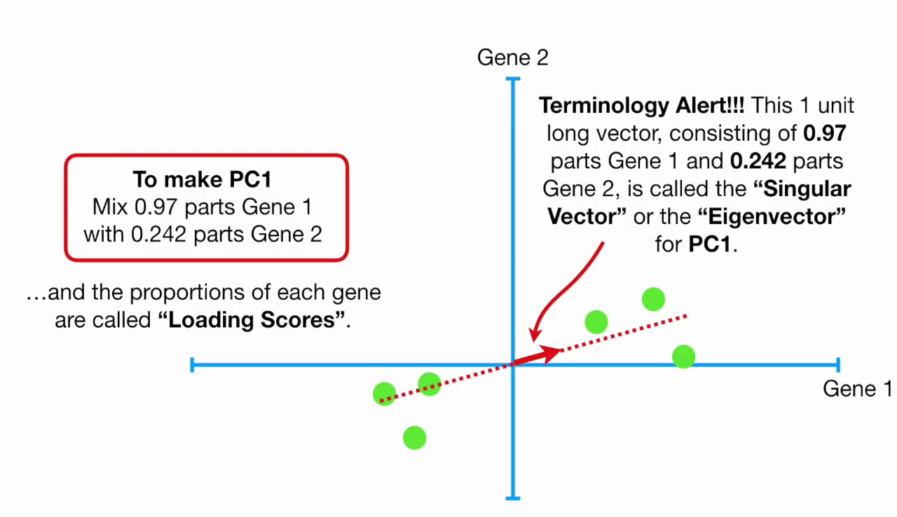

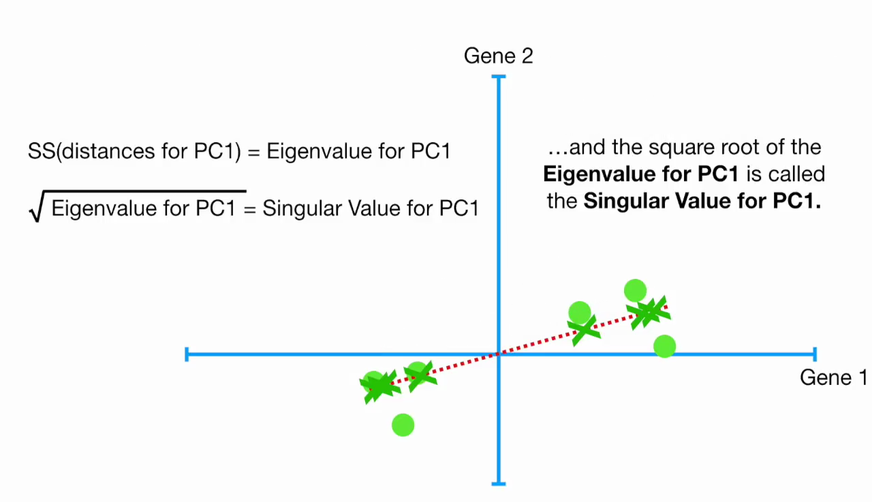

PCA

PCA is fundamentally a dimensionality reduction algorithm, but it can also be useful as a tool for
visualization, noise filtering, feature extraction and engineering,

PCA transformation is rotating the data and then dropping the components with low variance

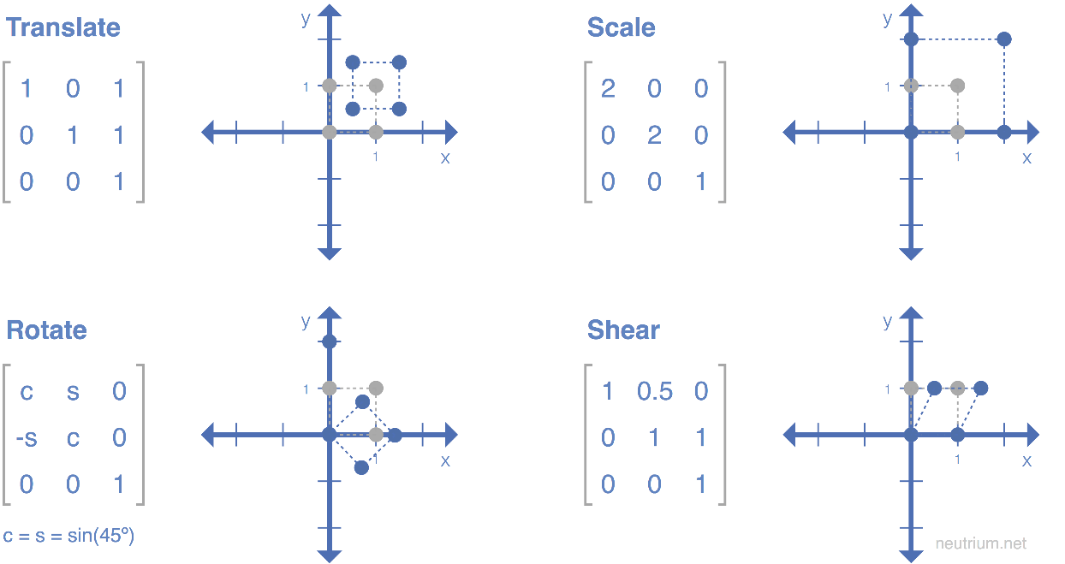

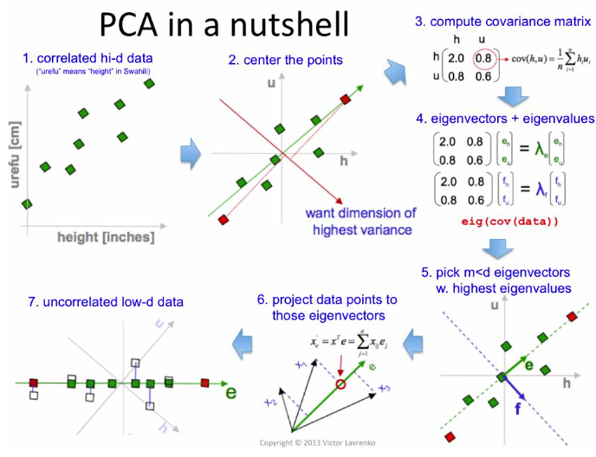
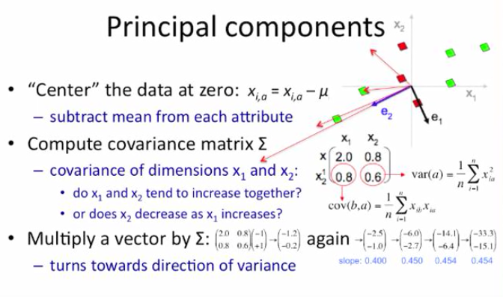

demo on PCA in 2D
import matplotlib.pyplot as plt, numpy as np
from scipy.stats import linregress
from scipy.linalg import eig

np.random.seed(0)
cov_mx = [[2,3],
[3,25]]
M = np.random.multivariate_normal(mean=[10,20], cov=cov_mx, size=100)
M = M[np.argsort(M[:,0])]
col = M[:,1]

#original data
plt.style.use('ggplot')
fig = plt.figure(figsize=(10,10))
fig.add_subplot(221)
plt.scatter(*M.T, cmap=plt.cm.viridis, c=col)
plt.title("original dataset")

#linear regression line
slope, intercept, *_ = linregress(*M.T)
t = plt.axis()
plt.plot([0,20], [intercept, slope*20+intercept], color='gray', label='OLS')
plt.axis(t)
plt.axis('square')
plt.legend()

#mean subtracted
fig.add_subplot(222)
M[:,0] = M[:,0].__sub__(M[:,0].mean())
M[:,1] = M[:,1].__sub__(M[:,1].mean())
plt.scatter(*M.T, cmap=plt.cm.viridis, c=col)
plt.title("mean subtracted")
ylim = plt.gca().get_ylim()

#linear regression line
slope, intercept, *_ = linregress(*M.T)
t = plt.axis()
plt.plot([-10,20], [slope*-10+intercept, slope*20+intercept], color='gray', label='OLS')
plt.axis([-13,13,-13,13])
plt.legend()

#eigenvectors
E = np.cov(M.T)
eigenvalues, eigenvectors = eig(E)
eigenvector1 = eigenvectors[:,1]
eigenvector2 = eigenvectors[:,0]
plt.plot(*zip([0,0], eigenvector1*10), color='k', lw=2, label='eigenvectors, scaled')
plt.plot(*zip([0,0], eigenvector2*2.5), color='k', lw=2)
plt.legend(loc='upper left')

#PC reduction
fig.add_subplot(223)
PC1 = np.dot(M,eigenvector1)
plt.scatter(PC1, [0,]*len(PC1), c=col)
plt.title("PC1")

#rotate back
fig.add_subplot(224)
T = np.rot90(eigenvectors) #transformation matrix
M = np.array([PC1, [0,]*len(PC1)])
M = T @ M
plt.scatter(*M, c=col)
plt.axis([-13,13,-13,13])
plt.title("rotated back");
plt.show()
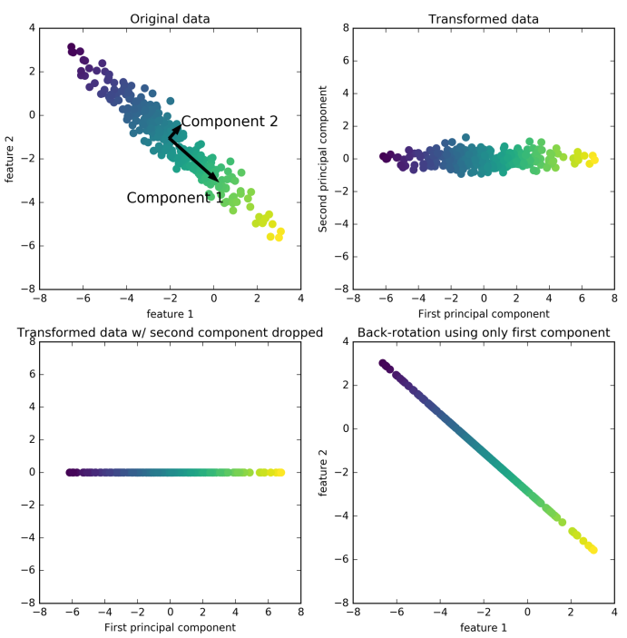

transform train and test data
X_train, X_test, y_train, y_test = train_test_split(X,y, stratify=y, random_state=0)
pca = sklearn.decomposition.PCA(n_components=100, whiten=True, random_state=0).fit(X_train)
X_train_pca = pca.transform(X_train)
X_test_pca = pca.transform(X_test)
E = pca.components_ # horizontal eigenvectors (n_components x n_features) = (100, 5655)
X_train_pca.shape # (1547, 100)

You can use PCA and then SVM to build a classification model (as with the Wild dataset)

build a pipeline
pca = PCA(n_components=150, whiten=True, random_state=42)
svc = SVC(kernel='rbf', class_weight='balanced')
pl = make_pipeline(pca, svc)

pl.fit(X,y)
y_pred = pl.predict(X)
score = pl.score(X,y)

rota
from sklearn.decomposition import PCA
from sklearn.svm import SVC
from sklearn.pipeline import make_pipeline
from sklearn.model_selection import train_test_split, GridSearchCV
from sklearn.metrics import classification_report, confusion_matrix
import seaborn as sns

#make a pipeline out of transformer(s) and estimators(s)
pca = PCA(n_components=150, svd_solver='randomized', whiten=True, random_state=42)
svc = SVC(kernel='rbf', class_weight='balanced')
pl = make_pipeline(pca, svc)

#split the data
Xtrain,Xtest, ytrain, ytest = train_test_split(X,y, stratify=y, random_state=42)

#cross-validation grid search
d = {'svc__C':[1,5,10,50], 'svc__gamma':[0.0005, 0.001, 0.005, 0.01]}
grid = GridSearchCV(pl, d) # %time grid.fit(Xtrain, ytrain)
grid.fit(Xtrain, ytrain) # cross-validation is not done on the test set!!!
d = grid.best_params_

#select the best parameters for the final model and predict
pl = grid.best_estimator_
ypred = pl.predict(Xtest)

#assess
score = pl.score(Xtest, ytest)
s = classification_report(ytest, ypred, target_names=classes_list)
mx = confusion_matrix(ytest, ypred)
sns.heatmap(mx.T, square=True, annot=True, fmt='d', cbar=False, cmap=plt.cm.viridis_r,
xticklabels=classes_list, yticklabels=classes_list)
plt.xlabel('TRUE'); plt.ylabel('PREDICTED')

Note that ytrue and ypred inputs for the confusion matrix come from either:
ypred_train = sklearn.model_selection.cross_val_predict(md, Xtrain, ytrain, cv=3, method='predict')
OR
ypred_test = md.predict(Xtest)

where
ytrue_train = ytrain
ytrue_test = ytest

Covariance Matrix

import numpy as np; np.set_printoptions(precision=2, suppress=True)
Σ = [[10,1,3],
[1,20,2],
[3,2,30]]
X = np.random.multivariate_normal(mean=[10,20,30], cov=Σ, size=10)
print(X)
Σ = np.cov(X.T) # the input: m by n matrix hence it must be transposed
print(Σ)
def cov(X:"m by n matrix") -> "square n by n matrix": # m = number of samples n = number of features
n = X.shape[0] # n = number of samples (mixup because n is used in the formula as number of data-points)
μ = X.mean(axis=0)
Σ = np.add.reduce([(x-μ)[:,None] @ (x-μ)[None,:] for x in X]).__truediv__(n - 1)
return Σ
Σ = cov(X)
print(Σ)

standard scaling
Xscaled = sklearn.preprocessing.StandardScaler().fit_transform(X)
Xscaled = sklearn.preprocessing.scale(X) #same

PCA
#scale the data
Xscaled = StandardScaler().fit_transform(X)
Xscaled = scale(X) #same

#PCA
pca = PCA().fit(Xscaled)
Xpca = pca.transform(Xscaled)

#scipy.linalg
Σ = numpy.cov(sklearn.preprocessing.scale(X).T)
eigenvalues, eigenvectors = scipy.linalg.eig(Σ) #eigenvectors vertical vectros here

#sklearn
eigenvectors = pca.components_ # (components, features) horizontal vectors, sorted by explained_variance_
singularvectors = pca.singular_values_ # eigenvalues?
variance_array = pca.explained_variance_
ratio_array = pca.explained_variance_ratio_ #Percentage of variance explained (use for a scree plot)
Xreversed = pca.inverse_transform(Xpca)

λ = pca.explained_variance_
a = pca.explained_variance_ratio_
a = np.cumsum(pca.explained_variance_ratio_) # cumulative

Each row in components_ corresponds to one principal component, and they are sorted by their importance (the first principal component comes first, etc.)
The columns correspond to the original features

import numpy as np
np.set_printoptions(suppress=True, precision=2)
from sklearn.preprocessing import StandardScaler, scale
from sklearn.decomposition import PCA
import matplotlib.pyplot as plt
Σ = [[5,0,0,0,0],
[0,4,0,2,0], # x2 correlate best with x4
[0,0,3,0,0],
[0,0,0,2,0],
[0,0,0,0,1]]
Σ = np.array(Σ).T.__or__(Σ) #make the cov matrix diagonally symmetrical
m = 100
X = np.random.multivariate_normal(mean=[10,9,8,7,6], cov=Σ, size=m)
nx = np.argsort(X[:,1]) ; X = X[nx]
Σ = np.cov(scale(X).T)
print(Σ.round(0), X.shape)
#scale the data
Xscaled = StandardScaler().fit_transform(X)
Xscaled = scale(X) #same
#PCA
pca = PCA().fit(Xscaled)
Xpca = pca.transform(Xscaled)
Xpca = Xpca[:,:2]
fig, SP = plt.subplots(1,2, figsize=(10,6))
fig.subplots_adjust(wspace=0.4)
SP[0].scatter(*Xpca.T, c=range(1,len(X)+1), cmap='viridis')
SP[0].axis('equal')
#screeplot
ratio_array = pca.explained_variance_ratio_
sp = SP[1]
sp.bar(x=range(1,len(ratio_array)+1), height=ratio_array, color='gray')
sp.set_xticks(range(1,len(ratio_array)+1))
sp.set(xlabel="PC", ylabel="variance explained", title="scree plot")
sp.yaxis.set_major_formatter(plt.FuncFormatter('{:.0%}'.format))
eigenvector1 = pca.components_[0]
print(eigenvector1) # note which axes are most important in this 'recepe'
plt.show()

Σ = numpy.cov(X.T)
eigenvalues, eigenvectors = scipy.linalg.eig(Σ)
eigenvalues == pca.explained_variance_
eigenvectors.T == pca.components_

Σ = numpy.cov(X.T) # covariance matrix
μ = pca.mean_ # vector of means
λ = pca.explained_variance_ # vector of lambdas

demo on how the covariance matrix transforms the original data but keeps the eigenvectors pointing in their original directions:
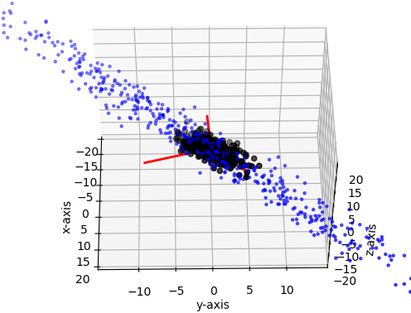

import numpy as np
import matplotlib.pyplot as plt
from mpl_toolkits import mplot3d
from scipy.linalg import eig

%matplotlib notebook
m = 500

Σ = [[9,4,2],
[0,4,1],
[0,0,1]]

Σ = np.array(Σ, dtype='i').T.__or__(Σ)
data = np.random.multivariate_normal(mean=[0,0,0], cov=Σ, size=m)
Σ = np.cov(data.T)

sp = plt.subplot(projection='3d')
sp.scatter(*data.T, s=20, color='k');
data_transformed = Σ @ data.T
sp.scatter(*data_transformed, s=5, color='b', zorder=-3);

sp.set_xlabel("x-axis");sp.set_ylabel("y-axis");sp.set_zlabel("z-axis")

eigenvalues, eigenvectors = eig(Σ) # eigenvectors are vertical vectors here
for (x,y,z) in eigenvectors.T*10:
sp.plot([0,x],[0,y],[0,z], color='red', zorder=-5, lw=2)
sp.axis('equal');
sp.set(xlim=(-20,20), ylim=(-20,20), zlim=(-20,20));

Whitening in PCA

The whitening option of PCA in sklearn rescales the principal components to have the same scale. This is the same as using StandardScaler after the transformation.
Whitening corresponds to not only rotating the data, but also rescaling it so that the center panel is a circle instead of an ellipse.

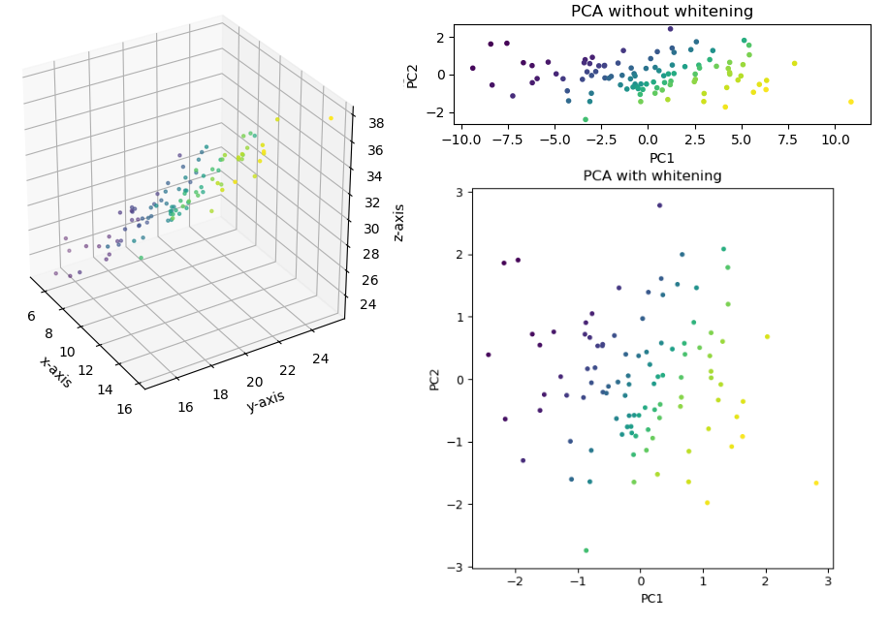

Note:
when doing eigenfaces remember to stratify when splitting into training and test sets and
whiten the PCA output

Eigendigits & Eigenfaces

eigendigits (exercise in Spyder)
import numpy as np, matplotlib.pyplot as plt
from mpl_toolkits import mplot3d
from scipy.linalg import eig
from sklearn.datasets import load_digits
from sklearn.decomposition import PCA

d = load_digits()

X = d.data
y = d.target

#subset 100 random samples and rescale
nx = np.random.choice(len(X), size=100, replace=True)
X = X[nx] / 255.
y = y[nx]

"""FIT"""
#compute cov.max.
Σ = np.cov(X.T) # 64x64

#compute eigenvectors
eigenvalues, eigenvectors = eig(Σ) #the eigenvectors are vertical
eigenvalues = [λ.real for λ in eigenvalues] #already sorted
d = 3 # number of components you want
E = eigenvectors[:,:d] #vertical eig.vectors matrix with the first 3 eig.vectors

e1 = E[:,0]
e2 = E[:,1]
e3 = E[:,2]

"""VIZUALISE"""
fig,SP = plt.subplots(2,2)
for i,(eigenvector,sp) in enumerate(zip(E.T,SP.flat)):
sp.imshow(eigenvector.reshape(8,8), cmap=plt.cm.binary)
sp.axis('off')
sp.set_title(f"eigenvector {i+1}")
else: SP[-1,-1].axis('off')
fig

#the same with sklearn
pca = PCA(n_components=d).fit(X)
E_ = pca.components_.T # from horizontal to vertical eigenvectors

fig,SP = plt.subplots(2,2)
for i,(eigenvector,sp) in enumerate(zip(E_.T,SP.flat)):
sp.imshow(eigenvector.reshape(8,8), cmap=plt.cm.binary)
sp.axis('off')
sp.set_title(f"eigenvector {i+1}")
else: SP[-1,-1].axis('off')
fig

"""TRANSFORM A RANDOM IMAGE"""
#transform a random image
T = E.T # horizontal eigenvectors matrix as tr.mx.
x = X[0][:,np.newaxis] # a random image/vector from the original dataset
w = T @ x #d x 1 vertical vector (its values can be viewd as pseudo-pixels of weights)

"""RECONSTRUCT"""
T = E # vertical eig.vec.mx
x = T @ w
image = x.reshape(8,8)
plt.imshow(image, cmap=plt.cm.binary)
print("this should look like a", y[0])

"""TRANSFORM THE WHOLE DATASET"""
T = E.T # horizontal eigenvectors matrix as tr.mx.
PP = (T @ X.T).T # m by d mx with d PC's
P3 = PP[:,:3] # three major PC's
plt.subplot(111, projection='3d').scatter(*P3.T, c=y)

"""USE A MACHINE LEARNING MODEL ON THE 3 PS's"""
from sklearn.neighbors import KNeighborsClassifier
knn = KNeighborsClassifier(n_neighbors=3).fit(PP,y)
print("kNN score:", knn.score(PP,y))

from sklearn.linear_model import LogisticRegression
lr = LogisticRegression().fit(PP,y)
print("Logisticregression score:", lr.score(PP,y))

Reconstruct an image
x_pca = X_test_pca[0] # a random image from the PCA's data
x_restored = pca.inverse_transform(x_pca)

#same as:
E = pca.components_.T # make the eigenvectors vertical
E = E / (len(X_train)**0.5) * pca.singular_values_ # UNWHITEN the eigenvectros if PCA(whiten=True)
μ = X.mean(axis=0)[:,None] # the μ vectror must be (n, 1)
x_restored = (E @ x_pca[:,np.newaxis]) + μ # adding μ back is not absolutely necessary

plt.imshow(x_restored.reshape(87, 65), cmap='binary_r')

another demo
import numpy as np
from sklearn.decomposition import PCA
from matplotlib.pyplot import show, legend
from myutils.graphics import create_cartesian_plane, draw_vector, draw_arrow
#make data
T = [[1,2],
[2,1.5]]
M = np.random.randn(100,2)
X = np.matmul(T, M.T).T
#PCA
pca = PCA(n_components=2).fit(X)
Xpca = pca.transform(X)
eigenvalues = pca.explained_variance_
eigenvectors = pca.components_
#draw eigenvectors
for λ,e in zip(eigenvalues,eigenvectors):
draw_vector(e* λ**0.5 * 3, label='eigenvector {}'.format(eigenvalues.tolist().index(λ)+1))
#plot data
sp = create_cartesian_plane(grid=True)
sp.scatter(*X.T, label="original data-point")
sp.scatter(*Xpca.T, color='gray', alpha=0.5, s=15, label="PCA'd data-points")
legend()
show()

inverse_transform
pca = PCA(n_components=d).fit(X) # X.shape=(m,n) X or Xscaled (?)
X_pca = pca.transform(X) # X_pca.shape=(m,d)
X_recinstructed = pca.inverse_transform(X_pca) # X_recinstructed.shape=(m,n); rotates the data back

PCA for Noise Filtering
PCA can also be used as a filtering approach for noisy data. The idea is this: any components with variance much larger than the effect of the noise should be relatively unaffected by the noise. So if you reconstruct the data using just the largest subset of principal components, you should be preferentially keeping the signal and throwing out the noise:
pca = PCA(0.50).fit(X) # number of components such that the cumulative variance is greater than the float number given
Xpca = pca.transform(X)
Xrecunstructed = pca.inverse_transform(Xpca)

number of components such that the cumulative variance is greater than the float number given
pca = PCA(0.50)
select the number of components such that the amount of variance that needs to be explained is greater than the percentage specified

demo
import numpy as np, matplotlib.pyplot as plt
from sklearn.decomposition import PCA

n8a = [
[0, 0, 0, 1, 1, 0, 0, 0],
[0, 0, 1, 0, 0, 1, 0, 0],
[0, 0, 1, 0, 0, 1, 0, 0],
[0, 0, 0, 1, 1, 0, 0, 0],
[0, 0, 1, 0, 0, 1, 0, 0],
[0, 1, 0, 0, 0, 0, 1, 0],
[0, 0, 1, 0, 0, 1, 0, 0],
[0, 0, 0, 1, 1, 0, 0, 0], ]

n8b = [
[0, 0, 0, 1, 1, 0, 0, 0],
[0, 0, 1, 0, 0, 1, 0, 0],
[0, 0, 1, 0, 0, 1, 0, 0],
[0, 0, 0, 1, 1, 0, 0, 0],
[0, 0, 1, 0, 0, 1, 0, 0],
[0, 0, 1, 0, 0, 1, 0, 0],
[0, 0, 1, 0, 0, 1, 0, 0],
[0, 0, 0, 1, 1, 0, 0, 0], ]

n5a = [
[0, 1, 1, 1, 1, 1, 1, 0],
[0, 1, 0, 0, 0, 0, 0, 0],
[0, 1, 1, 1, 0, 0, 0, 0],
[0, 0, 0, 0, 1, 1, 0, 0],
[0, 0, 0, 0, 0, 0, 1, 0],
[0, 1, 0, 0, 0, 0, 1, 0],
[0, 0, 1, 0, 0, 1, 0, 0],
[0, 0, 0, 1, 1, 0, 0, 0]]

n5b = [
[0, 1, 1, 1, 1, 1, 0, 0],
[0, 1, 0, 0, 0, 0, 0, 0],
[0, 0, 1, 1, 0, 0, 0, 0],
[0, 0, 0, 0, 1, 0, 0, 0],
[0, 0, 0, 0, 0, 1, 0, 0],
[0, 1, 0, 0, 0, 1, 0, 0],
[0, 0, 1, 0, 1, 0, 0, 0],
[0, 0, 0, 1, 0, 0, 0, 0]]

n1a = [
[0, 0, 0, 0, 1, 0, 0, 0],
[0, 0, 0, 1, 1, 0, 0, 0],
[0, 0, 1, 0, 1, 0, 0, 0],
[0, 0, 0, 0, 1, 0, 0, 0],
[0, 0, 0, 0, 1, 0, 0, 0],
[0, 0, 0, 0, 1, 0, 0, 0],
[0, 0, 0, 0, 1, 0, 0, 0],
[0, 0, 1, 1, 1, 1, 1, 0]]

n1b = [
[0, 0, 0, 0, 1, 0, 0, 0],
[0, 0, 0, 1, 1, 0, 0, 0],
[0, 0, 1, 0, 1, 0, 0, 0],
[0, 0, 0, 0, 1, 0, 0, 0],
[0, 0, 0, 0, 1, 0, 0, 0],
[0, 0, 0, 0, 1, 0, 0, 0],
[0, 0, 0, 0, 1, 0, 0, 0],
[0, 0, 0, 0, 1, 0, 0, 0]]

l = [n1a, n1b, n5a, n5b, n8a, n8b]
labels = [1,1,5,5,8,8]
X,y = [],[]
for i in range(len(l)):
mx = np.array(l[i], dtype='f')
X.append(mx.reshape(8 * 8))
X.append(np.roll(mx, axis=1, shift=1).reshape(8 * 8))
X.append(np.roll(mx, axis=1, shift=-1).reshape(8 * 8))
y.extend([labels[i],]*3)

del l, labels
m = len(X) * 100
nx = np.random.choice(len(X), size=m, replace=True)
data = np.array(X, dtype='f')[nx]
y = np.array(y, dtype=np.uint8)[nx]
σ = data.std() / 3 # std of the noise
data = np.random.normal(loc=data, scale=σ) # add noise to the data

# PLOT
def create_figure_with_images(data, title=None):
fig, sps = plt.subplots(3, 15, figsize=(8, 3), subplot_kw={'xticks': [], 'yticks': []}, gridspec_kw={'hspace': 0.1})
fig.suptitle(title or '')
for i, sp in enumerate(sps.flat):
sp.imshow(data[i].reshape(8, 8), cmap='binary')
sp.axis('off')
return fig

fig = create_figure_with_images(data, "Noisy digits")

# PCA AND PLOT RECONSTRUCTED
pca = PCA(0.90).fit(data)
data_pca = pca.transform(data)
data_reconstructed = pca.inverse_transform(data_pca)
fig = create_figure_with_images(data_reconstructed, "Reconstructed digits\n({:.0%} of cumulative variance corresponds to {:} components)".format(pca.n_components,
pca.n_components_))

# INCREASE CONTRAST
def decorator_vectorizer(func):
def closure_function(arr, **kwargs):
for i,a in enumerate(arr):
arr[i] = func(a, **kwargs)
return arr
return closure_function

@decorator_vectorizer
def increase_contrast(a, fun='mean'):
μ = a.mean() if fun == 'mean' else np.median(a)
a = np.where(a < μ, 0, 1)
return a

data_contrast = increase_contrast(data_reconstructed, fun='mean')
fig = create_figure_with_images(data_contrast, "increased contrast")

#PCA >>> 2 components
X = data_contrast
pca = PCA(n_components=2).fit(X)
X_pca = pca.transform(X)
fig,sp = plt.subplots()
sp.scatter(*X_pca.T, c=y)

#DECISION TREE
from sklearn.model_selection import train_test_split
from sklearn.tree import DecisionTreeClassifier

Xtrain,Xtest, ytrain,ytest = train_test_split(X,y)

MD = DecisionTreeClassifier(max_depth=4, min_samples_leaf=3).fit(Xtrain, ytrain)
print("tree score:", MD.score(Xtest, ytest))

plt.show()

make synthetic 3D data for PCA (blob, melon)
import numpy as np
import matplotlib.pyplot as plt
from mpl_toolkits.mplot3d import Axes3D
def gaussian_kernel(data, landmark='mean', gamma=None):
from numpy import array, exp
X = data
landmark = X.mean(axis=0) if landmark=='mean' else array(landmark)
assert landmark.shape == (2,), "bad landmark"
n = len(X)
a = ((X-landmark)**2).sum(1)
sqrt_a = a**0.5
mu = sqrt_a.mean()
sigma_squared = ((sqrt_a - mu)**2).sum() / (n-1)
gamma = gamma or 1/(2 * sigma_squared)
a = exp(-(gamma*a))
return a
############################################################################
"""MAKE DATA"""
Σ = [[16,0],
[ 0,3]]
m = 500
M = np.random.multivariate_normal(mean=[0,0], cov=Σ, size=m)
M += np.abs(M.min(axis=0))
a = gaussian_kernel(M, gamma=0.02)
a *= np.random.normal(loc=0, scale=a.std(), size=len(M))
a *= M.std(axis=0).min()
a += np.abs(a.min())
M = np.hstack([M, a[:,None]])
nx = np.argsort(M[:,0])
M = M[nx]
y = np.arange(1, len(M)+1)
#rotate the blob
n = 1/(2**0.5)
T = [[n,-n,-n],
[n, n,-n],
[n, 0, n]]
M = np.matmul(T,M.T).T
M += np.abs(M.min(axis=0))
X = M # data ready
#----------------------------------------------------
"""PCA"""
from sklearn.decomposition import PCA
pca = PCA(n_components=2).fit(X)
X_pca = pca.transform(X)
"""PLOT"""
fig = plt.figure(figsize=(12,5))
sp = fig.add_subplot(121, projection='3d')
sp.scatter(*M.T, cmap='viridis', c=y)
sp = fig.add_subplot(122)
sp.scatter(*X_pca.T, cmap='viridis', c=y)
sp.axis('equal')
sp.set_xlabel("PC1");sp.set_ylabel("PC2")
plt.show()

Data Reduction algorithms can be linear (e.g. PCA) and non-linera (e.g. manifolds)

PCA is used when ther is linear relationships in the data
Manifold algorithms are used when there are non-linear relationships in the data

KernelPCA

import numpy as np
import pandas as pd
import matplotlib.pyplot as plt

df = pd.read_csv(r"D:\Documents\Social_Network_Ads.csv")
df = df[['Age','EstimatedSalary','Purchased']]
df.columns = ['Age','Salary','Purchased']

X = df[['Age','Salary']].values.astype(np.float64)
y = df['Purchased'].values

#make a pipeline
from sklearn.pipeline import make_pipeline
from sklearn.preprocessing import StandardScaler
from sklearn.decomposition import KernelPCA
from sklearn.linear_model import LogisticRegression

PL = make_pipeline(StandardScaler(),
KernelPCA(n_components=2, kernel='rbf'),
LogisticRegression())
PL.fit(X,y)
y_pred = PL.predict(X)
print("score:", PL.score(X,y))

plt.scatter(*X.T, c=y, cmap=plt.cm.RdBu, s=10)
xlim,ylim = np.sort(X, axis=0)[[0,-1]].T
XX,YY = np.meshgrid(*[np.linspace(*lim,100) for lim in (xlim,ylim)])
ZZ = PL.predict(np.c_[XX.ravel(),YY.ravel()]).reshape(XX.shape)
plt.contourf(XX,YY,ZZ, cmap=plt.cm.RdBu, alpha=0.5, zorder=-3)

on the left image: PC1, PC2 and linear separation,
on the right image: original data and linear separation after transforming the data with Kernel PCA

Incremental PCA
import numpy as np
#data
from sklearn.datasets import load_digits
d = load_digits()
X,y = d.data, d.target
(m,n),d = (1797,64), 2
n_batches = 100
batch_size = m // n_batches # for the Incremental PCA which accepts a memeory-map

"""Incremental PCA with partial fit"""
from sklearn.decomposition import IncrementalPCA
pca = IncrementalPCA(n_components=d)

for Xbatch in np.array_split(X, n_batches):
pca.partial_fit(Xbatch)

Xpca = pca.transform(X)

"""Memory Map""" #(safe the data as a binary file first)
from tempfile import mkdtemp; from os.path import join; from shutil import rmtree

#temporary directory and file
dir_path = mkdtemp() # path is a str
file_path = join(dir_path, "X.dat")

#write the data to file
with open(file_path, mode="wb"):
X.tofile(file_path)

#Create a Memory Map (read only); the dtype must match the dtype of the X-data
mm = np.memmap(file_path, dtype=X.dtype, mode="r", shape=(m, n)) #X.dtype=float64

#Incremental PCA which accepts a memeory-map
pca = IncrementalPCA(n_components=d, batch_size=batch_size)
pca.fit(mm)

Xpca = pca.transform(X)

#remove the temporary folder and its contents
del mm
rmtree(dir_path)

#visualise
import matplotlib.pyplot as plt
plt.figure(figsize=(8,8))
for label in set(y):
plt.plot(*Xpca[y==label].T, linestyle='none',
marker='${}$'.format(str(label)), markersize=8)

SVD: Singular Value Decomposition

Singular Value Decomposition demo
import scipy.linalg
from mpmath import mp
import numpy as np
from sklearn.decomposition import PCA
from functools import partial
print = partial(print, end="\n"+"="*50+'\n')
np.set_printoptions(suppress=True, precision=2)

s =\
"""\
11100
33300
44400
55500
02044
00055
01022"""

M = np.matrix([[int(c) for c in s] for s in s.split('\n')])
U,s,V = scipy.linalg.svd(M, full_matrices=False)

I = np.eye(len(s))
I[range(len(s)),range(len(s))] = s
Σ = I

M = U @ (Σ @ V) # reconstructed matrix
print(M) # absolutely identical to the original matrix M

#use truncated U, Σ, V
U = U[:,:3]
Σ = Σ[:3,:3]
V = V[:3,:]
M = U @ (Σ @ V) # reconstructed matrix
print(M) # absolutely identical to the original matrix M

my SVD function
def svd(M:"matrix", d:"number of dimensions") -> "three matreces":
from scipy.linalg import svd
from numpy import diag
U,s,V = svd(M, full_matrices=False)
Σ = diag(s)[:d,:d]
U = U[:,:d]
V = V[:d,:].T
return U,Σ,V

U,Σ,V = svd(M, 3)
M = U @ (Σ @ V.T)

from numpy import matrix, set_printoptions; set_printoptions(suppress=True, precision=2)

s =\
"""\
11100
33300
44400
55500
02044
00055
01022"""
M = matrix([[int(c) for c in s] for s in s.split('\n')])

def svd(M:"matrix", d:"number of dimensions") -> "three matreces":
from scipy.linalg import svd
from numpy import diag
U,s,V = svd(M, full_matrices=False)
Σ = diag(s)[:d,:d]
U = U[:,:d]
V = V[:d,:].T
return U,Σ,V

U,Σ,V = svd(M, 3)
M = U @ (Σ @ V.T)
print(M.round().astype('i'))

NMF: Non-Negative Matrix Factorization (NMF)

Non-Negative Matrix Factorization (NMF)
md = sklearn.decomposition.NMF(n_components=d, random_state=0).fit(M)
W = md.transform(X) # W will have d columns
H = md.components_ # H will have d rows, i.e. n components = vectors
M = W @ H # will reverse the transformation back
md.inverse_transform(W) == W @ H

Non-Negative Matrix Factorization (NMF)
In PCA we wanted components that were orthogonal and that explained as much variance of the data as possible. In NMF, we want the components and the coefficients to be nonnegative. NMF can only be applied to data where each feature is non-negative: We need to ensure that our data is positive for NMF to be able to operate on the data. This means where the data lies relative to the origin (0,0) actually matters for NMF. Therefore, you can think of the non-negative components that are extracted as directions from (0,0) toward the data.

The process of decomposing data into a non-negative weighted sum is particularly helpful for data that is created as the addition (or overlay) of several independent sources, such as an audio track of multiple people speaking, or music with many instruments. In these situations, NMF can identify the original components that make up the combined data. Overall, NMF leads to more interpretable components than PCA, as negative components and coefficients can lead to hard-to-interpret effects.

If there are enough components to perfectly reconstruct the data (as many components as there are features), the algorithm will choose directions that point toward the extremes of the data:
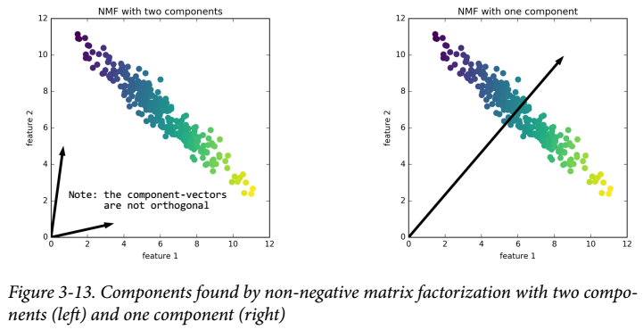
If we only use a single component, NMF creates a component that points toward the mean, as pointing there best explains the data. You can see that in contrast with PCA, reducing the number of components not only removes some directions, but creates an entirely different set of components! Components in NMF are also not ordered in any specific way, all components play an equal part. NMF uses a random initialization, which might lead to different results depending on the random seed.

d = 2 # number of latent features to extract
nmf = sklearn.decomposition.NMF(n_components=d).fit(M)
U = nmf.transform(M)
W = nmf.components_.T
M = U @ W.T

demo on component vectors
from sklearn.decomposition import NMF
import numpy as np
import matplotlib.pyplot as plt

#make data
T = [[-1, 4],
[ 2,-3]]
M = np.random.randn(2,100)
M = (T@M).T / 2
M += -M.min(axis=0) + 5

#decompose
d = 2 # number of latent features to extract
nmf = NMF(n_components=d).fit(M)
U = nmf.transform(M)
W = nmf.components_.T

#reconstruct back
M2 = U @ W.T

#plot
sp = plt.subplot(111)
sp.scatter(*M.T, s=50, facecolor='none', edgecolor='red')
sp.scatter(*M2.T, color='green', alpha=0.8, s=15) #shows that the data-points are reconstructed almost perfectly
sp.axis((0, sp.axis()[1]+3, 0, sp.axis()[-1]+3))

#plot the two component vectors
print(W) # vertical component vectors
v1,v2 = W.T
sp.annotate('', xy=(0,0), xytext=v1, arrowprops={'arrowstyle':'<-'})
sp.annotate('', xy=(0,0), xytext=v2, arrowprops={'arrowstyle':'<-'});
#plt.show()

simple NMF demo
from sklearn.decomposition import NMF

# matrix M can be factored into two matrices:
# U = matrix of components (aka learned latent features)
# W = matrix of weights

M = [[1,2,3,5], # original example matrix to decompose
[2,4,8,12],
[3,6,7,13]]

U = [[1, 3], # decomposed into matrix U with 2 latent features
[2,8],
[3,7]]

W = [[1, 2, 0, 2], # ...and matrix W also with 2 latent features
[0, 0, 1, 1]] # not yet transposed

# sklearn factors M into C and W full of decimals though
# but the matrix product CM results (approximately) into the original matrix M
d = 2 # number of latent features to extract
nmf = NMF(n_components=d).fit(M)
U = nmf.transform(M)
W = nmf.components_.T

M = U @ W.T
print(M.round(0))

U = [ # underlying features
[1,1,1],
[2,2,2],
[3,2,3],
[1,1,0],
[2,2,1],
[3,2,2],
[1,1,3]]
W = [ # weights
[1,0,0,1,1],
[0,1,0,1,-1],
[0,0,1,1,0]]
# Interpretation of the weights-matrix:
# for the 1st column of the resulting matrix take 1 times of the first column of U
# for the 2nd column - 1 times of column 2 of matrix U
# for the 3rd column - 1 times of column 3 of U
# for the 4th column - sum all columns of U together (axis=1)
# for the 5th column - subtract column 2 from column 1 of matrix U
M = __import__('numpy').matmul(U,W)
print(M)

signal scrambling and recovery with NMF
from mglearn.datasets import make_signals
import numpy as np, matplotlib.pyplot as plt
from sklearn.decomposition import NMF, PCA
def svd(M:"matrix", d:"number of dimensions") -> "three matreces":
from scipy.linalg import svd
from numpy import diag
U,s,V = svd(M, full_matrices=False)
Σ = diag(s)[:d,:d]
U = U[:,:d]
V = V[:d,:].T
return U,Σ,V

S = make_signals() # shape=(2000,3) 2000 data-points 3 features
T = np.random.RandomState(0).uniform(size=(100, 3))
M = (T @ S.T).T

nmf = NMF(n_components=3, random_state=42).fit(M)
S_NMF = nmf.transform(M)

pca = PCA(n_components=3, random_state=42).fit(M)
S_PCA = pca.transform(M)

S_SVD,Σ,V = svd(M, d=3)

from collections import OrderedDict
d = OrderedDict(zip(["Original 3 signals","Scrambled signals","Recovered with NMF","Recovered with SVD","Recovered with PCA"],
[S,M,S_NMF,S_SVD,S_PCA]))

fig, sps = plt.subplots(len(d), figsize=(12, 2*len(d)), subplot_kw={'xticks':[],'yticks':[]}, gridspec_kw={'hspace':.5})
for sp,(name,M) in zip(sps,d.items()):
sp.plot(M)
sp.set_title(name);
#plt.show()

make synthetic data of 3 signals, scramble and then recover with NMF
import numpy as np
import matplotlib.pyplot as plt
from math import cos, pi, floor

@np.vectorize
def signalA(t):
y = (1-cos(pi*t/2))/2
return y

@np.vectorize
def signalB(t):
return floor(t+0.25)%2

@np.vectorize
def signalC(t):
return t - floor(t)

def make_signals_matrix(m:"number of measurements"):
t = np.linspace(0, 10, m)
M = np.vstack([func(t) for func in (signalA, signalB, signalC)]).T
M = np.random.normal(loc=M, scale=0.075) # add noise
M += -M.min(axis=0) # shift up to make all values positive
return M

#make data
m = 1000
S = make_signals_matrix(m)

#scramble the original signals
n = 10 # make 10 mixed-up signals
d = 3 # 3 original signals
W = np.random.randint(1,11, size=(d,n)) #matrix of positive weights
M = S @ W # M = m by n matrix

#recover the original signals with NMF
from sklearn.decomposition import NMF
nmf = NMF(n_components=d, random_state=0).fit(M)
U = nmf.transform(M)
W_ = nmf.components_.round(1)
print("compare the original and factored weights matreces:", W, W_, sep="\n\n")

#plot and compare vizually
t = (("original signals",S),("scrambled signals",M),("recovered signals with NMF",U))
fig, sps = plt.subplots(len(t), figsize=(10, len(t)*2),
subplot_kw={'xticks':[],'yticks':[]}, gridspec_kw={'hspace':0.4})
for sp,(name,M) in zip(sps,t):
sp.plot(M)
sp.set_title(name);
#plt.show()

Note:
for noise filtering of images use PCA
for (audio) signal recovery use NMF

scipy.io.wavfile
from scipy.io import wavfile
rate = 44100 # values per second
seconds = 3
t = np.linspace(0,seconds, 44100*seconds, endpoint=True)
a = np.sin(2*π * t * 440) # A = 440 herz
a = np.int16(a/np.max(np.abs(a)) * 32767) # scale so that the values are in the range=[-32766, 32767]
wavfile.write(filename='sound.wav', rate=44100, data=a) #write to a file
rate,a = wavfile.read(filename=r'sound.wav') # read from a wav file

NAÏVE BAYES

GaussianNB, BernoulliNB, MultinomialNB
Naïve Bayes models are only for classification!
GaussianNB can be applied to any continuous data, (and categorical data)?
BernoulliNB assumes binary data, (and categorical data)?
MultinomialNB assumes count data (that is, that each feature represents an integer count of something, like how often a word appears in a sentence)

BernoulliNB and MultinomialNB are mostly used in text data classification.

my basic Naïve Bayes Classifier for descreet variables
import numpy as np, pandas as pd
def play_golf_table():
from pandas import DataFrame, Series, Categorical, concat
s,o,r = ['sunny','overcast','rainy']
ct = Categorical([s,s,o,r,r,r,o,s,s,r,s,o,o,r])
sr0 = Series(ct)
h,m,c = ['hot','mild','cool']
ct = Categorical([h,h,h,m,c,c,c,m,c,m,m,m,h,m])
sr1 = Series(ct)
h,n = "high normal".split()
ct = Categorical([h,h,h,h,n,n,n,h,n,n,n,h,n,h])
sr2 = Series(ct)
sr3 = Series([int(s) for s in "01000110001101"])
sr4 = Series([int(s) for s in "00111010111110"])
nx = ['outlook','temperature','humidity','wind','play']
df = DataFrame([sr0,sr1,sr2,sr3, sr4], index = nx).T
return df
def df_into_mx(df, decoder=None): #returns (integer-filled matrix, decoder as namedtuple)
from numpy import array, zeros
from pandas import factorize
from collections import namedtuple
factory = namedtuple("incoder", df.columns.values)
l = []
mx = zeros(shape=df.shape, dtype='i')
for i,s in enumerate(df):
t = factorize(df[s])
mx[:,i] = t[0] if not hasattr(decoder, "__iter__") else [list(decoder[i]).index(s) for s in df.iloc[:,i]]
l.append(t[-1])
nt = factory(*l)
return (mx, decoder or nt)
class NaiveBayesClassifier():
def __init__(self, X,y):
from itertools import product
from numpy import hstack
self._l = []; yy = y.ravel(); self._y = y
for xx in X.T:
g = product(*[sorted(set(e)) for e in (xx, yy)])
d = {}
for t in g:
nd = hstack([xx[:,None], yy[:,None]])
p = len(xx[xx==t[0]]) / len(xx) #marginal prob
d.setdefault(t[0], p)
nd = nd[nd[:,-1]==t[-1]]
denominator = len(nd[nd[:,-1]==t[-1]])
p = 0 if denominator == 0 else len(nd[nd[:,0]==t[0]]) / denominator #conditional prob
d.setdefault(t, p)
self._l.append(d)
d = {}
for i in sorted(set(yy)):
p = len(yy[yy==i]) / len(yy)
d.setdefault(i, p)
else: self._d = d; del d
@property
def prior_probabilities(self):
return self._d
def predict(self, X_pred):
from numpy import zeros, unique, argmax
from operator import mul
from functools import reduce
l = []
ct = sorted(unique(self._y.ravel()))
aProbs = zeros(shape=len(ct), dtype='f')
for xx in X_pred:
P_X = reduce(mul, [d[k] for d,k in zip(self._l, xx)])
for i in ct:
P_C = self._d.get(i)
P_XC = reduce(mul, [d.get((k, i), 1) for d,k in zip(self._l, xx)])
p = (P_C * P_XC) / P_X
aProbs[i] = p
l.append(ct[argmax(aProbs)])
return l
df = play_golf_table()
print(df)
mx,nt = df_into_mx(df)
X,_,y = np.split(df_into_mx(df)[0], [4,4], axis=1)
print(X)
print(y)
md = NaiveBayesClassifier(X,y)
print(md.prior_probabilities)
dfTest = pd.DataFrame([pd.Series(['sunny','cool','high',1,0], index=df.columns),df.iloc[0,:]]).reset_index(drop=True)
print(dfTest)
X_test = df_into_mx(dfTest, decoder=nt)[0][:,:-1]
print(X_test)
y_pred = md.predict(X_test)
print(y_pred)
y_pred = md.predict(X)
b = np.all(np.equal(y.ravel(), y_pred))
print(b)
print(y.ravel().tolist())
print(y_pred)
print("========================")
from sklearn.naive_bayes import MultinomialNB, BernoulliNB, GaussianNB
md = MultinomialNB()
md = BernoulliNB()
md = GaussianNB()
md.fit(X,y)
y_pred = md.predict(X)
print(y_pred)

Gaussian Naïve Bayes (for classification of data with continuous values)
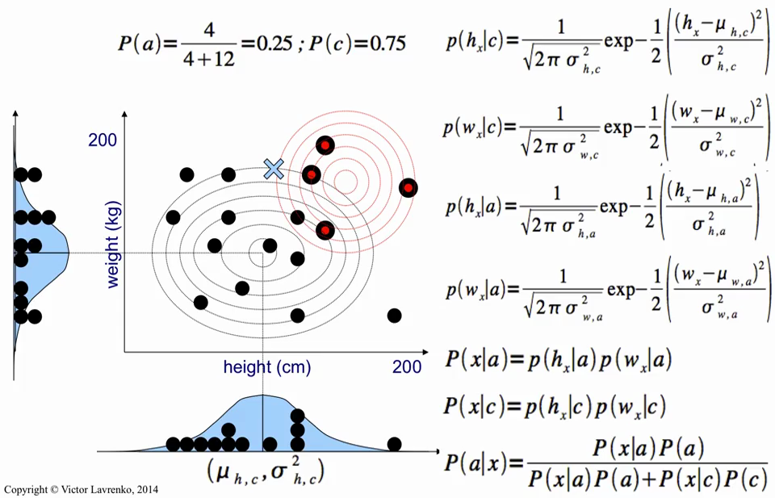

Gaussian curve formula

Multinomial Distribution Probabilities

Formula:
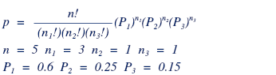

Example:
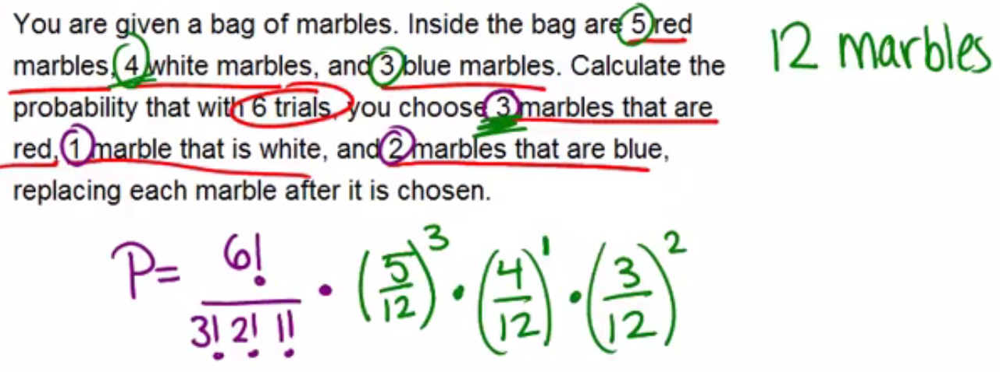
Example:
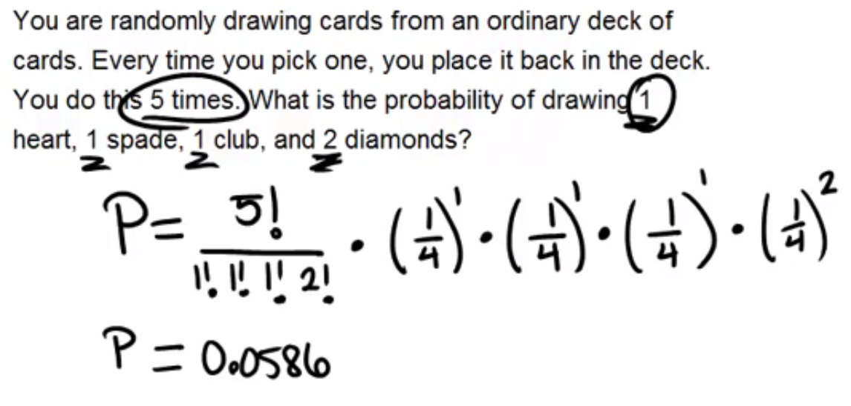
Code:
def multinomial_distribution_probability(probabilities_vector, counts_vector):
from math import factorial
from functools import reduce
from operator import mul
pp = probabilities_vector
nn = counts_vector
p = (factorial(sum(nn)) // reduce(mul, (factorial(n) for n in nn ))) * reduce(mul, (p**n for p,n in zip(pp,nn)))
return p
P = multinomial_distribution_probability([1/4,]*4, [1,1,1,2])
print(P)

which NaiveBayes class to use?
??? MultinomialNB? the classical descreet/categorical naïve Bayes classifier
sklearn.naive_bayes.BernoulliNB assumes binary data in the input matrix X
sklearn.naive_bayes.MultinomialNB assumes that the input matrix X contains counts*
sklearn.naive_bayes.GaussianNB Gaussian naïve Bayes classifier for continuous data
*the probabilities of observing those counts are described by the multinomial distribution

alpha in MultinomianNB
from numpy import set_printoptions; set_printoptions(precision=2, suppress=True)
from sklearn.naive_bayes import MultinomialNB
def make_data(*, print):
from io import StringIO; from pandas import read_table
s = """\
10 2 3 0
9 1 2 0
2 5 10 1
1 6 9 1
2 2 2 2
3 4 3 2
1 2 0 2
20 10 10 3
21 11 9 3
"""
df = read_table(StringIO(s), header=None, sep=r'\s+', names=['red', 'green', 'blue', 'class']) ; df.columns.name = 'marbles'
X = df.values[:, :-1]; y = df['class'].values
if print:
from sys import stdout
print = lambda o : stdout.write(str(o)+"\n\n")
print(df)
return X,y
X,y = make_data(print=True)
print(y)
"""MultinomialNB(alpha=???)"""
MD = MultinomialNB(alpha=0.01) #Additive (Laplace/Lidstone) smoothing parameter (0 for no smoothing)
MD.fit(X,y)
y_pred = MD.predict(X)
score = MD.score(X,y)
mx = MD.predict_proba(X)
print(y_pred, score); print(mx, mx.std(), end="\n\n") #the standard deviation is larger
"""MultinomialNB(alpha=???)"""
MD = MultinomialNB(alpha=100) #Additive (Laplace/Lidstone) smoothing parameter (0 for no smoothing)
MD.fit(X,y)
y_pred = MD.predict(X)
score = MD.score(X,y)
mx = MD.predict_proba(X)
print(y_pred, score); print(mx, mx.std()) #the standard deviation is small, i.e. the model is "smoother"

natural log of probabilities
#if you increase your odds by a certain factror (in this example by a factor of 2)
#the log of odds grows by the same amount (in thie case by 0.693)
from math import log as ln
odds = (1/10, 2/10, 4/10 , 8/10, 16/10) #when your odds are smaller (than of your rival) the log(odds) is negative
logs_of_probabilities = l = [ln(odds) for odds in odds] #when your odds are greater (than of your rival) the log(odds) is positive
Δ = [f2-f1 for f2,f1 in zip(l[1:],l[:-1])] #differences in ln(odds)'s
print(logs_of_probabilities, Δ, sep="\n")

from math import log as ln
odds = (1/3, 2/3, 4/3, 8/3) #odds growing by a factor of 2
pp = (1/4, 2/5, 4/7, 8/11) #respective probabilities
logs_of_odds = [ln(odds) for odds in odds]
logs_of_probabilities = [ln(p) for p in pp]

Δ1 = [f2-f1 for f2,f1 in zip(logs_of_odds[1:],logs_of_odds[:-1])] #differences in ln(odds)'s are all the same =0.693
Δ2 = [f2-f1 for f2,f1 in zip(logs_of_probabilities[1:],logs_of_probabilities[:-1])] #differences in ln(p)'s are not the same
Δ1

#when the probability of your win (i.e. share of your win of the whole) grows by a certain factor
#the log of the probabilities grows by the same amount (0.69)
pp = [0.01, 0.02, 0.04, 0.08, 0.16, 0.32, 0.64]
logs_of_probs = l = [ln(p) for p in pp]
logs_of_probs

diffs = [f2-f1 for f2,f1 in zip(l[1:],l[:-1])]
diffs

what are .class_log_prior_ and .feature_log_prob_ in MultinomialNB?
from numpy import exp, bincount, set_printoptions; set_printoptions(precision=2, suppress=True)
from sklearn.naive_bayes import MultinomialNB
def make_data(*, print):
from io import StringIO; from pandas import read_table
s = """\
10 2 3 0
9 1 2 0
2 5 10 1
1 6 9 1
2 2 2 2
3 4 3 2
1 2 0 2
20 10 10 3
21 11 9 3
"""
df = read_table(StringIO(s), header=None, sep=r'\s+', names=['red', 'green', 'blue', 'class']) ; df.columns.name = 'marbles'
X = df.values[:, :-1]; y = df['class'].values
if print:
from sys import stdout
print = lambda o : stdout.write(str(o)+"\n\n")
print(df)
return X,y
X,y = make_data(print=True)
MD = MultinomialNB(alpha=1.).fit(X,y)
y_pred = MD.predict(X)
score = MD.score(X,y)
mx = MD.predict_proba(X)
print(y_pred, score)
"""natural logs of the probabilities of classes - Smoothed empirical log probability for each class"""
a = MD.class_log_prior_ #array of 4
a = MD.intercept_ #same
print(a)
a = exp(a) #probabilities of classes
a = bincount(y) / len(y) #same
print(a)
"""natural logs of the probabilities - Empirical log probability of features given a class, P(x_i|y)"""
mx = MD.feature_log_prob_ #4x3 ndarray (4 classes, 3 features)
mx = MD.coef_ #same
print(mx)
mx = exp(mx) #probabilities - 4x3 ndarray (4 classes, 3 features)
print(mx)

GAUSSIAN STUFF

Gaussian Process Regression
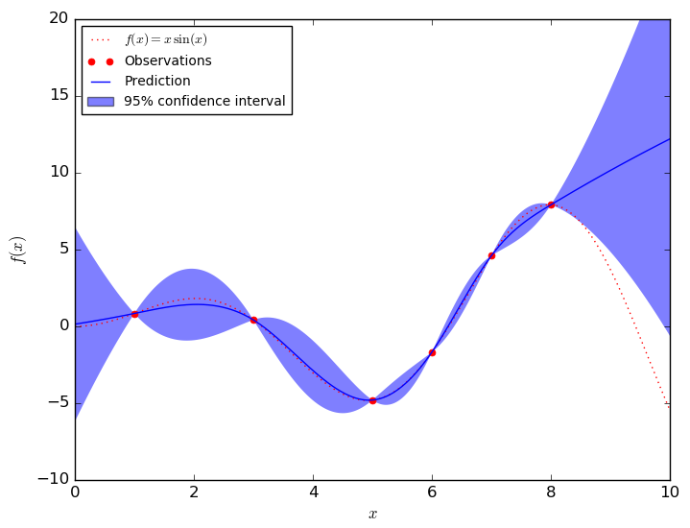
Continuous errors - Gaussian Process Regression
import numpy as np, matplotlib.pyplot as plt

#data
x = np.array([1, 3, 5, 6, 8])[:,None] # column vector
y = x * np.sin(x)

#model
from sklearn.gaussian_process import GaussianProcessRegressor
md = GaussianProcessRegressor().fit(x, y)

#grid
xgrid = np.linspace(0, max(x)+1, 100).reshape(-1,1) # columns vector of new data
ypred, σ = md.predict(xgrid, return_std=True) # σ = Standard deviation values of predictive distribution
σ = σ * 2

#plot
xgrid, ypred, σ = (a.reshape(-1) for a in (xgrid, ypred, σ)) # flatten all arrays for plt
plt.plot(x,y, 'or') # scatter the training points
plt.plot(xgrid, ypred) # draw the Gaussian Process Regression curve
plt.fill_between(xgrid, ypred-σ, ypred+σ, color='lightgray', alpha=0.5)
Handbook page 239

errors
x,y = [0,1,2], [1,2,3]
plt.bar(x=x, bottom=y, height=y, tick_label=['A','B','C'],
yerr=[.1, .2, .5], ecolor='r', capsize=2.5,
align='center', width=0.9, color='g', edgecolor='k', linewidth=1, fill=True, hatch='//')
plt.errorbar(x, y, yerr=0.5, fmt='.k')
sp.errorbar(x, y, yerr=0.5, fmt='o', color='black', ecolor='lightgray', elinewidth=3, capsize=0)

import sklearn.gaussian_process, numpy as np
x1 = (1,2,3,4,5)
x2 = (1,2,3,4,5)
x3 = (1,3,10,5,1)

X = np.vstack([x1,x2]).T # contains 5 data-points
X = np.c_[x1,x2] # smae
y = np.array(x3, dtype=np.float16)

MD = sklearn.gaussian_process.GaussianProcessRegressor(kernel=None).fit(X,y)

#new data:
x1,x2 = np.meshgrid(np.linspace(0, 5, 100),np.linspace(0, 5, 100))
X = np.c_[x1.ravel(), x2.flatten()] # shape = (10000, 2)

μ,σ = MD.predict(X, return_std=True) # μ = y_pred; σ = array of std's
μ,Σ = MD.predict(X, return_cov=True) # Σ = m x m covariance mx

pn = sklearn.datasets.load_sample_image("china.jpg")
pn = scipy.misc.face()

One version of kernelized k-means is implemented in Scikit-Learn within the SpectralClustering estimator. It uses the graph of nearest neighbors to compute a higher-dimensional representation of the data, and then assigns labels using a k-means algorithm.

import sklearn.cluster, sklearn.datasets
X, y = sklearn.datasets.make_moons(200, noise=.05, random_state=0)
MD = sklearn.cluster.SpectralClustering(n_clusters=2, affinity='nearest_neighbors', assign_labels='kmeans')
labels = MD.fit_predict(X)

use a subset of the data to update the cluster centers at each step
MD = sklearn.cluster.MiniBatchKMeans(n_clusters=2)
labels = MD.fit_predict(X)

pairwise distances
import sklearn.metrics, numpy, scipy
X = numpy.random.randint(0,6, size=(5,2)) # matrix of 5 data-points
C = numpy.arange(6).reshape(-1,2) # matrix of 3 centroids
mx = scipy.spatial.distance.cdist(X, C) # 5x3 distance matrix
mx = sklearn.metrics.pairwise_distances(X, C) # same
nx = sklearn.metrics.pairwise_distances_argmin(X, C) # index-arry of length 5
NX = numpy.argpartition(mx, kth=1, axis=1) # nx==NX[:,0]

import numpy as np, matplotlib.pyplot as plt
from sklearn.metrics import pairwise_distances_argmin

def find_clusters(X, n_clusters):
# assign n random data-points for the starting centroids
nx = np.random.permutation(len(X))[:n_clusters]
centroids = X[nx]

#loop
while True:
# expectation
nx = pairwise_distances_argmin(X, centroids)

# maximization
new_centroids = [X[nx==ix].mean(axis=0) for ix in range(n_clusters)]
new_centroids = np.array(new_centroids)

# check
if np.all(centroids == new_centroids): break
else: centroids = new_centroids

return nx, centroids
#############################################################################

from myutils.datasets import make_multidim_blobs
X,y = make_multidim_blobs(n_dim=2, n_blobs=5)

nx, centroids = find_clusters(X, n_clusters=5)

fig = plt.figure()
sp = fig.add_subplot(111)
sp.scatter(*X.T, c=y)

k-means as a decomposition method, where each point is represented using a single component, is called vector quantization.

k-means for color compression
import numpy
import matplotlib.pyplot as plt
from mpl_toolkits import mplot3d
from sklearn.datasets import load_sample_image
pn = load_sample_image("china.jpg") # shape=(427, 640, 3)
mx = pn.reshape(pn.shape[0] * pn.shape[1], -1) # shape=(m,3)
i = len(numpy.unique(mx, axis=0)) # 96615 colors in this image (out of 255^3 possible colors)
nx = numpy.random.permutation(mx.shape[0])[:5000] # m = 5000
mx = mx[nx] / 255.0
#3d plot
fig = plt.figure(figsize=(7,6))
fig.subplots_adjust(wspace=0.05)
fig.suptitle("image color compression with kmeans")
sp = fig.add_subplot(221, projection='3d')
sp.scatter(*mx.T, color=mx, marker='.')
sp.set(title="subset of original pixels\nof the image", xlabel="Red", ylabel="Green", zlabel="Blue")
#k-means color compression
from sklearn.cluster import MiniBatchKMeans
MD = MiniBatchKMeans(n_clusters=16, n_init=3).fit(mx)
y = MD.predict(mx)
X = MD.cluster_centers_[y]
sp = fig.add_subplot(222, projection='3d')
sp.scatter(*mx.T, color=X, marker='.')
sp.set(title="discretization of colors into\nonly 16 distinct colors", xlabel="Red", ylabel="Green", zlabel="Blue")
#show the original image vs the one with compressed colors
sp = fig.add_subplot(223)
sp.set(xticks=[], yticks=[], title="original image")
im = sp.imshow(pn)
#image with compressed colors
mx = pn.reshape(pn.shape[0] * pn.shape[1], -1) / 255.
y = MD.predict(mx)
mx = MD.cluster_centers_[y]
pn = mx.reshape(*pn.shape)
sp = fig.add_subplot(224)
sp.set(xticks=[], yticks=[], title="compressed with kmeans (16 colors)")
im = sp.imshow(pn)
plt.tight_layout()
plt.show()

Normal pdf curve formula
import scipy.stats; from math import e, pi as π

x = -2
μ = 0
σ = 1

y = (1 / (σ * (2*π)**0.5)) * e ** -((x-μ)**2 / (2 * σ**2))
y = scipy.stats.norm.pdf(x, loc=μ, scale=σ) # same
line, = plt.plot(x,y)

Gaussian Mixture Model

Gaussian mixture models are a kind of hybrid between a clustering estimator and a density estimator.

Gaussian Mixture Model (two Gaussian curves)
from scipy.stats import norm
x = np.linspace(-10, 10, 100)
p = 0.65
y = p*norm.pdf(x, loc=0, scale=1) + (1-p)*norm.pdf(x, loc=-5, scale=2)
line, = plt.plot(x,y)

GMM as Density Estimation
Though GMM is often categorized as a clustering algorithm, fundamentally it is an
algorithm for density estimation. That is to say, the result of a GMM fit to some data is
technically not a clustering model, but a generative probabilistic model describing the
distribution of the data.

import matplotlib.pyplot as plt
from sklearn.mixture import GaussianMixture
from sklearn.datasets import make_moons

X,y = make_moons(200, noise=.05, random_state=0)

MD = GaussianMixture(n_components=16, covariance_type='full').fit(X)
X_random_sampled, predicted_labels = MD.sample(100)

plt.plot(*X.T, 'ro', label='original data-points')
plt.plot(*X_random_sampled.T, 'g.', label='sampled data-points')
plt.legend()
plt.axis('off')

GMM
MD = sklearn.mixture.GaussianMixture(n_components=16, covariance_type='full').fit(X)
X_random_sampled, predicted_labels = MD.sample(100)

GMM for Generating New Data
import numpy as np
import matplotlib.pyplot as plt
from sklearn.mixture import GaussianMixture
from sklearn.decomposition import PCA
from sklearn.datasets import load_digits

def make_namedtuple(defaults:"dictionary of your function's default settings",
kwargs:"dictionary of kwargs passed into your function by the user"):
from collections import namedtuple

[kwargs.setdefault(k,v) for k,v in defaults.items()] # update

settings_list = list(kwargs.keys())
factory = namedtuple('defaults', settings_list)
d = factory(*list(kwargs.values())) # d = named-tuple of default settings
return d

def show_images(data:"panel or 2D-matrix",
n_images:"how many images from the data you want to see",
**kwargs):
from math import ceil, sqrt

#take care of defaults and kwargs
d = dict(figsize=(8,8), wspace=0.05, hspace=0.05, shape=(8,8))
d = make_namedtuple(defaults=d, kwargs=kwargs)

#arrange the images into a rectangular figure
m = ceil(sqrt(n_images))
n = ceil(n_images / m)

fig, sps = plt.subplots(m,n, figsize=d.figsize, subplot_kw={'xticks':[], 'yticks':[]})
fig.subplots_adjust(wspace=d.wspace, hspace=d.hspace)
#fig.tight_layout()

g = sps.flat
for i,sp in zip(range(n_images), g):
mx = data[i] if data.ndim==3 else data[i].reshape(d.shape)
im = sp.imshow(mx, cmap=plt.cm.binary)
im.set_clim(0, 16)
sp.set(aspect='equal')
else:
while True:
try: next(g).axis('off')
except StopIteration: break
return fig

#############################################################################

#data
d = load_digits()
X = d.data
pn = d.images
y = d.target

#PCA
pca = PCA(0.99, whiten=True)
X_pca = pca.fit_transform(X)

#GMM - determin best number of components
rng = range(100, 220, 10)
models_list = [GaussianMixture(n_components=i, covariance_type='full', random_state=0)
for i in rng]
metrics_list = [model.fit(X_pca).aic(X_pca) for model in models_list]

fig2 = plt.figure()
sp = fig2.add_subplot(111)
sp.plot(rng, metrics_list)

ix = np.array(metrics_list, dtype=np.int32).argmin()
n_components = rng[ix]

#build GMM
gmm = GaussianMixture(n_components=n_components, covariance_type='full').fit(X_pca)
b = gmm.converged_; print("converged?", b)

#draw samples from the subspace
samples,_ = gmm.sample(99)
samples_inverse_transformed = pca.inverse_transform(samples)

#show the "unreal" digits
fig = show_images(samples_inverse_transformed, len(samples_inverse_transformed), figsize=(6,6))
#plt.show()

Kernel Density Estimation

my density histogram
import random
import numpy as np
import matplotlib.pyplot as plt
sp = plt.subplot()

#data
n = 1000
a = [random.gauss(mu=0,sigma=1) for _ in range(n)]
a = sorted(round((n + abs(min(a)))*10+1, 2) for n in a)

#calculate the density
sensitivity = 3 # play around with 0.5 - 5
bins = granularity = 50
xlinspace = np.linspace(0, max(a), num=bins)
density = sum(np.abs(xlinspace - n) < sensitivity for n in a)

width = (max(a) - min(a)) / bins
density = np.array(density, dtype=np.float16)
density /= sum(density * width)

#plot my density histogram
sp.fill_between(xlinspace, density, alpha=0.5, label="my density")

#compare with the matplotlib hist
t = sp.hist(a, bins=50, normed=True, color='green', alpha=0.5, label="matplotlib hist")
sp.legend()
#plt.show()

y = scipy.stats.norm.pdf(x=0, loc=0, scale=1)
yy = scipy.stats.norm.pdf(x=[-1,0,1], loc=0, scale=1) # three points, same distribution
yy = scipy.stats.norm.pdf(x=1.5, loc=[-1,0,1], scale=1) # same point compared over three gaussians

my KDE curve
import numpy as np
import scipy.stats
import matplotlib.pyplot as plt

x = (1,3,4,6,10,12,13)

sp = plt.subplot()
sp.plot(x, [-0.01]*len(x), '|k', mew=2.5)
sp.set(xticks=range(max(x)+1), xticklabels=[str(n) if n in x else '' for n in range(max(x)+1)])

μμ = np.linspace(0, max(x), 50)
total_density = np.zeros(shape=(len(μμ)))

for xvalue in x:
density = scipy.stats.norm.pdf(x=xvalue, loc=μμ, scale=1)
sp.plot(μμ, density, color='blue')
total_density += density

sp.fill_between(μμ, total_density, color='blue', alpha=0.5)

Gaussian kernel density estimation in one dimension
import numpy as np
import scipy.stats
import matplotlib.pyplot as plt
sp = plt.subplot()

#data
rs = np.random.RandomState(0)
n = 20
a = rs.randn(n)
a[int(1/3*len(a)):] += 5
a += abs(min(a))

#plot
μμ = np.linspace(-3, max(a)+3, 50)
total_density = np.zeros(shape=(len(μμ)))

for x in a:
density = scipy.stats.norm.pdf(x=x, loc=μμ, scale=1)
sp.plot(μμ, density, color='blue')
total_density += density

sp.fill_between(μμ, total_density, color='blue', alpha=0.5)
sp.plot(a, [-0.01] * len(a), '|k', mew=1)
sp.axis('tight')
sp.margins(0.1,0.1)
#plt.show()

Gaussian kernel density estimation (in one dimension)
μμ = np.linspace(-3, max(a)+3, 50)
total_density = np.zeros(shape=(len(μμ)))

for x in a: # a = array of values
density = scipy.stats.norm.pdf(x=x, loc=μμ, scale=1)
sp.plot(μμ, density, color='blue')
total_density += density

plt.fill_between(μμ, total_density)

import numpy as np
import scipy.stats
import matplotlib.pyplot as plt
import seaborn as sns

def gaussian_kernel_density_estimation(data, return_xlinspace=False): # for one dimensional data
from numpy import linspace, zeros
from scipy.stats import norm

μμ = xlinspace = linspace(min(data)-3, max(data)+3, 100)
total_density = zeros(shape=(len(μμ)))

for x in data:
density = norm.pdf(x=x, loc=μμ, scale=1)
total_density += density
width = (max(data) - min(data)) / len(xlinspace)
integrated_density = total_density / sum(total_density * width)
return (integrated_density, xlinspace) if return_xlinspace else integrated_density

def plot_gaussian_kernel_density_curve(data, ax=None):
sp = ax or plt.gca()
density,xlinspace = gaussian_kernel_density_estimation(a, True)
sp.fill_between(xlinspace, density, color='blue', alpha=0.5)
sp.plot(a, [-0.01] * len(a), '|k', mew=1)
sp.set_ylim(-0.01, max(density))
return sp

##################################################################################

rs = np.random.RandomState(0)
n = 20
a = rs.randn(n)
a[int(1/3*len(a)):] += 5
a += abs(min(a))

#compare with builtin functions
sp = plt.subplot()
sp = sns.distplot(a, hist=False, kde=True)

#plot
sp = plot_gaussian_kernel_density_curve(a, sp)

KDE in 1D
import matplotlib.pyplot as plt
import scipy.stats
from sklearn.neighbors import KernelDensity
import numpy as np
fig = plt.figure()

#data
dist = scipy.stats.norm(loc=0, scale=1)
a = dist.rvs(size=100)

#draw hist
plt.hist(a, bins=10, normed=True)

#scipy kde
kde = scipy.stats.gaussian_kde(a)
xrange = [n/10 for n in range(-30,31)]
ycurve = kde.evaluate(xrange)
plt.plot(xrange, ycurve)

#sklearn kde
x_train = a.reshape(-1,1)
x_test = np.array(xrange).reshape(-1,1)
MD = KernelDensity(bandwidth=0.5, algorithm='auto', kernel='gaussian').fit(x_train)
y_pred = MD.score_samples(x_test)
y_pred = np.exp(y_pred).ravel()
plt.plot(xrange, y_pred)

KDE in 2D
import numpy as np, matplotlib.pyplot as plt
import scipy.stats
fig = plt.figure()

#data
Σ = [[1,1],
[1,2]]
mx = np.random.multivariate_normal(mean=[0,0], cov=Σ, size=100)
x,y = mx.T

#scatter the data.points
plt.plot(*mx.T, '.b')

#2d histogram (in this case purpously made invisible because of too few data points)
t = plt.hist2d(x, y, bins=50, cmap=plt.cm.Blues, normed=True, alpha=0)

#2D KDE
kde = scipy.stats.gaussian_kde(mx.T) # note that the mx must be transposed
r = np.linspace(-4,4,100) # the x and y lims are (-4,4)
X,Y = np.meshgrid(r,r)
mx = np.c_[X.flatten(), Y.ravel()] # mx.shape = (1000,2)
Z = kde.evaluate(mx.T).reshape(X.shape) # note that the mx must be transposed
im = plt.imshow(Z, origin='lower', extent=[-4,4,-4,4], aspect='auto', cmap='Blues', zorder=-1)
cb = plt.colorbar(label="density")
cb.set_label("density") # same as in the above line

#function contours
m = plt.contour(X,Y,Z, cmap=plt.cm.binary, zorder=0) # object with methods

GAUSSIAN MIXTURE MODEL

GMM as Density Estimator
import numpy as np
import matplotlib.pyplot as plt
from sklearn.datasets import make_moons
import sklearn.mixture
from functools import partial

X, y = make_moons(200, noise=.05, random_state=0)

GMM = partial(sklearn.mixture.GaussianMixture, covariance_type='full', n_init=3)
n_components = range(1,21)
models = [GMM(n_components=n).fit(X) for n in n_components]

bic = [md.bic(X) for md in models]
aic = [md.aic(X) for md in models]

plt.plot(n_components, bic, label="BIC")
plt.plot(n_components, aic, label="AIC")
plt.legend(loc='best')
plt.xlabel("number of gaussians")
plt.gca().xaxis.set_major_locator(plt.MultipleLocator(2))

optimal_n_gaussians = (bic.index(min(bic))+1 + aic.index(min(aic)) + 1) / 2
plt.text(0.1, 0.9, f"optimal number of gaussians: {optimal_n_gaussians:n}", transform=plt.gca().transAxes);

GMM as Density Estimator
from sklearn.datasets import make_moons
import sklearn.mixture
X, y = make_moons(200, noise=.05, random_state=0)

md = sklearn.mixture.GaussianMixture(n_components=8, covariance_type="full", n_init=3)
md.fit(X)

μμ = md.means_
ΣΣ = md.covariances_
ππ = md.weights_

ypred = md.predict(X)
BIC = md.bic(X)
AIC = md.aic(X)

Xsample,ysample = md.sample(100)

restore missing labels with GMM
import numpy as np
import matplotlib.pyplot as plt
from sklearn.datasets import make_blobs
from sklearn.mixture import GaussianMixture
from pandas import DataFrame

def restore_labels(ytrue, ypred):
def func(df):
mode = df["ytrue"].dropna().mode().values[0].astype("uint8")
df["labels"] = mode
return df
df = DataFrame({"ytrue":ytrue, "ypred":ypred})
labels = df.groupby(by="ypred").apply(func)["labels"].values
return(labels)

#small example
n = None
yfull = [0,0,0,1,1,1,2,2,2,3,3,3,3,3] # the target-array should look like this...
ytrue = [0,n,0,1,1,n,n,2,2,3,n,3,n,3] # but some labels are missing
ypred = [1,1,1,0,0,0,3,3,3,3,2,2,2,2] # this is what predicted targets may look like
labels = restore_labels(ytrue, ypred) #[0, 0, 0, 1, 1, 1, 2, 2, 2, 2, 3, 3, 3, 3]

#practical example of restoring labels with the help of GMM and my restore_labels function
X,y = make_blobs(n_samples=100, n_features=2, centers=3, cluster_std=1.0)
p = 0.3 # let 30% of the labels be missing
nx = np.random.choice(len(X), size=int(len(X)*p), replace=False) # indeces of the missing values
ytrue = y.astype("float16") # must be float-type to assign nan-values
ytrue[nx] = np.nan # corrupt the target-array by deleting 30% of labels

GMM = GaussianMixture(n_components=3, covariance_type="full", n_init=3)
GMM.fit(X)
ypred = GMM.predict(X)
labels = restore_labels(ytrue, ypred) # restored labels
plt.scatter(*X.T, c=labels)

KDE

KDE for 1D data
import numpy as np
import matplotlib.pyplot as plt

#data
m,n = 20,1
a = np.random.randn(m)
a[int(m*0.3):] += 5
X = a[:,None]
Xdomain = np.linspace(min(a)-3, max(a)+3, 50)[:,None]

#model
import sklearn.neighbors
md = sklearn.neighbors.KernelDensity(bandwidth=1.0, kernel="gaussian", metric="euclidean", atol=0, rtol=0)
md.fit(X)
logs = md.score_samples(Xdomain) # these are log-likelihoods
y = densities = np.exp(logs)

#score
log_likelihood = md.score(X) #smae as...
log_likelihood = md.score_samples(X).sum() # sum of log-likelihoods (of each pont)

#plot
plt.plot(Xdomain.ravel(), y)
plt.plot(a, np.full_like(a, -0.01), '|k')

KDE for 2D data
import numpy as np
import matplotlib.pyplot as plt

#data
m,n = 100,2
X = np.random.randn(m,n)
X[int(m*0.3):] += 4
r = np.linspace(X.min()-1, X.max()+1, 100)
XX,YY = np.meshgrid(r,r)
Xdomain = np.c_[XX.ravel(), YY.ravel()]

#model
import sklearn.neighbors
md = sklearn.neighbors.KernelDensity(bandwidth=1.0, kernel="gaussian", metric="euclidean", atol=0, rtol=0)
md.fit(X)
logs = md.score_samples(Xdomain) # these are log-likelihoods
y = densities = np.exp(logs)

#score
log_likelihood = md.score(X) #smae as...
log_likelihood = md.score_samples(X).sum()

#plot
ZZ = y.reshape(XX.shape)
plt.contourf(XX,YY,ZZ, levels=10, cmap='jet', alpha=0.5)
plt.plot(*X.T, 'bo')

grid-search for the best bandwidth
import numpy as np
import matplotlib.pyplot as plt
import sklearn.neighbors
from sklearn.model_selection import GridSearchCV, LeaveOneOut

#data
m,n = 100,2
X = np.random.randn(m,n)
X[int(m*0.3):] += 4
r = np.linspace(X.min()-1, X.max()+1, 100)
XX,YY = np.meshgrid(r,r)
Xdomain = np.c_[XX.ravel(), YY.ravel()]

#grid-search the model
md = sklearn.neighbors.KernelDensity(kernel="gaussian", metric="euclidean")
d = {'bandwidth':np.logspace(-1,1, base=10, num=25)} # same as: 10 ** np.linspace(-1, 1, 50)
me = GridSearchCV(md, param_grid=d, cv=LeaveOneOut(), verbose=3)
me.fit(X)

#get the best results
d = me.best_params_
md = me.best_estimator_

#get the densities
y = np.exp(md.score_samples(Xdomain))

#plot
ZZ = y.reshape(XX.shape)
plt.plot(*X.T, 'bo', zorder=1)
plt.contourf(XX,YY,ZZ, levels=10, cmap='jet', alpha=0.4, zorder=0)

#score
log_likelihood = md.score(X) #smae as...
log_likelihood = md.score_samples(X).sum()

ANOMALY AND NOVELTY DETECTION

Anomaly Detection / Outliers Analysis
import numpy as np
from sklearn.covariance import EllipticEnvelope

Σ = [[9,3,2],
[3,4,0],
[2,0,1]]
m = 100
X = np.random.multivariate_normal(mean=[10,20,30], cov=Σ, size=m)

md = EllipticEnvelope(contamination=0.1).fit(X)
ypred = md.predict(X) == -1
mask = ypred == 1

import numpy as np
import matplotlib.pyplot as plt
from sklearn.covariance import EllipticEnvelope

Σ = [[4,1],
[1,1]]
m = 100
X = np.random.multivariate_normal(mean=[0,0], cov=Σ, size=m)

md = EllipticEnvelope(contamination=0.1).fit(X)
ypred = md.predict(X) == -1
mask = ypred == 1
ppred = md.decision_function(X)

sp = plt.subplot()
sp.scatter(*X.T, c=ypred, cmap=plt.cm.RdBu_r)

rx,ry = np.sort(X[:,0])[::len(X)-1]+[-1,1], np.sort(X[:,1])[::len(X)-1]+[-1,1]
rx,ry = (np.linspace(*t, 100) for t in (rx,ry))
XX,YY = np.meshgrid(rx,ry)
XY = np.c_[XX.ravel(), YY.ravel()]
zz = md.decision_function(XY)
ZZ = zz.reshape(XX.shape)
sp.contour(XX,YY,ZZ, levels=0, colors='darkorange', linewidths=2)
https://scikit-learn.org/stable/modules/outlier_detection.html#outlier-detection

Mahalanobis distance
import numpy as np; import matplotlib.pyplot as plt
Σ = [[ 2,-1],
[-1, 1]]
m = 100
X = np.random.multivariate_normal(mean=[0,0], cov=Σ, size=m)

μ = X.mean(0)
Σ = np.cov(X.T)
mahalanobis = lambda x : np.sqrt( (x-μ).T @ np.linalg.inv(Σ) @ (x-μ))
mahalanobis_distances = [mahalanobis(x) for x in X]
plt.scatter(*X.T, c=mahalanobis_distances, cmap='jet_r')

One-class SVM with non-linear kernel (RBF) for novelty detection
import numpy as np; import matplotlib.pyplot as plt
def make_data():
Σ = [[ 9,-4], [-4, 4]]
m = 1000
X = np.random.multivariate_normal(mean=[0,0], cov=Σ, size=m//2)
X = (X-X.mean(0)) / X.std(axis=0, ddof=0)
#standardize:
μ = X.mean(0); Σ = np.cov(X.T)

mahalanobis = lambda x : np.sqrt( (x-μ).T @ np.linalg.inv(Σ) @ (x-μ))
Xoutliers = np.random.uniform(-4,4, size=(500,2))
mahalanobis_distances = [mahalanobis(x) for x in Xoutliers]
mask = mahalanobis_distances > np.quantile(mahalanobis_distances, 0.5)
Xoutliers = Xoutliers[mask]

y = [0]*len(X) + [1]*len(Xoutliers)
X = np.concatenate([X,Xoutliers])
return(X,y)

#===========================================================================

X,y = make_data()
mask = np.array(y)==1

from sklearn.svm import OneClassSVM
md = OneClassSVM(kernel='rbf', gamma=0.5, nu=0.5).fit(X)
ypred = md.predict(X) == -1

#vizualize
fig,sp = plt.subplots(1,2, figsize=(10,5), sharex=True)
sp[0].plot(*X[~mask].T, '.b'); sp[0].plot(*X[mask].T, '.r')
sp[1].plot(*X[ypred==0].T, '.b'); sp[1].plot(*X[ypred==1].T, '.r')

CLUSTERING

true labeling in clustering (aka permuting the labels)
def permute_labels(ytrue, ypred):
from numpy import zeros_like
from scipy.stats import mode
classes = sorted(set(ytrue))
labels = zeros_like(ytrue)

for k in classes:
mask = ypred == k
trueclass = mode(ytrue[mask]).mode[0]
labels[mask] = trueclass
return(labels)

import numpy
ytrue = numpy.array([0,0,0,1,1,1,1,2,2], dtype='uint8')
ypred = numpy.array([1,1,1,2,2,2,0,0,0], dtype='uint8')
ypred = permute_labels(ytrue, ypred)
accuracy = numpy.equal(ytrue, ypred).mean()
print(ypred, accuracy)

some clustering algorithms
import sklearn.datasets, sklearn.preprocessing, sklearn.cluster
X,y = sklearn.datasets.make_blobs(n_samples=1500, cluster_std=[1.0, 2.5, 0.5], random_state=170)
X = sklearn.preprocessing.StandardScaler().fit_transform(X)

md = sklearn.cluster.MeanShift()
ypred = md.fit_predict(X)

md = sklearn.cluster.AffinityPropagation(damping=0.9, preference=-200)
ypred2 = md.fit_predict(X)

md = sklearn.cluster.MiniBatchKMeans(n_clusters=3)
ypred3 = md.fit_predict(X)

import matplotlib, matplotlib.pyplot as plt
cmap = matplotlib.colors.ListedColormap(plt.cm.Dark2.colors[:-1])
fig,ax = plt.subplots(2,2, figsize=(10,10), subplot_kw={'xticks':[], 'yticks':[]})

sp = ax[0,0]
sp.scatter(*X.T, marker='o', c=y, s=10, cmap=cmap)
sp.set_title("ground truth")

sp = ax[0,1]
sp.scatter(*X.T, marker='o', c=ypred, s=10, cmap=cmap)
sp.set_title("mean-shift")

sp = ax[1,0]
sp.scatter(*X.T, marker='o', c=ypred2, s=10, cmap=cmap)
sp.set_title("affinity propagation")

sp = ax[1,1]
sp.scatter(*X.T, marker='o', c=ypred3, s=10, cmap=cmap)
sp.set_title("mini-batch k-means")

the weights hyperparameter in KNeighborsClassifier
from sklearn.neighbors import KNeighborsClassifier
knn = KNeighborsClassifier(n_neighbors=3, weights='uniform') # odd number of neighbours
knn = KNeighborsClassifier(n_neighbors=2, weights='distance') # even number of neighbours

sklearn.cluster.KMeans
md = sklearn.cluster.KMeans(n_clusters=3).fit(X)
y = md.labels_
nd = md.cluster_centers_
y_pred = md.predict(X_new)

sklearn.cluster.AgglomerativeClustering
md = sklearn.cluster.AgglomerativeClustering(n_clusters=3, linkage='ward', affinity='euclidean')
y = md.fit_predict(X) #assigned cluster labels
y = md.labels_ #same effect
agglomerative clustering cannot make predictions for new data points. Therefore, Agglomerative Clustering has no predict method.

ward
minimizes the variance of the clusters being merged i.e. it picks the two clusters to merge such that the variance within all clusters increases the least. This often leads to clusters that are relatively equally sized.

average linkage
uses the average of the distances of each observation of the two sets i.e. it merges the two clusters that have the smallest average distance between all their points.

complete linkage (also known as maximum linkage)
uses the maximum distances between all observations of the two sets i.e. it merges the two clusters that have the smallest maximum distance between their points

import sklearn.datasets
import sklearn.cluster
import matplotlib.pyplot as plt
X, y = sklearn.datasets.make_blobs(random_state=1)
md = sklearn.cluster.AgglomerativeClustering(n_clusters=3)
y = md.fit_predict(X) #assigned cluster labels
y = md.labels_ #same effect
plt.scatter(*X.T, c=y)
plt.show()

Hierarchical Clustering, Dendrogram
mx = scipy.cluster.hierarchy.ward(nd) # mx = linkage array
mx = scipy.cluster.hierarchy.linkage(nd, method='ward') # same
d = scipy.cluster.hierarchy.dendrogram(mx)
mp.show()

nd = scipy.cluster.hierarchy.ward(X)
scipy.cluster.hierarchy.dendrogram(nd)

- ward minimizes the variance of the clusters being merged.
- average uses the average of the distances of each observation of the two sets.
- complete or maximum linkage uses the maximum distances between all observations of the two sets.

DBSCAN

DBSCAN
X,_ = sklearn.datasets.make_moons(n_samples=200, noise=0.05, random_state=0)
X = sklearn.preprocessing.StandardScaler().fit_transform(X) # or MinMaxScaler
md = sklearn.cluster.DBSCAN(eps=0.5, min_samples=3) #eps=radius
y = md.fit_predict(X)
y == md.labels_

ARI & NMI
score = sklearn.metrics.cluster.adjusted_rand_score(y_true, y_pred)
score = sklearn.metrics.cluster.adjusted_mutual_info_score(y_true, y_pred)

sklearn.metrics.cluster.adjusted_rand_score(y_true, y_pred) can be used with DBSCAN, KMeans, AgglomerativeClustering

mean Silhouette Coefficient of all samples
import sklearn.datasets, sklearn.preprocessing, sklearn.cluster
X,_ = sklearn.datasets.make_moons(n_samples=200, noise=0.05, random_state=0)
X = sklearn.preprocessing.StandardScaler().fit_transform(X) # or sklearn.preprocessing.MinMaxScaler
md = sklearn.cluster.DBSCAN(eps=0.5, min_samples=3)
ypred = md.fit_predict(X)
score = sklearn.metrics.cluster.silhouette_score(X, ypred)
#The best value is 1 and the worst value is -1. Values near 0 indicate overlapping clusters

from sklearn.cluster import KMeans, AgglomerativeClustering, DBSCAN
SC = sklearn.preprocessing.StandardScaler().fit(X)
X_scaled = SC.transform(X)
MD = KMeans(n_clusters=2)
MD = AgglomerativeClustering(n_clusters=2)
MD = DBSCAN(eps=0.5, min_samples=5)
y_pred = labels = MD.fit_predict(X_scaled)

DBSCAN (densitybased spatial clustering of applications with noise)
X, y_true = sklearn.datasets.make_moons(n_samples=200, noise=0.05, random_state=0)

X_scaled = sklearn.preprocessing.StandardScaler().fit_transform(X)
SC = sklearn.preprocessing.MinMaxScaler().fit(X) # use either Standard or MinMax scaler
X_scaled = SC.transform(X)

MD = sklearn.cluster.DBSCAN(eps=0.5, min_samples=5, metric='euclidean')
y_pred = labels = MD.fit_predict(X_scaled)
y_pred = labels = MD.labels_ #same
nx = MD.core_sample_indices_

Evaluating clustering with ground truth
There are metrics that can be used to assess the outcome of a clustering algorithm relative to a ground truth clustering, the most important ones being the adjusted rand index (ARI) and normalized mutual information (NMI), which both provide a quantitative measure between 0 and 1

ARI & NMI
score = sklearn.metrics.cluster.adjusted_rand_score(y_true, y_pred)
score = sklearn.metrics.cluster.adjusted_mutual_info_score(y_true, y_pred)

imports for clustering
from sklearn.preprocessing import StandardScaler, MinMaxScaler
from sklearn.cluster import DBSCAN, KMeans, AgglomerativeClustering
from sklearn.metrics.cluster import adjusted_rand_score, adjusted_mutual_info_score, silhouette_score

outliers detection with DBSCAN - find the odd ones out - find the images that stand out
import matplotlib.pyplot as plt
from sklearn.datasets import fetch_lfw_people as func
from sklearn.decomposition import PCA
from sklearn.cluster import DBSCAN

d = func(min_faces_per_person=20, resize=0.7)
mx = d.data #(3023, 5655) shape of each image = (87,65)

pca = PCA(n_components=100, whiten=True, random_state=0).fit(mx)
mx_pca = pca.transform(mx)

p = 0.07 # maximum allowed proportion of outliers
n_samples = mx.shape[0]

r = range(1, 20, 3)
for distance in r:
dbscan = DBSCAN(eps=distance, min_samples=3, metric='euclidean')
print("analyzing:", dbscan)
y_pred = labels = dbscan.fit_predict(mx_pca)
mask = y_pred == -1
proportion = mask.sum() / n_samples
if proportion <= p: break

mx_outliers = mx[mask]
print("number of outliers:", len(mx_outliers))

#plot the outliers
fig, sps = plt.subplots(4,5, subplot_kw={'xticks':[],'yticks':[]}, figsize=(8,8))

for i,sp in enumerate(sps.flat):
sp.imshow(mx_outliers[i].reshape(87,65), cmap=plt.cm.binary_r)
else: fig.tight_layout()
#plt.show()

kmeans vs agglomirative clustering score
from sklearn.cluster import KMeans, AgglomerativeClustering
from sklearn.metrics.cluster import adjusted_rand_score
y_pred_km = KMeans(n_clusters=3).fit_predict(X)
y_pred_ag = AgglomerativeClustering(n_clusters=3, linkage='ward', affinity='euclidean').fit_predict(X)
score = adjusted_rand_score(y_pred_km, y_pred_ag)

import numpy as np, matplotlib.pyplot as plt
from mpl_toolkits import mplot3d
from myutils.datasets import make_three_3D_blobs_including_2_moons
from sklearn.cluster import DBSCAN, KMeans, AgglomerativeClustering
from sklearn.metrics.cluster import adjusted_rand_score
from sklearn.preprocessing import StandardScaler
sp = plt.subplot(111, projection='3d')
#data
X,y = make_three_3D_blobs_including_2_moons()
y_true = y
#scale (for DBSCAN)
X_scaled = StandardScaler().fit_transform(X)
y_pred = DBSCAN(eps=0.5, min_samples=15, metric='euclidean').fit_predict(X_scaled)
score = adjusted_rand_score(y_true, y_pred)
print("DBSCAN score:", score)
#kmeans vs agglomirative
y_pred_km = KMeans(n_clusters=3).fit_predict(X)
y_pred_ag = AgglomerativeClustering(n_clusters=3, linkage='ward', affinity='euclidean').fit_predict(X)
#scores
score = adjusted_rand_score(y_true, y_pred_km)
print("KMeans score:", score)
score = adjusted_rand_score(y_true, y_pred_ag)
print("Agg score:", score)
score = adjusted_rand_score(y_pred_km, y_pred_ag)
print("kmeans vs agglomirative clustering score:", score)
sp.scatter(*X.T, c=y_pred_ag)
sp.axis('equal')
sp.set(title="agglomerative clustering")
plt.show()

truncate a dendogram
from sklearn.cluster import AgglomerativeClustering
from scipy.cluster.hierarchy import linkage, dendrogram
y_pred = AgglomerativeClustering(n_clusters=3, linkage='ward', affinity='euclidean').fit_predict(X)

mx = linkage(X, method='ward', metric='euclidean')
sp = fig.add_subplot(121) # sets active subplot
d = dendrogram(mx, p=5, truncate_mode='level', no_labels=True)
# 5 = how many levels in the tree

TEXT

vectorization of categorical data
from sklearn.feature_extraction import DictVectorizer, FeatureHasher
ld = [{'x1':10, 'x2':"type 1", 'x3':True},
{'x1':25, 'x2':"type 2", 'x3':True},
{'x1':27, 'x2':"type 2", 'x3':False},
{'x1':15, 'x2':"type 3"}]
vectorizer = DictVectorizer(sparse=False, dtype=int).fit(ld) # in practice use sparse=True
columns_names = vectorizer.get_feature_names()
X = vectorizer.transform(ld)

#quick and dirty way to vectorise a list of dictionaries (may be suitable for online learning)
hasher = FeatureHasher(n_features=2, dtype=int).fit(ld) # small n_features may cause collision
X = hasher.transform(ld).toarray() # X.shape = (m, n_features)

vectorization of text data
from sklearn.feature_extraction.text import CountVectorizer, TfidfVectorizer
l = ["This is document one",
"this is document two",
"this is is is document three three"]
vectorizer = CountVectorizer().fit(l)
column_names = vectorizer.get_feature_names() # array of unique terms from the corpus
d = vectorizer.vocabulary_ # vocabulary of words in the corpus (in alphabetical order)
X = vectorizer.transform(l).toarray() #this is a bag-of-words

vectorizer = TfidfVectorizer().fit(l)
column_names = vectorizer.get_feature_names()
d = vectorizer.vocabulary_ # vocabulary of words in the corpus (in alphabetical order)
X = vectorizer.transform(l) # use .toarray() to convert from sparse matrix

CountVectorizer

CountVectorizer
import sklearn.feature_extraction.text
tr = sklearn.feature_extraction.text.CountVectorizer().fit(["This is document one",
"this is document two"])
d = tr.vocabulary_ # vocabulary of words in the corpus (in alphabetical order), with assigned ordinal numbers
print(d)
a = tr.get_feature_names() # array of unique terms from the corpus (in alphabetical order)
print(a)
sm = tr.transform(["This is document one", #matrix (denoting how many times a word from tr.get_feature_names() is encountered in the document)
"this is document two two"])
nd = sm.toarray()
print(nd)

bag-of-words
from sklearn.feature_extraction.text import CountVectorizer
l = ["This is document one",
"this is document two",
"this is is is document three three"]
vectorizer = CountVectorizer().fit(l)
column_names = vectorizer.get_feature_names() # array of unique terms from the corpus
d = vectorizer.vocabulary_ # vocabulary of words in the corpus (in alphabetical order)
X = vectorizer.transform(l).toarray() #this is a bag-of-words

CountVectorizer extracts tokens using a regular expression "\b\w\w+\b"
CountVectorizer(token_pattern='(?u)\\b\\w\\w+\\b', min_df=2, encoding='utf-8', strip_accents=None, lowercase=True, stop_words= ['but','and','etc'])

min_df = When building the vocabulary ignore terms that have a document frequency lower than the given number. If float, the parameter represents a proportion of documents, integer absolute counts. E.g. 2 means ignore the words that are encountered in less than two documents(?)

We have the training labels stored in y and the bag-of-words representation of the training data in X, so we can train a classifier on this data. For high-dimensional, sparse data like this, linear models like LogisticRegression often work best. LogisticRegression has a regularization parameter, C, which we can tune via cross-validation.

TfidfTransformer

import sklearn.feature_extraction.text
from numpy import set_printoptions
set_printoptions(suppress=True, linewidth=250, precision=2)
l = ["This is document one",
"this is document two two"]
TR = sklearn.feature_extraction.text.CountVectorizer(token_pattern='(?u)\\b\\w\\w+\\b',
min_df=1, encoding='utf-8',
strip_accents=None, lowercase=True,
stop_words=['but','and','etc'])
TR.fit(l)
sm = TR.transform(l)
sm = TR.fit_transform(l) #in effect the same
d = TR.vocabulary_ # vocabulary of words in the corpus (in alphabetical order), with assigned ordinal numbers
a = TR.get_feature_names() # array of unique terms from the corpus (in alphabetical order)
print(sm.toarray())
TR = sklearn.feature_extraction.text.TfidfTransformer(norm='l2')
TR.fit(sm)
sm = TR.transform(sm) #commnet one of these lines out!
sm = TR.fit_transform(sm) #in effect the same
print(sm.toarray())
#in one line:
from sklearn.feature_extraction.text import TfidfTransformer, CountVectorizer, TfidfVectorizer
nd = TfidfTransformer().fit_transform(CountVectorizer().fit_transform(l)).toarray()
nd = TfidfVectorizer().fit_transform(l).toarray() #same
print(nd)

l = ["This is document one", "this is document two two"]
sm = sklearn.feature_extraction.text.CountVectorizer().fit_transform(l)
TR = sklearn.feature_extraction.text.TfidfTransformer(norm='l2')
TR.fit(sm)
sm = TR.transform(sm)
sm = TR.fit_transform(sm) #in effect the same

TfidfTransformer takes in a sparse matrix produced by CountVectorizer and transforms it. TfidfVectorizer takes in text data and does both the bag-of-words feature extraction and the tf–idf transformation.

TfidfVectorizer

import sklearn.feature_extraction.text
from numpy import set_printoptions; set_printoptions(suppress=True, precision=2, linewidth=250)
l = ['problem of evil',
'Look at the evil queen',
'horizon problem of the horizon.\nLook beyond the horizon!']
TR = sklearn.feature_extraction.text.TfidfVectorizer(encoding='utf-8', lowercase=True, token_pattern=r"(?u)\b\w\w+\b", min_df=2, norm='l2')
TR.fit(l)
a = TR.get_feature_names()
print(a)
d = TR.vocabulary_
print(d)
sm = TR.transform(l)
sm = TR.fit_transform(l) # in effect the same
nd = sm.toarray()
print(nd)
nd = (nd**2).sum(1)**0.5 #[1. 1. 1.] proof that TfidfVectorizer used L2 normalization
print(nd)

VC = sklearn.feature_extraction.text.TfidfVectorizer(encoding='utf-8',
lowercase=True, token_pattern=r"(?u)\b\w\w+\b", min_df=2, norm='l2')
VC.fit(l)
sm = VC.transform(l)
sm = VC.fit_transform(l) # in effect the same
X = sm.toarray() # nd-matrix for machine learning
a = VC.get_feature_names()
d = VC.vocabulary_
a = VC.idf_

The tf–idf score in TfidfTransformer and TfidfVectorizer is implemented as:
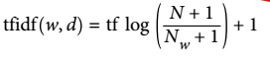
where N is the number of documents in the training set, is the number of documents in the training set that the word w appears in, and tf (the term frequency) is the number of times that the word w appears in the query document d (the document you want to transform or encode). Both classes also apply L2 normalization after computing the tf–idf representation. In other words, they rescale the representation of each document to have Euclidean norm 1. Rescaling in this way means that the length of a document (the number of words) does not change the vectorized representation.

The standard formula is:
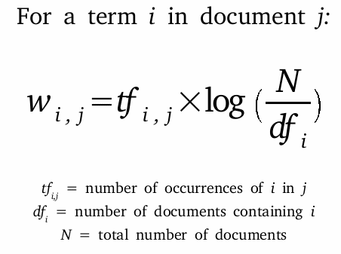

comprehensive exercise
from sklearn.feature_extraction.text import TfidfTransformer, CountVectorizer, TfidfVectorizer
from sklearn.linear_model import LogisticRegression
from sklearn.pipeline import make_pipeline
from sklearn.model_selection import GridSearchCV
from numpy import set_printoptions; set_printoptions(suppress=True, linewidth=250, precision=2)
from myutils import print
l = ["This is document one",
"this is a document too, namely document number two",
"aardvark is an animal that looks like an aardvark because it's an aardvark"]
classes = [0,0,1]
"""create a bag-of-words"""
VC = CountVectorizer(stop_words='english').fit(l)
a = VC.get_feature_names()
print(a)
d = VC.vocabulary_
print(d)
sm = VC.transform(l)
nd = VC.transform(l).toarray()
print(nd)
"""tf-idf table"""
sm = VC.transform(l)
nd = TfidfTransformer().fit_transform(sm).toarray()
print(nd)
"""tf-idf table"""
VC = TfidfVectorizer(stop_words='english').fit(l)
nd = VC.transform(l).toarray() #same as TfidfTransformer().fit_transform(sm)
print(nd)
a = VC.get_feature_names()
d = VC.vocabulary_
a = VC.idf_
print(a)
#calculations of idf for aardvark:
N = 3 #N is the number of documents in the corpus
Nw = 1 #Nw is the number of documents that the word w appears in
from math import log as ln
idf = ln((N+1)/(Nw+1)) + 1
print(idf)
"""predict"""
X = nd
y = classes
MD = LogisticRegression().fit(X,y)
y_pred = MD.predict(X) # 100% correct
print(y_pred)
"""pipeline and grid search"""
l = l*2; y = y*2 #because GridSearch needs a larger dataset
PL = make_pipeline(TfidfVectorizer(), LogisticRegression())
d = {'logisticregression__C':[0.001, 0.01, 0.1, 1, 10], 'tfidfvectorizer__stop_words':[None, 'english']}
ME = GridSearchCV(PL, param_grid=d, cv=2)
ME.fit(l,y)
score = ME.best_score_
d = ME.best_params_
PL = ME.best_estimator_
MD = PL.steps[1][1]
MD = PL.named_steps['logisticregression'] #same
print(score, d, PL, MD)

n-Grams

VC = sklearn.feature_extraction.text.CountVectorizer(ngram_range=(1,2)) min=unigram max=bigram
VC = sklearn.feature_extraction.text.TfidfVectorizer(ngram_range=(1,3)) min=unigram max=trigram
VC.fit(l)
sm = VC.transform(l)
sm = VC.fit_transform(l)
l = VC.get_feature_names()
d = VC.vocabulary_
a = VC.idf_

Natural Language Toolkit - nltk

nltk tag list
CC coordinating conjunction
CD cardinal digit
DT determiner
EX existential there (like: "there is" ... think of it like "there exists")
FW foreign word
IN preposition/subordinating conjunction
JJ adjective 'big'
JJR adjective, comparative 'bigger'
JJS adjective, superlative 'biggest'
LS list marker 1)
MD modal could, will
NN noun, singular 'desk'
NNS noun plural 'desks'
NNP proper noun, singular 'Harrison'
NNPS proper noun, plural 'Americans'
PDT predeterminer 'all the kids'
POS possessive ending parent's
PRP personal pronoun I, he, she
PRP$ possessive pronoun my, his, hers
RB adverb very, silently,
RBR adverb, comparative better
RBS adverb, superlative best
RP particle give up
TO to go 'to' the store.
UH interjection errrrrrrrm
VB verb, base form take
VBD verb, past tense took
VBG verb, gerund/present participle taking
VBN verb, past participle taken
VBP verb, sing. present, non-3d take
VBZ verb, 3rd person sing. present takes
WDT wh-determiner which
WP wh-pronoun who, what
WP$ possessive wh-pronoun whose
WRB wh-abverb where, when

nltk basic functionality
import nltk
s = "This is just a sentence with no meaning. Here is another one meaning nothing."
l = nltk.sent_tokenize(s) #split a string by sentences
l = nltk.word_tokenize(s) #split a string by words
lt = nltk.pos_tag(l) #list of tuples: ('word', 'speech part')

tr = nltk.stem.PorterStemmer() # tr = transformer
s = tr.stem("replaced") # 'replac'

spacy basic functionality
import spacy
s = "This is just a sentence meaning nothing."
ins = spacy.load('en')
doc = ins(s) # akin to a python string (spacy.tokens.doc.Doc)
doc = ins.tokenizer(s) # same

token = doc[-3] # just a word (spacy.tokens.token.Token)
s = token.norm_ # 'meaning'
s = token.lemma_ # 'mean'

sklearn.feature_extraction.text.CountVectorizer returns a (sparse) matrix of word counts (bag-of-words) which (in theory) can be used with sklearn.naive_bayes.MultinomialNB

sklearn.feature_extraction.text.TfidfVectorizer (on the other hand) returns a (sparse) matrix with TFIDF (term frequency–inverse document frequency) statistics, that is usually used with LogisticRegression

demo on the above-said
"""IMPORTS"""
from sklearn.pipeline import make_pipeline
from sklearn.naive_bayes import MultinomialNB
from sklearn.feature_extraction.text import CountVectorizer
"""MAKE DATA"""
t = ("God sent an angel to Earth to teach man about eternal life after death and God's will",
"the angel said to the man 'You are a mortal being whom death awaits, unlike us angels'",
"God, God's will and man awaiting eternal life after death",
"he thought about God and eternal life after death",
"technology and technological progress",
"the progress of technological thought",
"techno breakthrough in modern research",
"progress in investment in technology and research",
"we need more funds for portfolio investment in order to increase stock returns",
"London stock exchange experts thought that we will experience another financial crash",
"a financial bubble and its dangers for hedge-funds and how to avoid them",
"this financial guru predicts a stock crash and avoids byuing more stock",
"many hedge-fund managers made progress in increasing its customers returns on investment and avoided crashes",
"the man who teaches about the breakthroughs in technology and progress on financial markets, God, angel, eternal Earth death")
classes = d = {0:'religion', 1:'technology', 2:'finance'}
labels = y = y_true = (0,0,0,0,1,1,1,1,2,2,2,2,2,2)
"""MY WORD NORMILIZER"""
from sklearn.base import BaseEstimator, TransformerMixin
class NormalizeByStemming(BaseEstimator, TransformerMixin): #NORMALIZATION OF WORDS VIA STEMMING
def __init__(self):
self._a = None
self._y = None
def fit(self, array_of_strings, y=None):
self._a = list(array_of_strings)
self._y = list(y)
return self
def transform(self, array_of_strings=None, y=None):
from re import compile, sub
RE = compile(r"(\w+?)(es|ed|ing|s|'s)\b")
for i in range(len(self._a)):
s = self._a[i]
s = RE.sub(r"\1", s)
s = sub(r"\b\w\b", "", s)
self._a[i] = s
return self._a
#=========================================================================
"""MULTINOMIAL"""
PL = make_pipeline(NormalizeByStemming(), CountVectorizer(stop_words='english', min_df=2), MultinomialNB())
PL.fit(t,y)
y_pred = PL.predict(t)
score = PL.score(t,y)
print(y_pred, score)
"""LOGISTIC REGRESSION BASED ON THE CountVector ABOVE"""
from sklearn.feature_extraction.text import TfidfTransformer, TfidfVectorizer
from sklearn.linear_model import LogisticRegression
PL = make_pipeline(NormalizeByStemming(), TfidfVectorizer(), LogisticRegression(C=1, penalty='l2')).fit(t,y)
y_pred = PL.predict(t)
score = PL.score(t,y)
print(y_pred, score)
"""LOGISTIC REGRESSION BASED ON THE RAW/ORIGINAL DATA"""
from sklearn.feature_extraction.text import TfidfVectorizer
PL = make_pipeline(TfidfVectorizer(stop_words='english', min_df=2), LogisticRegression(C=1, penalty='l2'))
PL.fit(t,y)
y_pred = PL.predict(t)
score = PL.score(t,y)
print(y_pred, score)
"""CONFUSION MATRIX"""
from sklearn.metrics import confusion_matrix
from seaborn import heatmap
from pylab import show
mx = confusion_matrix(y_true, y_pred)
heatmap(mx, square=True, annot=True, fmt='d', cbar=False, cmap='viridis',
xticklabels=[d[k] for k in sorted(d.keys())], yticklabels=[d[k] for k in sorted(d.keys())])
show()

create and load data from a Bunch
#create a folder structure resembling the Bunch structure
import os
os.chdir(r"..\..\Working"); s = os.getcwd() #D:\Working
for k in (0,1,2): # 3 Classes
dirpath = r"Bunch\Class%i" % k
if not os.path.exists(dirpath): os.makedirs(dirpath)
for j in (1,2,3,4,5): # 5 documents in each Class
filepath = os.path.join(dirpath, f"document{j}.txt")
with open(filepath, mode="wt", encoding="utf_8") as fh:
fh.write("contents of дocüment%i of class %i" % (j,k))
else: 'end of the for loop'
#load the Bunch
import sklearn.datasets
d = sklearn.datasets.load_files(r"D:\Working\Bunch") # d = Bunch
X = d.data # X = list of 15 bytes-arrays = corpus with 15 documents
y = d.target # y.shape = (15,) y=[0 1 1 1 2 0 0 2 2 1 2 0 0 1 2]
classes_names = d.target_names # ['Class0', 'Class1', 'Class2']
bt = X[3]
z = d.keys() #dict_keys(['data', 'filenames', 'target_names', 'target', 'DESCR'])
l = d['filenames'] # list containing fullpaths of all txt-files

pickle the data
#pickle the data
import pickle, numpy
with open('X.pkl', mode='wb') as fh: pickle.dump(X, file=fh)
y.dump('y') # ndarray.dump('filename')
numpy.save('y.npy', y)
#reload the data
with open('X.pkl', mode='rb') as fh: X = pickle.load(fh)
y = numpy.load('y')
y = numpy.load('y.npy')

bag of words
from sklearn.feature_extraction.text import CountVectorizer
bag = CountVectorizer(input='content', encoding='utf-8', decode_error='strict',
strip_accents='ascii', lowercase=True,
preprocessor=None, tokenizer=None, # must be callables
token_pattern=r"(?u)\b\w\w+\b", ngram_range=(1,3),
stop_words='english',
min_df=2, max_df=1.0, max_features=None, dtype=np.int64)
bag.fit(corpus)
d = bag.vocabulary_
mx = bag.transform(corpus).toarray()
l = bag.get_feature_names()

CountVectorizer Notes:
CountVectorizer makes a matrix which is a bag-of-words. Each row represents a document, a column represents a particular term.

The CountVectorizer extracts tokens using a regular expression. By default, the regular expression that is used is "\b\w\w+\b"

If the transform method of CountVectorizer is called on a document that contains words that were not contained in the training data, these words will be ignored as they are not part of the dictionary.

from sklearn.feature_extraction.text import CountVectorizer, TfidfTransformer, TfidfVectorizer
bag = TfidfVectorizer(input='content', encoding='utf-8', decode_error='strict',
strip_accents='ascii', lowercase=True,
preprocessor=None, tokenizer=None,
stop_words={set}, token_pattern=r"(?u)\b\w\w+\b", ngram_range=(1,1),
max_df=1.0, min_df=1,
norm='l2', dtype=np.float64)
bag.fit(corpus) # corpus = a list of strings
d = bag.vocabulary_
mx = bag.transform(corpus).toarray()
l = bag.get_feature_names()
a = bag.idf_
df = DataFrame(mx, columns=bag.get_feature_names())

demo on tfidf
import numpy as np
from pandas import DataFrame, Series

"""DATA"""
corpus = [
"a common but specific word, specific to the specific ...",
"a common word, common to the ...",
"a rare word"]
y = labels = target = (1,0,1) # 1 = has a rare or specific word; 0 = usual words

"""PRE-PROCESS"""
from sklearn.feature_extraction.text import CountVectorizer, TfidfTransformer, TfidfVectorizer
bag = TfidfVectorizer(input='content', encoding='utf-8', decode_error='strict', strip_accents='ascii', lowercase=True,
preprocessor=None, tokenizer=None,
stop_words={'a','the','to','but'}, token_pattern=r"(?u)\b\w\w+\b", ngram_range=(1, 1),
max_df=1.0, min_df=1,
norm='l2', dtype=np.float64)
bag.fit(corpus)

d = bag.vocabulary_
mx = bag.transform(corpus).toarray()
l = bag.get_feature_names()
a = bag.idf_

m = len(corpus)
n = len(bag.get_feature_names())

df = DataFrame(mx, columns=bag.get_feature_names()).round(2)
df = df.append(Series(a, index=bag.get_feature_names()), ignore_index=True)#.round(2)
df.index = [f'doc{i}' for i in range(1,df.shape[0])] + ['idf']

"""LOGISTIC REGRESSION"""
X = mx
from sklearn.linear_model import LogisticRegression
md = LogisticRegression(solver='liblinear').fit(X,y)
score = md.score(X,y) # 100%

"""PREDICT"""
x = bag.transform(["common word with rare and specific meaning"]).toarray()
y_pred = md.predict(x) # predicted as 1
p = md.predict_proba(x) # 0.37 0.62 i.e. 62% that it is class 1

unigrams vs bigrams
from sklearn.feature_extraction.text import CountVectorizer, TfidfVectorizer, TfidfTransformer
from sklearn.linear_model import LogisticRegression

corpus = [ # ensure that n < m (must have more samples than features, otherwise you'll get 100%)
"not good",
"not bad",
"very bad",
"but very good",
"very bad actually",
"actually not bad"
]
y = (0,1,0,1,0,1)
S = {'actually', 'but'} #stop words

"""UNIGRAMS"""
bag = CountVectorizer(stop_words=S, ngram_range=(1,1))
bag.fit(corpus)
d = bag.vocabulary_
l = bag.get_feature_names()
mx = bag.transform(corpus).toarray()

X = TfidfTransformer().fit_transform(mx).toarray().round(3)
md = LogisticRegression(solver='liblinear').fit(X,y)
score = md.score(X,y) #66%

"""BIGRAMS"""
md = TfidfVectorizer(stop_words=S, ngram_range=(2,2)).fit(corpus)
X = md.fit_transform(corpus).toarray()
d = md.vocabulary_
l = md.get_feature_names()

md = LogisticRegression(solver='liblinear').fit(X,y)
score = md.score(X,y) #100%
w = [md.intercept_[0], *md.coef_[0]]

"""GRID SEARCH"""
from sklearn.pipeline import make_pipeline
from sklearn.model_selection import GridSearchCV, LeaveOneOut

bag = TfidfVectorizer(stop_words=S)
md = LogisticRegression(solver='liblinear')
pl = make_pipeline(bag, md)

d = {'tfidfvectorizer__ngram_range':[(1,1),(2,2)],
'logisticregression__C':[0.1, 1.0, 10]}

me = GridSearchCV(pl, d, cv=LeaveOneOut())
me.fit(corpus, y)

score = me.best_score_ # 67%
d = me.best_params_ #{'logisticregression__C': 0.1, 'tfidfvectorizer__ngram_range': (2, 2)}
pl = me.best_estimator_
d = me.cv_results_
a = d['mean_test_score']
mx = a.reshape(-1,3).T
from pandas import DataFrame
df = DataFrame(mx.round(2), index=[0.1, 1.0, 10], columns=[(1,1),(2,2)])
df.index.name = "C"; df.columns.name = "ngrams"

y_pred = pl.predict(corpus)
score = pl.score(corpus, y) # 100%

grid-search with a bag-of-words
from sklearn.pipeline import make_pipeline
from sklearn.model_selection import GridSearchCV, LeaveOneOut

#make a pipeline
bag = TfidfVectorizer(stop_words=S)
md = LogisticRegression(solver='liblinear')
pl = make_pipeline(bag, md)

#define the parameters to test
d = {'tfidfvectorizer__ngram_range':[(1,1),(2,2)],
'logisticregression__C':[0.1, 1.0, 10]}

#make a meta-estimator (with param_grid and cross-validation parameter)
me = GridSearchCV(pl, d, cv=LeaveOneOut())
me.fit(corpus, y)

#the best things
score = me.best_score_
d = me.best_params_
pl = me.best_estimator_

#use the best pipeline to predict
y_pred = pl.predict(corpus)
score = pl.score(corpus, y)

#analize the test metrics
d = me.cv_results_
a = d['mean_test_score']
mx = a.reshape(-1,3).T ; from pandas import DataFrame
df = DataFrame(mx.round(2), index=[0.1, 1.0, 10], columns=[(1,1),(2,2)])
df.index.name = "C"; df.columns.name = "ngrams"

"""vizualize the importance of features (i.e. terms) via logistic regression learned coefficients"""
import matplotlib.pyplot as plt
pl = me.best_estimator_
d = pl.named_steps
bag = d['tfidfvectorizer']
l = bag.get_feature_names()

md = d['logisticregression']
weights = md.coef_[0]

plt.bar(range(len(l)), height=weights, tick_label=l)

sklearn.feature_extraction.text.CountVectorizer(max_df, min_df, max_features)
min_df = ignore terms that have a document frequency lower than the given threshold (i.e. eliminate too rare words). Can be integer or float. E.g. min_df=3 means a term must appear in at least 3 documents to be included into the dictionary

max_df = ignore terms that have a document frequency higher than the given threshold (i.e. eliminate too common words). Can be integer or float. E.g. max_df=.2 means if a term appears in 20% of documents or more – do not include that term into the dictionary

max_features = build a vocabulary that only consider the top max_features ordered by term frequency across the corpus.

Latent Dirichlet Allocation
from sklearn.feature_extraction.text import CountVectorizer
from sklearn.decomposition import LatentDirichletAllocation
from pandas import DataFrame
from numpy import array

corpus = [
"music band",
"music band music",
"sports running",
"sports running",
"science and books on research",
"research books on science and research"]

S = {'and','on'}

m = 6 # observations
n = 7 # terms / features
k = 3 # topics

"""MAKE A BAG OF WORDS"""
bag = CountVectorizer(stop_words=S, min_df=2, max_df=1/3)
X = bag.fit_transform(corpus).toarray()
terms = bag.get_feature_names() # list of 7 strings
df = DataFrame(X, columns=terms) # 6x7

"""MODEL"""
md = LatentDirichletAllocation(n_components=3, learning_method='batch', random_state=1) # n_components is the same as n_topics
mx = md.fit_transform(X) # 6x3 probabilities of class
y_pred = mx.argmax(axis=1) # predicted clustering / labels

mx = md.components_ # 3x7
mx = mx.round(3)
nx = mx.argsort(axis=1)[:,::-1] # 3x7 3 rows of indeces
terms = array(terms)
nd = array([terms[nx] for nx in nx]) # 3x7 3 topics and their terms

#name the topics and make a more inteligable y_pred array
l = [str.join('&', a[:2]) for a in nd]
y_pred = [array(l)[ix] for ix in y_pred]

multinomial distribution
mx = numpy.random.multinomial(n=100, pvals=[0.5, 0.1, 0.4], size=10)
μμ = mx.mean(axis=0) #[50., 10., 40.]

multinomial distribution & multinomial naïve Bayes
#data
m = 2 # two data-points per multinomial probabilities combination
pvals = [(0.5,0.1,0.4),(0.1,0.5,0.4),(0.97, 0.01, 0.02)] # three multinomial probabilities combination

X = numpy.zeros(shape=(len(pvals)*m, 3), dtype=numpy.uint8) # 6x3 matrix of integer counts
for i,pvals in enumerate(pvals):
X[i*m:i*m+m,:] = numpy.random.multinomial(n=100, pvals=pvals, size=m)

y = sum([[i]*m for i in range(len(pvals))],[]) # [0, 0, 1, 1, 2, 2]

#model
from sklearn.naive_bayes import MultinomialNB
md = MultinomialNB().fit(X,y)
score = md.score(X,y) # 100%
y_pred = md.predict(X) # [0, 0, 1, 1, 2, 2] same as y-true

demo on multinomial distribution & multinomial naïve Bayes
import numpy

#data
m = 2 # two data-points per multinomial probabilities combination
pvals = [(0.5,0.1,0.4),(0.1,0.5,0.4),(0.97, 0.01, 0.02)] # three multinomial probabilities combination

X = numpy.zeros(shape=(len(pvals)*m, 3), dtype=numpy.uint8) # 6x3 matrix of integer counts
for i,pvals in enumerate(pvals):
X[i*m:i*m+m,:] = numpy.random.multinomial(n=100, pvals=pvals, size=m)

y = sum([[i]*m for i in range(len(pvals))],[]) # [0, 0, 1, 1, 2, 2]

#model
from sklearn.naive_bayes import MultinomialNB
md = MultinomialNB().fit(X,y)
score = md.score(X,y) # 100%
y_pred = md.predict(X) # [0, 0, 1, 1, 2, 2] same as y-true

#test
pvals = [(0.5,0.1,0.4),(0.1,0.5,0.4),(0.97, 0.01, 0.02)]
X_test = numpy.zeros(shape=(len(pvals)*m, 3), dtype=numpy.uint8) # 6x3 matrix of integer counts
for i,pvals in enumerate(pvals):
X_test[i*m:i*m+m,:] = numpy.random.multinomial(n=100, pvals=pvals, size=m)

y_test = sum([[i]*m for i in range(len(pvals))],[]) # [0, 0, 1, 1, 2, 2]
score = md.score(X_test, y_test)
print(score) #1.0

demo on multinomial naïve Bayes for text
#data
corpus = [
"banana apple orange",
"apple orange banana",
"banana banana apple",
"banana apple banana",
"apple apple orange orange orange banana",
"apple apple orange orange orange banana banana"]

y = ['mix','mix', 'exotica','exotica', 'citrus','citrus']

#preprocess
from sklearn.feature_extraction.text import CountVectorizer
bag = CountVectorizer()
X = bag.fit_transform(corpus).toarray()
column_names = bag.get_feature_names()

#model
from sklearn.naive_bayes import MultinomialNB
md = MultinomialNB().fit(X,y)
score = md.score(X,y) #1.0
y_pred = md.predict(X) #['mix', 'mix', 'exotica', 'exotica', 'citrus', 'citrus']

TfidfTransformer
corpus = ["common specific specific specific word",
"common common word",
"rare word"]
y = [0,0,1]

from sklearn.feature_extraction.text import CountVectorizer, TfidfTransformer, TfidfVectorizer
tr = CountVectorizer().fit(corpus)
vocabulary = tr.get_feature_names()
X1 = tr.transform(corpus).toarray() # word count matrix (bag-of-words)

tr = TfidfTransformer(norm=None, smooth_idf=False)
X2 = tr.fit_transform(X1).toarray()

tr = TfidfTransformer(norm=None, smooth_idf=True)
X3 = tr.fit_transform(X1).toarray()

tr = TfidfTransformer(norm='l2', smooth_idf=True)
X4 = tr.fit_transform(X1).toarray()

tr = TfidfVectorizer(norm='l2', smooth_idf=True)
X5 = tr.fit_transform(corpus).toarray() # same as X4

NEURAL NETWORKS

sklearn.linear_model.Perceptron
import numpy as np
def make_data(m=300):
m,n,k = m, 2, 3
m = m//k # per klass
X = np.matmul(np.random.randn(m*2,n),[(0.8, 0.3), (0.3, 0.8)])
y = X.sum(1) > np.random.normal(loc=0, scale=0.2, size=m*2)
X = np.vstack([X, np.random.randn(m,n) / 3 + (2.5,-1)])
y = np.array(tuple(y.astype("uint8")) + (2,)*m)
X = (X - X.mean(0)) / X.std(0, ddof=0)
nx = np.random.permutation(len(y))
X,y = (nd[nx] for nd in (X,y))
return(X,y)
###################################################################

X,y = make_data()

from sklearn.linear_model import Perceptron
md = Perceptron().fit(X,y)
acc = md.score(X,y)
print("Perceptron accuracy =", acc)

#visualize
import matplotlib.pyplot as plt
from matplotlib.colors import ListedColormap
cmap = ListedColormap(['r','g','b'])

r = np.linspace(-3, 3, 150)
XX,YY = np.meshgrid(r,r)

XXX = np.c_[XX.ravel(), YY.ravel()]
yyy = md.predict(XXX)

for k in range(len(set(y))):
nx = yyy == k
plt.plot(XX.ravel()[nx], YY.ravel()[nx], alpha=0.4, color=cmap.colors[k])
plt.plot(*X[y==k].T, color=cmap.colors[k], marker='o', linestyle='none')

Truth tables and Activation function (Logistic aka Sigmoid)
import numpy as np; e = np.exp(1)
from operator import and_, or_, xor

X = [[0,0],
[0,1],
[1,0],
[1,1]]

AND = [and_(x1,x2) for x1,x2 in X]
OR = [or_(x1,x2) for x1,x2 in X]
XOR = [xor(x1,x2) for x1,x2 in X]

X = np.c_[np.ones(len(X), dtype='uint8')[:,None], X]

z = X @ [-1.5, 1, 1]
p = 1 / (1 + e**-z)
y = p > 0.5
print(z, p, y, AND, sep='\n', end='\n\n')

z = X @ [0, 1, 1]
p = 1 / (1 + e**-z)
y = p > 0.5
print(z, p, y, OR, sep='\n', end='\n\n')

multilayer perceptrons for classification
md = sklearn.neural_network.MLPClassifier(hidden_layer_sizes=(100,),
activation='relu',
solver='lbfgs',
alpha=0.0001,
max_iter=200,
random_state=0)

sklearn.neural_network.MLPClassifier = Multi-layer Perceptron classifier

sklearn.neural_network.MLPClassifier
mlp = MLPClassifier(hidden_layer_sizes=[100,], activation='relu', solver='lbfgs', alpha=0.0001)
mlp = MLPClassifier(hidden_layer_sizes=[10,10], activation='tanh', solver='lbfgs', alpha=1, max_iter=200)
mlp = MLPClassifier(hidden_layer_sizes=(10,20,10), activation='logistic', solver='sgd', alpha=1E-6)

Types of activation functions:
logistic regression
tanh = hyperbolic tangent nonlinearity
relu = rectifed linear activation function (rectified linear unit)

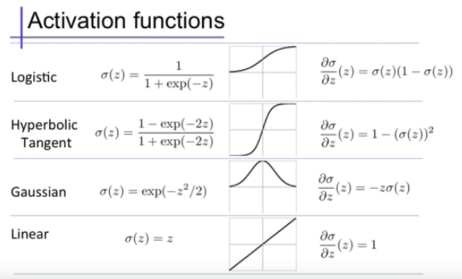

In neural networks the regularization parameter is alpha (whose equivalent is L2 in linear regression).
Low value of alpha = less regularization
High alpha = the weights are shrunk towards zero

demo
from sklearn.neural_network import MLPClassifier
from sklearn.datasets import make_moons
from sklearn.model_selection import train_test_split
import matplotlib.pyplot as plt

X, y = make_moons(n_samples=75, noise=0.25, random_state=3)

#try these settings one by one
MD = MLPClassifier(hidden_layer_sizes=[100,], activation='relu', solver='lbfgs', alpha=0.0001, max_iter=200,random_state=0)
MD = MLPClassifier(hidden_layer_sizes=[10], activation='relu', solver='lbfgs', alpha=0.0001, max_iter=200,random_state=0)
MD = MLPClassifier(hidden_layer_sizes=[10,10], activation='relu', solver='lbfgs', alpha=0.0001, max_iter=200,random_state=0)
MD = MLPClassifier(hidden_layer_sizes=[10,10], activation='tanh', solver='lbfgs', alpha=0.0001, max_iter=200,random_state=0)
MD = MLPClassifier(hidden_layer_sizes=[10,10], activation='tanh', solver='lbfgs', alpha=1, max_iter=200,random_state=0)

MD = MD.fit(X, y)
p = MD.score(X,y)
print("score:",p)

#plot
fig = plt.figure()
sp = fig.add_subplot(111)

#draw data-points
mask = y==0
[sp.scatter(*X[mask if m=='o' else ~mask].T, marker=m, s=80, edgecolor='k', color=c) for m,c in zip(['o','^'],['darkcyan','orange'])]

#draw decision boundries
from numpy import meshgrid, linspace, c_
t = sp.axis()
XX,YY = meshgrid(*[linspace(*t,500) for t in (t[:2],t[2:])])
ZZ = MD.predict(c_[XX.ravel(),YY.ravel()]).reshape(XX.shape)
sp.contourf(XX,YY,ZZ, zorder=-3, alpha=0.4, cmap='RdBu_r')
sp.set(xlabel="feature 0", ylabel="feature 1", xticks=[], yticks=[]);

Neural networks expect all input features to vary in a similar way, and ideally to have a mean of 0, and a variance of 1. This is because neural networks use activation functions (like tanh=sigmoid) which works best with low input values.
Use StandardScaler()

(the mean and standard deviation of the training set must be used on the test set as well in order to transform it)

MD = MLPClassifier(hidden_layer_sizes=[10,], activation='logistic', solver='sgd', alpha=0.0001).fit(X,y)
weights = MD.coefs_[0] # shape = (n,10) i.e. n features and 10 hidden layer units
weights = MD.coefs_[1] # len = 10 weights connecting the hidden layer to the output layer

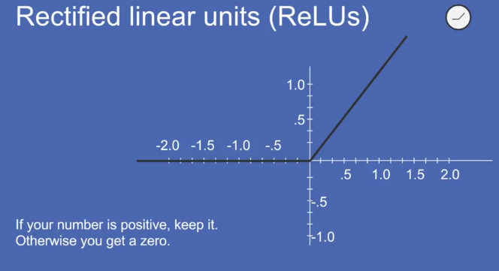

The default algorithm is 'adam'
When starting to work with MLPs stick to 'adam' and 'l-bfgs'

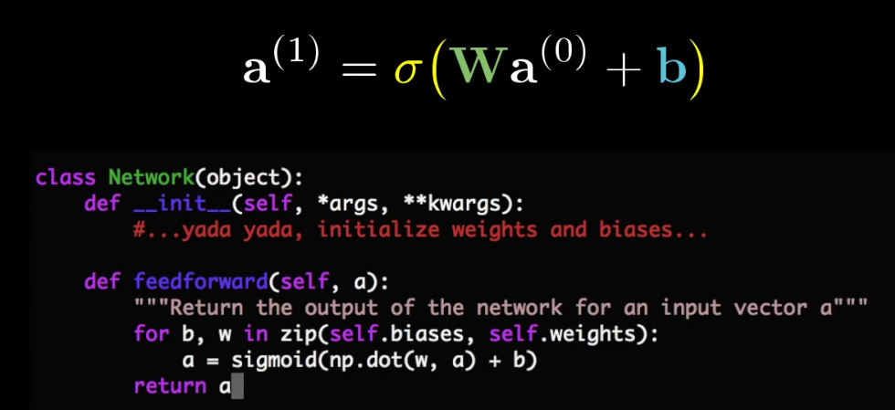

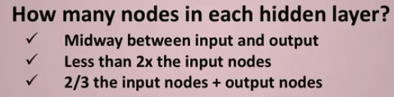

simple adjustable Neural Network (non learning)
import numpy as np
import matplotlib.pyplot as plt
from matplotlib.widgets import Slider
from unicodedata import normalize
class MLP: # a simple MLP Neural Network
def __init__(self, layer_sizes, **kwargs):
weight_shapes = [(m,n) for m,n in zip(layer_sizes[1:], layer_sizes[:-1])]
self.weights = [np.random.standard_normal((m,n))/n**.5 for m,n in weight_shapes] # n**0.5 == sqrt(n_features)
self.biases = [np.zeros((m,1)) for m in layer_sizes[1:]]
self.X = kwargs.get('X', None)
def reset(self):
self.weights = [np.zeros_like(w, dtype='f') for w in self.weights]
self.biases = [np.zeros_like(b, dtype='f') for b in self.biases]
def change_weight(self, layer_number, row_number, column_number, weight): # 0-based
w,n,d = (layer_number, row_number, column_number)
self.weights[w][n,d] = weight
def change_bias(self, layer_number, row_number, bias): # 0-based
w, n = (layer_number, row_number)
self.biases[w][n] = bias
@staticmethod
def activation_function(x):
return 1/(1+np.exp(-x))
def probabilities(self, X):
assert all([type(X) is np.ndarray, X.ndim==2]), "bad matrix"
mx = np.empty(shape=(len(X), len(self.biases[-1])), dtype='f')
for i,x in enumerate(X):
a = x[:,None]
for w,b in zip(self.weights, self.biases):
a = self.activation_function(np.matmul(w,a)+b)
else: mx[i] = a.ravel()
return mx # probabilities matrix: m = number of samples n = number of classes
def predict(self, X=None):
X = self.X if type(self.X) is np.ndarray else X
mx = self.probabilities(X)
y_pred = np.argmax(mx, axis=1)
return y_pred
def make_sliders(n:"number of weights", **kwargs):
from functools import partial
d = dict(x=0.2, y=0.8, width=0.15, height=0.015) #defaults
d.update(kwargs)
[globals().__setitem__(k,v) for k,v in d.items()]
func = d.get('func', lambda val:val)
l = []
for i in range(1,n+1):
sp = plt.axes([x, y-(0.04*i), width, height])
slider_id = "{}{}".format(d.get('label','w'), chr(8320+i) if i <=9 else chr(8321)+chr(8320+(i-10)))
slider = Slider(sp, label=slider_id, valmin=-3, valmax=3, valinit=0)
func = partial(func, slider_id=slider_id)
slider.on_changed(func)
l.append(slider)
return l
def find(mx, n):
for i in range(mx.shape[0]):
for j in range(mx.shape[1]):
if mx[i,j]==n:
return (i,j)
return None
def update(val, slider_id):
global nn, XX,YY
s = normalize('NFKD', slider_id) # from unicodedata
n = int(s[1:])
if s[0]=='w':
mx = np.arange(1,7).reshape(3,2) if n <=6 else np.arange(7,13).reshape(2,3)
i,j = find(mx, n)
nn.change_weight(layer_number=(0 if n <=6 else 1), row_number=i, column_number=j, weight=val)
elif s[0]=='b':
nn.change_bias(layer_number=(0 if n <=3 else 1), row_number=(n-1 if n <=3 else n-4), bias=val)
else: raise Exception("unforsen error")
ZZ = nn.predict().reshape(XX.shape)
SP[0].clear()
SP[0].contour(XX,YY,ZZ, cmap='gray', levels=[0,])
SP[0].set(xticks=[], yticks=[])
SP[0].axis('square')
fig.canvas.draw_idle()
#END
#==============================================================================
plt.rcParams['figure.figsize'] = (8,5)
fig,SP = plt.subplots(1,2)
SP[0].set(xticks=[], yticks=[])
SP[0].axis('square')
SP[1].axis('off')
lim = 200
SP[0].axis([-lim,lim,-lim,lim])
sliders = make_sliders(12, func=update, x=0.7, y=0.9)
biases = make_sliders(5, func=update, label='b', x=0.7, y=0.35)
XX,YY = np.meshgrid(np.linspace(*SP[0].axis()[:2], 200), np.linspace(*SP[0].axis()[2:], 200))
X = np.c_[XX.ravel(),YY.ravel()]
nn = MLP(layer_sizes=(2,3,2), X=X)
nn.reset()
plt.show()

demo on pushing data through a Neural Network
def make_data(m,n,k):
from numpy.random import randn
from numpy import log, digitize, linspace, quantile
X = randn(m,n)
y = 1/X[:,0] - log(X[:,1]**2)
breaks = linspace(0, 1, k+1)
breaks = quantile(y, q=breaks)
breaks[-1]+=0.0001
y = digitize(y, bins=breaks) - 1
return X,y

def create_weights_panel(n:"number of features in the input"=2,
k:"number of neurons in the output layer"=1,
s:"sequance with numbers denoting number of neurons in hidden layers"=[10,10],
max_abs_weight:"maximum absolute weight"=None,
max_abs_bias:"maximum absolute bias"=None,
random_seed=9836)->"list of weight-matreces":
assert hasattr(s, '__iter__'),"bad input"
from numpy.random import RandomState, randint
random_seed = random_seed or randint(0,10000)
rs = RandomState(random_seed)
Θ = []
s = list(s) + [k,]
max_abs_weight = max_abs_weight or 2.5
max_abs_bias = max_abs_bias or 3

for s in s:
mx = rs.uniform(-max_abs_weight, max_abs_weight, size=(s, n+1))
bias = rs.randint(-max_abs_bias, max_abs_bias, size=s)
mx[:,0] = bias
Θ.append(mx)
n = s
return(Θ)

def push_through_network(X, W:"Weights panel", return_labels_not_probs=False):
from numpy import zeros, uint8, float16, vectorize
from math import exp

m,n,k = *X.shape, W[-1].shape[0]

probs = zeros(shape=(m,k), dtype=float16)

e = exp(1)
σ = lambda z : 1 / (1 + e**-z)
σ = vectorize(σ)

for i,x in enumerate(X):
a = x
for Θ in W:
a = [1, *a]
z = Θ.dot(a)
a = σ(z)
probs[i] = a

ypred = probs.argmax(1) if return_labels_not_probs else probs
return ypred

#==============================================================================================

from numpy import set_printoptions; set_printoptions(suppress=True, precision=4)

m = 100
n = 2
k = 3 # number of classes in the target

X,y = make_data(m,n,k)

W = create_weights_panel(n=n, k=k, s=(10,10,10))

ypred = push_through_network(X, W, return_labels_not_probs=True)
print(ypred)

sklearn.neural_network.MLPClassifier hyperparameters (for the SGD algorithm)
md = MLPClassifier(hidden_layer_sizes=(64,64), activation='relu', alpha=0.0001, # activation and regularization
solver='sgd', batch_size=200, shuffle=True, # SGD hyperparameters
learning_rate='constant', learning_rate_init=0.001, momentum=0.9, #learning rate and momentum
tol=1e-4, max_iter=500, # when to end the optimization
early_stopping=True, validation_fraction=0.1, # early stopping (try commenting this line out)
warm_start=False, verbose=True, random_state=7)

1. The number of hidden neurons should be between the size of the input layer and the size of the output layer.
2. The number of hidden neurons should be 2/3 the size of the input layer, plus the size of the output layer.
3. The number of hidden neurons should be less than twice the size of the input layer.

You should start with one or two hidden layers, and possibly expand from there.
The number of nodes per hidden layer is often similar to the number of input features, but rarely higher than in the low to mid-thousands.

Looking at the MLP weights
Sometimes looking at the learned coefficients of a neural network can provide insight into the learning behavior. For example if weights look unstructured, maybe some were not used at all, or if very large coefficients exist, maybe regularization was too low or the learning rate too high

visualize weights of an MLP
from sklearn.datasets import load_digits
from sklearn.neural_network import MLPClassifier
import matplotlib.pyplot as plt

#get data
bunch = load_digits()
X = bunch.data
y = bunch.target
n = X.shape[1]
k = len(set(y))

#scale then split
mn = X.min(0)
rg = X.max(0)-X.min(0)
rg[rg==0] = 1
X = (X-mn)/rg

#model
md = MLPClassifier(hidden_layer_sizes=(52,), activation='relu', alpha=0.0001, # activation and regularization
solver='sgd', batch_size=10, shuffle=True, # SGD hyperparameters
learning_rate='constant', learning_rate_init=0.1, momentum=0.9, #learning rate and momentum
tol=1e-4, max_iter=5, # when to end the optimization
#early_stopping=True, validation_fraction=0.1, # early stopping (try commenting this line out)
warm_start=True, verbose=True, random_state=0)
md.fit(X,y) # does 5 iterations (max_iter)
md.fit(X,y) # because warm_start (this is iteration #6)
md.fit(X,y) # another iteration - the loss gets better

#evaluate
accuracy = md.score(X,y)
print("\ntrain/test accuracy = %.3f\n"%accuracy)

#visualize weights
from math import ceil,sqrt
root = ceil(sqrt(md.coefs_[0].T.shape[0]))

fig,ax = plt.subplots(root,root, figsize=(5,5))
fig.subplots_adjust(hspace=0.1, wspace=0.1)

for sp,weights in zip(ax.flat, md.coefs_[0].T):
sp.imshow(weights.reshape(8,8), cmap='binary', interpolation='none')
sp.set_axis_off()
[fig.axes[-1].remove() for i in range(ax.size - md.coefs_[0].T.shape[0])];

DATASETS

18 places to find data sets
https://www.dataquest.io/blog/free-datasets-for-projects

http://mlr.cs.umass.edu/ml/datasets.html
https://www.kaggle.com/datasets

make a dataset
X, y = sklearn.datasets.make_blobs(100, 2, centers=2, random_state=2, cluster_std=1.5)
#makes two blobs

t = sklearn.datasets.make_moons(1000, noise=0.05)
#makes two creascents

iris
df = seaborn.load_dataset("iris") # gets the dataset from the internet
d = sklearn.datasets.load_iris()

Eigenfaces
from sklearn.datasets import fetch_lfw_people
d = fetch_lfw_people(min_faces_per_person=20, resize=0.7)
X = d.data #3023 pics x 5655 pixels #subset: 2063 instead of 3023
pn = d.images #3023 pics x 87 rows x 65 columns #subset: 2063 instead of 3023
y = d.target #3023 integers denoting a person #subset: 2063 instead of 3023
people_names = d.target_names # array of 62 unique strings denoting a peerson (in alphabetical order)
image_shape = pn.shape[1:]
cmap = plt.cm.binary_r

from sklearn.datasets import fetch_lfw_people
d = fetch_lfw_people(min_faces_per_person=20, resize=0.7)
nd = d.images #(3023, 87, 65) 3023 pics each 87x65 pixels
ai = d.target # array of 3023 integers denoting a certain person
ac = d.target_names # array of 62 strings (names of the people)
ak = np.bincount(ai) #array of 62 integres denoting counts

titanic
df = seaborn.load_dataset('titanic')

the Wild dataset (62 people)
import sklearn.datasets
d = sklearn.datasets.fetch_lfw_people(min_faces_per_person=20, resize=0.7)
X = d.images #shape=(87, 65)
X = d.data #shape=(5655,)
y = d.target
tnames = d.target_names

from numpy import ndarray, zeros_like, where, array as numpyarray
def subset_atmost_n_cases_of_each_class(array:'e.g. target array y', atmost:int) -> 'boolean mask':
if type(array) is not ndarray: array = numpyarray(array, dtype='i')
classes_list = set(array)
mask = zeros_like(array, dtype='bool')
for each_class in classes_list:
nx = where(array==each_class)[0][:atmost]
mask[nx] = True
return mask
#############################################################################

from sklearn.datasets import fetch_lfw_people
d = fetch_lfw_people(min_faces_per_person=20, resize=0.7)
pn = d.images #shape=(87, 65)
mx = d.data #shape=(5655,)
y = d.target
names_list = d.target_names

mask = subset_atmost_n_cases_of_each_class(array=y, atmost=50)

X = mx = mx[mask]
y = y[mask]

X_train, X_test, y_train, y_test = train_test_split(X, y, stratify=y, random_state=0)

load MNIST (www.openml.org, http://yann.lecun.com/exdb/mnist/ )
import numpy as np
from os.path import exists
if not(exists("X.npy") and exists("y.npy")):
from sklearn.datasets import fetch_openml
print("loading from net..")
X,y = fetch_openml('mnist_784', version=1, return_X_y=True)
print("saving to disk..")
np.save("X.npy", X)
np.save("y.npy", y)
else:
print("laoding from disk..")
X = np.load("X.npy") # 418 MB
y = np.load("y.npy")
MNIST dataset is actually already split into a training set (the first 60,000 images) and a test set (the last 10,000 images)

Swiss Roll and S-curve
from sklearn.datasets import make_s_curve, make_swiss_roll
X,y = make_swiss_roll(n_samples=1500, random_state=42)
X,y = make_s_curve(n_samples=1500, random_state=42)

demo on making a multivariate random dataset
m = 100 # m data-points
n = 2 # n features
T = [[1, 3], # tr.mx.
[7, 9]] # this in not a covariance matrix but a matrix of random numbers

M = np.random.randn(m,n) # original data points with mean=[0,0] drawn from standard normal distribution

X = np.matmul(T, M.T).T # data-points after transformation
X = np.matmul(M, T) # same

μ = X.mean(axis=0)
Σ = np.cov(X.T)
print(μ.round(2), Σ.round().astype('i'), sep='\n\n')

plt.scatter(*X.T);

parametric equasion for a spiral – CORRECT THIS
t = np.linspace(0, 2*π*1.5, 250)
x = np.cos(t) * np.exp(rate * t)
y = np.sin(t) * np.exp(rate * t)

sklearn digits and faces datasets
from sklearn.datasets import load_digits, fetch_mldata, fetch_openml, fetch_lfw_people

#digits
d = load_digits()
pl = d.images # shape = (1797, 8, 8)
X = d.data # shape = (1797, 64)
y = d.target
classes_list = d.target_names

#MNIST dataset
d = fetch_mldata('MNIST original') #DEPRECATED
X, y = fetch_openml('mnist_784', version=1, return_X_y=True) #EXPERIMENTAL

#faces
d = fetch_lfw_people(min_faces_per_person=20, resize=0.7)
pn = d.images #3023 pics x 87 rows x 65 columns #subset: 2063 instead of 3023
X = d.data #3023 pics x 5655 pixels #subset: 2063 instead of 3023
y = d.target #3023 integers denoting a person #subset: 2063 instead of 3023
people_names = d.target_names # array of 62 unique strings denoting a peerson (in alphabetical order)

x = np.random.rand(100,1) **2
y = 10 - 1/(x+0.1)
plt.scatter(x,y)

RESEARCH, THEORY

demo on the relationship between entropy (or standard deviation) and feature importance in a Decision Tree
import numpy as np

def make_data(m=100, n_classes=3, balanced_classes=True, weights_correlation_with_entropy=True):
from scipy.stats import binom
X = binom.rvs(n=[10,10,10,10,10], p=[0.1, 0.25, 0.5, 0.75, 0.9], size=(m,5))
w1 = [0.1, 0.5, 1, 0.5, 0.1] # weights that correspond to the information/entropy of the probabilities above
w2 = [1, 0.5, 0.1, 0.5, 1] # weghts that do not support the entopy
w = w1 if weights_correlation_with_entropy else w2
z = X @ w
sigma = z.std()
e = np.random.normal(loc=0, scale=sigma, size=m) / 4 #error
z += e

if balanced_classes:
q = np.linspace(0,1, num=n_classes+1)[1:-1]
breaks = np.quantile(z, q=q)
labels = np.digitize(z, breaks)
else:
breaks = np.linspace(z.min(), z.max()+1e-6, n_classes+1)
labels = np.digitize(z, breaks) - 1
return X,labels

#================================================================================================

from sklearn.tree import DecisionTreeClassifier
md = DecisionTreeClassifier()

X,y = make_data(weights_correlation_with_entropy=True) # the middle feature will have the most entropy, therefore - most importane
md.fit(X,y)
importances = md.feature_importances_.round(2) # the middle feature is the most important one
print(importances)

X,y = make_data(weights_correlation_with_entropy=False) # the weights blurred up the entropy
md.fit(X,y)
importances = md.feature_importances_.round(2) # the middle feature is NOT the most important one
print(importances)

MATHAMATICS

What are non-parametric tests in statistics?
When the word “parametric” is used in stats, it usually means tests like ANOVA or a t-test. Those tests both assume that the population data has a normal distribution. Nonparametric tests do not assume that the data is normally distributed (e.g. Chi-Square test)

Matrix-Vector Multiplication & Matrix-Matrix Multiplication (application for linear modeling)
data = (10,20,30,40) # e.g. prices
X = numpy.matrix([[1, 10],
[1, 20],
[1, 30],
[1, 40]])
# y = 100 + 2x
w = scipy.matrix([[100], # intercection
[ 2 ]]) # slope

W = sympy.Matrix([[100,200,300], # intercections of the 3 hypotheses
[ 2, 3, 4]]) # slopes of the 3 hypotheses
same
y = X*w
y = X@w
y = numpy.matmul(X,w)
y = T.__matmul__(w)

Y = X*W
Y = X@W
Y = scipy.matmul(X,W)
Y = X.__matmul__(W)

vector multiplication (ndarray vs ndmatrix)
u,v = (1,2,3), (10,20,30)
u,v = (numpy.array(v) for v in (u,v)) # horizontal 1D arrays
s = numpy.dot(u,v) # a numpy.int32

v = v[:,None] # vertical vector (oficially 2D nd array)
s = numpy.dot(u,v) # array([140]) a single-value array

θ,x = (1, 0.5, -2), (100, 20, 30) # horizontal vectors
θ,x = (numpy.matrix(a).T for a in (θ,x)) # vertical vectors

y = θ.T @ x # a single-value-matrix

basic linear algebra with numpy
import numpy, numpy.linalg, scipy.linalg
"""NUMPY LINALG"""
A = numpy.matrix([[1,1,1], #solve the system of linear equasions
[1,2,4], #Ax = b aka Xw = y
[1,3,9]]) #A = square matrix
b = numpy.matrix([[102],[108],[118]]) #column vector
b = numpy.matrix([ 102, 108, 118]) #becomes [[102, 108, 118]] shape=(1, 3) row-vector, 2D-np-matrix
b = b.T # b[:,None] would result in [[[102, 108, 118]]] i.e. add another dimension

#solve for x
A_ = A.I #A_ = inverse of A
A_ = numpy.linalg.inv(A) #same
A_ = (A.T*A).I * A.T #via Normal Equasion (used if matrix A is not square)
x = A_ * b #x = the solution vector (x1,x2,x3)=(w1,w2,w3)=(100, 0, 2)
x = A.I * b #same

#verify
b = A * x # see whether b equals the b vector above
z = A * x - b # z = zero vector (with 3 components all zeros)
I = A * A.I # id matrix

#solve with linalg package
x = numpy.linalg.solve(A,b) # analogous to: x = A.I * b
ε = numpy.matrix((0.1, 0.5, -0.1)).T # column vector i.e. 2D vertical numpy-matrix
x = w = θ = β = numpy.linalg.solve(A, b+ε) # with errors

#predict
X = A
y = X * w #predict all values
x = X[1].T #one observation (made into a column vector)
y = θ.T * x #yhat=[[108.5]]

#eigenvectors of a matrix
λλ,ee = numpy.linalg.eig(A) # lambdas and vertical unit eigenvectors

"""NUMPY ARRAY"""
X = numpy.array([[1,1,1], #non-square matrix
[1,2,4],
[1,3,9],
[1,4,18]], dtype='i')
y = numpy.array([102, 108, 118, 136], dtype='i')

#calculate the weights
X_ = numpy.linalg.inv(X.T @ X) @ X.T #via Normal Equasion because X is non-square
X_ = scipy.linalg.pinv(X) #same
w = X_ @ y #horizontal 1D nd-array
w = numpy.matmul(X_, y) #same
θ = X_ @ y[:,None] #vertical vectror (2D nd-array)

#predict
y = X @ w #horizontal 1D nd-array
y = X @ θ #column vector (2D nd-array)
x = X[2] #one observation
y = numpy.dot(w, x) # predict one value
y = θ.T @ x # predict one value

numpy outer
mx = np.outer([1,2,3], [1,2,3,4,5])
mx = np.multiply.outer([1,2,3], [1,2,3,4,5]) #same as above
mx = np.subtract.outer([1,2,3], [1,2,3,4,5])

vector norm
import numpy.linalg, scipy.linalg, pylab
from numpy import array,sqrt
a = array([0,0,1]) # point a in 3D
b = array([1,2,3]) # point b in 3D

d = numpy.linalg.norm(a-b) # Euclidean distance
d = scipy.linalg.norm(a-b, ord=2) # same i.e. l2-norm
d = sqrt(sum((a - b)**2)) # same

d = numpy.linalg.norm(a-b, ord=1) # l1-norm
d = pylab.norm(a-b, ord=0) # l0-norm aka vector cardinality

Solving a system of linear scalar equations
import numpy as np
#Ax = b x = A_1 b
#Xw = y w = X_1 y

X = np.array(
[[1,1,3,1], # 1*x1 + 1*x2 + 3*x3 + 1*x4 = 16
[2,2,3,1], # analogous
[3,3,2,2],
[4,0,1,2]], dtype=np.int16)

w = [1,2,3,4] # intercection of the 4 hyperplanes

y = X @ w #note that there is no bias in this example
y = X.dot(w) #same
y = np.matmul(X,w) #same

#suppose we know X and y, and need to figure out w
w = np.linalg.solve(X,y) #[1., 2., 3., 4.]
X_1 = np.linalg.inv(X.T@X) @ X.T #or via inverse-matrix
X_1 = np.linalg.inv(X) #same because X is a square matrix
w = X_1 @ y #[1., 2., 3., 4.]

Greenwich is located at a latitude of 51 degrees North and a longitude of 0 degrees East (51N 0E) = (51,0)

Sydney is at 34 degrees latitude South and 151 degrees longitude East (34S 151E) = (-34, 151)

great circle distance between two points on a sphere (haversine)
def distance(lat1, lon1, lat2, lon2): # input: in decimal degrees
from math import sin, cos, radians, atan2, sqrt
haversine = lambda θ : sin(θ/2)**2 # haversine formula (input: in radians)
lat1, lon1, lat2, lon2 = (radians(a) for a in (lat1, lon1, lat2, lon2)) # convert to radians
y = haversine(lat2-lat1) + haversine(lon2-lon1) * cos(lat1) * cos(lat2)
θ = 2*atan2(sqrt(y), sqrt(1-y)) # angle/length in radians
r = 6371 # Earth's radius
d = r*θ # (earth's radius) x (θ radians)
return d

"""51°30′N 0°15′W <---> 33°45′S 151°00′E"""
lat1, lon1, lat2, lon2 = 51.5, -0.25, -33.75, 151.0 # in decimal degrees
d = distance(lat1, lon1, lat2, lon2)

import sklearn.neighbors
import numpy as np

r = 6371

mx = [( 51.5, -0.25), # decimal angles
(-33.75, 151)]
mx = np.array(mx)
mx = np.deg2rad(mx) # must convert to radians

θ = sklearn.neighbors.DistanceMetric.get_metric("haversine").pairwise(mx)[0,1]
d = θ*r

STATISTICS

binomial distribution
import scipy.stats # library(stats)
p = 0.5 # probability of success in a single Bernoulli trial
n = 100 # number of Bernoulli trials
k = x = z = 50 # number of successes i.e. value on the x-axis (comparable to z-sqores)
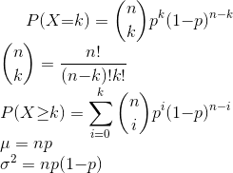
k = x = z = range(0, n+1) # array of x-values

y = "density i.e. point-probability"
c = "cumulative probability"

μ = n*p
var = n*p*(1-p)

y = scipy.stats.binom.pmf(k, n, p) #probability that you get x successes in n trials ...
y <- dbinom(x, size=n, prob=p) #... where the probability of each success is p

c = scipy.stats.binom.cdf(k, n, p)
c <- pbinom(x, size=n, prob=p, lower.tail=TRUE)

x = scipy.stats.binom.ppf(c, n, p)
x <- qbinom(c, size=n, prob=p, lower.tail=TRUE)

x = scipy.stats.binom.rvs(n, p, size=m) # m = number of random numbers (i.e. obseravtions) you want
x <- rbinom(m, size=n, prob=p)

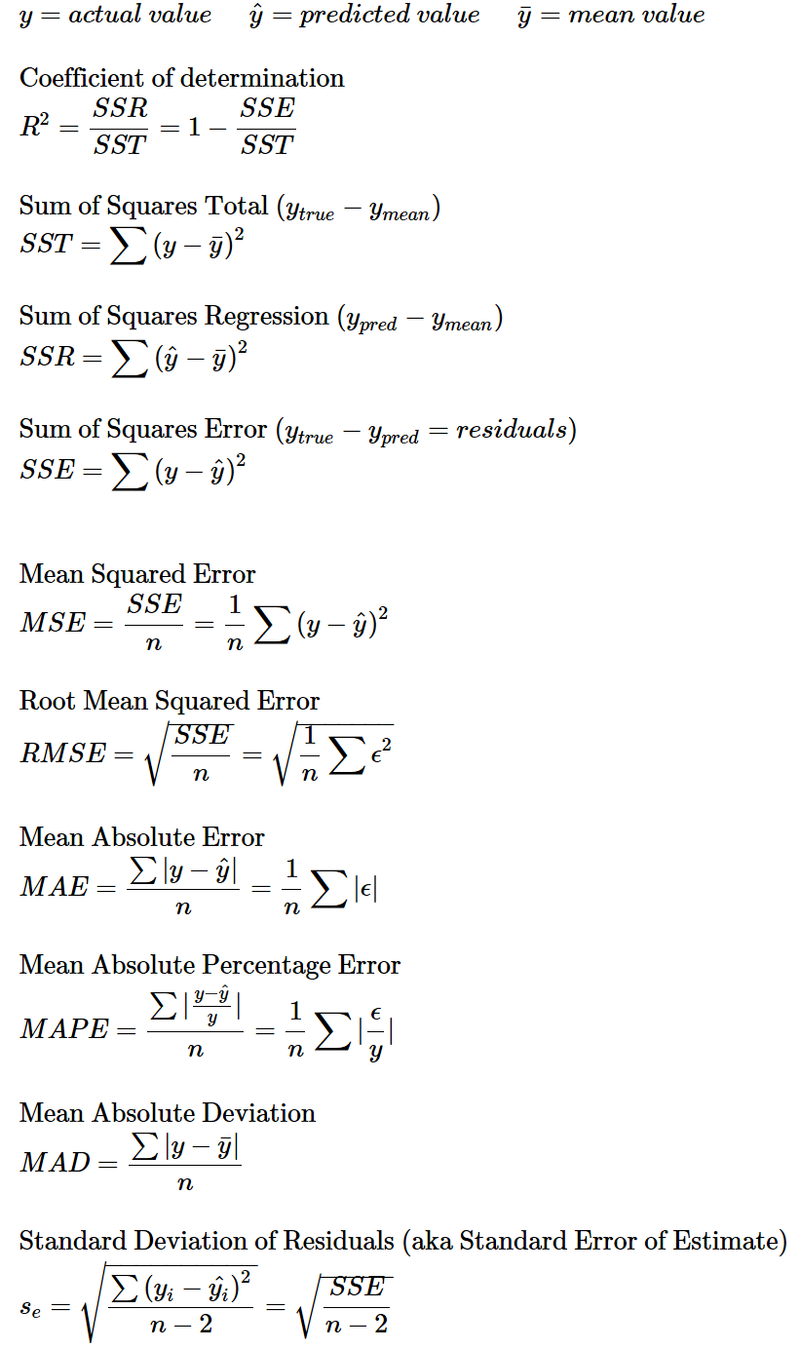
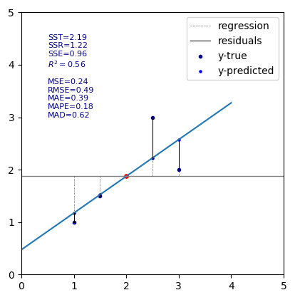

UNIVARIATE LINEAR REGRESSION

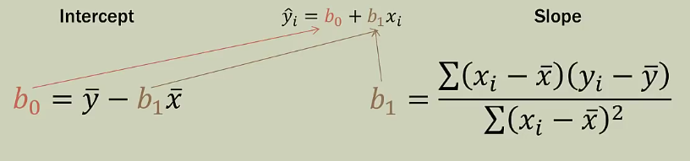
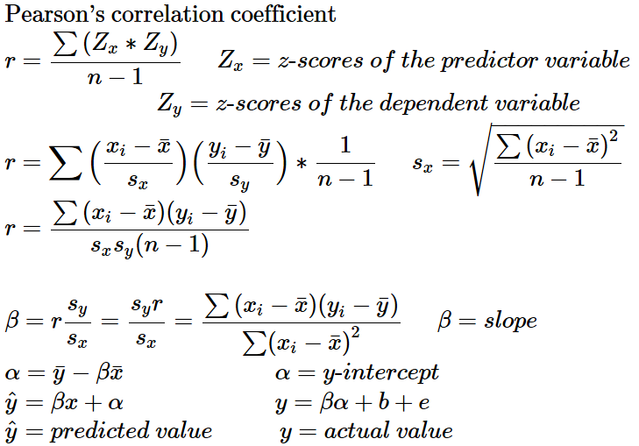
a = intercept
b = slope

Consider using the least-squares line to predict the value of y associated with an x value some specified number of standard deviations away from . Then the predicted y value will be only r times this number of standard deviations from

The regression line of y on x should not be used to predict x, because it is not the line that minimizes the sum of squared deviations in the x direction.

Difference between an outlier and an influential observation:
Influential observation: An observation is potentially influential if it has an x value that is far away from the rest of the data (separated from the rest of the data in the x direction). to determine if the observation is in fact influential, we
assess whether removal of this observation has a large impact on the value of the slope or intercept of the least-squares line.
Outlier: An observation that has a large residual. outlier observations fall far away from the least-squares line in the y direction
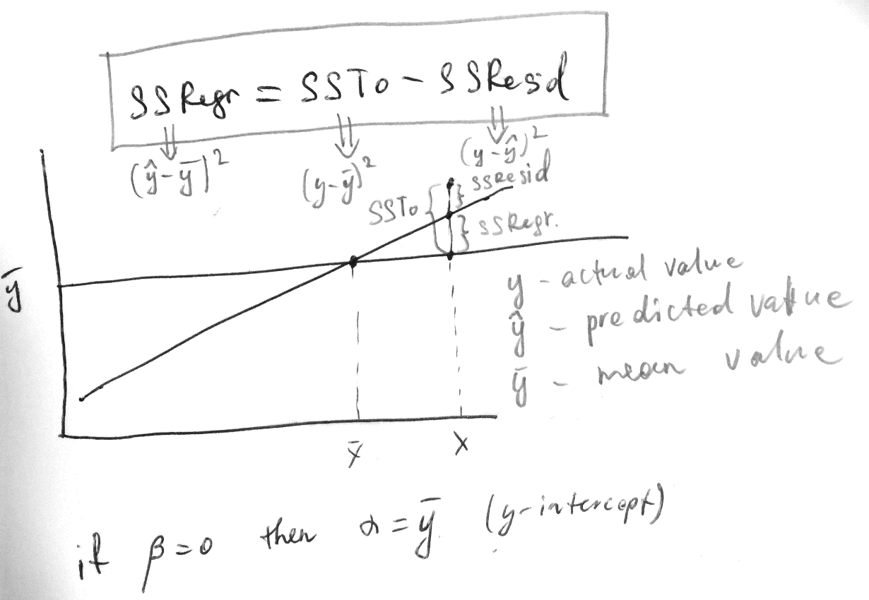
Coefficient of determination

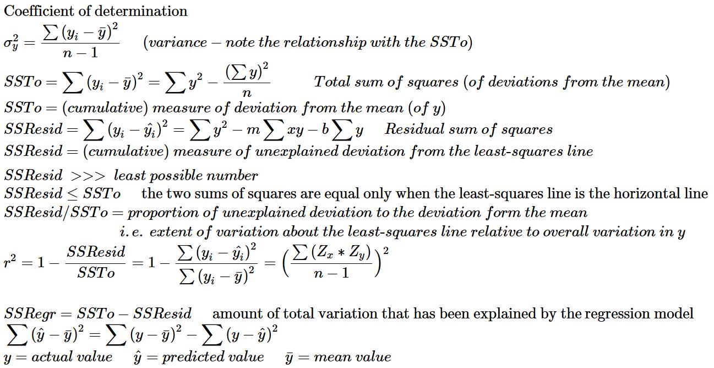

Coefficient of determination is the proportion of the variability in the dependent variable that is predictable from the independent variable.

Standard Deviation of Residuals (aka Standard Error of Estimate)

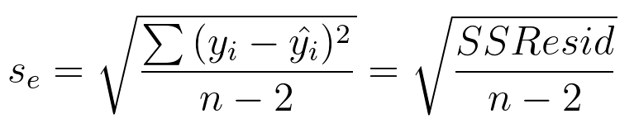
Roughly speaking, is the typical amount by which an observation deviates from the least-squares line,
in other words, the value of tells us that if the least-squares regression line is used to predict a y-value, a typical difference between the predicted value and the actual value would be about units (cm, dollars, pieces etc)

Note:
coefficient of determination explains the deviation in proportional terms (i.e. in %), while
SD about the least-squares line explains the deviation in absolute terms (i.e. if we’re dealing with height, it says that the typical deviation from the regression line is x centimeters)

As a rule the greater the smaller
We decide whether the least-squares regression line is useful based the residual plot, and
is a point estimate for the population standard deviation of errors

Inference about the Slope of the Regression Line (advanced stuff)
b (slope of the regression line based on a particular sample) is a point estimate for the true slope
Confidence Interval for
Hypothesis Test for p. 675
Examination of the residuals: standardized residual plot

(see next page)

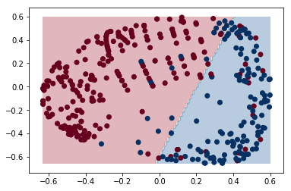

MULTIVARIATE REGRESSION

Coefficient of multiple determination
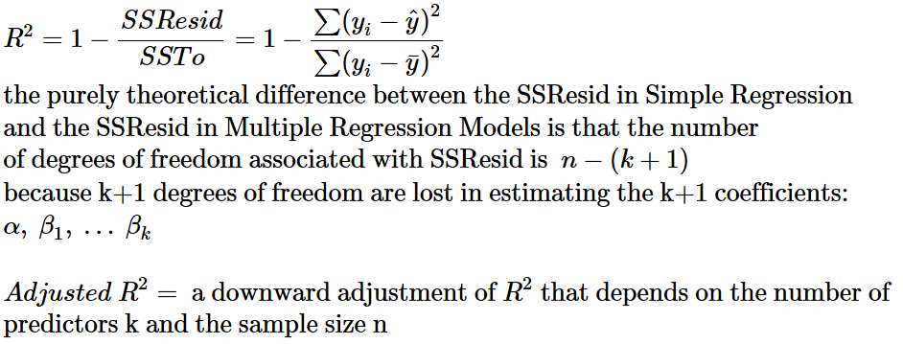

Model Utility F Test for multiple regression
The model utility test in simple linear regression was based on a test statistic that has a t distribution when is true. The model utility test for multiple regression is based on a test statistic that has a probability distribution called an F distribution.

We prefer a larger SSRegr relative to a smaller SSResid
The relationship of SSRegr to SSResid (adjusted with corresponding degrees of freedom*) is described by F.
So we prefer a larger F.
An F-statistic is like a z-score in a normal distribution. So a larger F would lie farther to the right in an F-distribution, meaning that the area under the curve (to the right) is small. This area under the curve (from an F value to the right) is the pvalue, i.e. the probability of the null hypothesis, which (the null hypothesis) suggests that the true regression line must be a horizontal line with all coefficients equal to 0 ( ), because it is supposedly useless to try to find an appropriate regression line.
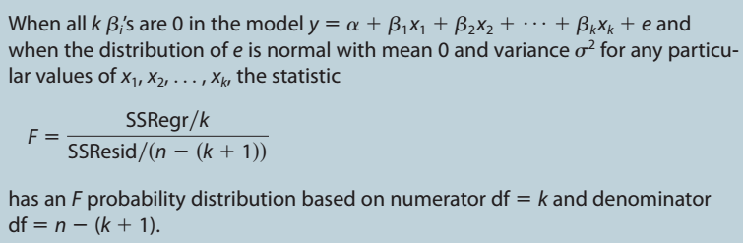

x1 | x2 | y
12 | 1.7 | 120
14 | 3.2 | 130
Note that if we have the following data:

and use the following model:
then k = 5, and not 2 !!!

* degrees of freedom
df1 = k
df2 = n-(k+1)
note that degrees of freedom are used twice: once in the formula for the F statistic
and once when pvalue (i.e. the area under an F distribution curve) is calculated:

pvalue = 1 - pf(F, df1=k, df2=n-(k+1))

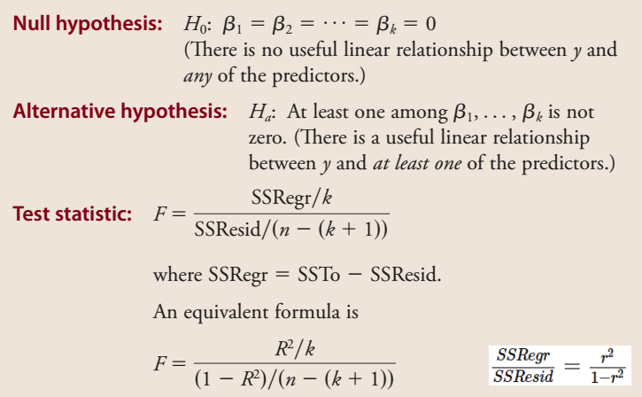

More on F and p for Multivariate Regression

F and therefore p are the measures of model utility.
Conceptual similarity between R² and F:

n = number of data-points
k = number of predictors
SSR = sum of squared (explained) regressions (i.e. predicted by the line)
SSE = sum of squared errors / residuals
SST = sum of squared total deviations from the mean line

F value is comparable to odds =

if meaning this large number will be located at the far right end of the F-curve, whereas smaller numbers will be located at the lower/left tail of the curve.
Small numbers are numerous and large numbers are rare, that’s why the F curve tapers to the right. We measure the probability of our large number or even larger numbers by figuring out the area under the F-curve from our large number to the right end. This area will be of course a small portion of the curve (since our number is large):
That area under the curve is the p-value which is calculated as follows:

p <- 1 - pf(F, df1 = k, df2 = n-(k+1))
p <- pf(F, df1, df2, lower.tail = FALSE)

p = probability of our (large) F value or even larger F values if null hypothesis is true
So, we need a large R² and a small p for our model to be of any use. If the p-value is small (<0.05) then we reject the null hypothesis and come to a conclusion that our model is useful.

ANOVA

factor is what influences the change between the groups (aka levels, populations) compared.
if is true then the factor has no influence, i.e. is not causing any change in real life populations, so the observed differences in means between the groups (aka levels) is misleading.

Here is a summary of the single-factor analysis of variance, but more advanced techniques can do ANOVA on samples on which more than one factor has influence.

The question that ANOVA asks is: are the really different or is the seeming difference in the is caused by the variability within the populations (which caused the to be different). In other words: if the differences between can be explained by the variabilities within the populations (estimated from the variances of samples of course) then we cannot reject

Notation
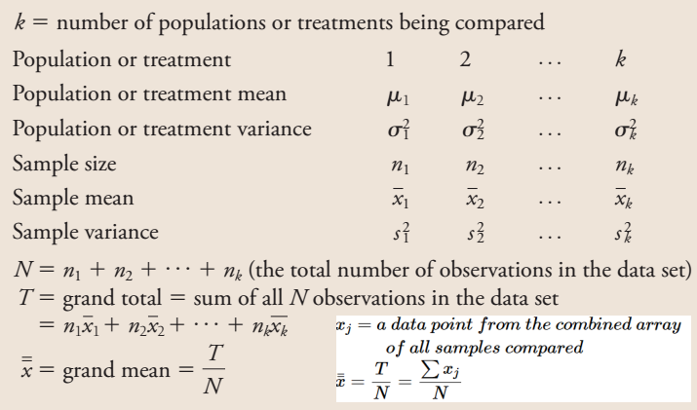

Calculation of SSW, SSB

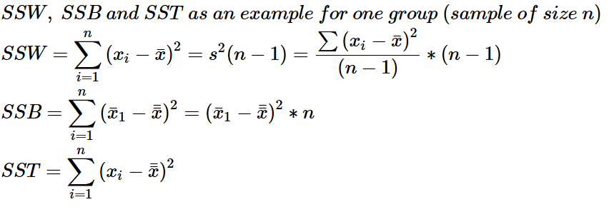

Hypothesis test

What you will need (for each group):

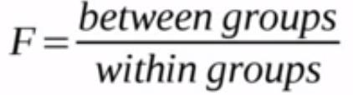
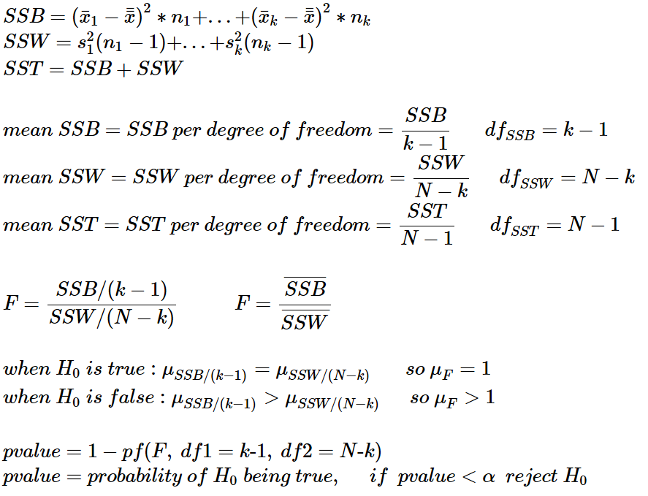

Alternative nomenclature:
SSB = Treatment (sum of squares), SSC = sum of squares between the columns (which represent treatments/groups)
SSW = Error (sum of squares), SSE = sum of squares of error

We need these conditions to be fulfilled:
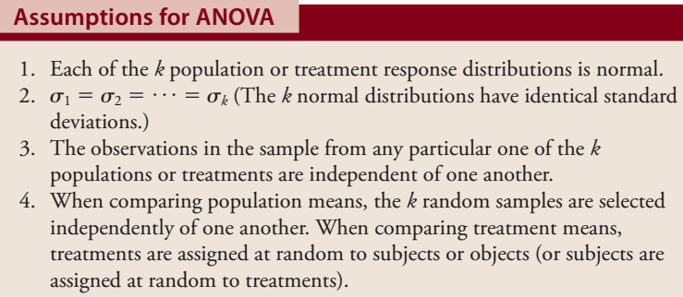

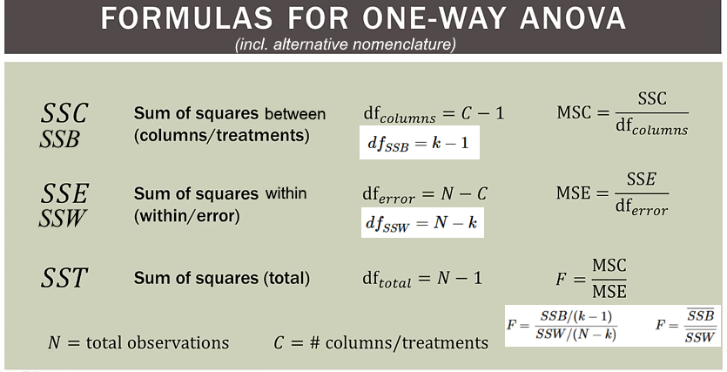

Example
We take three samples (in this case all of different sizes) from three populations
The largest standard deviation must be at most 1.5 times larger than the smallest standard deviation.
In our example the smallest SD = 10
the largest = 28.6
 | Sample 1 | Sample 2 | Sample 3
 | 10 | 40 | 50
 | 20 | 60 | 70
 | 30 | 80 | 90
 |  | 100 | 110
 |  |  | 120
n | 3 | 4 | 5
 | 20 | 70 | 88
s | 10 | 25.8 | 28.6
 | 100 | 666.7 | 820

Dot-plot of the samples’ data points and their means
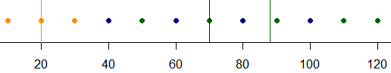

Boxplots
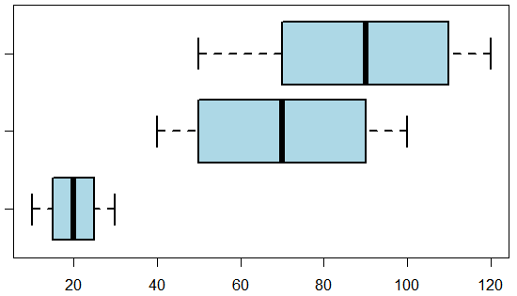

Normal Probability Plot
We can build QQ-plots for each sample but because our samples are small we build a combined qq plot. First we subtract the means from the data points of each respective sample, and then just pool all the values together. The sorted combined array will look like this: -38 -30 -18 -10 -10 0 2 10 10 22 30 32

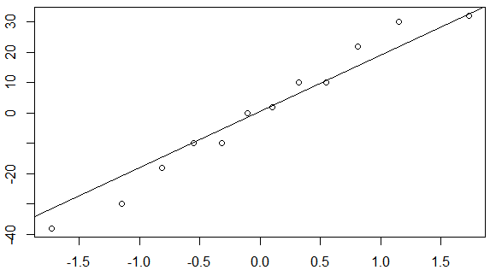

Calculate the P-Value
note that mean(c(a1,a2,a3)) ≠ mean(c(mean(a1), mean(a3), mean(a3)))

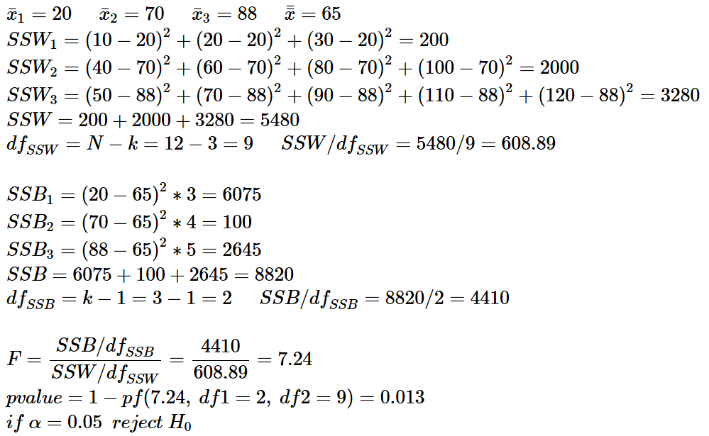

Rejecting we proclaim that we cannot support the claim that the of our three samples are all the same.

Summary table

source of variation | df | sum of squares | mean square | F
Treatments (SSB) | 2 | 8820 | 4410 | 7.24
Error (SSW) | 9 | 5480 | 608.89
Total (SST) | 11 | 14300
P-Value = 0.013

Multiple comparisons procedure (Tukey-Kramer) (p. 746)

From the boxplots we see that the mean of sample 1 is definitely different from the means of the other two samples. Can we test the hypothesis that the means of sample 2 and sample 3 are equal?

Hypothesis test for difference in means of two unpaired populations
here sample 2 = sample 1 sample 2 = sample3

The probability that the true means of the two populations are equal is 36%

BAYES’ PROBABILITIES

 | Yes (B) | No | margin totals
Control (A) | 0.1 | 0.3 | 0.4
Treatment | 0.2 | 0.4 | 0.6
margin totals | 0.3 | 0.7 | 1

P(A) marginal or unconditional probability
P(A|B) conditional probability (probability of a cell in the table’s column or row subset)
P(A⋂B) a particular cell in the table, intersection in a Venn diagram

Probability of the union

analogy: A=1 on a die B=6 on a die

analogy: if A=Control, and B=Yes then P(A⋃B) is the probability that a randomly chosen patient either belongs to the Control group or has been heeled (Yes) (but not both):
P(Control OR Yes) = 0.4 + 0.3 – 0.1 = 0.6

Probability of the intersection, multiplication law

analogy: coin tosses (0.5*0.5=0.25)

analogy: table (see above);
two draws from a bag of marbles (because the second draw is dependent upon the result from the first draw: 1/10 * 1/9)
cell

margin total
cell in a table’s subset

Bayes' theorem

B
A
C

so we can rewrite:

Medical test

Suppose we have two samples each of size 100. One of them (Yes) is contaminated for our test to test it, and the other one (No) is disease free:
Counts Probabilities (conditional!) i.e. likelihoods
supertest  our test | Yes | No
Positive | 0.9 | 0.05
Negative | 0.1 | 0.95
supertest  our test | Yes | No
Positive | 90 | 5
Negative | 10 | 95
 | 100 | 100
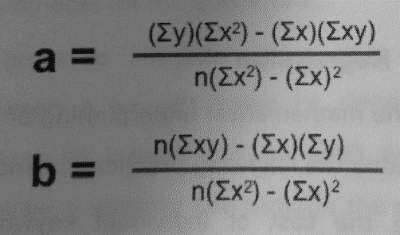
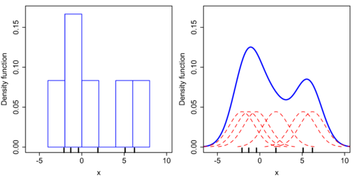
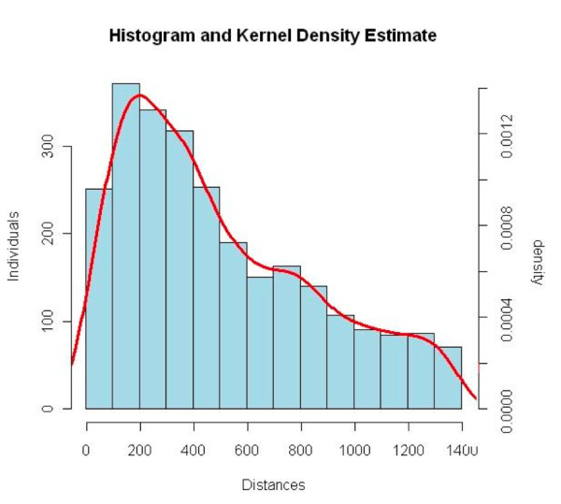
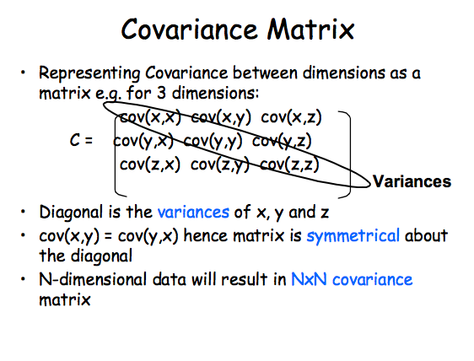
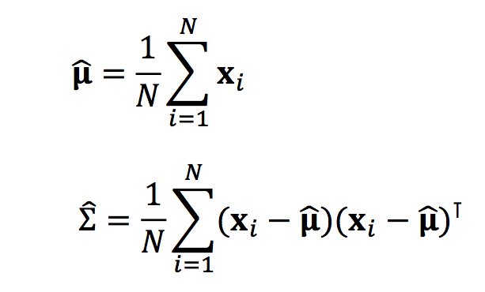
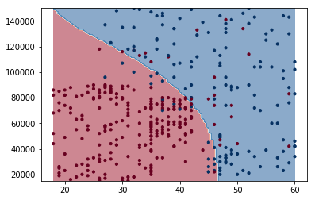
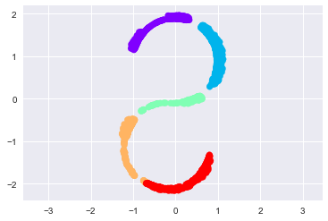
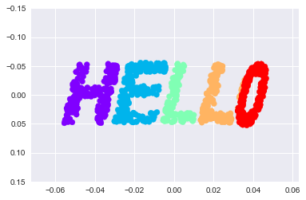
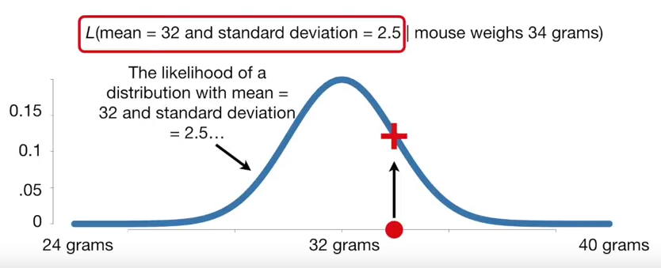
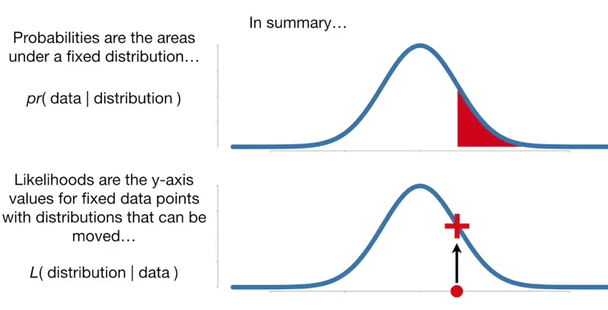
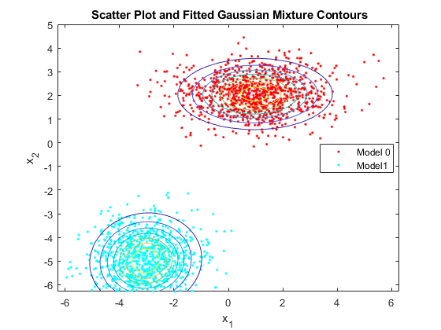
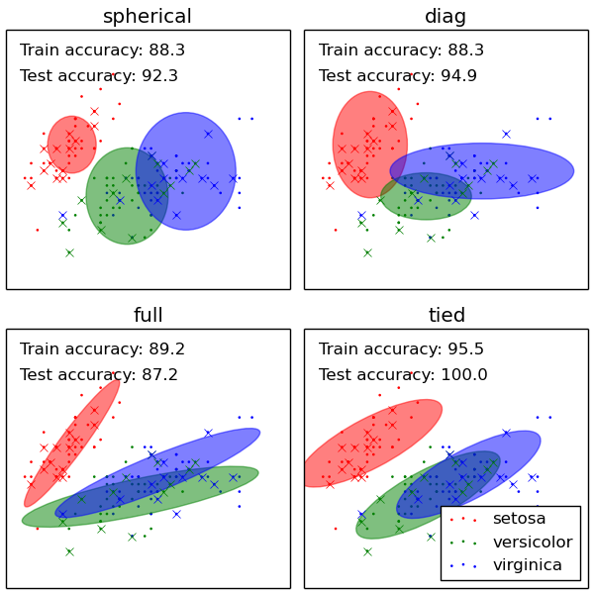
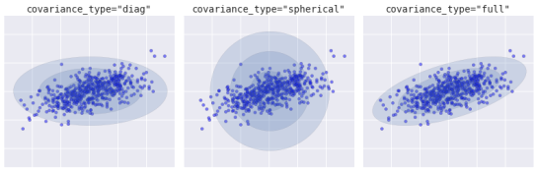
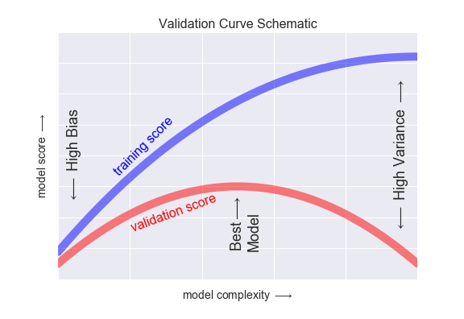
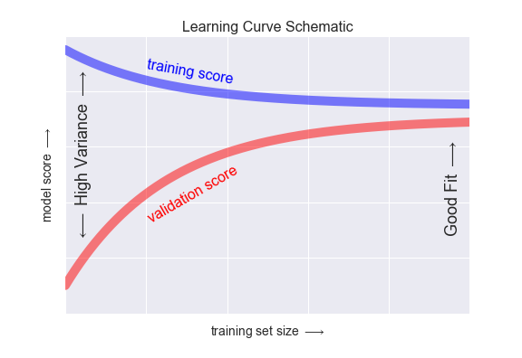
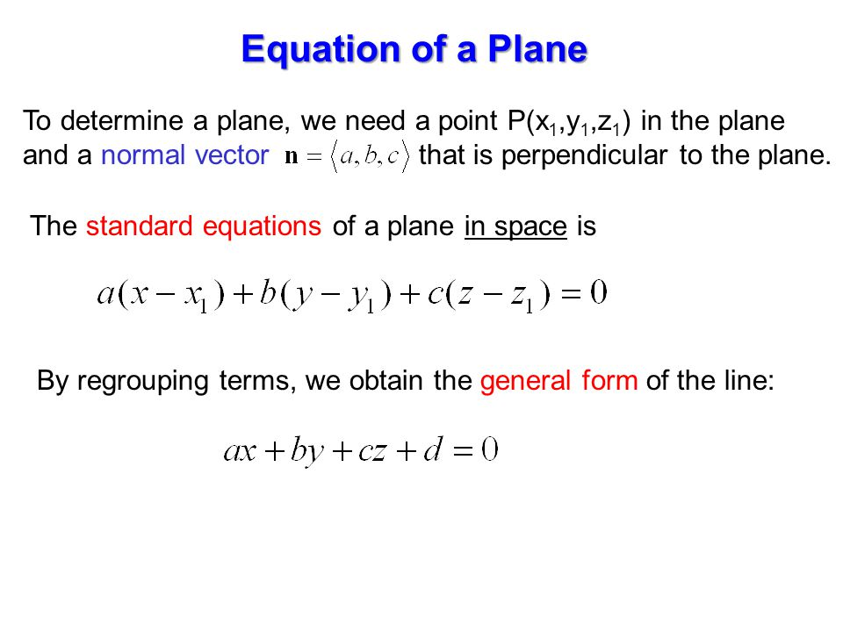
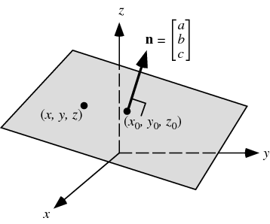
Control
0.3
Yes
0.2
0.1
supertest  our test | Yes | No
Positive | true positive | false positive
Negative | false negative | true negative

P(Yes) in our testing situation is 100/200=0.5 but we are interested in the prevalence of the disease in real life. Suppose P(Yes) in real life is 4.5% i.e. the probability that a random person has the disease is 0.045
We are interested in P(Yes|Positive) i.e. the probability of a person actually having the disease if he is tested positive.

so we can rewrite:

because

You get the same result with the Tree method

“Yes”, ”No” and “A” (in the examples above) are mutually exclusive states of nature
“Positive”, “Negative” and “B” are mutually exclusive observable events

P(A) and P(Yes) are prior probabilities
P(A|B) and P(Yes|Positive) are posterior probabilities
P(B|A) and P(Positive|Yes) are likelihoods

Summary:

P(A) P(H) prior probability / proposition (a state of nature) probability of having disease
P(B) P(E) marginal probability / evidence (an observable event) probability of being tested positive
P(B|A) P(E|H) likelihood = sensitivity being tested positive if infected???
P(A|B) P(H|E) posterior probability prob. of being infected if tested positive
P(H) / P(H’) odds
(P(H) / P(H’)) / (P(E) / P(E’)) odds ratio???

A = proposition/hypothesis = prior = state of nature = H disease
B = evidence = marginal = observable event = E tested positive or negative

 |  | Exposure aka Evidence, Test, Symptoms ?
 |  | Treatment/Intervention  Group | Control  Group | total
Hypothesis | disease | 40 | 20 | 60
Hypothesis | no disease | 10 | 30 | 40
 | marginal | 50 | 50 | 100

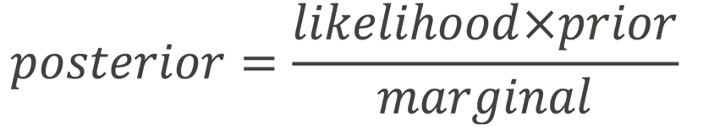

P(data | distribution) what’s the probability of this particular value given this distribution?
L(distribution | data) what’s the likelihood that the value we observe belongs to this distribution?

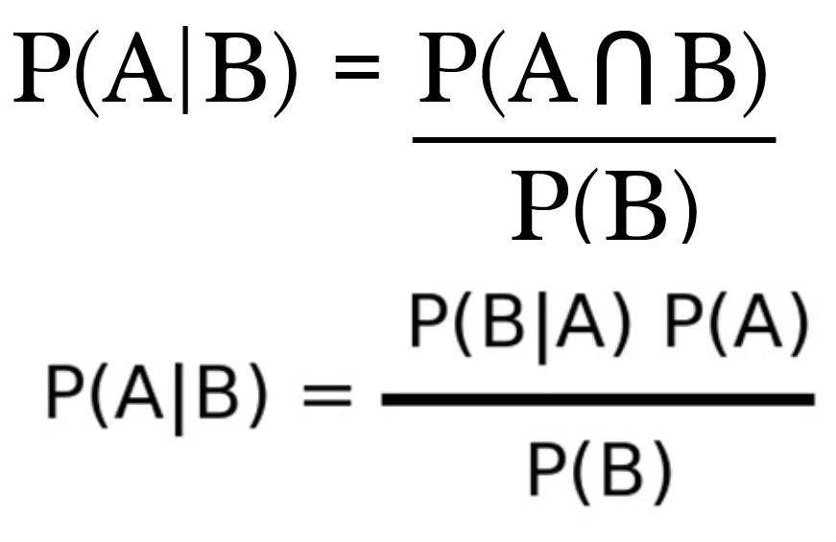

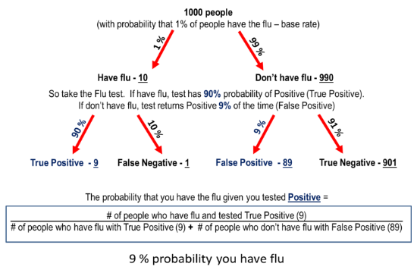
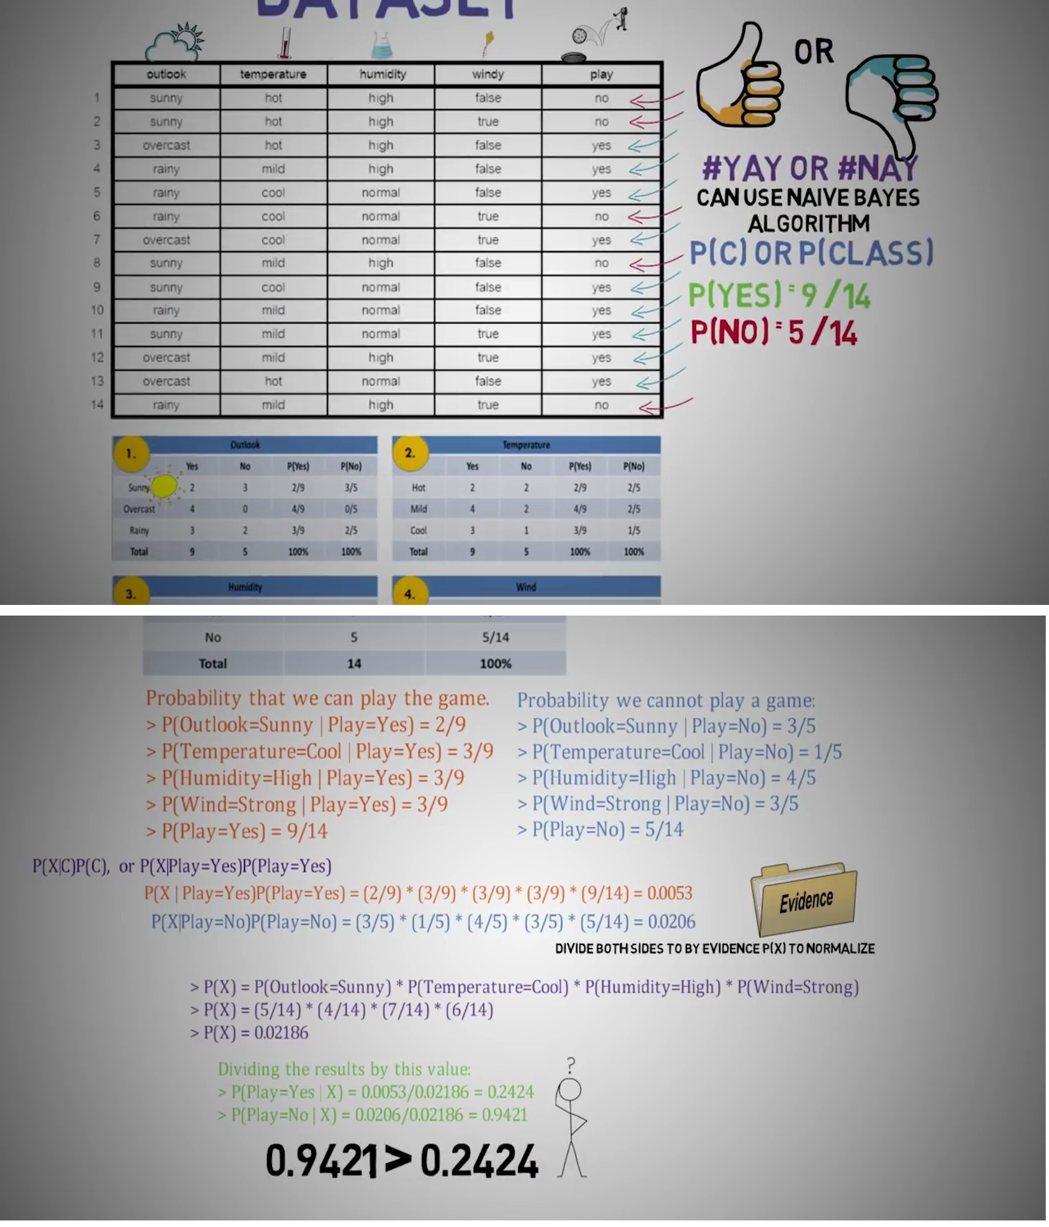

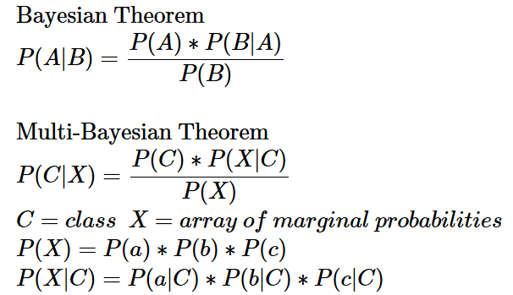

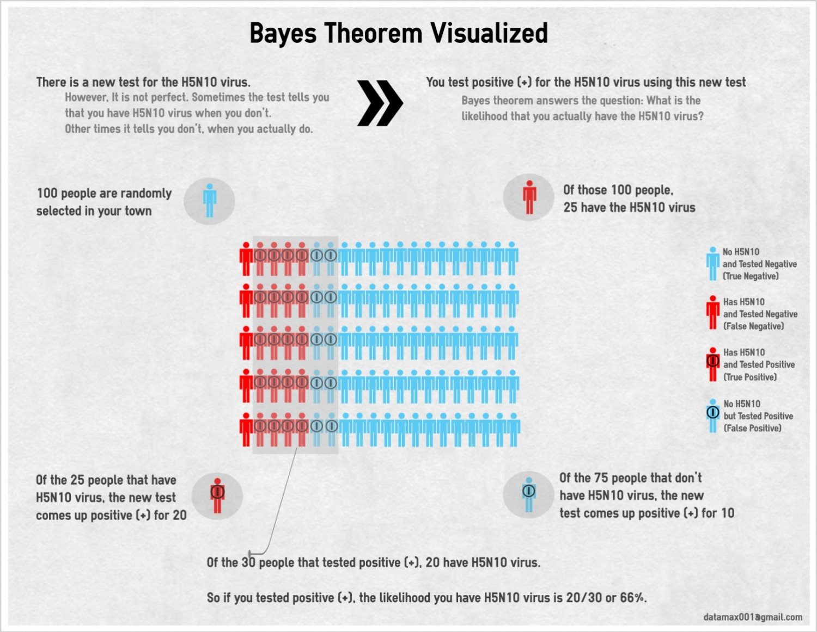

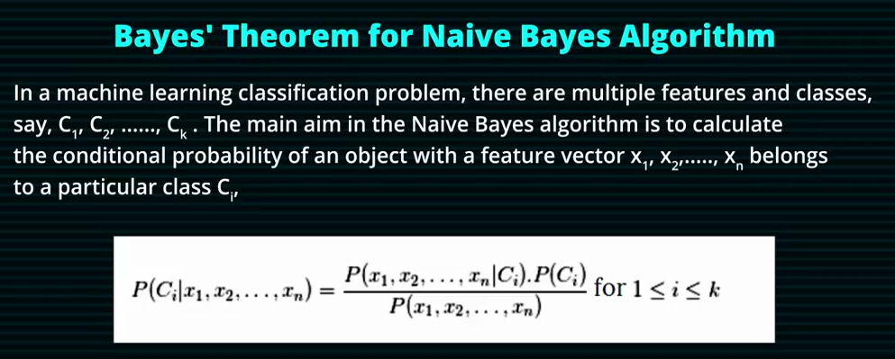
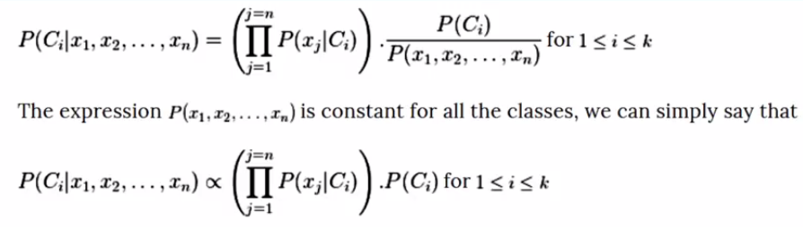

Practice Bayse Theorem with:
- Wenn diagram
- Table
- Tree
- 10 dots

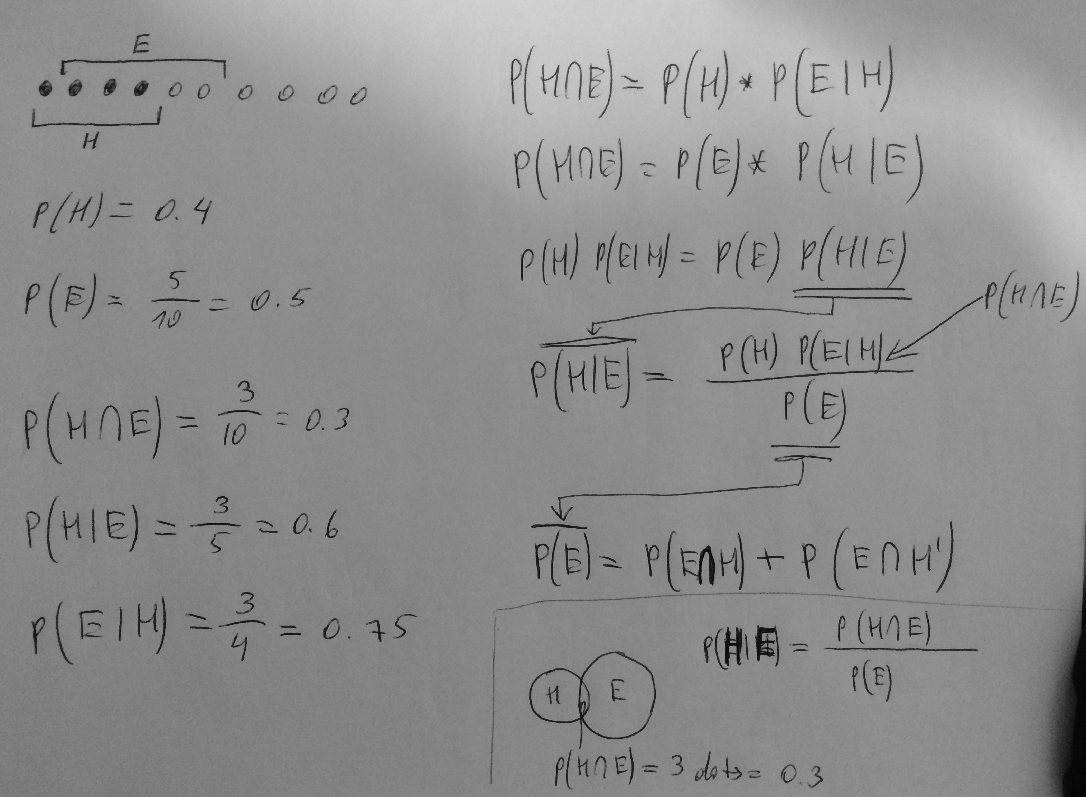

 |  | SUPERTEST - TRUTH
 |  | H  Yes disease | H’  No disease
TEST  EVIDENCE  EXPOSURE  INTERVENSION  PREDICTION | E  Positive  Treatment/Intervention | TP | P(H|E) = precision = posterior  :  FP  :  Type I = | P(E)  marginal probability
TEST  EVIDENCE  EXPOSURE  INTERVENSION  PREDICTION | E’  Negative  Control group | FN  Type II = | TN
P(H)
P(E|H) = sensitivity = likelihood
prior proposition

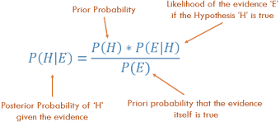

demo on poisson distribution
# 2 events per minute
# if random == 30 or 60 : event

from random import randint
from numpy.random import poisson

λ = 2
events = []
hours = 80 # how many hours

for second in range(60*60*hours):
if randint(1,60) in (30,60):
minute = (second // 60)+1
events.append(minute)

counts = [events.count(minute) for minute in range(min(events), max(events)+1)]
counts_poisson = poisson(λ, len(counts)) # analogous to the above

from matplotlib.pyplot import hist, subplots
breaks = range(max(*counts, *counts_poisson)+1)
fig, SP = subplots(1,2, sharey=True)

#COMPARE..
SP[0].hist(counts, bins=breaks) ;SP[0].set_title("Poisson distribution\ngenerated from uniform distribution")
SP[1].hist(counts_poisson, bins=breaks) ;SP[1].set_title("numpy-poisson generator")

