CPS209 Assignment 2:

Data Structure Simulator

Due Date: April 8 11:59pm

Objective: To practice using Linked Lists, Queues, inheritance, frames, listeners.

General Application: Simulate linked lists and a queue graphically.

Instructions:

Write a graphical application for drawing and linking railcars. The interface for the simulation should look something like the following:

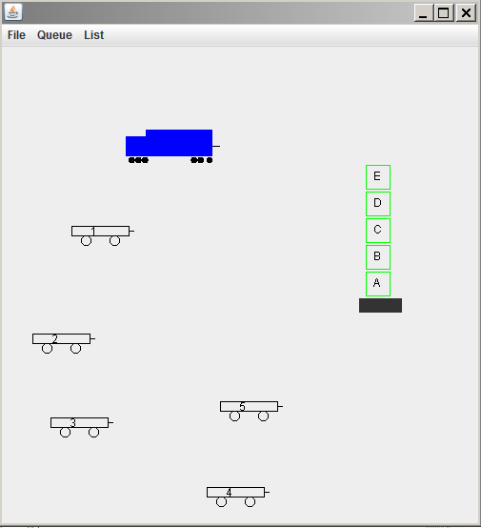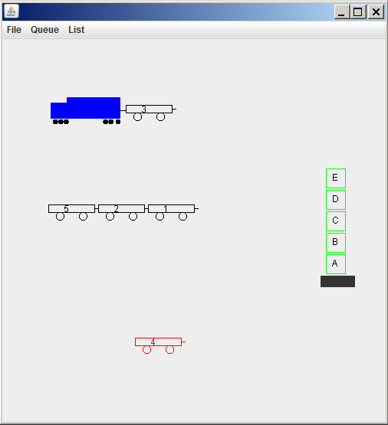
Figure 1: The figure on the left shows the panel after the user has pressed the mouse in seven locations to first create the train engine, then five railcars and then the queue of storage containers (with a base) shown. The figure on the right shows the panel after railcar 3 has been hitched to the train and after railcar 2 has been selected and hitched to railcar 5, then railcar 1 selected and hitched to railcar 2. Railcar 4 is currently selected. Note the line used to visually depict a vehicle’s trailer “hitch”.

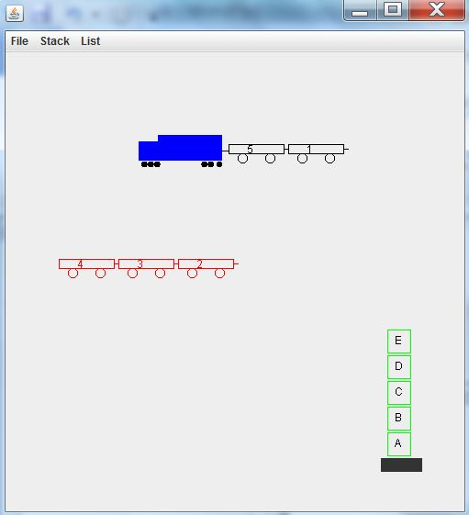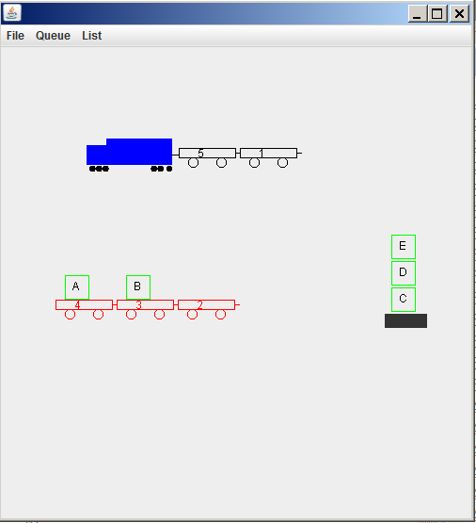

Figure 2: In the left figure, railcar 5 and 1 are hitched to the train engine. Railcar 3 has been selected and hitched to railcar 4 and then railcar 2 has been selected and hitched to railcar 3. Railcars 4, 3, and 2 have been linked and then railcar 4 has been selected. This causes the trailer of railcar 4 (railcar 3) and the trailer of railcar 3 (railcar 2) to also be selected. The user can now move railcars 4, 3, 2 as a single unit. In the right figure, the Queue menu was used to remove a storage container from the front (bottom, above the base) of the queue and add it to railcar 4, then another queue remove was carried out and the container added to the next available railcar of the current selection (railcar 3)

Terminology:

• Vehicle: Abstract class which is a superclass of classes RailCar and TrainEngine. This class should contain variables and methods that are common to RailCar and TrainEngine. The methods supply default behavior and may be overridden in RailCar and TrainEngine.

• trailer: This is not a class, but rather just a term that refers to a railcar attached to the hitch of another vehicle. So, in figure 1 on the right, railcar 3 is a trailer for the train engine, and railcar 1 is a trailer for railcar 3. Class Vehicle should have an instance variable trailer of type Vehicle. This variable is set to refer to the towed vehicle object or is set to null (indicating there is no towed vehicle).

Functionality:

- You cannot use the mouse to select a towed vehicle. Only the lead vehicle can be selected. When a lead vehicle is selected, the vehicle and its trailer (and the trailer’s trailer etc.) are all selected and move as a single unit. We will refer to a trailer railcar, and the trailer’s trailer etc. as the “linked railcars”.
- When you draw a lead vehicle (either a lead railcar of linked railcars or a train engine and its linked railcars), you must traverse the trailer links and draw all linked railcars). How do you know whether a railcar is a lead railcar and not a trailer of another railcar of the train engine? See the hint below in the NOTE WELL section.

Basic mouse operations are as follows:

• Press: Initially the panel is blank. The user can then press the mouse button and the train engine is created at the mouse position. Then, wherever they press the mouse button a railcar is created at that location. After five railcars have been created in this manner, then the next mouse button press creates a queue of 5 storage containers and a container base. Any subsequent mouse button presses on a railcar selects the railcar (and any linked railcars) and changes its (and any linked railcars) color to red.

• Drag: If the user presses and holds the mouse button and drags the mouse on a railcar which has been selected, then the railcar (and any linked railcars) moves with the mouse. You can look up MouseMotionListener in the java API to implement dragging. Note: the train engine can be selected and dragged, along with all of its linked railcars.

• Release: When you release the mouse button, if the bounding box of the selected railcar intersects the bounding box of another vehicle (railcar or train engine) which does not already have a trailer, then the selected railcar (and any linked railcars) becomes the trailer for that vehicle.

The File menu lets the user do the following:

• New: Start a new simulation.
• Exit: Exit from the application.

The List menu should let the user do the following:

• Add First: Link the selected railcar (along with any linked railcars) to the train engine as the first one in the chain of vehicles towed by the train engine.

• Add Last: Link the selected railcar (along with any linked railcars) to the last railcar in the chain of vehicles towed by the train engine.

• Remove First: Remove the first railcar from the chain of railcars linked to the train engine. The other railcars remain attached to the train engine. Position the removed railcar randomly.

• Remove Last: Remove the last railcar from the chain of railcars attached to the train engine.

The Queue menu lets the user do the following:

• remove: remove the front storage container from the container queue and load it onto the selected railcar only if the railcar is empty. If the railcar is not empty then check the linked railcars (i.e. traverse the linked railcars) for an empty railcar. If one is found, load the storage container onto it. If none is found, leave the container queue unchanged.
• add: unload the storage container from the selected railcar and add it to the end (rear) of the container queue. If the selected railcar is empty, traverse the linked railcars looking for the first nonempty railcar. If one is found, unload the container and add it to the container queue.

Note: if the train engine is selected, apply remove and add to its linked railcars

NOTE WELL!!:
The train engine and railcar part of this assignment is a linked list simulator. This means *you must manage the linked list yourself* by setting a vehicle's (i.e. a railcar or the train engine) trailer variable to refer to the railcar object you want to attach as a trailer. Do not use the java LinkedList class to do this.
Also, when your paintComponent() method is executed, you must draw the train engine and the 5 railcars. However, inside paintComponent() you only call the draw() method for a railcar *if it is not a trailer* (of the train engine or of another railcar).
If a railcar is a trailer of the train engine or of another railcar, then the draw method of class RailCar/class TrainEngine will draw it.
So, if you refer to figure 2 left, your paintComponent() method should call the draw() method for the train engine and for the lead railcar 4. RailCars 1, 3, 2 will be drawn via the draw method of the trainengine and the lead railcar 4.
For drawing purposes only, you might want to keep a separate Java ArrayList/LinkedList of the 6 vehicle objects inside your JComponent class. When paintComponent() is executed, it gets a vehicle from this list and only draws it if it is not a trailer (Hint: a vehicle could use a boolean instance variable, isTrailer, to keep track of its trailer status). Set this variable to true when you link a railcar to another railcar or to the train engine.

For the container queue part of the assignment, you must either use the java Queue interface or manage the container queue yourself with links (similar to the railcars above).

Sample files that may be useful to extend and modify:
RailCar.java (based on class Car from BigJava)
TrainEngine.java

Sample files that may be useful as an example or guide for GUI menus:
FontViewer.java (From Chapter 19 of BigJava)
FontFrame.java (From Chapter 19 of BigJava)

Grading Details:
- For a maximum of 6 marks do all of the above except no mouse functionality and no container queue add/remove functionality. Automatically create the train engine, the five railcars and the container queue and place them randomly in the panel.
- For a maximum of 7 marks, add the mouse press functionality.
- For a maximum of 7.5 marks, add the mouse drag functionality.
- For a maximum of 8.5 marks, add the mouse release functionality.
- For a maximum of 10 marks, add the container queue add/remove functionality.
- Note that 10% of your mark is for program structure, style and documentation. You must use inheritance. You must use javadoc style documentation, have proper indentation, meaningful variable names, class names starting with uppercase, variable names starting with lower case, constants all capitals.
- Submit your java files on D2L by Apr. 8

Copying or letting your work be copied results in a zero as well as other repercussions.

